**Problem Statement**

Identify usable space within a social media safezone which doesn’t intersect with any faces for a 9:16 aspect ratio vertical video.

Social media safe zones are identified using the following formula.



Within the safe zone( green region) identify the maximum area where the text can be placed such that it doesn’t intersect with any face.

Divide the video into different scenes based on fast-cut detection of each shot.Within each scene identify faces.Keep track of any movement.Suggest a maximum common area within each scene such that no faces are intersected.

Solution should be in Python.You are free to use any framework/model.

Solution will be tested for correctness,speed and ability to adapt for a horizontal 16:9 aspect ratio video.

Please use the video attached below for testing.

<https://drive.google.com/file/d/157XnzrrubyxwjmYvCmOhn0_wVpvNzMN8/view?usp=sharing>

If you have any questions you can call or email us.

**Example Output**

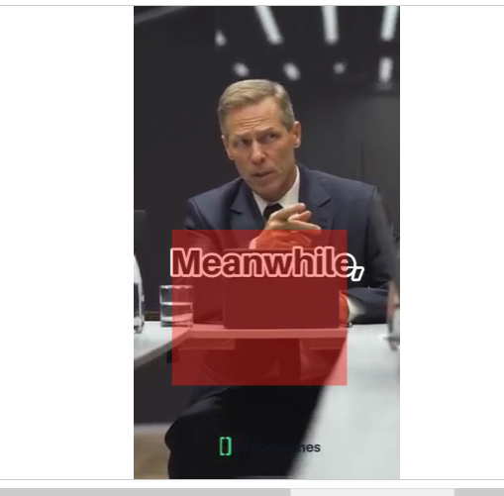

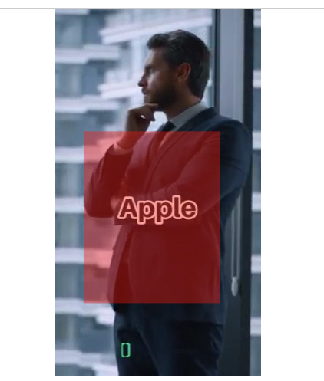

**Bonus Question**

Think about scaling the solution to more challenging use cases.

For example, will your solution scale to the following case ?

