REPORT FOR ‘ASSIS - DUMMY ASSISTANT'

**Group Project Work for the Course**

PYTHON PROGRAMMING (INT 213)

Name : Satish Kumar

Registration Number : 12020945

Name : Sai Kumar Muddada

Registration Number : 12020945

Program : CSE (B.Tech)

Semester : 3rd

School : School of Computer

. Science and Engineering

Name of University : Lovely Professional . University

Date of Submission : 20th November, 2021

Lovely Professional University

Phagwara, Punjab, India

**Assis – Dummy Assistant**

**Git-hub link of project :** <https://github.com/Satishkumarsingh0/assis>

**20th  November, 2021**

***Abstract:-***

In everyday life, sometimes we need to use our phone or other devise while working as making a call, switching off or on an electronic device present in the house, searching something on google, playing music, setting alarm, writing notes etc. but, we don’t want to use devises again and again for such operation. So we need a technical system which can perform these works without manual operation.

Hence, virtual voice assistant comes in picture. As many virtual assistants are available at present time as ‘Cortana’, ‘Siri’, ‘Google Assistant’. These have capability to perform many tasks without manual operation. Just we need to give voice commands to your virtual assistant for pre-defined operations and your work will be done.

‘Assis’ is a dummy virtual voice assistant which can perform some defined tasks. This is a very basic dummy virtual assistant, developed as project in LPU. The virtual assistants can perform many tasks and make our lives comfortable, easy and also save our time.

*Acknowledgement:-*

We would like to thank our python programming course teacher ‘Ashish Srivastava’ and LPU for giving such opportunity to develop a project like this. Also thank to our team member who worked hard to complete the program.

***Contents***

|  |  |
| --- | --- |
| 1. Cover | 1 |
| 1. Abstract | 2 |
| 1. Acknowledgement | 2 |
| 1. Content | 3 |
| 1. Introduction    1. Context    2. Motivation    3. Idea | 4 |
| 1. Roles of Team member | 5 |
| 1. Libraries and Modules | 6 |
| 1. Basic layout of Tkinter GUI | 7 |
| 1. Screenshots :    1. Obtained GUI interface    2. Running program    3. Error : when command not given | 8  9  10 |
| 1. Solving Errors | 11 |
| 1. Conclusions | 12 |
| 1. References | 13 |
|  |  |
|  |  |

**Introduction:-**

* 1. *Context:-*

This project has been done as part of the course for CSE(B.Tech) at Lovely Professional University. Supervised by ‘Ashish Srivastava’. We gave several weeks for completing the project in order to succeed the module.

* 1. *Motivation:-*

At present time everyone uses smart AI gadgets or software every day and for many times in a day. And having extremely interest in artificial intelligence and machine learning, this group project was a great opportunity to learn and implement machine learning for first time and also increased our interest in machine learning. In fact, we tried to grab thing from many source and tried to implement it at our own node. We can use it for searching or finding things on internet without manual operation but only by giving

voice command. It can save time and make life easy.

* 1. *Idea:-*

At first we went through the list of projects and we find it as interesting and challenging project and we dived into it. We tried different approaches to complete the project as we went through many websites of Google, many YouTube videos in order to learn the things and complete the project and solving errors while during coding. The main goal was to make a voice assistant dummy program which can give output as our given command.

Team Members:-

*Team Leader:*

Satish Kumar:-

Contributions:-

1. Coding (joined)

2. Improved GUI Tkinter

3. Report (joined)

4. README.md file for solving errors

Sai Kumar Muddada:-

Contributions:-

1. Coding (joined)

2. Introduced GUI Tkinter

3. Report (joined)

Libraries and Modules:-

*Tkinter:-*

Tkinter is the GUI module offered by python. It is a standard Python interface to the Tk GUI toolkit shipped with python. Python with tkinter is the fastest and easiest way to create the GUI applications.

We have use this module for creating a interface from where program can be run easily.

*Pyttsx3:-*

Pyttsx3 is a text-to-speech conversation library in python. It works offline and compatible with all python versions. An application involes the pyttsx3.init() factory function to get a reference to pyttsx3. Engine instance is used to convert entered text to speech. The pyttsx3 module supports two voices first is female and the second is male which is provided by ‘sapi5’.

*Speech_Recognitionion:-*

Speech recognition library is used to convert spoken words to text. We have used this module for the same and use spoken words as command which is named as query variable.

*webbrowser:-*

The webbrowser module provides a high-level interface to allow displaying web-based documents. As we have used open() function for getting web based results.

Basic Layout of tkinter GUI

Start Button

Name of program

Description 1

Start

cm

Exit Button

Exit

Stop

Stop Button

Description 2

Description 3

Descriptions labels

Screenshots:-

1. *Tkinter GUI obtained*

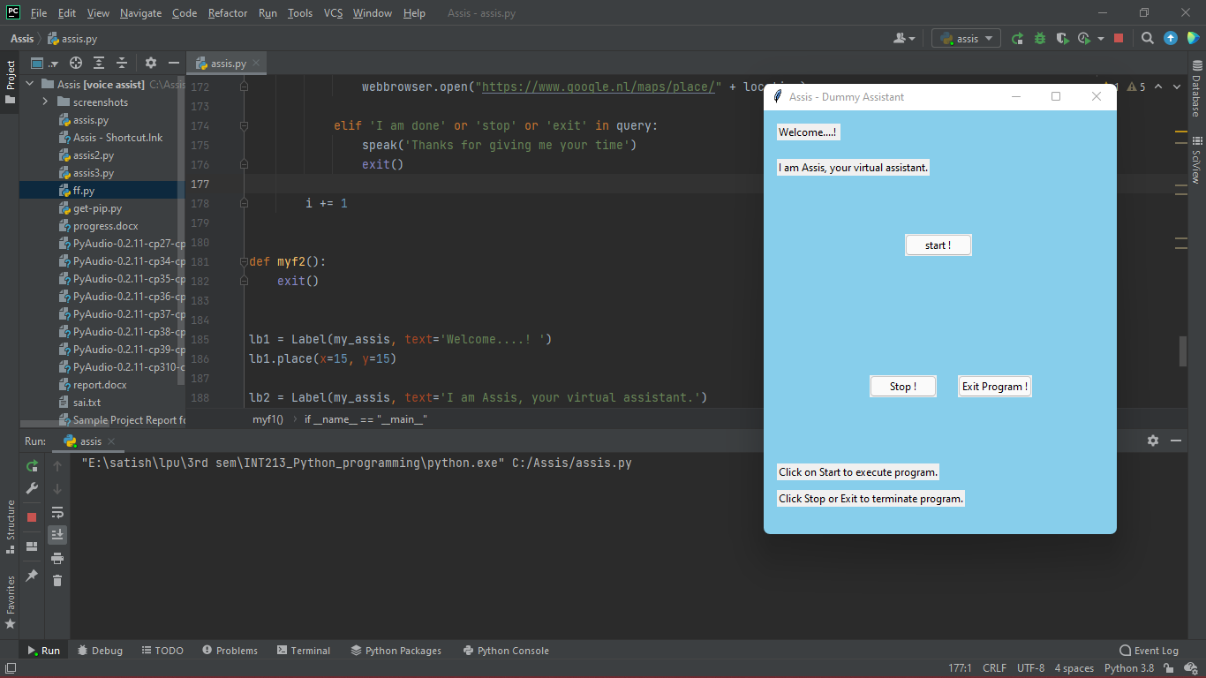

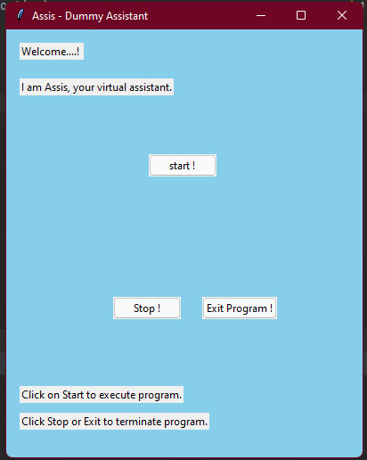

1. *Running program Screenshot*

Clicked on start

command given: where is lovely professional university

Output :

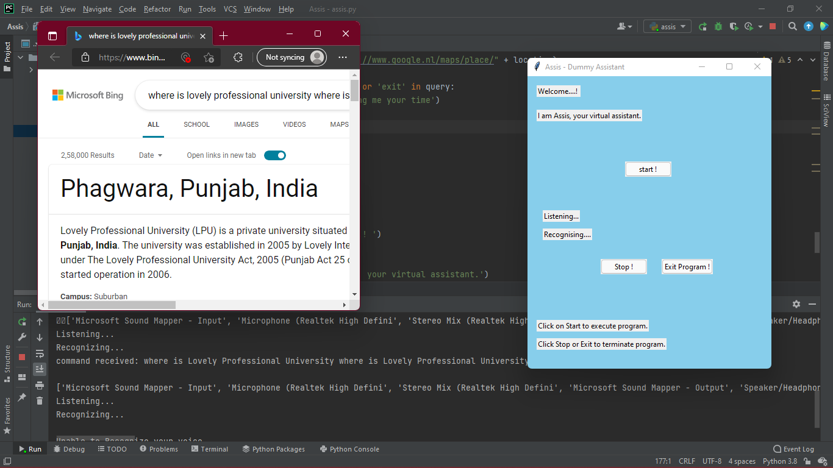

*3. When command not given :*

Showing given voice command given by user as text in terminal

Output : Lovely professional University is shown on default browser.

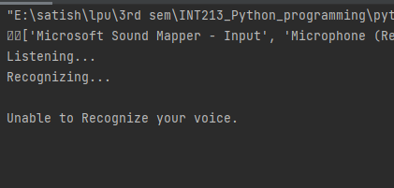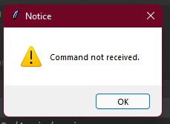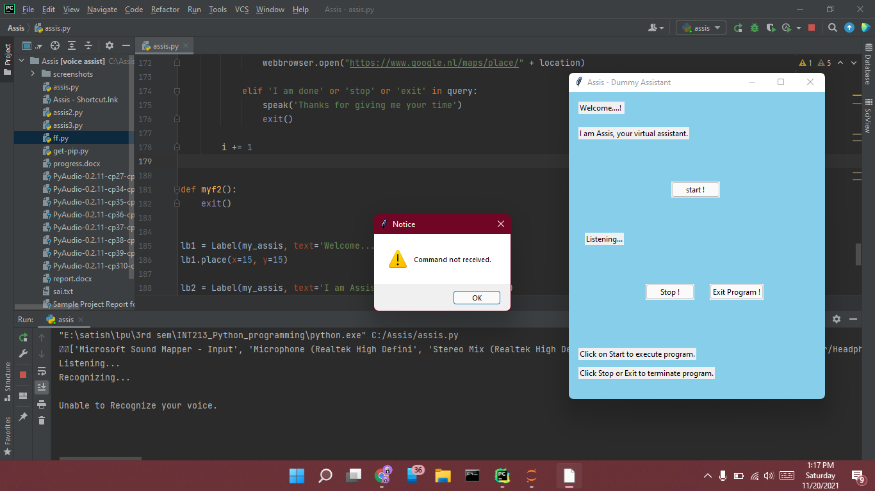

Output : in terminal string received as “ Unable to Recognize your voice”.

Output : notice window appeared showing “Command not received”.

*README.md :*

Solving Errors:

Before running the program, we must install these modules in terminal :

pyttsx3 : pip install pyttsx3

speech_recognition : pip install Speech_Recognition

wheel : pip install wheel

pipwin : pip install pipwin

PyAudio : pipwin install PyAudio

------------------------------------------------------------------------------------------------------------

Error case 1 :

In case PyAudio is not directly supported to your system, then try to install given external PyAudio versions which is supported to your system named :

PyAudio-0.2.11-cp27-cp27m-win_amd64.whl

or

PyAudio-0.2.11-cp34-cp34m-win_amd64.whl

or

PyAudio-0.2.11-cp35-cp35m-win_amd64.whl

or

PyAudio-0.2.11-cp36-cp36m-win_amd64.whl

or

PyAudio-0.2.11-cp37-cp37m-win_amd64.whl

or

PyAudio-0.2.11-cp38-cp38-win_amd64.whl

or

PyAudio-0.2.11-cp39-cp39-win_amd64.whl

or

PyAudio-0.2.11-cp310-cp310-win_amd64.whl

or try another from

https://www.lfd.uci.edu/~gohlke/pythonlibs/

for python 3.8.2, 64 bit recommended PyAudio version : - <https://download.lfd.uci.edu/pythonlibs/w6tyco5e/PyAudio-0.2.11-cp38-cp38-win_amd64.whl>

----------------------------------------------------------------------------------------------------------------

Error Case 2 :

if program is running but not taking command input of you voice then try with an external microphone device.

Conclusions:-

We hope that this document report will be helpful in understanding our basic dummy voice assistant project as we have used basic tkinter GUI for making project user friendly so that user can run the program very easily by just clicking the left button on appeared window. As PyAudio was not supporting in many devices so for solving this error, it took so time so we couldn’t add more options or idea but we wish we will improve the project furthermore. Hopefully, I will try to make the program bug or exception or error free.

References:-

To conduct the project, following IDEs or tools have been used (any can be used, no need to install each) :

Jupyter notebook (IDE) : <https://jupyter.org/>

Pycharm (IDE) : <https://www.jetbrains.com/pycharm/>

Python (IDE) : <https://www.python.org/> (compulsory)

V S Code (IDE) : <https://code.visualstudio.com/>

* 1. Greeks for Greeks :-

We have used this website for our basic knowledge and for solving errors and for going through modules used in the project

<https://www.geeksforgeeks.org/voice-assistant-using-python/>

* 1. CodeWithHarry (from YouTube) :-

We have used this website for initial basic knowledge gain of the methods that will be used in the project

<https://www.youtube.com/watch?v=Lp9Ftuq2sVI>

* 1. Stackoverflow :-

We have used this website for basic knowledge of the tkinter GUI used in the project

<https://stackoverflow.com/questions/34108841/creating-a-simple-gui-program-using-tkinter-in-python>

***End***