**Documentation**

**Username: admin**

**Password: 123**

**Overview:-**

This API allows for managing organizations, roles, and users within an organization. There are four main roles: Super Admin, Admin, Manager, and Member. Each role has specific permissions for creating, retrieving, updating, and deleting organizations, roles, and users.

**Organization Endpoints:-**

**1.List Organizations**

 URL: /api/organizations/

 Method: GET

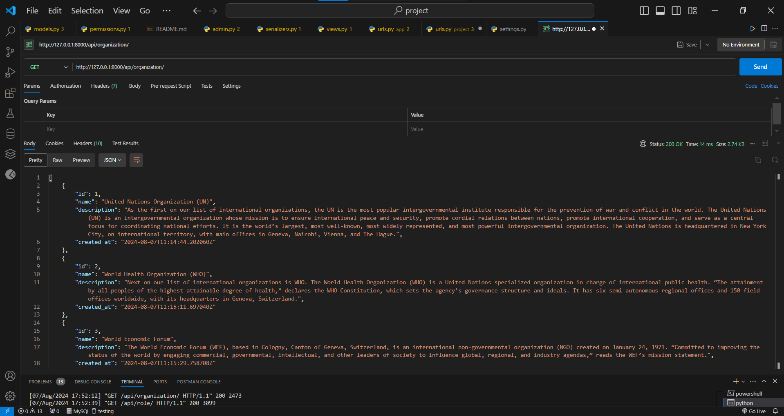

**2.Retrieve Organization Details**

URL: /api/organizations/{id}/

 Method: GET

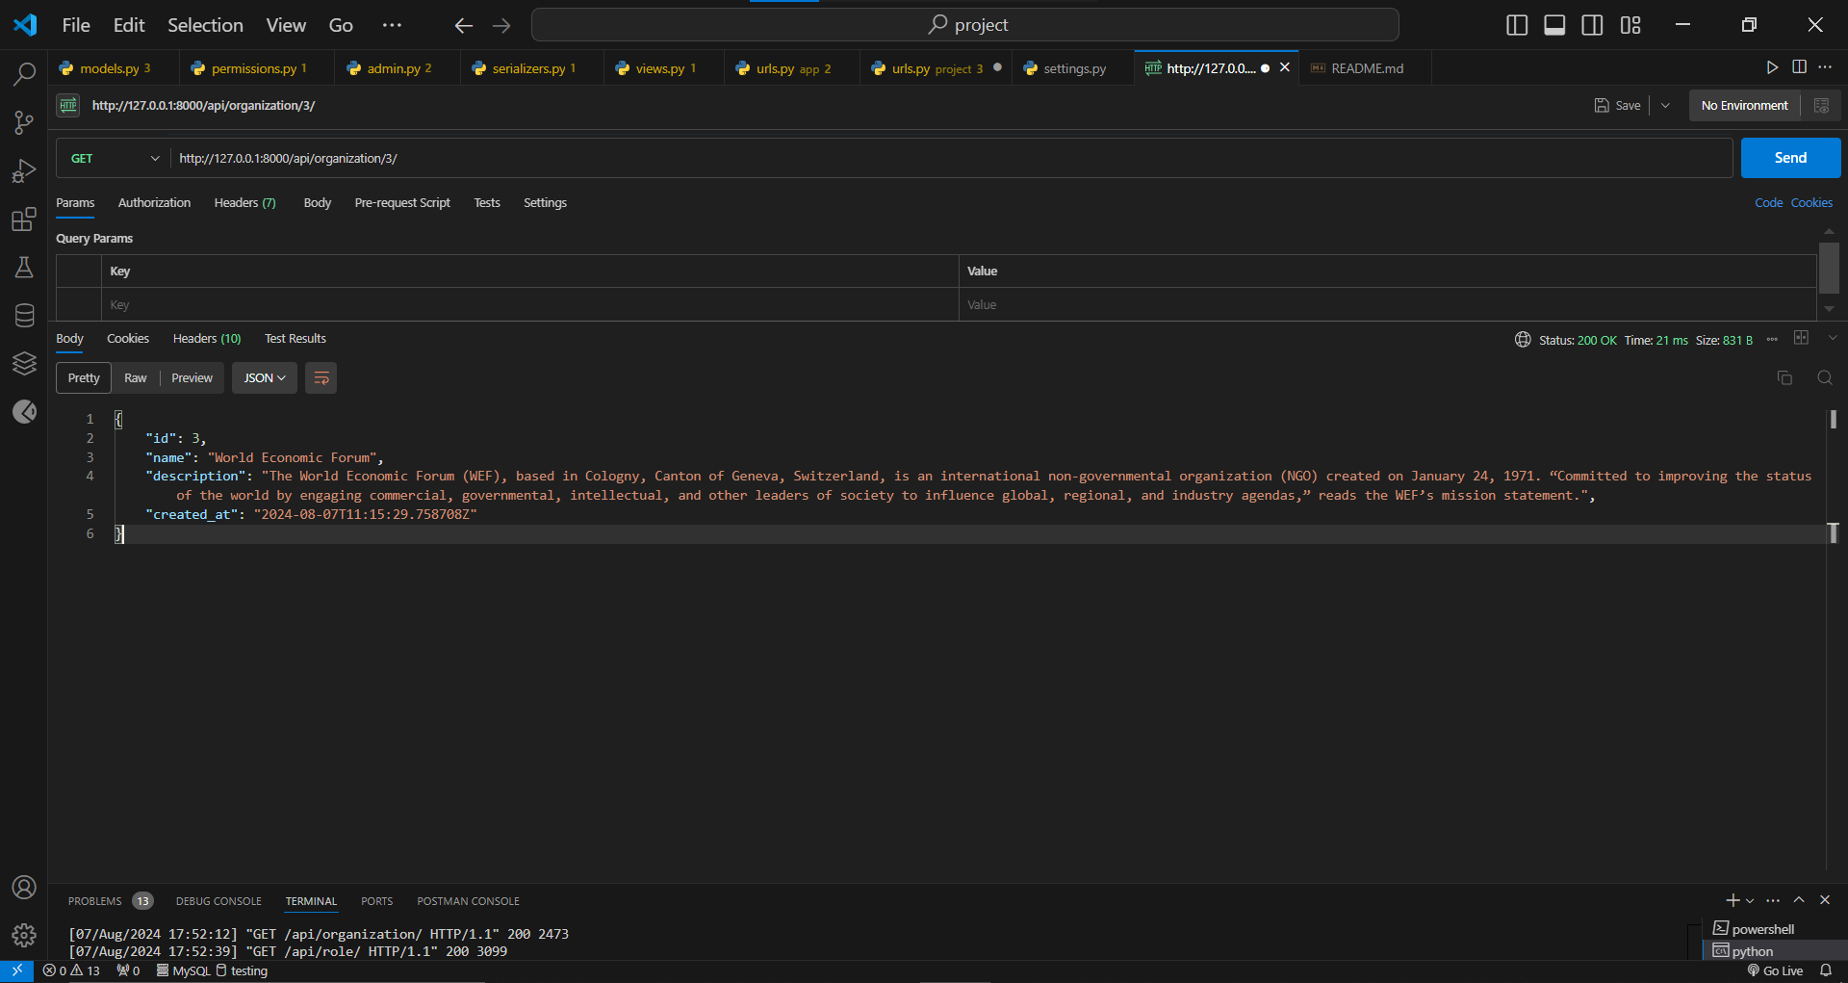

**3.Create Organization**

 URL: /api/organizations/

 Method: POST

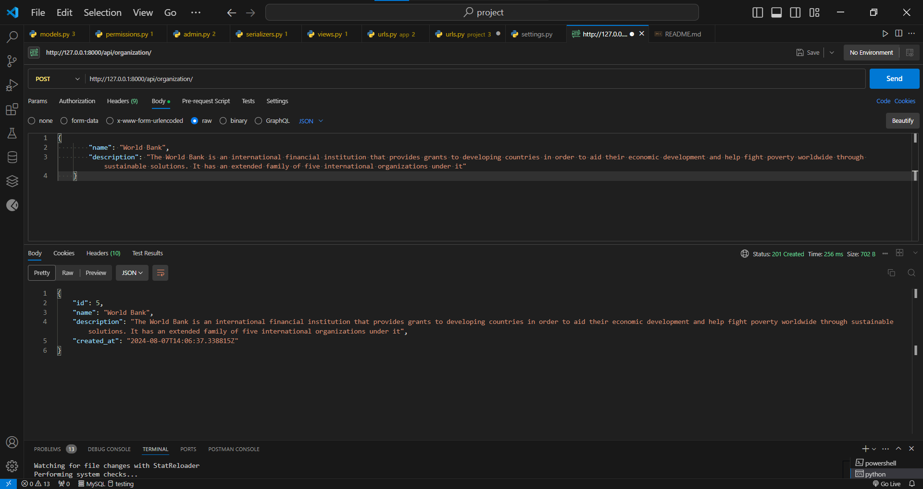

**4.Update Organization Information**

 URL: /api/organizations/{id}/

 Method: PUT, PATCH

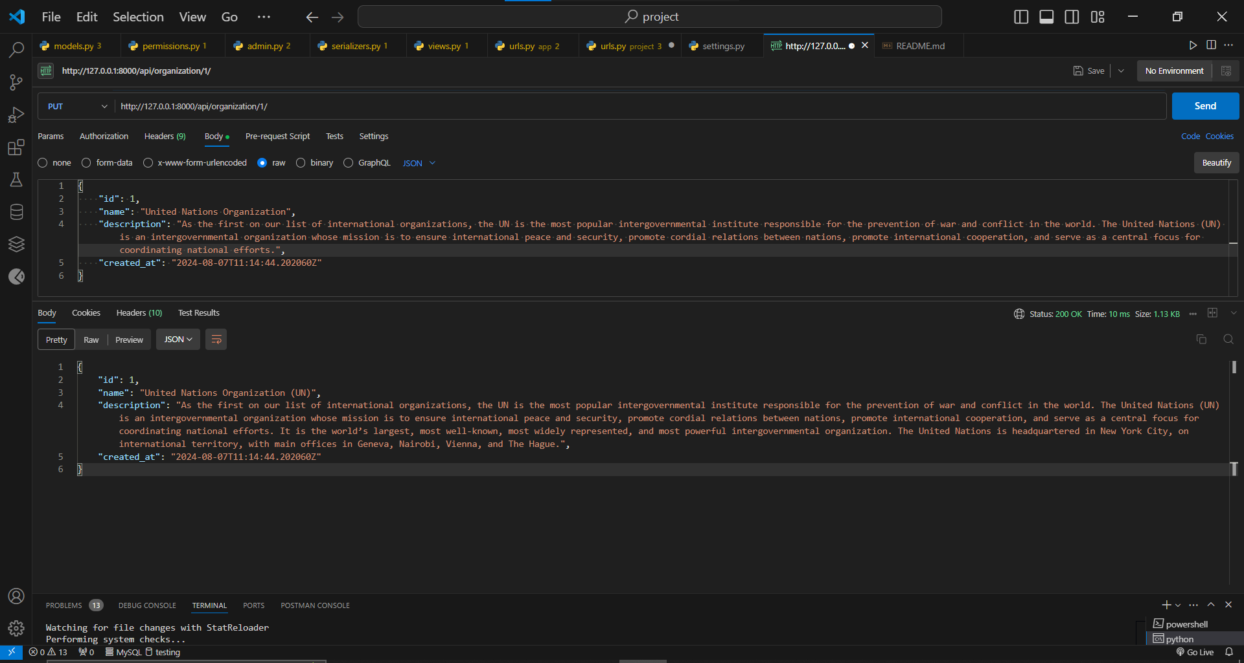

**5.Delete Organization**

 URL: /api/organizations/{id}/

 Method: DELETE

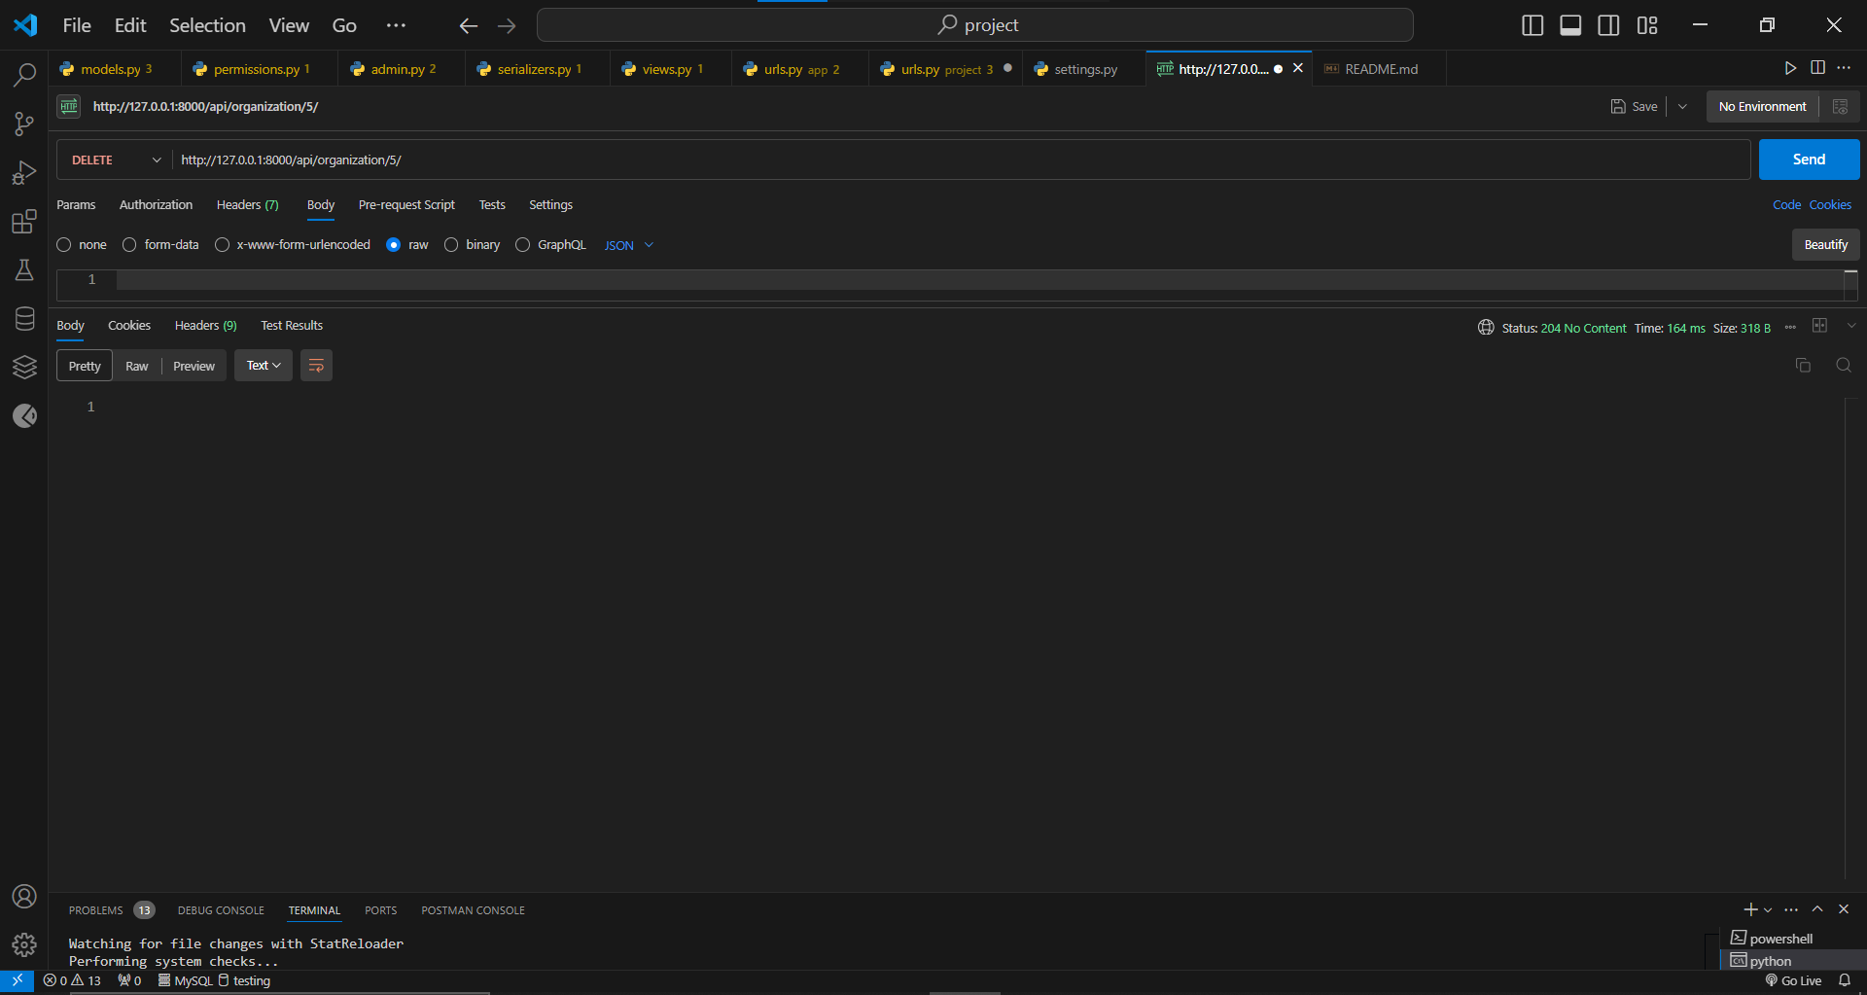

**Role Endpoints:-**

**1.List Role**

 URL: /api/role/

 Method: GET

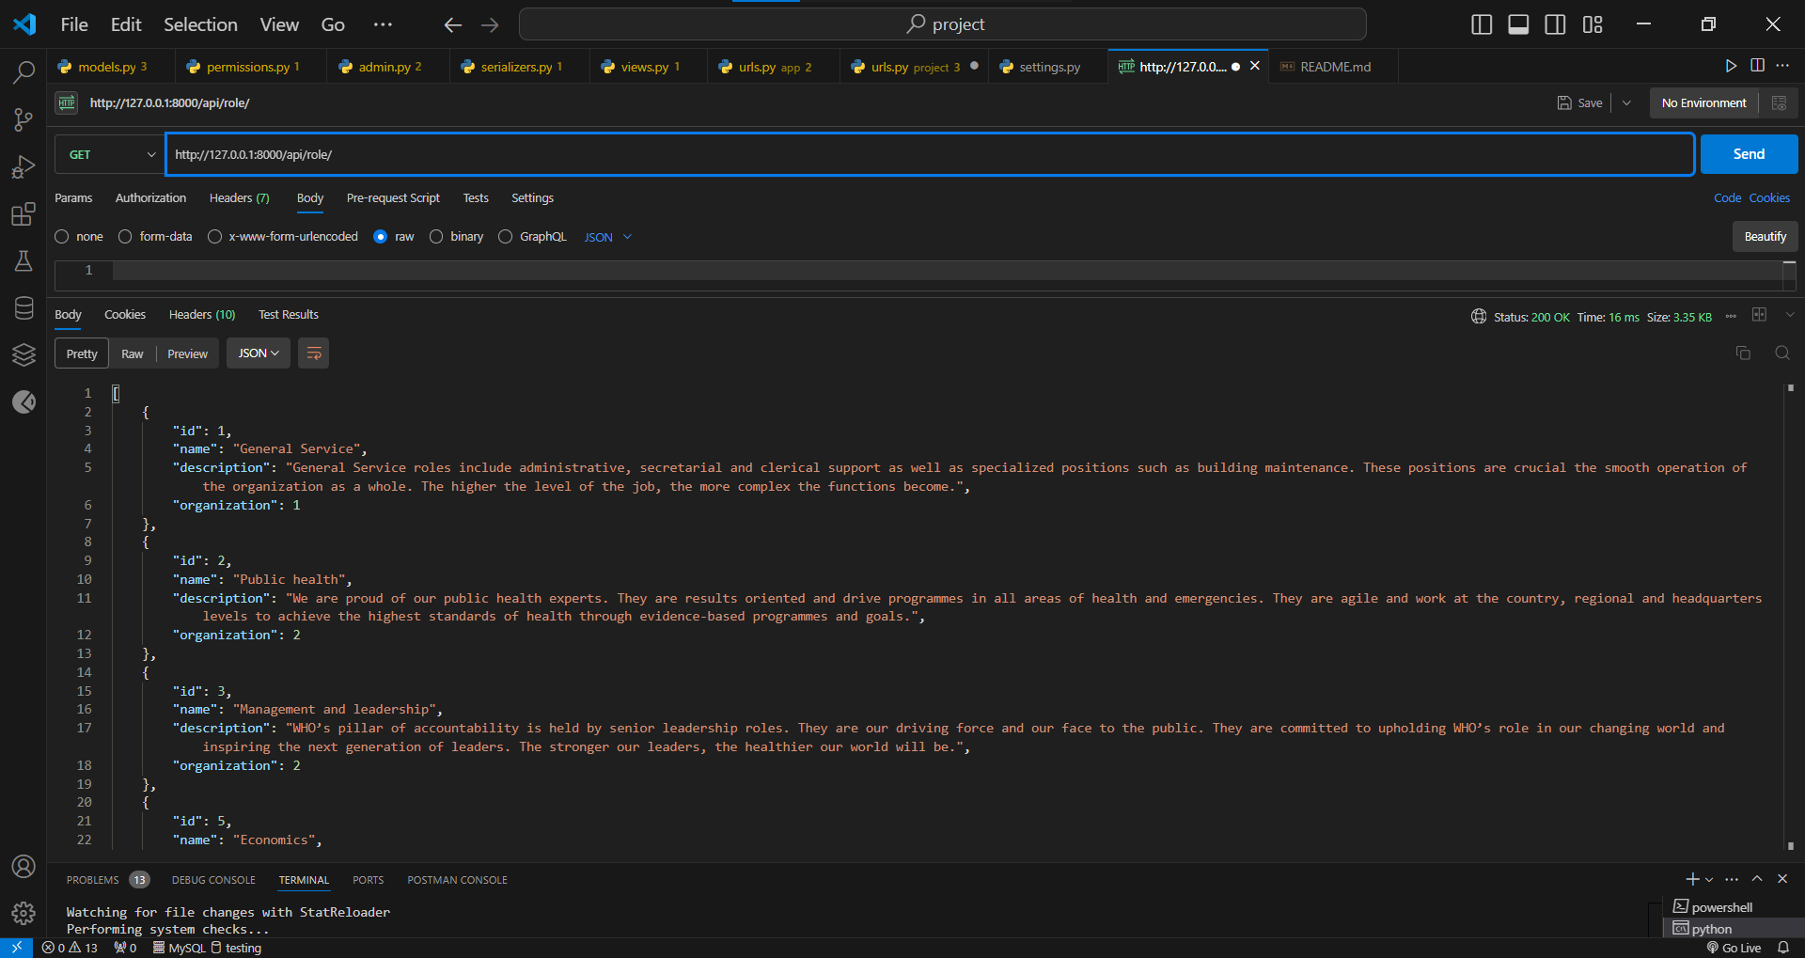

**2.Retrieve Role Details**

 URL: /api/role/{id}/

 Method: GET

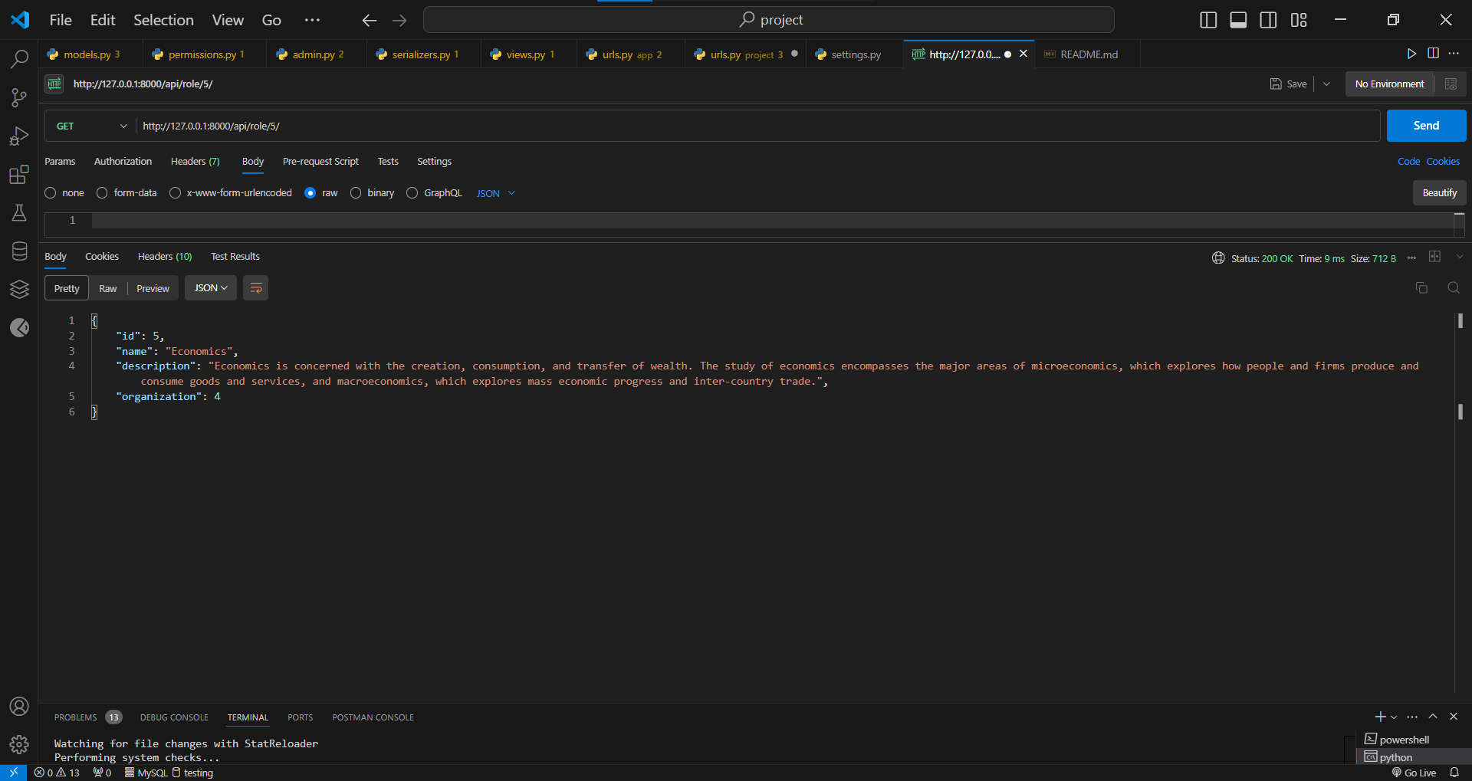

**3.Create Role**

 URL: /api/role/

 Method: POST

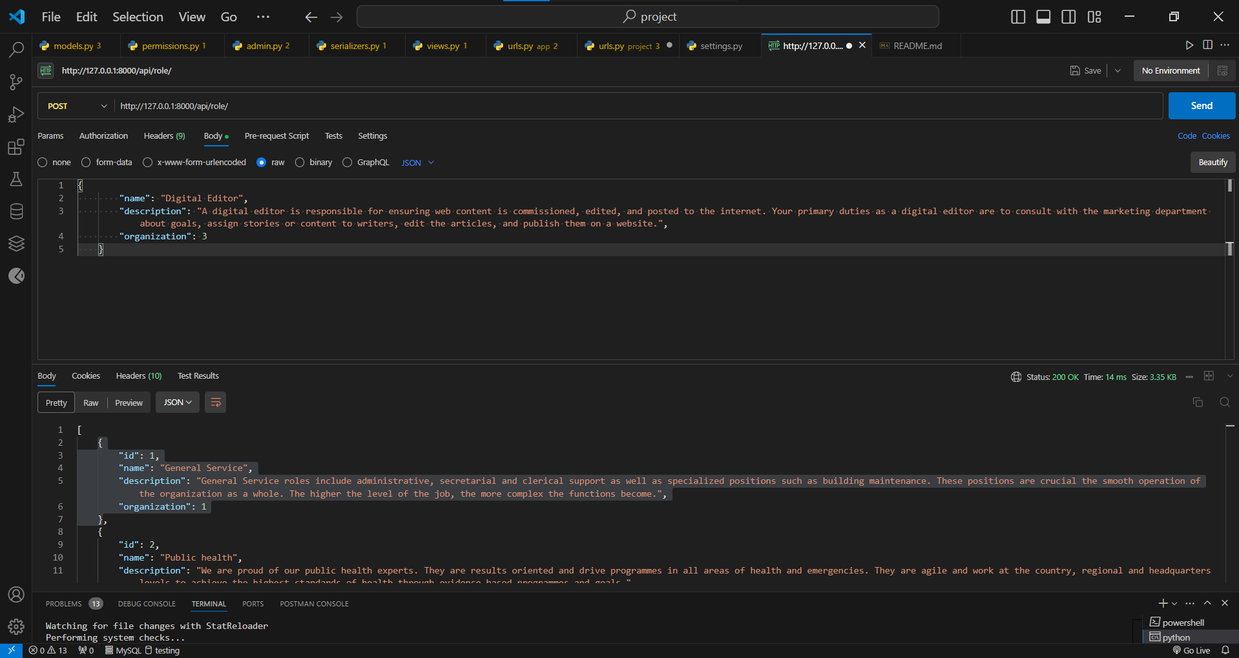

**4.Update Role Information**

 URL: /api/role/{id}/

 Method: PUT, PATCH

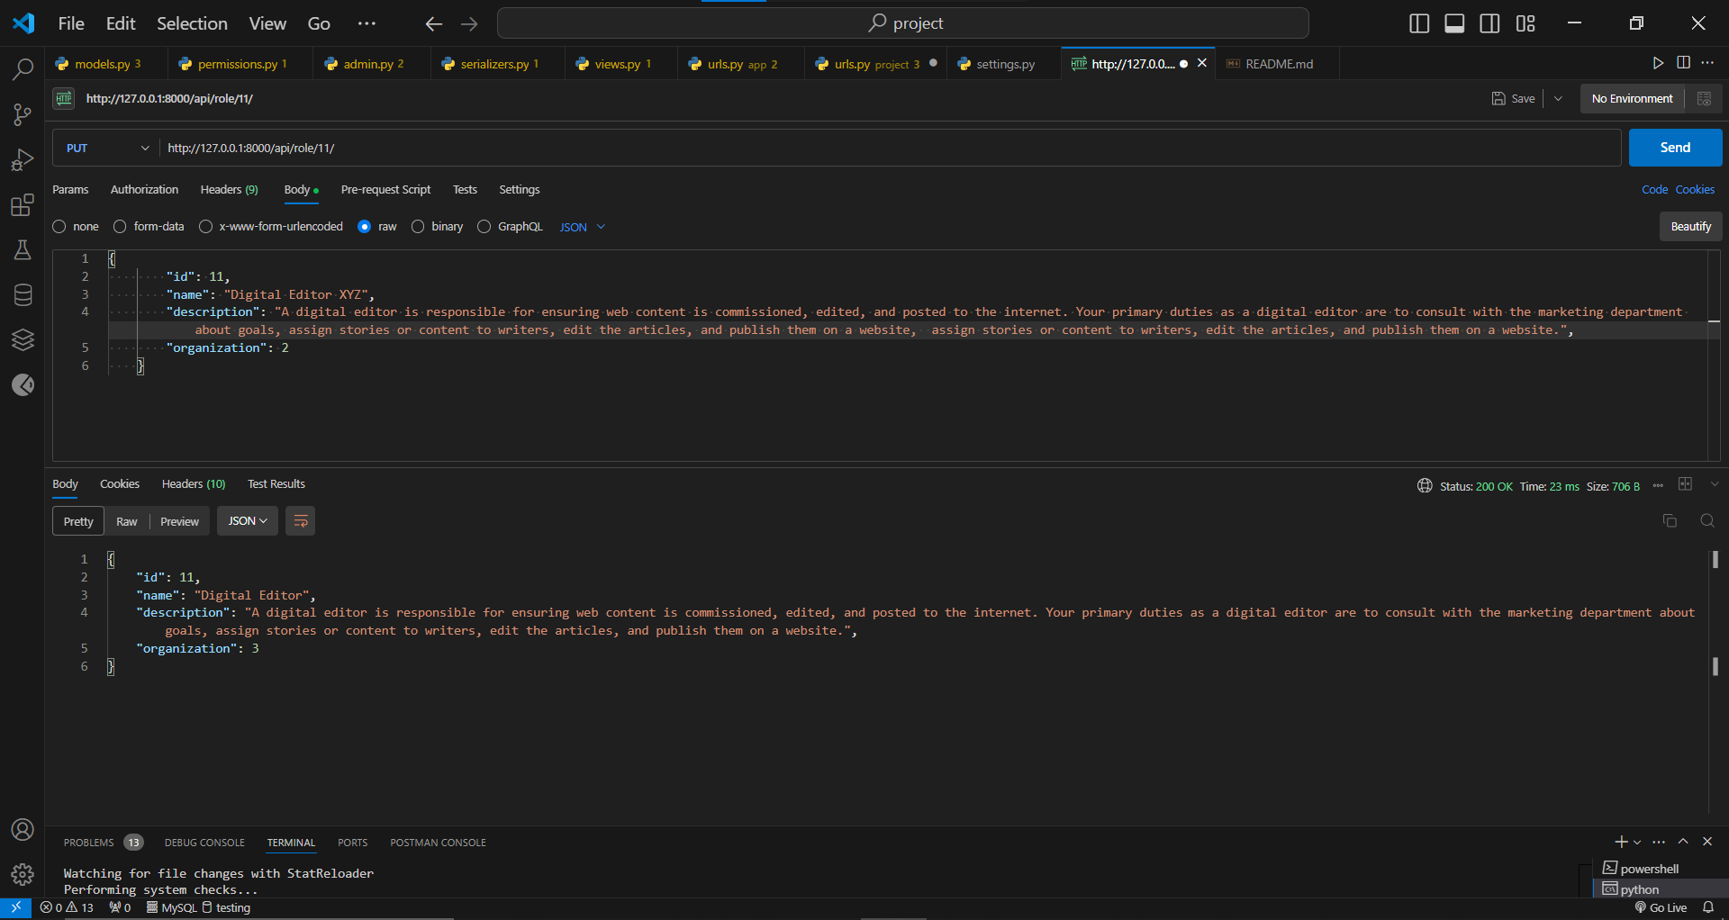

**5.Delete Role**

 URL: /api/role/{id}/

 Method: DELETE

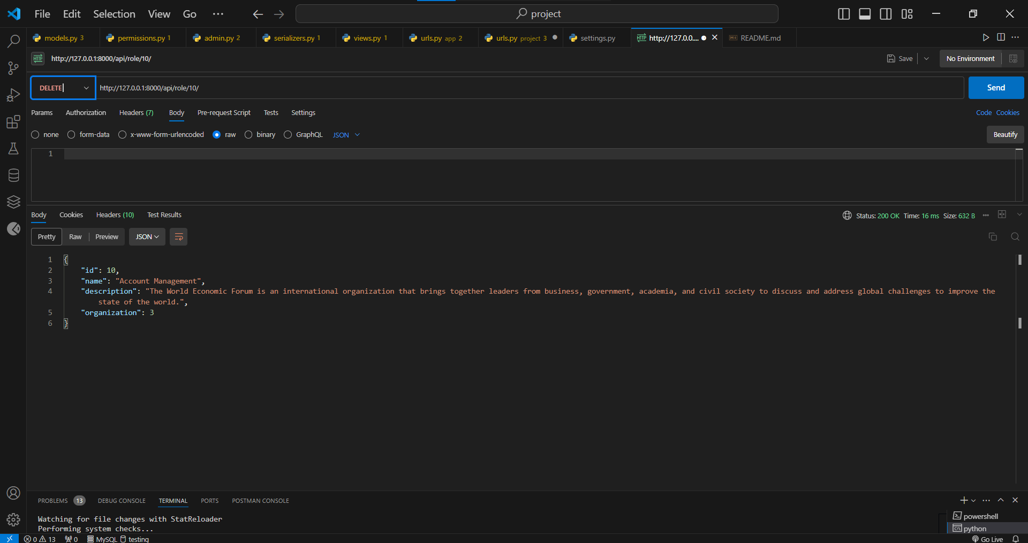

**User Endpoints:-**

**1.List User**

 URL: /api/ user /

 Method: GET

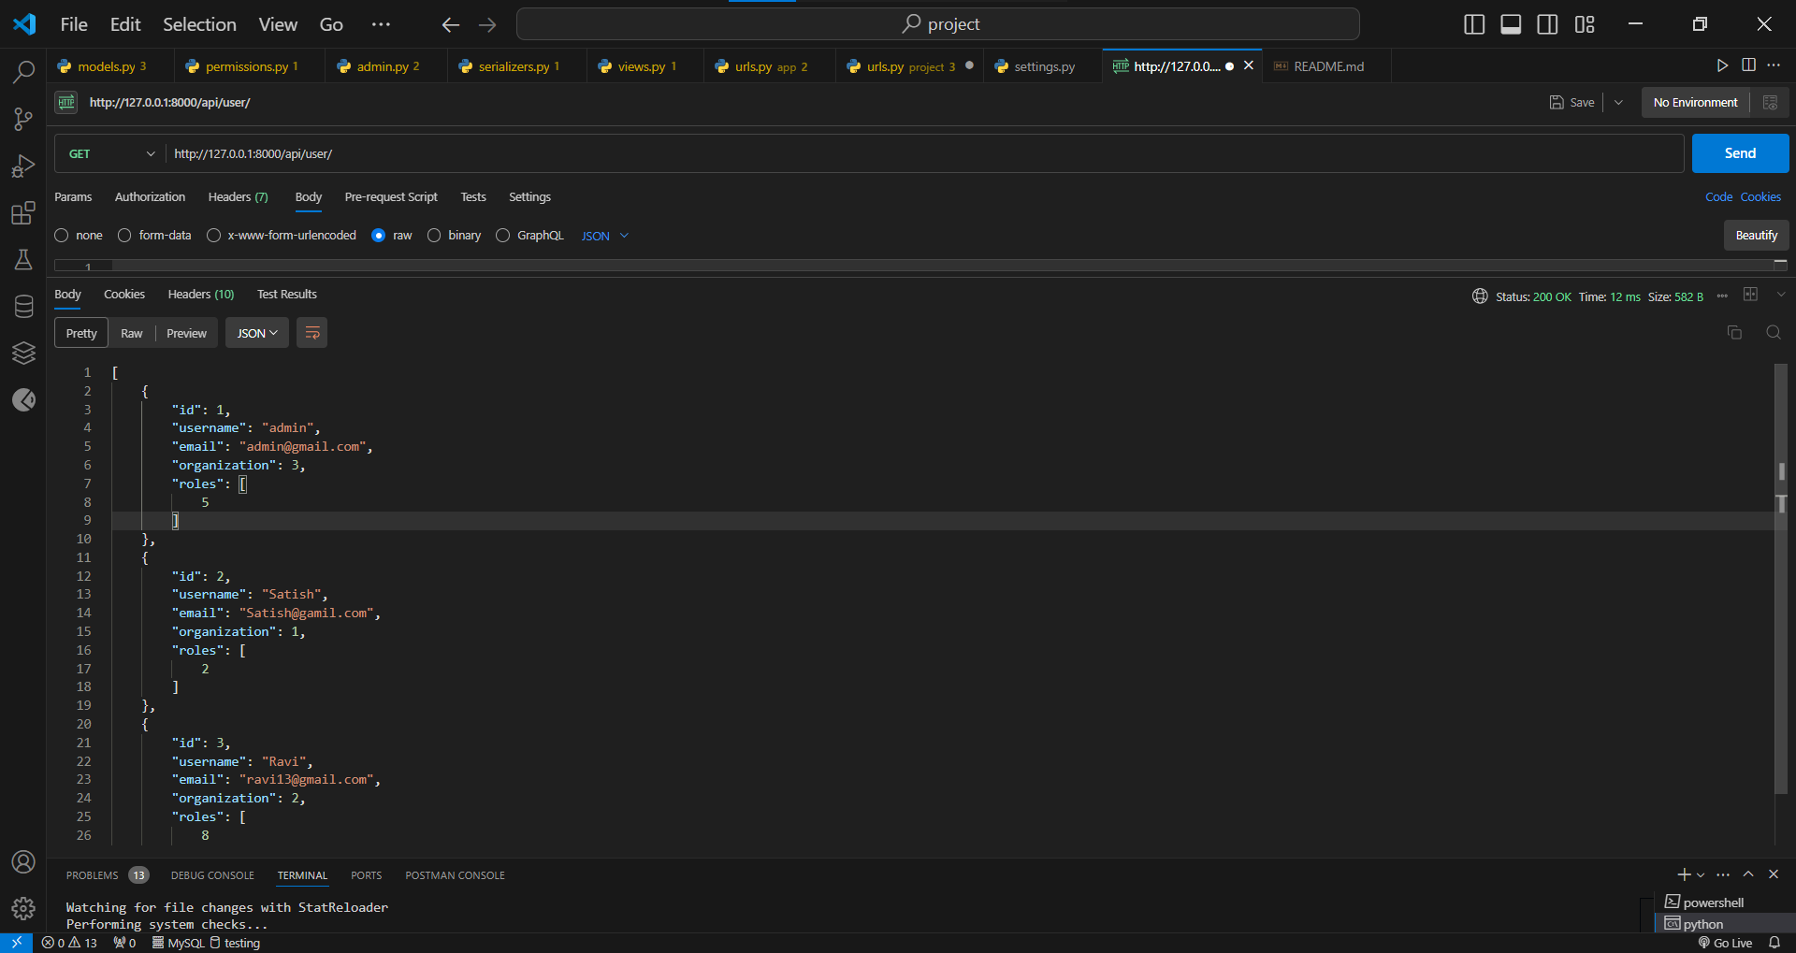

**2.Retrieve User Details**

 URL: /api/ user /{id}/

 Method: GET

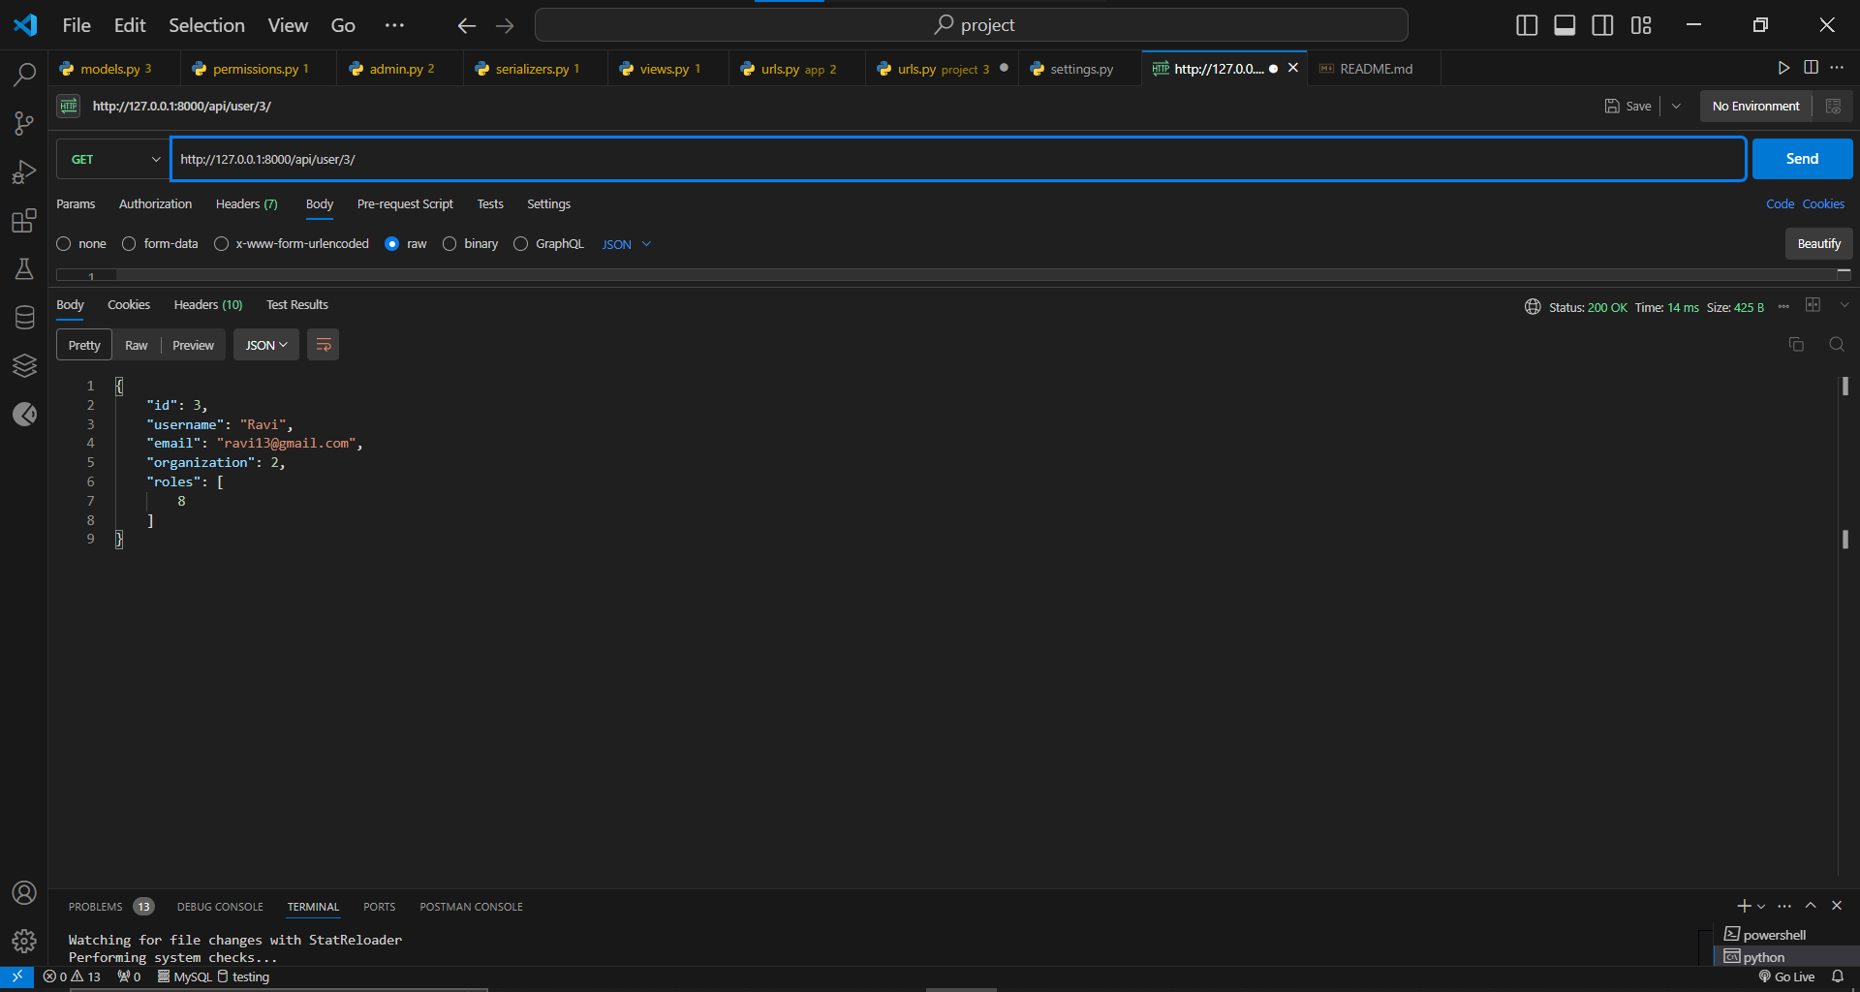

**3.Create User**

 URL: /api/ user /

 Method: POST

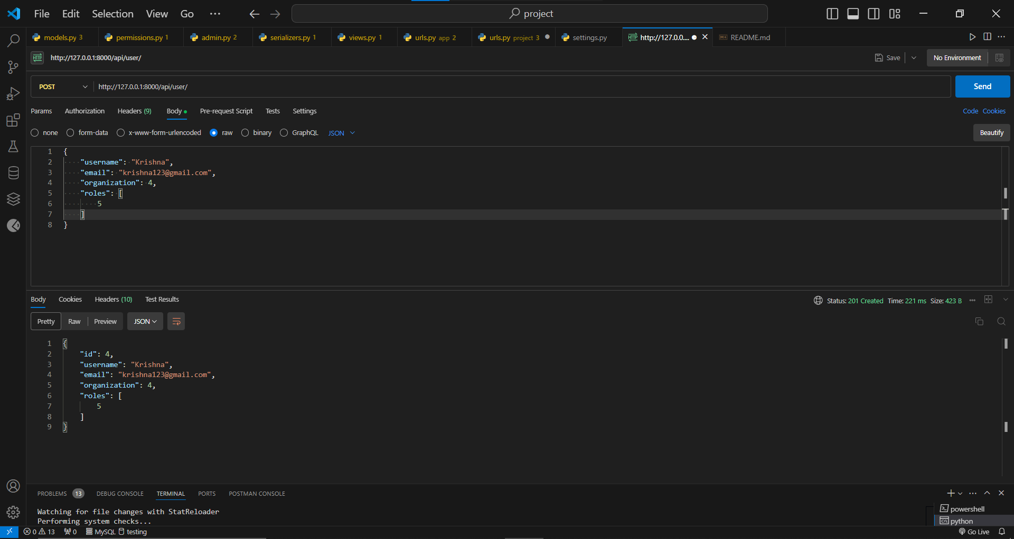

**4.Update User Information**

 URL: /api/user/{id}/

 Method: PUT, PATCH

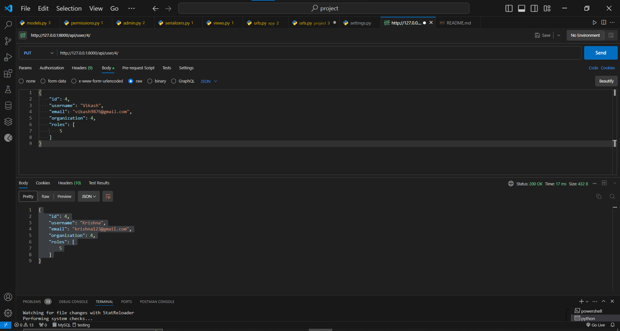

**5.Delete User**

 URL: /api/ user /{id}/

 Method: DELETE

