1>

select * from classroom
where capacity>50;

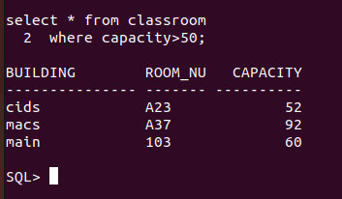

2>
select * from instructor
where debt_name='Computer Science';

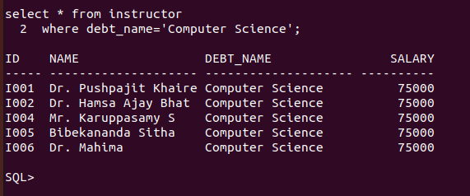

3>
select * from course
natural join takes ;

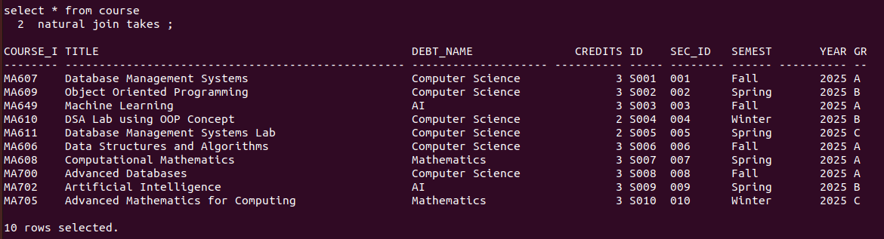

select * from course
natural join takes
where semester='Spring' and year=2025 ;

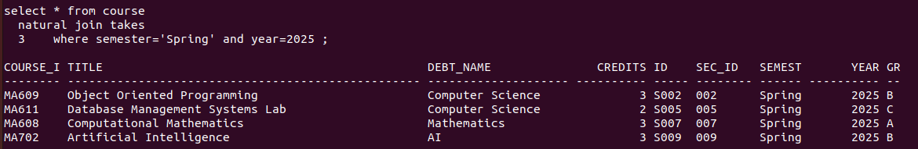
4->
select * from student
where tot_cred >10;

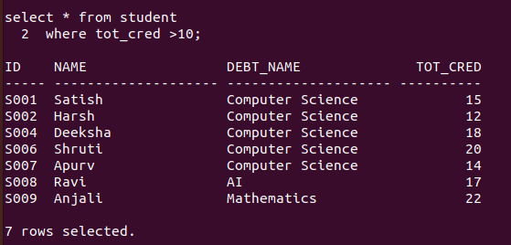

5->
select debt_name from department
where budget>300000;


6->
select debt_name,building from department;

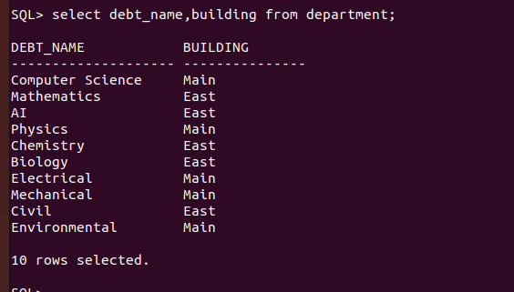

7->
select name from student
where debt_name='Computer Science';



8->

select title from course
where credits=3;
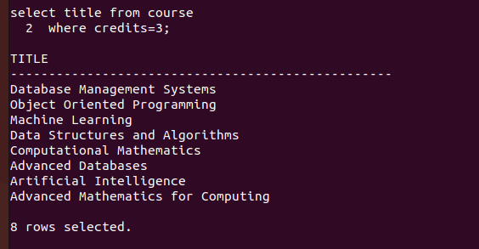

9->
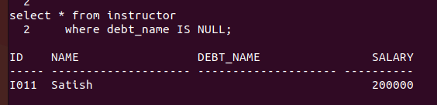
select * from instructor
where debt_name IS NULL;

10->
select Building ,count(*) AS total_classroom from classroom
group by building;
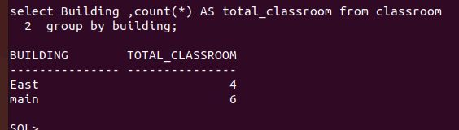

11->
select course_ID from teaches
where ID='I002';


12->
select debt_name,count(*) as Total_enrolled_student from student
group by debt_name;

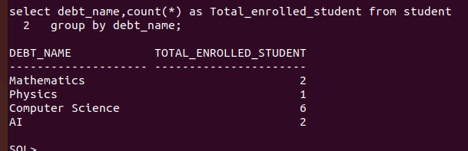
13->
select * from student natural join takes ;
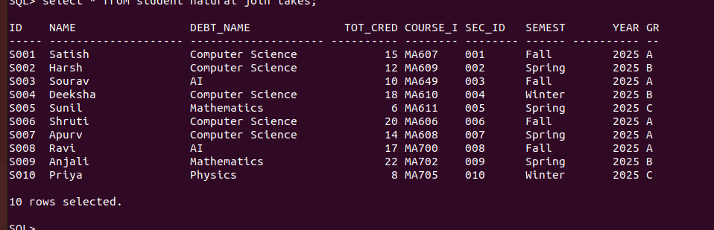

select * from student natural join takes where Course_id='MA606' and Grade='A';

14->
select NAME from instructor
where salary>50000;


15->
select debt_name,avg(salary) as avg_salary from instructor
group by debt_name;

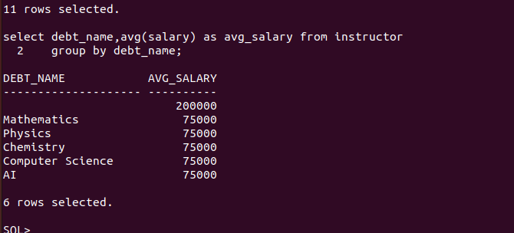
17->
select name from student natural join advisor
where I_ID is null;


18->
select building ,count(*) as total_section from section
group by building;

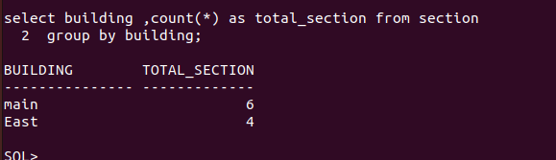

19->
select * from student natural join takes;

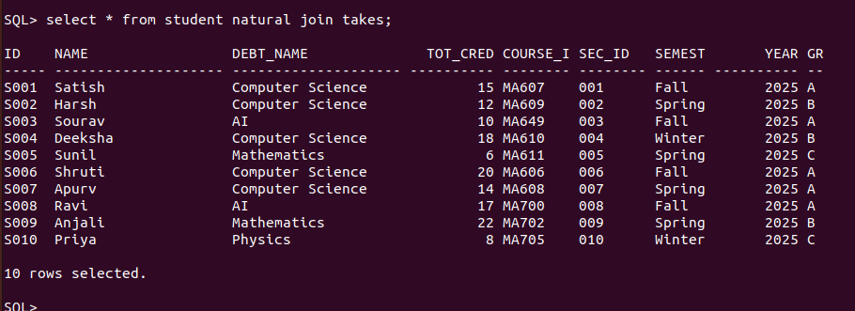
select name from student natural join takes
where semester='Fall' and year='2025';


20->
select room_number,building from classroom minus select room_number,building from section;


21>
select title from course
where debt_name='Mathematics';


22->>select name from student join takes on student.id=takes.id where takes.semester in ('Fall','Spring') group by student.id,student.name having count(distinct takes.semester) =2

