Exercise 4

1. List all students who have taken exactly 120 total credits.
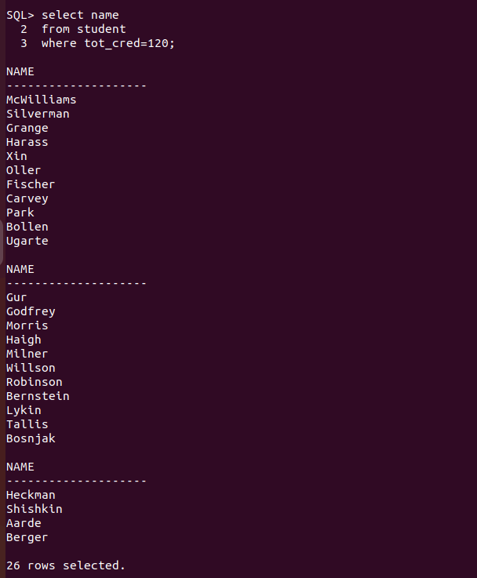
2. Find the names of all courses offered by the "Civil Engineering" department.

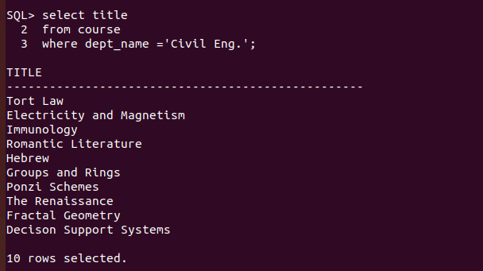
3. Retrieve the names of all instructors who earn exactly ₹60,000.
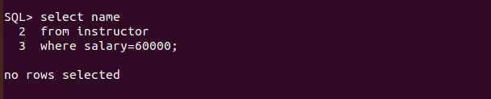
4. List all classrooms located in the "Dunn" building.
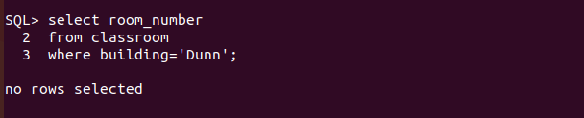
5. Find the total number of courses offered in the "Summer" semester of 2023.
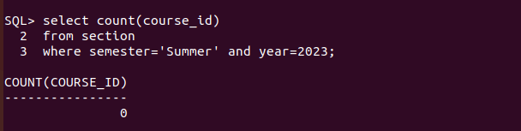
6. List all students who have taken exactly 150 total credits.
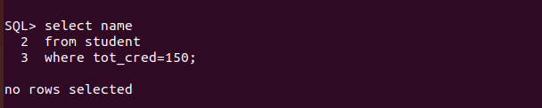
7. Find the names of all courses offered by the "Aerospace Engineering" department.
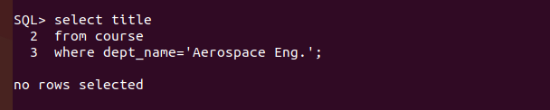
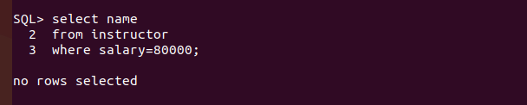
8. Retrieve the names of all instructors who earn exactly ₹80,000.
9. List all classrooms located in the "Smith" building.
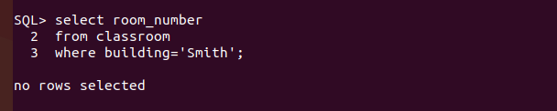
10. Find the total number of courses offered in the "Fall" semester of 2022.
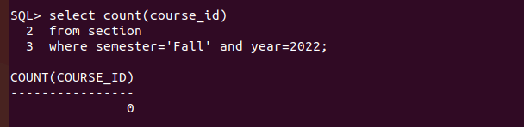
11. List all students who have taken courses with a grade of "A" in the "Spring" semester of
2022.
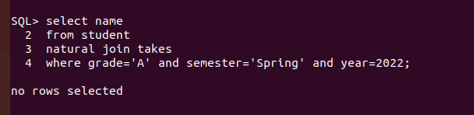

12. Retrieve the names of instructors who have taught in the "Winter" semester of 2022.
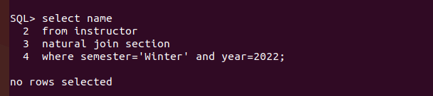
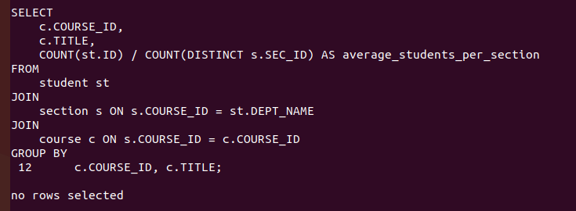
13. Find the average number of students per section in each course.
14. List all courses that have exactly 5 credits.
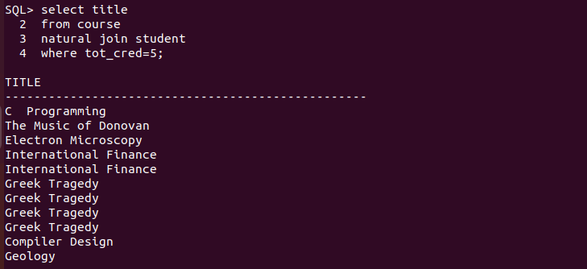
15. Retrieve the names of students who have taken courses in the "Main" building.
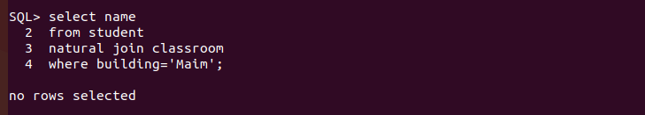
16. Find the total number of sections held in each building.
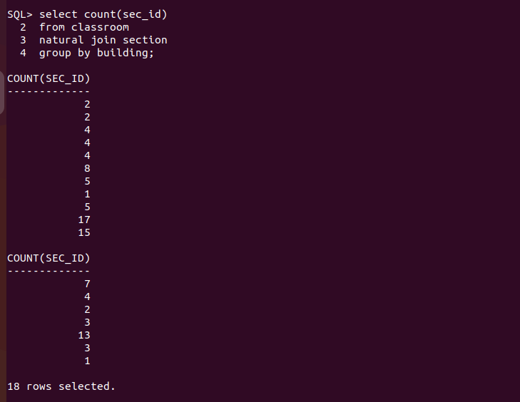

17. List all sections that are held in rooms with a capacity of exactly 50.
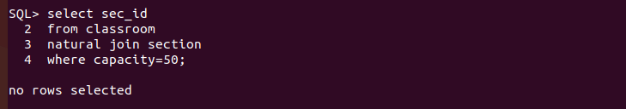
18. Retrieve the names of students who have taken courses with the highest number of
credits in the university.
SELECT
st.NAME
FROM
student st
JOIN
takes t ON st.ID = t.ID
JOIN
course c ON t.COURSE_ID = c.COURSE_ID
WHERE
c.credits = (SELECT MAX(credits) FROM course);
19. Find the departments with the highest number of courses.
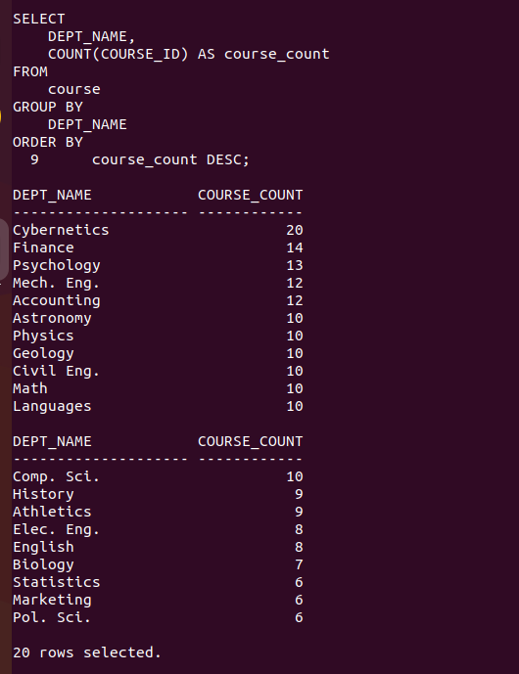

20. List all courses that have been taught by exactly 2 instructors.
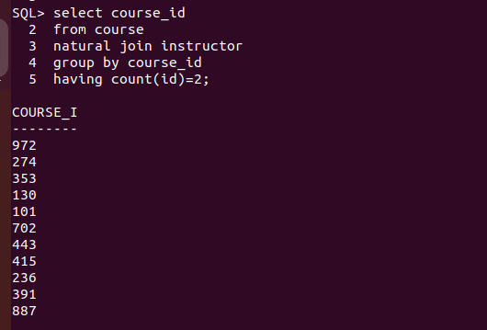

21. List all students who have taken courses with a grade of "B" in the "Summer" semester
of 2023.
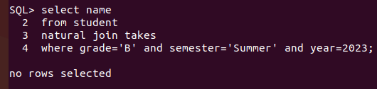

22. Retrieve the names of instructors who have taught in the "Spring" semester of 2021.
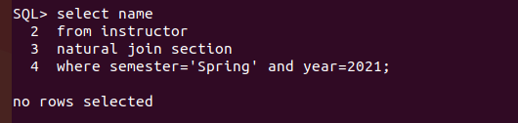

23. Find the average number of credits per student in each department.

24. List all courses that have exactly 6 credits.
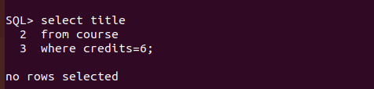

25. Retrieve the names of students who have taken courses in the "Lambert" building.
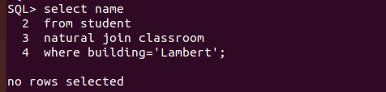

26. Find the total number of sections taught in each semester.
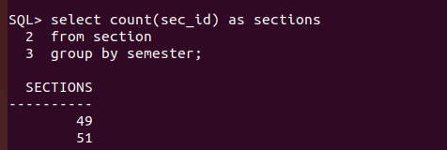

27. List all sections that are held in rooms with a capacity of exactly 200.
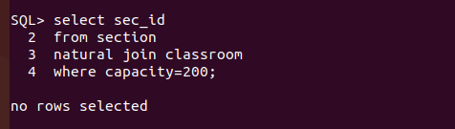

28. Retrieve the names of students who have taken courses with the lowest number of
credits in the university.
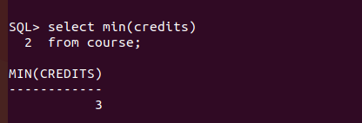

29. List all courses that have been taught by exactly 4 instructors.
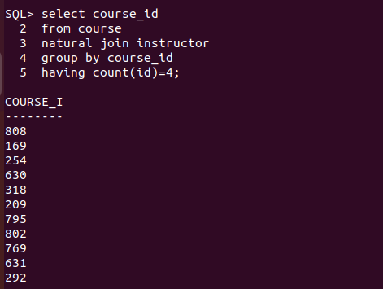

30. Find the students who have taken courses from at least 6 different departments.
