4CS015 – Workshop 7
Note: This is an assessed workshop.
Tasks 1 & 2 are Windows based (50%), Tasks 3 & 4 are Linux based (50%)
Task1 = 20 marks, Task2=30 marks, Task3=20 marks, Task4=30 marks = Total = 100 Marks
STUDENT NAME: Familua Oladipupo Roland
STUDENT NUMBER: 2326310
This forms the final part of your portfolio. You will need to complete the workshop and then submit this Word file, complete with your answers, via Canvas.
For this assignment (workshop) you will show you how to navigate and create file systems from command prompts in both Windows and Linux.
Task 1 (20 marks)
- Start the "Command Prompt" from the Windows Start Menu (Start -> Accessories -> Command Prompt).
- To create a directory "test", type :
md test
in the Command Prompt window and press the Return or Enter key.
- To see the files and directories in the Command Prompt window, type:
dir
and press the Return key. You should see a list of all the files and directories in the window.
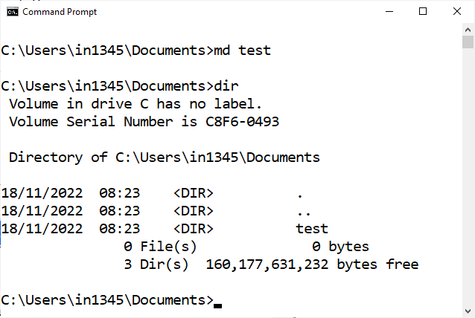
- To create a file "hello.txt" containing the word "Hello", type the following into the Command Prompt window:
echo Hello > hello.txt
Check that it is there by using the "dir" command.
- You can "type out" the content of the file by entering the following:
type hello.txt
You should get the content of the file displayed in the window.
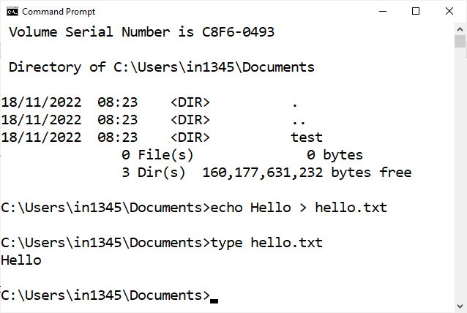
- You can make a copy of the file and put it the "test" directory that you created earlier by typing:
copy hello.txt test
- Now delete the file hello.txt in the current directory by typing:
del hello.txt
It may ask you if you are sure. If it does ask, type y and the "Return" key. Verify that the file is gone by using the "dir" command.
- Change into the test directory by entering:
cd test
- Check that you are in the correct directory by entering just:
cd
- Check that your earlier copy of the hello.txt was copied into this directory by using the "dir" command.
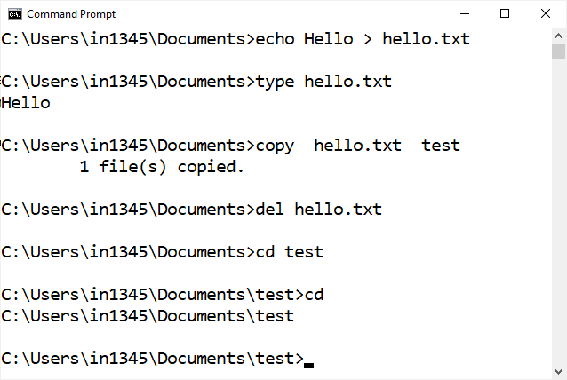
- Now rename the file to hello2.txt by typing:
ren hello.txt hello2.txt
Verify that it has been changed by using the dir command.
- Now create a sub-directory "test2" by typing:
md test2
- Move the hello2.txt file into the directory test2:
move hello2.txt test2
- Use the "cd" command to change into the test2 directory and then use the dir command to verify that the file hello2.txt is indeed there. You should see something like:
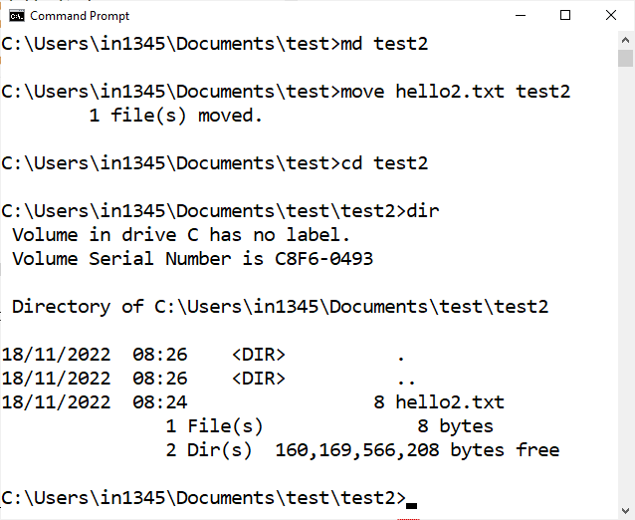
- Now change to the directory above test2 by typing:
cd ..
That's two dots, one after another. You should get:
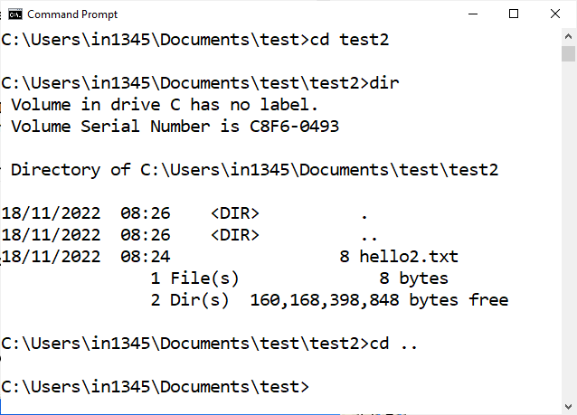
- Change to the directory above that by entering :
cd ..
again.
- Now to check that you have created the correct structure, type:
tree test /f
You should get:
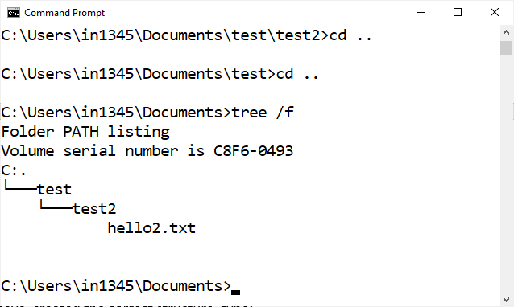
- If it is correct, press ALT Print Screen to copy the Command Prompt window, and then paste it below:
[insert your screenshot here]
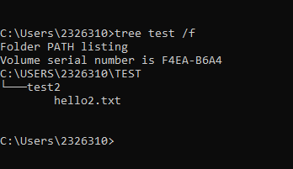

Task 2 (30 marks)
Using all the above commands, create the following directory structure and paste it after this picture:
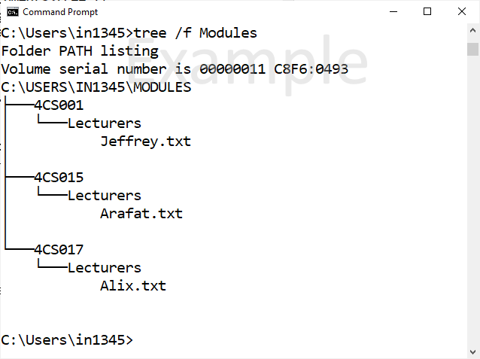
[Insert your screenshot here]
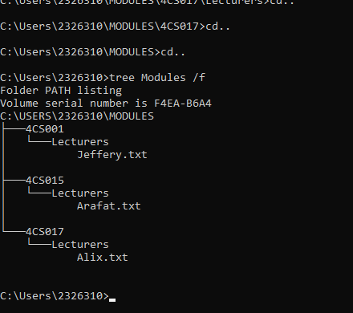
Task 3 (20 marks)
Working with Linux.
- Locate "ThinLinc" with AppsAnywhere and start it:
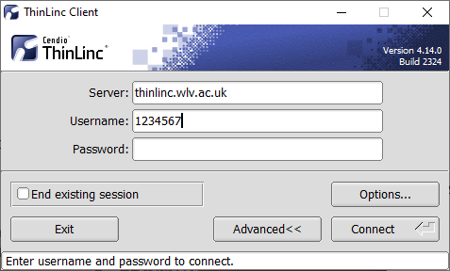
Note: Those of you working on your own laptops and computers, you can download and install the ThinLinc client from :
https://www.cendio.com/thinlinc/download
- Enter thinlinc.wlv.ac.uk for the "Server", your student ID for the Username and your usual university password for the pass, can click "Connect".
- Your MAY get the following popup window when you use thinlinc for the first time:
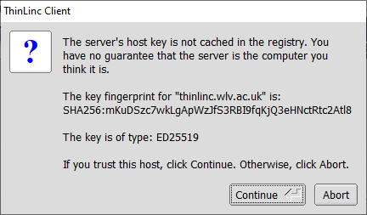
- Click "Continue"
- You will then see the following screen: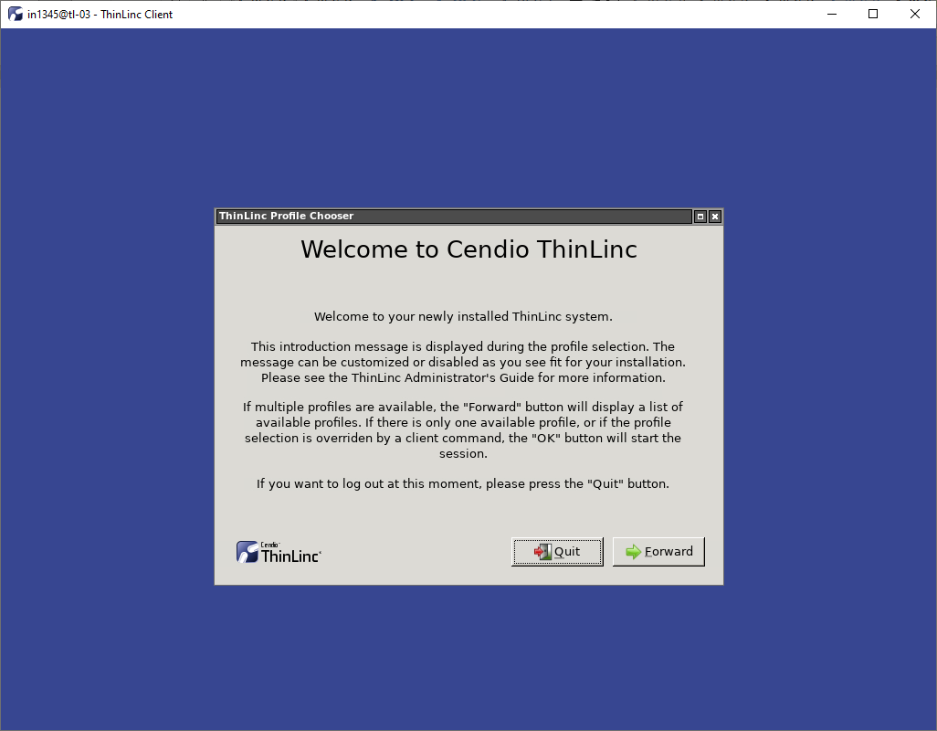
- Click "Forward" to continue.
- One the next screen, select "Mate Desktop" and click OK:
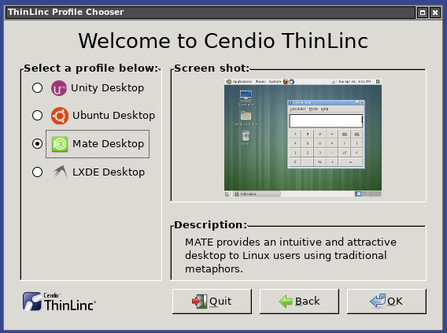
- Click on the “Menu” at the top-left and then “System Tools” and then "Mate Terminal" to start it
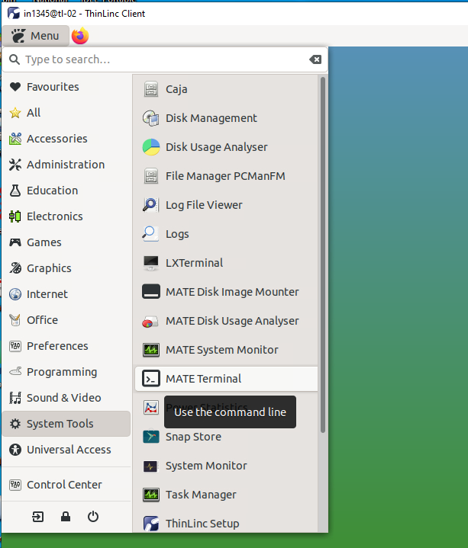
- To make a directory "test", type :
mkdir test
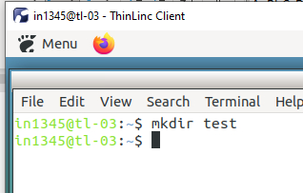ec
in the Terminal window and press the Return or Enter key.
- To list the files and directories in the Terminal window, type:
ls
and press the Return key. You should see a list of all the files and directories in the window.
- To get a more informative listing of the files and directories, you can use:
ls -l
The "-l" stands for "long".
- To create a file "hello.txt" containing the word "Hello", type the following into the Terminal window:
echo Hello > hello.txt
Check that it is there by using the "ls" command.
- You can view the content of the file by entering the following:
more hello.txt
You should get the content of the file displayed in the window.
- You can make a copy of the file and put it the "test" directory that you created earlier by typing:
cp hello.txt test
- Now remove the file hello.txt in the current directory by typing:
rm hello.txt
Verify that the file is gone by using the "ls" command.
- Change into the test directory by using the change directory command:
cd test
- Check that you are in the correct directory by using the print working directory:
pwd
- Check that your earlier copy of the hello.txt was copied into this directory by using the "ls" command.
Now rename the file to hello2.txt by moving it from hello.txt to hello2.txt:
mv hello.txt hello2.txt
Verify that it has been changed by using the ls command.
- Now create a sub-directory "test2" by typing:
mkdir test2
- Move the hello2.txt file into the directory test2:
mv hello2.txt test2
- Use the "cd" command to change into the test2 directory and then use the ls command to verify that the file hello2.txt is indeed there.
- Now change to the directory above test2 by typing:
cd ..
That's two dots, one after another.
- Change to the directory above that by entering :
cd ..
again.
- Now to check that you have created the correct structure, enter:
ls -R test
You should get:
test:
test2
test/test2:
hello2.txt
- If it is correct, press Print Screen key to capture the screen as a picture and then paste it below :
[paste your screenshot here]
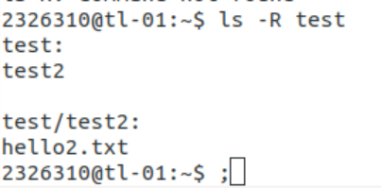

Task 4 (30 marks)
Using all the above commands, create the following directory structure (identical to the one that you created in Windows Command Prompt)(Example below):
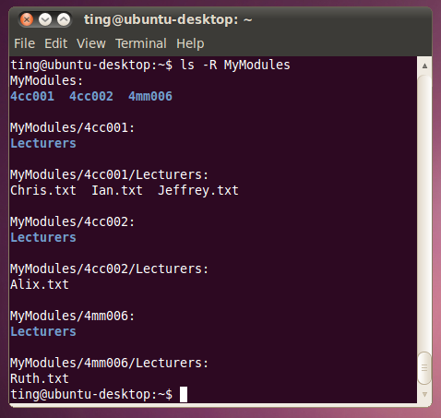

[Insert your screenshot here]

