Query:

1. Gradient clipping:

Document score: 0.67

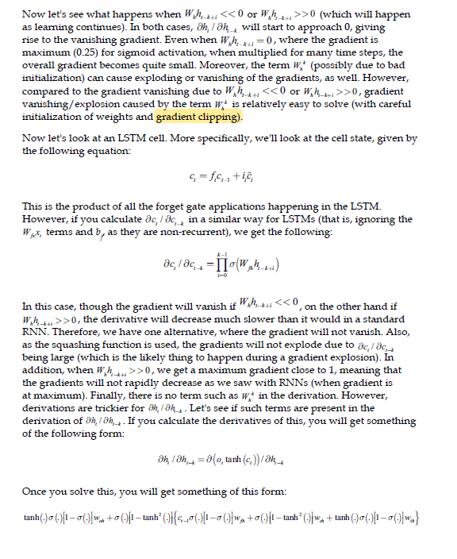

Document score: 0.583

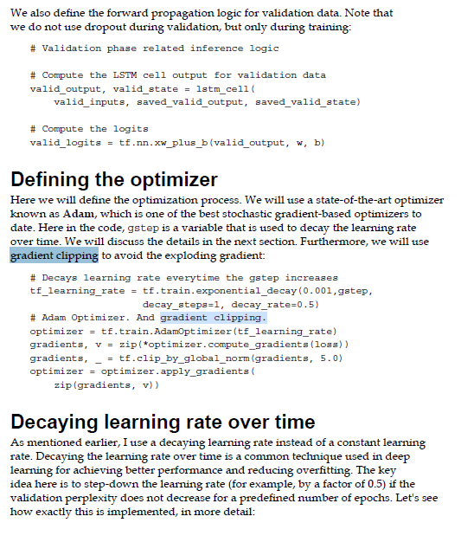

Loss function :

2) Loss function:

Document score: 0.71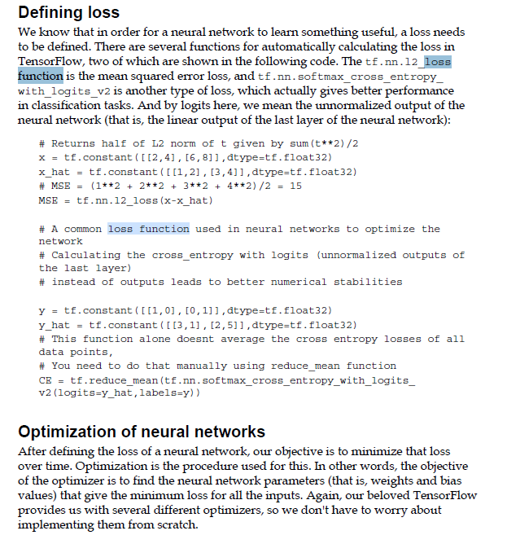

Document score: 0.59

