AI-Driven Real Estate Price Prediction and Business Intelligence Platform
Data Analytics Project Report
Student Name: Satnam Singh
Registration ID: STU6a7edb5cc09041786698588
Institution: Chandigarh University
GitHub: https://github.com/Satnam-Singh-Analyst/house-price-analytics

1. Executive Summary
This project delivers an interactive Streamlit platform that predicts residential property prices and converts model output into business insights. A dataset of 500 properties (square footage, bedrooms, bathrooms, age, price) is cleaned, explored, and used to train a Random Forest Regressor.
On a held-out 20% test set the model achieved R² = 0.990, RMSE ≈ $17,381 and MAE ≈ $13,619; 5-fold cross-validation gave R² = 0.984, indicating stable generalisation. Square footage accounts for about 98% of the model's feature importance. The platform lets buyers, developers and portfolio managers enter property attributes and receive an instant valuation with an uncertainty range, alongside an Executive Risk & Action Matrix calculated from the data.
Note: the default dataset is synthetic and generated from a near-linear pricing rule, so accuracy is higher than would be expected on real market data. The application accepts a CSV upload so the same pipeline can be applied to real datasets such as the Kaggle House Prices data.

2. Problem Statement & Objectives
Manual property valuation is slow, subjective and inconsistent, which leads to overpayment, mispriced listings and poor portfolio decisions. This project addresses the problem with an automated, data-driven machine learning model.

Objectives
- Clean and explore housing data to identify the main price drivers.
- Train and evaluate a regression model that predicts property price.
- Present KPIs and predictions in an interactive dashboard.
- Translate model results into actionable business recommendations.

3. Data Analytics Framework

3.1 Data Source
The default data is a reproducible synthetic dataset (500 records, fixed random seed 42) mirroring the core schema of the Kaggle House Prices dataset. Users can upload their own CSV with the columns SquareFeet, Bedrooms, Bathrooms, Age and Price.

3.2 Data Cleaning & EDA
- Required columns are selected and coerced to numeric types; non-numeric values become missing.
- Rows with missing values, duplicate rows, and non-positive prices or areas are removed.
- Random Forests are scale-invariant, so no feature scaling is required.
- Correlation analysis shows square footage is by far the strongest driver of price:

Feature | Correlation with Price
SquareFeet | 0.988
Bedrooms | 0.059
Age | -0.068
Bathrooms | -0.023

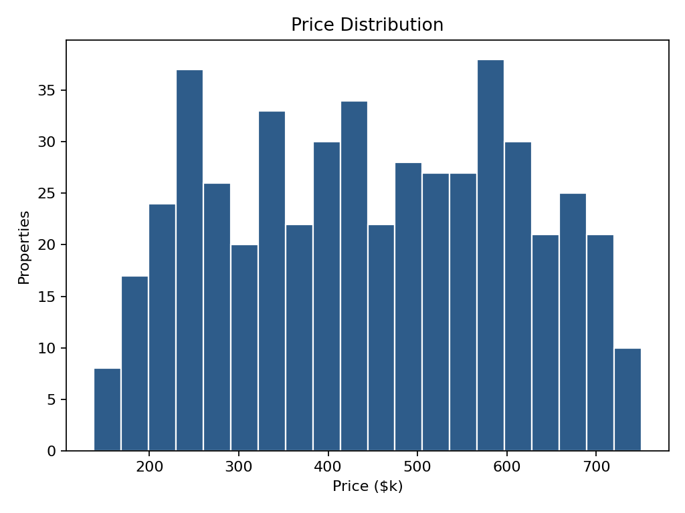
Figure 1: Distribution of property prices in the dataset

3.3 KPIs Defined
KPI | Definition | Value (default data)
Average Price | Mean sale price | $446,187
Avg Square Footage | Mean living area | 2,646 sqft
Total Inventory | Properties analysed | 500
Avg Property Age | Mean age in years | 23.8 years

4. Machine Learning Model Architecture

4.1 Algorithm
A Random Forest Regressor (200 trees, random_state = 42) is used. It is an ensemble of decision trees, each trained on a bootstrap sample with random feature subsets; predictions are averaged, which reduces variance, captures non-linear relationships and is robust to outliers. The features are SquareFeet, Bedrooms, Bathrooms and Age; the target is Price. Data is split 80% training / 20% testing.

4.2 Evaluation Metrics
Metric | Value | Interpretation
R² (test set) | 0.990 | 99% of price variance explained
5-fold CV R² | 0.984 | Consistent across data splits
RMSE | $17,381 | Penalises large errors
MAE | $13,619 | Average absolute error per property

4.3 Feature Importance
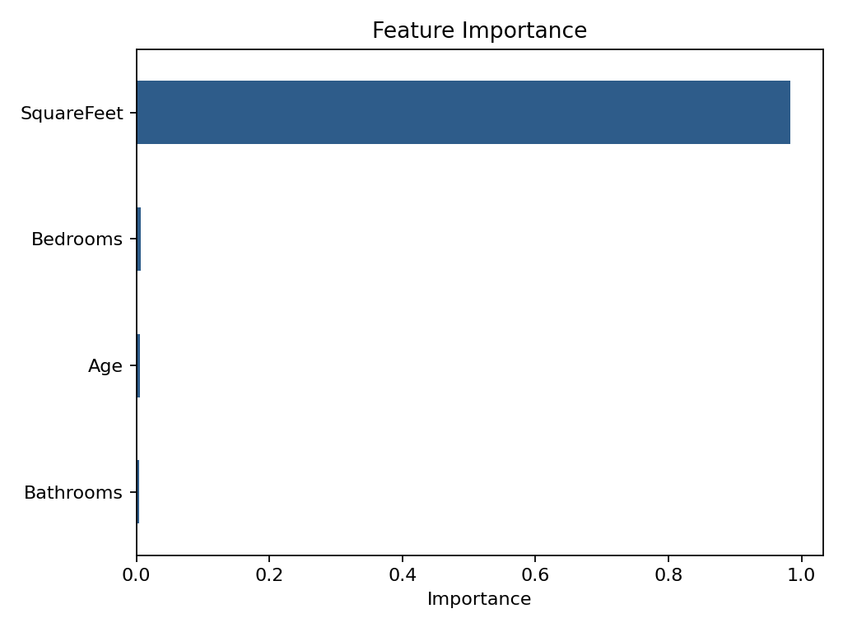
Figure 2: Random Forest feature importance
Square footage contributes about 98.3% of importance; bedrooms (0.7%), age (0.5%) and bathrooms (0.4%) are minor in this dataset.
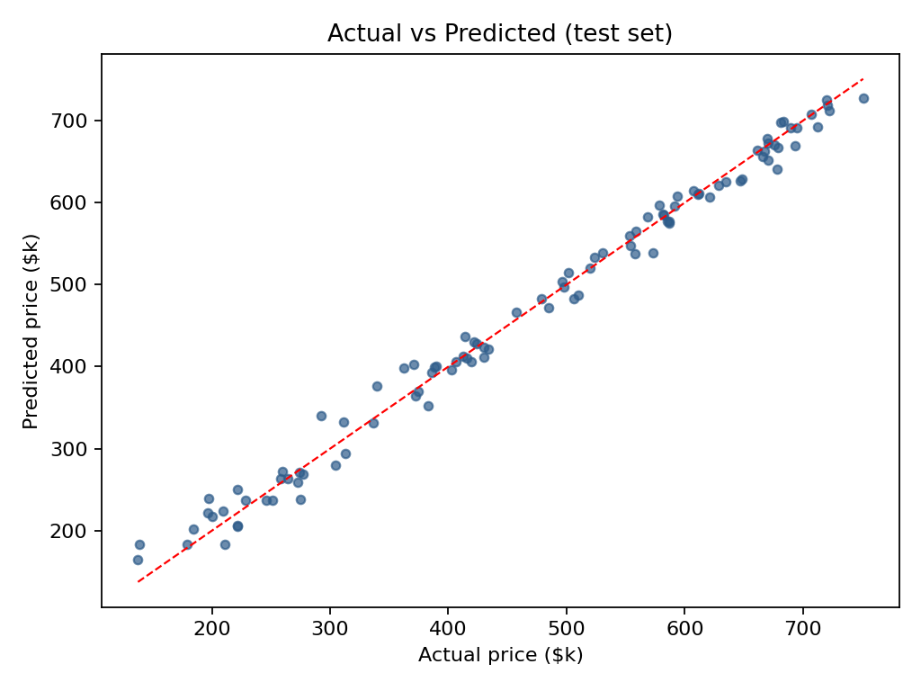
Figure 3: Actual vs predicted prices on the test set (dashed line = perfect prediction)

4.4 Prediction with Uncertainty
For each input the app reports the forest's mean prediction plus an 80% range (10th–90th percentile of the individual trees' predictions). For the default inputs (2,000 sqft, 3 bedrooms, 2 bathrooms, 10 years) the predicted value is about $340,757 with a range of roughly $322,900–$354,900.

5. Strategic Business Recommendations

Property developers
- Prioritise floor area: it is the dominant price driver, so larger layouts yield the strongest valuation uplift.
- Bedroom and bathroom counts matter far less than total area in this data; avoid over-investing in extra rooms at the expense of space.

Buyers
- Use the model's predicted range as a benchmark: listings well above the upper bound may be overpriced.
- Older properties (>30 years) sold at about 2.9% less per sq ft than properties ≤10 years old; negotiate using expected repair costs.

Portfolio managers
- Target larger (>2,500 sqft), newer (<10 years) properties to maximise ROI, and include a maintenance reserve for older assets.
- Retrain the model regularly with fresh market data and monitor MAE to detect drift.

Limitations & Future Work
- The default data is synthetic; validate on real data (e.g. the Kaggle set) before relying on predictions.
- Add location, neighbourhood quality and market-timing features, and compare against gradient boosting models.

