PYTHON FOR DATA SCIENCE: PROJECT REPORT
Market Regime Engine
Detecting Bull, Bear and Sideways Regimes in NSE Stocks with a Hidden Markov Model
Team member | Roll number
Akshat Jain | [Roll No.]
[Team member 2] | [Roll No.]
[Team member 3] | [Roll No.]

Symbiosis School of Economics, Pune
BSc Economics · October 2026
Code: github.com/Satore-spector/Stock-Market-Trend-Prediction-HMM-

Contents
1. Project Title
2. Team Members and Roll Numbers
3. Problem Statement
4. Project Objectives
5. Research Questions
6. Dataset Description and Source
7. Tools and Technologies Used
8. Data Cleaning and Preprocessing
9. Exploratory Data Analysis
10. Key Results and Visualisations
11. Major Findings
12. Limitations
13. Conclusion
14. References
15. Individual Contribution
Note: sections 7 (Big Data 5V Justification) and 10 (PySpark / Spark SQL / Hadoop) of the course template apply to the Big Data Analytics project only and are omitted from this Python for Data Science report; the remaining sections are numbered consecutively.

1. Project Title
Market Regime Engine: Detecting Bull, Bear and Sideways ("Chop") Regimes in NSE Stocks with a Hidden Markov Model.

2. Team Members and Roll Numbers
Name | Roll number
Akshat Jain | [Roll No.]
[Team member 2] | [Roll No.]
[Team member 3] | [Roll No.]

3. Problem Statement
Equity markets move through distinct phases: sustained rallies, sustained declines, and long sideways stretches where prices go nowhere. These phases are not labelled in any price data; an investor only sees a noisy daily price series and has to infer, as it happens, which phase the market is in. Getting this wrong is costly. A rule built for trending markets loses money in sideways markets, and staying fully invested through a long decline produces deep drawdowns.
This project builds a market regime engine: a model that reads only past prices and assigns each trading day a probability of being in a Bull, Bear or Chop regime. The regimes are treated as hidden states of a Hidden Markov Model (HMM), with observable features (trend, volatility and path efficiency) generated differently in each state. The project then asks whether these regime labels carry useful information, either about future returns or about risk.

4. Project Objectives
- Build a reproducible Python pipeline that downloads daily NSE price data and engineers regime-relevant features using only information available on each day.
- Implement a three-state Hidden Markov Model with a causal forward filter, so that every regime label could have been known in real time.
- Diagnose and correct bias in the initial model, which over-labelled days as Bull and almost never detected sideways markets.
- Evaluate the regimes honestly: what returns followed each regime, and how a simple regime-based allocation rule compares with buy-and-hold after transaction costs.
- Test robustness by estimating the model's parameters from data (Baum-Welch) and evaluating them on a period the model never saw.

5. Research Questions
RQ1. Can a three-state HMM built on trend, volatility and efficiency features separate rallies, declines and sideways markets in individual NSE stocks?
RQ2. Do the regime labels predict returns over the following 1 and 20 trading days?
RQ3. Does holding a stock only during Bull regimes improve returns or reduce risk compared with buy-and-hold, after transaction costs?
RQ4. When the parameters are learned from data rather than set by hand, does the data recover the same Bull/Bear/Chop structure, and do the benefits survive out of sample?

6. Dataset Description and Source
Daily OHLCV (open, high, low, close, volume) data for three large-cap NSE stocks was downloaded from Yahoo Finance through the open-source yfinance Python library. The three stocks were chosen to cover different sectors and price behaviour: ITC (FMCG; range-bound with a sharp gap-down in January 2026), Maruti Suzuki (automobiles; a long uptrend) and TCS (IT services; a rally followed by a long decline). Five years of history were downloaded so that the one-year volatility window has enough data to warm up; after the warm-up, about four years of usable data remain for each stock.
Table 1: Usable sample after cleaning and warm-up
Stock (ticker) | First date | Last date | Trading days | Min close (₹) | Max close (₹)
ITC (ITC.NS) | 03 Oct 2022 | 30 Sep 2026 | 986 | 256 | 464
MARUTI (MARUTI.NS) | 03 Oct 2022 | 30 Sep 2026 | 985 | 7,826 | 17,120
TCS (TCS.NS) | 03 Oct 2022 | 30 Sep 2026 | 985 | 1,972 | 4,231

Table 2: Raw fields downloaded from Yahoo Finance
Field | Description
Date | Trading date (exchange time zone)
Open, High, Low, Close | Daily prices in rupees, adjusted for splits and dividends by yfinance
Volume | Number of shares traded
Dividends, Stock Splits | Corporate actions on that day (not used as features)

7. Tools and Technologies Used
Table 3: Tools and libraries
Tool | Purpose in this project
Python 3.11 | Programming language for the whole pipeline
yfinance | Downloading daily price data from Yahoo Finance
pandas, NumPy | Data cleaning, rolling-window feature engineering, time-series alignment
SciPy (scipy.stats) | Normal and multivariate-normal densities for the HMM emission likelihoods
hmmlearn | Baum-Welch estimation of HMM parameters for the out-of-sample comparison
Matplotlib | Regime probability plots, equity curves and EDA charts
Git and GitHub | Version control and public code repository
VS Code | Development environment

The code is organised as a four-stage pipeline:
- extract.py: downloads data, cleans it and computes the three features; writes one CSV per stock.
- Model_form.py: runs the hand-specified HMM forward filter and plots regime probabilities.
- backtest.py: measures returns after each regime and compares a regime-based rule with buy-and-hold.
- fit_hmm.py: fits the HMM by Baum-Welch on 2022–2024 and tests it on 2025–26.

8. Data Cleaning and Preprocessing

8.1 Cleaning steps
- Zero-volume rows removed. Days with zero traded volume are exchange holidays or data errors rather than real trading days (6 rows each for ITC and TCS, 5 for Maruti).
- Feature construction (Section 8.2), using only rolling or exponentially weighted windows over past data, so no feature uses future information.
- Warm-up rows dropped. The first ~250 rows of each stock have no one-year volatility history, so the volatility z-score is undefined there; these rows were dropped (about 250 per stock).
- Infinite values removed. A ratio can become infinite if a denominator is zero (for example, zero realised volatility); these rows are converted to missing and dropped.
- Outlier clipping. Momentum and volatility features are clipped to ±4 before entering the model, so a single extreme day cannot dominate the likelihood.
- Date alignment. Regime probabilities are indexed by the same filtered rows as the features, so dates and probabilities cannot drift out of sync (this fixed a bug in an earlier version).

8.2 Feature engineering
Each trading day is described by three features. Their design was the main lever for fixing the initial model's bias (Section 10.2).
Table 4: The three model features
Feature | Formula | What it captures
Momentum (obs_mom) | 40-day EWM mean of log returns ÷ 40-day EWM std of log returns × √40 | Trend direction and strength, scaled by the stock's own volatility (a trend t-statistic)
Volatility (obs_vol) | log(20-day ATR ÷ Close), z-scored over a 250-day rolling window | Whether volatility is unusually high or low relative to the past year
Efficiency ratio (obs_er) | |Close(t) − Close(t−20)| ÷ Σ |daily price changes| over 20 days | Whether price went somewhere (≈1) or moved back and forth (≈0)

The original version z-scored momentum and ATR against only their own last 20 days. That removed the trend's level and effectively measured acceleration: when a decline merely slowed, momentum turned positive and the model called it Bull. The redesigned momentum keeps its sign through a whole trend, and the one-year volatility window stops post-crash volatility decay from looking "calm".

9. Exploratory Data Analysis

9.1 Price behaviour
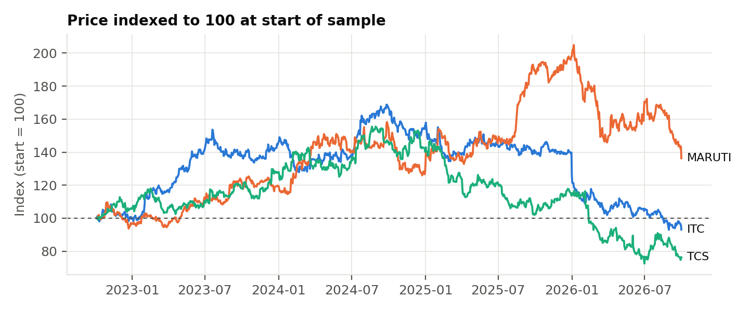
Figure 1: Prices of the three stocks indexed to 100 at the start of the sample
The three stocks followed very different paths, which makes them a useful test set. Maruti roughly doubled into early 2026 before falling back; TCS peaked in late 2024 and then declined about 50%; ITC climbed to mid-2024, drifted sideways through 2025, and then gapped down sharply in January 2026.
Table 5: Daily log-return statistics over the sample
Stock | Annualised return | Annualised volatility | Skewness | Excess kurtosis | Worst day | Best day
ITC | -1.8% | 18.6% | -0.38 | 7.2 | -10.2% | +5.4%
MARUTI | +7.9% | 21.1% | +0.46 | 3.8 | -5.0% | +8.4%
TCS | -6.9% | 22.3% | -0.01 | 4.2 | -8.8% | +6.4%

All three stocks show strongly fat-tailed daily returns (excess kurtosis of 3.8 to 7.2, where a normal distribution has 0). ITC's −10.2% worst day is the January 2026 gap-down. Fat tails and volatility that changes over time are exactly the features a regime model is meant to capture: a single normal distribution fits these returns poorly, but a mixture of calmer and more volatile states fits them much better.

9.2 Feature distributions and correlations
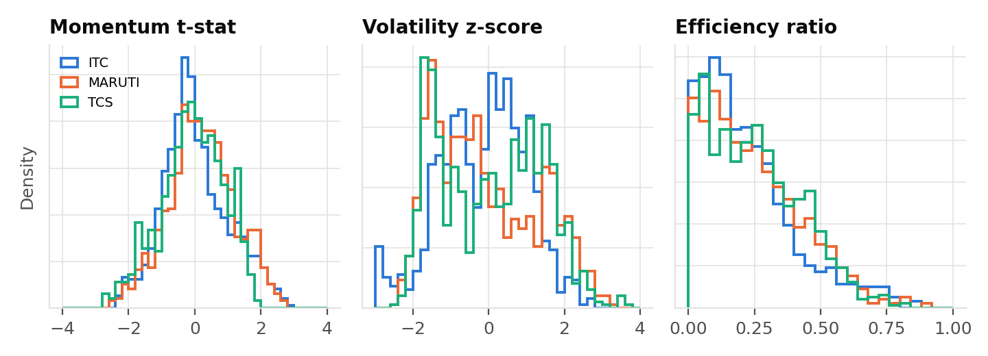
Figure 2: Distribution of the three model features by stock
Momentum is roughly symmetric and centred near zero, as expected for a trend t-statistic. The volatility z-score is spread out and bimodal for some stocks, suggesting distinct calm and turbulent periods. The efficiency ratio is right-skewed: most 20-day windows are inefficient (below 0.3), and clean trends with ratios above 0.5 are relatively rare.
Table 6: Pearson correlation between features (all stocks pooled)
 | Momentum | Volatility | Efficiency ratio
Momentum | 1.00 | -0.30 | 0.01
Volatility | -0.30 | 1.00 | 0.06
Efficiency ratio | 0.01 | 0.06 | 1.00

Momentum and volatility are moderately negatively correlated (−0.30): rising markets tend to be calmer, and falling markets more volatile. The efficiency ratio is almost uncorrelated with both, because it measures how direct the price path was regardless of direction. It therefore adds information the other two features do not contain.

10. Key Results and Visualisations

10.1 Model specification
The model has three hidden states. Each day, the forward filter (i) carries the previous day's state probabilities forward through the transition matrix, (ii) multiplies by the likelihood of today's three features under each state, and (iii) normalises. Only past and current data are used, so every label is available in real time [1, 2].
Table 7: Hand-specified emission and transition parameters
State | Momentum (mean, sd) | Volatility (mean, sd) | Efficiency ratio (mean, sd) | Prob. of staying
Bull | (+1.0, 0.8) | (−0.3, 1.0) | (0.30, 0.15) | 0.95
Bear | (−1.0, 0.8) | (+0.5, 1.0) | (0.30, 0.15) | 0.95
Chop | (0.0, 0.6) | (0.0, 1.0) | (0.12, 0.08) | 0.92

When a regime ends, Bull and Bear switch to Chop 80% of the time and to each other 20% of the time; Chop exits to Bull or Bear with equal probability.

10.2 Fixing the initial model's bias
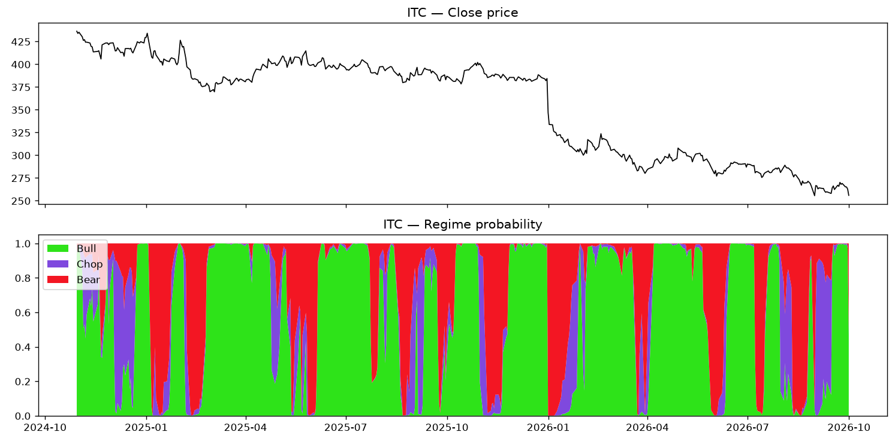
Figure 3: Initial model on ITC: Bull dominates, Chop is rare, and the post-crash decline of 2026 is labelled Bull
The first version had three problems. Chop was defined as "no trend at volatility 1.5 standard deviations above normal", a combination that almost never occurs, so ordinary sideways markets were labelled Bull. The 20-day z-scored features turned slowing declines into apparent positive momentum. And Chop was the least persistent state, with an expected duration of only 2.5 days. Section 8.2 describes the feature fixes; the parameter fixes were to centre Chop on normal volatility, add the efficiency ratio, and make all states more persistent.
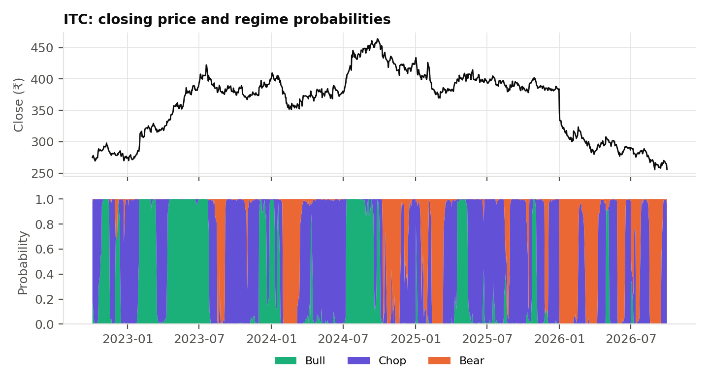
Figure 4: Final model on ITC: rallies are Bull, sideways stretches are Chop, and the January 2026 gap-down is Bear immediately

10.3 Regimes across stocks
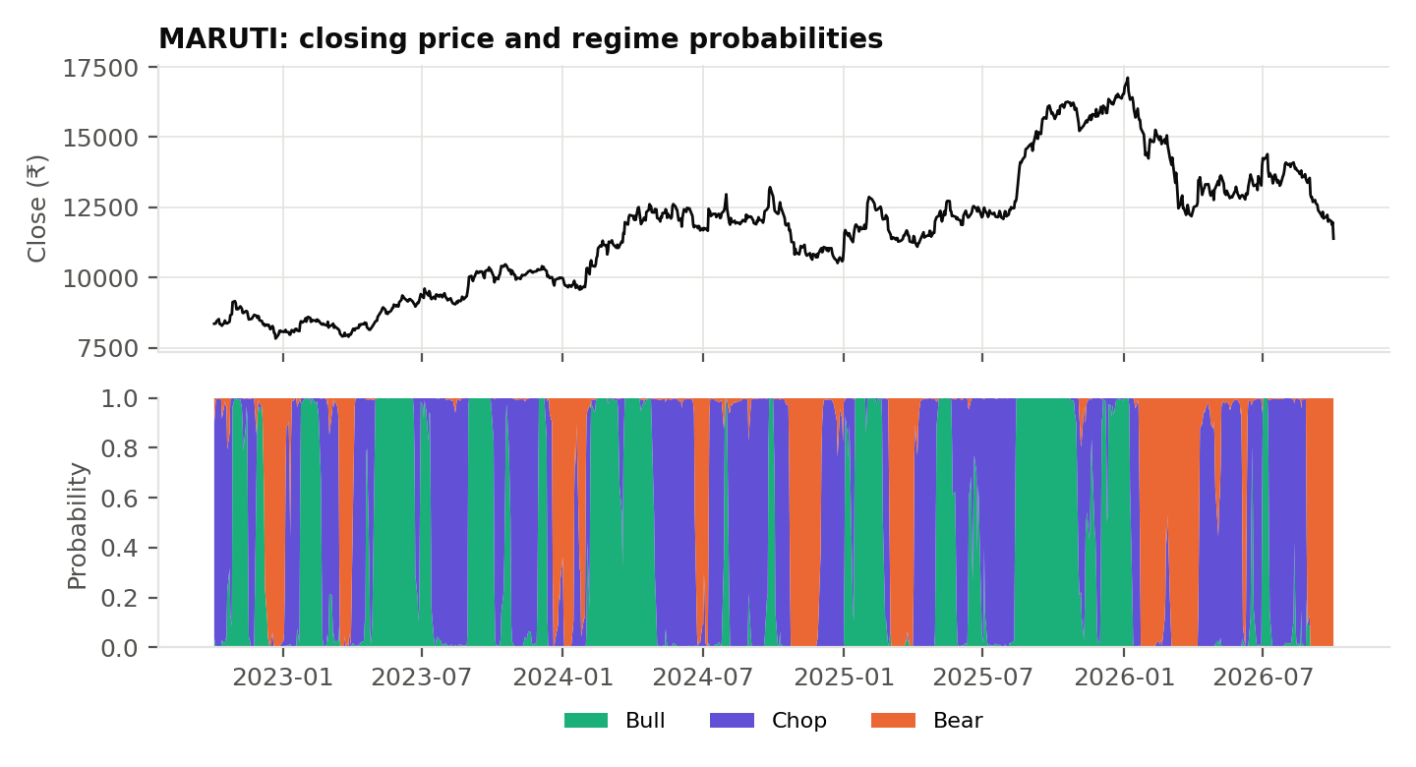
Figure 5: Maruti Suzuki: the 2023 and 2025 rallies are Bull, the 2024 range is Chop, and the 2026 crash is Bear
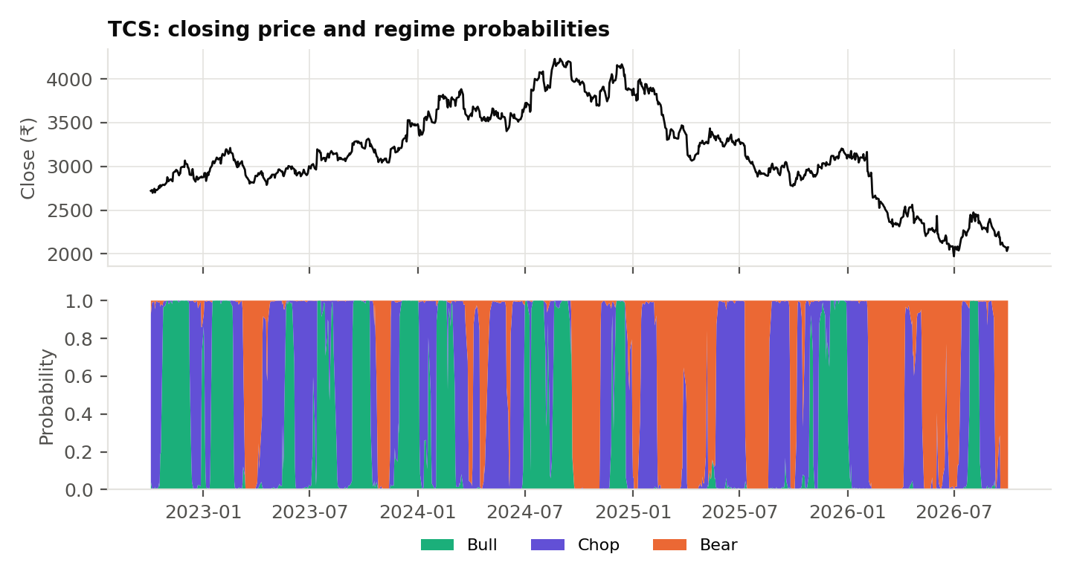
Figure 6: TCS: the long 2025–26 decline is identified as Bear, with Chop during pauses
Table 8: Regime summary for the final model
Stock | Bull share | Chop share | Bear share | Regime switches | Avg. regime length (days) | Median confidence
ITC | 25% | 52% | 24% | 66 | 14.7 | 0.99
MARUTI | 35% | 45% | 19% | 74 | 13.1 | 0.99
TCS | 29% | 42% | 29% | 72 | 13.5 | 0.99

Chop is now the most common regime (42–52% of days), which matches how much time these stocks actually spent going sideways. Regimes last about two to three weeks on average, and the model is usually decisive, with a median top-state probability of 0.99.

10.4 Do regimes predict returns?
Table 9: Average returns following each regime label
Stock | Regime | Avg. next-day return | Avg. next-20-day return | Days
ITC | Bull | +0.11% | +0.65% | 244
ITC | Chop | -0.07% | -0.31% | 509
ITC | Bear | +0.00% | -0.58% | 233
MARUTI | Bull | +0.04% | +0.07% | 345
MARUTI | Chop | +0.10% | +1.57% | 448
MARUTI | Bear | -0.15% | -0.04% | 192
TCS | Bull | -0.02% | -0.84% | 281
TCS | Chop | +0.01% | -0.42% | 416
TCS | Bear | -0.09% | -0.32% | 288

The pattern is inconsistent. On ITC the ordering is what a trend-follower would hope for (Bull > Chop > Bear over 20 days). On Maruti the best subsequent returns followed Chop, and on TCS every regime was followed by losses, with Bull the worst. The regime labels describe the current trend well but do not reliably forecast the next month's return.

10.5 Regime-based allocation versus buy-and-hold
A simple rule was tested: hold the stock only while the regime is Bull, otherwise hold cash. The position is taken the day after each signal (no look-ahead), and every change of position costs 0.1% for brokerage and slippage.
Table 10: Bull-only rule versus buy-and-hold, full sample, after costs
Stock | B&H return p.a. | Bull-only return p.a. | B&H Sharpe | Bull-only Sharpe | B&H max loss | Bull-only max loss | Trades | Time invested
ITC | -1.8% | +6.1% | -0.10 | 0.61 | -44.9% | -15.1% | 30 | 25%
MARUTI | +7.9% | +2.0% | 0.38 | 0.16 | -33.5% | -15.6% | 50 | 35%
TCS | -6.9% | -2.6% | -0.31 | -0.26 | -53.4% | -22.0% | 40 | 29%

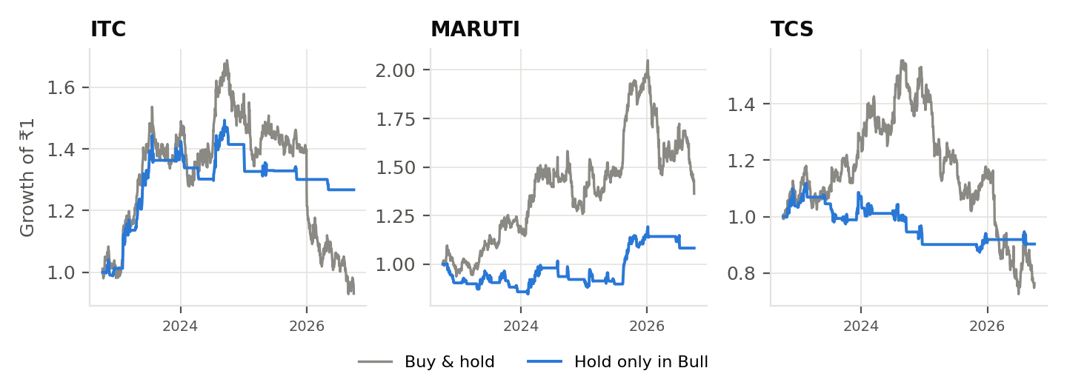
Figure 7: Growth of ₹1: buy-and-hold versus holding only during Bull regimes
The rule beat buy-and-hold on ITC and TCS and lagged on Maruti. Its most consistent effect was on risk: it cut the maximum drawdown by more than half on all three stocks, mainly by sitting in cash through the long declines. It did this while invested only 25–35% of the time.

10.6 Learning the parameters from data (out-of-sample test)
The parameters above were tuned by eye on the same charts used to evaluate them, so those results are in-sample. As an honest check, an HMM with full-covariance Gaussian emissions was fitted by the Baum-Welch algorithm [6] (hmmlearn, best of 10 random starts) on all three stocks pooled for 2022–2024 only, and then run with the same causal forward filter on 2025–26, which it never saw.
Table 11: Parameters learned by Baum-Welch on 2022–2024
Fitted state | Mean momentum | Mean volatility | Mean efficiency | Prob. of staying | Avg. length
Down | -0.59 | +0.41 | 0.22 | 0.962 | ~27 days
Calm uptrend | +0.73 | -1.16 | 0.24 | 0.975 | ~39 days
Volatile uptrend | +0.97 | +0.98 | 0.25 | 0.970 | ~34 days

Left to itself, the data separates regimes mainly by volatility, not by trend versus chop: one falling state, one calm uptrend and one volatile uptrend. The efficiency ratio is almost identical across the three learned states. The Bull/Bear/Chop structure is therefore a definition imposed on the data rather than one the data finds unprompted. Because of this, the fitted model's rule is to hold the stock in every state except Down.
Table 12: 2025–26 results: annualised return / maximum drawdown
Stock | Buy & hold | Fitted model (out of sample) | Hand-tuned model (in sample)
ITC | -30% / -41% | -20% / -30% | -6% / -10%
MARUTI | +4% / -33% | +8% / -18% | +9% / -9%
TCS | -35% / -51% | -13% / -21% | +0% / -5%

On data it had never seen, the fitted model beat buy-and-hold on all three stocks and reduced the maximum drawdown by roughly a third to a half. The hand-tuned model looks better still, but it was tuned while looking at these same years, so most of that gap reflects look-ahead rather than skill.

11. Major Findings
- The engine separates market phases well (RQ1). After redesigning the features, the model correctly labels the major rallies, declines and sideways ranges in all three stocks, including switching to Bear in the same week as ITC's January 2026 gap-down.
- Feature design mattered more than parameters. The initial Bull bias came from features that measured change relative to the last 20 days rather than the trend itself. Fixing the features did more than any amount of parameter tuning.
- Regimes are descriptive, not predictive (RQ2). Returns following each regime were inconsistent across stocks; the labels do not reliably forecast the next month's return.
- The real value is risk control (RQ3). Holding only in Bull cut the maximum drawdown by more than half on every stock, at the cost of missing part of Maruti's uptrend.
- The risk benefit survives out of sample, but the regime definitions are partly imposed (RQ4). A data-fitted model still reduced drawdowns on unseen 2025–26 data, but it organised regimes by volatility rather than trend versus chop.

12. Limitations
- In-sample tuning. The main model's parameters were chosen by inspecting the same period they are evaluated on; only the Baum-Welch model provides a true out-of-sample test.
- Small universe. Three stocks over four years is too few to draw general conclusions; the results may not hold for other stocks, sectors or market cycles.
- Independence assumption. The model multiplies the three feature likelihoods as if they were independent, while momentum and volatility are correlated (−0.30). This makes the model somewhat overconfident.
- Short regime blips. Some regime changes last only a few days. Acting on every one would add trades; a minimum-duration filter would be needed in practice.
- Simplified costs. A flat 0.1% per trade ignores taxes, market impact and the opportunity cost or interest earned on cash.

13. Conclusion
This project built a working market regime engine in Python: a data pipeline from Yahoo Finance, three engineered features, a three-state Hidden Markov Model with a causal forward filter, and an evaluation framework with an out-of-sample test. The main technical lesson was that the initial model's bias towards Bull came from poorly designed features, not from the HMM itself. Redesigning momentum as a volatility-scaled trend statistic, z-scoring volatility over a full year, and adding the efficiency ratio produced regimes that match the visible structure of the price charts.
The main empirical lesson is that these regimes are better treated as a risk filter than as a return forecast. They did not reliably predict next-month returns, but staying out of the market during Bear and Chop regimes consistently halved drawdowns, and this held up on data the fitted model had never seen. Natural extensions are walk-forward refitting every year, a broader universe including the Nifty 50 index, and sizing positions by regime probability instead of switching fully in and out.

14. References
- Hamilton, J. D. (1989). A new approach to the economic analysis of nonstationary time series and the business cycle. Econometrica, 57(2), 357–384.
- Rabiner, L. R. (1989). A tutorial on hidden Markov models and selected applications in speech recognition. Proceedings of the IEEE, 77(2), 257–286.
- Moskowitz, T. J., Ooi, Y. H., & Pedersen, L. H. (2012). Time series momentum. Journal of Financial Economics, 104(2), 228–250.
- Wilder, J. W. (1978). New Concepts in Technical Trading Systems. Trend Research.
- Kaufman, P. J. (1995). Smarter Trading: Improving Performance in Changing Markets. McGraw-Hill.
- Baum, L. E., Petrie, T., Soules, G., & Weiss, N. (1970). A maximization technique occurring in the statistical analysis of probabilistic functions of Markov chains. Annals of Mathematical Statistics, 41(1), 164–171.
- yfinance (Python library). https://github.com/ranaroussi/yfinance. Data source: Yahoo Finance.
- hmmlearn (Python library). https://hmmlearn.readthedocs.io

15. Individual Contribution
Team member | Roll number | Contribution
Akshat Jain | [Roll No.] | [e.g. data pipeline, feature engineering, HMM implementation and tuning, evaluation scripts, report]
[Team member 2] | [Roll No.] | [Contribution]
[Team member 3] | [Roll No.] | [Contribution]

