BioETL Architecture Diagrams
Complete Inventory & Documentation

Generated: 2026-02-16
Repository: SatoryKono/BioactivityDataAcquisition
Diagram Source: docs/02-architecture/diagrams/
Total Diagrams: 34 Mermaid (.mermaid) + 22 placeholder (.mmd)
Rendering: Playwright + mermaid.js v10.4.0

Table of Contents
(Update this field in Word to populate the Table of Contents)

Diagram Inventory
Total diagrams in repository: 34 Mermaid source files (.mermaid), 22 placeholder files (.mmd), ~79 embedded Mermaid blocks in documentation Markdown files.
Fig. # | Filename | Category | Title | Lines
1 | 01-full-system-component.mermaid | Architectural Overview | Full System Component Diagram | 150
2 | 01-high-level.mermaid | Architectural Overview | High-Level System Overview | 45
3 | 04-domain-layer-class-diagram.mermaid | Architectural Overview | Domain Layer Class Diagram | 244
4 | 05-layers-interaction.mermaid | Architectural Overview | Layer Interaction Diagram | 71
5 | 06-application-layer-class-diagram.mermaid | Architectural Overview | Application Layer Class Diagram | 222
6 | 08-domain-ddd.mermaid | Architectural Overview | Domain-Driven Design Diagram | 81
7 | 02-full-medallion-data-flow.mermaid | Data Lineage | Full Medallion Data Flow | 68
8 | 02-medallion.mermaid | Data Lineage | Medallion Architecture (Simplified) | 30
9 | 07-medallion-flow.mermaid | Data Lineage | Medallion Data Flow | 61
10 | 18-bronze-write-sequence.mermaid | Data Lineage | Bronze Write Sequence | 78
11 | 19-delta-lake-write-sequence.mermaid | Data Lineage | Delta Lake Write Sequence | 99
12 | 23-silver-writer-class.mermaid | Data Lineage | SilverWriter Class Diagram | 121
13 | 03-pipeline-execution-happy-path.mermaid | Pipeline Diagrams | Pipeline Execution (Happy Path) | 87
14 | 03-pipeline-sequence.mermaid | Pipeline Diagrams | Pipeline Sequence Diagram | 35
15 | 06-pipeline-execution.mermaid | Pipeline Diagrams | Pipeline Execution Flow | 73
16 | 17-pipeline-hierarchy.mermaid | Pipeline Diagrams | Pipeline/Transformer Hierarchy | 142
17 | 04-error-flow.mermaid | Workflow & Orchestration | Error Handling Flow | 12
18 | 05-pipeline-lifecycle-states.mermaid | Workflow & Orchestration | Pipeline Lifecycle States | 173
19 | 08-complete-etl-workflow.mermaid | Workflow & Orchestration | Complete ETL Workflow | 109
20 | 09-full-er-diagram.mermaid | ER Diagrams & Data Models | Full Entity-Relationship Diagram | 247
21 | 13-domain-models-relationship.mermaid | ER Diagrams & Data Models | Domain Models Relationship | 244
22 | 21-activity-entity-data-flow.mermaid | ER Diagrams & Data Models | Activity Entity Data Flow | 93
23 | 05-locking.mermaid | Security & Infrastructure | Locking Mechanism | 37
24 | 10-infrastructure-layer-class-diagram.mermaid | Security & Infrastructure | Infrastructure Layer Class Diagram | 257
25 | 11-lock-acquisition-sequence.mermaid | Security & Infrastructure | Lock Acquisition Sequence | 81
26 | 12-full-aws-deployment.mermaid | Security & Infrastructure | Full Deployment Diagram (Local) | 84
27 | 16-memory-lock-class.mermaid | Security & Infrastructure | MemoryLock Class Diagram | 103
28 | 24-hash-service-class.mermaid | Security & Infrastructure | Hash Service Class Diagram | 60
29 | 07-circuit-breaker-states.mermaid | Monitoring & CI/CD | Circuit Breaker State Machine | 74
30 | 14-provider-health-states.mermaid | Monitoring & CI/CD | Provider Health States | 97
31 | 15-dq-check-workflow.mermaid | Monitoring & CI/CD | Data Quality Check Workflow | 96
32 | 20-quarantine-record-states.mermaid | Monitoring & CI/CD | Quarantine Record States | 118
33 | 25-circuit-breaker-observer-class.mermaid | Monitoring & CI/CD | CircuitBreaker & Observer Class Diagram | 118
34 | 22-client-api-request-sequence.mermaid | API & Integration | Client API Request Sequence | 105

Architectural Overview
6 diagram(s) in this category.

Figure 1 -- Full System Component Diagram
Source File | 01-full-system-component.mermaid
Category | Architectural Overview
Source Lines | 150
Rendered Size | 1560 x 354 px

Description
C4-style component diagram showing the complete BioETL system: 7 external API providers, 5 architectural layers (Interfaces, Application, Domain, Infrastructure, Composition), data lake storage (Bronze/Silver/Gold), and all primary components with their relationships.

Rendered Diagram
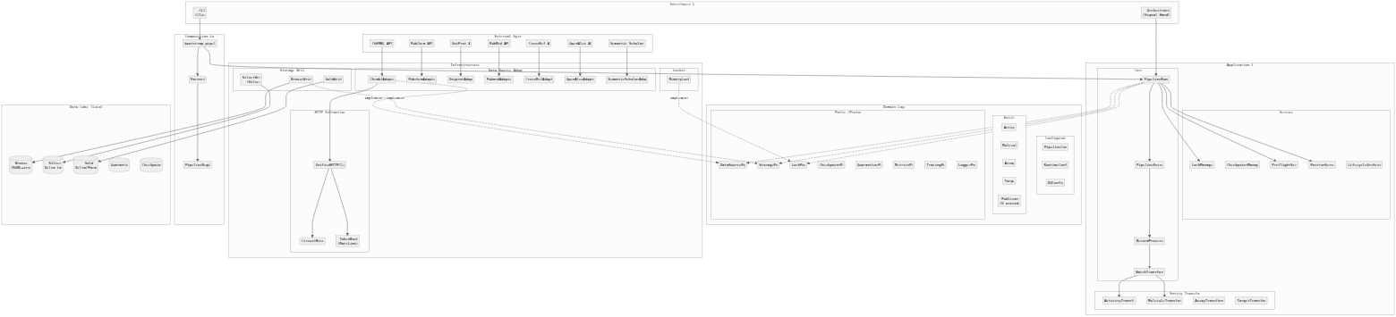
Figure 1: Full System Component Diagram

Mermaid Source
%%{init: {'theme': 'neutral', 'themeVariables': {'fontFamily': 'Inter, system-ui', 'lineWidth': '2'}}}%%
flowchart TB
subgraph External["External Systems"]
ChEMBL_API["ChEMBL API"]
PubChem_API["PubChem API"]
UniProt_API["UniProt API"]
PubMed_API["PubMed API"]
CrossRef_API["CrossRef API"]
OpenAlex_API["OpenAlex API"]
S2_API["Semantic Scholar API"]
end
subgraph Interfaces["Interfaces Layer"]
CLI["CLI\n(Click)"]
Orchestration["Orchestration\n(Signal Handling)"]
end
subgraph Application["Application Layer"]
subgraph Core["Core"]
PipelineRunner["PipelineRunner"]
PipelineExecutor["PipelineExecutor"]
RecordProcessor["RecordProcessor"]
BatchTransformer["BatchTransformer"]
end
subgraph Services["Services"]
LockManager["LockManager"]
CheckpointManager["CheckpointManager"]
PreflightService["PreflightService"]
PostrunService["PostrunService"]
LifecycleOrchestrator["LifecycleOrchestrator"]
end
subgraph Transformers["Entity Transformers"]
ActivityTransformer["ActivityTransformer"]
MoleculeTransformer["MoleculeTransformer"]
AssayTransformer["AssayTransformer"]
TargetTransformer["TargetTransformer"]
end
end
subgraph Domain["Domain Layer"]
subgraph Ports["Ports (Protocols)"]
DataSourcePort["DataSourcePort"]
StoragePort["StoragePort"]
LockPort["LockPort"]
CheckpointPort["CheckpointPort"]
QuarantinePort["QuarantinePort"]
MetricsPort["MetricsPort"]
TracingPort["TracingPort"]
LoggerPort["LoggerPort"]
end
subgraph Entities["Entities"]
Activity["Activity"]
Molecule["Molecule"]
Assay["Assay"]
Target["Target"]
Publication["Publication\n(5 providers)"]
end
subgraph Config["Configuration"]
PipelineConfig["PipelineConfig"]
RuntimeConfig["RuntimeConfig"]
DQConfig["DQConfig"]
end
end
subgraph Infrastructure["Infrastructure Layer"]
subgraph Adapters["Data Source Adapters"]
ChemblAdapter["ChemblAdapter"]
PubchemAdapter["PubchemAdapter"]
UniprotAdapter["UniprotAdapter"]
PubmedAdapter["PubmedAdapter"]
CrossRefAdapter["CrossRefAdapter"]
OpenAlexAdapter["OpenAlexAdapter"]
S2Adapter["SemanticScholarAdapter"]
end
subgraph HTTP["HTTP Infrastructure"]
UnifiedHTTPClient["UnifiedHTTPClient"]
CircuitBreaker["CircuitBreaker"]
TokenBucket["TokenBucket\n(RateLimiter)"]
end
subgraph Storage["Storage Writers"]
BronzeWriter["BronzeWriter"]
SilverWriter["SilverWriter\n(Silver)"]
GoldWriter["GoldWriter"]
end
subgraph Locking["Locking"]
MemoryLock["MemoryLock"]
end
end
subgraph Composition["Composition Layer"]
Bootstrap["bootstrap_pipeline()"]
Factories["Factories"]
Registry["PipelineRegistry"]
end
subgraph DataLake["Data Lake (Local FS)"]
Bronze[("Bronze\nJSONL+zstd")]
Silver[("Silver\nDelta Lake")]
Gold[("Gold\nDelta/Parquet")]
Quarantine[("Quarantine")]
Checkpoints[("Checkpoints")]
end
%% External connections
ChEMBL_API --> ChemblAdapter
PubChem_API --> PubchemAdapter
UniProt_API --> UniprotAdapter
PubMed_API --> PubmedAdapter
CrossRef_API --> CrossRefAdapter
OpenAlex_API --> OpenAlexAdapter
S2_API --> S2Adapter
%% Interface to Application
CLI --> Bootstrap
Orchestration --> PipelineRunner
%% Composition wiring
Bootstrap --> Factories
Factories --> Registry
Bootstrap --> PipelineRunner
%% Application internal
PipelineRunner --> PipelineExecutor
PipelineRunner --> LockManager
PipelineRunner --> PreflightService
PipelineRunner --> PostrunService
PipelineExecutor --> RecordProcessor
RecordProcessor --> BatchTransformer
BatchTransformer --> ActivityTransformer
BatchTransformer --> MoleculeTransformer
%% Domain dependencies (interfaces)
PipelineRunner -.-> DataSourcePort
PipelineRunner -.-> StoragePort
PipelineRunner -.-> LockPort
%% Infrastructure implements Ports
ChemblAdapter -.->|implements| DataSourcePort
BronzeWriter -.->|implements| StoragePort
MemoryLock -.->|implements| LockPort
%% HTTP infrastructure
ChemblAdapter --> UnifiedHTTPClient
UnifiedHTTPClient --> CircuitBreaker
UnifiedHTTPClient --> TokenBucket
%% Storage writes
BronzeWriter --> Bronze
SilverWriter --> Silver
GoldWriter --> Gold

Figure 2 -- High-Level System Overview
Source File | 01-high-level.mermaid
Category | Architectural Overview
Source Lines | 45
Rendered Size | 1560 x 593 px

Description
Simplified high-level view of BioETL architecture showing the main subsystems and their interactions without internal component details.

Rendered Diagram
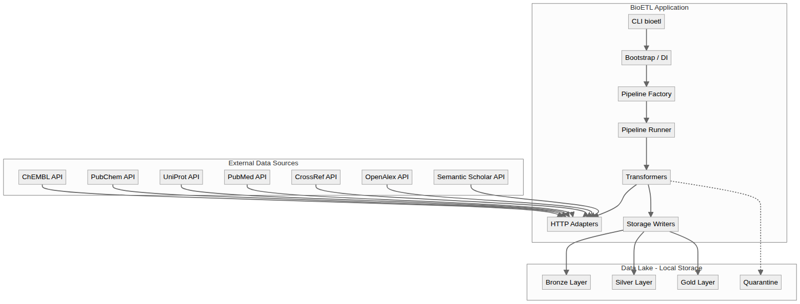
Figure 2: High-Level System Overview

Mermaid Source
flowchart TD
subgraph Sources["External Data Sources"]
A1[ChEMBL API]
A2[PubChem API]
A3[UniProt API]
A4[PubMed API]
A5[CrossRef API]
A6[OpenAlex API]
A7[Semantic Scholar API]
end
subgraph App["BioETL Application"]
CLI[CLI bioetl]
Boot[Bootstrap / DI]
Factory[Pipeline Factory]
Runner[Pipeline Runner]
Trans[Transformers]
Adapters[HTTP Adapters]
Storage[Storage Writers]
end
subgraph Lake["Data Lake - Local Storage"]
Bronze[Bronze Layer]
Silver[Silver Layer]
Gold[Gold Layer]
Quarantine[Quarantine]
end
A1 --> Adapters
A2 --> Adapters
A3 --> Adapters
A4 --> Adapters
A5 --> Adapters
A6 --> Adapters
A7 --> Adapters
CLI --> Boot
Boot --> Factory
Factory --> Runner
Runner --> Trans
Trans --> Adapters
Trans --> Storage
Storage --> Bronze
Storage --> Silver
Storage --> Gold
Trans -.-> Quarantine

Figure 3 -- Domain Layer Class Diagram
Source File | 04-domain-layer-class-diagram.mermaid
Category | Architectural Overview
Source Lines | 244
Rendered Size | 1560 x 1466 px

Description
Complete class diagram of the Domain layer: 24 Port protocols, DDD aggregates (PipelineRun, Batch, QuarantineEntry), value objects, entities, configuration objects, and the exception hierarchy.

Rendered Diagram
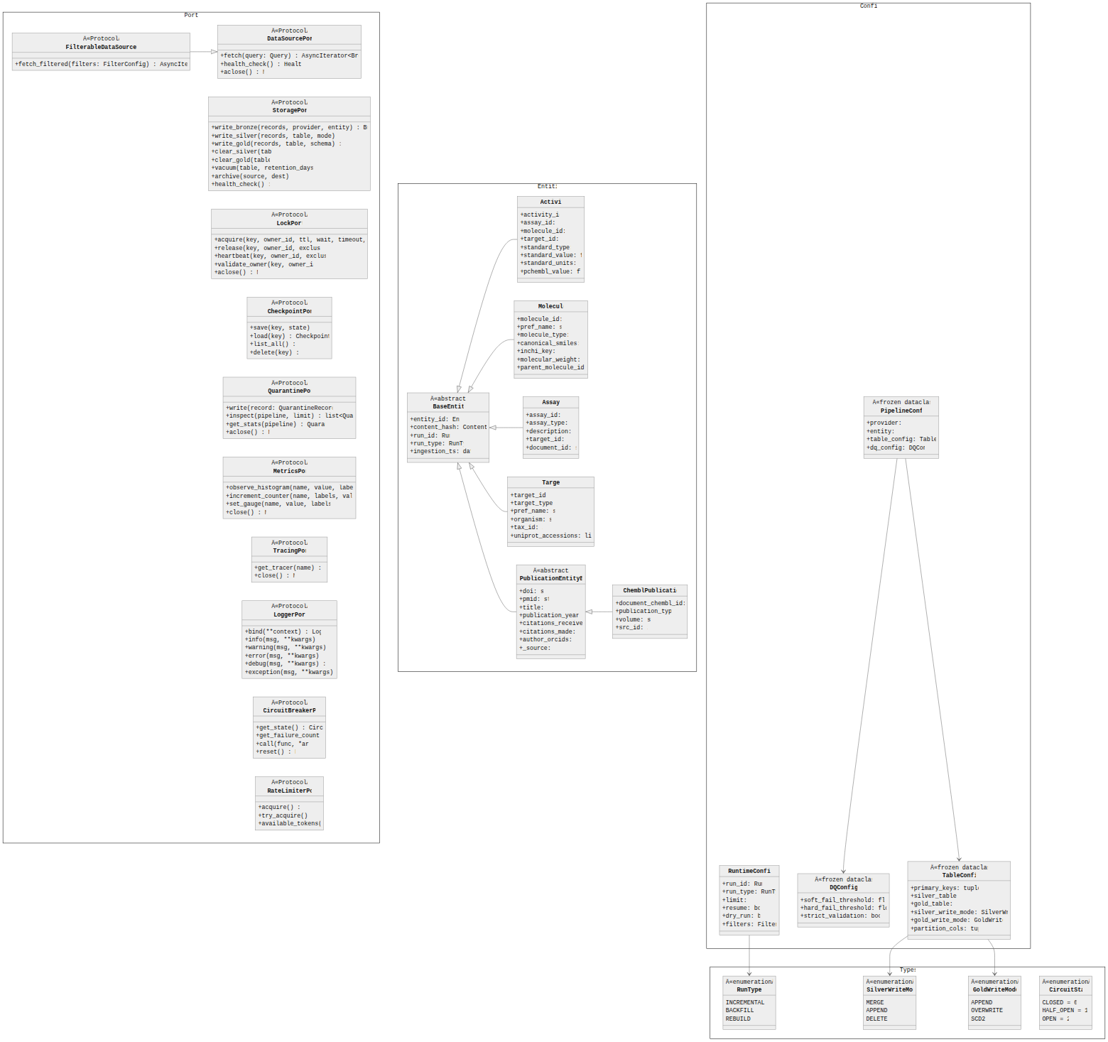
Figure 3: Domain Layer Class Diagram

Mermaid Source
%%{init: {'theme': 'neutral', 'themeVariables': {'fontFamily': 'Inter, system-ui', 'lineWidth': '2'}}}%%
classDiagram
direction TB
namespace Ports {
class DataSourcePort {
<<Protocol>>
+fetch(query: Query) AsyncIterator~BronzeRecord~
+health_check() HealthStatus
+aclose() None
}
class FilterableDataSourcePort {
<<Protocol>>
+fetch_filtered(filters: FilterConfig) AsyncIterator~BronzeRecord~
}
class StoragePort {
<<Protocol>>
+write_bronze(records, provider, entity) BronzeWriteResult
+write_silver(records, table, mode) WriteResult
+write_gold(records, table, schema) WriteResult
+clear_silver(table) int
+clear_gold(table) int
+vacuum(table, retention_days) None
+archive(source, dest) None
+health_check() bool
}
class LockPort {
<<Protocol>>
+acquire(key, owner_id, ttl, wait, timeout, exclusive) bool
+release(key, owner_id, exclusive) bool
+heartbeat(key, owner_id, exclusive) bool
+validate_owner(key, owner_id) bool
+aclose() None
}
class CheckpointPort {
<<Protocol>>
+save(key, state) None
+load(key) CheckpointState?
+list_all() list~str~
+delete(key) None
}
class QuarantinePort {
<<Protocol>>
+write(record: QuarantineRecord) None
+inspect(pipeline, limit) list~QuarantineRecord~
+get_stats(pipeline) QuarantineStats
+aclose() None
}
class MetricsPort {
<<Protocol>>
+observe_histogram(name, value, labels) None
+increment_counter(name, labels, value) None
+set_gauge(name, value, labels) None
+close() None
}
class TracingPort {
<<Protocol>>
+get_tracer(name) Tracer
+close() None
}
class LoggerPort {
<<Protocol>>
+bind(**context) LoggerPort
+info(msg, **kwargs) None
+warning(msg, **kwargs) None
+error(msg, **kwargs) None
+debug(msg, **kwargs) None
+exception(msg, **kwargs) None
}
class CircuitBreakerPort {
<<Protocol>>
+get_state() CircuitState
+get_failure_count() int
+call(func, *args) T
+reset() None
}
class RateLimiterPort {
<<Protocol>>
+acquire() None
+try_acquire() bool
+available_tokens() int
}
}
namespace Entities {
class BaseEntity {
<<abstract>>
+entity_id: EntityID
+content_hash: ContentHash
+run_id: RunID
+run_type: RunType
+ingestion_ts: datetime
}
class Activity {
+activity_id: str
+assay_id: str
+molecule_id: str
+target_id: str?
+standard_type: str
+standard_value: float?
+standard_units: str?
+pchembl_value: float?
}
class Molecule {
+molecule_id: str
+pref_name: str?
+molecule_type: str
+canonical_smiles: str?
+inchi_key: str?
+molecular_weight: float?
+parent_molecule_id: str?
}
class Assay {
+assay_id: str
+assay_type: str
+description: str?
+target_id: str?
+document_id: str?
}
class Target {
+target_id: str
+target_type: str
+pref_name: str?
+organism: str?
+tax_id: int?
+uniprot_accessions: list~str~?
}
class PublicationEntityBase {
<<abstract>>
+doi: str?
+pmid: str?
+title: str?
+publication_year: int?
+citations_received: int?
+citations_made: int?
+author_orcids: str?
+_source: str
}
class ChemblPublication {
+document_chembl_id: str
+publication_type: str
+volume: str?
+src_id: int?
}
}
namespace Config {
class PipelineConfig {
<<frozen dataclass>>
+provider: str
+entity: str
+table_config: TableConfig
+dq_config: DQConfig
}
class RuntimeConfig {
+run_id: RunID
+run_type: RunType
+limit: int?
+resume: bool
+dry_run: bool
+filters: FilterConfig?
}
class DQConfig {
<<frozen dataclass>>
+soft_fail_threshold: float = 0.05
+hard_fail_threshold: float = 0.20
+strict_validation: bool = False
}
class TableConfig {
<<frozen dataclass>>
+primary_keys: tuple~str~
+silver_table: str?
+gold_table: str?
+silver_write_mode: SilverWriteMode
+gold_write_mode: GoldWriteMode
+partition_cols: tuple~str~
}
}
namespace Types {
class RunType {
<<enumeration>>
INCREMENTAL
BACKFILL
REBUILD
}
class SilverWriteMode {
<<enumeration>>
MERGE
APPEND
DELETE
}
class GoldWriteMode {
<<enumeration>>
APPEND
OVERWRITE
SCD2
}
class CircuitState {
<<enumeration>>
CLOSED = 0
HALF_OPEN = 1
OPEN = 2
}
}
%% Inheritance
BaseEntity <|-- Activity
BaseEntity <|-- Molecule
BaseEntity <|-- Assay
BaseEntity <|-- Target
BaseEntity <|-- PublicationEntityBase
PublicationEntityBase <|-- ChemblPublication
FilterableDataSourcePort --|> DataSourcePort
%% Associations
PipelineConfig --> TableConfig
PipelineConfig --> DQConfig
RuntimeConfig --> RunType
TableConfig --> SilverWriteMode
TableConfig --> GoldWriteMode

Figure 4 -- Layer Interaction Diagram
Source File | 05-layers-interaction.mermaid
Category | Architectural Overview
Source Lines | 71
Rendered Size | 1560 x 557 px

Description
Shows how the 5 architectural layers interact: dependency direction, allowed imports matrix, and the Ports & Adapters boundary between Domain and Infrastructure.

Rendered Diagram
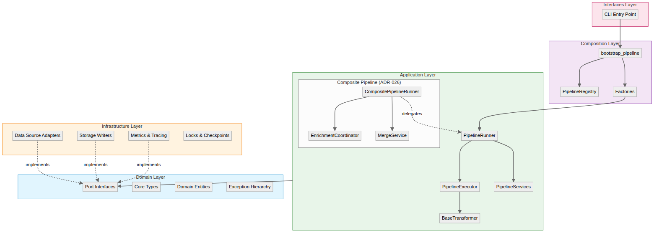
Figure 4: Layer Interaction Diagram

Mermaid Source
%% BioETL Layer Interaction Diagram
%% Shows how layers communicate following Hexagonal Architecture
flowchart TB
subgraph Interfaces["Interfaces Layer"]
CLI[CLI Entry Point]
end
subgraph Composition["Composition Layer"]
Bootstrap[bootstrap_pipeline]
Registry[PipelineRegistry]
Factories[Factories]
Bootstrap --> Registry
Bootstrap --> Factories
end
subgraph Application["Application Layer"]
Runner[PipelineRunner]
Executor[PipelineExecutor]
Transformer[BaseTransformer]
Services[PipelineServices]
subgraph Composite["Composite Pipeline (ADR-026)"]
CompositeRunner[CompositePipelineRunner]
Coordinator[EnrichmentCoordinator]
Merger[MergeService]
end
Runner --> Executor
Executor --> Transformer
Runner --> Services
CompositeRunner --> Coordinator
CompositeRunner --> Merger
CompositeRunner -.->|"delegates"| Runner
end
subgraph Domain["Domain Layer"]
Ports[Port Interfaces]
Types[Core Types]
Entities[Domain Entities]
Exceptions[Exception Hierarchy]
end
subgraph Infrastructure["Infrastructure Layer"]
Adapters[Data Source Adapters]
Storage[Storage Writers]
Observability[Metrics & Tracing]
Locking[Locks & Checkpoints]
end
%% Layer Dependencies
CLI --> Bootstrap
Factories --> Runner
Application --> Ports
Adapters -.->|implements| Ports
Storage -.->|implements| Ports
Observability -.->|implements| Ports
%% Styling
classDef domainStyle fill:#e1f5fe,stroke:#0288d1
classDef appStyle fill:#e8f5e9,stroke:#388e3c
classDef infraStyle fill:#fff3e0,stroke:#f57c00
classDef compStyle fill:#f3e5f5,stroke:#7b1fa2
classDef ifaceStyle fill:#fce4ec,stroke:#c2185b
class Domain domainStyle
class Application appStyle
class Infrastructure infraStyle
class Composition compStyle
class Interfaces ifaceStyle

Figure 5 -- Application Layer Class Diagram
Source File | 06-application-layer-class-diagram.mermaid
Category | Architectural Overview
Source Lines | 222
Rendered Size | 1560 x 355 px

Description
Complete class diagram of the Application layer: PipelineRunner, BatchExecutor, RecordProcessor, 14 application services, BaseTransformer hierarchy, and PipelineServices bundle.

Rendered Diagram
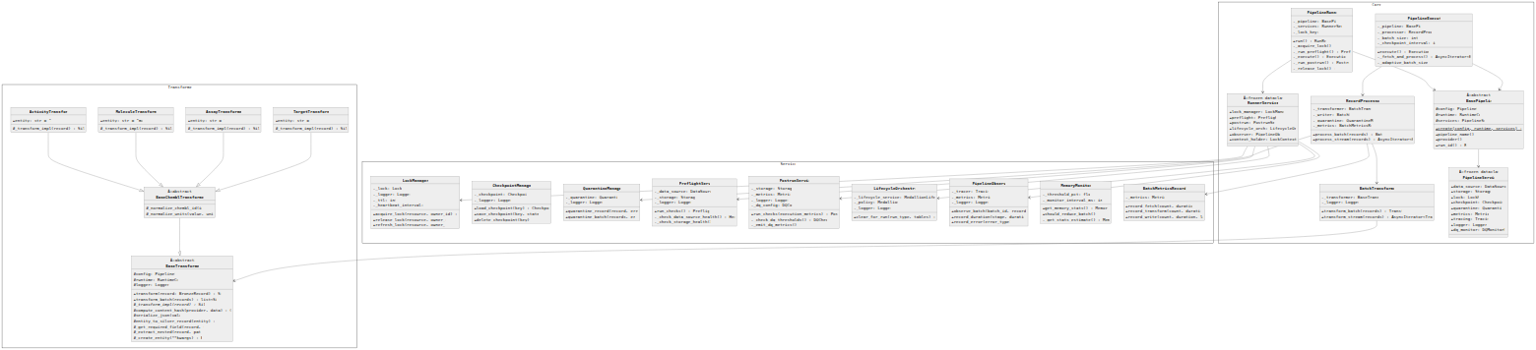
Figure 5: Application Layer Class Diagram

Mermaid Source
%%{init: {'theme': 'neutral', 'themeVariables': {'fontFamily': 'Inter, system-ui', 'lineWidth': '2'}}}%%
classDiagram
direction TB
namespace Core {
class BasePipeline {
<<abstract>>
#config: PipelineConfig
#runtime: RuntimeConfig
#services: PipelineServices
+create(config, runtime, services)$ BasePipeline
+pipeline_name() str
+provider() str
+run_id() RunID
}
class PipelineRunner {
-_pipeline: BasePipeline
-_services: RunnerServices
-_lock_key: str
+run() RunResult
-_acquire_lock() bool
-_run_preflight() PreflightResult
-_execute() ExecutionResult
-_run_postrun() PostrunResult
-_release_lock() None
}
class PipelineExecutor {
-_pipeline: BasePipeline
-_processor: RecordProcessor
-_batch_size: int = 100
-_checkpoint_interval: int = 1000
+execute() ExecutionResult
-_fetch_and_process() AsyncIterator~BatchResult~
-_adaptive_batch_size() int
}
class RecordProcessor {
-_transformer: BatchTransformer
-_writer: BatchWriter
-_quarantine: QuarantineManager
-_metrics: BatchMetricsRecorder
+process_batch(records) BatchResult
+process_stream(records) AsyncIterator~BatchResult~
}
class BatchTransformer {
-_transformer: BaseTransformer
-_logger: LoggerPort
+transform_batch(records) TransformResult
+transform_stream(records) AsyncIterator~TransformResult~
}
class PipelineServices {
<<frozen dataclass>>
+data_source: DataSourcePort
+storage: StoragePort
+lock: LockPort
+checkpoint: CheckpointPort
+quarantine: QuarantinePort
+metrics: MetricsPort
+tracing: TracingPort
+logger: LoggerPort
+dq_monitor: DQMonitorPort?
}
class RunnerServices {
<<frozen dataclass>>
+lock_manager: LockManager
+preflight: PreflightService
+postrun: PostrunService
+lifecycle_orch: LifecycleOrchestrator
+observer: PipelineObserver
+context_holder: LockContextHolder?
}
}
namespace Services {
class LockManager {
-_lock: LockPort
-_logger: LoggerPort
-_ttl: int = 90
-_heartbeat_interval: int = 30
+acquire_lock(resource, owner_id) LockResult
+release_lock(resource, owner_id) bool
+refresh_lock(resource, owner_id) bool
}
class CheckpointManager {
-_checkpoint: CheckpointPort
-_logger: LoggerPort
+load_checkpoint(key) CheckpointState?
+save_checkpoint(key, state) None
+delete_checkpoint(key) None
}
class QuarantineManager {
-_quarantine: QuarantinePort
-_logger: LoggerPort
+quarantine_record(record, error) None
+quarantine_batch(records, errors) int
}
class PreflightService {
-_data_source: DataSourcePort
-_storage: StoragePort
-_logger: LoggerPort
+run_checks() PreflightResult
-_check_data_source_health() HealthStatus
-_check_storage_health() bool
}
class PostrunService {
-_storage: StoragePort
-_metrics: MetricsPort
-_logger: LoggerPort
-_dq_config: DQConfig
+run_checks(execution_metrics) PostrunResult
-_check_dq_thresholds() DQCheckResult
-_emit_dq_metrics() None
}
class LifecycleOrchestrator {
-_lifecycle_service: MedallionLifecycleService
-_policy: MedallionPolicy
-_logger: LoggerPort
+clear_for_run(run_type, tables) ClearResult
}
class PipelineObserver {
-_tracer: TracingPort
-_metrics: MetricsPort
-_logger: LoggerPort
+observe_batch(batch_id, records) Span
+record_duration(stage, duration) None
+record_error(error_type) None
}
class MemoryMonitor {
-_threshold_pct: float = 0.8
-_monitor_interval_ms: int = 1000
+get_memory_stats() MemoryStats
+should_reduce_batch() bool
-_get_stats_estimate() MemoryStats
}
class BatchMetricsRecorder {
-_metrics: MetricsPort
+record_fetch(count, duration) None
+record_transform(count, duration) None
+record_write(count, duration, layer) None
}
}
namespace Transformers {
class BaseTransformer {
<<abstract>>
#config: PipelineConfig
#runtime: RuntimeConfig
#logger: LoggerPort
+transform(record: BronzeRecord) SilverRecord
+transform_batch(records) list~SilverRecord~
#_transform_impl(record)* SilverRecord
#compute_content_hash(provider, data) ContentHash
#serialize_json(value) str
#entity_to_silver_record(entity) SilverRecord
#_get_required_field(record, field) Any
#_extract_nested(record, path) Any?
#_create_entity(**kwargs) BaseEntity
}
class BaseChemblTransformer {
<<abstract>>
#_normalize_chembl_id(id) str
#_normalize_units(value, units) tuple
}
class ActivityTransformer {
+entity: str = "activity"
#_transform_impl(record) SilverRecord
}
class MoleculeTransformer {
+entity: str = "molecule"
#_transform_impl(record) SilverRecord
}
class AssayTransformer {
+entity: str = "assay"
#_transform_impl(record) SilverRecord
}
class TargetTransformer {
+entity: str = "target"
#_transform_impl(record) SilverRecord
}
}
%% Inheritance
BaseChemblTransformer --|> BaseTransformer
ActivityTransformer --|> BaseChemblTransformer
MoleculeTransformer --|> BaseChemblTransformer
AssayTransformer --|> BaseChemblTransformer
TargetTransformer --|> BaseChemblTransformer
%% Composition
PipelineRunner --> BasePipeline
PipelineRunner --> RunnerServices
PipelineExecutor --> BasePipeline
PipelineExecutor --> RecordProcessor
RecordProcessor --> BatchTransformer
RecordProcessor --> QuarantineManager
RecordProcessor --> BatchMetricsRecorder
BatchTransformer --> BaseTransformer
BasePipeline --> PipelineServices
RunnerServices --> LockManager
RunnerServices --> PreflightService
RunnerServices --> PostrunService
RunnerServices --> LifecycleOrchestrator
RunnerServices --> PipelineObserver

Figure 6 -- Domain-Driven Design Diagram
Source File | 08-domain-ddd.mermaid
Category | Architectural Overview
Source Lines | 81
Rendered Size | 1560 x 876 px

Description
DDD tactical patterns in BioETL: aggregates with invariants, value objects (immutable), domain events, and bounded context boundaries.

Rendered Diagram
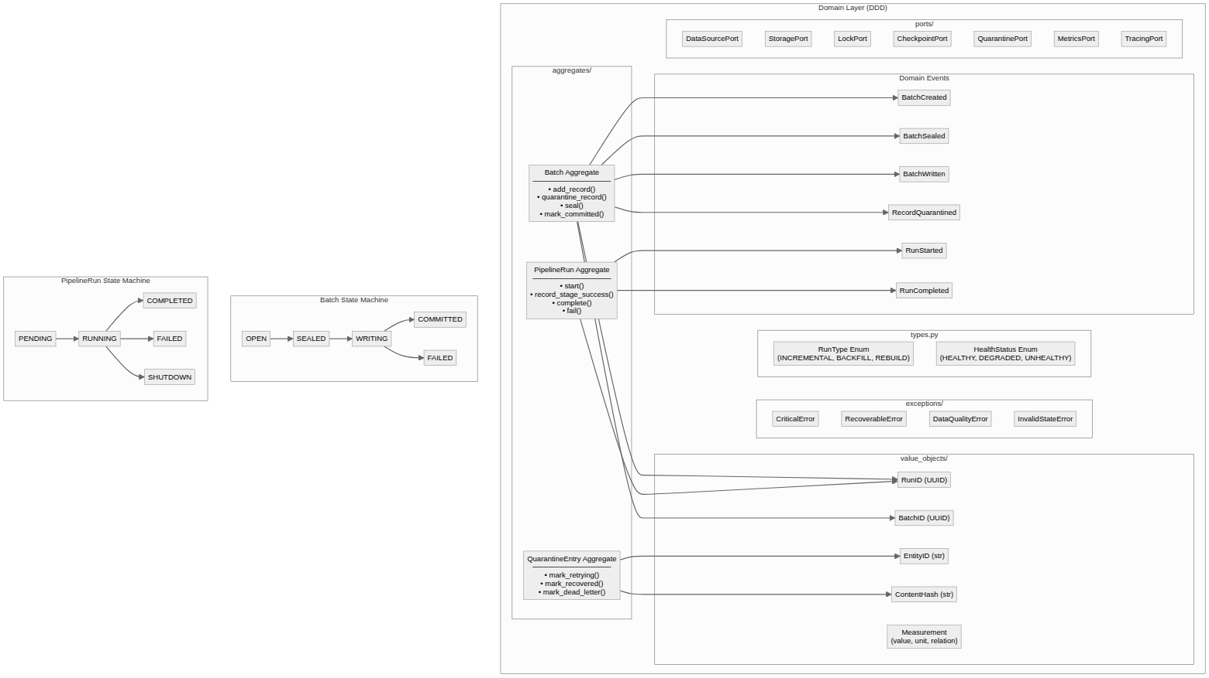
Figure 6: Domain-Driven Design Diagram

Mermaid Source
%% Domain Layer DDD Components
%% See ADR-021: DDD Aggregates Adoption
flowchart TB
subgraph domain["Domain Layer (DDD)"]
subgraph ports["ports/"]
DataSourcePort
StoragePort
LockPort
CheckpointPort
QuarantinePort
MetricsPort
TracingPort
end
subgraph aggregates["aggregates/"]
Batch["Batch Aggregate<br/>───────────────<br/>• add_record()<br/>• quarantine_record()<br/>• seal()<br/>• mark_committed()"]
PipelineRun["PipelineRun Aggregate<br/>───────────────<br/>• start()<br/>• record_stage_success()<br/>• complete()<br/>• fail()"]
QuarantineEntry["QuarantineEntry Aggregate<br/>───────────────<br/>• mark_retrying()<br/>• mark_recovered()<br/>• mark_dead_letter()"]
end
subgraph events["Domain Events"]
BatchCreated
BatchSealed
BatchWritten
RunStarted
RunCompleted
RecordQuarantined
end
subgraph value_objects["value_objects/"]
RunID["RunID (UUID)"]
BatchID["BatchID (UUID)"]
EntityID["EntityID (str)"]
ContentHash["ContentHash (str)"]
Measurement["Measurement<br/>(value, unit, relation)"]
end
subgraph types["types.py"]
RunType["RunType Enum<br/>(INCREMENTAL, BACKFILL, REBUILD)"]
HealthStatus["HealthStatus Enum<br/>(HEALTHY, DEGRADED, UNHEALTHY)"]
end
subgraph exceptions["exceptions/"]
CriticalError
RecoverableError
DataQualityError
InvalidStateError
end
end
%% Relationships
Batch --> BatchCreated
Batch --> BatchSealed
Batch --> BatchWritten
Batch --> RecordQuarantined
PipelineRun --> RunStarted
PipelineRun --> RunCompleted
Batch --> RunID
Batch --> BatchID
PipelineRun --> RunID
QuarantineEntry --> EntityID
QuarantineEntry --> ContentHash
%% State machines
subgraph batch_states["Batch State Machine"]
B_OPEN["OPEN"] --> B_SEALED["SEALED"]
B_SEALED --> B_WRITING["WRITING"]
B_WRITING --> B_COMMITTED["COMMITTED"]
B_WRITING --> B_FAILED["FAILED"]
end
subgraph run_states["PipelineRun State Machine"]
R_PENDING["PENDING"] --> R_RUNNING["RUNNING"]
R_RUNNING --> R_COMPLETED["COMPLETED"]
R_RUNNING --> R_FAILED["FAILED"]
R_RUNNING --> R_SHUTDOWN["SHUTDOWN"]
end

Data Lineage
6 diagram(s) in this category.

Figure 7 -- Full Medallion Data Flow
Source File | 02-full-medallion-data-flow.mermaid
Category | Data Lineage
Source Lines | 68
Rendered Size | 1560 x 569 px

Description
Detailed data flow through the Medallion architecture layers: Raw API responses -> Bronze (JSONL+zstd) -> Silver (Delta Lake, deduplicated) -> Gold (Delta/Parquet, validated). Shows transformations, validation gates, and quarantine branching at each layer.

Rendered Diagram
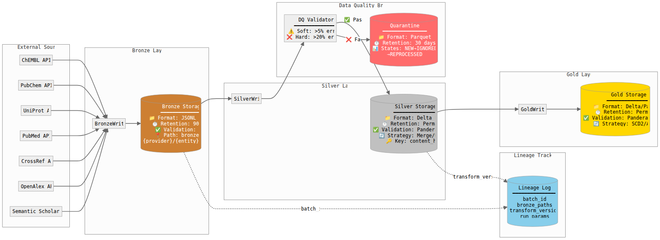
Figure 7: Full Medallion Data Flow

Mermaid Source
%%{init: {'theme': 'neutral', 'themeVariables': {'fontFamily': 'Inter, system-ui', 'lineWidth': '2'}}}%%
flowchart LR
subgraph Sources["External Sources"]
ChEMBL["ChEMBL API"]
PubChem["PubChem API"]
UniProt["UniProt API"]
PubMed["PubMed API"]
CrossRef["CrossRef API"]
OpenAlex["OpenAlex API"]
S2["Semantic Scholar API"]
end
subgraph Bronze_Layer["Bronze Layer"]
direction TB
BronzeWriter["BronzeWriter"]
Bronze[("Bronze Storage\n━━━━━━━━━━━━━━━\n📁 Format: JSONL + zstd\n⏱️ Retention: 90 days\n✅ Validation: None\n📍 Path: bronze/v1/\n {provider}/{entity}/{date}/")]
end
subgraph Silver_Layer["Silver Layer"]
direction TB
SilverWriter["SilverWriter"]
Silver[("Silver Storage\n━━━━━━━━━━━━━━━\n📁 Format: Delta Lake\n⏱️ Retention: Permanent\n✅ Validation: Pandera (soft)\n🔄 Strategy: Merge/Upsert\n🔑 Key: content_hash")]
end
subgraph Gold_Layer["Gold Layer"]
direction TB
GoldWriter["GoldWriter"]
Gold[("Gold Storage\n━━━━━━━━━━━━━━━\n📁 Format: Delta/Parquet\n⏱️ Retention: Permanent\n✅ Validation: Pandera (strict)\n🔄 Strategy: SCD2/Append")]
end
subgraph DQ_Branch["Data Quality Branch"]
DQValidator["DQ Validator\n━━━━━━━━━━━━━━━\n⚠️ Soft: >5% errors\n❌ Hard: >20% errors"]
Quarantine[("Quarantine\n━━━━━━━━━━━━━━━\n📁 Format: Parquet\n⏱️ Retention: 30 days\n📊 States: NEW→IGNORED\n →REPROCESSED")]
end
subgraph Lineage["Lineage Tracking"]
LineageLog[("Lineage Log\n━━━━━━━━━━━━━━━\nbatch_id\nbronze_paths\ntransform_version\nrun_params")]
end
%% Main flow
ChEMBL --> BronzeWriter
PubChem --> BronzeWriter
UniProt --> BronzeWriter
PubMed --> BronzeWriter
CrossRef --> BronzeWriter
OpenAlex --> BronzeWriter
S2 --> BronzeWriter
BronzeWriter --> Bronze
Bronze --> SilverWriter
SilverWriter --> DQValidator
DQValidator -->|"✅ Pass"| Silver
DQValidator -->|"❌ Fail"| Quarantine
Silver --> GoldWriter
GoldWriter --> Gold
%% Lineage tracking
Bronze -.->|"batch_id"| LineageLog
Silver -.->|"transform_version"| LineageLog
%% Styling
style Bronze fill:#CD7F32,color:#fff
style Silver fill:#C0C0C0,color:#000
style Gold fill:#FFD700,color:#000
style Quarantine fill:#FF6B6B,color:#fff
style LineageLog fill:#87CEEB,color:#000

Figure 8 -- Medallion Architecture (Simplified)
Source File | 02-medallion.mermaid
Category | Data Lineage
Source Lines | 30
Rendered Size | 914 x 498 px

Description
Simplified view of the Bronze -> Silver -> Gold medallion architecture with key characteristics of each layer.

Rendered Diagram
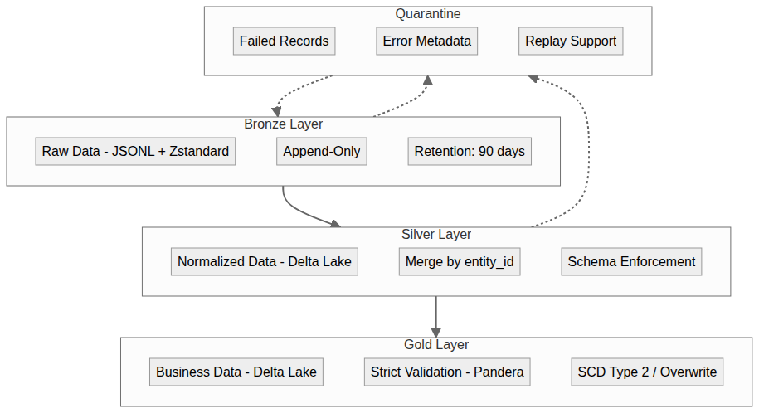
Figure 8: Medallion Architecture (Simplified)

Mermaid Source
graph TD
subgraph Bronze["Bronze Layer"]
B1[Raw Data - JSONL + Zstandard]
B2[Append-Only]
B3[Retention: 90 days]
end
subgraph Silver["Silver Layer"]
S1[Normalized Data - Delta Lake]
S2[Merge by entity_id]
LocalFS[Schema Enforcement]
end
subgraph Gold["Gold Layer"]
G1[Business Data - Delta Lake]
G2[Strict Validation - Pandera]
G3[SCD Type 2 / Overwrite]
end
subgraph Quarantine["Quarantine"]
Q1[Failed Records]
Q2[Error Metadata]
Q3[Replay Support]
end
Bronze --> Silver
Silver --> Gold
Bronze -.-> Quarantine
Silver -.-> Quarantine
Quarantine -.-> Bronze

Figure 9 -- Medallion Data Flow
Source File | 07-medallion-flow.mermaid
Category | Data Lineage
Source Lines | 61
Rendered Size | 1560 x 458 px

Description
Data flow through Bronze/Silver/Gold layers with transformation details at each stage and the role of content hashing for deduplication.

Rendered Diagram
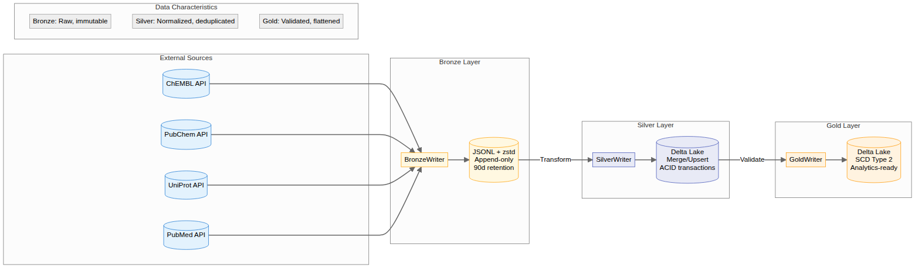
Figure 9: Medallion Data Flow

Mermaid Source
%% BioETL Medallion Data Flow
%% Shows data transformation through Bronze → Silver → Gold layers
flowchart LR
subgraph Sources["External Sources"]
ChEMBL[(ChEMBL API)]
PubChem[(PubChem API)]
UniProt[(UniProt API)]
PubMed[(PubMed API)]
end
subgraph Bronze["Bronze Layer"]
direction TB
BronzeWriter[BronzeWriter]
BronzeData[("JSONL + zstd<br/>Append-only<br/>90d retention")]
BronzeWriter --> BronzeData
end
subgraph Silver["Silver Layer"]
direction TB
SilverWriter[SilverWriter]
SilverData[("Delta Lake<br/>Merge/Upsert<br/>ACID transactions")]
SilverWriter --> SilverData
end
subgraph Gold["Gold Layer"]
direction TB
GoldWriter[GoldWriter]
GoldData[("Delta Lake<br/>SCD Type 2<br/>Analytics-ready")]
GoldWriter --> GoldData
end
%% Data Flow
ChEMBL --> BronzeWriter
PubChem --> BronzeWriter
UniProt --> BronzeWriter
PubMed --> BronzeWriter
BronzeData --> |Transform| SilverWriter
SilverData --> |Validate| GoldWriter
%% Annotations
subgraph Legend["Data Characteristics"]
B["Bronze: Raw, immutable"]
S["Silver: Normalized, deduplicated"]
G["Gold: Validated, flattened"]
end
%% Styling
classDef source fill:#e3f2fd,stroke:#1976d2
classDef bronze fill:#fff8e1,stroke:#ffa000
classDef silver fill:#e8eaf6,stroke:#3f51b5
classDef gold fill:#fff3e0,stroke:#ff9800
class ChEMBL,PubChem,UniProt,PubMed source
class BronzeWriter,BronzeData bronze
class SilverWriter,SilverData silver
class GoldWriter,GoldData gold

Figure 10 -- Bronze Write Sequence
Source File | 18-bronze-write-sequence.mermaid
Category | Data Lineage
Source Lines | 78
Rendered Size | 1560 x 1170 px

Description
Sequence diagram for Bronze layer writes: batch preparation, JSONL serialization, zstd compression, metadata YAML sidecar creation, and file system write with atomic operations.

Rendered Diagram
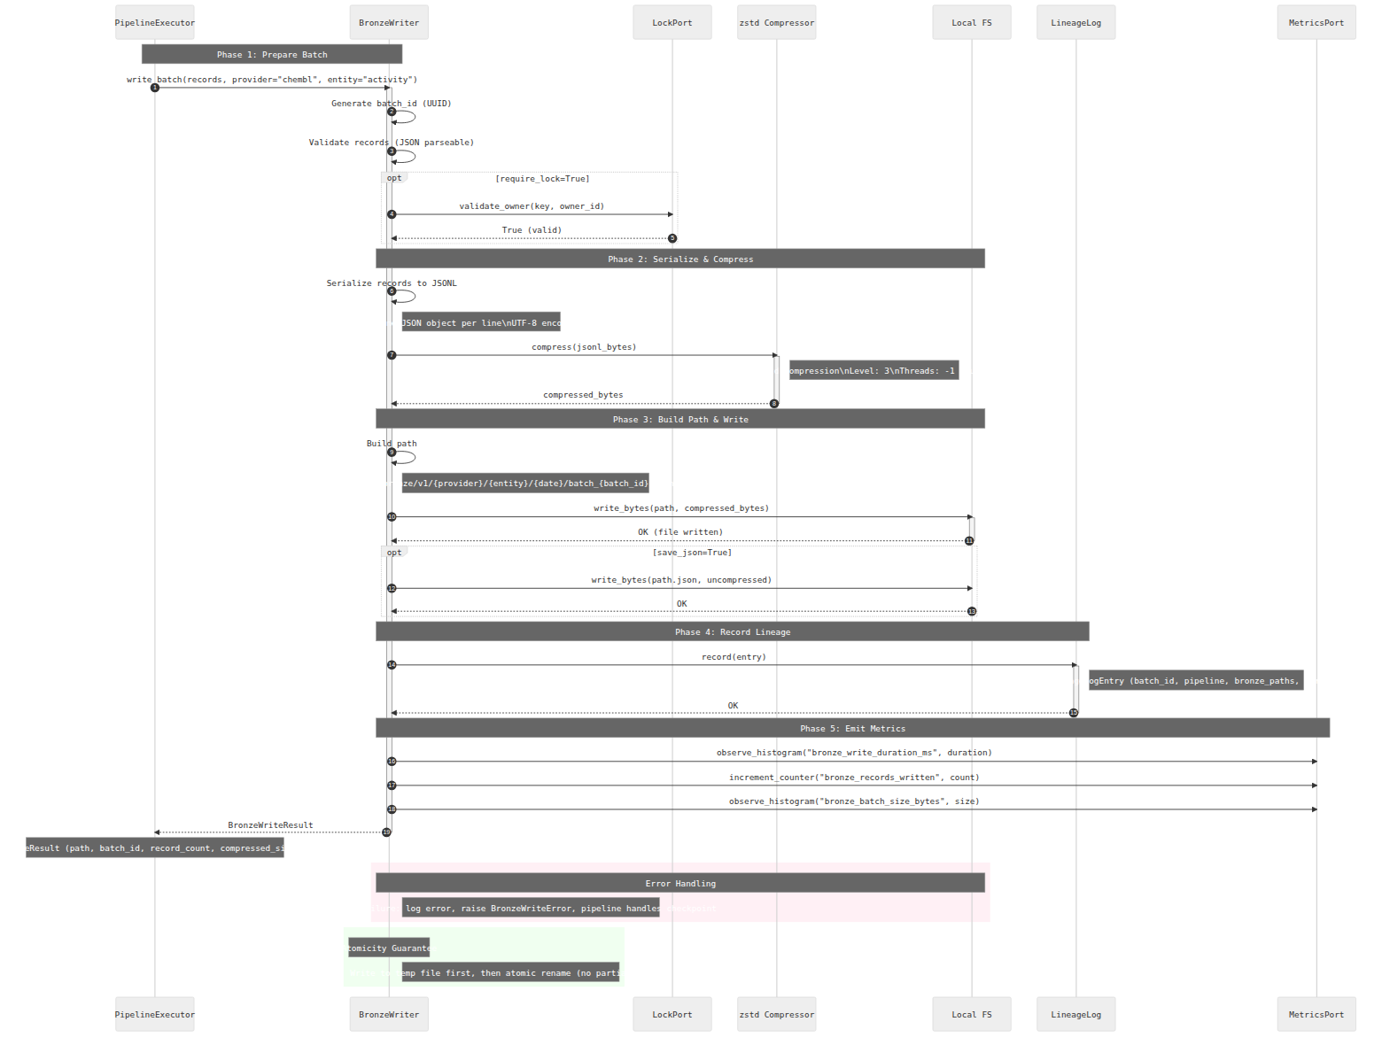
Figure 10: Bronze Write Sequence

Mermaid Source
%%{init: {'theme': 'neutral', 'themeVariables': {'fontFamily': 'Inter, system-ui', 'lineWidth': '2'}}}%%
sequenceDiagram
autonumber
participant Executor as PipelineExecutor
participant Writer as BronzeWriter
participant Lock as LockPort
participant Compressor as zstd Compressor
participant Storage as Local FS
participant Lineage as LineageLog
participant Metrics as MetricsPort
Note over Executor,Writer: Phase 1: Prepare Batch
Executor->>Writer: write_batch(records, provider="chembl", entity="activity")
activate Writer
Writer->>Writer: Generate batch_id (UUID)
Writer->>Writer: Validate records (JSON parseable)
opt require_lock=True
Writer->>Lock: validate_owner(key, owner_id)
Lock-->>Writer: True (valid)
end
Note over Writer,Storage: Phase 2: Serialize & Compress
Writer->>Writer: Serialize records to JSONL
Note right of Writer: One JSON object per line\nUTF-8 encoding
Writer->>Compressor: compress(jsonl_bytes)
activate Compressor
Note right of Compressor: zstd compression\nLevel: 3\nThreads: -1 (auto)
Compressor-->>Writer: compressed_bytes
deactivate Compressor
Note over Writer,Storage: Phase 3: Build Path & Write
Writer->>Writer: Build path
Note right of Writer: Path: bronze/v1/{provider}/{entity}/{date}/batch_{batch_id}.jsonl.zst
Writer->>Storage: write_bytes(path, compressed_bytes)
activate Storage
Storage-->>Writer: OK (file written)
deactivate Storage
opt save_json=True
Writer->>Storage: write_bytes(path.json, uncompressed)
Storage-->>Writer: OK
end
Note over Writer,Lineage: Phase 4: Record Lineage
Writer->>Lineage: record(entry)
activate Lineage
Note right of Lineage: LineageLogEntry (batch_id, pipeline, bronze_paths, version)
Lineage-->>Writer: OK
deactivate Lineage
Note over Writer,Metrics: Phase 5: Emit Metrics
Writer->>Metrics: observe_histogram("bronze_write_duration_ms", duration)
Writer->>Metrics: increment_counter("bronze_records_written", count)
Writer->>Metrics: observe_histogram("bronze_batch_size_bytes", size)
Writer-->>Executor: BronzeWriteResult
deactivate Writer
Note over Executor: BronzeWriteResult (path, batch_id, record_count, compressed_size, ratio)
rect rgb(255, 240, 245)
Note over Writer,Storage: Error Handling
Note right of Writer: On failure: log error, raise BronzeWriteError, pipeline handles checkpoint
end
rect rgb(240, 255, 240)
Note over Writer: Atomicity Guarantee
Note right of Writer: Write to temp file first, then atomic rename (no partial writes)
end

Figure 11 -- Delta Lake Write Sequence
Source File | 19-delta-lake-write-sequence.mermaid
Category | Data Lineage
Source Lines | 99
Rendered Size | 1560 x 2074 px

Description
Sequence diagram for Delta Lake operations in Silver/Gold layers: merge by content_hash, ACID transaction commit, schema enforcement, VACUUM scheduling, and forensic retention (7 days).

Rendered Diagram
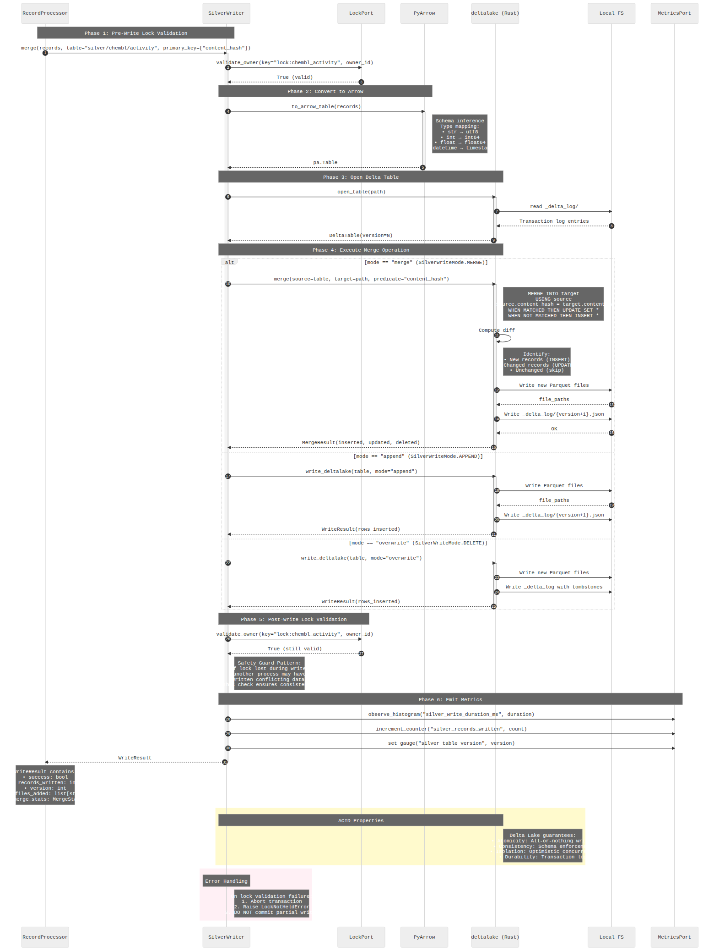
Figure 11: Delta Lake Write Sequence

Mermaid Source
%%{init: {'theme': 'neutral', 'themeVariables': {'fontFamily': 'Inter, system-ui', 'lineWidth': '2'}}}%%
sequenceDiagram
autonumber
participant Processor as RecordProcessor
participant Writer as SilverWriter
participant Lock as LockPort
participant Arrow as PyArrow
participant Delta as deltalake (Rust)
participant Storage as Local FS
participant Metrics as MetricsPort
Note over Processor,Writer: Phase 1: Pre-Write Lock Validation
Processor->>Writer: merge(records, table="silver/chembl/activity", primary_key=["content_hash"])
activate Writer
Writer->>Lock: validate_owner(key="lock:chembl_activity", owner_id)
Lock-->>Writer: True (valid)
Note over Writer,Arrow: Phase 2: Convert to Arrow
Writer->>Arrow: to_arrow_table(records)
activate Arrow
Note right of Arrow: Schema inference<br/>Type mapping:<br/>• str → utf8<br/>• int → int64<br/>• float → float64<br/>• datetime → timestamp
Arrow-->>Writer: pa.Table
deactivate Arrow
Note over Writer,Delta: Phase 3: Open Delta Table
Writer->>Delta: open_table(path)
activate Delta
Delta->>Storage: read _delta_log/
Storage-->>Delta: Transaction log entries
Delta-->>Writer: DeltaTable(version=N)
deactivate Delta
Note over Writer,Delta: Phase 4: Execute Merge Operation
alt mode == "merge" (SilverWriteMode.MERGE)
Writer->>Delta: merge(source=table, target=path, predicate="content_hash")
activate Delta
Note right of Delta: MERGE INTO target<br/>USING source<br/>ON source.content_hash = target.content_hash<br/>WHEN MATCHED THEN UPDATE SET *<br/>WHEN NOT MATCHED THEN INSERT *
Delta->>Delta: Compute diff
Note right of Delta: Identify:<br/>• New records (INSERT)<br/>• Changed records (UPDATE)<br/>• Unchanged (skip)
Delta->>Storage: Write new Parquet files
Storage-->>Delta: file_paths
Delta->>Storage: Write _delta_log/{version+1}.json
Storage-->>Delta: OK
Delta-->>Writer: MergeResult(inserted, updated, deleted)
deactivate Delta
else mode == "append" (SilverWriteMode.APPEND)
Writer->>Delta: write_deltalake(table, mode="append")
activate Delta
Delta->>Storage: Write Parquet files
Storage-->>Delta: file_paths
Delta->>Storage: Write _delta_log/{version+1}.json
Delta-->>Writer: WriteResult(rows_inserted)
deactivate Delta
else mode == "overwrite" (SilverWriteMode.DELETE)
Writer->>Delta: write_deltalake(table, mode="overwrite")
activate Delta
Delta->>Storage: Write new Parquet files
Delta->>Storage: Write _delta_log with tombstones
Delta-->>Writer: WriteResult(rows_inserted)
deactivate Delta
end
Note over Writer,Lock: Phase 5: Post-Write Lock Validation
Writer->>Lock: validate_owner(key="lock:chembl_activity", owner_id)
Lock-->>Writer: True (still valid)
Note right of Writer: Safety Guard Pattern:<br/>If lock lost during write,<br/>another process may have<br/>written conflicting data.<br/>This check ensures consistency.
Note over Writer,Metrics: Phase 6: Emit Metrics
Writer->>Metrics: observe_histogram("silver_write_duration_ms", duration)
Writer->>Metrics: increment_counter("silver_records_written", count)
Writer->>Metrics: set_gauge("silver_table_version", version)
Writer-->>Processor: WriteResult
deactivate Writer
Note over Processor: WriteResult contains:<br/>• success: bool<br/>• records_written: int<br/>• version: int<br/>• files_added: list[str]<br/>• merge_stats: MergeStats
rect rgb(255, 250, 205)
Note over Writer,Delta: ACID Properties
Note right of Delta: Delta Lake guarantees:<br/>• Atomicity: All-or-nothing writes<br/>• Consistency: Schema enforcement<br/>• Isolation: Optimistic concurrency<br/>• Durability: Transaction log
end
rect rgb(255, 240, 245)
Note over Writer: Error Handling
Note right of Writer: On lock validation failure:<br/>1. Abort transaction<br/>2. Raise LockNotHeldError<br/>3. DO NOT commit partial writes
end

Figure 12 -- SilverWriter Class Diagram
Source File | 23-silver-writer-class.mermaid
Category | Data Lineage
Source Lines | 121
Rendered Size | 1560 x 934 px

Description
Class diagram for SilverWriter: Delta Lake merge logic, content hash deduplication, schema evolution handling, VACUUM management, and the StoragePort protocol implementation.

Rendered Diagram
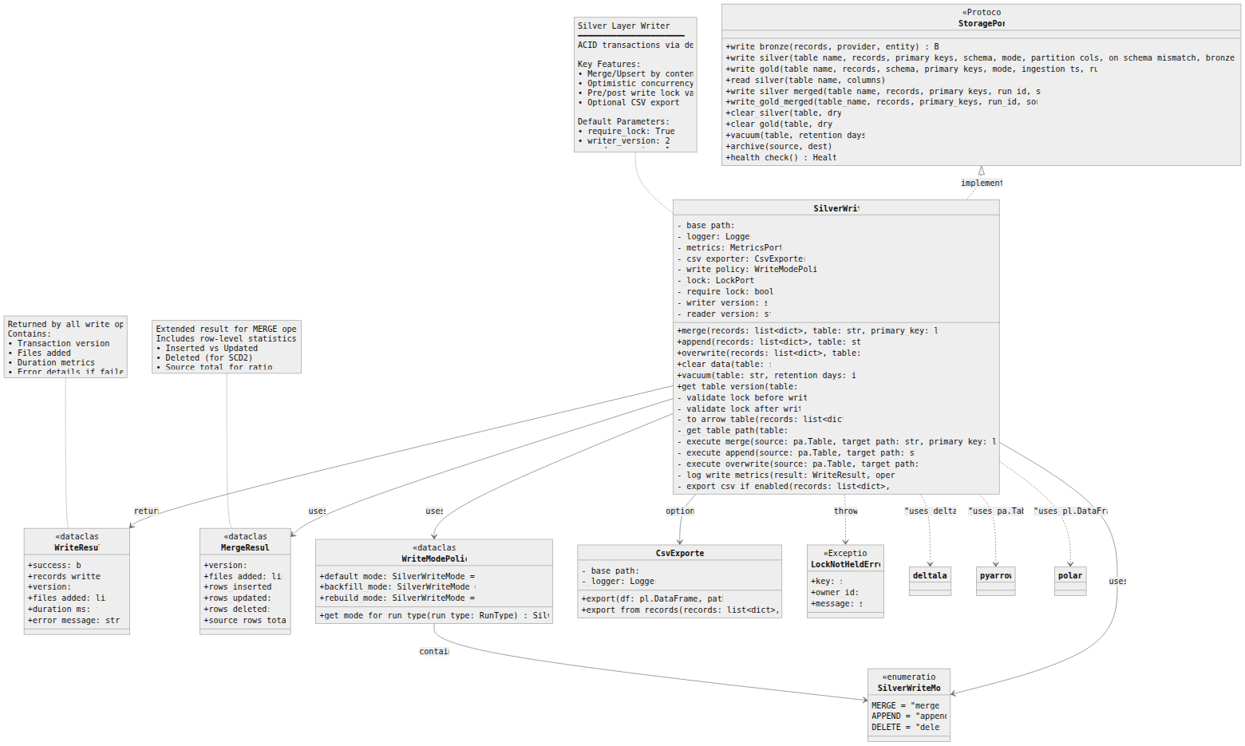
Figure 12: SilverWriter Class Diagram

Mermaid Source
%%{init: {'theme': 'neutral', 'themeVariables': {'fontFamily': 'Inter, system-ui', 'lineWidth': '2'}}}%%
classDiagram
direction TB
class StoragePort {
<<Protocol>>
+write_bronze(records, provider, entity) BronzeWriteResult
+write_silver(table_name, records, primary_keys, schema, mode, partition_cols, on_schema_mismatch, bronze_refs) SilverWriteResult | None
+write_gold(table_name, records, schema, primary_keys, mode, ingestion_ts, run_id, silver_refs) None
+read_silver(table_name, columns) list~dict~
+write_silver_merged(table_name, records, primary_keys, run_id, sources_used) None
+write_gold_merged(table_name, records, primary_keys, run_id, sources_used) None
+clear_silver(table, dry_run) int
+clear_gold(table, dry_run) int
+vacuum(table, retention_days) None
+archive(source, dest) None
+health_check() HealthStatus
}
class SilverWriter {
-_base_path: str
-_logger: LoggerPort
-_metrics: MetricsPort | None
-_csv_exporter: CsvExporter | None
-_write_policy: WriteModePolicy | None
-_lock: LockPort | None
-_require_lock: bool = True
-_writer_version: str = "2"
-_reader_version: str = "1"
+merge(records: list~dict~, table: str, primary_key: list~str~) WriteResult
+append(records: list~dict~, table: str) WriteResult
+overwrite(records: list~dict~, table: str) WriteResult
+clear_data(table: str) int
+vacuum(table: str, retention_days: int = 7) None
+get_table_version(table: str) int
-_validate_lock_before_write() bool
-_validate_lock_after_write() bool
-_to_arrow_table(records: list~dict~) pa.Table
-_get_table_path(table: str) str
-_execute_merge(source: pa.Table, target_path: str, primary_key: list~str~) MergeResult
-_execute_append(source: pa.Table, target_path: str) WriteResult
-_execute_overwrite(source: pa.Table, target_path: str) WriteResult
-_log_write_metrics(result: WriteResult, operation: str) None
-_export_csv_if_enabled(records: list~dict~, table: str) None
}
class WriteResult {
<<dataclass>>
+success: bool
+records_written: int
+version: int
+files_added: list~str~
+duration_ms: float
+error_message: str | None
}
class MergeResult {
<<dataclass>>
+version: int
+files_added: list~str~
+rows_inserted: int
+rows_updated: int
+rows_deleted: int
+source_rows_total: int
}
class SilverWriteMode {
<<enumeration>>
MERGE = "merge"
APPEND = "append"
DELETE = "delete"
}
class WriteModePolicy {
<<dataclass>>
+default_mode: SilverWriteMode = MERGE
+backfill_mode: SilverWriteMode = MERGE
+rebuild_mode: SilverWriteMode = DELETE
+get_mode_for_run_type(run_type: RunType) SilverWriteMode
}
class CsvExporter {
-_base_path: str
-_logger: LoggerPort
+export(df: pl.DataFrame, path: str) str
+export_from_records(records: list~dict~, path: str) str
}
class LockNotHeldError {
<<Exception>>
+key: str
+owner_id: str
+message: str
}
%% Relationships
StoragePort <|.. SilverWriter : implements
SilverWriter --> WriteResult : returns
SilverWriter --> MergeResult : uses
SilverWriter --> WriteModePolicy : uses
SilverWriter --> CsvExporter : optional
SilverWriter --> SilverWriteMode : uses
SilverWriter ..> LockNotHeldError : throws
WriteModePolicy --> SilverWriteMode : contains
%% External dependencies
SilverWriter ..> deltalake : "uses delta-rs"
SilverWriter ..> pyarrow : "uses pa.Table"
SilverWriter ..> polars : "uses pl.DataFrame"
note for SilverWriter "Silver Layer Writer\n━━━━━━━━━━━━━━━━━━━━━━\nACID transactions via delta-rs\n\nKey Features:\n• Merge/Upsert by content_hash\n• Optimistic concurrency\n• Pre/post write lock validation\n• Optional CSV export\n\nDefault Parameters:\n• require_lock: True\n• writer_version: 2\n• reader_version: 1"
note for WriteResult "Returned by all write operations.\nContains:\n• Transaction version\n• Files added\n• Duration metrics\n• Error details if failed"
note for MergeResult "Extended result for MERGE operations.\nIncludes row-level statistics:\n• Inserted vs Updated\n• Deleted (for SCD2)\n• Source total for ratio"

Pipeline Diagrams
4 diagram(s) in this category.

Figure 13 -- Pipeline Execution (Happy Path)
Source File | 03-pipeline-execution-happy-path.mermaid
Category | Pipeline Diagrams
Source Lines | 87
Rendered Size | 1560 x 1095 px

Description
Sequence diagram showing the successful (happy path) pipeline execution: CLI invocation -> bootstrap -> preflight checks -> lock acquisition -> data fetch -> batch processing -> medallion writes -> postrun -> cleanup.

Rendered Diagram
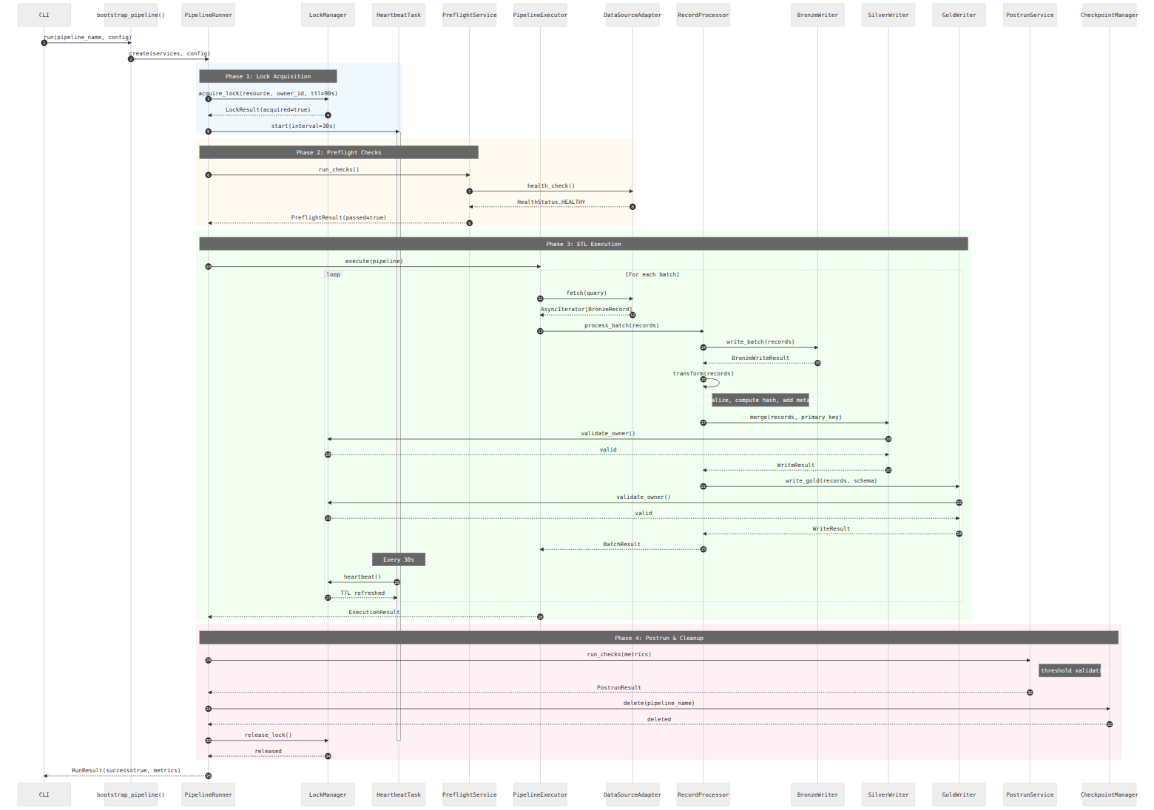
Figure 13: Pipeline Execution (Happy Path)

Mermaid Source
%%{init: {'theme': 'neutral', 'themeVariables': {'fontFamily': 'Inter, system-ui', 'lineWidth': '2'}}}%%
sequenceDiagram
autonumber
participant CLI
participant Bootstrap as bootstrap_pipeline()
participant Runner as PipelineRunner
participant Lock as LockManager
participant Heartbeat as HeartbeatTask
participant Preflight as PreflightService
participant Executor as PipelineExecutor
participant Adapter as DataSourceAdapter
participant Processor as RecordProcessor
participant Bronze as BronzeWriter
participant Silver as SilverWriter
participant Gold as GoldWriter
participant Postrun as PostrunService
participant Checkpoint as CheckpointManager
CLI->>Bootstrap: run(pipeline_name, config)
Bootstrap->>Runner: create(services, config)
rect rgb(240, 248, 255)
Note over Runner,Lock: Phase 1: Lock Acquisition
Runner->>Lock: acquire_lock(resource, owner_id, ttl=90s)
Lock-->>Runner: LockResult(acquired=true)
Runner->>Heartbeat: start(interval=30s)
activate Heartbeat
end
rect rgb(255, 250, 240)
Note over Runner,Preflight: Phase 2: Preflight Checks
Runner->>Preflight: run_checks()
Preflight->>Adapter: health_check()
Adapter-->>Preflight: HealthStatus.HEALTHY
Preflight-->>Runner: PreflightResult(passed=true)
end
rect rgb(240, 255, 240)
Note over Runner,Gold: Phase 3: ETL Execution
Runner->>Executor: execute(pipeline)
loop For each batch
Executor->>Adapter: fetch(query)
Adapter-->>Executor: AsyncIterator[BronzeRecord]
Executor->>Processor: process_batch(records)
Processor->>Bronze: write_batch(records)
Bronze-->>Processor: BronzeWriteResult
Processor->>Processor: transform(records)
Note right of Processor: normalize, compute hash, add metadata
Processor->>Silver: merge(records, primary_key)
Silver->>Lock: validate_owner()
Lock-->>Silver: valid
Silver-->>Processor: WriteResult
Processor->>Gold: write_gold(records, schema)
Gold->>Lock: validate_owner()
Lock-->>Gold: valid
Gold-->>Processor: WriteResult
Processor-->>Executor: BatchResult
Note over Heartbeat: Every 30s
Heartbeat->>Lock: heartbeat()
Lock-->>Heartbeat: TTL refreshed
end
Executor-->>Runner: ExecutionResult
end
rect rgb(255, 240, 245)
Note over Runner,Checkpoint: Phase 4: Postrun & Cleanup
Runner->>Postrun: run_checks(metrics)
Note right of Postrun: DQ threshold validation
Postrun-->>Runner: PostrunResult
Runner->>Checkpoint: delete(pipeline_name)
Checkpoint-->>Runner: deleted
Runner->>Lock: release_lock()
deactivate Heartbeat
Lock-->>Runner: released
end
Runner-->>CLI: RunResult(success=true, metrics)

Figure 14 -- Pipeline Sequence Diagram
Source File | 03-pipeline-sequence.mermaid
Category | Pipeline Diagrams
Source Lines | 35
Rendered Size | 1560 x 583 px

Description
Core pipeline execution sequence showing interactions between PipelineRunner, PipelineExecutor, RecordProcessor, and storage layers.

Rendered Diagram
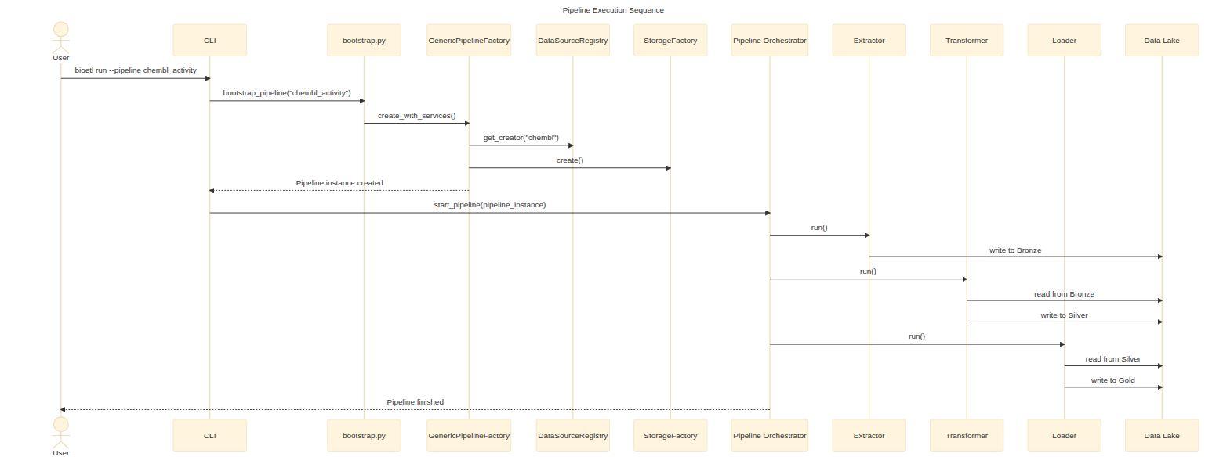
Figure 14: Pipeline Sequence Diagram

Mermaid Source
%%{init: {'theme': 'base'}}%%
sequenceDiagram
title Pipeline Execution Sequence
actor User
participant CLI
participant bootstrap as bootstrap.py
participant Factory as GenericPipelineFactory
participant Registry as DataSourceRegistry
participant Storage as StorageFactory
participant Orchestrator as Pipeline Orchestrator
participant Extractor
participant Transformer
participant Loader
participant Lake as Data Lake
User->>CLI: bioetl run --pipeline chembl_activity
CLI->>bootstrap: bootstrap_pipeline("chembl_activity")
bootstrap->>Factory: create_with_services()
Factory->>Registry: get_creator("chembl")
Factory->>Storage: create()
Factory-->>CLI: Pipeline instance created
CLI->>Orchestrator: start_pipeline(pipeline_instance)
Orchestrator->>Extractor: run()
Extractor->>Lake: write to Bronze
Orchestrator->>Transformer: run()
Transformer->>Lake: read from Bronze
Transformer->>Lake: write to Silver
Orchestrator->>Loader: run()
Loader->>Lake: read from Silver
Loader->>Lake: write to Gold
Orchestrator-->>User: Pipeline finished

Figure 15 -- Pipeline Execution Flow
Source File | 06-pipeline-execution.mermaid
Category | Pipeline Diagrams
Source Lines | 73
Rendered Size | 1560 x 1520 px

Description
Detailed pipeline execution flow including error handling paths, retry logic, checkpoint saves, and graceful shutdown handling.

Rendered Diagram
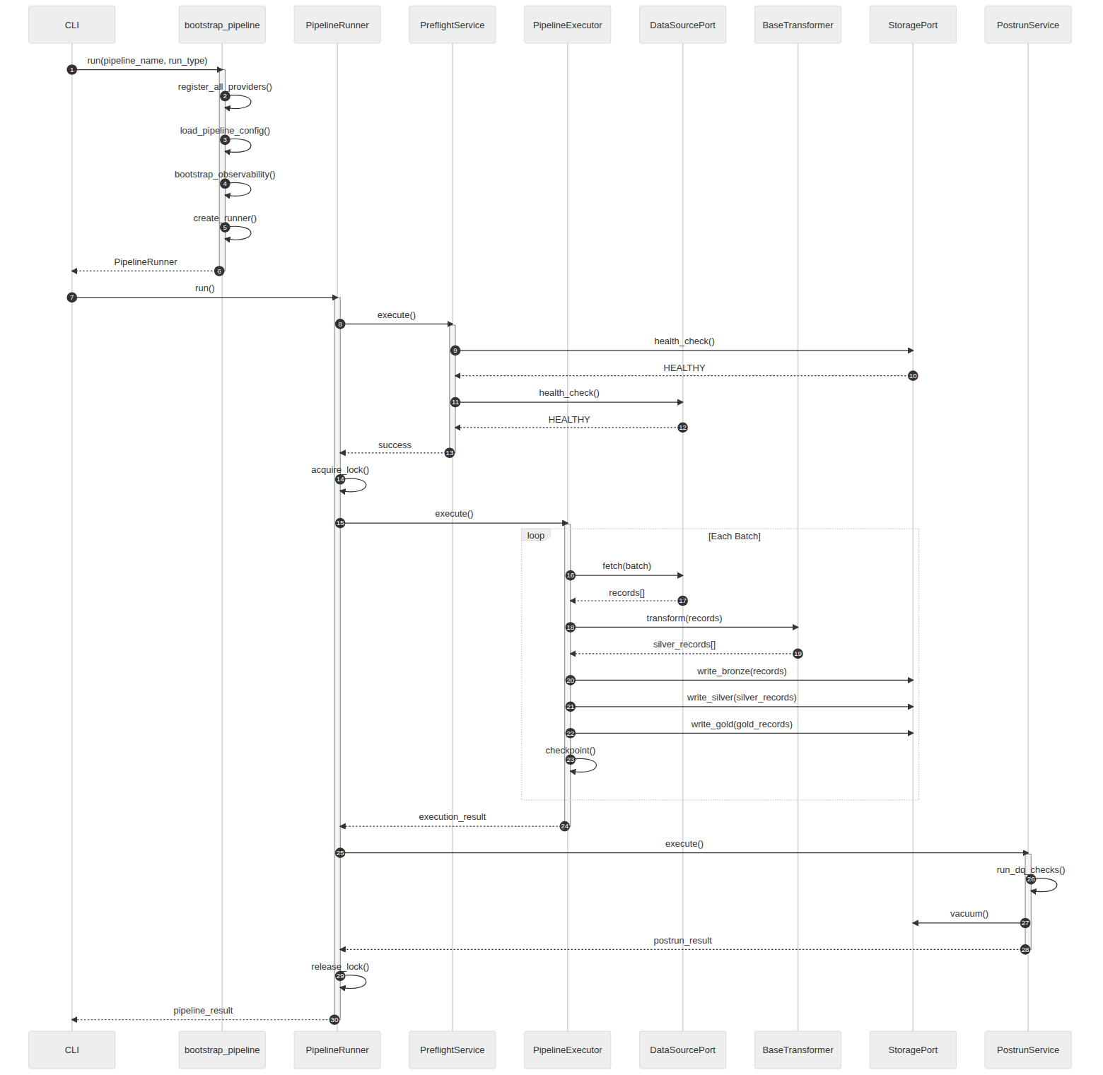
Figure 15: Pipeline Execution Flow

Mermaid Source
%% BioETL Pipeline Execution Sequence
%% Shows the complete execution flow from CLI to data storage
sequenceDiagram
autonumber
participant CLI as CLI
participant Boot as bootstrap_pipeline
participant Runner as PipelineRunner
participant Preflight as PreflightService
participant Executor as PipelineExecutor
participant DataSource as DataSourcePort
participant Transformer as BaseTransformer
participant Storage as StoragePort
participant Postrun as PostrunService
%% Bootstrap Phase
CLI->>Boot: run(pipeline_name, run_type)
activate Boot
Boot->>Boot: register_all_providers()
Boot->>Boot: load_pipeline_config()
Boot->>Boot: bootstrap_observability()
Boot->>Boot: create_runner()
Boot-->>CLI: PipelineRunner
deactivate Boot
%% Pre-flight Phase
CLI->>Runner: run()
activate Runner
Runner->>Preflight: execute()
activate Preflight
Preflight->>Storage: health_check()
Storage-->>Preflight: HEALTHY
Preflight->>DataSource: health_check()
DataSource-->>Preflight: HEALTHY
Preflight-->>Runner: success
deactivate Preflight
%% Lock Acquisition
Runner->>Runner: acquire_lock()
%% Execution Phase
Runner->>Executor: execute()
activate Executor
loop Each Batch
Executor->>DataSource: fetch(batch)
DataSource-->>Executor: records[]
Executor->>Transformer: transform(records)
Transformer-->>Executor: silver_records[]
Executor->>Storage: write_bronze(records)
Executor->>Storage: write_silver(silver_records)
Executor->>Storage: write_gold(gold_records)
Executor->>Executor: checkpoint()
end
Executor-->>Runner: execution_result
deactivate Executor
%% Post-run Phase
Runner->>Postrun: execute()
activate Postrun
Postrun->>Postrun: run_dq_checks()
Postrun->>Storage: vacuum()
Postrun-->>Runner: postrun_result
deactivate Postrun
%% Cleanup
Runner->>Runner: release_lock()
Runner-->>CLI: pipeline_result
deactivate Runner

Figure 16 -- Pipeline/Transformer Hierarchy
Source File | 17-pipeline-hierarchy.mermaid
Category | Pipeline Diagrams
Source Lines | 142
Rendered Size | 1560 x 750 px

Description
Class hierarchy of pipelines and transformers: BasePipeline, BaseTransformer with template method pattern, and concrete implementations for each entity type across all providers.

Rendered Diagram
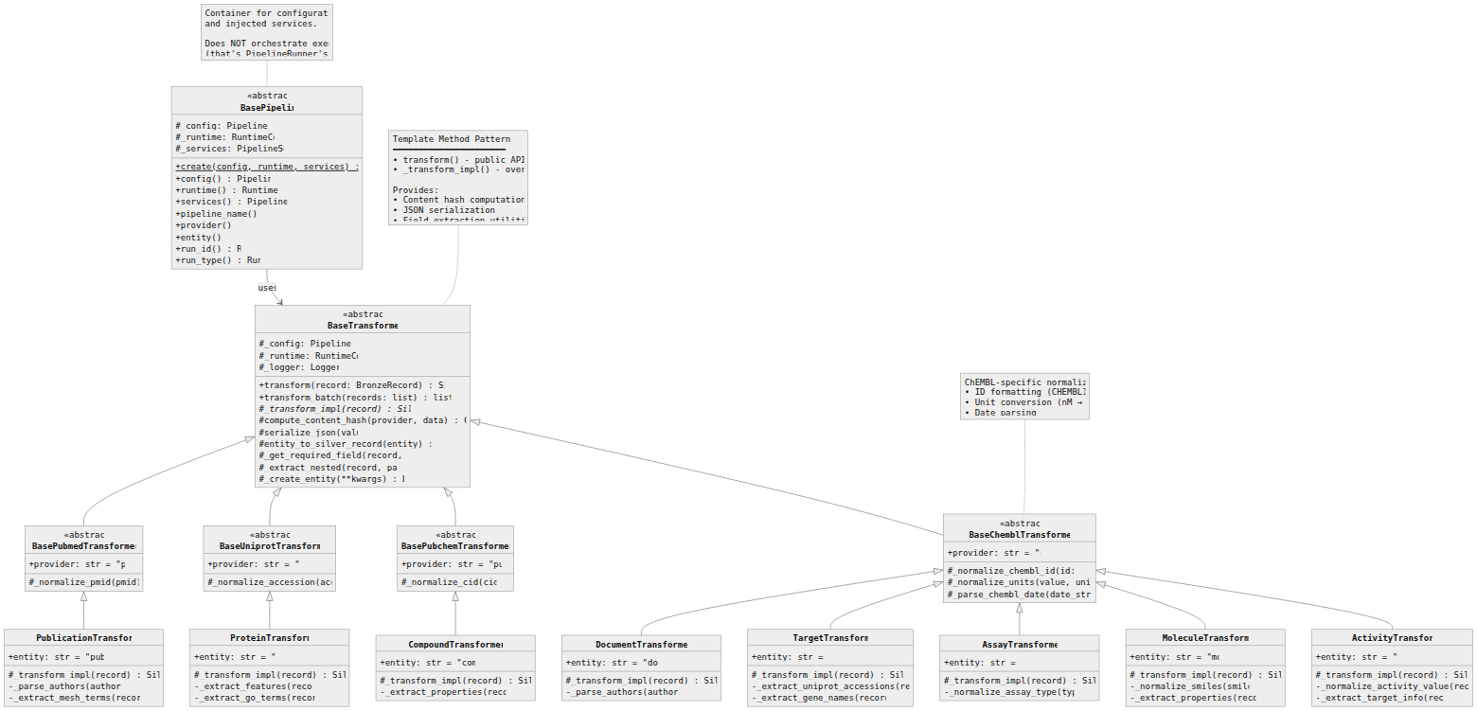
Figure 16: Pipeline/Transformer Hierarchy

Mermaid Source
%%{init: {'theme': 'neutral', 'themeVariables': {'fontFamily': 'Inter, system-ui', 'lineWidth': '2'}}}%%
classDiagram
direction TB
class BasePipeline {
<<abstract>>
#_config: PipelineConfig
#_runtime: RuntimeConfig
#_services: PipelineServices
+create(config, runtime, services)$ BasePipeline
+config() PipelineConfig
+runtime() RuntimeConfig
+services() PipelineServices
+pipeline_name() str
+provider() str
+entity() str
+run_id() RunID
+run_type() RunType
}
class BaseTransformer {
<<abstract>>
#_config: PipelineConfig
#_runtime: RuntimeConfig
#_logger: LoggerPort
+transform(record: BronzeRecord) SilverRecord
+transform_batch(records: list) list~SilverRecord~
#_transform_impl(record)* SilverRecord
#compute_content_hash(provider, data) ContentHash
#serialize_json(value) str
#entity_to_silver_record(entity) SilverRecord
#_get_required_field(record, field) Any
#_extract_nested(record, path) Any
#_create_entity(**kwargs) BaseEntity
}
class BaseChemblTransformer {
<<abstract>>
+provider: str = "chembl"
#_normalize_chembl_id(id: str) str
#_normalize_units(value, units) tuple
#_parse_chembl_date(date_str) date
}
class ActivityTransformer {
+entity: str = "activity"
#_transform_impl(record) SilverRecord
-_normalize_activity_value(record) float
-_extract_target_info(record) dict
}
class MoleculeTransformer {
+entity: str = "molecule"
#_transform_impl(record) SilverRecord
-_normalize_smiles(smiles) str
-_extract_properties(record) dict
}
class AssayTransformer {
+entity: str = "assay"
#_transform_impl(record) SilverRecord
-_normalize_assay_type(type) str
}
class TargetTransformer {
+entity: str = "target"
#_transform_impl(record) SilverRecord
-_extract_uniprot_accessions(record) list
-_extract_gene_names(record) list
}
class DocumentTransformer {
+entity: str = "document"
#_transform_impl(record) SilverRecord
-_parse_authors(authors) list
}
class BasePubchemTransformer {
<<abstract>>
+provider: str = "pubchem"
#_normalize_cid(cid) str
}
class CompoundTransformer {
+entity: str = "compound"
#_transform_impl(record) SilverRecord
-_extract_properties(record) dict
}
class BaseUniprotTransformer {
<<abstract>>
+provider: str = "uniprot"
#_normalize_accession(acc) str
}
class ProteinTransformer {
+entity: str = "protein"
#_transform_impl(record) SilverRecord
-_extract_features(record) dict
-_extract_go_terms(record) list
}
class BasePubmedTransformer {
<<abstract>>
+provider: str = "pubmed"
#_normalize_pmid(pmid) str
}
class PublicationTransformer {
+entity: str = "publication"
#_transform_impl(record) SilverRecord
-_parse_authors(authors) list
-_extract_mesh_terms(record) list
}
%% Inheritance - Transformers
BaseTransformer <|-- BaseChemblTransformer
BaseTransformer <|-- BasePubchemTransformer
BaseTransformer <|-- BaseUniprotTransformer
BaseTransformer <|-- BasePubmedTransformer
BaseChemblTransformer <|-- ActivityTransformer
BaseChemblTransformer <|-- MoleculeTransformer
BaseChemblTransformer <|-- AssayTransformer
BaseChemblTransformer <|-- TargetTransformer
BaseChemblTransformer <|-- DocumentTransformer
BasePubchemTransformer <|-- CompoundTransformer
BaseUniprotTransformer <|-- ProteinTransformer
BasePubmedTransformer <|-- PublicationTransformer
%% Pipeline uses Transformer
BasePipeline --> BaseTransformer : uses
%% Notes
note for BasePipeline "Container for configuration\nand injected services.\n\nDoes NOT orchestrate execution\n(that's PipelineRunner's job)"
note for BaseTransformer "Template Method Pattern\n━━━━━━━━━━━━━━━━━━━━━━\n• transform() - public API\n• _transform_impl() - override point\n\nProvides:\n• Content hash computation\n• JSON serialization\n• Field extraction utilities"
note for BaseChemblTransformer "ChEMBL-specific normalization:\n• ID formatting (CHEMBL123)\n• Unit conversion (nM → μM)\n• Date parsing"

Workflow & Orchestration
3 diagram(s) in this category.

Figure 17 -- Error Handling Flow
Source File | 04-error-flow.mermaid
Category | Workflow & Orchestration
Source Lines | 12
Rendered Size | 359 x 951 px

Description
Error classification and handling flow: Critical errors (immediate abort), Recoverable errors (retry with backoff), and Data Quality errors (quarantine + threshold evaluation).

Rendered Diagram
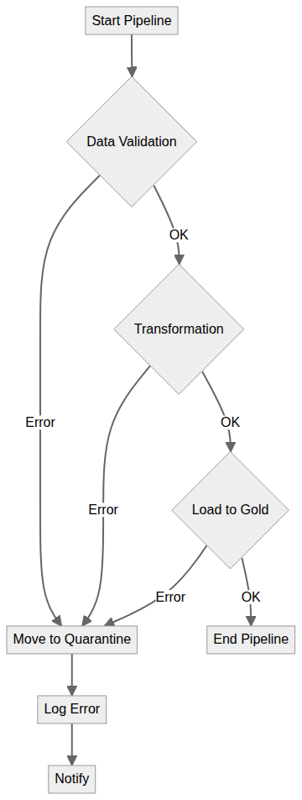
Figure 17: Error Handling Flow

Mermaid Source
flowchart TD
A[Start Pipeline] --> B{Data Validation};
B -- OK --> C{Transformation};
B -- Error --> D[Move to Quarantine];
D --> E[Log Error];
E --> F[Notify];
C -- OK --> G{Load to Gold};
C -- Error --> D;
G -- OK --> H[End Pipeline];
G -- Error --> D;

Figure 18 -- Pipeline Lifecycle States
Source File | 05-pipeline-lifecycle-states.mermaid
Category | Workflow & Orchestration
Source Lines | 173
Rendered Size | 1560 x 3522 px

Description
State machine diagram for the pipeline lifecycle: PENDING -> RUNNING -> COMPLETED/FAILED/CANCELLED with all valid transitions, guard conditions, and side effects at each state change.

Rendered Diagram
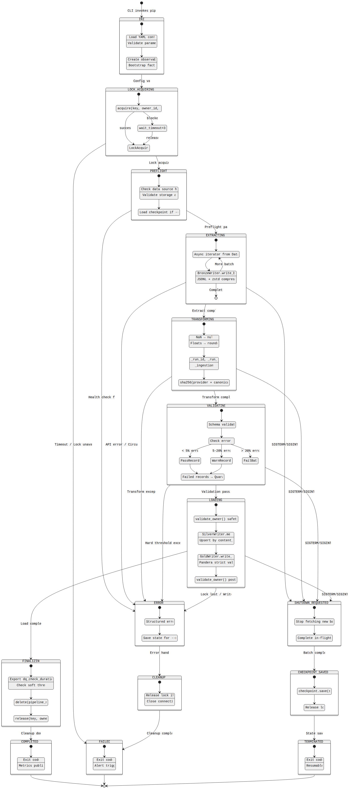
Figure 18: Pipeline Lifecycle States

Mermaid Source
%%{init: {'theme': 'neutral', 'themeVariables': {'fontFamily': 'Inter, system-ui', 'lineWidth': '2'}}}%%
stateDiagram-v2
[*] --> INIT: CLI invokes pipeline
state INIT {
[*] --> LoadingConfig
LoadingConfig: Load YAML config
LoadingConfig: Validate parameters
LoadingConfig --> BootstrapServices
BootstrapServices: Create observability
BootstrapServices: Bootstrap factories
}
INIT --> LOCK_ACQUIRING: Config valid
state LOCK_ACQUIRING {
[*] --> RequestLock
RequestLock: acquire(key, owner_id, ttl=90s)
RequestLock --> WaitingForLock: blocked
WaitingForLock: wait_timeout=300s
RequestLock --> LockAcquired: success
WaitingForLock --> LockAcquired: released
}
LOCK_ACQUIRING --> PREFLIGHT: Lock acquired
LOCK_ACQUIRING --> FAILED: Timeout / Lock unavailable
state PREFLIGHT {
[*] --> HealthChecks
HealthChecks: Check data source health
HealthChecks: Validate storage access
HealthChecks --> CheckpointLoad
CheckpointLoad: Load checkpoint if --resume
}
PREFLIGHT --> EXTRACTING: Preflight passed
PREFLIGHT --> ERROR: Health check failed
state EXTRACTING {
[*] --> FetchBatch
FetchBatch: Async iterator from DataSource
FetchBatch --> WriteBronze
WriteBronze: BronzeWriter.write_batch()
WriteBronze: JSONL + zstd compression
WriteBronze --> FetchBatch: More batches
WriteBronze --> [*]: Complete
}
EXTRACTING --> TRANSFORMING: Extract complete
EXTRACTING --> ERROR: API error / Circuit open
state TRANSFORMING {
[*] --> NormalizeValues
NormalizeValues: NaN → null
NormalizeValues: Floats → round(10)
NormalizeValues --> AddMetadata
AddMetadata: _run_id, _run_type
AddMetadata: _ingestion_ts
AddMetadata --> ComputeHash
ComputeHash: sha256(provider + canonical_json)
}
TRANSFORMING --> VALIDATING: Transform complete
TRANSFORMING --> ERROR: Transform exception
state VALIDATING {
[*] --> PanderaCheck
PanderaCheck: Schema validation
PanderaCheck --> ThresholdCheck
ThresholdCheck: Check error rate
ThresholdCheck --> PassRecords: < 5% errors
ThresholdCheck --> WarnRecords: 5-20% errors
ThresholdCheck --> FailBatch: > 20% errors
PassRecords --> RouteQuarantine
WarnRecords --> RouteQuarantine
RouteQuarantine: Failed records → Quarantine
}
VALIDATING --> LOADING: Validation pass/warn
VALIDATING --> ERROR: Hard threshold exceeded
state LOADING {
[*] --> ValidateLock
ValidateLock: validate_owner() safety guard
ValidateLock --> MergeSilver
MergeSilver: SilverWriter.merge()
MergeSilver: Upsert by content_hash
MergeSilver --> WriteGold
WriteGold: GoldWriter.write_gold()
WriteGold: Pandera strict validation
WriteGold --> PostWriteCheck
PostWriteCheck: validate_owner() post-check
}
LOADING --> FINALIZING: Load complete
LOADING --> ERROR: Lock lost / Write failed
state FINALIZING {
[*] --> DQMetrics
DQMetrics: Export dq_check_duration_ms
DQMetrics: Check soft threshold
DQMetrics --> CleanupCheckpoint
CleanupCheckpoint: delete(pipeline_name)
CleanupCheckpoint --> ReleaseLock
ReleaseLock: release(key, owner_id)
}
FINALIZING --> COMPLETED: Cleanup done
state COMPLETED {
[*] --> Success
Success: Exit code 0
Success: Metrics published
}
COMPLETED --> [*]
state ERROR {
[*] --> LogError
LogError: Structured error log
LogError --> SaveCheckpoint
SaveCheckpoint: Save state for --resume
}
ERROR --> CLEANUP: Error handled
state CLEANUP {
[*] --> ReleaseResources
ReleaseResources: Release lock if held
ReleaseResources: Close connections
}
CLEANUP --> FAILED: Cleanup complete
state FAILED {
[*] --> Failure
Failure: Exit code 1
Failure: Alert triggered
}
FAILED --> [*]
%% Graceful shutdown path
EXTRACTING --> SHUTDOWN_REQUESTED: SIGTERM/SIGINT
TRANSFORMING --> SHUTDOWN_REQUESTED: SIGTERM/SIGINT
VALIDATING --> SHUTDOWN_REQUESTED: SIGTERM/SIGINT
LOADING --> SHUTDOWN_REQUESTED: SIGTERM/SIGINT
state SHUTDOWN_REQUESTED {
[*] --> StopNewWork
StopNewWork: Stop fetching new batches
StopNewWork --> FinishCurrentBatch
FinishCurrentBatch: Complete in-flight writes
}
SHUTDOWN_REQUESTED --> CHECKPOINT_SAVED: Batch complete
state CHECKPOINT_SAVED {
[*] --> SaveState
SaveState: checkpoint.save(state)
SaveState --> ReleaseForShutdown
ReleaseForShutdown: Release lock
}
CHECKPOINT_SAVED --> TERMINATED: State saved
state TERMINATED {
[*] --> GracefulExit
GracefulExit: Exit code 0
GracefulExit: Resumable
}
TERMINATED --> [*]

Figure 19 -- Complete ETL Workflow
Source File | 08-complete-etl-workflow.mermaid
Category | Workflow & Orchestration
Source Lines | 109
Rendered Size | 1560 x 1808 px

Description
End-to-end ETL workflow from data source fetch through Bronze write, Silver merge, Gold validation, to DQ reporting and cleanup. Covers all three run types: incremental, backfill, rebuild.

Rendered Diagram
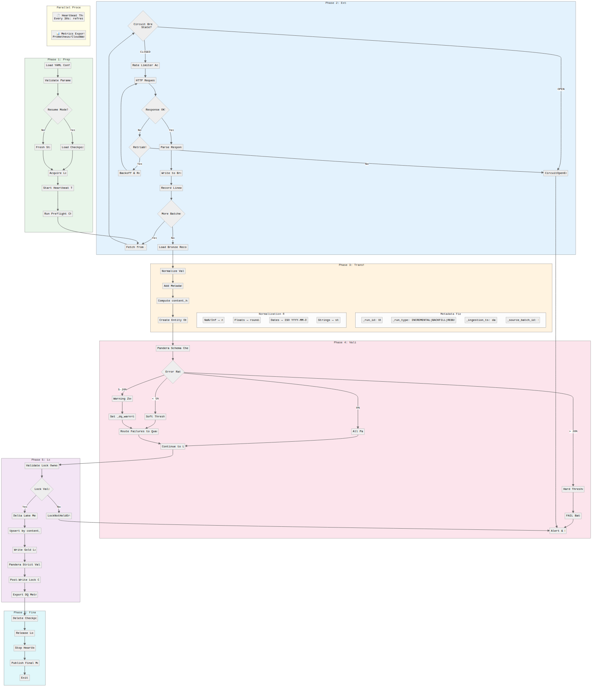
Figure 19: Complete ETL Workflow

Mermaid Source
%%{init: {'theme': 'neutral', 'themeVariables': {'fontFamily': 'Inter, system-ui', 'lineWidth': '2'}}}%%
flowchart TD
subgraph Prepare["Phase 1: Prepare"]
A1[Load YAML Config] --> A2[Validate Parameters]
A2 --> A3{Resume Mode?}
A3 -->|Yes| A4[Load Checkpoint]
A3 -->|No| A5[Fresh Start]
A4 --> A6[Acquire Lock]
A5 --> A6
A6 --> A7[Start Heartbeat Thread]
A7 --> A8[Run Preflight Checks]
end
subgraph Extract["Phase 2: Extract"]
B1[Fetch from API] --> B2{Circuit Breaker\nState?}
B2 -->|CLOSED| B3[Rate Limiter Acquire]
B2 -->|OPEN| B_ERR[CircuitOpenError]
B3 --> B4[HTTP Request]
B4 --> B5{Response OK?}
B5 -->|Yes| B6[Parse Response]
B5 -->|No| B7{Retriable?}
B7 -->|Yes| B8[Backoff & Retry]
B7 -->|No| B_ERR
B8 --> B4
B6 --> B9[Write to Bronze]
B9 --> B10[Record Lineage]
B10 --> B11{More Batches?}
B11 -->|Yes| B1
B11 -->|No| C1
end
subgraph Transform["Phase 3: Transform"]
C1[Load Bronze Records] --> C2[Normalize Values]
C2 --> C3[Add Metadata]
C3 --> C4[Compute content_hash]
C4 --> C5[Create Entity Objects]
subgraph Normalize["Normalization Rules"]
N1["NaN/Inf → null"]
N2["Floats → round(10)"]
N3["Dates → ISO YYYY-MM-DD"]
N4["Strings → strip()"]
end
subgraph Metadata["Metadata Fields"]
M1["_run_id: UUID"]
M2["_run_type: INCREMENTAL|BACKFILL|REBUILD"]
M3["_ingestion_ts: datetime"]
M4["_source_batch_id: UUID"]
end
end
subgraph Validate["Phase 4: Validate"]
D1[Pandera Schema Check] --> D2{Error Rate?}
D2 -->|0%| D3[All Pass]
D2 -->|"< 5%"| D4[Soft Threshold]
D2 -->|"5-20%"| D5[Warning Zone]
D2 -->|"> 20%"| D6[Hard Threshold]
D3 --> D7[Continue to Load]
D4 --> D8[Route Failures to Quarantine]
D8 --> D7
D5 --> D9[Set _dq_warn=true]
D9 --> D8
D6 --> D10[FAIL Batch]
D10 --> E_ERR[Alert & Exit]
end
subgraph Load["Phase 5: Load"]
E1[Validate Lock Ownership] --> E2{Lock Valid?}
E2 -->|No| E_ERR2[LockNotHeldError]
E2 -->|Yes| E3[Delta Lake Merge]
E3 --> E4[Upsert by content_hash]
E4 --> E5[Write Gold Layer]
E5 --> E6[Pandera Strict Validation]
E6 --> E7[Post-Write Lock Check]
E7 --> F1
end
subgraph Finalize["Phase 6: Finalize"]
F1[Export DQ Metrics] --> F2[Delete Checkpoint]
F2 --> F3[Release Lock]
F3 --> F4[Stop Heartbeat]
F4 --> F5[Publish Final Metrics]
F5 --> F6[Exit 0]
end
subgraph Parallel["Parallel Processes"]
direction LR
P1["⏱️ Heartbeat Thread\nEvery 30s: refresh TTL"]
P2["📊 Metrics Export\nPrometheus/CloudWatch"]
end
%% Flow connections
A8 --> B1
C5 --> D1
D7 --> E1
%% Error paths
B_ERR --> E_ERR
E_ERR2 --> E_ERR
%% Styling
style Prepare fill:#E8F5E9
style Extract fill:#E3F2FD
style Transform fill:#FFF3E0
style Validate fill:#FCE4EC
style Load fill:#F3E5F5
style Finalize fill:#E0F7FA
style Parallel fill:#FFFDE7

ER Diagrams & Data Models
3 diagram(s) in this category.

Figure 20 -- Full Entity-Relationship Diagram
Source File | 09-full-er-diagram.mermaid
Category | ER Diagrams & Data Models
Source Lines | 247
Rendered Size | 1560 x 1969 px

Description
Complete ER diagram showing all domain entities, their attributes, and relationships: Activity, Molecule, Assay, Target, Publication, Protein, Compound, and their cross-references.

Rendered Diagram
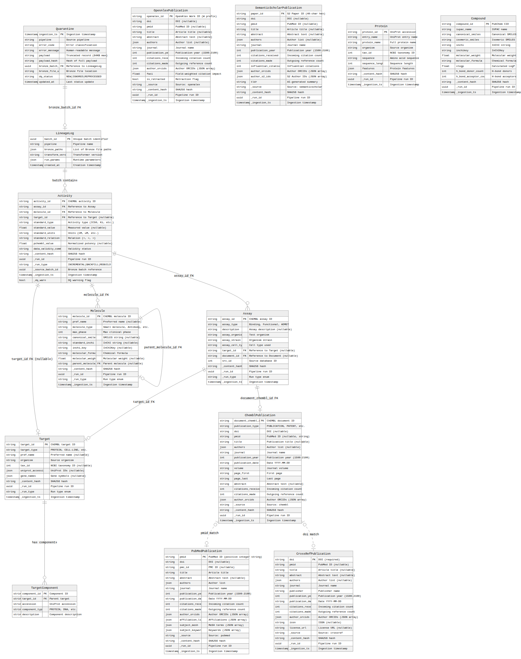
Figure 20: Full Entity-Relationship Diagram

Mermaid Source
%%{init: {'theme': 'neutral', 'themeVariables': {'fontFamily': 'Inter, system-ui', 'lineWidth': '2'}}}%%
erDiagram
Activity ||--o{ Assay : "assay_id FK"
Activity ||--o{ Molecule : "molecule_id FK"
Activity ||--o| Target : "target_id FK (nullable)"
Assay ||--o| Target : "target_id FK"
Assay ||--o| ChemblPublication : "document_chembl_id FK"
Molecule ||--o| Molecule : "parent_molecule_id FK"
Target ||--o{ TargetComponent : "has components"
LineageLog ||--o{ Activity : "batch contains"
Quarantine ||--o| LineageLog : "bronze_batch_id FK"
ChemblPublication |o..o| PubMedPublication : "pmid match"
ChemblPublication |o..o| CrossRefPublication : "doi match"
Activity {
string activity_id PK "ChEMBL activity ID"
string assay_id FK "Reference to Assay"
string molecule_id FK "Reference to Molecule"
string target_id FK "Reference to Target (nullable)"
string standard_type "Activity type (IC50, Ki, etc.)"
float standard_value "Measured value (nullable)"
string standard_units "Units (nM, uM, etc.)"
string standard_relation "Relation (=, <, >)"
float pchembl_value "Normalized potency (nullable)"
string data_validity_comment "Validity status"
string _content_hash "SHA256 hash"
uuid _run_id "Pipeline run ID"
string _run_type "INCREMENTAL|BACKFILL|REBUILD"
uuid _source_batch_id "Bronze batch reference"
timestamp _ingestion_ts "Ingestion timestamp"
bool _dq_warn "DQ warning flag"
}
Assay {
string assay_id PK "ChEMBL assay ID"
string assay_type "Binding, Functional, ADMET"
string description "Assay description (nullable)"
string assay_organism "Test organism"
string assay_strain "Organism strain"
string assay_cell_type "Cell type used"
string target_id FK "Reference to Target (nullable)"
string document_id FK "Reference to Document (nullable)"
int src_id "Source database ID"
string _content_hash "SHA256 hash"
uuid _run_id "Pipeline run ID"
string _run_type "Run type enum"
timestamp _ingestion_ts "Ingestion timestamp"
}
Target {
string target_id PK "ChEMBL target ID"
string target_type "PROTEIN, CELL-LINE, etc."
string pref_name "Preferred name (nullable)"
string organism "Source organism"
int tax_id "NCBI taxonomy ID (nullable)"
json uniprot_accessions "UniProt IDs (nullable)"
json gene_names "Gene symbols (nullable)"
string _content_hash "SHA256 hash"
uuid _run_id "Pipeline run ID"
string _run_type "Run type enum"
timestamp _ingestion_ts "Ingestion timestamp"
}
TargetComponent {
string component_id PK "Component ID"
string target_id FK "Parent target"
string accession "UniProt accession"
string component_type "PROTEIN, DNA, etc."
string description "Component description"
}
Molecule {
string molecule_id PK "ChEMBL molecule ID"
string pref_name "Preferred name (nullable)"
string molecule_type "Small molecule, Antibody, etc."
int max_phase "Max clinical phase"
string canonical_smiles "SMILES string (nullable)"
string standard_inchi "InChI string (nullable)"
string inchi_key "InChIKey (nullable)"
string molecular_formula "Chemical formula"
float molecular_weight "Molecular weight (nullable)"
string parent_molecule_id FK "Parent molecule (nullable)"
string _content_hash "SHA256 hash"
uuid _run_id "Pipeline run ID"
string _run_type "Run type enum"
timestamp _ingestion_ts "Ingestion timestamp"
}
ChemblPublication {
string document_chembl_id PK "ChEMBL document ID"
string publication_type "PUBLICATION, PATENT, etc."
string doi "DOI (nullable)"
string pmid "PubMed ID (nullable, string)"
string title "Publication title (nullable)"
json authors "Author list (nullable)"
string journal "Journal name"
int publication_year "Publication year (1500-2100)"
string publication_date "Date YYYY-MM-DD"
string volume "Journal volume"
string page_first "First page"
string page_last "Last page"
string abstract "Abstract text (nullable)"
int citations_received "Incoming citation count"
int citations_made "Outgoing reference count"
json author_orcids "Author ORCIDs (JSON array)"
string _source "Source: chembl"
string _content_hash "SHA256 hash"
uuid _run_id "Pipeline run ID"
timestamp _ingestion_ts "Ingestion timestamp"
}
PubMedPublication {
string pmid PK "PubMed ID (positive integer string)"
string doi "DOI (nullable)"
string pmc_id "PMC ID (nullable)"
string title "Article title"
string abstract "Abstract text (nullable)"
json authors "Author list"
string journal "Journal name"
int publication_year "Publication year (1500-2100)"
string publication_date "Date YYYY-MM-DD"
int citations_received "Incoming citation count"
int citations_made "Outgoing reference count"
json author_orcids "Author ORCIDs (JSON array)"
json affiliation_list "Affiliations (JSON array)"
json subject_mesh "MeSH terms (JSON array)"
json subject_keywords "Keywords (JSON array)"
string _source "Source: pubmed"
string _content_hash "SHA256 hash"
uuid _run_id "Pipeline run ID"
timestamp _ingestion_ts "Ingestion timestamp"
}
CrossRefPublication {
string doi PK "DOI (required)"
string pmid "PubMed ID (nullable)"
string title "Article title (nullable)"
string abstract "Abstract text (nullable)"
json authors "Author list (nullable)"
string journal "Journal name"
string publisher "Publisher name"
int publication_year "Publication year (1500-2100)"
string publication_date "Date YYYY-MM-DD"
int citations_received "Incoming citation count"
int citations_made "Outgoing reference count"
json author_orcids "Author ORCIDs (JSON array)"
string issn "ISSN (nullable)"
string license_url "License URL (nullable)"
string _source "Source: crossref"
string _content_hash "SHA256 hash"
uuid _run_id "Pipeline run ID"
timestamp _ingestion_ts "Ingestion timestamp"
}
OpenAlexPublication {
string openalex_id PK "OpenAlex Work ID (W prefix)"
string doi "DOI (nullable)"
string pmid "PubMed ID (nullable)"
string title "Article title (nullable)"
string abstract "Abstract text (nullable)"
json authors "Author list (nullable)"
string journal "Journal name"
int publication_year "Publication year (1500-2100)"
int citations_received "Incoming citation count"
int citations_made "Outgoing reference count"
json author_orcids "Author ORCIDs (JSON array)"
float fwci "Field-weighted citation impact"
bool is_retracted "Retraction flag"
string _source "Source: openalex"
string _content_hash "SHA256 hash"
uuid _run_id "Pipeline run ID"
timestamp _ingestion_ts "Ingestion timestamp"
}
SemanticScholarPublication {
string paper_id PK "S2 Paper ID (40-char hex)"
string doi "DOI (nullable)"
string pmid "PubMed ID (nullable)"
string title "Article title (nullable)"
string abstract "Abstract text (nullable)"
json authors "Author list (nullable)"
string journal "Journal name"
int publication_year "Publication year (1500-2100)"
int citations_received "Incoming citation count"
int citations_made "Outgoing reference count"
int influential_citation_count "Influential citations"
json author_orcids "Author ORCIDs (JSON array)"
json author_s2_ids "S2 Author IDs (JSON array)"
string tldr "AI-generated summary"
string _source "Source: semanticscholar"
string _content_hash "SHA256 hash"
uuid _run_id "Pipeline run ID"
timestamp _ingestion_ts "Ingestion timestamp"
}
LineageLog {
uuid batch_id PK "Unique batch identifier"
string pipeline "Pipeline name"
json bronze_paths "List of Bronze file paths"
string transform_version "Transformer version"
json run_params "Runtime parameters"
timestamp created_at "Creation timestamp"
}
Quarantine {
timestamp ingestion_ts PK "Ingestion timestamp"
string pipeline "Source pipeline"
string error_code "Error classification"
string error_message "Human-readable message"
string payload "Truncated record (64KB max)"
string payload_hash "Hash of full payload"
uuid bronze_batch_id FK "Reference to LineageLog"
string bronze_file_uri "Bronze file location"
string dq_status "NEW|IGNORED|REPROCESSED"
timestamp updated_at "Last status update"
}
Protein {
string protein_id PK "UniProt accession"
string entry_name "UniProt entry name"
string protein_name "Full protein name"
string organism "Source organism"
int tax_id "NCBI taxonomy ID"
string sequence "Amino acid sequence"
int sequence_length "Sequence length"
json features "Protein features"
string _content_hash "SHA256 hash"
uuid _run_id "Pipeline run ID"
timestamp _ingestion_ts "Ingestion timestamp"
}
Compound {
string compound_id PK "PubChem CID"
string iupac_name "IUPAC name"
string canonical_smiles "Canonical SMILES"
string isomeric_smiles "Isomeric SMILES"
string inchi "InChI string"
string inchikey "InChIKey"
float molecular_weight "Molecular weight"
string molecular_formula "Chemical formula"
float xlogp "Calculated LogP"
int h_bond_donor_count "H-bond donors"
int h_bond_acceptor_count "H-bond acceptors"
string _content_hash "SHA256 hash"
uuid _run_id "Pipeline run ID"
timestamp _ingestion_ts "Ingestion timestamp"
}

Figure 21 -- Domain Models Relationship
Source File | 13-domain-models-relationship.mermaid
Category | ER Diagrams & Data Models
Source Lines | 244
Rendered Size | 1560 x 1587 px

Description
Relationships between domain models: how Activity connects to Molecule, Target, Assay; how publications link to compounds and proteins; and how configuration objects govern pipeline behavior.

Rendered Diagram
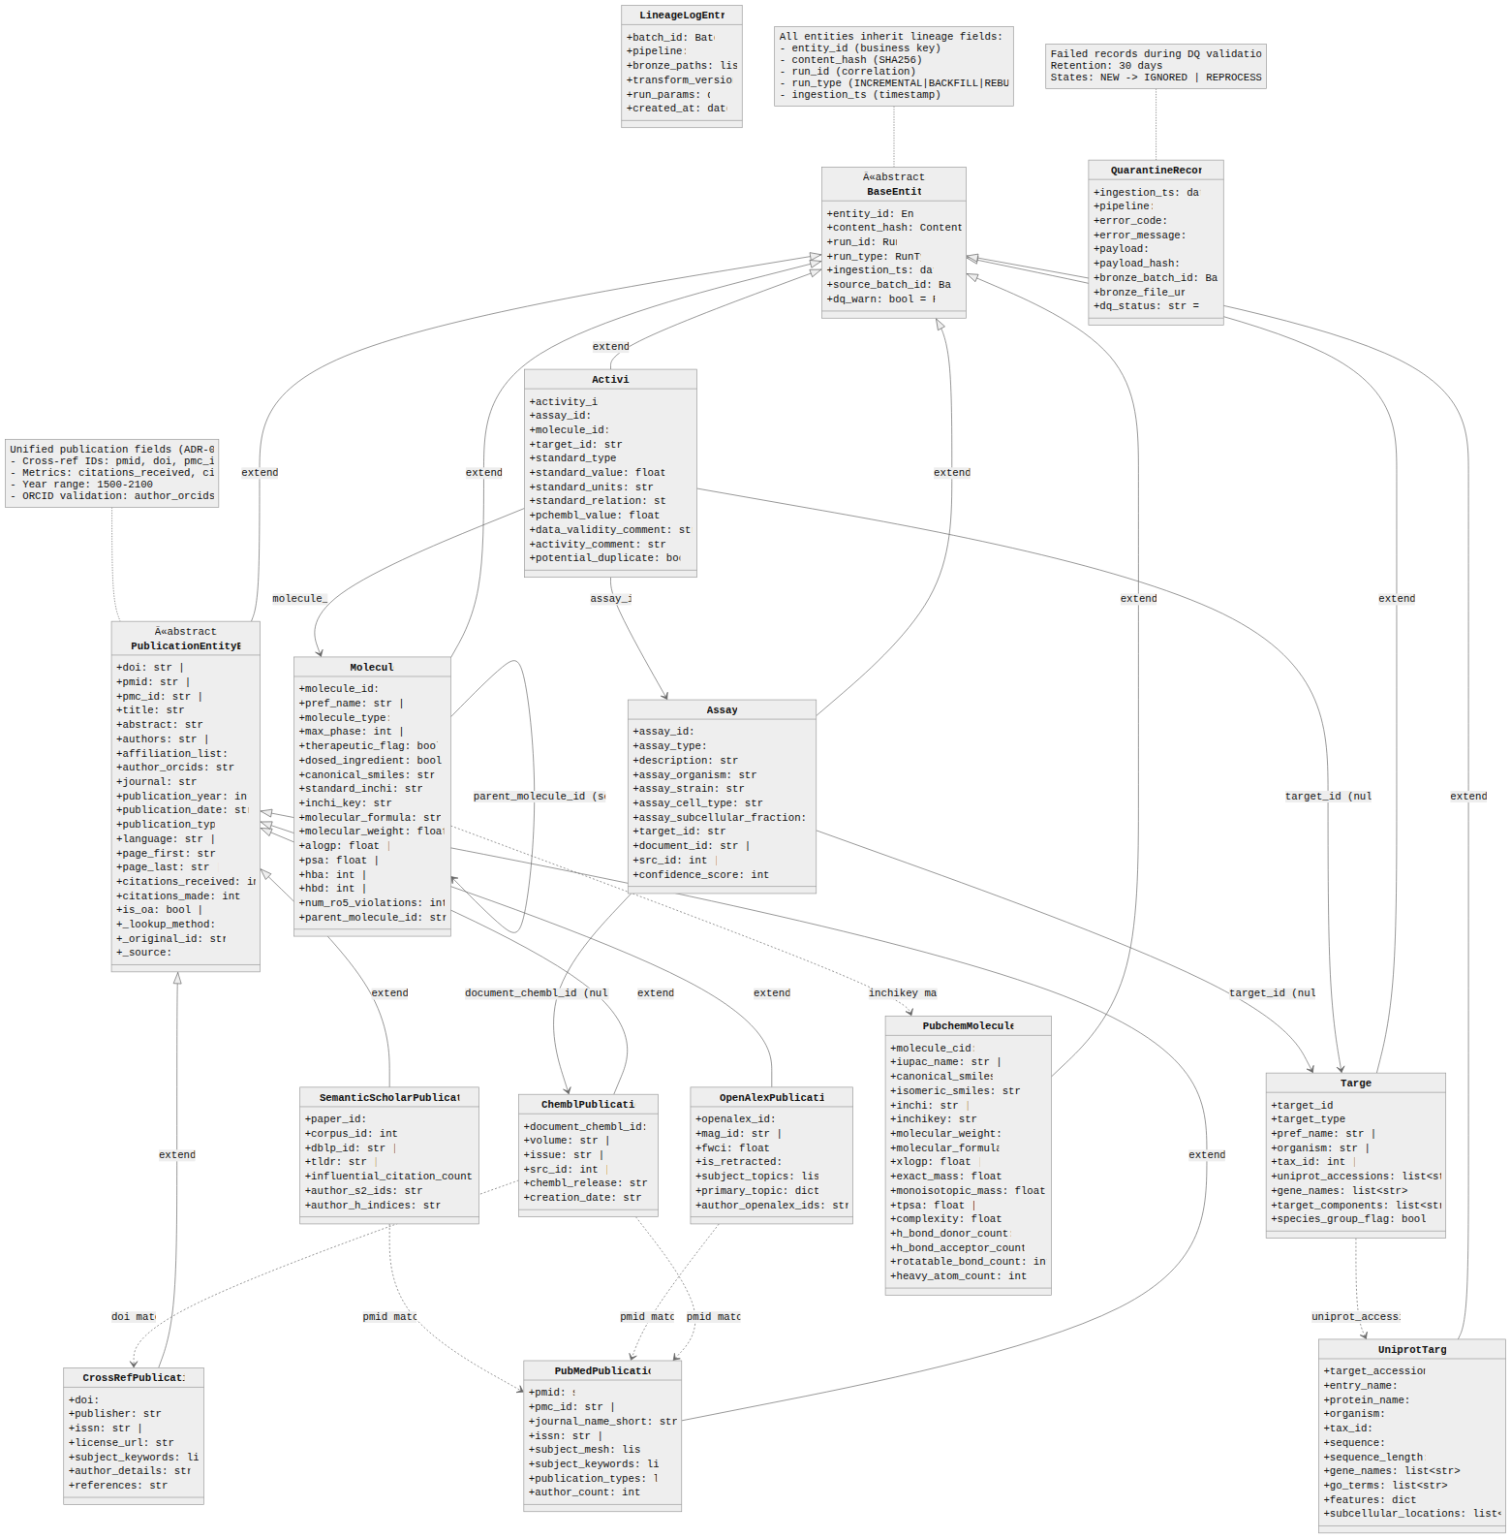
Figure 21: Domain Models Relationship

Mermaid Source
%%{init: {'theme': 'neutral', 'themeVariables': {'fontFamily': 'Inter, system-ui', 'lineWidth': '2'}}}%%
classDiagram
direction TB
class BaseEntity {
<<abstract>>
+entity_id: EntityID
+content_hash: ContentHash
+run_id: RunID
+run_type: RunType
+ingestion_ts: datetime
+source_batch_id: BatchID
+dq_warn: bool = False
}
class Activity {
+activity_id: str
+assay_id: str
+molecule_id: str
+target_id: str | None
+standard_type: str
+standard_value: float | None
+standard_units: str | None
+standard_relation: str | None
+pchembl_value: float | None
+data_validity_comment: str | None
+activity_comment: str | None
+potential_duplicate: bool | None
}
class Assay {
+assay_id: str
+assay_type: str
+description: str | None
+assay_organism: str | None
+assay_strain: str | None
+assay_cell_type: str | None
+assay_subcellular_fraction: str | None
+target_id: str | None
+document_id: str | None
+src_id: int | None
+confidence_score: int | None
}
class Target {
+target_id: str
+target_type: str
+pref_name: str | None
+organism: str | None
+tax_id: int | None
+uniprot_accessions: list~str~ | None
+gene_names: list~str~ | None
+target_components: list~str~ | None
+species_group_flag: bool | None
}
class Molecule {
+molecule_id: str
+pref_name: str | None
+molecule_type: str
+max_phase: int | None
+therapeutic_flag: bool | None
+dosed_ingredient: bool | None
+canonical_smiles: str | None
+standard_inchi: str | None
+inchi_key: str | None
+molecular_formula: str | None
+molecular_weight: float | None
+alogp: float | None
+psa: float | None
+hba: int | None
+hbd: int | None
+num_ro5_violations: int | None
+parent_molecule_id: str | None
}
class PublicationEntityBase {
<<abstract>>
+doi: str | None
+pmid: str | None
+pmc_id: str | None
+title: str | None
+abstract: str | None
+authors: str | None
+affiliation_list: str | None
+author_orcids: str | None
+journal: str | None
+publication_year: int | None
+publication_date: str | None
+publication_type: str
+language: str | None
+page_first: str | None
+page_last: str | None
+citations_received: int | None
+citations_made: int | None
+is_oa: bool | None
+_lookup_method: str
+_original_id: str | None
+_source: str
}
class ChemblPublication {
+document_chembl_id: str
+volume: str | None
+issue: str | None
+src_id: int | None
+chembl_release: str | None
+creation_date: str | None
}
class PubMedPublication {
+pmid: str
+pmc_id: str | None
+journal_name_short: str | None
+issn: str | None
+subject_mesh: list~str~
+subject_keywords: list~str~
+publication_types: list~str~
+author_count: int | None
}
class CrossRefPublication {
+doi: str
+publisher: str | None
+issn: str | None
+license_url: str | None
+subject_keywords: list~str~
+author_details: str | None
+references: str | None
}
class OpenAlexPublication {
+openalex_id: str
+mag_id: str | None
+fwci: float | None
+is_retracted: bool
+subject_topics: list | None
+primary_topic: dict | None
+author_openalex_ids: str | None
}
class SemanticScholarPublication {
+paper_id: str
+corpus_id: int | None
+dblp_id: str | None
+tldr: str | None
+influential_citation_count: int | None
+author_s2_ids: str | None
+author_h_indices: str | None
}
class UniprotTarget {
+target_accession: str
+entry_name: str
+protein_name: str
+organism: str
+tax_id: int
+sequence: str
+sequence_length: int
+gene_names: list~str~ | None
+go_terms: list~str~ | None
+features: dict | None
+subcellular_locations: list~str~ | None
}
class PubchemMolecule {
+molecule_cid: str
+iupac_name: str | None
+canonical_smiles: str
+isomeric_smiles: str | None
+inchi: str | None
+inchikey: str | None
+molecular_weight: float
+molecular_formula: str
+xlogp: float | None
+exact_mass: float | None
+monoisotopic_mass: float | None
+tpsa: float | None
+complexity: float | None
+h_bond_donor_count: int
+h_bond_acceptor_count: int
+rotatable_bond_count: int | None
+heavy_atom_count: int | None
}
class QuarantineRecord {
+ingestion_ts: datetime
+pipeline: str
+error_code: str
+error_message: str
+payload: str
+payload_hash: str
+bronze_batch_id: BatchID
+bronze_file_uri: str
+dq_status: str = "NEW"
}
class LineageLogEntry {
+batch_id: BatchID
+pipeline: str
+bronze_paths: list~str~
+transform_version: str
+run_params: dict
+created_at: datetime
}
%% Inheritance from BaseEntity
BaseEntity <|-- Activity : extends
BaseEntity <|-- Assay : extends
BaseEntity <|-- Target : extends
BaseEntity <|-- Molecule : extends
BaseEntity <|-- PublicationEntityBase : extends
BaseEntity <|-- UniprotTarget : extends
BaseEntity <|-- PubchemMolecule : extends
%% Publication hierarchy
PublicationEntityBase <|-- ChemblPublication : extends
PublicationEntityBase <|-- PubMedPublication : extends
PublicationEntityBase <|-- CrossRefPublication : extends
PublicationEntityBase <|-- OpenAlexPublication : extends
PublicationEntityBase <|-- SemanticScholarPublication : extends
%% ChEMBL Entity Relationships
Activity --> Assay : assay_id
Activity --> Molecule : molecule_id
Activity --> Target : target_id (nullable)
Assay --> Target : target_id (nullable)
Assay --> ChemblPublication : document_chembl_id (nullable)
Molecule --> Molecule : parent_molecule_id (self-ref)
%% Cross-provider relationships (conceptual)
Target ..> UniprotTarget : uniprot_accessions
Molecule ..> PubchemMolecule : inchikey match
ChemblPublication ..> PubMedPublication : pmid match
ChemblPublication ..> CrossRefPublication : doi match
OpenAlexPublication ..> PubMedPublication : pmid match
SemanticScholarPublication ..> PubMedPublication : pmid match
%% Notes
note for BaseEntity "All entities inherit lineage fields:\n- entity_id (business key)\n- content_hash (SHA256)\n- run_id (correlation)\n- run_type (INCREMENTAL|BACKFILL|REBUILD)\n- ingestion_ts (timestamp)"
note for PublicationEntityBase "Unified publication fields (ADR-024):\n- Cross-ref IDs: pmid, doi, pmc_id\n- Metrics: citations_received, citations_made\n- Year range: 1500-2100\n- ORCID validation: author_orcids"
note for QuarantineRecord "Failed records during DQ validation\nRetention: 30 days\nStates: NEW -> IGNORED | REPROCESSED"

Figure 22 -- Activity Entity Data Flow
Source File | 21-activity-entity-data-flow.mermaid
Category | ER Diagrams & Data Models
Source Lines | 93
Rendered Size | 1560 x 216 px

Description
Data flow specific to the Activity entity: ChEMBL API response -> DTO parsing -> domain entity mapping -> Bronze/Silver/Gold transformation with field-level detail on normalization and validation.

Rendered Diagram
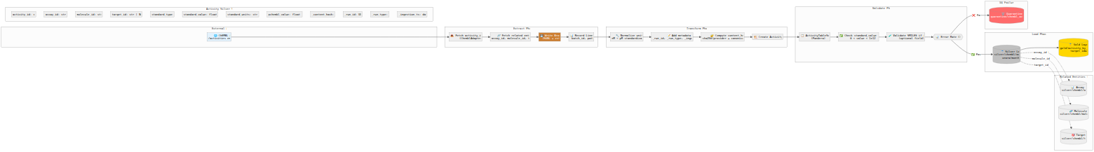
Figure 22: Activity Entity Data Flow

Mermaid Source
%%{init: {'theme': 'neutral', 'themeVariables': {'fontFamily': 'Inter, system-ui', 'lineWidth': '2'}}}%%
flowchart LR
subgraph External["External API"]
API["🌐 ChEMBL API<br/>/activities endpoint"]
end
subgraph Extract["Extract Phase"]
E1["📥 Fetch activity_id batch<br/>(ChemblAdapter)"]
E2["🔗 Fetch related entities<br/>assay_id, molecule_id, target_id"]
E3["💾 Write Bronze<br/>JSONL + zstd"]
E4["📊 Record Lineage<br/>batch_id, paths"]
end
subgraph Transform["Transform Phase"]
T1["🔧 Normalize units<br/>nM → μM standardization"]
T2["📝 Add metadata<br/>_run_id, _run_type, _ingestion_ts"]
T3["🔐 Compute content_hash<br/>sha256(provider + canonical_json)"]
T4["🏗️ Create Activity entity"]
end
subgraph Validate["Validate Phase"]
V1["📋 ActivityTableSchema<br/>(Pandera)"]
V2["✅ Check standard_value range<br/>0 < value < 1e12"]
V3["🧪 Validate SMILES if present<br/>(optional field)"]
V4{{"📊 Error Rate Check"}}
end
subgraph Load["Load Phase"]
L1[("🥈 Silver Layer<br/>silver/chembl/activity/<br/>year=/month=/")]
L2[("🥇 Gold Layer<br/>gold/activity_by_target/<br/>target_id=/")]
end
subgraph Related["Related Entities (Silver)"]
Assay[("📊 Assay<br/>silver/chembl/assay/")]
Molecule[("🧬 Molecule<br/>silver/chembl/molecule/")]
Target[("🎯 Target<br/>silver/chembl/target/")]
end
subgraph Quarantine["DQ Failures"]
Q[("🗑️ Quarantine<br/>quarantine/chembl_activity/")]
end
%% Extract flow
API --> E1
E1 --> E2
E2 --> E3
E3 --> E4
%% Transform flow
E4 --> T1
T1 --> T2
T2 --> T3
T3 --> T4
%% Validate flow
T4 --> V1
V1 --> V2
V2 --> V3
V3 --> V4
%% Load flow
V4 -->|"✅ Pass"| L1
V4 -->|"❌ Fail"| Q
L1 --> L2
%% Foreign key relationships
L1 -.->|"assay_id FK"| Assay
L1 -.->|"molecule_id FK"| Molecule
L1 -.->|"target_id FK"| Target
%% Styling
style API fill:#E3F2FD
style E3 fill:#CD7F32,color:#fff
style L1 fill:#C0C0C0,color:#000
style L2 fill:#FFD700,color:#000
style Q fill:#FF6B6B,color:#fff
%% Activity Schema annotation
subgraph Schema["Activity Silver Schema"]
direction TB
S1["activity_id: str (PK)"]
S2["assay_id: str (FK)"]
LocalFS["molecule_id: str (FK)"]
S4["target_id: str | None (FK)"]
S5["standard_type: str"]
S6["standard_value: float | None"]
S7["standard_units: str | None"]
S8["pchembl_value: float | None"]
S9["_content_hash: str"]
S10["_run_id: UUID"]
S11["_run_type: str"]
S12["_ingestion_ts: datetime"]
end

Security & Infrastructure
6 diagram(s) in this category.

Figure 23 -- Locking Mechanism
Source File | 05-locking.mermaid
Category | Security & Infrastructure
Source Lines | 37
Rendered Size | 840 x 1321 px

Description
Concurrency control via MemoryLock: lock acquisition with TTL (90s), heartbeat mechanism (30s interval), owner validation, and auto-release on expiry.

Rendered Diagram
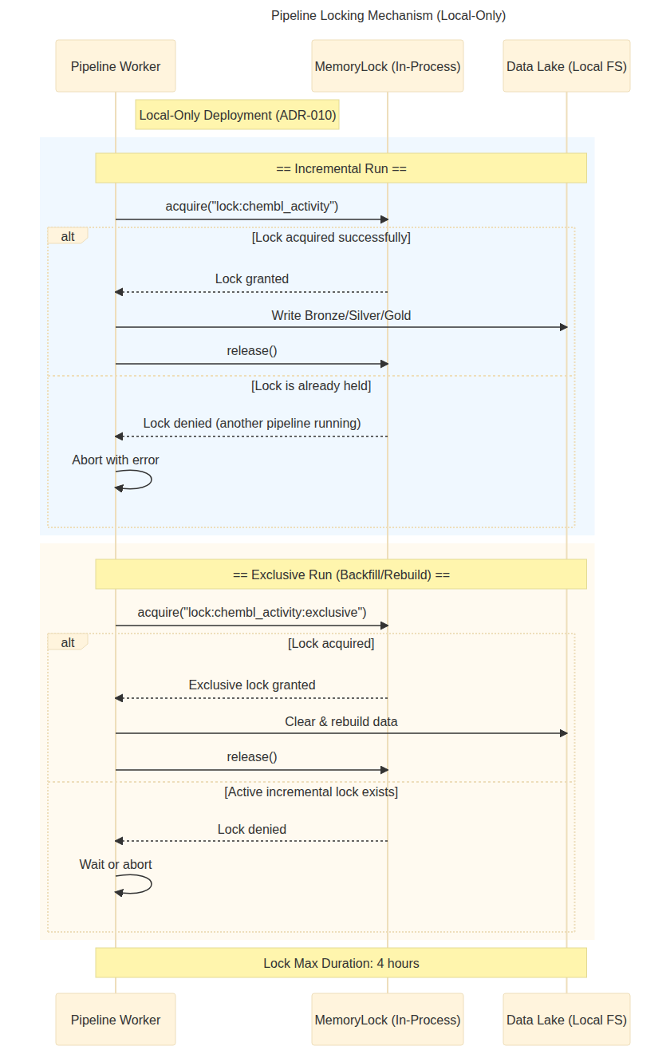
Figure 23: Locking Mechanism

Mermaid Source
%%{init: {'theme': 'base'}}%%
sequenceDiagram
title Pipeline Locking Mechanism (Local-Only)
Note right of Worker: Local-Only Deployment (ADR-010)
participant Worker as Pipeline Worker
participant LockManager as MemoryLock (In-Process)
participant Lake as Data Lake (Local FS)
rect rgb(240, 248, 255)
Note over Worker,Lake: == Incremental Run ==
Worker->>LockManager: acquire("lock:chembl_activity")
alt Lock acquired successfully
LockManager-->>Worker: Lock granted
Worker->>Lake: Write Bronze/Silver/Gold
Worker->>LockManager: release()
else Lock is already held
LockManager-->>Worker: Lock denied (another pipeline running)
Worker->>Worker: Abort with error
end
end
rect rgb(255, 250, 240)
Note over Worker,Lake: == Exclusive Run (Backfill/Rebuild) ==
Worker->>LockManager: acquire("lock:chembl_activity:exclusive")
alt Lock acquired
LockManager-->>Worker: Exclusive lock granted
Worker->>Lake: Clear & rebuild data
Worker->>LockManager: release()
else Active incremental lock exists
LockManager-->>Worker: Lock denied
Worker->>Worker: Wait or abort
end
end
Note over Worker,Lake: Lock Max Duration: 4 hours

Figure 24 -- Infrastructure Layer Class Diagram
Source File | 10-infrastructure-layer-class-diagram.mermaid
Category | Security & Infrastructure
Source Lines | 257
Rendered Size | 1560 x 415 px

Description
Complete class diagram of the Infrastructure layer: 7 provider adapters, UnifiedHTTPClient with CircuitBreaker and RateLimiter, Bronze/Silver/Gold writers, MemoryLock, and observability implementations.

Rendered Diagram
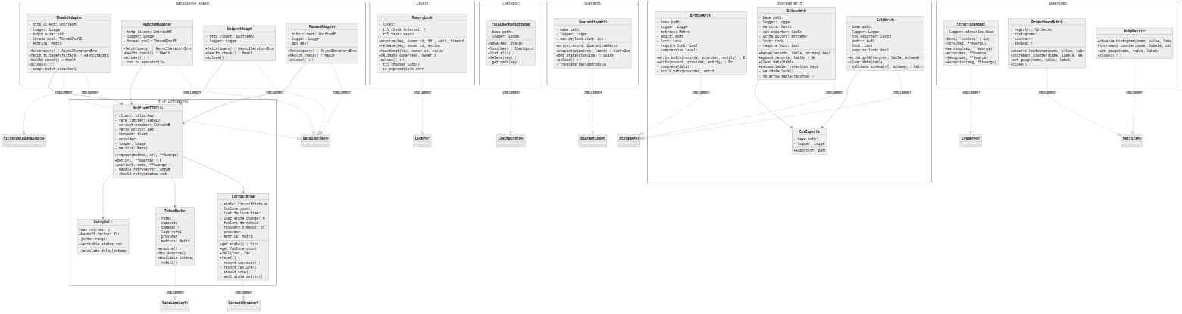
Figure 24: Infrastructure Layer Class Diagram

Mermaid Source
%%{init: {'theme': 'neutral', 'themeVariables': {'fontFamily': 'Inter, system-ui', 'lineWidth': '2'}}}%%
classDiagram
direction TB
namespace HTTP_Infrastructure {
class UnifiedHTTPClient {
-_client: httpx.AsyncClient
-_rate_limiter: RateLimiterPort
-_circuit_breaker: CircuitBreakerPort
-_retry_policy: RetryPolicy
-_timeout: float = 30.0
-_provider: str
-_logger: LoggerPort
-_metrics: MetricsPort
+request(method, url, **kwargs) Response
+get(url, **kwargs) Response
+post(url, data, **kwargs) Response
-_handle_retry(error, attempt) None
-_should_retry(status_code) bool
}
class CircuitBreaker {
-_state: CircuitState = CLOSED
-_failure_count: int = 0
-_last_failure_time: datetime
-_last_state_change: datetime
-_failure_threshold: int = 5
-_recovery_timeout: int = 300
-_provider: str
-_metrics: MetricsPort
+get_state() CircuitState
+get_failure_count() int
+call(func, *args) T
+reset() None
-_record_success() None
-_record_failure() None
-_should_trip() bool
-_emit_state_metric() None
}
class TokenBucket {
-_rate: float
-_capacity: int
-_tokens: float
-_last_refill: float
-_provider: str
-_metrics: MetricsPort
+acquire() None
+try_acquire() bool
+available_tokens() int
-_refill() None
}
class RetryPolicy {
+max_retries: int = 3
+backoff_factor: float = 2.0
+jitter_range: tuple
+retriable_status_codes: set
+calculate_delay(attempt) float
}
}
namespace DataSource_Adapters {
class ChemblAdapter {
-_http_client: UnifiedHTTPClient
-_logger: LoggerPort
-_batch_size: int = 1000
-_thread_pool: ThreadPoolExecutor
-_metrics: MetricsPort
+fetch(query) AsyncIterator~BronzeRecord~
+fetch_filtered(filters) AsyncIterator~BronzeRecord~
+health_check() HealthStatus
+aclose() None
-_adapt_batch_size(health) int
}
class PubchemAdapter {
-_http_client: UnifiedHTTPClient
-_logger: LoggerPort
-_thread_pool: ThreadPoolExecutor
+fetch(query) AsyncIterator~BronzeRecord~
+health_check() HealthStatus
+aclose() None
-_run_in_executor(func) T
}
class UniprotAdapter {
-_http_client: UnifiedHTTPClient
-_logger: LoggerPort
+fetch(query) AsyncIterator~BronzeRecord~
+health_check() HealthStatus
+aclose() None
}
class PubmedAdapter {
-_http_client: UnifiedHTTPClient
-_logger: LoggerPort
-_api_key: str
+fetch(query) AsyncIterator~BronzeRecord~
+health_check() HealthStatus
+aclose() None
}
}
namespace Storage_Writers {
class BronzeWriter {
-_base_path: str
-_logger: LoggerPort
-_metrics: MetricsPort
-_audit: AuditPort
-_lock: LockPort
-_require_lock: bool = True
-_compression_level: int = 3
+write_batch(records, provider, entity) BronzeWriteResult
+write(record, provider, entity) BronzeWriteResult
-_compress(data) bytes
-_build_path(provider, entity, date) str
}
class SilverWriter {
-_base_path: str
-_logger: LoggerPort
-_metrics: MetricsPort
-_csv_exporter: CsvExporter
-_write_policy: WriteModePolicy
-_lock: LockPort
-_require_lock: bool = True
+merge(records, table, primary_key) WriteResult
+append(records, table) WriteResult
+clear_data(table) int
+vacuum(table, retention_days) None
-_validate_lock() bool
-_to_arrow_table(records) pa.Table
}
class GoldWriter {
-_base_path: str
-_logger: LoggerPort
-_csv_exporter: CsvExporter
-_audit: AuditPort
-_lock: LockPort
-_require_lock: bool = True
+write_gold(records, table, schema) WriteResult
+clear_data(table) int
-_validate_schema(df, schema) ValidationResult
}
class CsvExporter {
-_base_path: str
-_logger: LoggerPort
+export(df, path) str
}
}
namespace Locking {
class MemoryLock {
-_locks: dict
-_ttl_check_interval: float = 1.0
-_ttl_task: asyncio.Task
+acquire(key, owner_id, ttl, wait, timeout, exclusive) bool
+release(key, owner_id, exclusive) bool
+heartbeat(key, owner_id, exclusive) bool
+validate_owner(key, owner_id) bool
+aclose() None
-_ttl_checker_loop() None
-_is_expired(lock_entry) bool
}
}
namespace Quarantine {
class QuarantineWriter {
-_base_path: str
-_logger: LoggerPort
-_max_payload_size: int = 65536
+write(record: QuarantineRecord) None
+inspect(pipeline, limit) list~QuarantineRecord~
+get_stats(pipeline) QuarantineStats
+aclose() None
-_truncate_payload(payload) str
}
}
namespace Checkpoint {
class FileCheckpointManager {
-_base_path: str
-_logger: LoggerPort
+save(key, state) None
+load(key) CheckpointState?
+list_all() list~str~
+delete(key) None
-_get_path(key) Path
}
}
namespace Observability {
class StructlogAdapter {
-_logger: structlog.BoundLogger
+bind(**context) LoggerPort
+info(msg, **kwargs) None
+warning(msg, **kwargs) None
+error(msg, **kwargs) None
+debug(msg, **kwargs) None
+exception(msg, **kwargs) None
}
class PrometheusMetrics {
-_registry: CollectorRegistry
-_histograms: dict
-_counters: dict
-_gauges: dict
+observe_histogram(name, value, labels) None
+increment_counter(name, labels, value) None
+set_gauge(name, value, labels) None
+close() None
}
class NoOpMetrics {
+observe_histogram(name, value, labels) None
+increment_counter(name, labels, value) None
+set_gauge(name, value, labels) None
+close() None
}
}
%% Port implementations (dotted lines)
ChemblAdapter ..|> DataSourcePort : implements
ChemblAdapter ..|> FilterableDataSourcePort : implements
PubchemAdapter ..|> DataSourcePort : implements
UniprotAdapter ..|> DataSourcePort : implements
PubmedAdapter ..|> DataSourcePort : implements
BronzeWriter ..|> StoragePort : implements
SilverWriter ..|> StoragePort : implements
GoldWriter ..|> StoragePort : implements
MemoryLock ..|> LockPort : implements
FileCheckpointManager ..|> CheckpointPort : implements
QuarantineWriter ..|> QuarantinePort : implements
CircuitBreaker ..|> CircuitBreakerPort : implements
TokenBucket ..|> RateLimiterPort : implements
StructlogAdapter ..|> LoggerPort : implements
PrometheusMetrics ..|> MetricsPort : implements
NoOpMetrics ..|> MetricsPort : implements
%% Dependencies
ChemblAdapter --> UnifiedHTTPClient
PubchemAdapter --> UnifiedHTTPClient
UniprotAdapter --> UnifiedHTTPClient
PubmedAdapter --> UnifiedHTTPClient
UnifiedHTTPClient --> CircuitBreaker
UnifiedHTTPClient --> TokenBucket
UnifiedHTTPClient --> RetryPolicy
SilverWriter --> CsvExporter
GoldWriter --> CsvExporter

Figure 25 -- Lock Acquisition Sequence
Source File | 11-lock-acquisition-sequence.mermaid
Category | Security & Infrastructure
Source Lines | 81
Rendered Size | 1560 x 2403 px

Description
Sequence diagram for distributed lock lifecycle: acquire() with TTL, heartbeat loop (every 30s), lock validation, owner checking, and release/auto-expire mechanisms.

Rendered Diagram
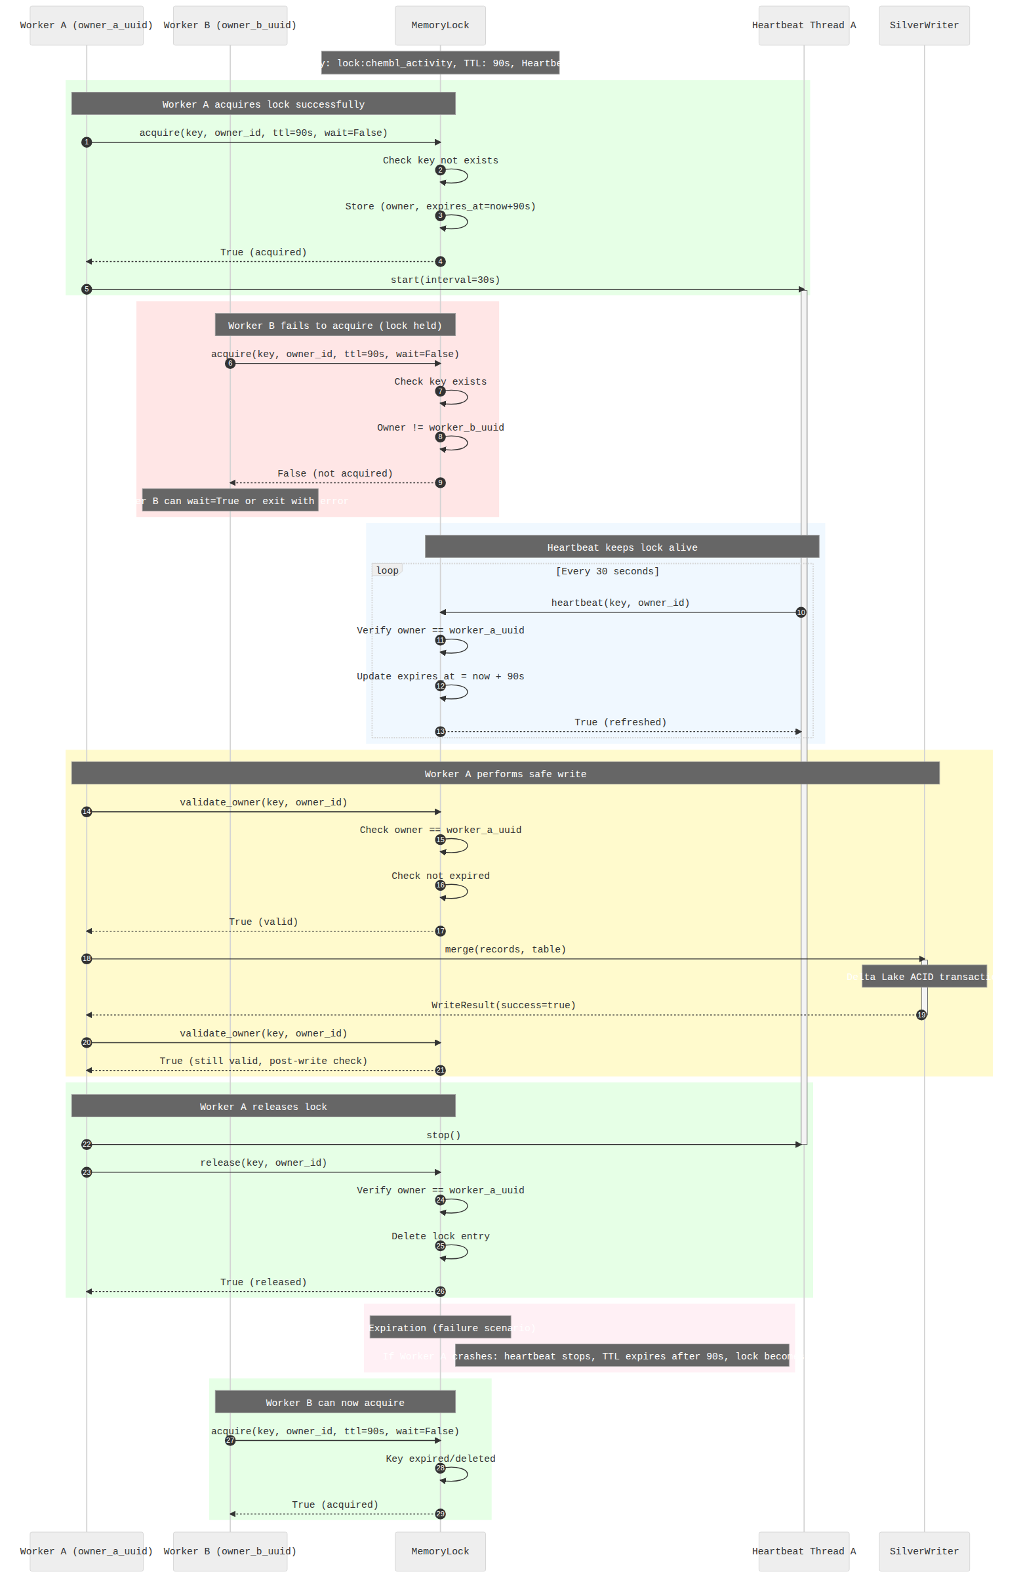
Figure 25: Lock Acquisition Sequence

Mermaid Source
%%{init: {'theme': 'neutral', 'themeVariables': {'fontFamily': 'Inter, system-ui', 'lineWidth': '2'}}}%%
sequenceDiagram
autonumber
participant WorkerA as Worker A (owner_a_uuid)
participant WorkerB as Worker B (owner_b_uuid)
participant Lock as MemoryLock
participant HeartbeatA as Heartbeat Thread A
participant Storage as SilverWriter
Note over Lock: Lock Key: lock:chembl_activity, TTL: 90s, Heartbeat: 30s
rect rgb(230, 255, 230)
Note over WorkerA,Lock: Worker A acquires lock successfully
WorkerA->>Lock: acquire(key, owner_id, ttl=90s, wait=False)
Lock->>Lock: Check key not exists
Lock->>Lock: Store (owner, expires_at=now+90s)
Lock-->>WorkerA: True (acquired)
WorkerA->>HeartbeatA: start(interval=30s)
activate HeartbeatA
end
rect rgb(255, 230, 230)
Note over WorkerB,Lock: Worker B fails to acquire (lock held)
WorkerB->>Lock: acquire(key, owner_id, ttl=90s, wait=False)
Lock->>Lock: Check key exists
Lock->>Lock: Owner != worker_b_uuid
Lock-->>WorkerB: False (not acquired)
Note over WorkerB: Worker B can wait=True or exit with error
end
rect rgb(240, 248, 255)
Note over HeartbeatA,Lock: Heartbeat keeps lock alive
loop Every 30 seconds
HeartbeatA->>Lock: heartbeat(key, owner_id)
Lock->>Lock: Verify owner == worker_a_uuid
Lock->>Lock: Update expires_at = now + 90s
Lock-->>HeartbeatA: True (refreshed)
end
end
rect rgb(255, 250, 205)
Note over WorkerA,Storage: Worker A performs safe write
WorkerA->>Lock: validate_owner(key, owner_id)
Lock->>Lock: Check owner == worker_a_uuid
Lock->>Lock: Check not expired
Lock-->>WorkerA: True (valid)
WorkerA->>Storage: merge(records, table)
activate Storage
Note over Storage: Delta Lake ACID transaction
Storage-->>WorkerA: WriteResult(success=true)
deactivate Storage
WorkerA->>Lock: validate_owner(key, owner_id)
Lock-->>WorkerA: True (still valid, post-write check)
end
rect rgb(230, 255, 230)
Note over WorkerA,Lock: Worker A releases lock
WorkerA->>HeartbeatA: stop()
deactivate HeartbeatA
WorkerA->>Lock: release(key, owner_id)
Lock->>Lock: Verify owner == worker_a_uuid
Lock->>Lock: Delete lock entry
Lock-->>WorkerA: True (released)
end
rect rgb(255, 240, 245)
Note over Lock: TTL Expiration (failure scenario)
Note right of Lock: If Worker A crashes: heartbeat stops, TTL expires after 90s, lock becomes available
end
rect rgb(230, 255, 230)
Note over WorkerB,Lock: Worker B can now acquire
WorkerB->>Lock: acquire(key, owner_id, ttl=90s, wait=False)
Lock->>Lock: Key expired/deleted
Lock-->>WorkerB: True (acquired)
end

Figure 26 -- Full Deployment Diagram (Local)
Source File | 12-full-aws-deployment.mermaid
Category | Security & Infrastructure
Source Lines | 84
Rendered Size | 1560 x 359 px

Description
Deployment architecture diagram showing BioETL in its local-only deployment model (per ADR-010): CLI execution, local scheduler, in-process locking, local filesystem storage, and observability. Historical AWS reference included for context.

Rendered Diagram
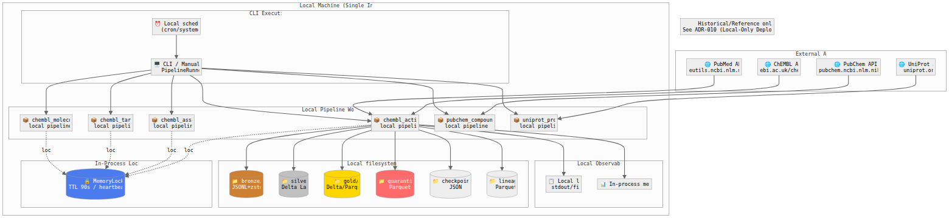
Figure 26: Full Deployment Diagram (Local)

Mermaid Source
%%{init: {'theme': 'neutral', 'themeVariables': {'fontFamily': 'Inter, system-ui', 'lineWidth': '2'}}}%%
%% DEPRECATED: Historical/Reference only. See ADR-010 (Local-Only Deployment): ../decisions/ADR-010-local-only-deployment.md
flowchart TB
ReferenceNote["Historical/Reference only<br/>See ADR-010 (Local-Only Deployment)"]
subgraph External["External APIs"]
ChEMBL_API["🌐 ChEMBL API<br/>ebi.ac.uk/chembl"]
PubChem_API["🌐 PubChem API<br/>pubchem.ncbi.nlm.nih.gov"]
UniProt_API["🌐 UniProt API<br/>uniprot.org"]
PubMed_API["🌐 PubMed API<br/>eutils.ncbi.nlm.nih.gov"]
end
subgraph Local["Local Machine (Single Instance)"]
subgraph Orchestration["CLI Execution"]
CLI["🖥️ CLI / Manual run<br/>PipelineRunner"]
Schedule["⏰ Local scheduler<br/>(cron/systemd)"]
end
subgraph Runtime["Local Pipeline Workers"]
chembl_activity["📦 chembl_activity<br/>local pipeline"]
chembl_assay["📦 chembl_assay<br/>local pipeline"]
chembl_target["📦 chembl_target<br/>local pipeline"]
chembl_molecule["📦 chembl_molecule<br/>local pipeline"]
pubchem_compound["📦 pubchem_compound<br/>local pipeline"]
uniprot_protein["📦 uniprot_protein<br/>local pipeline"]
end
subgraph Locking["In-Process Locking"]
MemoryLock[("🔒 MemoryLock<br/>TTL 90s / heartbeat 30s")]
end
subgraph Data["Local filesystem (data/)"]
Bronze[("📁 bronze/<br/>JSONL+zstd")]
Silver[("📁 silver/<br/>Delta Lake")]
Gold[("📁 gold/<br/>Delta/Parquet")]
Quarantine[("📁 quarantine/<br/>Parquet")]
Checkpoints[("📁 checkpoints/<br/>JSON")]
Lineage[("📁 lineage/<br/>Parquet")]
end
subgraph Observability["Local Observability"]
Logs["📋 Local logs<br/>stdout/file"]
Metrics["📊 In-process metrics"]
end
end
%% External API connections
ChEMBL_API --> chembl_activity
PubChem_API --> pubchem_compound
UniProt_API --> uniprot_protein
PubMed_API --> chembl_activity
%% Orchestration to runtime
CLI --> chembl_activity
CLI --> chembl_assay
CLI --> chembl_target
CLI --> chembl_molecule
CLI --> pubchem_compound
CLI --> uniprot_protein
Schedule --> CLI
%% Runtime to MemoryLock
chembl_activity -.->|lock| MemoryLock
chembl_assay -.->|lock| MemoryLock
chembl_target -.->|lock| MemoryLock
chembl_molecule -.->|lock| MemoryLock
%% Runtime to local filesystem
chembl_activity --> Bronze
chembl_activity --> Silver
chembl_activity --> Gold
chembl_activity --> Quarantine
chembl_activity --> Checkpoints
chembl_activity --> Lineage
%% Runtime to local observability
chembl_activity --> Logs
chembl_activity --> Metrics
%% Styling
style Bronze fill:#CD7F32,color:#fff
style Silver fill:#C0C0C0,color:#000
style Gold fill:#FFD700,color:#000
style Quarantine fill:#FF6B6B,color:#fff
style MemoryLock fill:#4B7BEC,color:#fff

Figure 27 -- MemoryLock Class Diagram
Source File | 16-memory-lock-class.mermaid
Category | Security & Infrastructure
Source Lines | 103
Rendered Size | 512 x 108 px

Description
Class diagram for MemoryLock implementation: in-memory lock store, TTL management, heartbeat scheduling, owner validation, and the LockPort protocol it implements.

Rendered Diagram
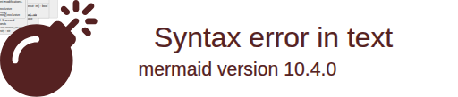
Figure 27: MemoryLock Class Diagram

Mermaid Source
%%{init: {'theme': 'neutral', 'themeVariables': {'fontFamily': 'Inter, system-ui', 'lineWidth': '2'}}}%%
classDiagram
direction TB
class LockPort {
<<Protocol>>
+acquire(key: str, owner_id: str, ttl: int, wait: bool, timeout: int, exclusive: bool) bool
+release(key: str, owner_id: str, exclusive: bool) bool
+heartbeat(key: str, owner_id: str, exclusive: bool) bool
+validate_owner(key: str, owner_id: str) bool
+aclose() None
}
class MemoryLock {
-_locks: dict~str, LockEntry~
-_lock: asyncio.Lock
-_ttl_check_interval: float = 1.0
-_ttl_task: asyncio.Task | None
-_running: bool = True
+acquire(key: str, owner_id: str, ttl: int = 90, wait: bool = False, timeout: int = 300, exclusive: bool = False) bool
+release(key: str, owner_id: str, exclusive: bool = False) bool
+heartbeat(key: str, owner_id: str, exclusive: bool = False) bool
+validate_owner(key: str, owner_id: str) bool
+aclose() None
-_start_ttl_checker() None
-_ttl_checker_loop() None
-_cleanup_expired() None
-_is_expired(entry: LockEntry) bool
-_wait_for_lock(key: str, timeout: int) bool
}
class LockEntry {
<<dataclass>>
+owner_id: str
+lock: asyncio.Lock
+expires_at: float
+original_ttl: int
+exclusive: bool = False
}
class LockResult {
<<dataclass>>
+acquired: bool
+owner_id: str
+key: str
+ttl: int
+message: str | None
}
class LockNotHeldError {
<<Exception>>
+key: str
+expected_owner: str
+actual_owner: str | None
+message: str
}
class LockManager {
-_lock: LockPort
-_logger: LoggerPort
-_ttl: int = 90
-_heartbeat_interval: int = 30
-_wait_for_lock: bool = False
-_wait_timeout: int = 300
-_heartbeat_task: asyncio.Task | None
+acquire_lock(resource: str, owner_id: str) LockResult
+release_lock(resource: str, owner_id: str) bool
+refresh_lock(resource: str, owner_id: str) bool
+start_heartbeat(resource: str, owner_id: str) None
+stop_heartbeat() None
-_heartbeat_loop(resource: str, owner_id: str) None
-_build_lock_key(resource: str) str
}
class BackfillLock {
-_lock: LockPort
-_run_type: RunType
-_logger: LoggerPort
+acquire_exclusive(resource: str, owner_id: str, wait_timeout: int) bool
+release_exclusive(resource: str, owner_id: str) bool
+get_lock_key(provider: str, entity: str, run_type: RunType)$ str
}
%% Relationships
LockPort <|.. MemoryLock : implements
MemoryLock --> LockEntry : stores
MemoryLock ..> LockNotHeldError : throws
LockManager --> LockPort : uses
LockManager --> LockResult : returns
BackfillLock --> LockPort : uses
note for MemoryLock "Local-Only Architecture\n━━━━━━━━━━━━━━━━━━━━━━\nDesigned for single-process execution.\nNO Redis dependency required.\n\nKey Features:\n• TTL-based auto-expiration\n• Heartbeat refresh support\n• Ownership validation (Safety Guard)\n• Async-safe operations\n\nDefault Parameters:\n• TTL: 90 seconds\n• TTL check interval: 1 second\n• Heartbeat: 30 seconds"
note for LockManager "Orchestration Layer\n━━━━━━━━━━━━━━━━━━━━━━\nWraps LockPort with:\n• Automatic heartbeat management\n• Lock key construction\n• Logging integration\n\nKey Format:\nlock:{provider}_{entity}\nlock:{provider}_{entity}:exclusive"
note for BackfillLock "Exclusive Locking\n━━━━━━━━━━━━━━━━━━━━━━\nUsed for BACKFILL/REBUILD runs.\nPrevents concurrent modifications.\n\nLock Key Suffix: :exclusive"

Figure 28 -- Hash Service Class Diagram
Source File | 24-hash-service-class.mermaid
Category | Security & Infrastructure
Source Lines | 60
Rendered Size | 1153 x 1227 px

Description
Class diagram for the hash service: SHA256 content hashing, PII hashing (email/identifiers), hash comparison for deduplication, and integration with Silver merge operations.

Rendered Diagram
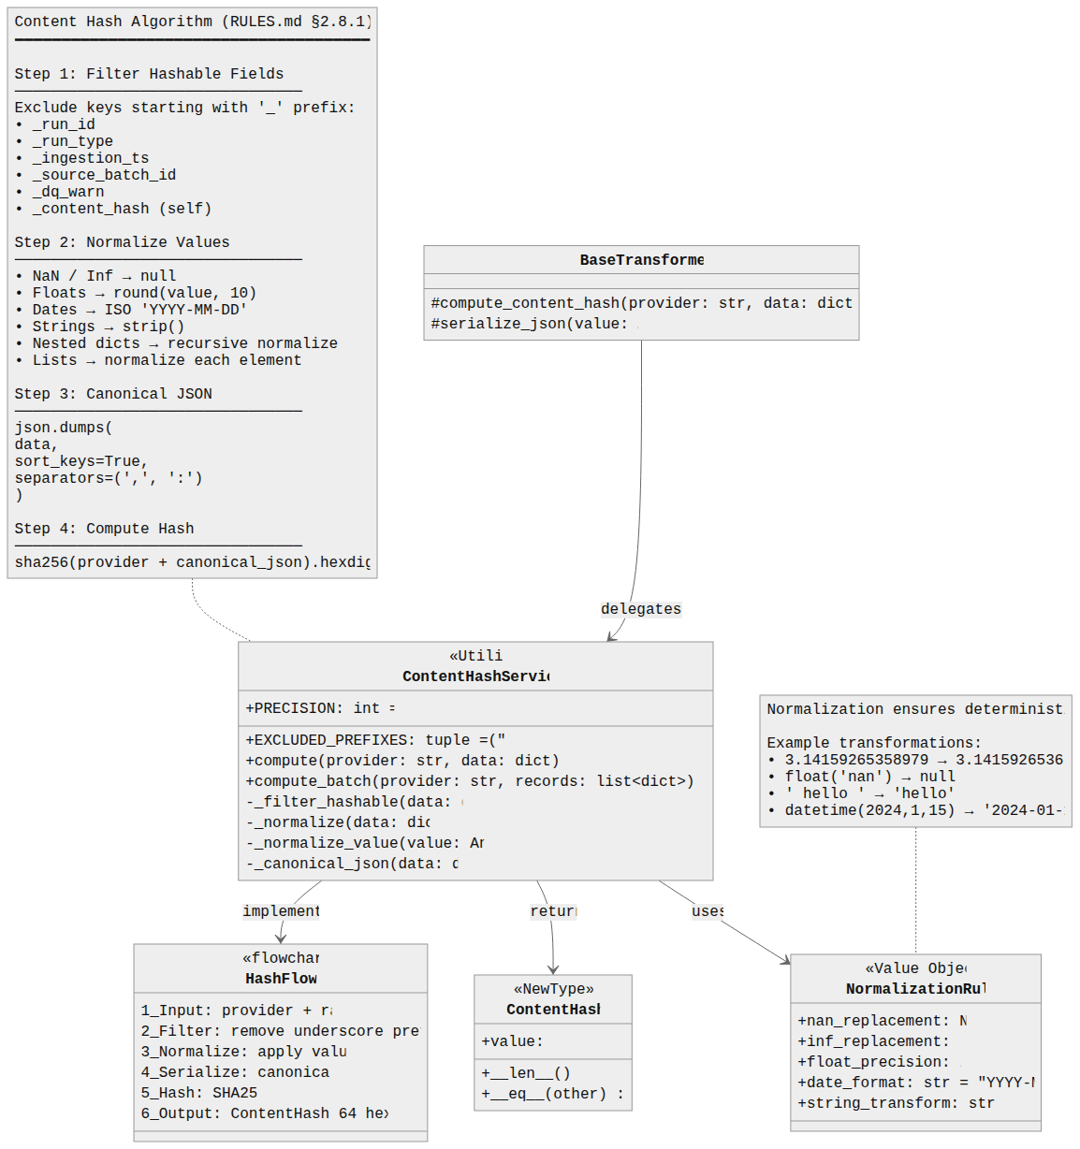
Figure 28: Hash Service Class Diagram

Mermaid Source
%%{init: {'theme': 'neutral', 'themeVariables': {'fontFamily': 'Inter, system-ui', 'lineWidth': '2'}}}%%
classDiagram
direction TB
class ContentHashService {
<<Utility>>
+PRECISION: int = 10
+EXCLUDED_PREFIXES: tuple = ("_",)
+compute(provider: str, data: dict) ContentHash
+compute_batch(provider: str, records: list~dict~) list~ContentHash~
-_filter_hashable(data: dict) dict
-_normalize(data: dict) dict
-_normalize_value(value: Any) Any
-_canonical_json(data: dict) str
}
class NormalizationRules {
<<Value Object>>
+nan_replacement: None
+inf_replacement: None
+float_precision: int = 10
+date_format: str = "YYYY-MM-DD"
+string_transform: str = "strip"
}
class ContentHash {
<<NewType>>
+value: str
+__len__() int
+__eq__(other) bool
}
class BaseTransformer {
#compute_content_hash(provider: str, data: dict) ContentHash
#serialize_json(value: Any) str
}
%% Relationships
ContentHashService --> NormalizationRules : uses
ContentHashService --> ContentHash : returns
BaseTransformer --> ContentHashService : delegates to
note for ContentHashService "Content Hash Algorithm (RULES.md §2.8.1)\n━━━━━━━━━━━━━━━━━━━━━━━━━━━━━━━━━━━━━━\n\nStep 1: Filter Hashable Fields\n────────────────────────────────\nExclude keys starting with '_' prefix:\n• _run_id\n• _run_type\n• _ingestion_ts\n• _source_batch_id\n• _dq_warn\n• _content_hash (self)\n\nStep 2: Normalize Values\n────────────────────────────────\n• NaN / Inf → null\n• Floats → round(value, 10)\n• Dates → ISO 'YYYY-MM-DD'\n• Strings → strip()\n• Nested dicts → recursive normalize\n• Lists → normalize each element\n\nStep 3: Canonical JSON\n────────────────────────────────\njson.dumps(\n data,\n sort_keys=True,\n separators=(',', ':')\n)\n\nStep 4: Compute Hash\n────────────────────────────────\nsha256(provider + canonical_json).hexdigest()"
note for NormalizationRules "Normalization ensures deterministic hashing.\n\nExample transformations:\n• 3.14159265358979 → 3.1415926536\n• float('nan') → null\n• ' hello ' → 'hello'\n• datetime(2024,1,15) → '2024-01-15'"
%% Implementation flow
class HashFlow {
<<flowchart>>
1_Input: provider + raw_data
2_Filter: remove underscore prefixed keys
3_Normalize: apply value rules
4_Serialize: canonical JSON
5_Hash: SHA256
6_Output: ContentHash 64 hex chars
}
ContentHashService --> HashFlow : implements

Monitoring & CI/CD
5 diagram(s) in this category.

Figure 29 -- Circuit Breaker State Machine
Source File | 07-circuit-breaker-states.mermaid
Category | Monitoring & CI/CD
Source Lines | 74
Rendered Size | 1560 x 1013 px

Description
Circuit breaker states: CLOSED (normal) -> OPEN (after 5 failures, 300s timeout) -> HALF_OPEN (probe) -> CLOSED/OPEN. Shows failure counting, recovery probing, and state transitions.

Rendered Diagram
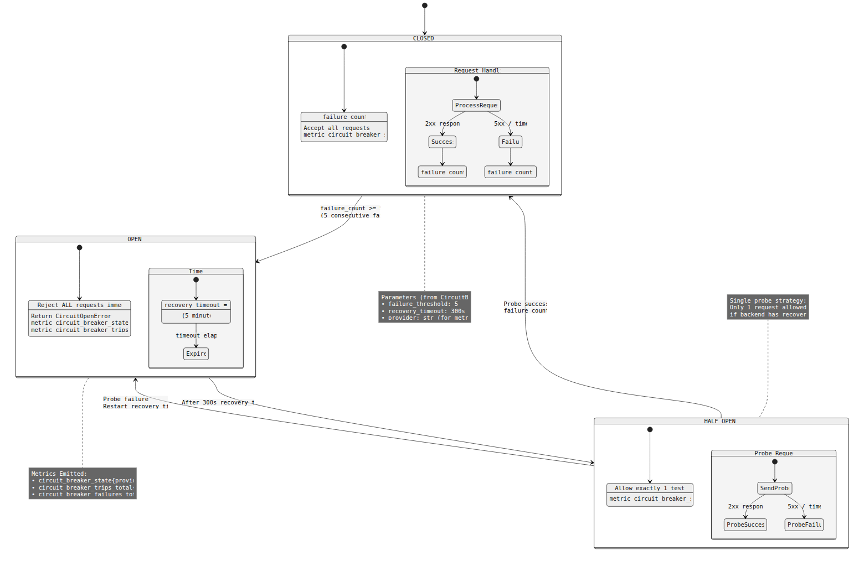
Figure 29: Circuit Breaker State Machine

Mermaid Source
%%{init: {'theme': 'neutral', 'themeVariables': {'fontFamily': 'Inter, system-ui', 'lineWidth': '2'}}}%%
stateDiagram-v2
[*] --> CLOSED
state CLOSED {
[*] --> Operational
Operational: failure_count = 0
Operational: Accept all requests
Operational: metric circuit_breaker_state = 0
state "Request Handling" as CH {
[*] --> ProcessRequest
ProcessRequest --> Success: 2xx response
ProcessRequest --> Failure: 5xx / timeout
Success --> RecordSuccess
Failure --> RecordFailure
RecordSuccess: failure_count = 0
RecordFailure: failure_count += 1
}
}
CLOSED --> OPEN: failure_count >= 5\n(5 consecutive failures)
state OPEN {
[*] --> Blocking
Blocking: Reject ALL requests immediately
Blocking: Return CircuitOpenError
Blocking: metric circuit_breaker_state = 2
Blocking: metric circuit_breaker_trips_total += 1
state "Timer" as OT {
[*] --> Waiting
Waiting: recovery_timeout = 300s
Waiting: (5 minutes)
Waiting --> Expired: timeout elapsed
}
}
OPEN --> HALF_OPEN: After 300s recovery_timeout
state HALF_OPEN {
[*] --> Probing
Probing: Allow exactly 1 test request
Probing: metric circuit_breaker_state = 1
state "Probe Request" as HP {
[*] --> SendProbe
SendProbe --> ProbeSuccess: 2xx response
SendProbe --> ProbeFailure: 5xx / timeout
}
}
HALF_OPEN --> CLOSED: Probe success\nfailure_count = 0
HALF_OPEN --> OPEN: Probe failure\nRestart recovery_timeout
note right of CLOSED
Parameters (from CircuitBreaker):
• failure_threshold: 5
• recovery_timeout: 300s
• provider: str (for metrics labels)
end note
note right of OPEN
Metrics Emitted:
• circuit_breaker_state{provider}
• circuit_breaker_trips_total{provider}
• circuit_breaker_failures_total{provider}
end note
note left of HALF_OPEN
Single probe strategy:
Only 1 request allowed to test
if backend has recovered
end note

Figure 30 -- Provider Health States
Source File | 14-provider-health-states.mermaid
Category | Monitoring & CI/CD
Source Lines | 97
Rendered Size | 1560 x 1086 px

Description
Health state management for all 7 data providers: HEALTHY, DEGRADED, UNHEALTHY states with transition conditions based on response times, error rates, and circuit breaker status.

Rendered Diagram
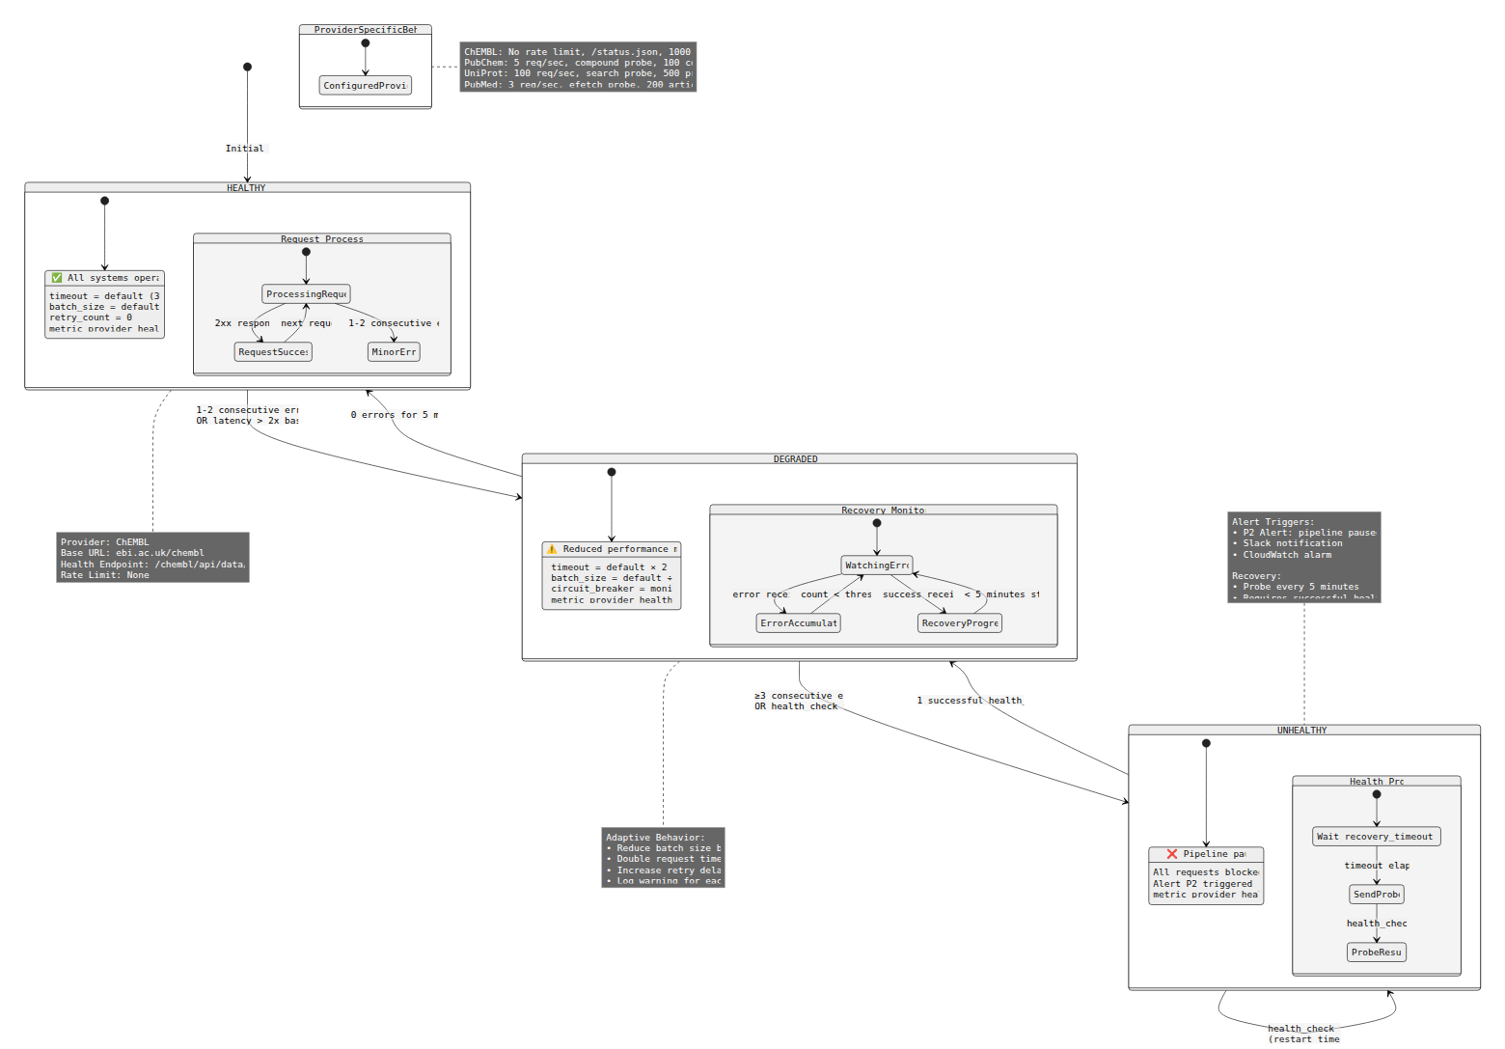
Figure 30: Provider Health States

Mermaid Source
%%{init: {'theme': 'neutral', 'themeVariables': {'fontFamily': 'Inter, system-ui', 'lineWidth': '2'}}}%%
stateDiagram-v2
[*] --> HEALTHY: Initial state
state HEALTHY {
[*] --> NormalOperation
NormalOperation: ✅ All systems operational
NormalOperation: timeout = default (30s)
NormalOperation: batch_size = default (1000)
NormalOperation: retry_count = 0
NormalOperation: metric provider_health = 2
state "Request Processing" as HP {
[*] --> ProcessingRequest
ProcessingRequest --> RequestSuccess: 2xx response
ProcessingRequest --> MinorError: 1-2 consecutive errors
RequestSuccess --> ProcessingRequest: next request
}
}
HEALTHY --> DEGRADED: 1-2 consecutive errors\nOR latency > 2x baseline
state DEGRADED {
[*] --> ReducedCapacity
ReducedCapacity: ⚠️ Reduced performance mode
ReducedCapacity: timeout = default × 2 (60s)
ReducedCapacity: batch_size = default ÷ 2 (500)
ReducedCapacity: circuit_breaker = monitoring
ReducedCapacity: metric provider_health = 1
state "Recovery Monitoring" as DM {
[*] --> WatchingErrors
WatchingErrors --> ErrorAccumulating: error received
WatchingErrors --> RecoveryProgress: success received
ErrorAccumulating --> WatchingErrors: count < threshold
RecoveryProgress --> WatchingErrors: < 5 minutes stable
}
}
DEGRADED --> HEALTHY: 0 errors for 5 minutes
DEGRADED --> UNHEALTHY: ≥3 consecutive errors\nOR health_check fails
state UNHEALTHY {
[*] --> Paused
Paused: ❌ Pipeline paused
Paused: All requests blocked
Paused: Alert P2 triggered
Paused: metric provider_health = 0
state "Health Probe" as UH {
[*] --> WaitingForProbe
WaitingForProbe: Wait recovery_timeout (300s)
WaitingForProbe --> SendProbe: timeout elapsed
SendProbe --> ProbeResult: health_check()
}
}
UNHEALTHY --> DEGRADED: 1 successful health_check
UNHEALTHY --> UNHEALTHY: health_check fails\n(restart timer)
note right of HEALTHY
Provider: ChEMBL
Base URL: ebi.ac.uk/chembl
Health Endpoint: /chembl/api/data/status.json
Rate Limit: None
end note
note right of DEGRADED
Adaptive Behavior:
• Reduce batch size by 50%
• Double request timeout
• Increase retry delays
• Log warning for each error
end note
note left of UNHEALTHY
Alert Triggers:
• P2 Alert: pipeline paused
• Slack notification
• CloudWatch alarm
Recovery:
• Probe every 5 minutes
• Requires successful health_check
end note
%% Provider-specific configurations
note right of ProviderSpecificBehavior
ChEMBL: No rate limit, /status.json, 1000 records
PubChem: 5 req/sec, compound probe, 100 compounds
UniProt: 100 req/sec, search probe, 500 proteins
PubMed: 3 req/sec, efetch probe, 200 articles
end note
state ProviderSpecificBehavior {
[*] --> ConfiguredProviders
}

Figure 31 -- Data Quality Check Workflow
Source File | 15-dq-check-workflow.mermaid
Category | Monitoring & CI/CD
Source Lines | 96
Rendered Size | 1560 x 1175 px

Description
Data quality monitoring workflow: Bronze/Silver/Gold DQ analyzers, soft threshold (5% warning) and hard threshold (20% failure), DQ report generation, and quarantine handling.

Rendered Diagram
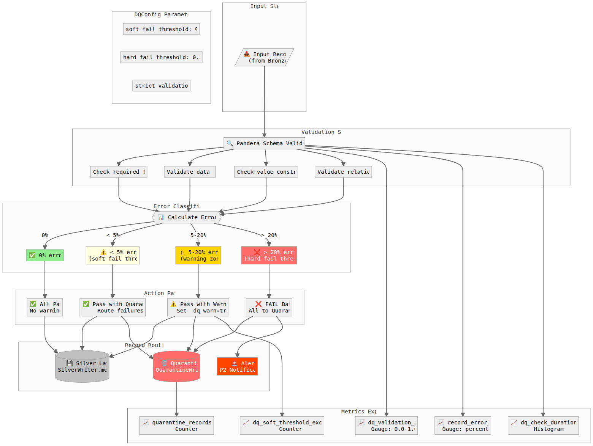
Figure 31: Data Quality Check Workflow

Mermaid Source
%%{init: {'theme': 'neutral', 'themeVariables': {'fontFamily': 'Inter, system-ui', 'lineWidth': '2'}}}%%
flowchart TD
subgraph Input["Input Stage"]
A[/"📥 Input Records<br/>(from Bronze)"/]
end
subgraph Validation["Validation Stage"]
B["🔍 Pandera Schema Validation"]
B1["Check required fields"]
B2["Validate data types"]
B3["Check value constraints"]
B4["Validate relationships"]
B --> B1
B --> B2
B --> B3
B --> B4
end
subgraph Classification["Error Classification"]
C{{"📊 Calculate Error Rate"}}
D["✅ 0% errors"]
E["⚠️ < 5% errors<br/>(soft_fail_threshold)"]
F["⚠️ 5-20% errors<br/>(warning zone)"]
G["❌ > 20% errors<br/>(hard_fail_threshold)"]
end
subgraph Actions["Action Paths"]
H["✅ All Pass<br/>No warnings"]
I["✅ Pass with Quarantine<br/>Route failures"]
J["⚠️ Pass with Warnings<br/>Set _dq_warn=true"]
K["❌ FAIL Batch<br/>All to Quarantine"]
end
subgraph Routing["Record Routing"]
L[("💾 Silver Layer<br/>SilverWriter.merge()")]
M[("🗑️ Quarantine<br/>QuarantineWriter")]
N["🚨 Alert<br/>P2 Notification"]
end
subgraph Metrics["Metrics Export"]
O["📈 dq_validation_score<br/>Gauge: 0.0-1.0"]
P["📈 record_error_rate<br/>Gauge: percentage"]
Q["📈 dq_check_duration_ms<br/>Histogram"]
R["📈 dq_soft_threshold_exceeded<br/>Counter"]
S["📈 quarantine_records_total<br/>Counter"]
end
%% Main flow
A --> B
B1 --> C
B2 --> C
B3 --> C
B4 --> C
C -->|"0%"| D
C -->|"< 5%"| E
C -->|"5-20%"| F
C -->|"> 20%"| G
D --> H
E --> I
F --> J
G --> K
H --> L
I --> L
I --> M
J --> L
J --> M
J --> R
K --> M
K --> N
%% Metrics connections
B --> O
B --> P
B --> Q
M --> S
%% Styling
style D fill:#90EE90,color:#000
style E fill:#FFFFE0,color:#000
style F fill:#FFD700,color:#000
style G fill:#FF6B6B,color:#fff
style L fill:#C0C0C0,color:#000
style M fill:#FF6B6B,color:#fff
style N fill:#FF4500,color:#fff
%% Configuration annotation
subgraph Config["DQConfig Parameters"]
direction LR
CFG1["soft_fail_threshold: 0.05 (5%)"]
CFG2["hard_fail_threshold: 0.20 (20%)"]
CFG3["strict_validation: false"]
end

Figure 32 -- Quarantine Record States
Source File | 20-quarantine-record-states.mermaid
Category | Monitoring & CI/CD
Source Lines | 118
Rendered Size | 1560 x 411 px

Description
State machine for quarantine records: NEW -> UNDER_REVIEW -> RESOLVED/DISCARDED with review workflow, age-based expiry (30 days), and reprocessing capabilities.

Rendered Diagram
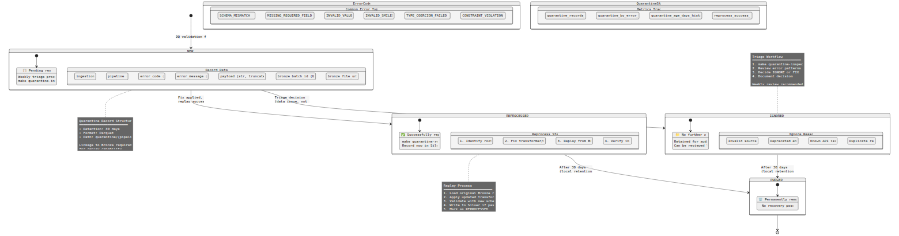
Figure 32: Quarantine Record States

Mermaid Source
%%{init: {'theme': 'neutral', 'themeVariables': {'fontFamily': 'Inter, system-ui', 'lineWidth': '2'}}}%%
stateDiagram-v2
[*] --> NEW: DQ validation failure
state NEW {
[*] --> AwaitingTriage
AwaitingTriage: 📋 Pending review
AwaitingTriage: Weekly triage process
AwaitingTriage: make quarantine-inspect
state "Record Details" as ND {
ND1: ingestion_ts
ND2: pipeline (str)
ND3: error_code (str)
ND4: error_message (str)
ND5: payload (str, truncated 64KB)
ND6: bronze_batch_id (UUID)
ND7: bronze_file_uri (str)
}
}
NEW --> IGNORED: Triage decision\n(data issue, not fixable)
NEW --> REPROCESSED: Fix applied,\nreplay successful
state IGNORED {
[*] --> Archived
Archived: 📁 No further action
Archived: Retained for audit trail
Archived: Can be reviewed later
state "Ignore Reasons" as IR {
IR1: Invalid source data
IR2: Deprecated entity
IR3: Known API issue
IR4: Duplicate record
}
}
state REPROCESSED {
[*] --> FixApplied
FixApplied: ✅ Successfully replayed
FixApplied: make quarantine-replay
FixApplied: Record now in Silver
state "Reprocess Steps" as RS {
RS1: 1. Identify root cause
RS2: 2. Fix transformer/schema
RS3: 3. Replay from Bronze
RS4: 4. Verify in Silver
}
}
IGNORED --> PURGED: After 30 days\n(local retention policy)
REPROCESSED --> PURGED: After 30 days\n(local retention policy)
state PURGED {
[*] --> Deleted
Deleted: 🗑️ Permanently removed
Deleted: No recovery possible
}
PURGED --> [*]
note right of NEW
Quarantine Record Structure
━━━━━━━━━━━━━━━━━━━━━━━━
• Retention: 30 days
• Format: Parquet
• Path: quarantine/{pipeline}/{date}/
Linkage to Bronze required
for replay capability
end note
note left of IGNORED
Triage Workflow
━━━━━━━━━━━━━━━━━━━━━━━━
1. make quarantine-inspect
2. Review error patterns
3. Decide IGNORE or FIX
4. Document decision
Weekly review recommended
end note
note right of REPROCESSED
Replay Process
━━━━━━━━━━━━━━━━━━━━━━━━
1. Load original Bronze record
2. Apply updated transformer
3. Validate with new schema
4. Write to Silver if pass
5. Mark as REPROCESSED
end note
%% Error codes section
state ErrorCodes {
state "Common Error Types" as CET {
E1: SCHEMA_MISMATCH
E2: MISSING_REQUIRED_FIELD
E3: INVALID_VALUE
E4: INVALID_SMILES
E5: TYPE_COERCION_FAILED
E6: CONSTRAINT_VIOLATION
}
}
%% Statistics and metrics section
state QuarantineStats {
state "Metrics Tracked" as MT {
M1: quarantine_records_total
M2: quarantine_by_error_code
M3: quarantine_age_days_histogram
M4: reprocess_success_rate
}
}

Figure 33 -- CircuitBreaker & Observer Class Diagram
Source File | 25-circuit-breaker-observer-class.mermaid
Category | Monitoring & CI/CD
Source Lines | 118
Rendered Size | 512 x 108 px

Description
Class diagram showing CircuitBreaker implementation with Observer pattern: state tracking, failure counting, recovery probing, and integration with PipelineObserver for metrics and tracing.

Rendered Diagram
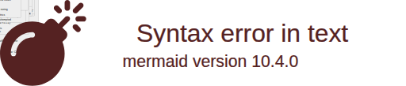
Figure 33: CircuitBreaker & Observer Class Diagram

Mermaid Source
%%{init: {'theme': 'neutral', 'themeVariables': {'fontFamily': 'Inter, system-ui', 'lineWidth': '2'}}}%%
classDiagram
direction TB
class CircuitState {
<<enumeration>>
CLOSED = 0
HALF_OPEN = 1
OPEN = 2
+is_allowing_requests() bool
+to_metric_value() int
}
class CircuitBreakerPort {
<<Protocol>>
+get_state() CircuitState
+get_failure_count() int
+call(func: Callable, *args, **kwargs) T
+reset() None
}
class CircuitBreaker {
-_state: CircuitState = CLOSED
-_failure_count: int = 0
-_success_count: int = 0
-_last_failure_time: datetime | None
-_last_state_change: datetime
-_failure_threshold: int = 5
-_recovery_timeout: int = 300
-_half_open_max_calls: int = 1
-_provider: str
-_metrics: MetricsPort | None
-_logger: LoggerPort | None
-_lock: asyncio.Lock
+get_state() CircuitState
+get_failure_count() int
+call(func: Callable, *args, **kwargs) T
+reset() None
+is_closed() bool
+is_open() bool
+is_half_open() bool
-_record_success() None
-_record_failure() None
-_should_trip() bool
-_should_attempt_reset() bool
-_transition_to(new_state: CircuitState) None
-_emit_state_metric() None
-_emit_trip_metric() None
-_log_state_change(old: CircuitState, new: CircuitState) None
}
class CircuitBreakerMetrics {
<<dataclass>>
+state_gauge: str = "circuit_breaker_state"
+trips_counter: str = "circuit_breaker_trips_total"
+failures_counter: str = "circuit_breaker_failures_total"
+calls_counter: str = "circuit_breaker_calls_total"
+success_counter: str = "circuit_breaker_success_total"
}
class CircuitBreakerConfig {
<<dataclass>>
+failure_threshold: int = 5
+recovery_timeout: int = 300
+half_open_max_calls: int = 1
+excluded_exceptions: tuple = ()
+from_provider(provider: str)$ CircuitBreakerConfig
}
class CircuitOpenError {
<<Exception>>
+provider: str
+state: CircuitState
+time_until_half_open: float
+message: str
}
class ProviderHealthTracker {
-_circuit_breakers: dict~str, CircuitBreaker~
-_health_states: dict~str, HealthState~
-_logger: LoggerPort
-_metrics: MetricsPort
+get_circuit_breaker(provider: str) CircuitBreaker
+get_health_state(provider: str) HealthState
+record_success(provider: str) None
+record_failure(provider: str, error: Exception) None
+is_healthy(provider: str) bool
}
class HealthState {
<<enumeration>>
HEALTHY = 2
DEGRADED = 1
UNHEALTHY = 0
}
%% Relationships
CircuitBreakerPort <|.. CircuitBreaker : implements
CircuitBreaker --> CircuitState : uses
CircuitBreaker --> CircuitBreakerMetrics : emits
CircuitBreaker --> CircuitBreakerConfig : configured by
CircuitBreaker ..> CircuitOpenError : throws
ProviderHealthTracker --> CircuitBreaker : manages
ProviderHealthTracker --> HealthState : tracks
note for CircuitBreaker "Circuit Breaker Implementation\n━━━━━━━━━━━━━━━━━━━━━━━━━━━━\n\nState Machine:\n┌────────┐ 5 failures ┌──────┐\n│ CLOSED │─────────────→│ OPEN │\n└────────┘ └──────┘\n ↑ │\n │ success │ 300s timeout\n │ ↓\n │ ┌───────────┐\n └────────────────│ HALF_OPEN │\n └───────────┘\n │\n failure\n ↓\n back to OPEN\n\nParameters (RULES.md §3.1.4):\n• failure_threshold: 5\n• recovery_timeout: 300s\n• Alert if OPEN > 10 min"
note for CircuitBreakerMetrics "Prometheus Metrics\n━━━━━━━━━━━━━━━━━━━━━━━━━━━━\n\ncircuit_breaker_state{provider}\n Gauge: 0=Closed, 1=Half-Open, 2=Open\n\ncircuit_breaker_trips_total{provider}\n Counter: Number of times opened\n\ncircuit_breaker_failures_total{provider}\n Counter: Total failures recorded\n\ncircuit_breaker_calls_total{provider}\n Counter: Total calls attempted"
note for CircuitOpenError "Raised when call attempted on OPEN circuit.\n\nContains:\n• Provider name for context\n• Time remaining until HALF_OPEN\n• Actionable error message"
note for ProviderHealthTracker "Centralized health management.\n\nTracks per-provider:\n• Circuit breaker state\n• Overall health status\n• Consecutive error count\n\nIntegrates with:\n• Adaptive batch sizing\n• Alert triggering\n• Dashboard metrics"

API & Integration
1 diagram(s) in this category.

Figure 34 -- Client API Request Sequence
Source File | 22-client-api-request-sequence.mermaid
Category | API & Integration
Source Lines | 105
Rendered Size | 1560 x 2034 px

Description
Sequence diagram for API client requests: rate limiting (token bucket), circuit breaker check, HTTP request with retries (exponential backoff), response parsing, and error classification.

Rendered Diagram
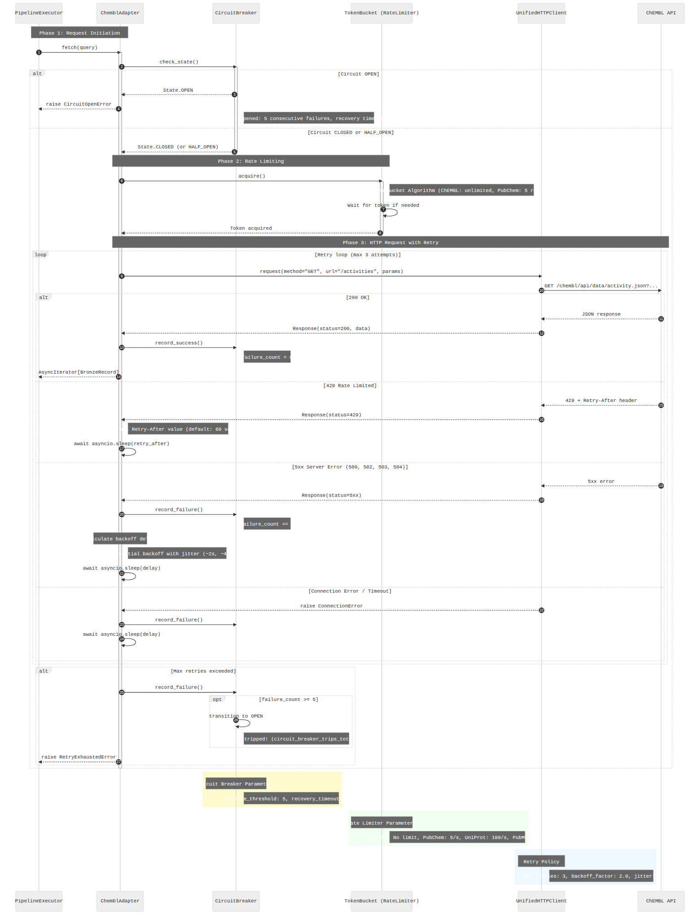
Figure 34: Client API Request Sequence

Mermaid Source
%%{init: {'theme': 'neutral', 'themeVariables': {'fontFamily': 'Inter, system-ui', 'lineWidth': '2'}}}%%
sequenceDiagram
autonumber
participant Executor as PipelineExecutor
participant Adapter as ChemblAdapter
participant CB as CircuitBreaker
participant RL as TokenBucket (RateLimiter)
participant HTTP as UnifiedHTTPClient
participant API as ChEMBL API
Note over Executor,Adapter: Phase 1: Request Initiation
Executor->>Adapter: fetch(query)
activate Adapter
Adapter->>CB: check_state()
activate CB
alt Circuit OPEN
CB-->>Adapter: State.OPEN
Adapter-->>Executor: raise CircuitOpenError
Note right of CB: Circuit opened: 5 consecutive failures, recovery timeout: 300s
else Circuit CLOSED or HALF_OPEN
CB-->>Adapter: State.CLOSED (or HALF_OPEN)
deactivate CB
Note over Adapter,RL: Phase 2: Rate Limiting
Adapter->>RL: acquire()
activate RL
Note right of RL: Token Bucket Algorithm (ChEMBL: unlimited, PubChem: 5 req/sec)
RL->>RL: Wait for token if needed
RL-->>Adapter: Token acquired
deactivate RL
Note over Adapter,API: Phase 3: HTTP Request with Retry
loop Retry loop (max 3 attempts)
Adapter->>HTTP: request(method="GET", url="/activities", params)
HTTP->>API: GET /chembl/api/data/activity.json?...
alt 200 OK
API-->>HTTP: JSON response
HTTP-->>Adapter: Response(status=200, data)
Adapter->>CB: record_success()
Note right of CB: failure_count = 0
Adapter-->>Executor: AsyncIterator[BronzeRecord]
else 429 Rate Limited
API-->>HTTP: 429 + Retry-After header
HTTP-->>Adapter: Response(status=429)
Note right of Adapter: Extract Retry-After value (default: 60 seconds)
Adapter->>Adapter: await asyncio.sleep(retry_after)
else 5xx Server Error (500, 502, 503, 504)
API-->>HTTP: 5xx error
HTTP-->>Adapter: Response(status=5xx)
Adapter->>CB: record_failure()
Note right of CB: failure_count += 1
Note over Adapter: Calculate backoff delay
Note right of Adapter: Exponential backoff with jitter (~2s, ~4s, ~8s)
Adapter->>Adapter: await asyncio.sleep(delay)
else Connection Error / Timeout
HTTP-->>Adapter: raise ConnectionError
Adapter->>CB: record_failure()
Adapter->>Adapter: await asyncio.sleep(delay)
end
end
alt Max retries exceeded
Adapter->>CB: record_failure()
opt failure_count >= 5
CB->>CB: transition to OPEN
Note right of CB: Circuit tripped! (circuit_breaker_trips_total += 1)
end
Adapter-->>Executor: raise RetryExhaustedError
end
end
deactivate Adapter
rect rgb(255, 250, 205)
Note over CB: Circuit Breaker Parameters
Note right of CB: failure_threshold: 5, recovery_timeout: 300s
end
rect rgb(240, 255, 240)
Note over RL: Rate Limiter Parameters
Note right of RL: ChEMBL: No limit, PubChem: 5/s, UniProt: 100/s, PubMed: 3/s
end
rect rgb(240, 248, 255)
Note over HTTP: Retry Policy
Note right of HTTP: max_retries: 3, backoff_factor: 2.0, jitter: 0.1-0.5
end

Verification Checklist
[x] Completeness: 34 .mermaid files found in repository, 34 included in document, 34 rendered to PNG, 0 failed/placeholder.
[x] Numbering: Figures numbered 1-34 without gaps or duplicates.
[x] Rendering: Each diagram rendered at minimum 1200px width (where Mermaid layout permits). Viewport: 1600x1200px.
[x] 34 vs 33 Discrepancy Resolution: Index claimed 34 files. Actual count: 34 .mermaid files. The 'missing' entry was 12-full-aws-deployment.mermaid (AWS deployment diagram, marked DEPRECATED per ADR-010). It was not listed in the user's extracted table but exists on disk.
[x] .mmd Placeholder Files: 22 .mmd files exist but contain only placeholder comments ('Placeholder diagram. The original .mmd source is not in the repo.'). These are NOT included as rendered diagrams.
[x] Embedded Mermaid Blocks: ~79 Mermaid blocks found embedded in 26 markdown documentation files outside the diagrams directory. These are inline documentation aids and are catalogued in the Appendix.
[x] Reproducibility: Document can be regenerated via: python scripts/generate_diagrams_docx.py

Appendix A: Embedded Mermaid Blocks in Documentation
The following markdown files outside docs/02-architecture/diagrams/ contain embedded Mermaid blocks (```mermaid). These are inline diagrams used for documentation context and are not standalone source files.
# | File Path | Mermaid Blocks
1 | docs/00-project/00-map.md | 1
2 | docs/00-project/agents/AGENT.md | 1
3 | docs/02-architecture/container-diagram.md | 1
4 | docs/02-architecture/data-flow.md | 3
5 | docs/02-architecture/diagrams.md | 7
6 | docs/02-architecture/observability-layers.md | 1
7 | docs/02-architecture/system-context.md | 1
8 | docs/03-guides/pipeline-lifecycle.md | 1
9 | docs/03-guides/publication-validation-guide.md | 1
10 | docs/04-reference/api/application.md | 2
11 | docs/04-reference/api/application/transformers.md | 1
12 | docs/04-reference/api/composition.md | 1
13 | docs/04-reference/api/composition/bootstrap.md | 1
14 | docs/04-reference/api/composition/factories.md | 1
15 | docs/04-reference/api/domain.md | 1
16 | docs/04-reference/api/domain/exceptions.md | 1
17 | docs/04-reference/api/index.md | 1
18 | docs/04-reference/api/infrastructure.md | 1
19 | docs/04-reference/api/infrastructure/adapters-common.md | 1
20 | docs/04-reference/api/infrastructure/storage.md | 1
21 | docs/04-reference/api/infrastructure/unified-http-client.md | 1
22 | docs/04-reference/pipelines/openalex-publication.md | 1
23 | docs/04-reference/pipelines/semanticscholar-publication.md | 1
24 | docs/99-archive/reports/documentation_merged.md | 1
Total embedded Mermaid blocks: 33 across 24 files.

