Dose-specific G-signaling Figures

Модель болевого синдрома, индуцированная введением формалина.
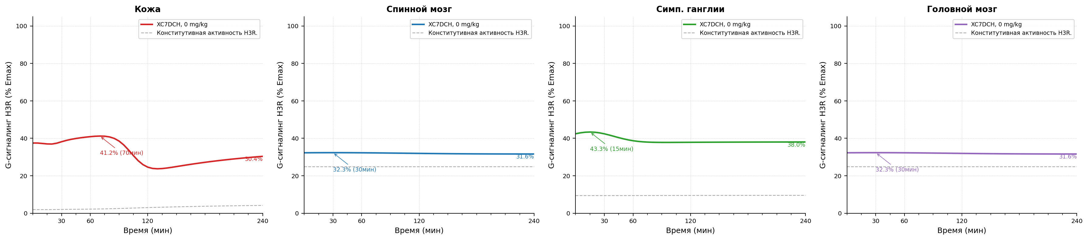
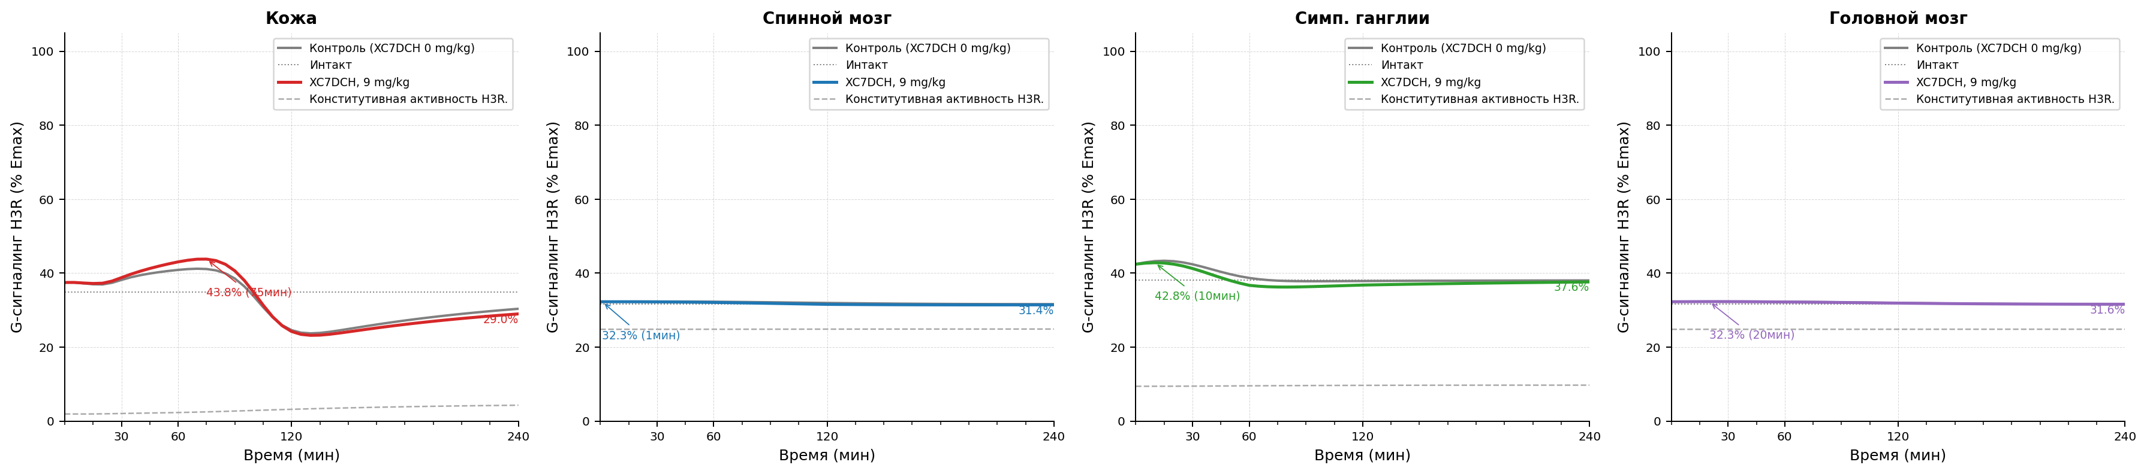
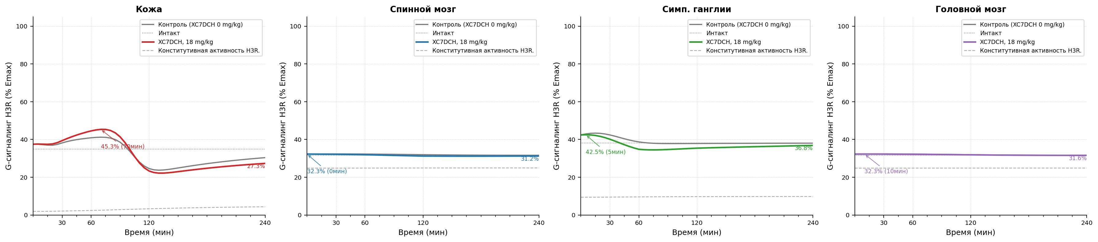
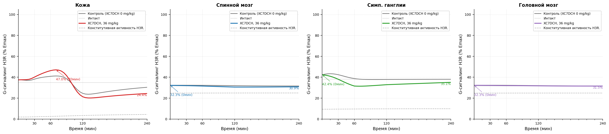
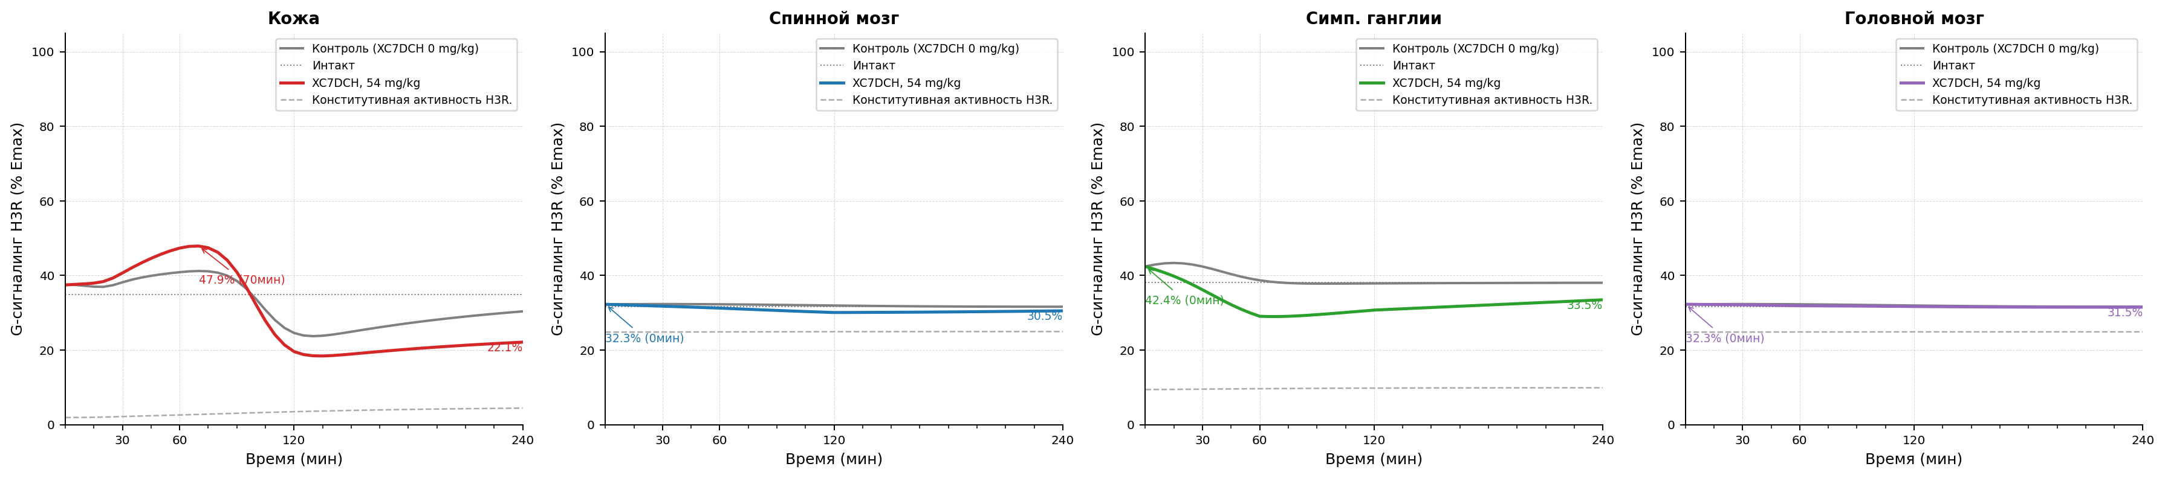
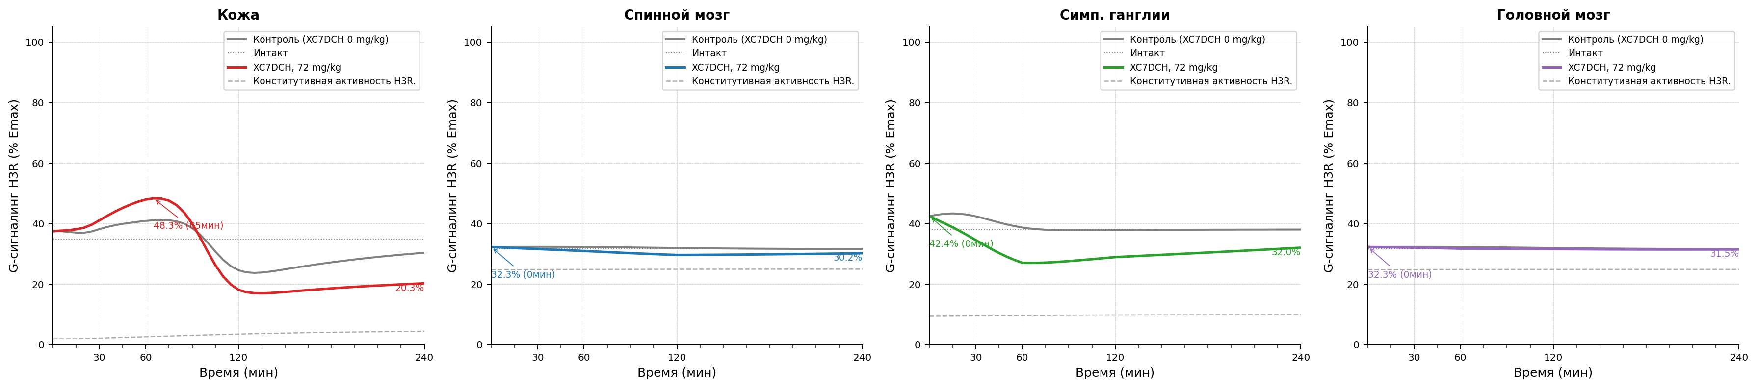
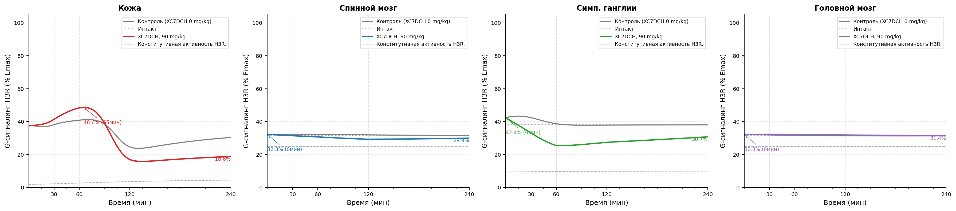
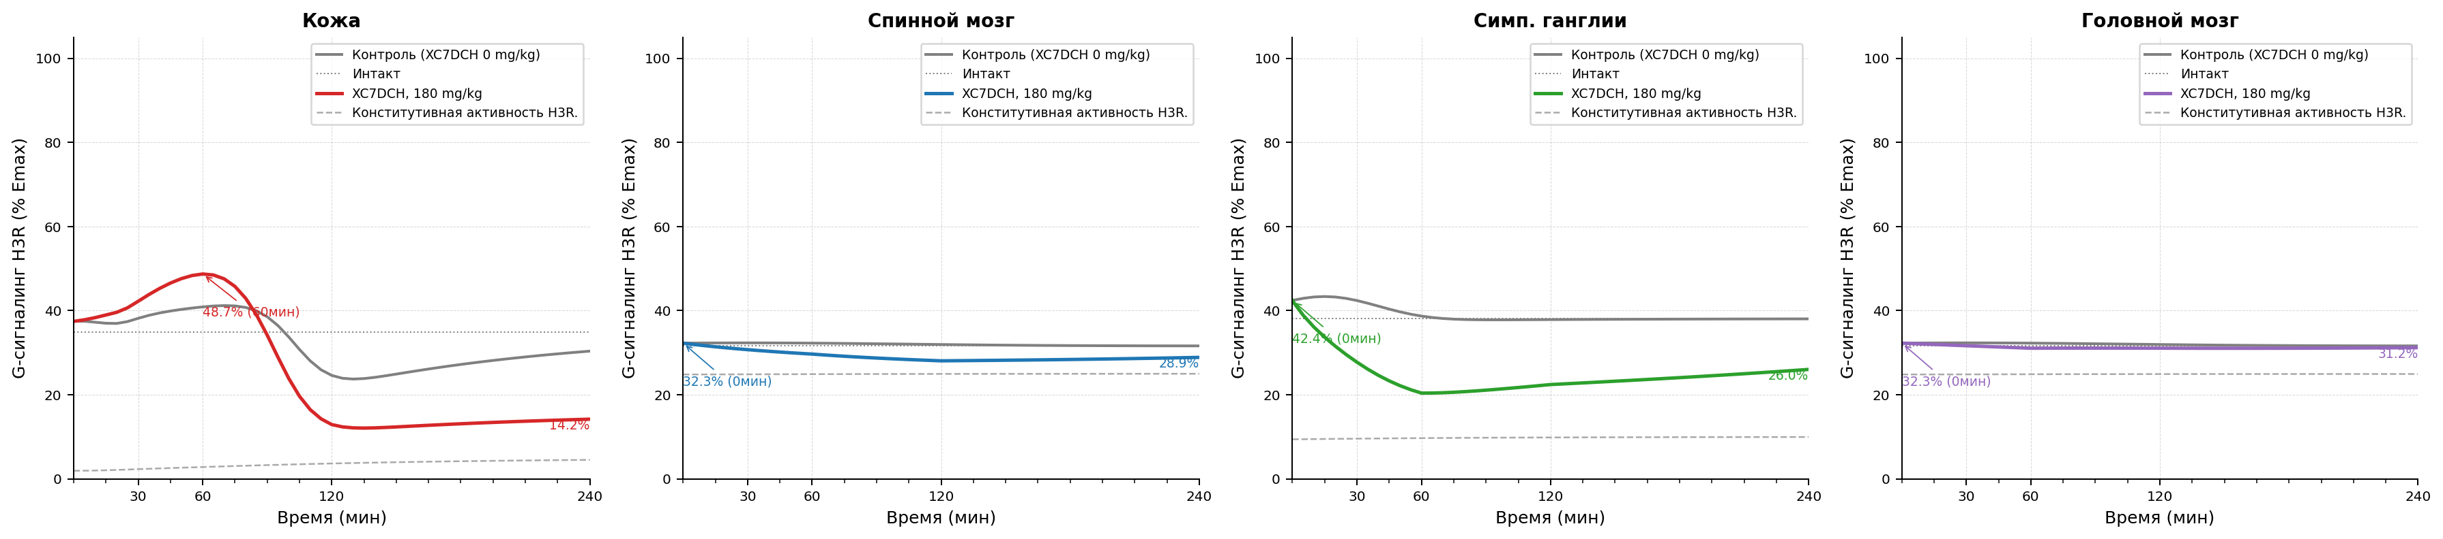
Рисунок 1.1 Модель болевого синдрома, индуцированная введением формалина. Уровень функциональной активности H3 рецепторов после индукции патологии. A - контроль патологии, B - XC7DCH в дозе 9 мг/кг, C - XC7DCH в дозе 18 мг/кг, D - XC7DCH в дозе 36 мг/кг, E - XC7DCH в дозе 54 мг/кг, F - XC7DCH в дозе 72 мг/кг, G - XC7DCH в дозе 90 мг/кг, H - XC7DCH в дозе 180 мг/кг.

Параметры конфигурации
Параметр | Значение
trafficking.k_int_max_per_h | 1.25
trafficking.k_rec_per_h | 0.5
trafficking.k_synth_per_h | 0.05
trafficking.ec50_barr_nm | 500.0
trafficking.kb_arr_nm | 600
trafficking.hill_n | 1.0
trafficking.ec50_g_nm | 20.0
trafficking.kb_g_nm | 6000.0
trafficking.constitutive_activity | 0.05
trafficking.h_base_nm | 10.0
antagonist_pk.enabled | true
antagonist_pk.source_xlsx | examples/configs/shared/SINGLE_REP_pred_mice_rats.xlsx
antagonist_pk.regimen | single
antagonist_pk.concentration_column | C_nM
antagonist_pk.method_time | linear
antagonist_pk.method_dose | log-linear
antagonist_pk.extrapolation | clip
antagonist_pk.tissue_map.skin | skin
antagonist_pk.tissue_map.muscle | muscles
antagonist_pk.tissue_map.spinal_coord | spinal cord
antagonist_pk.tissue_map.brain | brain
antagonist_pk.tissue_map.ganglia | sympathetic ganglia
antagonist_pk.tissue_map.peritoneum | peritoneum
tissue_overrides.skin.trafficking.k_int_max_per_h | 1.25
tissue_overrides.skin.trafficking.k_rec_per_h | 0.5
tissue_overrides.skin.trafficking.k_synth_per_h | 0.05
tissue_overrides.skin.trafficking.ec50_barr_nm | 500.0
tissue_overrides.skin.trafficking.hill_n | 1.0
tissue_overrides.skin.trafficking.ec50_g_nm | 20.0
tissue_overrides.skin.trafficking.constitutive_activity | 0.05
tissue_overrides.skin.trafficking.h_base_nm | 10.0
tissue_overrides.skin.formalin_profile.profile_shape | gaussian_sum
tissue_overrides.skin.formalin_profile.phase1.amplitude_nm | 990.0
tissue_overrides.skin.formalin_profile.phase1.center_min | 5.0
tissue_overrides.skin.formalin_profile.phase1.sigma_min | 7.6
tissue_overrides.skin.formalin_profile.phase2.amplitude_nm | 390.0
tissue_overrides.skin.formalin_profile.phase2.center_min | 40.0
tissue_overrides.skin.formalin_profile.phase2.sigma_min | 25.0
tissue_overrides.muscle.trafficking.k_int_max_per_h | 1.25
tissue_overrides.muscle.trafficking.k_rec_per_h | 0.5
tissue_overrides.muscle.trafficking.k_synth_per_h | 0.05
tissue_overrides.muscle.trafficking.ec50_barr_nm | 500.0
tissue_overrides.muscle.trafficking.hill_n | 1.0
tissue_overrides.muscle.trafficking.ec50_g_nm | 20.0
tissue_overrides.muscle.trafficking.constitutive_activity | 0.05
tissue_overrides.muscle.trafficking.h_base_nm | 10.0
tissue_overrides.spinal_coord.trafficking.k_int_max_per_h | 1.4
tissue_overrides.spinal_coord.trafficking.k_rec_per_h | 0.8
tissue_overrides.spinal_coord.trafficking.k_synth_per_h | 0.05
tissue_overrides.spinal_coord.trafficking.ec50_barr_nm | 500.0
tissue_overrides.spinal_coord.trafficking.hill_n | 1.0
tissue_overrides.spinal_coord.trafficking.ec50_g_nm | 20.0
tissue_overrides.spinal_coord.trafficking.constitutive_activity | 0.25
tissue_overrides.spinal_coord.trafficking.h_base_nm | 2.0
tissue_overrides.spinal_coord.formalin_profile.profile_shape | gaussian_sum
tissue_overrides.spinal_coord.formalin_profile.phase1.amplitude_nm | 0.246
tissue_overrides.spinal_coord.formalin_profile.phase1.center_min | 30.0
tissue_overrides.spinal_coord.formalin_profile.phase1.sigma_min | 73.9
tissue_overrides.spinal_coord.formalin_profile.phase2.amplitude_nm | 7.883
tissue_overrides.spinal_coord.formalin_profile.phase2.center_min | 120.0
tissue_overrides.spinal_coord.formalin_profile.phase2.sigma_min | 73.9
tissue_overrides.brain.trafficking.k_int_max_per_h | 1.4
tissue_overrides.brain.trafficking.k_rec_per_h | 0.8
tissue_overrides.brain.trafficking.k_synth_per_h | 0.05
tissue_overrides.brain.trafficking.ec50_barr_nm | 500.0
tissue_overrides.brain.trafficking.hill_n | 1.0
tissue_overrides.brain.trafficking.ec50_g_nm | 20.0
tissue_overrides.brain.trafficking.constitutive_activity | 0.25
tissue_overrides.brain.trafficking.h_base_nm | 2.0
tissue_overrides.brain.formalin_profile.profile_shape | gaussian_sum
tissue_overrides.brain.formalin_profile.phase1.amplitude_nm | 0.246
tissue_overrides.brain.formalin_profile.phase1.center_min | 30.0
tissue_overrides.brain.formalin_profile.phase1.sigma_min | 73.9
tissue_overrides.brain.formalin_profile.phase2.amplitude_nm | 7.883
tissue_overrides.brain.formalin_profile.phase2.center_min | 120.0
tissue_overrides.brain.formalin_profile.phase2.sigma_min | 73.9
tissue_overrides.ganglia.trafficking.k_int_max_per_h | 1.8
tissue_overrides.ganglia.trafficking.k_rec_per_h | 0.7
tissue_overrides.ganglia.trafficking.k_synth_per_h | 0.05
tissue_overrides.ganglia.trafficking.ec50_barr_nm | 500.0
tissue_overrides.ganglia.trafficking.hill_n | 1.0
tissue_overrides.ganglia.trafficking.ec50_g_nm | 20.0
tissue_overrides.ganglia.trafficking.constitutive_activity | 0.1
tissue_overrides.ganglia.trafficking.h_base_nm | 10.0
tissue_overrides.ganglia.formalin_profile.profile_shape | gaussian_sum
tissue_overrides.ganglia.formalin_profile.phase1.amplitude_nm | 3.426
tissue_overrides.ganglia.formalin_profile.phase1.center_min | 15.0
tissue_overrides.ganglia.formalin_profile.phase1.sigma_min | 23.8
tissue_overrides.ganglia.formalin_profile.phase2.amplitude_nm | 9.428
tissue_overrides.ganglia.formalin_profile.phase2.center_min | 60.0
tissue_overrides.ganglia.formalin_profile.phase2.sigma_min | 23.8
tissue_overrides.peritoneum.trafficking.k_int_max_per_h | 1.25
tissue_overrides.peritoneum.trafficking.k_rec_per_h | 0.5
tissue_overrides.peritoneum.trafficking.k_synth_per_h | 0.05
tissue_overrides.peritoneum.trafficking.ec50_barr_nm | 500.0
tissue_overrides.peritoneum.trafficking.hill_n | 1.0
tissue_overrides.peritoneum.trafficking.ec50_g_nm | 20.0
tissue_overrides.peritoneum.trafficking.constitutive_activity | 0.05
tissue_overrides.peritoneum.trafficking.h_base_nm | 10.0
time_grid | [0, 1, 5, 10, 15, 20, ..., 230, 235, 240] (len=50)
time_unit | min
model_id | formalin_pkpd_v1
compound | xc7
species | rat
loss_mode | mse
traceability.source_in_report | Scenario matrix row: formalin
traceability.source_reference
traceability.source_version | 2026-04-06
assumptions | ["canonical scenario_id formalin is used directly", "shared/common trafficking and top-level formalin_profile act as deterministic defaults before tissue_overrides, including tissue-specific profile_shape, are applied", "brain is included as a mandatory CNS tissue and currently uses a spinal_coord proxy profile until a source-backed brain profile is introduced", "formalin skin phase-1 half-life of 9 min is approximated as gaussian sigma_min=7.6", "phase-2 skin peak is encoded via formalin_profile amplitude override to reach 400 nM on a 50 nM baseline", "spinal_coord and ganglia phase centers are fixed at 30/120 min and 15/60 min respectively because the source table specifies peaks and t1/2 but not phase timing"]
driver.driver_type | scenario
driver.scenario_id | formalin
formalin_profile.phase1.amplitude_nm | 990.0
formalin_profile.phase1.sigma_min | 7.6
formalin_profile.phase2.amplitude_nm | 390.0
tissues | ["skin", "spinal_coord", "ganglia", "brain"]

Модель болевого синдрома, индуцированная введением Compound 48/80.
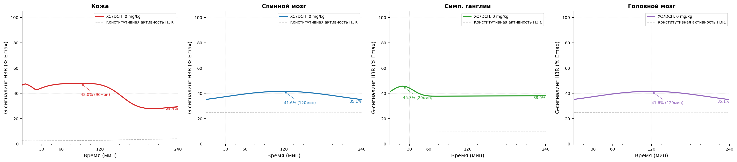
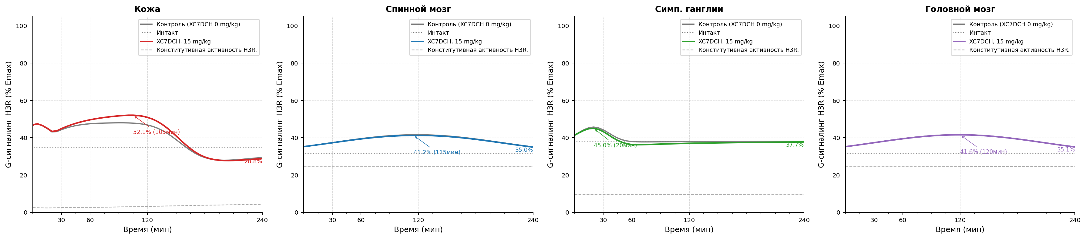
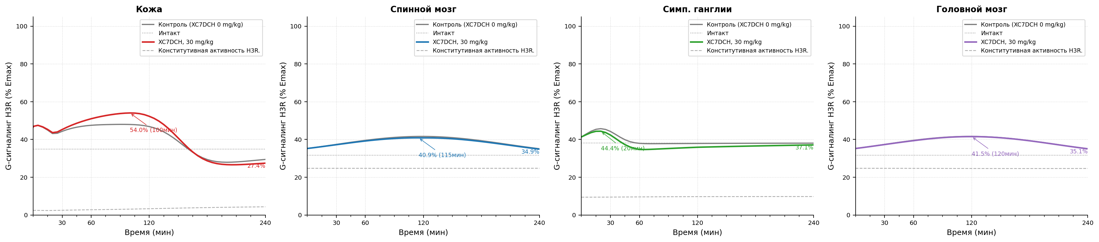
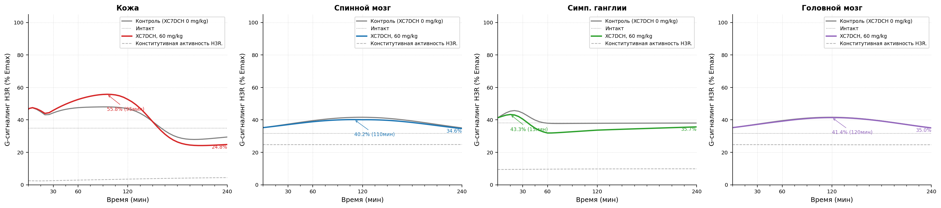
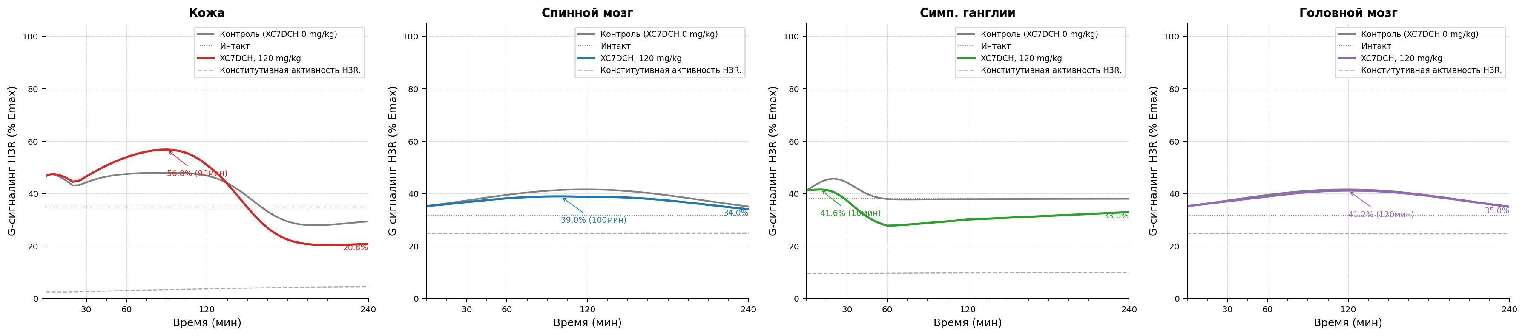
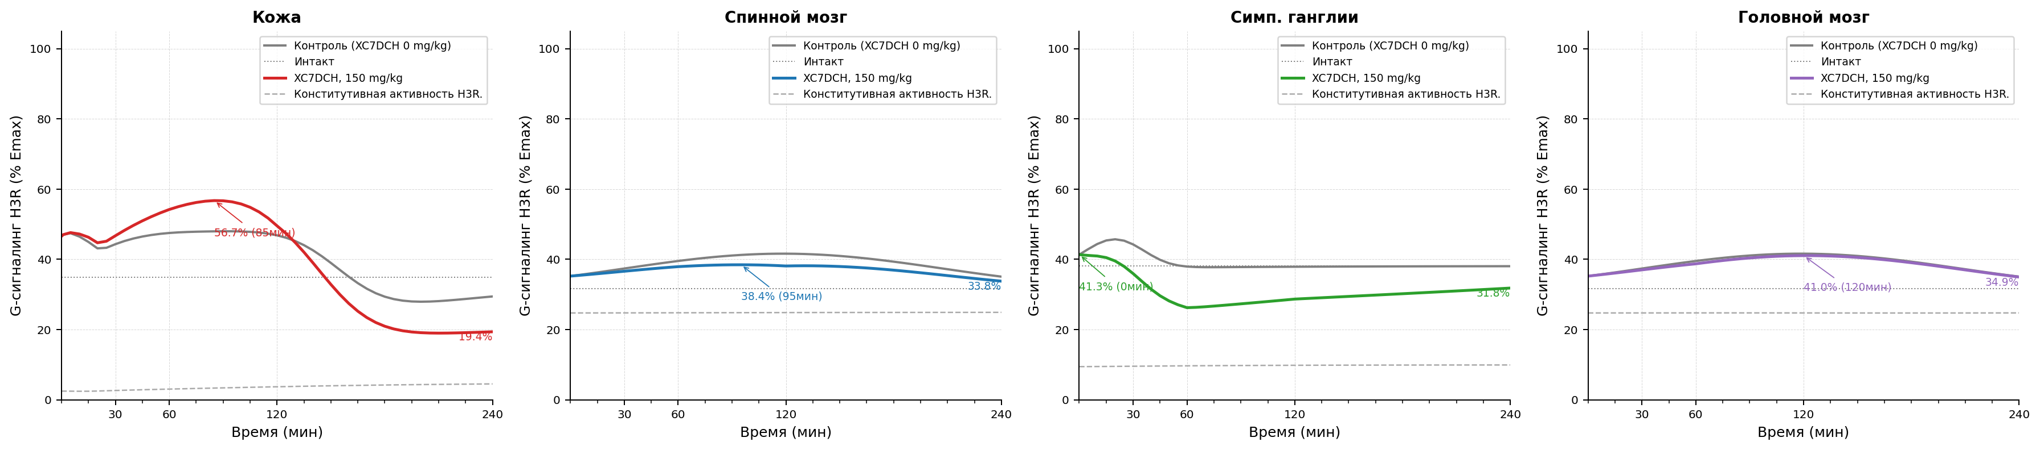
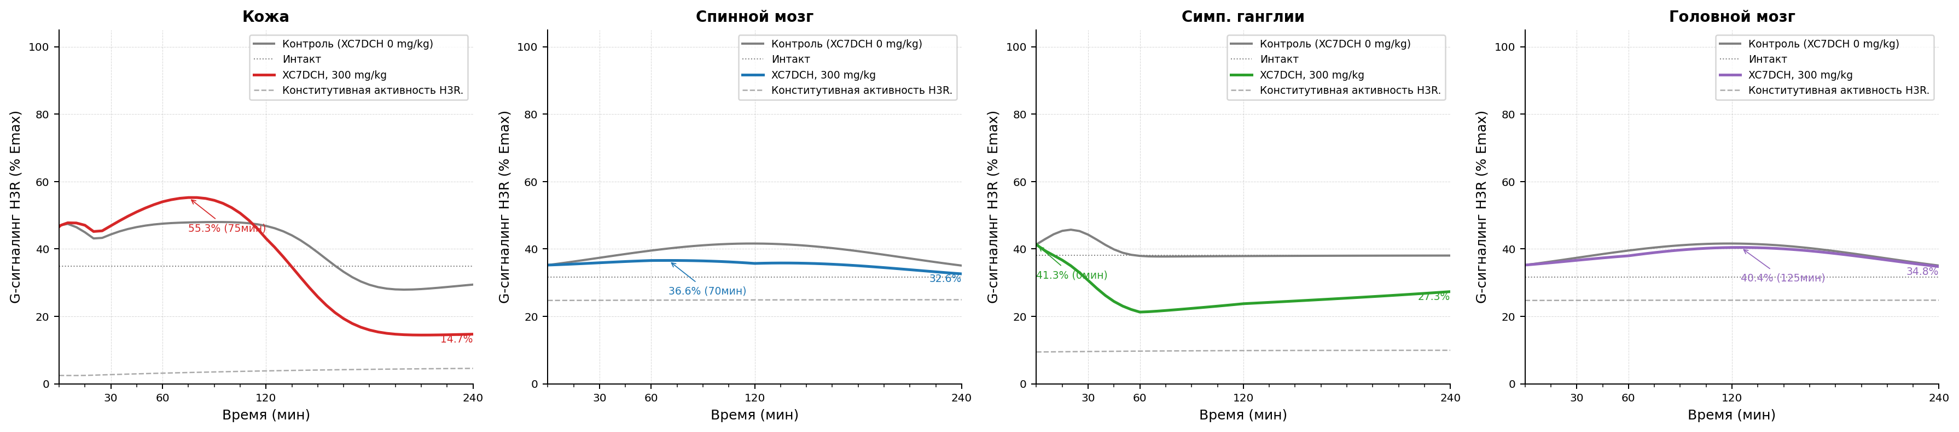
Рисунок 2.1 Модель болевого синдрома, индуцированная введением Compound 48/80. Уровень функциональной активности H3 рецепторов после индукции патологии. A - контроль патологии, B - XC7DCH в дозе 15 мг/кг, C - XC7DCH в дозе 30 мг/кг, D - XC7DCH в дозе 60 мг/кг, E - XC7DCH в дозе 120 мг/кг, F - XC7DCH в дозе 150 мг/кг, G - XC7DCH в дозе 300 мг/кг.

Параметры конфигурации
Параметр | Значение
trafficking.k_int_max_per_h | 1.25
trafficking.k_rec_per_h | 0.5
trafficking.k_synth_per_h | 0.05
trafficking.ec50_barr_nm | 500.0
trafficking.kb_arr_nm | 600
trafficking.hill_n | 1.0
trafficking.ec50_g_nm | 20.0
trafficking.kb_g_nm | 6000.0
trafficking.constitutive_activity | 0.05
trafficking.h_base_nm | 10.0
antagonist_pk.enabled | true
antagonist_pk.source_xlsx | examples/configs/shared/SINGLE_REP_pred_mice_rats.xlsx
antagonist_pk.regimen | single
antagonist_pk.concentration_column | C_nM
antagonist_pk.method_time | linear
antagonist_pk.method_dose | log-linear
antagonist_pk.extrapolation | clip
antagonist_pk.tissue_map.skin | skin
antagonist_pk.tissue_map.muscle | muscles
antagonist_pk.tissue_map.spinal_coord | spinal cord
antagonist_pk.tissue_map.brain | brain
antagonist_pk.tissue_map.ganglia | sympathetic ganglia
antagonist_pk.tissue_map.peritoneum | peritoneum
tissue_overrides.skin.trafficking.k_int_max_per_h | 1.25
tissue_overrides.skin.trafficking.k_rec_per_h | 0.5
tissue_overrides.skin.trafficking.k_synth_per_h | 0.05
tissue_overrides.skin.trafficking.ec50_barr_nm | 500.0
tissue_overrides.skin.trafficking.hill_n | 1.0
tissue_overrides.skin.trafficking.ec50_g_nm | 20.0
tissue_overrides.skin.trafficking.constitutive_activity | 0.05
tissue_overrides.skin.trafficking.h_base_nm | 10.0
tissue_overrides.muscle.trafficking.k_int_max_per_h | 1.25
tissue_overrides.muscle.trafficking.k_rec_per_h | 0.5
tissue_overrides.muscle.trafficking.k_synth_per_h | 0.05
tissue_overrides.muscle.trafficking.ec50_barr_nm | 500.0
tissue_overrides.muscle.trafficking.hill_n | 1.0
tissue_overrides.muscle.trafficking.ec50_g_nm | 20.0
tissue_overrides.muscle.trafficking.constitutive_activity | 0.05
tissue_overrides.muscle.trafficking.h_base_nm | 10.0
tissue_overrides.spinal_coord.trafficking.k_int_max_per_h | 1.4
tissue_overrides.spinal_coord.trafficking.k_rec_per_h | 0.8
tissue_overrides.spinal_coord.trafficking.k_synth_per_h | 0.05
tissue_overrides.spinal_coord.trafficking.ec50_barr_nm | 500.0
tissue_overrides.spinal_coord.trafficking.hill_n | 1.0
tissue_overrides.spinal_coord.trafficking.ec50_g_nm | 20.0
tissue_overrides.spinal_coord.trafficking.constitutive_activity | 0.25
tissue_overrides.spinal_coord.trafficking.h_base_nm | 2.0
tissue_overrides.brain.trafficking.k_int_max_per_h | 1.4
tissue_overrides.brain.trafficking.k_rec_per_h | 0.8
tissue_overrides.brain.trafficking.k_synth_per_h | 0.05
tissue_overrides.brain.trafficking.ec50_barr_nm | 500.0
tissue_overrides.brain.trafficking.hill_n | 1.0
tissue_overrides.brain.trafficking.ec50_g_nm | 20.0
tissue_overrides.brain.trafficking.constitutive_activity | 0.25
tissue_overrides.brain.trafficking.h_base_nm | 2.0
tissue_overrides.ganglia.trafficking.k_int_max_per_h | 1.8
tissue_overrides.ganglia.trafficking.k_rec_per_h | 0.7
tissue_overrides.ganglia.trafficking.k_synth_per_h | 0.05
tissue_overrides.ganglia.trafficking.ec50_barr_nm | 500.0
tissue_overrides.ganglia.trafficking.hill_n | 1.0
tissue_overrides.ganglia.trafficking.ec50_g_nm | 20.0
tissue_overrides.ganglia.trafficking.constitutive_activity | 0.1
tissue_overrides.ganglia.trafficking.h_base_nm | 10.0
tissue_overrides.peritoneum.trafficking.k_int_max_per_h | 1.25
tissue_overrides.peritoneum.trafficking.k_rec_per_h | 0.5
tissue_overrides.peritoneum.trafficking.k_synth_per_h | 0.05
tissue_overrides.peritoneum.trafficking.ec50_barr_nm | 500.0
tissue_overrides.peritoneum.trafficking.hill_n | 1.0
tissue_overrides.peritoneum.trafficking.ec50_g_nm | 20.0
tissue_overrides.peritoneum.trafficking.constitutive_activity | 0.05
tissue_overrides.peritoneum.trafficking.h_base_nm | 10.0
time_grid | [0, 1, 5, 10, 15, 20, ..., 230, 235, 240] (len=50)
time_unit | min
model_id | compound_48_80_pkpd_v1
compound | xc7
species | mouse
loss_mode | mse
traceability.source_in_report | Scenario matrix row: compound 48/80
traceability.source_reference
traceability.source_version | 2026-04-06
assumptions | ["canonical scenario_id compound_48_80 is used directly", "skin two-phase profile and CNS profiles are taken from scenario_registry as the source of truth", "brain is included as a mandatory CNS tissue and currently uses a spinal_coord proxy profile until a source-backed brain profile is introduced", "top-level trafficking acts as deterministic defaults before tissue_overrides are applied", "legacy file examples/configs/compound48_80.yaml is retained only as a compatibility example"]
driver.driver_type | scenario
driver.scenario_id | compound_48_80
tissues | ["skin", "spinal_coord", "ganglia", "brain"]

Модель болевого синдрома, индуцированная введением капсаицина.
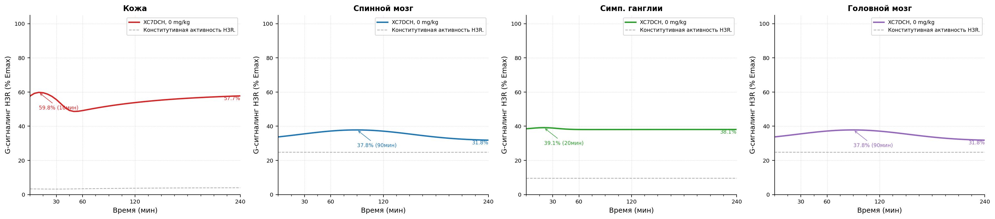
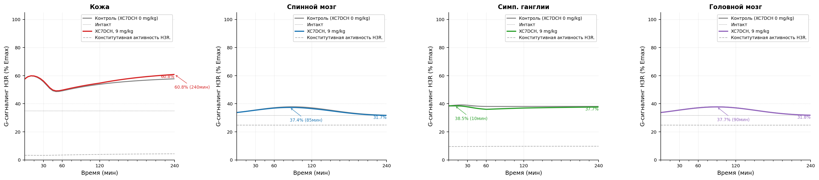
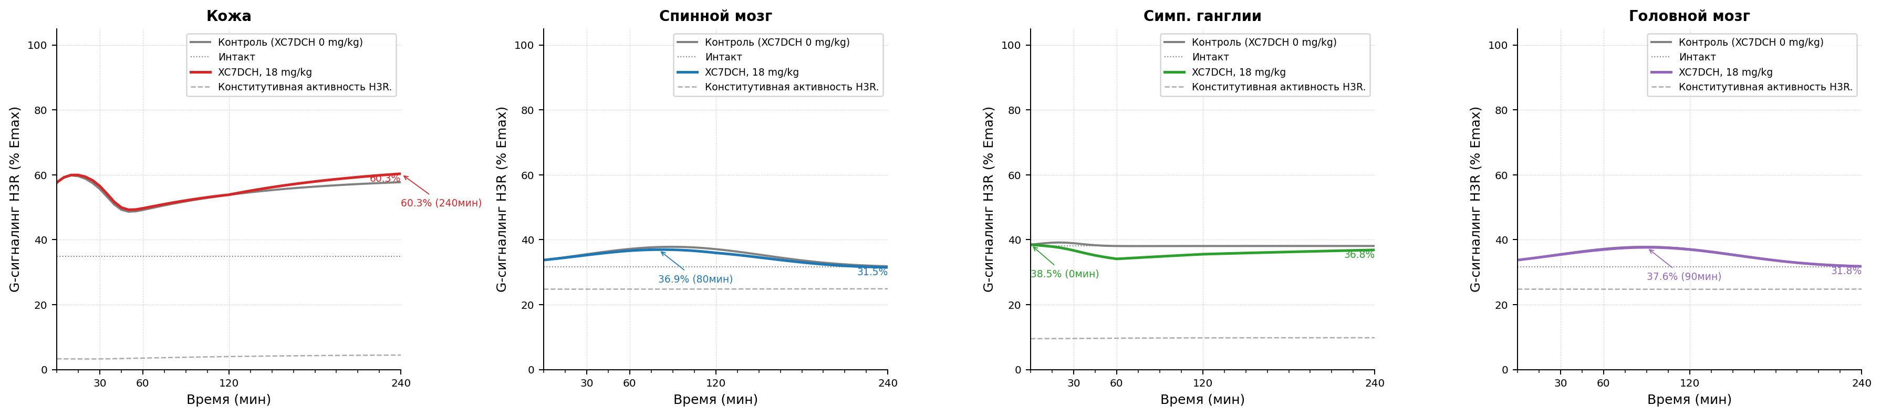
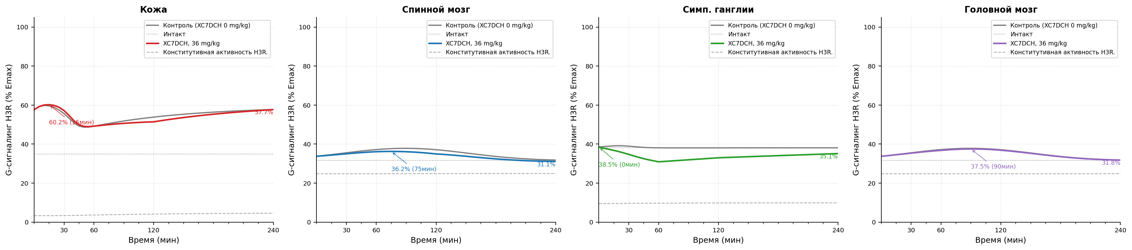
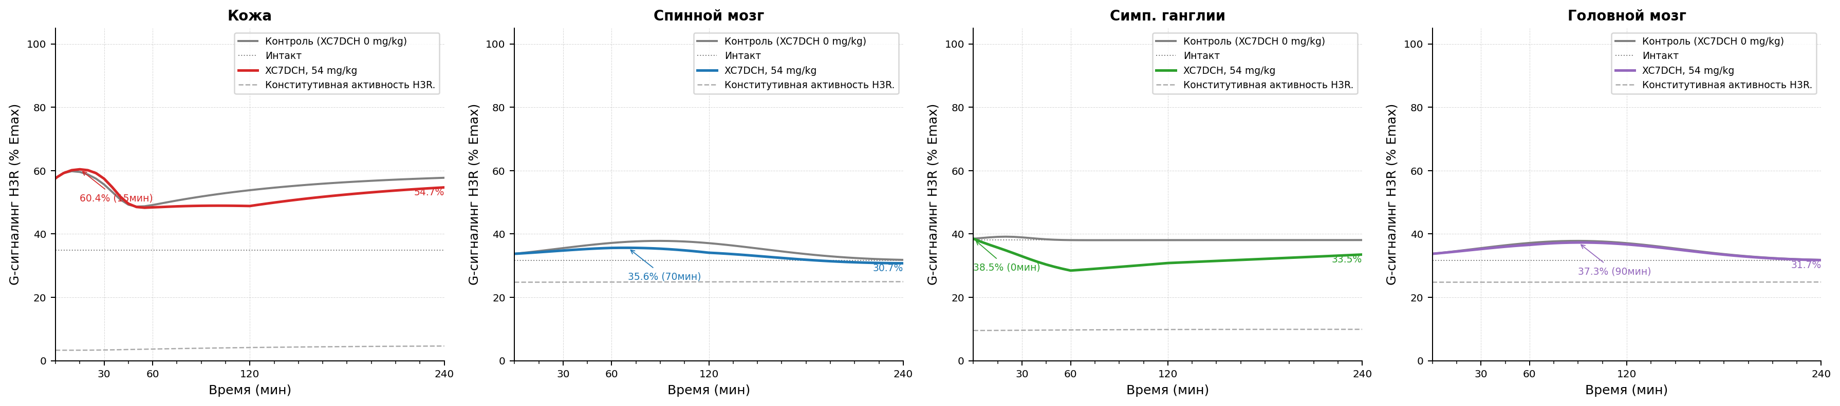
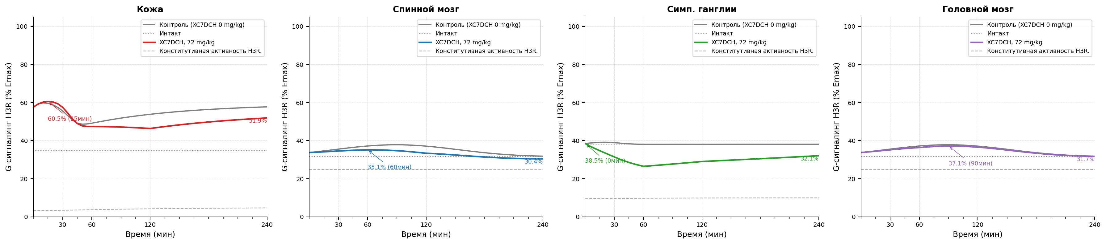
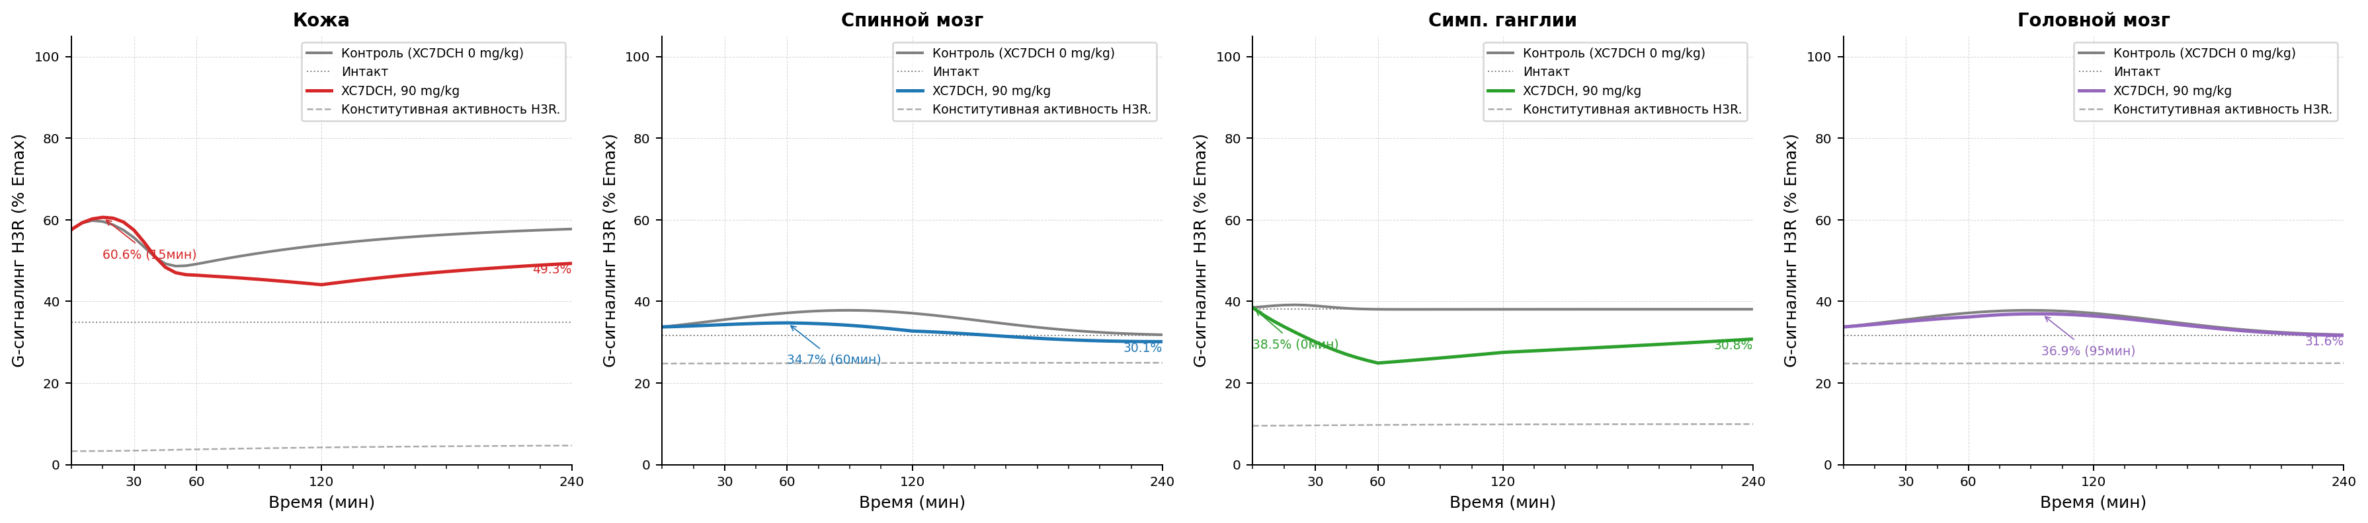
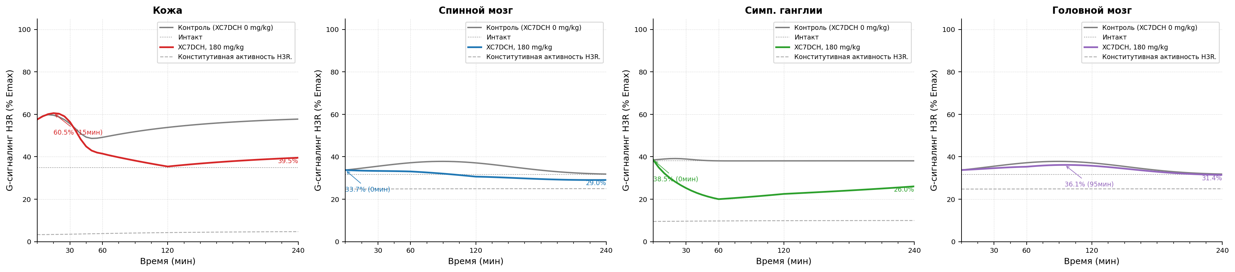
Рисунок 3.1 Модель болевого синдрома, индуцированная введением капсаицина. Уровень функциональной активности H3 рецепторов после индукции патологии. A - контроль патологии, B - XC7DCH в дозе 9 мг/кг, C - XC7DCH в дозе 18 мг/кг, D - XC7DCH в дозе 36 мг/кг, E - XC7DCH в дозе 54 мг/кг, F - XC7DCH в дозе 72 мг/кг, G - XC7DCH в дозе 90 мг/кг, H - XC7DCH в дозе 180 мг/кг.

Параметры конфигурации
Параметр | Значение
trafficking.k_int_max_per_h | 1.25
trafficking.k_rec_per_h | 0.5
trafficking.k_synth_per_h | 0.05
trafficking.ec50_barr_nm | 500.0
trafficking.kb_arr_nm | 600
trafficking.hill_n | 1.0
trafficking.ec50_g_nm | 20.0
trafficking.kb_g_nm | 6000.0
trafficking.constitutive_activity | 0.05
trafficking.h_base_nm | 10.0
antagonist_pk.enabled | true
antagonist_pk.source_xlsx | examples/configs/shared/SINGLE_REP_pred_mice_rats.xlsx
antagonist_pk.regimen | single
antagonist_pk.concentration_column | C_nM
antagonist_pk.method_time | linear
antagonist_pk.method_dose | log-linear
antagonist_pk.extrapolation | clip
antagonist_pk.tissue_map.skin | skin
antagonist_pk.tissue_map.muscle | muscles
antagonist_pk.tissue_map.spinal_coord | spinal cord
antagonist_pk.tissue_map.brain | brain
antagonist_pk.tissue_map.ganglia | sympathetic ganglia
antagonist_pk.tissue_map.peritoneum | peritoneum
tissue_overrides.skin.trafficking.k_int_max_per_h | 1.25
tissue_overrides.skin.trafficking.k_rec_per_h | 0.5
tissue_overrides.skin.trafficking.k_synth_per_h | 0.05
tissue_overrides.skin.trafficking.ec50_barr_nm | 500.0
tissue_overrides.skin.trafficking.hill_n | 1.0
tissue_overrides.skin.trafficking.ec50_g_nm | 20.0
tissue_overrides.skin.trafficking.constitutive_activity | 0.05
tissue_overrides.skin.trafficking.h_base_nm | 50.0
tissue_overrides.muscle.trafficking.k_int_max_per_h | 1.25
tissue_overrides.muscle.trafficking.k_rec_per_h | 0.5
tissue_overrides.muscle.trafficking.k_synth_per_h | 0.05
tissue_overrides.muscle.trafficking.ec50_barr_nm | 500.0
tissue_overrides.muscle.trafficking.hill_n | 1.0
tissue_overrides.muscle.trafficking.ec50_g_nm | 20.0
tissue_overrides.muscle.trafficking.constitutive_activity | 0.05
tissue_overrides.muscle.trafficking.h_base_nm | 10.0
tissue_overrides.spinal_coord.trafficking.k_int_max_per_h | 1.4
tissue_overrides.spinal_coord.trafficking.k_rec_per_h | 0.8
tissue_overrides.spinal_coord.trafficking.k_synth_per_h | 0.05
tissue_overrides.spinal_coord.trafficking.ec50_barr_nm | 500.0
tissue_overrides.spinal_coord.trafficking.hill_n | 1.0
tissue_overrides.spinal_coord.trafficking.ec50_g_nm | 20.0
tissue_overrides.spinal_coord.trafficking.constitutive_activity | 0.25
tissue_overrides.spinal_coord.trafficking.h_base_nm | 2.0
tissue_overrides.brain.trafficking.k_int_max_per_h | 1.4
tissue_overrides.brain.trafficking.k_rec_per_h | 0.8
tissue_overrides.brain.trafficking.k_synth_per_h | 0.05
tissue_overrides.brain.trafficking.ec50_barr_nm | 500.0
tissue_overrides.brain.trafficking.hill_n | 1.0
tissue_overrides.brain.trafficking.ec50_g_nm | 20.0
tissue_overrides.brain.trafficking.constitutive_activity | 0.25
tissue_overrides.brain.trafficking.h_base_nm | 2.0
tissue_overrides.ganglia.trafficking.k_int_max_per_h | 1.8
tissue_overrides.ganglia.trafficking.k_rec_per_h | 0.7
tissue_overrides.ganglia.trafficking.k_synth_per_h | 0.05
tissue_overrides.ganglia.trafficking.ec50_barr_nm | 500.0
tissue_overrides.ganglia.trafficking.hill_n | 1.0
tissue_overrides.ganglia.trafficking.ec50_g_nm | 20.0
tissue_overrides.ganglia.trafficking.constitutive_activity | 0.1
tissue_overrides.ganglia.trafficking.h_base_nm | 10.0
tissue_overrides.peritoneum.trafficking.k_int_max_per_h | 1.25
tissue_overrides.peritoneum.trafficking.k_rec_per_h | 0.5
tissue_overrides.peritoneum.trafficking.k_synth_per_h | 0.05
tissue_overrides.peritoneum.trafficking.ec50_barr_nm | 500.0
tissue_overrides.peritoneum.trafficking.hill_n | 1.0
tissue_overrides.peritoneum.trafficking.ec50_g_nm | 20.0
tissue_overrides.peritoneum.trafficking.constitutive_activity | 0.05
tissue_overrides.peritoneum.trafficking.h_base_nm | 10.0
time_grid | [0, 1, 5, 10, 15, 20, ..., 230, 235, 240] (len=50)
time_unit | min
model_id | capsaicin_pkpd_v1
compound | xc7
species | rat
loss_mode | mse
traceability.source_in_report | Scenario matrix row: capsaicin
traceability.source_reference
traceability.source_version | 2026-04-06
assumptions | ["canonical scenario_id capsaicin is used directly", "skin, spinal_coord, and ganglia H(t) profiles are taken from scenario_registry as the source of truth", "brain is included as a mandatory CNS tissue and currently uses a spinal_coord proxy profile until a source-backed brain profile is introduced", "top-level trafficking acts as deterministic defaults before tissue_overrides are applied", "skin h_base_nm is overridden to 50 nM so the marker-tissue H(t) peak matches the tabulated 227 nM at 15 min"]
driver.driver_type | scenario
driver.scenario_id | capsaicin
tissues | ["skin", "spinal_coord", "ganglia", "brain"]

Модель болевого синдрома, индуцированная введением карагенина.
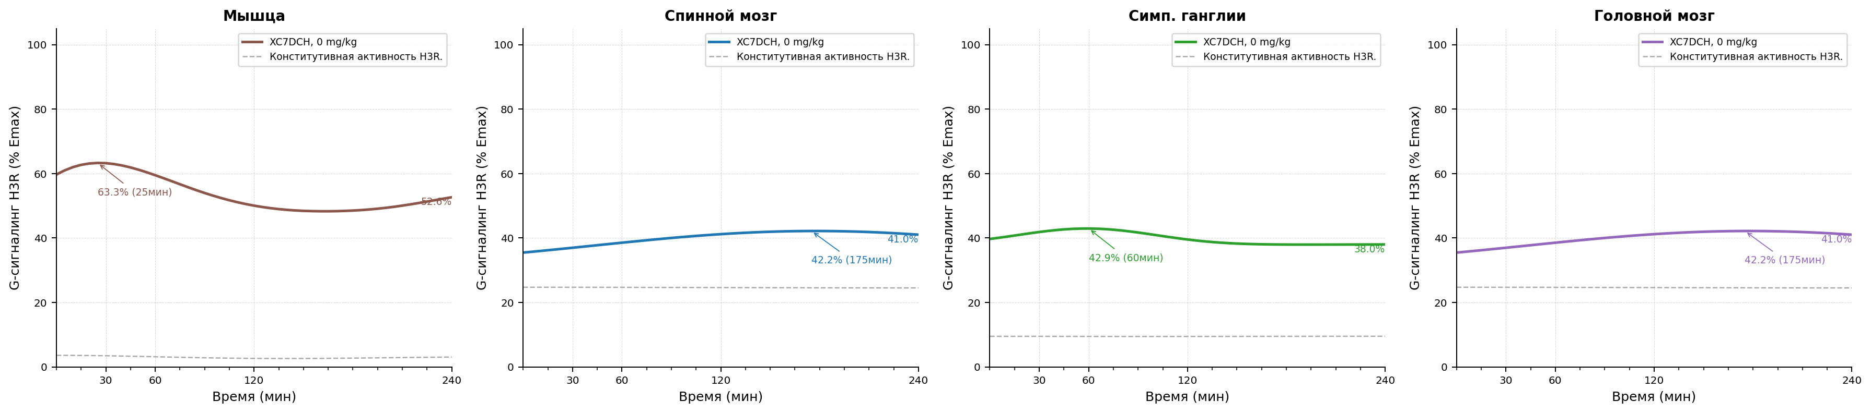
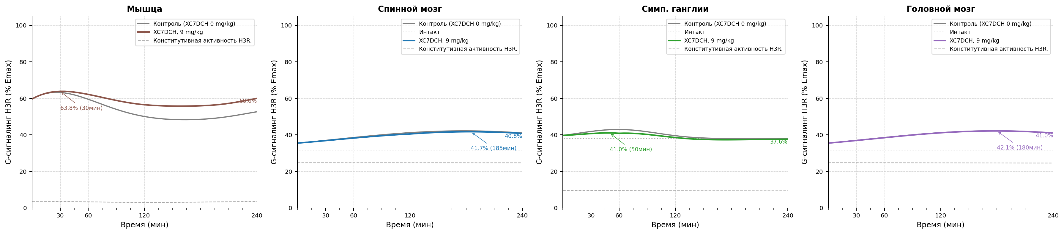
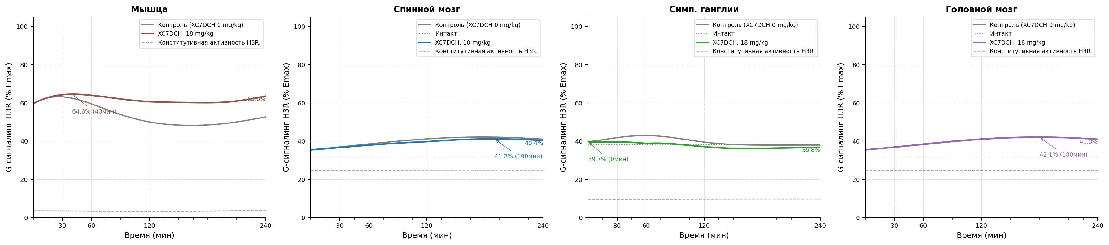
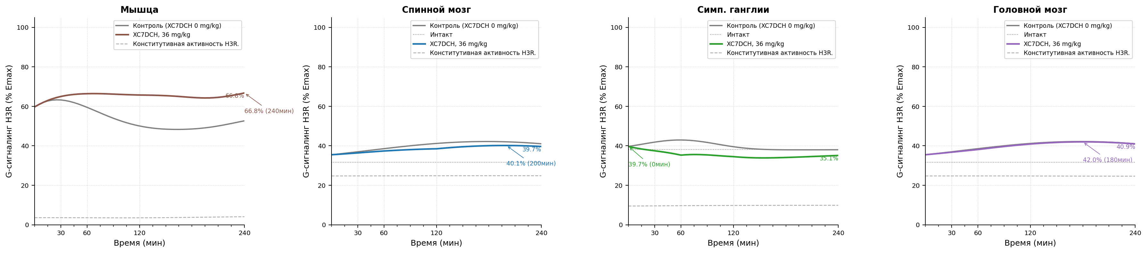
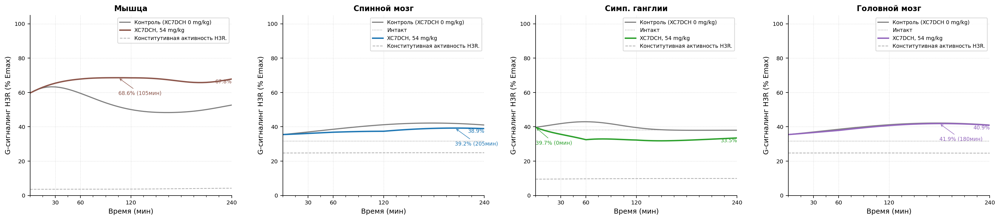
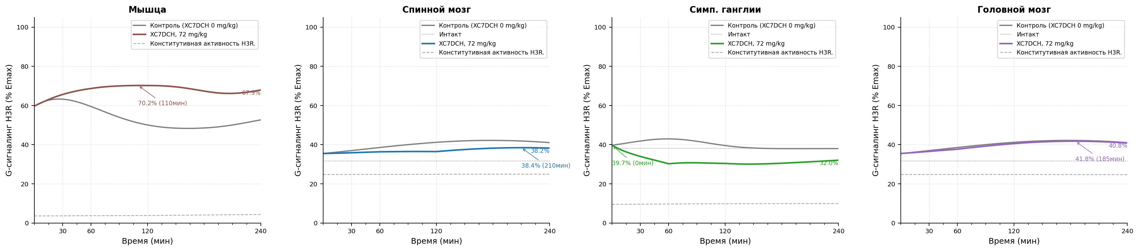
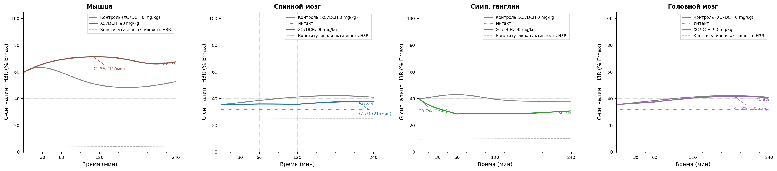
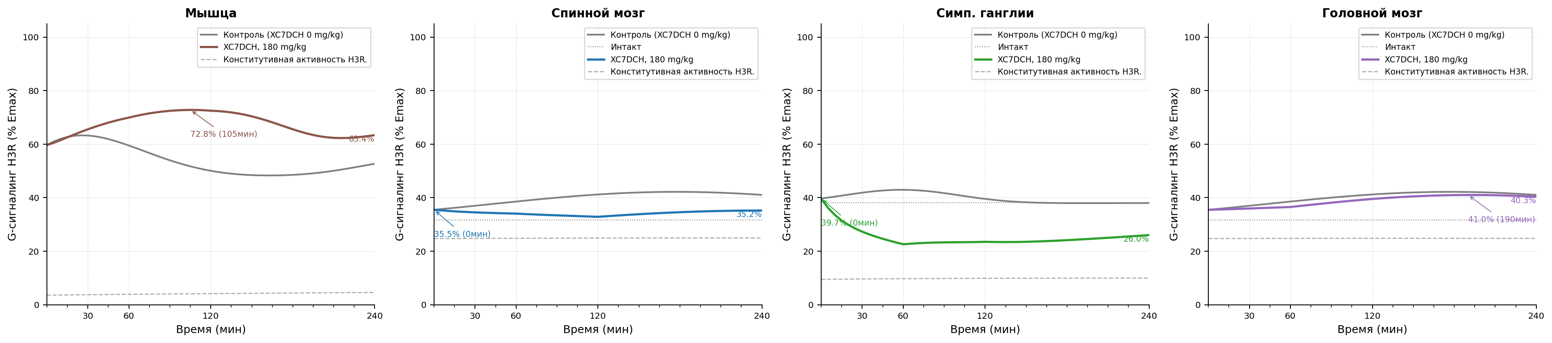
Рисунок 4.1 Модель болевого синдрома, индуцированная введением карагенина. Уровень функциональной активности H3 рецепторов после индукции патологии. A - контроль патологии, B - XC7DCH в дозе 9 мг/кг, C - XC7DCH в дозе 18 мг/кг, D - XC7DCH в дозе 36 мг/кг, E - XC7DCH в дозе 54 мг/кг, F - XC7DCH в дозе 72 мг/кг, G - XC7DCH в дозе 90 мг/кг, H - XC7DCH в дозе 180 мг/кг.

Параметры конфигурации
Параметр | Значение
trafficking.k_int_max_per_h | 1.25
trafficking.k_rec_per_h | 0.5
trafficking.k_synth_per_h | 0.05
trafficking.ec50_barr_nm | 500.0
trafficking.kb_arr_nm | 600
trafficking.hill_n | 1.0
trafficking.ec50_g_nm | 20.0
trafficking.kb_g_nm | 6000.0
trafficking.constitutive_activity | 0.05
trafficking.h_base_nm | 10.0
antagonist_pk.enabled | true
antagonist_pk.source_xlsx | examples/configs/shared/SINGLE_REP_pred_mice_rats.xlsx
antagonist_pk.regimen | single
antagonist_pk.concentration_column | C_nM
antagonist_pk.method_time | linear
antagonist_pk.method_dose | log-linear
antagonist_pk.extrapolation | clip
antagonist_pk.tissue_map.skin | skin
antagonist_pk.tissue_map.muscle | muscles
antagonist_pk.tissue_map.spinal_coord | spinal cord
antagonist_pk.tissue_map.brain | brain
antagonist_pk.tissue_map.ganglia | sympathetic ganglia
antagonist_pk.tissue_map.peritoneum | peritoneum
tissue_overrides.skin.trafficking.k_int_max_per_h | 1.25
tissue_overrides.skin.trafficking.k_rec_per_h | 0.5
tissue_overrides.skin.trafficking.k_synth_per_h | 0.05
tissue_overrides.skin.trafficking.ec50_barr_nm | 500.0
tissue_overrides.skin.trafficking.hill_n | 1.0
tissue_overrides.skin.trafficking.ec50_g_nm | 20.0
tissue_overrides.skin.trafficking.constitutive_activity | 0.05
tissue_overrides.skin.trafficking.h_base_nm | 10.0
tissue_overrides.muscle.trafficking.k_int_max_per_h | 1.25
tissue_overrides.muscle.trafficking.k_rec_per_h | 0.5
tissue_overrides.muscle.trafficking.k_synth_per_h | 0.05
tissue_overrides.muscle.trafficking.ec50_barr_nm | 500.0
tissue_overrides.muscle.trafficking.hill_n | 1.0
tissue_overrides.muscle.trafficking.ec50_g_nm | 20.0
tissue_overrides.muscle.trafficking.constitutive_activity | 0.05
tissue_overrides.muscle.trafficking.h_base_nm | 10.0
tissue_overrides.spinal_coord.trafficking.k_int_max_per_h | 1.4
tissue_overrides.spinal_coord.trafficking.k_rec_per_h | 0.8
tissue_overrides.spinal_coord.trafficking.k_synth_per_h | 0.05
tissue_overrides.spinal_coord.trafficking.ec50_barr_nm | 500.0
tissue_overrides.spinal_coord.trafficking.hill_n | 1.0
tissue_overrides.spinal_coord.trafficking.ec50_g_nm | 20.0
tissue_overrides.spinal_coord.trafficking.constitutive_activity | 0.25
tissue_overrides.spinal_coord.trafficking.h_base_nm | 2.0
tissue_overrides.brain.trafficking.k_int_max_per_h | 1.4
tissue_overrides.brain.trafficking.k_rec_per_h | 0.8
tissue_overrides.brain.trafficking.k_synth_per_h | 0.05
tissue_overrides.brain.trafficking.ec50_barr_nm | 500.0
tissue_overrides.brain.trafficking.hill_n | 1.0
tissue_overrides.brain.trafficking.ec50_g_nm | 20.0
tissue_overrides.brain.trafficking.constitutive_activity | 0.25
tissue_overrides.brain.trafficking.h_base_nm | 2.0
tissue_overrides.ganglia.trafficking.k_int_max_per_h | 1.8
tissue_overrides.ganglia.trafficking.k_rec_per_h | 0.7
tissue_overrides.ganglia.trafficking.k_synth_per_h | 0.05
tissue_overrides.ganglia.trafficking.ec50_barr_nm | 500.0
tissue_overrides.ganglia.trafficking.hill_n | 1.0
tissue_overrides.ganglia.trafficking.ec50_g_nm | 20.0
tissue_overrides.ganglia.trafficking.constitutive_activity | 0.1
tissue_overrides.ganglia.trafficking.h_base_nm | 10.0
tissue_overrides.peritoneum.trafficking.k_int_max_per_h | 1.25
tissue_overrides.peritoneum.trafficking.k_rec_per_h | 0.5
tissue_overrides.peritoneum.trafficking.k_synth_per_h | 0.05
tissue_overrides.peritoneum.trafficking.ec50_barr_nm | 500.0
tissue_overrides.peritoneum.trafficking.hill_n | 1.0
tissue_overrides.peritoneum.trafficking.ec50_g_nm | 20.0
tissue_overrides.peritoneum.trafficking.constitutive_activity | 0.05
tissue_overrides.peritoneum.trafficking.h_base_nm | 10.0
time_grid | [0, 1, 5, 10, 15, 20, ..., 230, 235, 240] (len=50)
time_unit | min
model_id | carrageenan_pkpd_v1
compound | xc7
species | rat
loss_mode | mse
traceability.source_in_report | Scenario matrix row: carrageenan
traceability.source_reference
traceability.source_version | 2026-04-06
assumptions | ["canonical scenario_id carrageenan is used directly", "muscle is used as the marker tissue because the source table points to m. gastrocnemius", "early and late muscle phases are taken from scenario_registry as the source of truth", "brain is included as a mandatory CNS tissue and currently uses a spinal_coord proxy profile until a source-backed brain profile is introduced", "top-level trafficking acts as deterministic defaults before tissue_overrides are applied"]
driver.driver_type | scenario
driver.scenario_id | carrageenan
tissues | ["muscle", "spinal_coord", "ganglia", "brain"]

Модель болевого синдрома, индуцированная термическим воздействием в тесте «Горячая пластина».
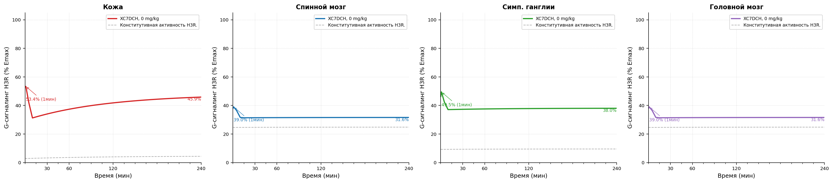
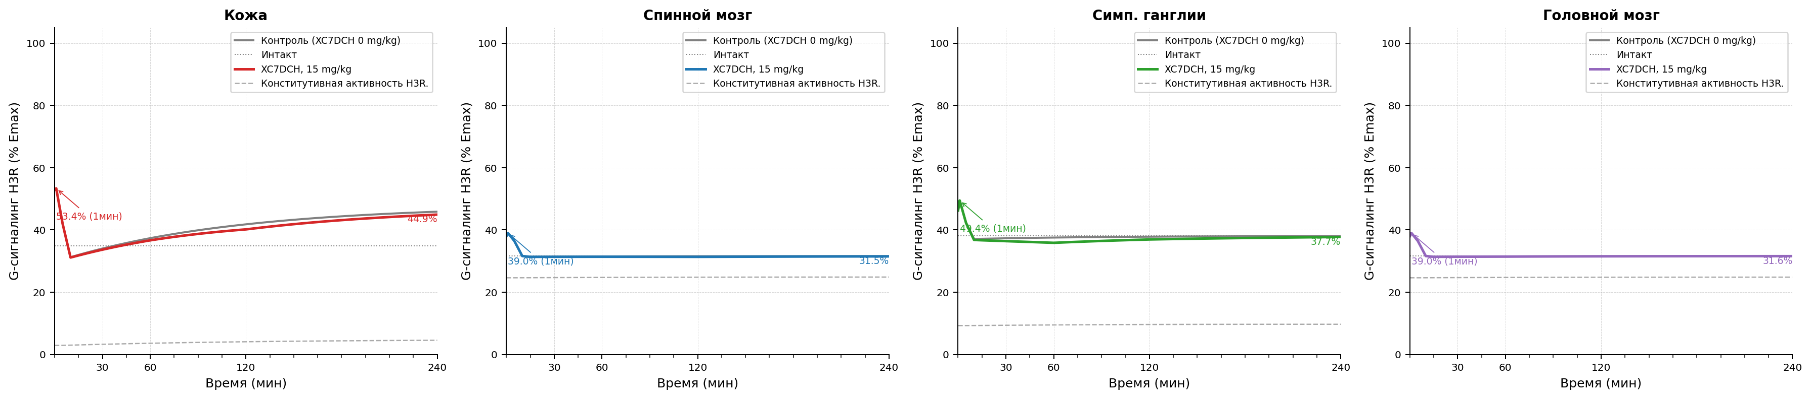
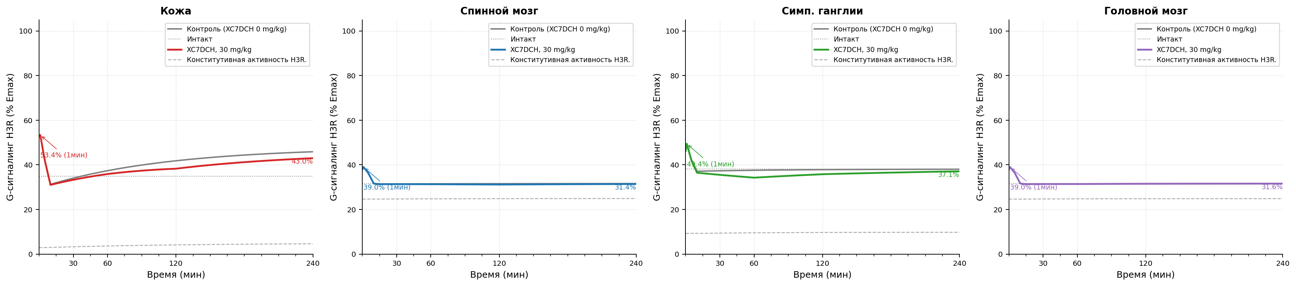
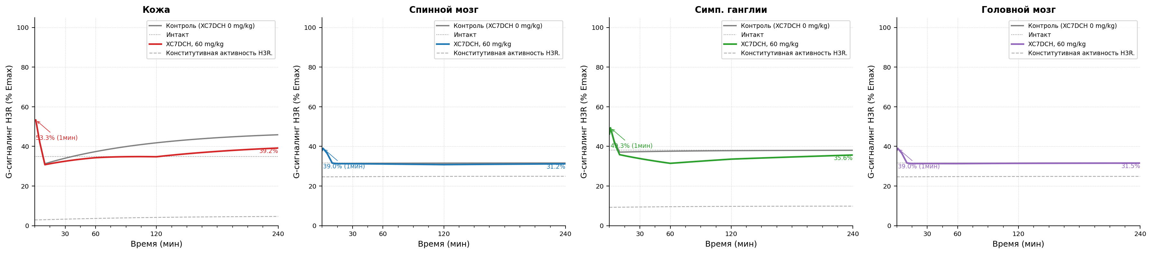
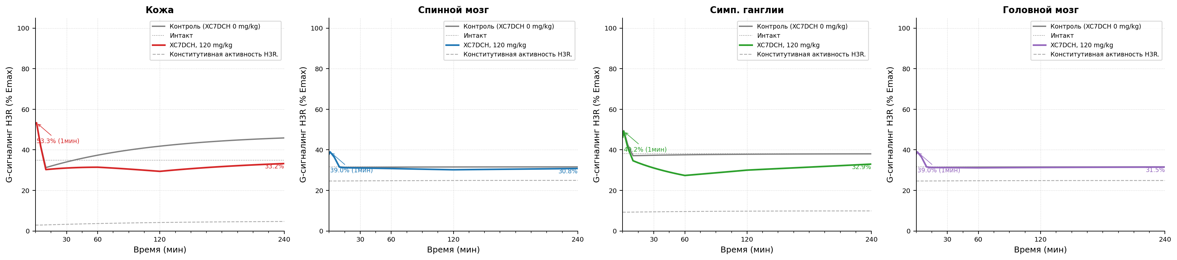
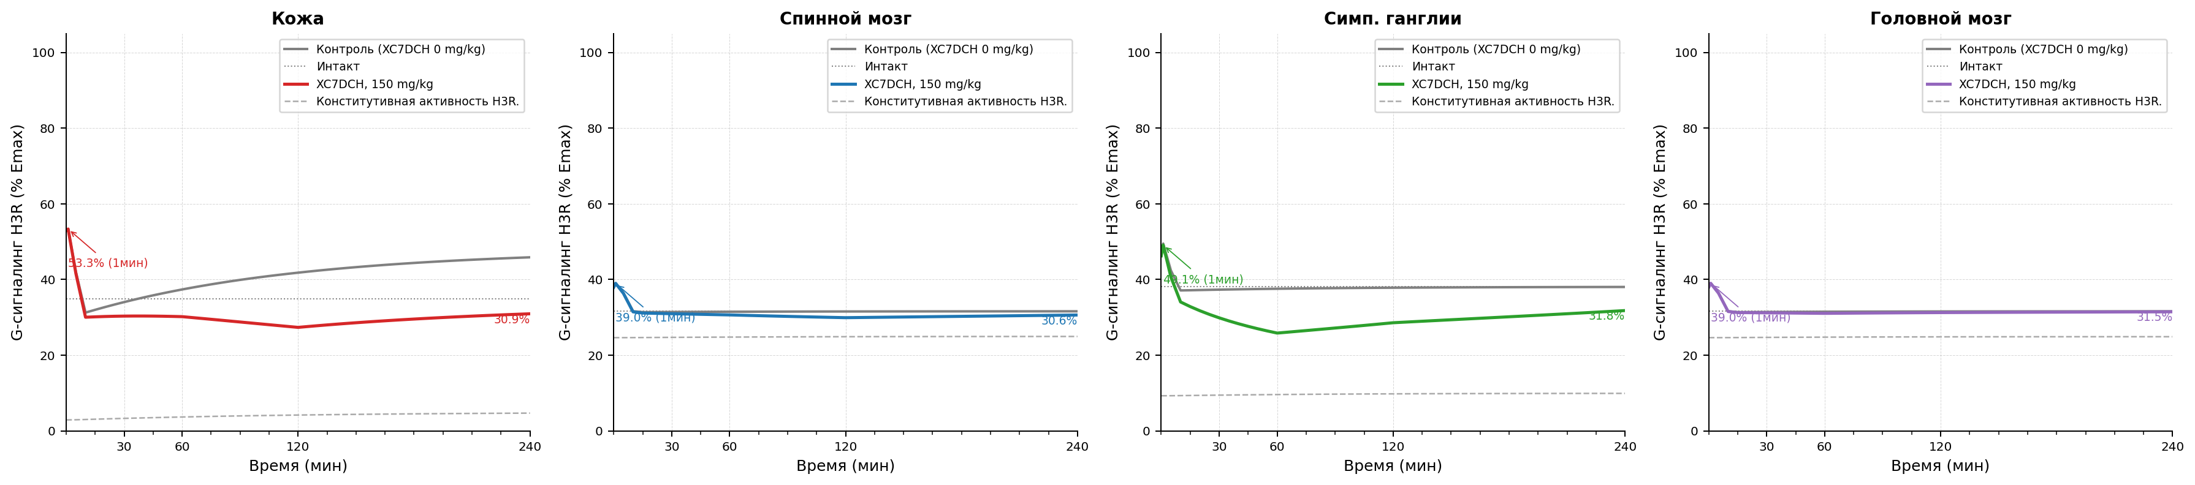
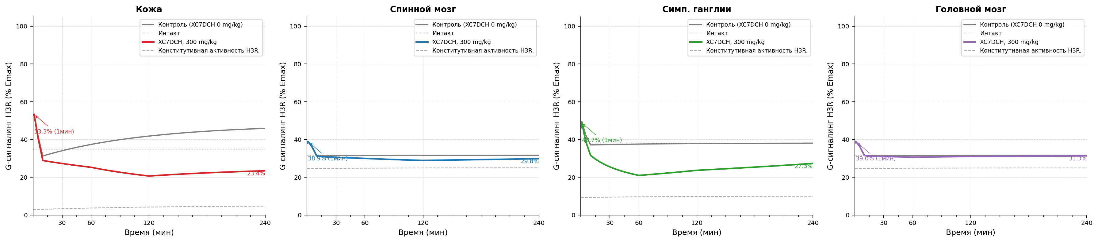
Рисунок 5.1 Модель болевого синдрома, индуцированная термическим воздействием в тесте «Горячая пластина». Уровень функциональной активности H3 рецепторов после индукции патологии. A - контроль патологии, B - XC7DCH в дозе 15 мг/кг, C - XC7DCH в дозе 30 мг/кг, D - XC7DCH в дозе 60 мг/кг, E - XC7DCH в дозе 120 мг/кг, F - XC7DCH в дозе 150 мг/кг, G - XC7DCH в дозе 300 мг/кг.

Параметры конфигурации
Параметр | Значение
trafficking.k_int_max_per_h | 1.25
trafficking.k_rec_per_h | 0.5
trafficking.k_synth_per_h | 0.05
trafficking.ec50_barr_nm | 500.0
trafficking.kb_arr_nm | 600
trafficking.hill_n | 1.0
trafficking.ec50_g_nm | 20.0
trafficking.kb_g_nm | 6000.0
trafficking.constitutive_activity | 0.05
trafficking.h_base_nm | 10.0
antagonist_pk.enabled | true
antagonist_pk.source_xlsx | examples/configs/shared/SINGLE_REP_pred_mice_rats.xlsx
antagonist_pk.regimen | single
antagonist_pk.concentration_column | C_nM
antagonist_pk.method_time | linear
antagonist_pk.method_dose | log-linear
antagonist_pk.extrapolation | clip
antagonist_pk.tissue_map.skin | skin
antagonist_pk.tissue_map.muscle | muscles
antagonist_pk.tissue_map.spinal_coord | spinal cord
antagonist_pk.tissue_map.brain | brain
antagonist_pk.tissue_map.ganglia | sympathetic ganglia
antagonist_pk.tissue_map.peritoneum | peritoneum
tissue_overrides.skin.trafficking.k_int_max_per_h | 1.25
tissue_overrides.skin.trafficking.k_rec_per_h | 0.5
tissue_overrides.skin.trafficking.k_synth_per_h | 0.05
tissue_overrides.skin.trafficking.ec50_barr_nm | 500.0
tissue_overrides.skin.trafficking.hill_n | 1.0
tissue_overrides.skin.trafficking.ec50_g_nm | 20.0
tissue_overrides.skin.trafficking.constitutive_activity | 0.05
tissue_overrides.skin.trafficking.h_base_nm | 20.0
tissue_overrides.muscle.trafficking.k_int_max_per_h | 1.25
tissue_overrides.muscle.trafficking.k_rec_per_h | 0.5
tissue_overrides.muscle.trafficking.k_synth_per_h | 0.05
tissue_overrides.muscle.trafficking.ec50_barr_nm | 500.0
tissue_overrides.muscle.trafficking.hill_n | 1.0
tissue_overrides.muscle.trafficking.ec50_g_nm | 20.0
tissue_overrides.muscle.trafficking.constitutive_activity | 0.05
tissue_overrides.muscle.trafficking.h_base_nm | 10.0
tissue_overrides.spinal_coord.trafficking.k_int_max_per_h | 1.4
tissue_overrides.spinal_coord.trafficking.k_rec_per_h | 0.8
tissue_overrides.spinal_coord.trafficking.k_synth_per_h | 0.05
tissue_overrides.spinal_coord.trafficking.ec50_barr_nm | 500.0
tissue_overrides.spinal_coord.trafficking.hill_n | 1.0
tissue_overrides.spinal_coord.trafficking.ec50_g_nm | 20.0
tissue_overrides.spinal_coord.trafficking.constitutive_activity | 0.25
tissue_overrides.spinal_coord.trafficking.h_base_nm | 2.0
tissue_overrides.brain.trafficking.k_int_max_per_h | 1.4
tissue_overrides.brain.trafficking.k_rec_per_h | 0.8
tissue_overrides.brain.trafficking.k_synth_per_h | 0.05
tissue_overrides.brain.trafficking.ec50_barr_nm | 500.0
tissue_overrides.brain.trafficking.hill_n | 1.0
tissue_overrides.brain.trafficking.ec50_g_nm | 20.0
tissue_overrides.brain.trafficking.constitutive_activity | 0.25
tissue_overrides.brain.trafficking.h_base_nm | 2.0
tissue_overrides.ganglia.trafficking.k_int_max_per_h | 1.8
tissue_overrides.ganglia.trafficking.k_rec_per_h | 0.7
tissue_overrides.ganglia.trafficking.k_synth_per_h | 0.05
tissue_overrides.ganglia.trafficking.ec50_barr_nm | 500.0
tissue_overrides.ganglia.trafficking.hill_n | 1.0
tissue_overrides.ganglia.trafficking.ec50_g_nm | 20.0
tissue_overrides.ganglia.trafficking.constitutive_activity | 0.1
tissue_overrides.ganglia.trafficking.h_base_nm | 10.0
tissue_overrides.peritoneum.trafficking.k_int_max_per_h | 1.25
tissue_overrides.peritoneum.trafficking.k_rec_per_h | 0.5
tissue_overrides.peritoneum.trafficking.k_synth_per_h | 0.05
tissue_overrides.peritoneum.trafficking.ec50_barr_nm | 500.0
tissue_overrides.peritoneum.trafficking.hill_n | 1.0
tissue_overrides.peritoneum.trafficking.ec50_g_nm | 20.0
tissue_overrides.peritoneum.trafficking.constitutive_activity | 0.05
tissue_overrides.peritoneum.trafficking.h_base_nm | 10.0
time_grid | [0, 1, 5, 10, 15, 20, ..., 230, 235, 240] (len=50)
time_unit | min
model_id | hot_plate_pkpd_v1
compound | xc7
species | mouse
loss_mode | mse
traceability.source_in_report | Scenario matrix row: hot plate
traceability.source_reference
traceability.source_version | 2026-04-06
assumptions | ["canonical scenario_id hot_plate is used directly", "runtime registry is treated as the source of truth for skin, spinal_coord, and ganglia H(t)", "brain is included as a mandatory CNS tissue and currently uses a spinal_coord proxy profile until a source-backed brain profile is introduced", "skin h_base_nm is overridden to 50 nM so the marker-tissue H(t) peak matches the primary 262 nM text value at 1 min", "top-level trafficking acts as deterministic defaults before tissue_overrides are applied"]
driver.driver_type | scenario
driver.scenario_id | hot_plate
tissues | ["skin", "spinal_coord", "ganglia", "brain"]

