PKPD Figures

Модель болевого синдрома, индуцированная введением формалина.
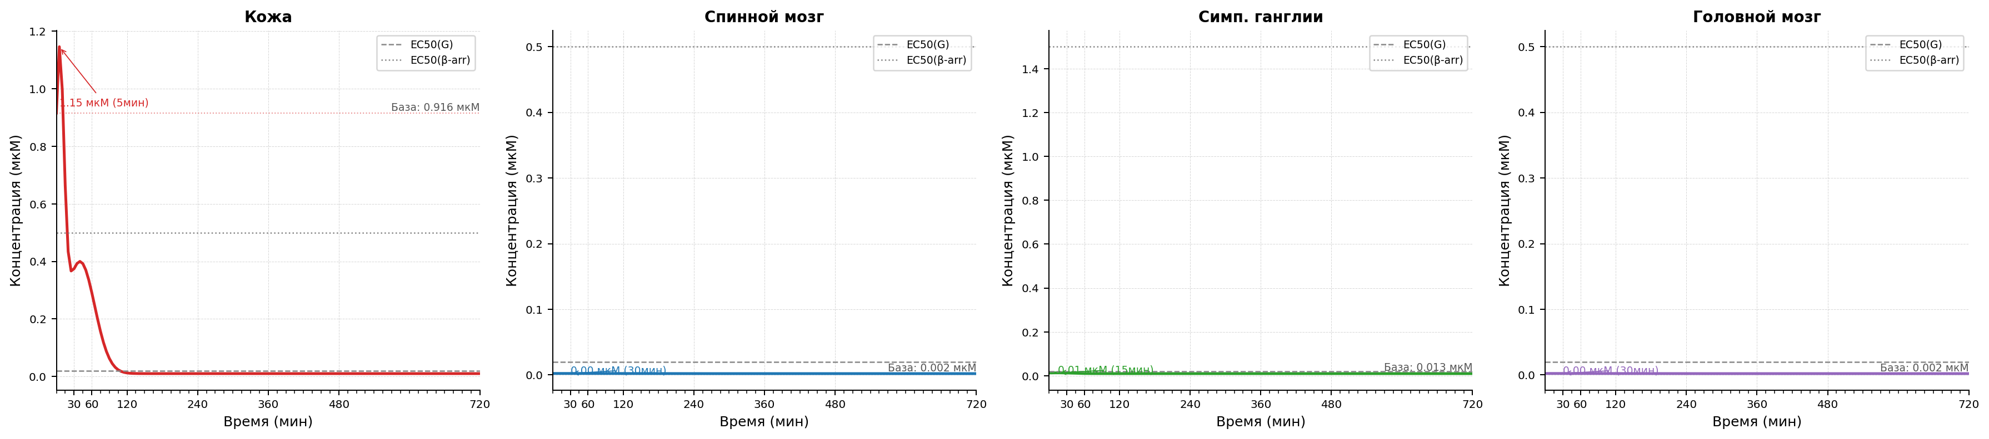
Рисунок 1.1 Модель болевого синдрома, индуцированная введением формалина. Изменение концентрации гистамина после индукции паталогии.
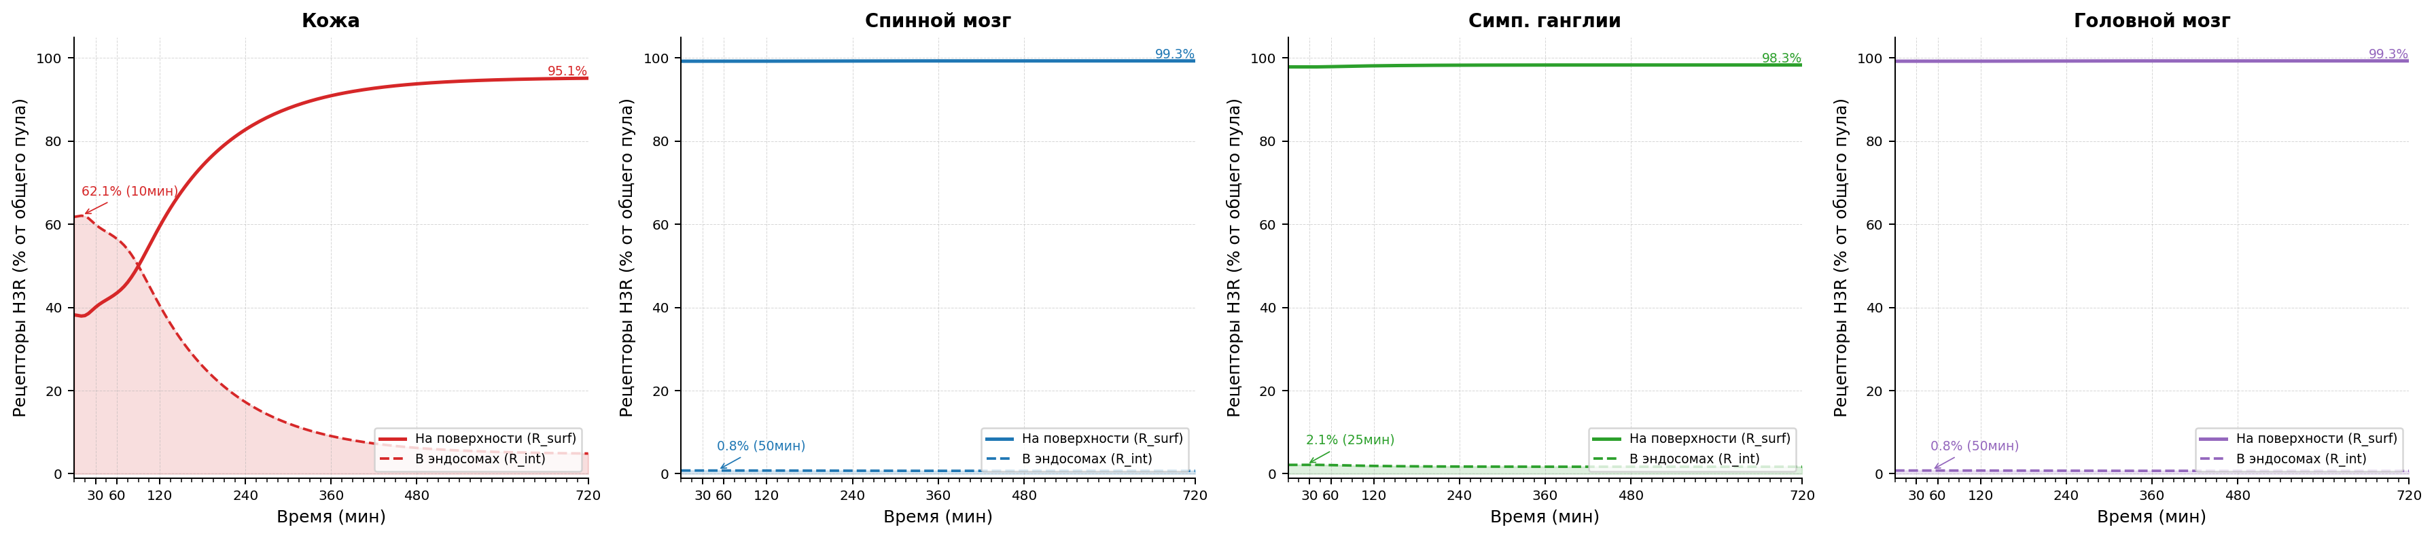
Рисунок 1.2 Модель болевого синдрома, индуцированная введением формалина. Интернализация H3 рецепторов после индукции паталогии.
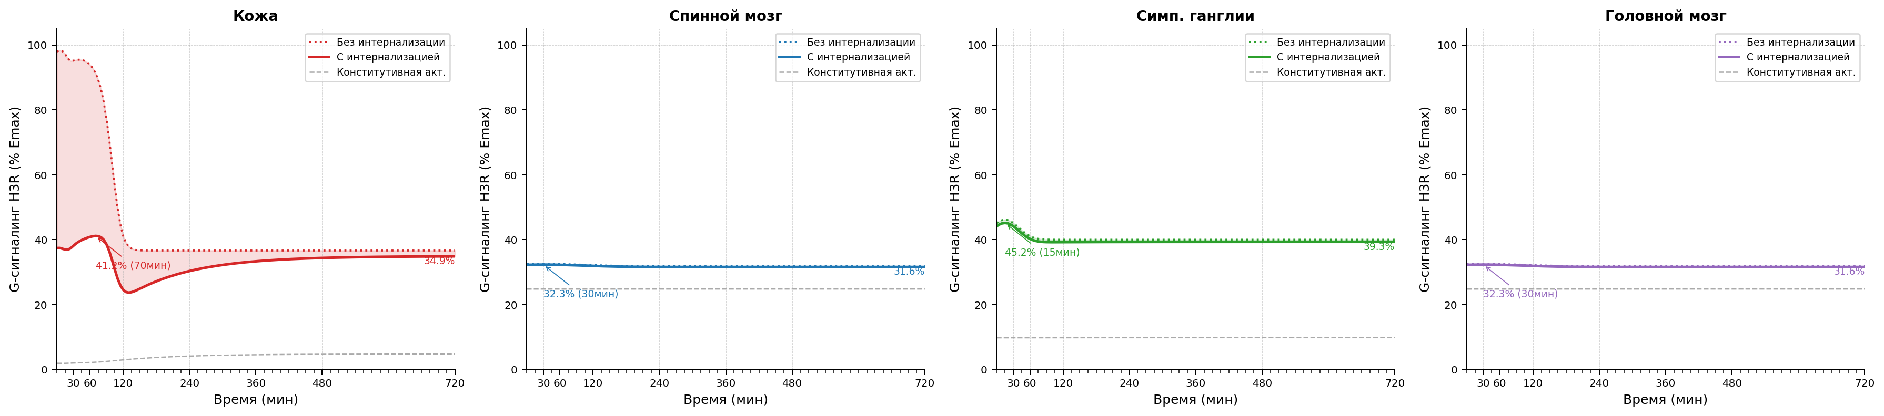
Рисунок 1.3 Модель болевого синдрома, индуцированная введением формалина. Уровень функциональной активности H3 рецепторов после индукции паталогии.

Параметры конфигурации
Параметр | Значение
trafficking.k_int_max_per_h | 1.25
trafficking.k_rec_per_h | 0.5
trafficking.k_synth_per_h | 0.05
trafficking.ec50_barr_nm | 500.0
trafficking.hill_n | 1.0
trafficking.ec50_g_nm | 20.0
trafficking.constitutive_activity | 0.05
trafficking.h_base_nm | 10.0
antagonist_pk.enabled | true
antagonist_pk.source_xlsx | E:/Users/Fedor/Downloads/Telegram Desktop/SINGLE_REP_pred_mice_rats.xlsx
antagonist_pk.regimen | single
antagonist_pk.dose_mg_per_kg | 90.0
antagonist_pk.concentration_column | C_nM
antagonist_pk.method_time | linear
antagonist_pk.method_dose | log-linear
antagonist_pk.extrapolation | clip
antagonist_pk.tissue_map.skin | skin
antagonist_pk.tissue_map.muscle | muscles
antagonist_pk.tissue_map.spinal_coord | spinal cord
antagonist_pk.tissue_map.brain | brain
antagonist_pk.tissue_map.ganglia | sympathetic ganglia
tissue_overrides.skin.trafficking.k_int_max_per_h | 1.25
tissue_overrides.skin.trafficking.k_rec_per_h | 0.5
tissue_overrides.skin.trafficking.k_synth_per_h | 0.05
tissue_overrides.skin.trafficking.ec50_barr_nm | 500.0
tissue_overrides.skin.trafficking.hill_n | 1.0
tissue_overrides.skin.trafficking.ec50_g_nm | 20.0
tissue_overrides.skin.trafficking.constitutive_activity | 0.05
tissue_overrides.skin.trafficking.h_base_nm | 10.0
tissue_overrides.skin.formalin_profile.profile_shape | gaussian_sum
tissue_overrides.skin.formalin_profile.phase1.amplitude_nm | 990.0
tissue_overrides.skin.formalin_profile.phase1.center_min | 5.0
tissue_overrides.skin.formalin_profile.phase1.sigma_min | 7.6
tissue_overrides.skin.formalin_profile.phase2.amplitude_nm | 390.0
tissue_overrides.skin.formalin_profile.phase2.center_min | 40.0
tissue_overrides.skin.formalin_profile.phase2.sigma_min | 25.0
tissue_overrides.muscle.trafficking.k_int_max_per_h | 1.25
tissue_overrides.muscle.trafficking.k_rec_per_h | 0.5
tissue_overrides.muscle.trafficking.k_synth_per_h | 0.05
tissue_overrides.muscle.trafficking.ec50_barr_nm | 500.0
tissue_overrides.muscle.trafficking.hill_n | 1.0
tissue_overrides.muscle.trafficking.ec50_g_nm | 20.0
tissue_overrides.muscle.trafficking.constitutive_activity | 0.05
tissue_overrides.muscle.trafficking.h_base_nm | 10.0
tissue_overrides.spinal_coord.trafficking.k_int_max_per_h | 1.4
tissue_overrides.spinal_coord.trafficking.k_rec_per_h | 0.8
tissue_overrides.spinal_coord.trafficking.k_synth_per_h | 0.05
tissue_overrides.spinal_coord.trafficking.ec50_barr_nm | 500.0
tissue_overrides.spinal_coord.trafficking.hill_n | 1.0
tissue_overrides.spinal_coord.trafficking.ec50_g_nm | 20.0
tissue_overrides.spinal_coord.trafficking.constitutive_activity | 0.25
tissue_overrides.spinal_coord.trafficking.h_base_nm | 2.0
tissue_overrides.spinal_coord.formalin_profile.profile_shape | gaussian_sum
tissue_overrides.spinal_coord.formalin_profile.phase1.amplitude_nm | 0.246
tissue_overrides.spinal_coord.formalin_profile.phase1.center_min | 30.0
tissue_overrides.spinal_coord.formalin_profile.phase1.sigma_min | 73.9
tissue_overrides.spinal_coord.formalin_profile.phase2.amplitude_nm | 7.883
tissue_overrides.spinal_coord.formalin_profile.phase2.center_min | 120.0
tissue_overrides.spinal_coord.formalin_profile.phase2.sigma_min | 73.9
tissue_overrides.brain.trafficking.k_int_max_per_h | 1.4
tissue_overrides.brain.trafficking.k_rec_per_h | 0.8
tissue_overrides.brain.trafficking.k_synth_per_h | 0.05
tissue_overrides.brain.trafficking.ec50_barr_nm | 500.0
tissue_overrides.brain.trafficking.hill_n | 1.0
tissue_overrides.brain.trafficking.ec50_g_nm | 20.0
tissue_overrides.brain.trafficking.constitutive_activity | 0.25
tissue_overrides.brain.trafficking.h_base_nm | 2.0
tissue_overrides.brain.formalin_profile.profile_shape | gaussian_sum
tissue_overrides.brain.formalin_profile.phase1.amplitude_nm | 0.246
tissue_overrides.brain.formalin_profile.phase1.center_min | 30.0
tissue_overrides.brain.formalin_profile.phase1.sigma_min | 73.9
tissue_overrides.brain.formalin_profile.phase2.amplitude_nm | 7.883
tissue_overrides.brain.formalin_profile.phase2.center_min | 120.0
tissue_overrides.brain.formalin_profile.phase2.sigma_min | 73.9
tissue_overrides.ganglia.trafficking.k_int_max_per_h | 1.8
tissue_overrides.ganglia.trafficking.k_rec_per_h | 0.7
tissue_overrides.ganglia.trafficking.k_synth_per_h | 0.05
tissue_overrides.ganglia.trafficking.ec50_barr_nm | 1500.0
tissue_overrides.ganglia.trafficking.hill_n | 1.0
tissue_overrides.ganglia.trafficking.ec50_g_nm | 20.0
tissue_overrides.ganglia.trafficking.constitutive_activity | 0.1
tissue_overrides.ganglia.trafficking.h_base_nm | 10.0
tissue_overrides.ganglia.formalin_profile.profile_shape | gaussian_sum
tissue_overrides.ganglia.formalin_profile.phase1.amplitude_nm | 3.426
tissue_overrides.ganglia.formalin_profile.phase1.center_min | 15.0
tissue_overrides.ganglia.formalin_profile.phase1.sigma_min | 23.8
tissue_overrides.ganglia.formalin_profile.phase2.amplitude_nm | 9.428
tissue_overrides.ganglia.formalin_profile.phase2.center_min | 60.0
tissue_overrides.ganglia.formalin_profile.phase2.sigma_min | 23.8
model_id | formalin_pkpd_v1
compound | xc7
species | rat
loss_mode | mse
traceability.source_in_report | Scenario matrix row: formalin
traceability.source_reference
traceability.source_version | 2026-04-06
assumptions | ["canonical scenario_id formalin is used directly", "shared/common trafficking and top-level formalin_profile act as deterministic defaults before tissue_overrides, including tissue-specific profile_shape, are applied", "brain is included as a mandatory CNS tissue and currently uses a spinal_coord proxy profile until a source-backed brain profile is introduced", "formalin skin phase-1 half-life of 9 min is approximated as gaussian sigma_min=7.6", "phase-2 skin peak is encoded via formalin_profile amplitude override to reach 400 nM on a 50 nM baseline", "spinal_coord and ganglia phase centers are fixed at 30/120 min and 15/60 min respectively because the source table specifies peaks and t1/2 but not phase timing"]
driver.driver_type | scenario
driver.scenario_id | formalin
formalin_profile.phase1.amplitude_nm | 990.0
formalin_profile.phase1.sigma_min | 7.6
formalin_profile.phase2.amplitude_nm | 390.0
tissues | ["skin", "spinal_coord", "ganglia", "brain"]
time_grid | [0, 5, 10, 15, 20, 25, ..., 710, 715, 720] (len=145)
time_unit | min

Figures
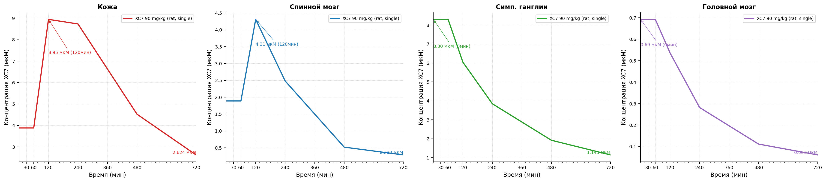
Рисунок 1.4 Figures. Fig1 4 Formalin Xc7 Concentration.

Модель болевого синдрома, индуцированная введением Compound 48/80.
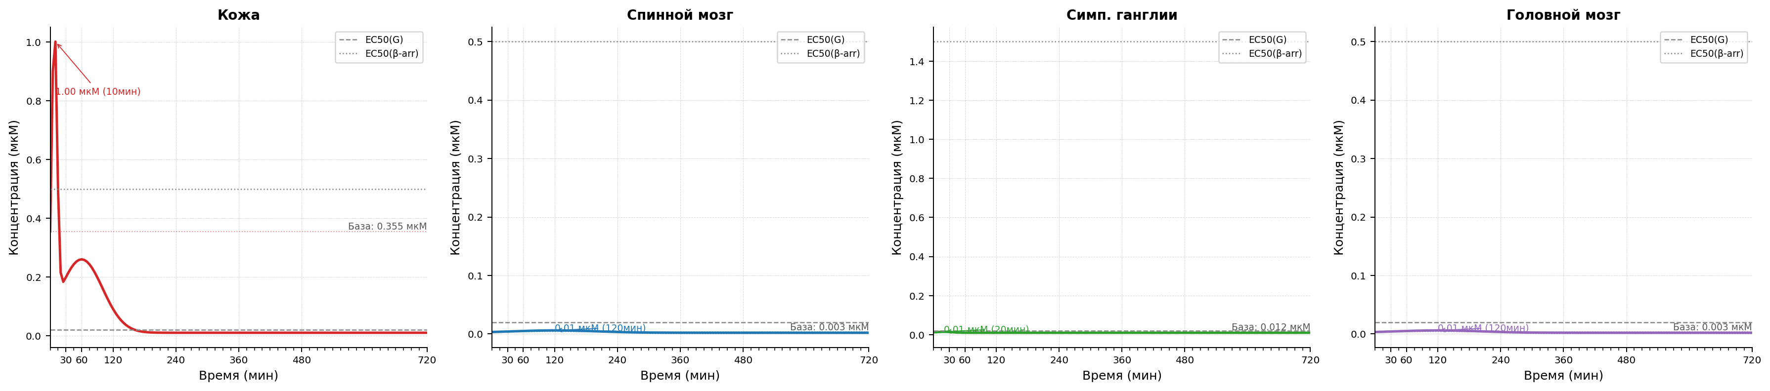
Рисунок 2.1 Модель болевого синдрома, индуцированная введением Compound 48/80. Изменение концентрации гистамина после индукции паталогии.
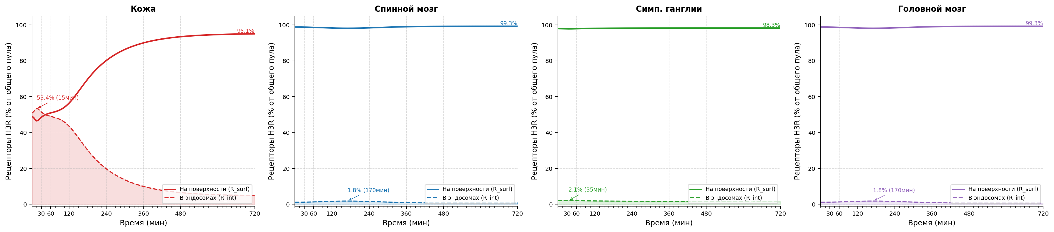
Рисунок 2.2 Модель болевого синдрома, индуцированная введением Compound 48/80. Интернализация H3 рецепторов после индукции паталогии.
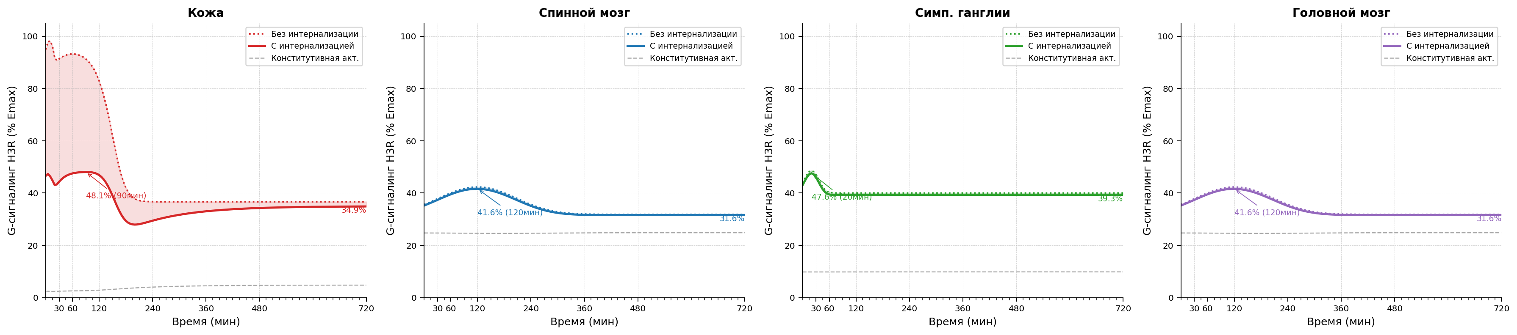
Рисунок 2.3 Модель болевого синдрома, индуцированная введением Compound 48/80. Уровень функциональной активности H3 рецепторов после индукции паталогии.

Параметры конфигурации
Параметр | Значение
trafficking.k_int_max_per_h | 1.25
trafficking.k_rec_per_h | 0.5
trafficking.k_synth_per_h | 0.05
trafficking.ec50_barr_nm | 500.0
trafficking.hill_n | 1.0
trafficking.ec50_g_nm | 20.0
trafficking.constitutive_activity | 0.05
trafficking.h_base_nm | 10.0
antagonist_pk.enabled | true
antagonist_pk.source_xlsx | E:/Users/Fedor/Downloads/Telegram Desktop/SINGLE_REP_pred_mice_rats.xlsx
antagonist_pk.regimen | single
antagonist_pk.dose_mg_per_kg | 90.0
antagonist_pk.concentration_column | C_nM
antagonist_pk.method_time | linear
antagonist_pk.method_dose | log-linear
antagonist_pk.extrapolation | clip
antagonist_pk.tissue_map.skin | skin
antagonist_pk.tissue_map.muscle | muscles
antagonist_pk.tissue_map.spinal_coord | spinal cord
antagonist_pk.tissue_map.brain | brain
antagonist_pk.tissue_map.ganglia | sympathetic ganglia
tissue_overrides.skin.trafficking.k_int_max_per_h | 1.25
tissue_overrides.skin.trafficking.k_rec_per_h | 0.5
tissue_overrides.skin.trafficking.k_synth_per_h | 0.05
tissue_overrides.skin.trafficking.ec50_barr_nm | 500.0
tissue_overrides.skin.trafficking.hill_n | 1.0
tissue_overrides.skin.trafficking.ec50_g_nm | 20.0
tissue_overrides.skin.trafficking.constitutive_activity | 0.05
tissue_overrides.skin.trafficking.h_base_nm | 10.0
tissue_overrides.muscle.trafficking.k_int_max_per_h | 1.25
tissue_overrides.muscle.trafficking.k_rec_per_h | 0.5
tissue_overrides.muscle.trafficking.k_synth_per_h | 0.05
tissue_overrides.muscle.trafficking.ec50_barr_nm | 500.0
tissue_overrides.muscle.trafficking.hill_n | 1.0
tissue_overrides.muscle.trafficking.ec50_g_nm | 20.0
tissue_overrides.muscle.trafficking.constitutive_activity | 0.05
tissue_overrides.muscle.trafficking.h_base_nm | 10.0
tissue_overrides.spinal_coord.trafficking.k_int_max_per_h | 1.4
tissue_overrides.spinal_coord.trafficking.k_rec_per_h | 0.8
tissue_overrides.spinal_coord.trafficking.k_synth_per_h | 0.05
tissue_overrides.spinal_coord.trafficking.ec50_barr_nm | 500.0
tissue_overrides.spinal_coord.trafficking.hill_n | 1.0
tissue_overrides.spinal_coord.trafficking.ec50_g_nm | 20.0
tissue_overrides.spinal_coord.trafficking.constitutive_activity | 0.25
tissue_overrides.spinal_coord.trafficking.h_base_nm | 2.0
tissue_overrides.brain.trafficking.k_int_max_per_h | 1.4
tissue_overrides.brain.trafficking.k_rec_per_h | 0.8
tissue_overrides.brain.trafficking.k_synth_per_h | 0.05
tissue_overrides.brain.trafficking.ec50_barr_nm | 500.0
tissue_overrides.brain.trafficking.hill_n | 1.0
tissue_overrides.brain.trafficking.ec50_g_nm | 20.0
tissue_overrides.brain.trafficking.constitutive_activity | 0.25
tissue_overrides.brain.trafficking.h_base_nm | 2.0
tissue_overrides.ganglia.trafficking.k_int_max_per_h | 1.8
tissue_overrides.ganglia.trafficking.k_rec_per_h | 0.7
tissue_overrides.ganglia.trafficking.k_synth_per_h | 0.05
tissue_overrides.ganglia.trafficking.ec50_barr_nm | 1500.0
tissue_overrides.ganglia.trafficking.hill_n | 1.0
tissue_overrides.ganglia.trafficking.ec50_g_nm | 20.0
tissue_overrides.ganglia.trafficking.constitutive_activity | 0.1
tissue_overrides.ganglia.trafficking.h_base_nm | 10.0
model_id | compound_48_80_pkpd_v1
compound | xc7
species | mouse
loss_mode | mse
traceability.source_in_report | Scenario matrix row: compound 48/80
traceability.source_reference
traceability.source_version | 2026-04-06
assumptions | ["canonical scenario_id compound_48_80 is used directly", "skin two-phase profile and CNS profiles are taken from scenario_registry as the source of truth", "brain is included as a mandatory CNS tissue and currently uses a spinal_coord proxy profile until a source-backed brain profile is introduced", "top-level trafficking acts as deterministic defaults before tissue_overrides are applied", "legacy file examples/configs/compound48_80.yaml is retained only as a compatibility example"]
driver.driver_type | scenario
driver.scenario_id | compound_48_80
tissues | ["skin", "spinal_coord", "ganglia", "brain"]
time_grid | [0, 5, 10, 15, 20, 25, ..., 710, 715, 720] (len=145)
time_unit | min

Figures
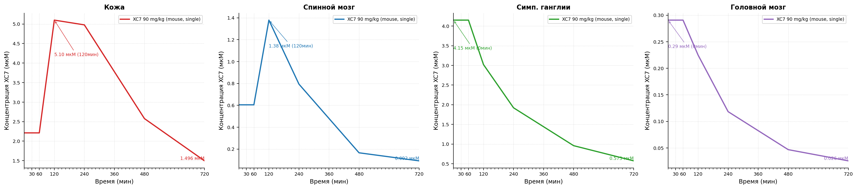
Рисунок 2.4 Figures. Fig2 4 Compound 48 80 Xc7 Concentration.

Модель болевого синдрома, индуцированная введением капсаицина.
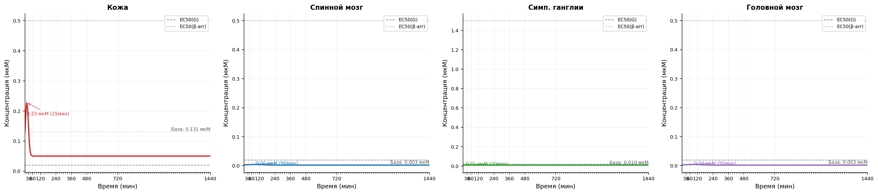
Рисунок 3.1 Модель болевого синдрома, индуцированная введением капсаицина. Изменение концентрации гистамина после индукции паталогии.
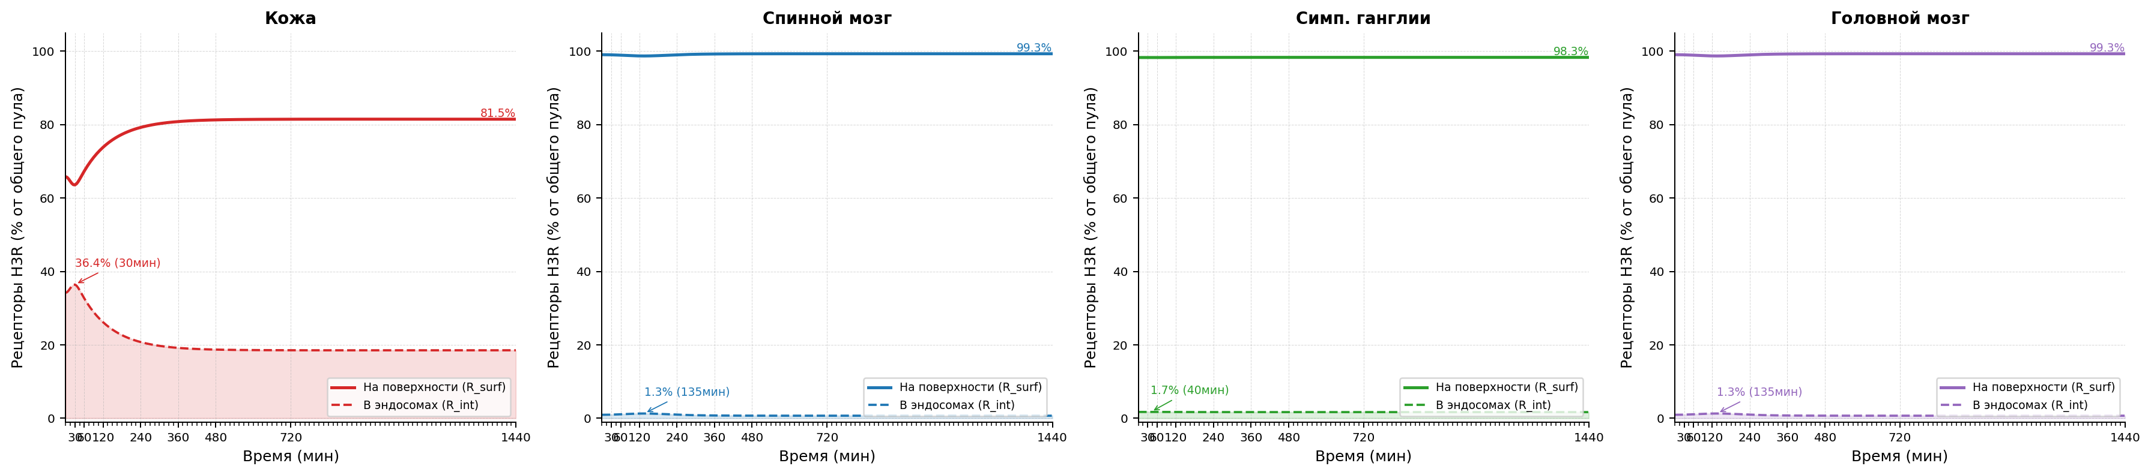
Рисунок 3.2 Модель болевого синдрома, индуцированная введением капсаицина. Интернализация H3 рецепторов после индукции паталогии.
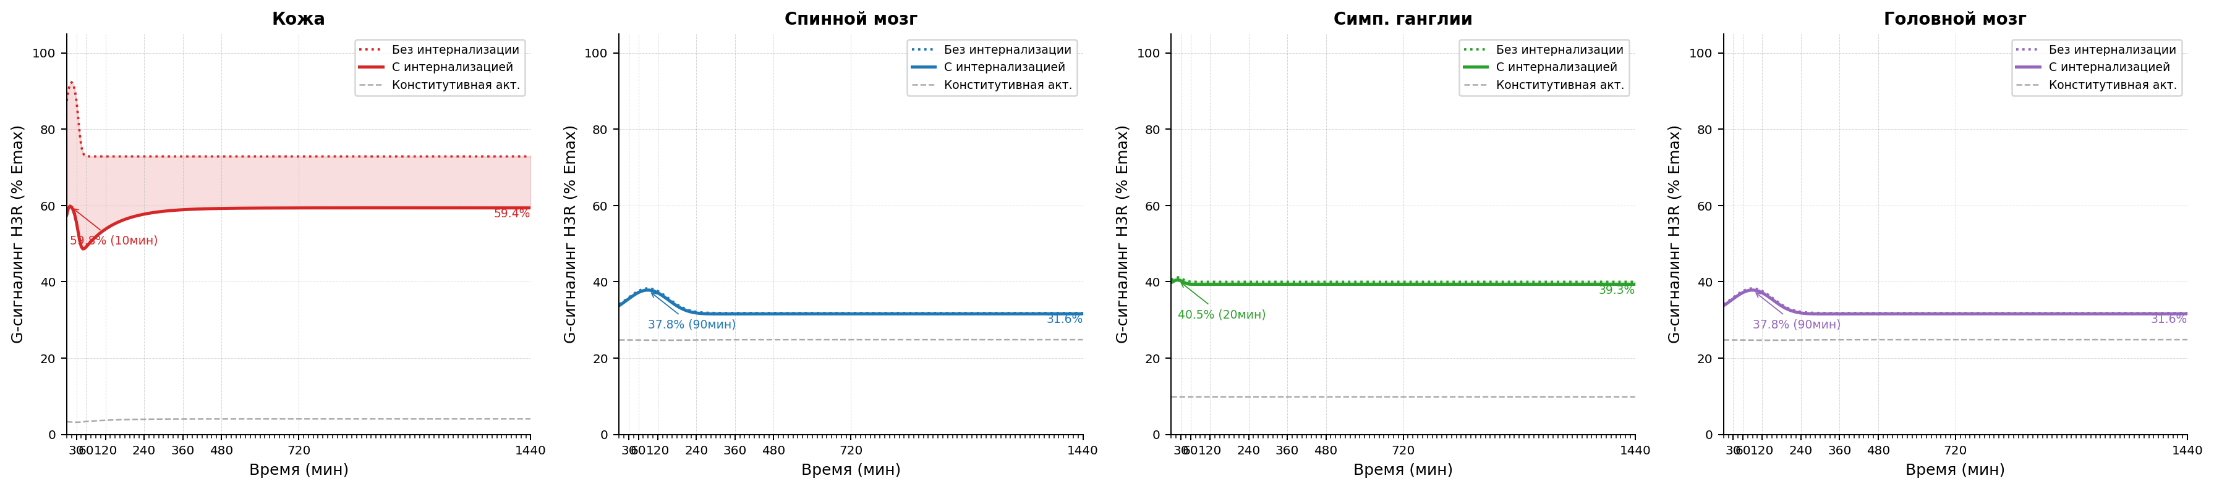
Рисунок 3.3 Модель болевого синдрома, индуцированная введением капсаицина. Уровень функциональной активности H3 рецепторов после индукции паталогии.

Параметры конфигурации
Параметр | Значение
trafficking.k_int_max_per_h | 1.25
trafficking.k_rec_per_h | 0.5
trafficking.k_synth_per_h | 0.05
trafficking.ec50_barr_nm | 500.0
trafficking.hill_n | 1.0
trafficking.ec50_g_nm | 20.0
trafficking.constitutive_activity | 0.05
trafficking.h_base_nm | 10.0
antagonist_pk.enabled | true
antagonist_pk.source_xlsx | E:/Users/Fedor/Downloads/Telegram Desktop/SINGLE_REP_pred_mice_rats.xlsx
antagonist_pk.regimen | single
antagonist_pk.dose_mg_per_kg | 90.0
antagonist_pk.concentration_column | C_nM
antagonist_pk.method_time | linear
antagonist_pk.method_dose | log-linear
antagonist_pk.extrapolation | clip
antagonist_pk.tissue_map.skin | skin
antagonist_pk.tissue_map.muscle | muscles
antagonist_pk.tissue_map.spinal_coord | spinal cord
antagonist_pk.tissue_map.brain | brain
antagonist_pk.tissue_map.ganglia | sympathetic ganglia
tissue_overrides.skin.trafficking.k_int_max_per_h | 1.25
tissue_overrides.skin.trafficking.k_rec_per_h | 0.5
tissue_overrides.skin.trafficking.k_synth_per_h | 0.05
tissue_overrides.skin.trafficking.ec50_barr_nm | 500.0
tissue_overrides.skin.trafficking.hill_n | 1.0
tissue_overrides.skin.trafficking.ec50_g_nm | 20.0
tissue_overrides.skin.trafficking.constitutive_activity | 0.05
tissue_overrides.skin.trafficking.h_base_nm | 50.0
tissue_overrides.muscle.trafficking.k_int_max_per_h | 1.25
tissue_overrides.muscle.trafficking.k_rec_per_h | 0.5
tissue_overrides.muscle.trafficking.k_synth_per_h | 0.05
tissue_overrides.muscle.trafficking.ec50_barr_nm | 500.0
tissue_overrides.muscle.trafficking.hill_n | 1.0
tissue_overrides.muscle.trafficking.ec50_g_nm | 20.0
tissue_overrides.muscle.trafficking.constitutive_activity | 0.05
tissue_overrides.muscle.trafficking.h_base_nm | 10.0
tissue_overrides.spinal_coord.trafficking.k_int_max_per_h | 1.4
tissue_overrides.spinal_coord.trafficking.k_rec_per_h | 0.8
tissue_overrides.spinal_coord.trafficking.k_synth_per_h | 0.05
tissue_overrides.spinal_coord.trafficking.ec50_barr_nm | 500.0
tissue_overrides.spinal_coord.trafficking.hill_n | 1.0
tissue_overrides.spinal_coord.trafficking.ec50_g_nm | 20.0
tissue_overrides.spinal_coord.trafficking.constitutive_activity | 0.25
tissue_overrides.spinal_coord.trafficking.h_base_nm | 2.0
tissue_overrides.brain.trafficking.k_int_max_per_h | 1.4
tissue_overrides.brain.trafficking.k_rec_per_h | 0.8
tissue_overrides.brain.trafficking.k_synth_per_h | 0.05
tissue_overrides.brain.trafficking.ec50_barr_nm | 500.0
tissue_overrides.brain.trafficking.hill_n | 1.0
tissue_overrides.brain.trafficking.ec50_g_nm | 20.0
tissue_overrides.brain.trafficking.constitutive_activity | 0.25
tissue_overrides.brain.trafficking.h_base_nm | 2.0
tissue_overrides.ganglia.trafficking.k_int_max_per_h | 1.8
tissue_overrides.ganglia.trafficking.k_rec_per_h | 0.7
tissue_overrides.ganglia.trafficking.k_synth_per_h | 0.05
tissue_overrides.ganglia.trafficking.ec50_barr_nm | 1500.0
tissue_overrides.ganglia.trafficking.hill_n | 1.0
tissue_overrides.ganglia.trafficking.ec50_g_nm | 20.0
tissue_overrides.ganglia.trafficking.constitutive_activity | 0.1
tissue_overrides.ganglia.trafficking.h_base_nm | 10.0
model_id | capsaicin_pkpd_v1
compound | xc7
species | rat
loss_mode | mse
traceability.source_in_report | Scenario matrix row: capsaicin
traceability.source_reference
traceability.source_version | 2026-04-06
assumptions | ["canonical scenario_id capsaicin is used directly", "skin, spinal_coord, and ganglia H(t) profiles are taken from scenario_registry as the source of truth", "brain is included as a mandatory CNS tissue and currently uses a spinal_coord proxy profile until a source-backed brain profile is introduced", "top-level trafficking acts as deterministic defaults before tissue_overrides are applied", "skin h_base_nm is overridden to 50 nM so the marker-tissue H(t) peak matches the tabulated 227 nM at 15 min"]
driver.driver_type | scenario
driver.scenario_id | capsaicin
tissues | ["skin", "spinal_coord", "ganglia", "brain"]
time_grid | [0, 5, 10, 15, 20, 25, ..., 1430, 1435, 1440] (len=289)
time_unit | min

Figures
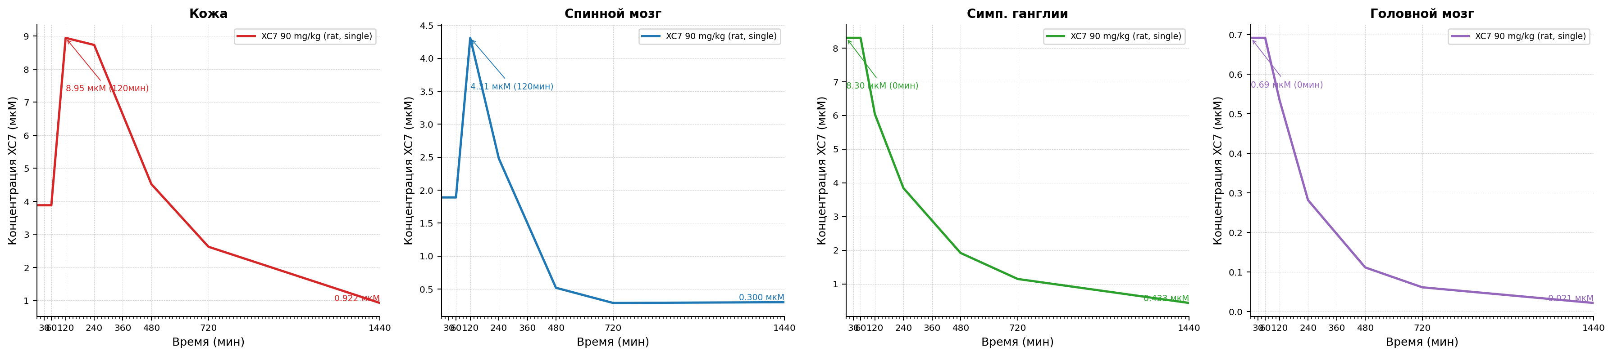
Рисунок 3.4 Figures. Fig3 4 Capsaicin Xc7 Concentration.

Модель болевого синдрома, индуцированная введением карагенина.
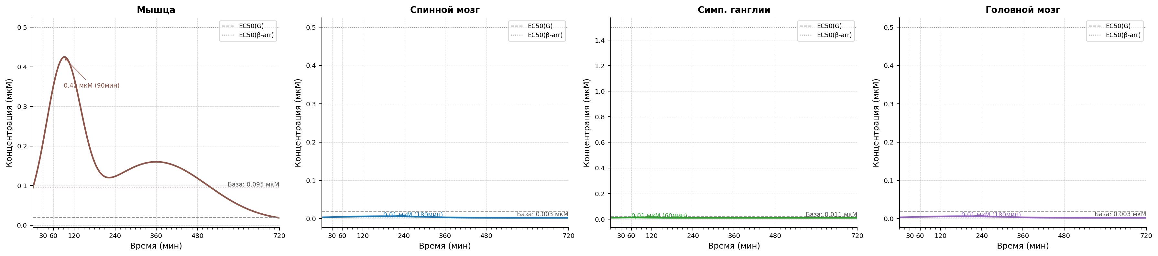
Рисунок 4.1 Модель болевого синдрома, индуцированная введением карагенина. Изменение концентрации гистамина после индукции паталогии.
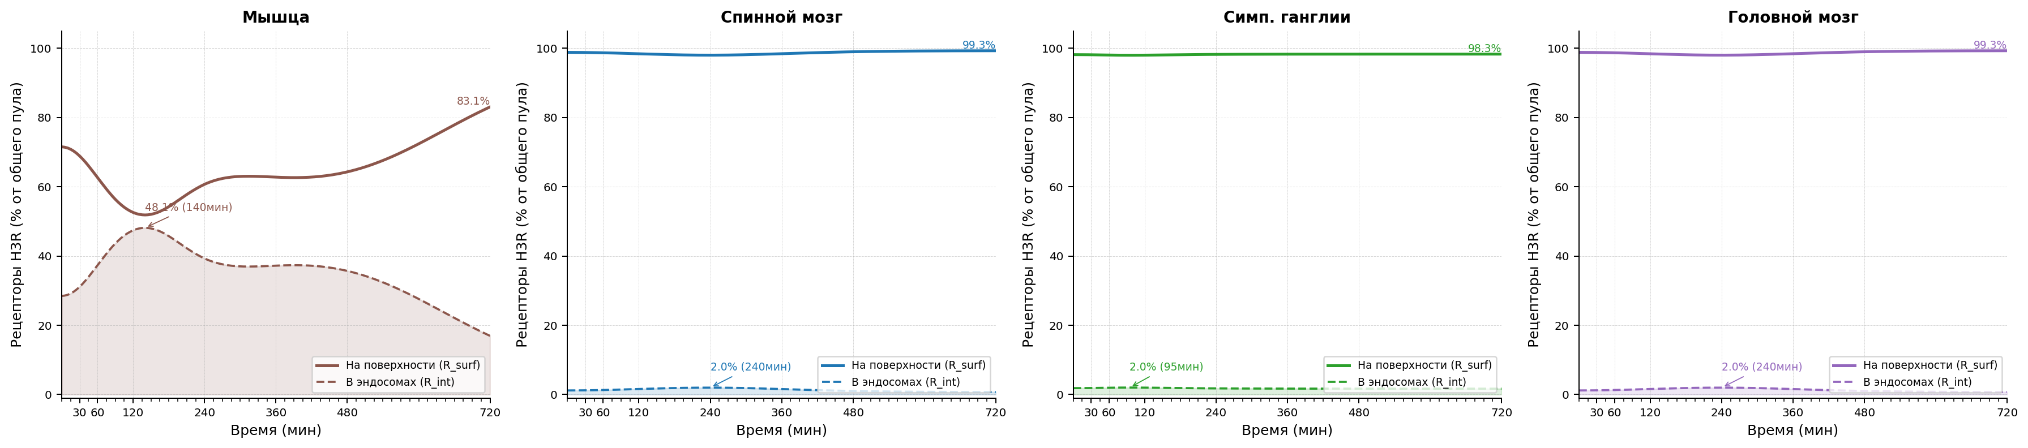
Рисунок 4.2 Модель болевого синдрома, индуцированная введением карагенина. Интернализация H3 рецепторов после индукции паталогии.
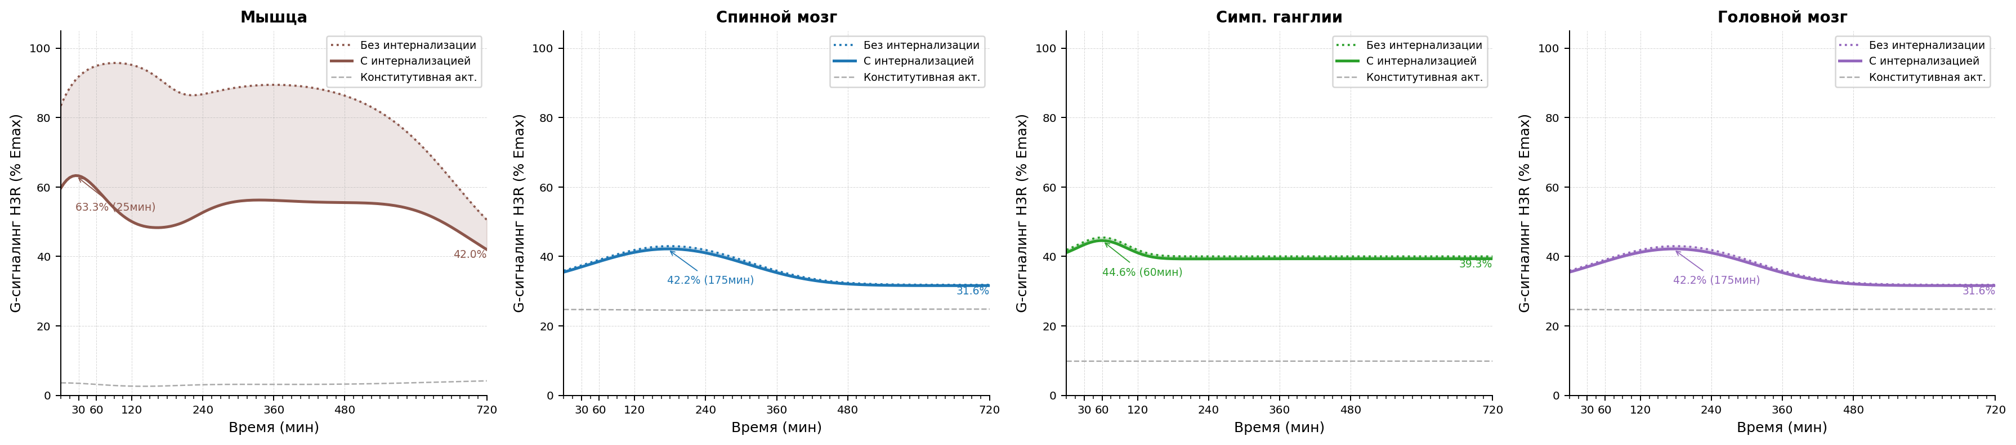
Рисунок 4.3 Модель болевого синдрома, индуцированная введением карагенина. Уровень функциональной активности H3 рецепторов после индукции паталогии.

Параметры конфигурации
Параметр | Значение
trafficking.k_int_max_per_h | 1.25
trafficking.k_rec_per_h | 0.5
trafficking.k_synth_per_h | 0.05
trafficking.ec50_barr_nm | 500.0
trafficking.hill_n | 1.0
trafficking.ec50_g_nm | 20.0
trafficking.constitutive_activity | 0.05
trafficking.h_base_nm | 10.0
antagonist_pk.enabled | true
antagonist_pk.source_xlsx | E:/Users/Fedor/Downloads/Telegram Desktop/SINGLE_REP_pred_mice_rats.xlsx
antagonist_pk.regimen | single
antagonist_pk.dose_mg_per_kg | 90.0
antagonist_pk.concentration_column | C_nM
antagonist_pk.method_time | linear
antagonist_pk.method_dose | log-linear
antagonist_pk.extrapolation | clip
antagonist_pk.tissue_map.skin | skin
antagonist_pk.tissue_map.muscle | muscles
antagonist_pk.tissue_map.spinal_coord | spinal cord
antagonist_pk.tissue_map.brain | brain
antagonist_pk.tissue_map.ganglia | sympathetic ganglia
tissue_overrides.skin.trafficking.k_int_max_per_h | 1.25
tissue_overrides.skin.trafficking.k_rec_per_h | 0.5
tissue_overrides.skin.trafficking.k_synth_per_h | 0.05
tissue_overrides.skin.trafficking.ec50_barr_nm | 500.0
tissue_overrides.skin.trafficking.hill_n | 1.0
tissue_overrides.skin.trafficking.ec50_g_nm | 20.0
tissue_overrides.skin.trafficking.constitutive_activity | 0.05
tissue_overrides.skin.trafficking.h_base_nm | 10.0
tissue_overrides.muscle.trafficking.k_int_max_per_h | 1.25
tissue_overrides.muscle.trafficking.k_rec_per_h | 0.5
tissue_overrides.muscle.trafficking.k_synth_per_h | 0.05
tissue_overrides.muscle.trafficking.ec50_barr_nm | 500.0
tissue_overrides.muscle.trafficking.hill_n | 1.0
tissue_overrides.muscle.trafficking.ec50_g_nm | 20.0
tissue_overrides.muscle.trafficking.constitutive_activity | 0.05
tissue_overrides.muscle.trafficking.h_base_nm | 10.0
tissue_overrides.spinal_coord.trafficking.k_int_max_per_h | 1.4
tissue_overrides.spinal_coord.trafficking.k_rec_per_h | 0.8
tissue_overrides.spinal_coord.trafficking.k_synth_per_h | 0.05
tissue_overrides.spinal_coord.trafficking.ec50_barr_nm | 500.0
tissue_overrides.spinal_coord.trafficking.hill_n | 1.0
tissue_overrides.spinal_coord.trafficking.ec50_g_nm | 20.0
tissue_overrides.spinal_coord.trafficking.constitutive_activity | 0.25
tissue_overrides.spinal_coord.trafficking.h_base_nm | 2.0
tissue_overrides.brain.trafficking.k_int_max_per_h | 1.4
tissue_overrides.brain.trafficking.k_rec_per_h | 0.8
tissue_overrides.brain.trafficking.k_synth_per_h | 0.05
tissue_overrides.brain.trafficking.ec50_barr_nm | 500.0
tissue_overrides.brain.trafficking.hill_n | 1.0
tissue_overrides.brain.trafficking.ec50_g_nm | 20.0
tissue_overrides.brain.trafficking.constitutive_activity | 0.25
tissue_overrides.brain.trafficking.h_base_nm | 2.0
tissue_overrides.ganglia.trafficking.k_int_max_per_h | 1.8
tissue_overrides.ganglia.trafficking.k_rec_per_h | 0.7
tissue_overrides.ganglia.trafficking.k_synth_per_h | 0.05
tissue_overrides.ganglia.trafficking.ec50_barr_nm | 1500.0
tissue_overrides.ganglia.trafficking.hill_n | 1.0
tissue_overrides.ganglia.trafficking.ec50_g_nm | 20.0
tissue_overrides.ganglia.trafficking.constitutive_activity | 0.1
tissue_overrides.ganglia.trafficking.h_base_nm | 10.0
model_id | carrageenan_pkpd_v1
compound | xc7
species | rat
loss_mode | mse
traceability.source_in_report | Scenario matrix row: carrageenan
traceability.source_reference
traceability.source_version | 2026-04-06
assumptions | ["canonical scenario_id carrageenan is used directly", "muscle is used as the marker tissue because the source table points to m. gastrocnemius", "early and late muscle phases are taken from scenario_registry as the source of truth", "brain is included as a mandatory CNS tissue and currently uses a spinal_coord proxy profile until a source-backed brain profile is introduced", "top-level trafficking acts as deterministic defaults before tissue_overrides are applied"]
driver.driver_type | scenario
driver.scenario_id | carrageenan
tissues | ["muscle", "spinal_coord", "ganglia", "brain"]
time_grid | [0, 5, 10, 15, 20, 25, ..., 710, 715, 720] (len=145)
time_unit | min

Figures
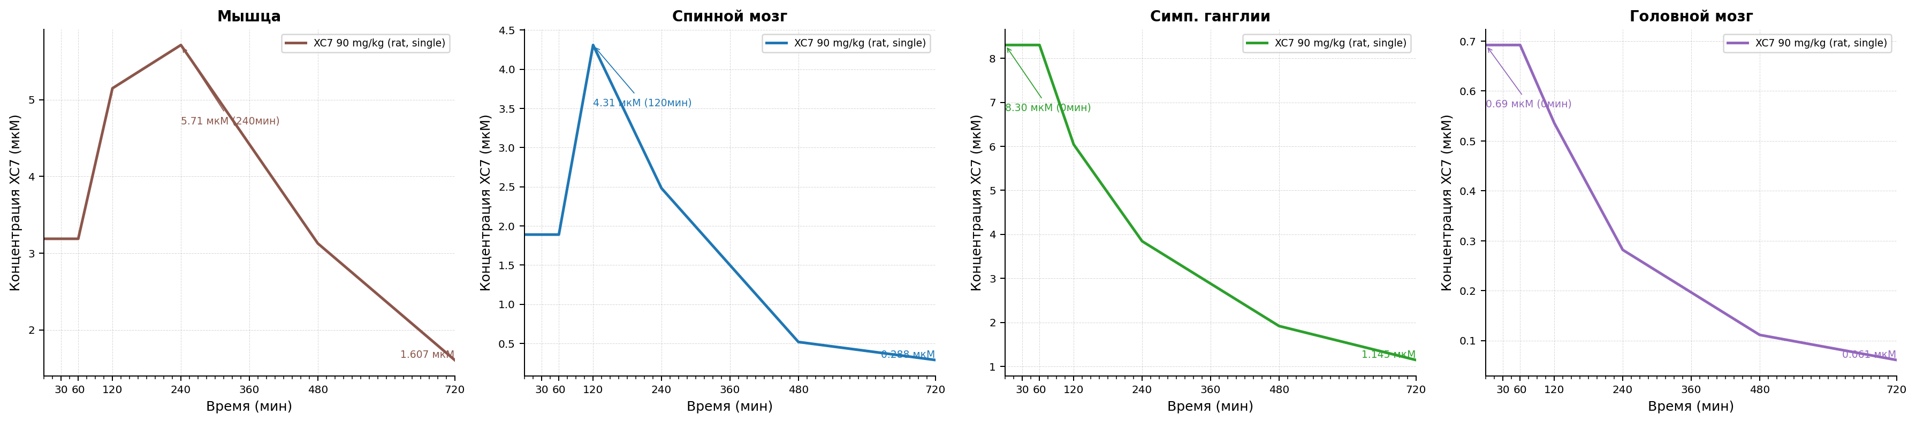
Рисунок 4.4 Figures. Fig4 4 Carrageenan Xc7 Concentration.

Модель болевого синдрома, индуцированная термическим воздействием в тесте «Горячая пластина».
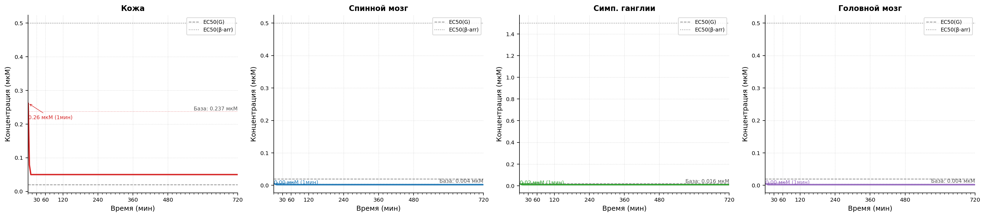
Рисунок 5.1 Модель болевого синдрома, индуцированная термическим воздействием в тесте «Горячая пластина». Изменение концентрации гистамина после индукции паталогии.
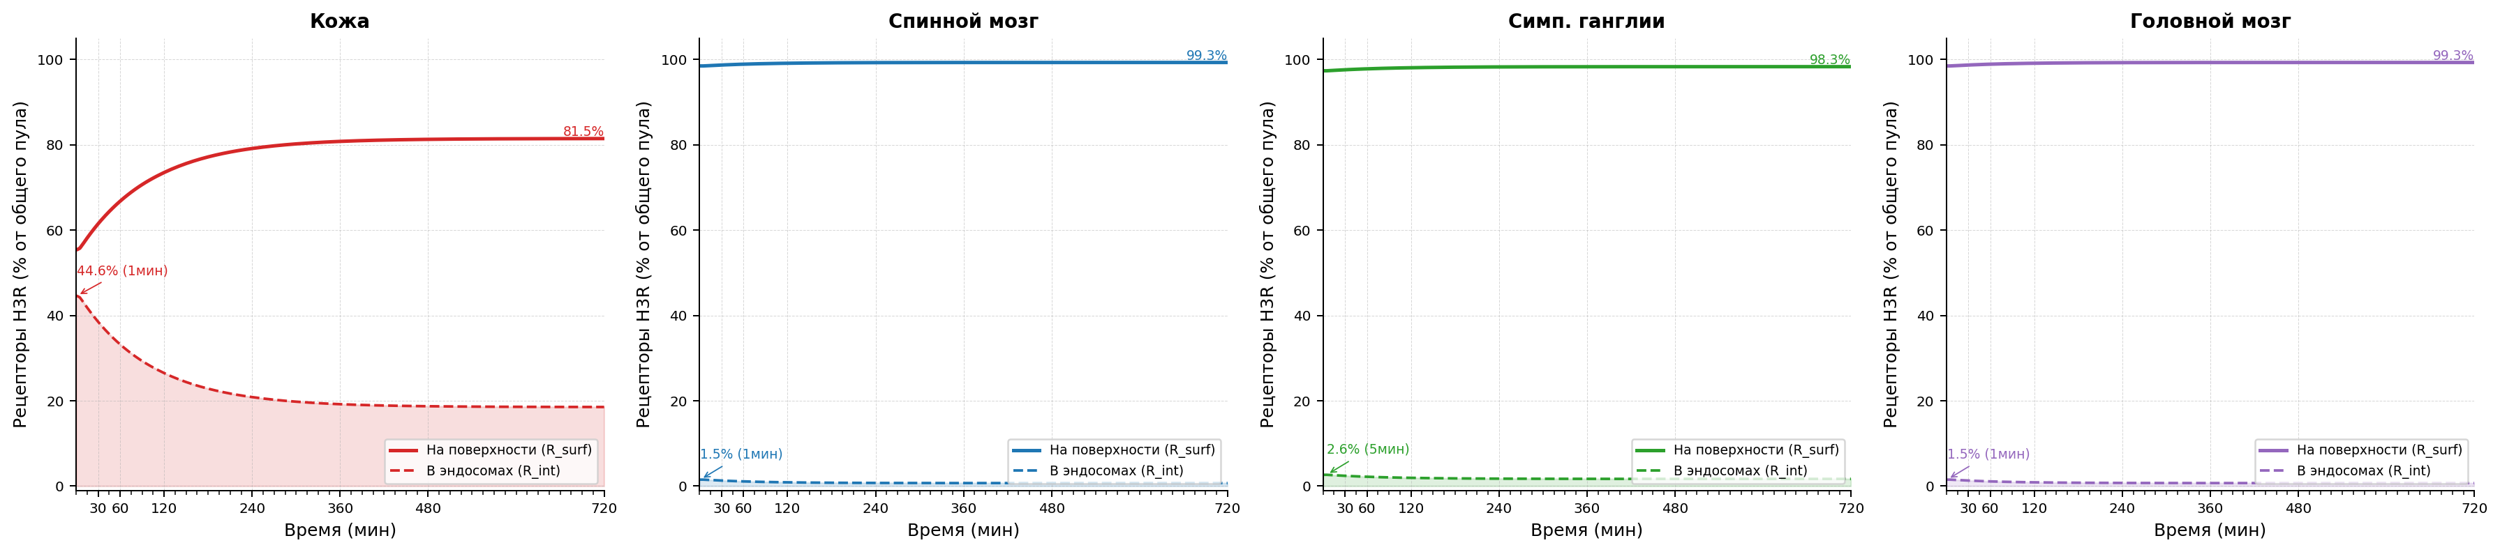
Рисунок 5.2 Модель болевого синдрома, индуцированная термическим воздействием в тесте «Горячая пластина». Интернализация H3 рецепторов после индукции паталогии.
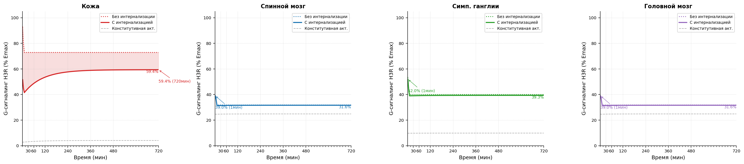
Рисунок 5.3 Модель болевого синдрома, индуцированная термическим воздействием в тесте «Горячая пластина». Уровень функциональной активности H3 рецепторов после индукции паталогии.

Параметры конфигурации
Параметр | Значение
trafficking.k_int_max_per_h | 1.25
trafficking.k_rec_per_h | 0.5
trafficking.k_synth_per_h | 0.05
trafficking.ec50_barr_nm | 500.0
trafficking.hill_n | 1.0
trafficking.ec50_g_nm | 20.0
trafficking.constitutive_activity | 0.05
trafficking.h_base_nm | 10.0
antagonist_pk.enabled | true
antagonist_pk.source_xlsx | E:/Users/Fedor/Downloads/Telegram Desktop/SINGLE_REP_pred_mice_rats.xlsx
antagonist_pk.regimen | single
antagonist_pk.dose_mg_per_kg | 90.0
antagonist_pk.concentration_column | C_nM
antagonist_pk.method_time | linear
antagonist_pk.method_dose | log-linear
antagonist_pk.extrapolation | clip
antagonist_pk.tissue_map.skin | skin
antagonist_pk.tissue_map.muscle | muscles
antagonist_pk.tissue_map.spinal_coord | spinal cord
antagonist_pk.tissue_map.brain | brain
antagonist_pk.tissue_map.ganglia | sympathetic ganglia
tissue_overrides.skin.trafficking.k_int_max_per_h | 1.25
tissue_overrides.skin.trafficking.k_rec_per_h | 0.5
tissue_overrides.skin.trafficking.k_synth_per_h | 0.05
tissue_overrides.skin.trafficking.ec50_barr_nm | 500.0
tissue_overrides.skin.trafficking.hill_n | 1.0
tissue_overrides.skin.trafficking.ec50_g_nm | 20.0
tissue_overrides.skin.trafficking.constitutive_activity | 0.05
tissue_overrides.skin.trafficking.h_base_nm | 50.0
tissue_overrides.muscle.trafficking.k_int_max_per_h | 1.25
tissue_overrides.muscle.trafficking.k_rec_per_h | 0.5
tissue_overrides.muscle.trafficking.k_synth_per_h | 0.05
tissue_overrides.muscle.trafficking.ec50_barr_nm | 500.0
tissue_overrides.muscle.trafficking.hill_n | 1.0
tissue_overrides.muscle.trafficking.ec50_g_nm | 20.0
tissue_overrides.muscle.trafficking.constitutive_activity | 0.05
tissue_overrides.muscle.trafficking.h_base_nm | 10.0
tissue_overrides.spinal_coord.trafficking.k_int_max_per_h | 1.4
tissue_overrides.spinal_coord.trafficking.k_rec_per_h | 0.8
tissue_overrides.spinal_coord.trafficking.k_synth_per_h | 0.05
tissue_overrides.spinal_coord.trafficking.ec50_barr_nm | 500.0
tissue_overrides.spinal_coord.trafficking.hill_n | 1.0
tissue_overrides.spinal_coord.trafficking.ec50_g_nm | 20.0
tissue_overrides.spinal_coord.trafficking.constitutive_activity | 0.25
tissue_overrides.spinal_coord.trafficking.h_base_nm | 2.0
tissue_overrides.brain.trafficking.k_int_max_per_h | 1.4
tissue_overrides.brain.trafficking.k_rec_per_h | 0.8
tissue_overrides.brain.trafficking.k_synth_per_h | 0.05
tissue_overrides.brain.trafficking.ec50_barr_nm | 500.0
tissue_overrides.brain.trafficking.hill_n | 1.0
tissue_overrides.brain.trafficking.ec50_g_nm | 20.0
tissue_overrides.brain.trafficking.constitutive_activity | 0.25
tissue_overrides.brain.trafficking.h_base_nm | 2.0
tissue_overrides.ganglia.trafficking.k_int_max_per_h | 1.8
tissue_overrides.ganglia.trafficking.k_rec_per_h | 0.7
tissue_overrides.ganglia.trafficking.k_synth_per_h | 0.05
tissue_overrides.ganglia.trafficking.ec50_barr_nm | 1500.0
tissue_overrides.ganglia.trafficking.hill_n | 1.0
tissue_overrides.ganglia.trafficking.ec50_g_nm | 20.0
tissue_overrides.ganglia.trafficking.constitutive_activity | 0.1
tissue_overrides.ganglia.trafficking.h_base_nm | 10.0
model_id | hot_plate_pkpd_v1
compound | xc7
species | mouse
loss_mode | mse
traceability.source_in_report | Scenario matrix row: hot plate
traceability.source_reference
traceability.source_version | 2026-04-06
assumptions | ["canonical scenario_id hot_plate is used directly", "runtime registry is treated as the source of truth for skin, spinal_coord, and ganglia H(t)", "brain is included as a mandatory CNS tissue and currently uses a spinal_coord proxy profile until a source-backed brain profile is introduced", "skin h_base_nm is overridden to 50 nM so the marker-tissue H(t) peak matches the primary 262 nM text value at 1 min", "top-level trafficking acts as deterministic defaults before tissue_overrides are applied"]
driver.driver_type | scenario
driver.scenario_id | hot_plate
tissues | ["skin", "spinal_coord", "ganglia", "brain"]
time_grid | [0, 1, 5, 10, 15, 20, ..., 710, 715, 720] (len=146)
time_unit | min

Figures

Рисунок 5.4 Figures. Fig5 4 Hot Plate Xc7 Concentration.

Модель болевого синдрома, индуцированная введением уксусной кислоты.
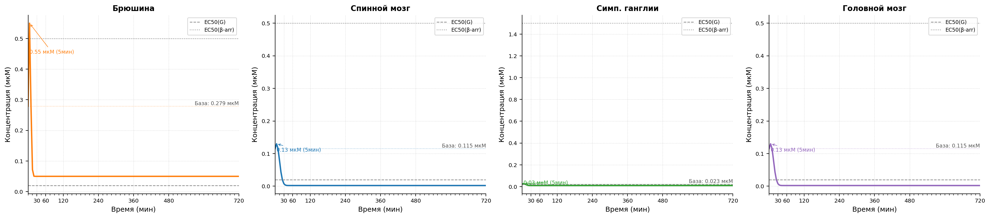
Рисунок 6.1 Модель болевого синдрома, индуцированная введением уксусной кислоты. Изменение концентрации гистамина после индукции паталогии.
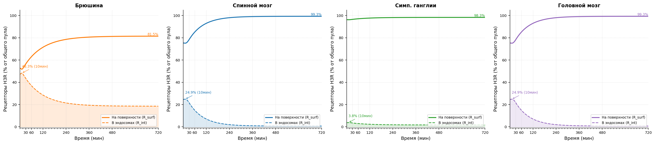
Рисунок 6.2 Модель болевого синдрома, индуцированная введением уксусной кислоты. Интернализация H3 рецепторов после индукции паталогии.
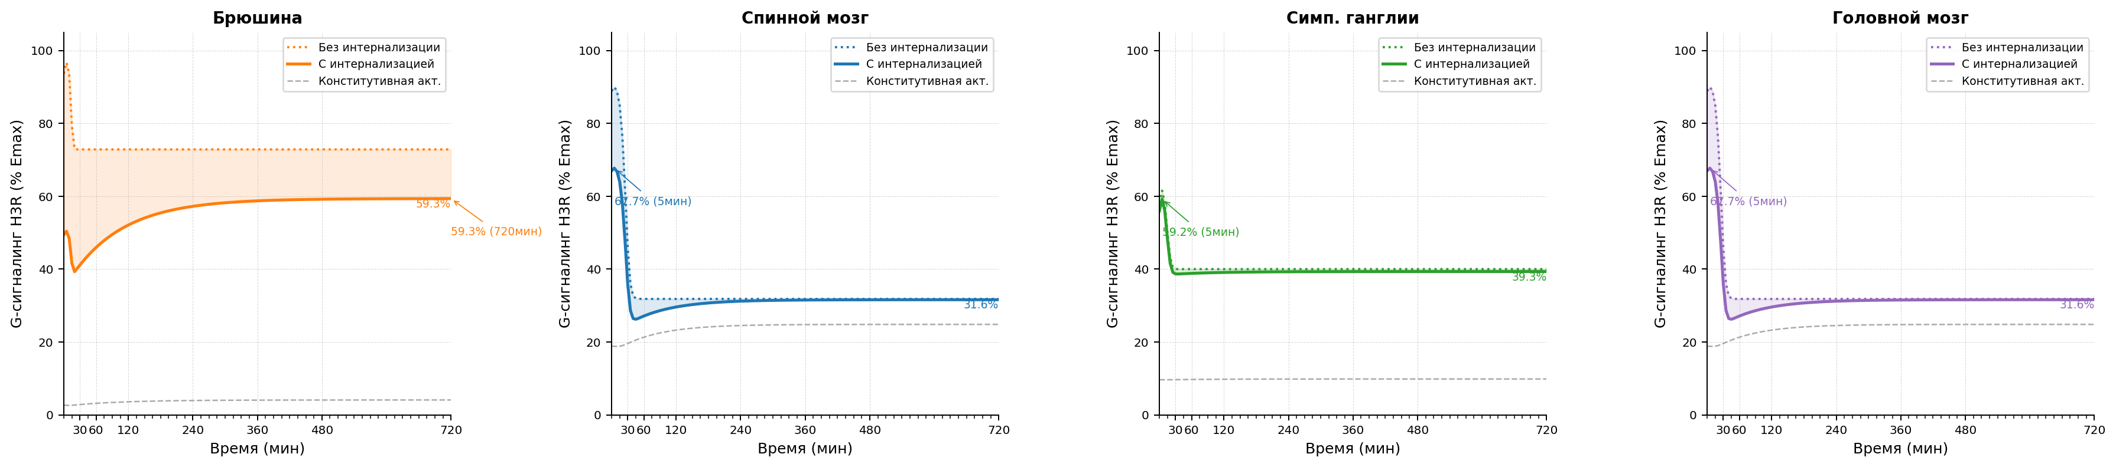
Рисунок 6.3 Модель болевого синдрома, индуцированная введением уксусной кислоты. Уровень функциональной активности H3 рецепторов после индукции паталогии.

Параметры конфигурации
Параметр | Значение
trafficking.k_int_max_per_h | 1.25
trafficking.k_rec_per_h | 0.5
trafficking.k_synth_per_h | 0.05
trafficking.ec50_barr_nm | 500.0
trafficking.hill_n | 1.0
trafficking.ec50_g_nm | 20.0
trafficking.constitutive_activity | 0.05
trafficking.h_base_nm | 10.0
antagonist_pk.enabled | true
antagonist_pk.source_xlsx | E:/Users/Fedor/Downloads/Telegram Desktop/SINGLE_REP_pred_mice_rats.xlsx
antagonist_pk.regimen | repeated
antagonist_pk.dose_mg_per_kg | 90.0
antagonist_pk.concentration_column | C_nM
antagonist_pk.method_time | linear
antagonist_pk.method_dose | log-linear
antagonist_pk.extrapolation | clip
antagonist_pk.tissue_map.skin | skin
antagonist_pk.tissue_map.muscle | muscles
antagonist_pk.tissue_map.spinal_coord | spinal cord
antagonist_pk.tissue_map.brain | brain
antagonist_pk.tissue_map.ganglia | sympathetic ganglia
antagonist_pk.tissue_map.peritoneum | bladder
tissue_overrides.skin.trafficking.k_int_max_per_h | 1.25
tissue_overrides.skin.trafficking.k_rec_per_h | 0.5
tissue_overrides.skin.trafficking.k_synth_per_h | 0.05
tissue_overrides.skin.trafficking.ec50_barr_nm | 500.0
tissue_overrides.skin.trafficking.hill_n | 1.0
tissue_overrides.skin.trafficking.ec50_g_nm | 20.0
tissue_overrides.skin.trafficking.constitutive_activity | 0.05
tissue_overrides.skin.trafficking.h_base_nm | 10.0
tissue_overrides.muscle.trafficking.k_int_max_per_h | 1.25
tissue_overrides.muscle.trafficking.k_rec_per_h | 0.5
tissue_overrides.muscle.trafficking.k_synth_per_h | 0.05
tissue_overrides.muscle.trafficking.ec50_barr_nm | 500.0
tissue_overrides.muscle.trafficking.hill_n | 1.0
tissue_overrides.muscle.trafficking.ec50_g_nm | 20.0
tissue_overrides.muscle.trafficking.constitutive_activity | 0.05
tissue_overrides.muscle.trafficking.h_base_nm | 10.0
tissue_overrides.spinal_coord.trafficking.k_int_max_per_h | 1.4
tissue_overrides.spinal_coord.trafficking.k_rec_per_h | 0.8
tissue_overrides.spinal_coord.trafficking.k_synth_per_h | 0.05
tissue_overrides.spinal_coord.trafficking.ec50_barr_nm | 500.0
tissue_overrides.spinal_coord.trafficking.hill_n | 1.0
tissue_overrides.spinal_coord.trafficking.ec50_g_nm | 20.0
tissue_overrides.spinal_coord.trafficking.constitutive_activity | 0.25
tissue_overrides.spinal_coord.trafficking.h_base_nm | 2.0
tissue_overrides.brain.trafficking.k_int_max_per_h | 1.4
tissue_overrides.brain.trafficking.k_rec_per_h | 0.8
tissue_overrides.brain.trafficking.k_synth_per_h | 0.05
tissue_overrides.brain.trafficking.ec50_barr_nm | 500.0
tissue_overrides.brain.trafficking.hill_n | 1.0
tissue_overrides.brain.trafficking.ec50_g_nm | 20.0
tissue_overrides.brain.trafficking.constitutive_activity | 0.25
tissue_overrides.brain.trafficking.h_base_nm | 2.0
tissue_overrides.ganglia.trafficking.k_int_max_per_h | 1.8
tissue_overrides.ganglia.trafficking.k_rec_per_h | 0.7
tissue_overrides.ganglia.trafficking.k_synth_per_h | 0.05
tissue_overrides.ganglia.trafficking.ec50_barr_nm | 1500.0
tissue_overrides.ganglia.trafficking.hill_n | 1.0
tissue_overrides.ganglia.trafficking.ec50_g_nm | 20.0
tissue_overrides.ganglia.trafficking.constitutive_activity | 0.1
tissue_overrides.ganglia.trafficking.h_base_nm | 10.0
tissue_overrides.peritoneum.trafficking.h_base_nm | 50.0
model_id | acetic_writhing_pkpd_v1
compound | xc7
species | mouse
loss_mode | mse
traceability.source_in_report | Scenario matrix row: acetic writhing
traceability.source_reference
traceability.source_version | 2026-04-06
assumptions | ["canonical scenario_id acetic_writhing is used directly", "runtime tissue peritoneum is used as a proxy for peritoneal wall/lavage marker measurements", "XC7 antagonist PK for peritoneum is proxied by bladder using the repeated-regimen rows because the single-regimen source omits bladder", "peritoneum, spinal_coord, and ganglia H(t) profiles are taken from scenario_registry as the source of truth", "brain is included as a mandatory CNS tissue and currently uses a spinal_coord proxy profile until a source-backed brain profile is introduced", "peritoneum h_base_nm is overridden to 50 nM so the marker-tissue H(t) peak matches the tabulated 550 nM range at 5-10 min", "top-level trafficking acts as deterministic defaults before tissue_overrides are applied"]
driver.driver_type | scenario
driver.scenario_id | acetic_writhing
tissues | ["peritoneum", "spinal_coord", "ganglia", "brain"]
time_grid | [0, 5, 10, 15, 20, 25, ..., 710, 715, 720] (len=145)
time_unit | min

Figures
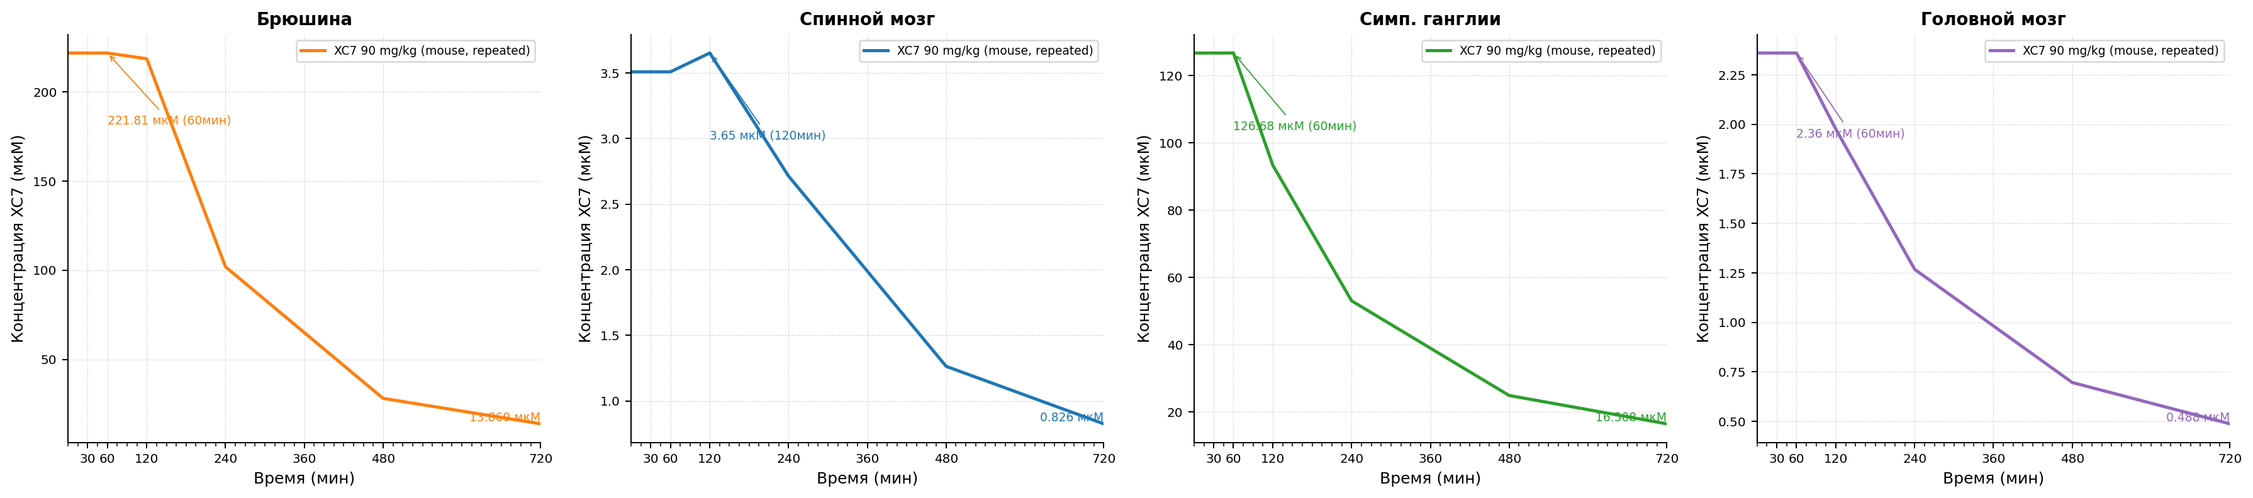
Рисунок 6.4 Figures. Fig6 4 Acetic Writhing Xc7 Concentration.

Модель болевого синдрома, индуцированная введением зимозана.
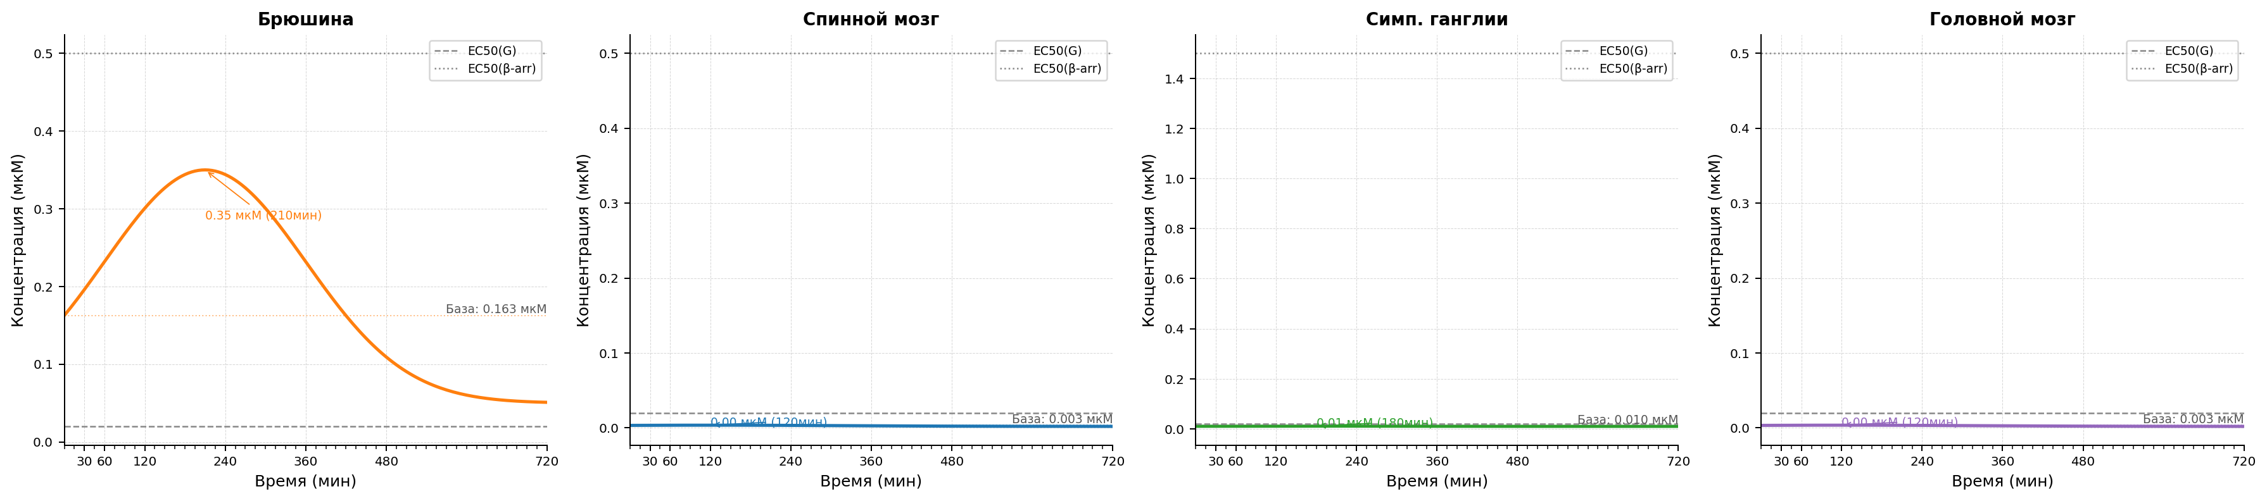
Рисунок 7.1 Модель болевого синдрома, индуцированная введением зимозана. Изменение концентрации гистамина после индукции паталогии.
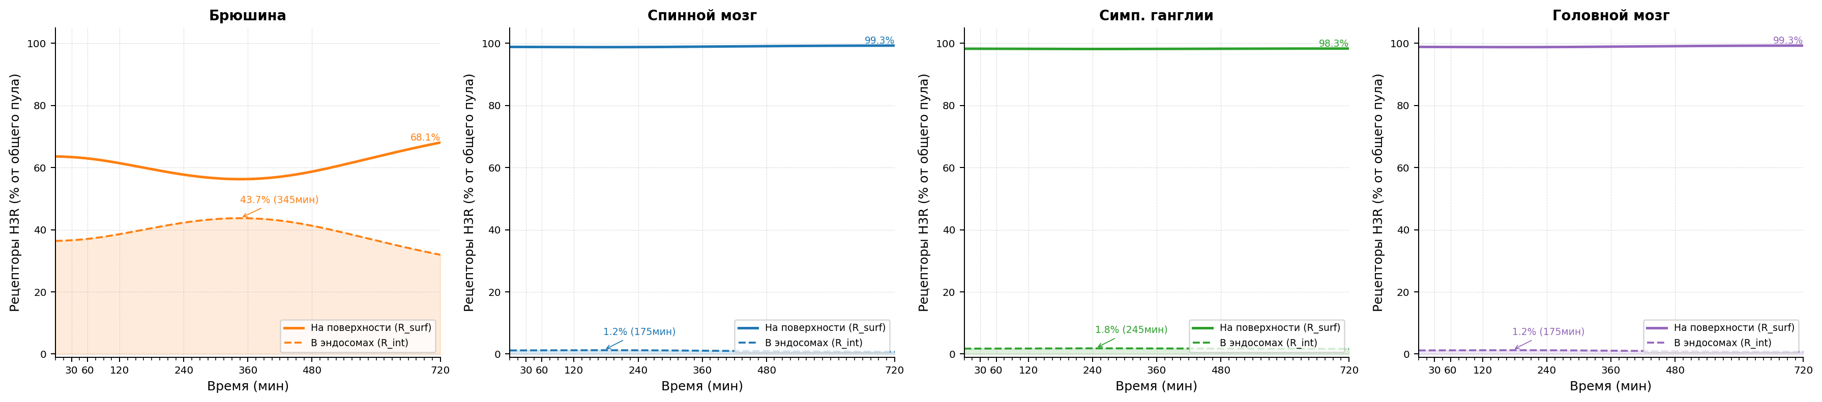
Рисунок 7.2 Модель болевого синдрома, индуцированная введением зимозана. Интернализация H3 рецепторов после индукции паталогии.
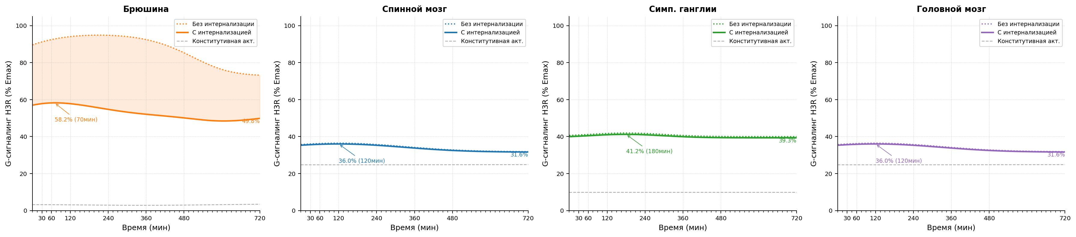
Рисунок 7.3 Модель болевого синдрома, индуцированная введением зимозана. Уровень функциональной активности H3 рецепторов после индукции паталогии.

Параметры конфигурации
Параметр | Значение
trafficking.k_int_max_per_h | 0.28
trafficking.k_rec_per_h | 0.12
trafficking.k_synth_per_h | 0.05
trafficking.ec50_barr_nm | 500.0
trafficking.hill_n | 1.0
trafficking.ec50_g_nm | 20.0
trafficking.constitutive_activity | 0.05
trafficking.h_base_nm | 10.0
antagonist_pk.enabled | true
antagonist_pk.source_xlsx | E:/Users/Fedor/Downloads/Telegram Desktop/SINGLE_REP_pred_mice_rats.xlsx
antagonist_pk.regimen | repeated
antagonist_pk.dose_mg_per_kg | 90.0
antagonist_pk.concentration_column | C_nM
antagonist_pk.method_time | linear
antagonist_pk.method_dose | log-linear
antagonist_pk.extrapolation | clip
antagonist_pk.tissue_map.skin | skin
antagonist_pk.tissue_map.muscle | muscles
antagonist_pk.tissue_map.spinal_coord | spinal cord
antagonist_pk.tissue_map.brain | brain
antagonist_pk.tissue_map.ganglia | sympathetic ganglia
antagonist_pk.tissue_map.peritoneum | bladder
tissue_overrides.skin.trafficking.k_int_max_per_h | 1.25
tissue_overrides.skin.trafficking.k_rec_per_h | 0.5
tissue_overrides.skin.trafficking.k_synth_per_h | 0.05
tissue_overrides.skin.trafficking.ec50_barr_nm | 500.0
tissue_overrides.skin.trafficking.hill_n | 1.0
tissue_overrides.skin.trafficking.ec50_g_nm | 20.0
tissue_overrides.skin.trafficking.constitutive_activity | 0.05
tissue_overrides.skin.trafficking.h_base_nm | 10.0
tissue_overrides.muscle.trafficking.k_int_max_per_h | 1.25
tissue_overrides.muscle.trafficking.k_rec_per_h | 0.5
tissue_overrides.muscle.trafficking.k_synth_per_h | 0.05
tissue_overrides.muscle.trafficking.ec50_barr_nm | 500.0
tissue_overrides.muscle.trafficking.hill_n | 1.0
tissue_overrides.muscle.trafficking.ec50_g_nm | 20.0
tissue_overrides.muscle.trafficking.constitutive_activity | 0.05
tissue_overrides.muscle.trafficking.h_base_nm | 10.0
tissue_overrides.spinal_coord.trafficking.k_int_max_per_h | 1.4
tissue_overrides.spinal_coord.trafficking.k_rec_per_h | 0.8
tissue_overrides.spinal_coord.trafficking.k_synth_per_h | 0.05
tissue_overrides.spinal_coord.trafficking.ec50_barr_nm | 500.0
tissue_overrides.spinal_coord.trafficking.hill_n | 1.0
tissue_overrides.spinal_coord.trafficking.ec50_g_nm | 20.0
tissue_overrides.spinal_coord.trafficking.constitutive_activity | 0.25
tissue_overrides.spinal_coord.trafficking.h_base_nm | 2.0
tissue_overrides.brain.trafficking.k_int_max_per_h | 1.4
tissue_overrides.brain.trafficking.k_rec_per_h | 0.8
tissue_overrides.brain.trafficking.k_synth_per_h | 0.05
tissue_overrides.brain.trafficking.ec50_barr_nm | 500.0
tissue_overrides.brain.trafficking.hill_n | 1.0
tissue_overrides.brain.trafficking.ec50_g_nm | 20.0
tissue_overrides.brain.trafficking.constitutive_activity | 0.25
tissue_overrides.brain.trafficking.h_base_nm | 2.0
tissue_overrides.ganglia.trafficking.k_int_max_per_h | 1.8
tissue_overrides.ganglia.trafficking.k_rec_per_h | 0.7
tissue_overrides.ganglia.trafficking.k_synth_per_h | 0.05
tissue_overrides.ganglia.trafficking.ec50_barr_nm | 1500.0
tissue_overrides.ganglia.trafficking.hill_n | 1.0
tissue_overrides.ganglia.trafficking.ec50_g_nm | 20.0
tissue_overrides.ganglia.trafficking.constitutive_activity | 0.1
tissue_overrides.ganglia.trafficking.h_base_nm | 10.0
tissue_overrides.peritoneum.trafficking.h_base_nm | 50.0
model_id | zymosan_pkpd_v1
compound | xc7
species | mouse
loss_mode | mse
traceability.source_in_report | Scenario matrix row: zymosan
traceability.source_reference
traceability.source_version | 2026-04-06
assumptions | ["canonical scenario_id zymosan is used directly", "runtime tissue peritoneum is used as a proxy for peritoneal exudate marker measurements", "XC7 antagonist PK for peritoneum is proxied by bladder using the repeated-regimen rows because the single-regimen source omits bladder", "zymosan uses the current gaussian_sum MVP approximation from scenario_registry until a dedicated delayed profile is implemented", "brain is included as a mandatory CNS tissue and currently uses a spinal_coord proxy profile until a source-backed brain profile is introduced", "peritoneum h_base_nm is overridden to 50 nM so the marker-tissue H(t) peak matches the primary tabulated 350 nM value", "marker-oriented trafficking values k_int_max=0.28 and k_rec=0.12 act as deterministic defaults before tissue_overrides are applied"]
driver.driver_type | scenario
driver.scenario_id | zymosan
tissues | ["peritoneum", "spinal_coord", "ganglia", "brain"]
time_grid | [0, 5, 10, 15, 20, 25, ..., 710, 715, 720] (len=145)
time_unit | min

Figures

Рисунок 7.4 Figures. Fig7 4 Zymosan Xc7 Concentration.

