Report code: Treamid_2024_XC268_HPF_Bleomycin_ROS
Study Report on XC268
Investigating the Effect of XC268 on Bleomycin-Induced Oxidative Stress in Human Pulmonary Fibroblasts

Study Initiation: 02.10.2023 | Valid as of: 18.10.2023
Study End: 18.10.2023 | Date: 18.10.2023

Authors:  Mr. Erik Gandalipov  Scientist in preclinical research | 18.10.2023  Date | ______________________  Signature
Study Director:  Dr. Maria Brachs  Head of Preclinical Research | 18.10.2023  Date | ______________________  Signature
CSO Treamid Therapeutics:  Dr. Maria Brachs  Managing Director | 18.10.2023  Date | ______________________  Signature

Test Facility | Treamid Therapeutics GmbH  c/o CoLaborator (Bayer), Building S141  Muellerstr. 178, 13353 Berlin, Germany

Version | Effective Date
Final draft version | 18.10.2023

Attachments:

Table of content
1. List of Tables 4
2. List of Figures 4
3. Summary 5
4. Introduction and study aim 6
5. Materials 7
5.1 Test substance 7
5.2 Cell line 7
5.3 Experimental procedures 8
5.3.1 Bleomycin-induced Reactive Oxygen Species (ROS) Assay 8
5.3.2 Data analysis 9
5.4 Archive 9
6. Results 10
7. Conclusion 12
8. Limitations 12
9. Literature 13
10. Appendix 14

Abbreviations
ATM | ATM serine/threonine kinase (Ataxia telangiectasia mutated)
CB | Citrate buffer
CTR | Untreated control
DSB | DNA double strand breaks
H2A.X | H2A histone family member X
HPF | Human pulmonary fibroblasts
HRP | Horse radish peroxidase
IgG | Immunoglobin G
RT | Room temperature
SSB | DNA single strand breaks
XC268 | N,N'-bis[2-(1H-imidazole-2-yl)ethyl]pentane diamide

- List of Tables
Table 1 The study substances tested in the model of cellular response to bleomycin-induced oxidative stress 7

- List of Figures
Figure 1. Bleomycin induced ROS generation 8
Figure 2. Measurement of bleomycin-induced Intracellular Reactive Oxygen Species (ROS) by a microtiter plate assay (first experiment) 10
Figure 3. Measurement of bleomycin-induced Intracellular Reactive Oxygen Species (ROS) by a microtiter plate assay (second experiment) 11
Figure 4. Measurement of bleomycin-induced Intracellular Reactive Oxygen Species (ROS) by a microtiter plate assay (third experiment) 11

- Summary
The in vitro laboratory at Treamid Therapeutics investigated the potential effects of XC268 on bleomycin-induced intracellular reactive oxygen species (ROS) levels in human pulmonary fibroblasts (HPF). Stimulation with bleomycin at concentrations of 5, 10, and 25 ng/mL resulted in increased intracellular ROS levels in HPF. ROS levels were measured by the H2DCFDA (2',7'-dichlorodihydrofluorescein diacetate) cell-based assay at 1, 2, 3, 4, 5, 6, and 24 h post-bleomycin stimulation.
Treatment with XC268 led to a significant reduction in ROS levels at all examined time points, with the peak efficacy observed 4 to 6 h after bleomycin exposure.
In conclusion, XC268 may mitigate bleomycin-induced oxidative stress. Further studies are needed to reinforce these findings, specifically by investigating physiological responses such as the extent of DNA repair and the formation of DNA damage foci.

- Introduction and study aim
DNA damage describes lesions of DNA, which include among others impaired base paring, single- or double-strand breaks (SSB or DSB, respectively). They can be induced by different ways in mammalian cells incl. chemicals like chemotherapeutic agents, radiation, or inflammatory state induced by e.g., viral infection. DSB are highly toxic and if not repaired, will lead to cell death by apoptosis (Jackson and Bartek, 2009; Kay et al., 2019; Yousefzadeh et al., 2021). One well described inducer of DNA damage is the chemotherapeutic agent Bleomycin, commonly used in cancer chemotherapy, particularly for treating Hodgkin's lymphoma, testicular cancer, and certain types of head and neck cancers. Bleomycin clinical utility is largely derived from its ability to induce DNA damage, which hampers cancer cell replication and leads to cell death. However Bleomycin-induced DNA damage leads to severe side effects including development of lung fibrosis (Bolzán and Bianchi, 2018; Della Latta et al., 2015).
In the human body, Bleomycin can bind to iron or other metal ions, forming a complex that subsequently reacts with oxygen to create a highly reactive intermediate. This oxygenated complex can participate in redox reactions, generating reactive oxygen species (ROS) such as superoxide and hydroxyl radicals. These ROS are powerful oxidizing agents capable of inducing double-strand breaks (DSBs) in DNA. This triggers a cellular response to DNA damage, notably the phosphorylation of Histone H2A.X at serine 139 (pH2A.X), which serves as a critical recognition site for DNA repair proteins. Historic studies have shown that pH2A.X levels correlate with the number of DSBs and can be employed as a marker for cell death induced by chemotherapeutic agents, including Bleomycin (Banáth and Olive, 2003; Namas et al., 2016; Scarpato et al., 2013; Stope, 2021).
XC268, a newly developed small molecular compound, showed in murine models of Bleomycin-induced lung fibrosis beneficial effects as visible in reduced fibrotic area and lower amount of collagen deposition. However, the mechanism of action in this model is not understood.
This study aims to complement the in vivo idiopathic pulmonary fibrosis (IPF) model conducted with XC268 (study report: TreamidXX_XXXXX). In vitro models investigating the effect of XC268 on Bleomycin-induced ROS were developed. Based on the in vivo data lung cells were chose as primary target. Human lung fibroblasts were utilized to assess the effects on ROS levels using the H2DCFDA (2',7'-dichlorodihydrofluorescein diacetate) cell-based assay, Materials

Materials

Test substance
Table 1 The study substances tested in the model of cellular response to bleomycin-induced oxidative stress
Substance Name | Chemical Name | Supplier | Batch number | Date of manufacture | Expiry date | Storage condition
XC268 | N,N'-bis[2-(1H-imidazole-2-yl)ethyl]pentane diamide | Alven Laboratories s.r.o. | 001012022 | 01/2022 | 01/2027 | RT

A 50µM stock solution of XC268 was prepared for each experiment by solving 15.9 mg XC268 powder in 1ml citrate buffer. The mixed was vortexed until the solution appeared clear. The solution was prepared right before use.

Cell line
HPF-c (PromoCell, C-12360) – primary human pulmonary fibroblasts isolated from human lung tissue. HPF main function is to produce type III collagen, elastin, and proteoglycans of the extracellular matrix of the alveolar septa. Pulmonary fibroblasts (PF) play an important role in the repair and remodeling processes following injury. They are often used for studying lung tissue repair, tissue remodeling after injury, or the response after pulmonary inflammation.
The HPF cells cultured in RPMI-1640 medium, supplemented with 20% fetal bovine serum (FBS) and 50 µg/mL gentamicin, under conditions of 5% CO₂ and 37°C.

Experimental procedures

Bleomycin-induced Reactive Oxygen Species (ROS) Assay
HPF cells were seeded on 96-well black cell culture plate (Corning-3603) (at the density 15x10⁴ cells/ml) in RPMI-1640 medium supplemented with 20% FBS, 50 μg/mL gentamicin at 5% CO₂ and 37°C. After seeding, the cells were cultured for 16 h and after inoculation cells were washed twice in PBS (pH 7.4) and covered by 100 µL of PBS (pH 7.4) containing 20 µM carboxy-H₂DCFDA for 45 min in 37°C.
After staining cells were washed twice in PBS (pH 7.4) and covered by 100 µL of growth medium. Then, XC268 in 0.6% citrate buffer (CB) or 0.6% CB without drug in appropriate concentrations was added according to the Scheme 1 and incubated at 37°C.
After 30 min of incubation with XC268, 5 µg/mL, 10 µg/mL or 25 µg/mL bleomycin was added and concentrations of XC268 was adjusted to the initial ones according to the Figure 1.
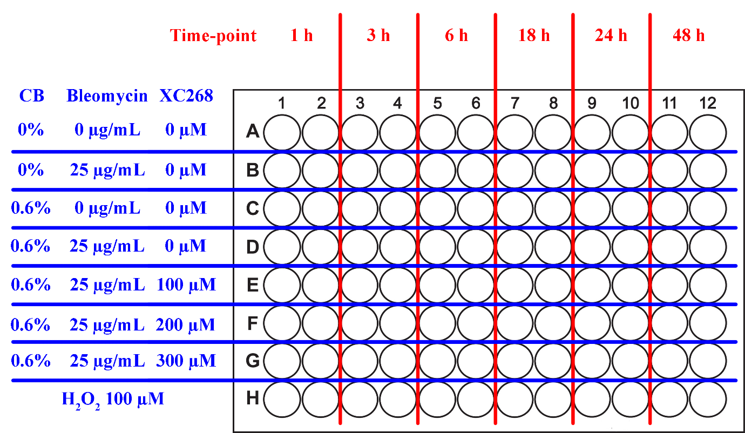
Figure 1 Bleomycin induced ROS generation

Measurements of carboxy-DCF were provided according to the time-points from Scheme 1. Fluorescent signal was measured at 485_{ex}/535_{em} nm from the plate using Tecan Spark. For each time-point cells incubated with 100 µM H₂O₂ for 4 hours were measured as an internal control of carboxy-H₂DCFDA staining.
Mean of fluorescent signals from untreated control (0% CB, 0 µg/mL bleomycin, 0 µM XC268) was subtracted from mean of samples. Then, oxidative stress development was calculated as a ratio between treated ample and CB control (0.6% CB, 0 µg/mL bleomycin, 0 µM XC268).
Three independent experiments were performed in a similar set up as described above. Results were pooled for data analysis and evaluation.

Data analysis
All data were analysed and plotted using GraphPad Prism (version 8.4.2). Data from independent experiments were pooled for analysis.

Archive
All the study documentation shall be retained in the laboratory archive for 2 years after signing the report.

Results
To investigate the effects of Bleomycin on intracellular ROS level, HPC cells were challenged by 5 µg/mL, 10 µg/mL or 25 µg/mL bleomycin for 24h. After 0, 1, 2, 3, 4, 5, 6 and 24 h the bleomycin-induced Intracellular Reactive Oxygen Species (ROS) level were evaluated by H2DCFDA (2′,7′-dichlorodihydrofluorescein diacetate) cell-based assay. As previously reported, intracellular ROS level induced already after 1h with a reduction in the response by 24h. Similar response were observed for all Bleomycin concentrations, however 25µg/ml showed a higher induction of ROS.
To investigate the potential effects of XC268 compound application in relation to cellular challenge with Bleomycin cells were treated with XC268 at the following concentrations: 0µM, 10µM, 30µM, 100µM and 300µM for 0—24h. Treatment with XC268 resulted in reduced ROS level at all investigated time points with the highest efficacy at 4-5 h after bleomycin challenge (see Figure 2).

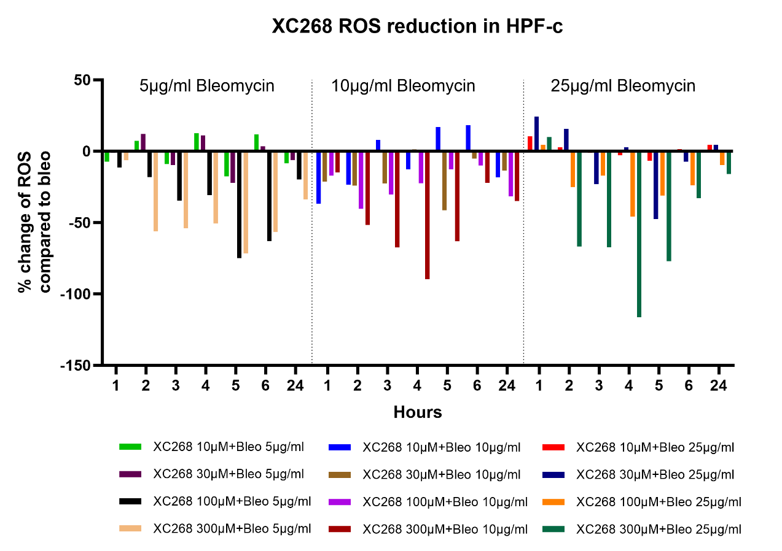
Figure 2. Measurement of bleomycin-induced Intracellular Reactive Oxygen Species (ROS) by a microtiter plate assay (first experiment). HPF cells were treated with 5 µg/mL, 10 µg/mL or 25 µg/mL bleomycin and XC268 (10µM, 30µM, 100µM and 300µM). Reactive oxygen species were determined by H2DCFDA cell-based assay
Two independent experiments investigating the effect of XC268 in bleomycin-induced Intracellular Reactive Oxygen Species (ROS) level were performed in a similar set up as described above (see Figure 3 and 4).
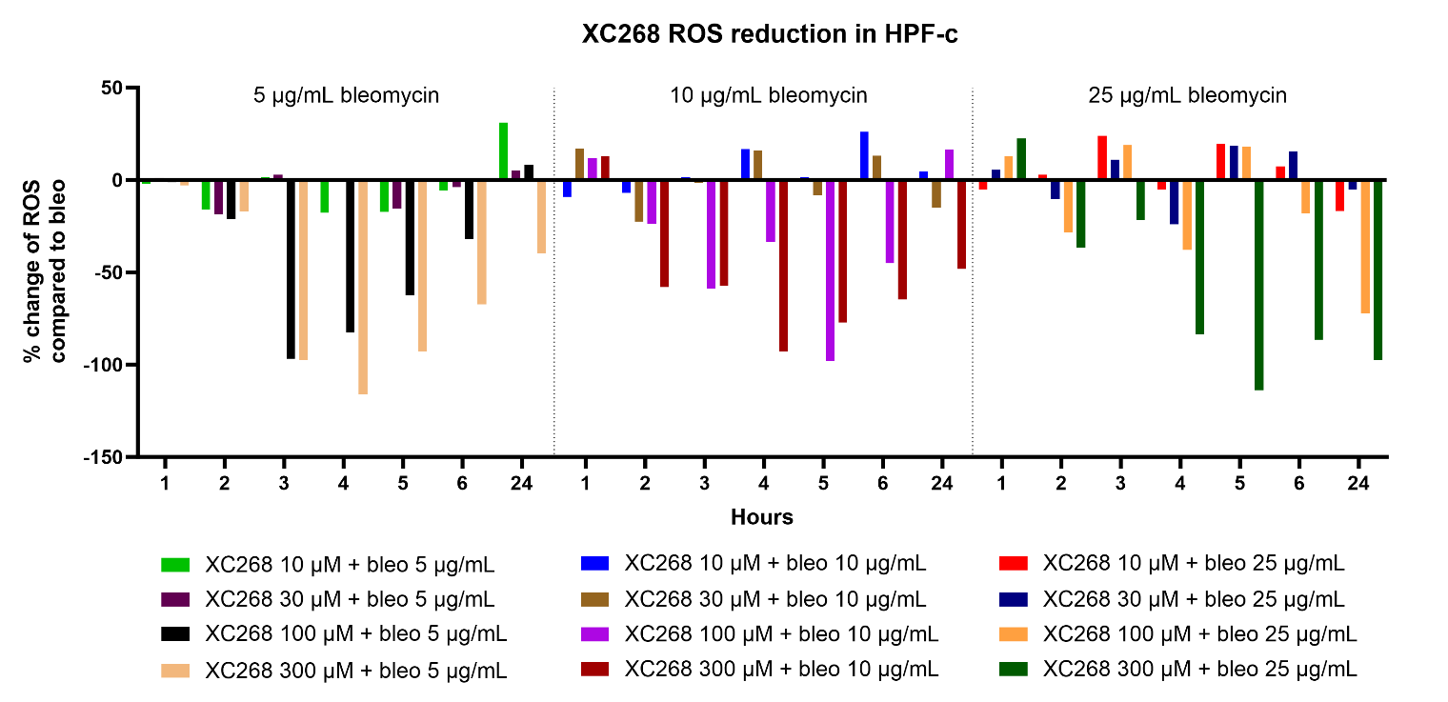
Figure 3. Measurement of bleomycin-induced Intracellular Reactive Oxygen Species (ROS) by a microtiter plate assay (second experiment). HPF cells were treated with 5 µg/mL, 10 µg/mL or 25 µg/mL bleomycin and XC268 (10µM, 30µM, 100µM and 300µM). Reactive oxygen species were determined by H2DCFDA cell-based assay

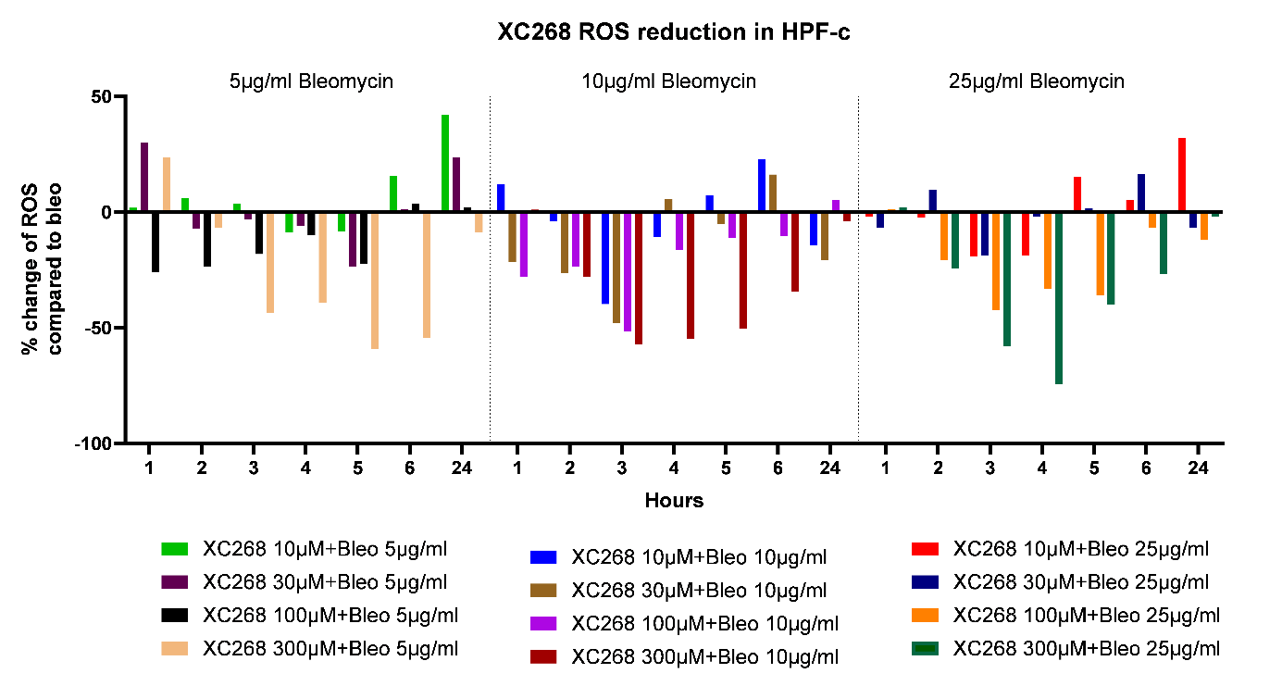
Figure 4. Measurement of bleomycin-induced Intracellular Reactive Oxygen Species (ROS) by a microtiter plate assay (third experiment). HPF cells were treated with 5 µg/mL, 10 µg/mL or 25 µg/mL bleomycin and XC268 (10µM, 30µM, 100µM and 300µM). Reactive oxygen species were determined by H₂DCFDA cell-based assay

Conclusion
A models of Bleomycin-induced intracellular reactive oxygen species (ROS) and subsequent DNA damage was successfully established to investigate the effect of XC268 in human pulmonary fibroblasts (HPF). Stimulation with bleomycin at concentrations of 5, 10, and 25 ng/mL resulted in upregulated intracellular ROS levels 1h after Bleomycin challenge.
In HPF-c XC268 treatment led to a reduction of intracellular ROS with a concentration-dependent effect starting already 1h after Bleomycin application and with the peak efficacy observed 4 to 6 h after bleomycin exposure.
In conclusion, the study demonstrates that XC268 effectively reduces bleomycin-induced oxidative stress in human pulmonary fibroblasts by decreasing intracellular ROS levels. These findings suggest that XC268 could serve as a potential therapeutic agent against bleomycin-induced cellular damage. However, additional research is necessary to further validate these results, particularly by exploring the mechanisms involving DNA repair processes and the formation of DNA damage foci.

Limitations
The experiments performed were investigating phosphorylation and total protein levels based on Western Blotting. This method has some general limitations to be considered: a) dependence on efficient and specific antibodies, b) high molecular weight proteins possess a lower transfer efficacy, c) semi-quantitative evaluation only.

Literature
[1] Sgalla G, Iovene B, Calvello M, Ori M, Varone F, Richeldi L. Idiopathic pulmonary fibrosis: pathogenesis and management. Respir Res. 2018 Feb 22;19(1):32.
[2] Li Y, Zhao J, Yin Y, Li K, Zhang C, Zheng Y. The Role of IL-6 in Fibrotic Diseases: Molecular and Cellular Mechanisms. Int J Biol Sci. 2022 Aug 29;18(14):5405-5414.
[3] Effendi WI, Nagano T. Connective Tissue Growth Factor in Idiopathic Pulmonary Fibrosis: Breaking the Bridge. Int J Mol Sci. 2022 May 28;23(11):6064.
[4] Aumiller V, Balsara N, Wilhelm J, Günther A, Königshoff M. WNT/β-catenin signaling induces IL-1β expression by alveolar epithelial cells in pulmonary fibrosis. Am J Respir Cell Mol Biol. 2013 Jul;49(1):96-104.
[5] Ou SC, Bai KJ, Cheng WH, Chen JY, Lin CH, Wen HC, Chen BC. TGF-β Induced CTGF Expression in Human Lung Epithelial Cells through ERK, ADAM17, RSK1, and C/EBPβ Pathways. Int J Mol Sci. 2020 Nov 29;21(23):9084

Appendix
Table 1A – Bleomycin 5 µg/mL (Experiment 1)
Sample |  | 0h | 1h | 2h | 3h | 4h | 5h | 6h | 24h
Bleo  5 µg/mL | + CB | 100,0 | 87,4 | 123,9 | 127,5 | 122,3 | 209,3 | 184,7 | 250,8
 | + XC268 10 µM | 100,0 | 80,1 | 131,3 | 118,5 | 134,9 | 191,5 | 196,5 | 242,4
 | % change of ROS compared to bleo | - | -7,3 | 7,4 | -9,0 | 12,6 | -17,8 | 11,8 | -8,5
 | + CB | 100,0 | 87,4 | 123,9 | 127,5 | 122,3 | 209,3 | 184,7 | 250,8
 | + XC268 30 µM | 100,0 | 86,2 | 136,0 | 117,8 | 133,4 | 187,1 | 188,2 | 244,8
 | % change of ROS compared to bleo | - | -1,1 | 12,1 | -9,7 | 11,1 | -22,1 | 3,5 | -6,1
 | + CB | 100,0 | 87,4 | 123,9 | 127,5 | 122,3 | 209,3 | 184,7 | 250,8
 | + XC268 100 µM | 100,0 | 76,0 | 105,7 | 92,8 | 91,5 | 134,4 | 121,7 | 231,0
 | % change of ROS compared to bleo | - | -11,4 | -18,2 | -34,7 | -30,8 | -74,8 | -63,0 | -19,9
 | + CB | 100,0 | 87,4 | 123,9 | 127,5 | 122,3 | 209,3 | 184,7 | 250,8
 | + XC268 300 µM | 100,0 | 80,9 | 67,7 | 73,5 | 71,7 | 137,7 | 128,1 | 217,2
 | % change of ROS compared to bleo | - | -6,5 | -56,2 | -54,1 | -50,6 | -71,5 | -56,6 | -33,7

Table 2A – Bleomycin 10 µg/mL (Experiment 1)
Sample |  | 0h | 1h | 2h | 3h | 4h | 5h | 6h | 24h
Bleo  10 µg/mL | + CB | 100,0 | 98,9 | 140,8 | 142,1 | 159,7 | 200,1 | 206,5 | 297,3
 | + XC268 10 µM | 100,0 | 62,1 | 117,3 | 150,1 | 147,0 | 216,9 | 224,7 | 278,9
 | % change of ROS compared to bleo | - | -36,8 | -23,5 | 7,9 | -12,6 | 16,8 | 18,2 | -18,4
 | + CB | 100,0 | 98,9 | 140,8 | 142,1 | 159,7 | 200,1 | 206,5 | 297,3
 | + XC268 30 µM | 100,0 | 77,5 | 116,8 | 119,4 | 160,9 | 158,7 | 201,4 | 283,5
 | % change of ROS compared to bleo | - | -21,4 | -24,1 | -22,8 | 1,2 | -41,5 | -5,1 | -13,8
 | + CB | 100,0 | 98,9 | 140,8 | 142,1 | 159,7 | 200,1 | 206,5 | 297,3
 | + XC268 100 µM | 100,0 | 81,7 | 100,4 | 111,7 | 137,1 | 187,4 | 196,6 | 265,6
 | % change of ROS compared to bleo | - | -17,2 | -40,4 | -30,4 | -22,6 | -12,7 | -9,9 | -31,7
 | + CB | 100,0 | 98,9 | 140,8 | 142,1 | 159,7 | 200,1 | 206,5 | 297,3
 | + XC268 300 µM | 100,0 | 84,2 | 89,2 | 74,5 | 69,9 | 136,8 | 184,3 | 262,4
 | % change of ROS compared to bleo | - | -14,7 | -51,6 | -67,6 | -89,8 | -63,3 | -22,2 | -34,9

Table 3A – Bleomycin 25 µg/mL (Experiment 1)
Sample |  | 0h | 1h | 2h | 3h | 4h | 5h | 6h | 24h
Bleo  25 µg/mL | + CB | 100,0 | 78,1 | 162,9 | 178,1 | 210,0 | 250,4 | 279,1 | 438,2
 | + XC268 10 µM | 100,0 | 88,4 | 165,7 | 179,2 | 207,3 | 243,9 | 280,7 | 442,8
 | % change of ROS compared to bleo | - | 10,3 | 2,8 | 1,2 | -2,7 | -6,5 | 1,6 | 4,5
 | + CB | 100,0 | 78,1 | 162,9 | 178,1 | 210,0 | 250,4 | 279,1 | 438,2
 | + XC268 30 µM | 100,0 | 102,4 | 178,6 | 154,8 | 212,8 | 202,8 | 271,7 | 442,6
 | % change of ROS compared to bleo | - | 24,3 | 15,7 | -23,3 | 2,8 | -47,7 | -7,4 | 4,4
 | + CB | 100,0 | 78,1 | 162,9 | 178,1 | 210,0 | 250,4 | 279,1 | 438,2
 | + XC268 100 µM | 100,0 | 82,5 | 137,8 | 160,8 | 164,0 | 219,3 | 255,2 | 428,6
 | % change of ROS compared to bleo | - | 4,4 | -25,1 | -17,3 | -45,9 | -31,1 | -23,9 | -9,7
 | + CB | 100,0 | 78,1 | 162,9 | 178,1 | 210,0 | 250,4 | 279,1 | 438,2
 | + XC268 300 µM | 100,0 | 88,0 | 96,2 | 110,8 | 93,8 | 173,4 | 246,2 | 422,2
 | % change of ROS compared to bleo | - | 9,9 | -66,8 | -67,3 | -116,1 | -77,0 | -32,9 | -16,0

Table 4A – Bleomycin 5 µg/mL (Experiment 2)
Sample |  | 0h | 1h | 2h | 3h | 4h | 5h | 6h | 24h
Bleo  5 µg/mL | + CB | 100,0 | 100,9 | 142,4 | 188,0 | 225,6 | 199,5 | 170,0 | 166,1
 | + XC268 10 µM | 97,8 | 108,6 | 126,5 | 189,5 | 208,0 | 182,1 | 164,3 | 197,2
 | % change of ROS compared to bleo | -2,2 | 7,7 | -15,9 | 1,5 | -17,6 | -17,3 | -5,7 | 31,2
 | + CB | 100,0 | 100,9 | 142,4 | 188,0 | 225,6 | 199,5 | 170,0 | 166,1
 | + XC268 30 µM | 99,0 | 115,6 | 123,7 | 190,9 | 225,7 | 183,8 | 166,1 | 171,2
 | % change of ROS compared to bleo | -1,0 | 14,7 | -18,8 | 3,0 | 0,1 | -15,6 | -3,9 | 5,2
 | + CB | 100,0 | 100,9 | 142,4 | 188,0 | 225,6 | 199,5 | 170,0 | 166,1
 | + XC268 100 µM | 101,1 | 107,3 | 121,3 | 91,1 | 142,9 | 137,0 | 138,1 | 174,3
 | % change of ROS compared to bleo | 1,1 | 6,4 | -21,1 | -96,8 | -82,8 | -62,5 | -31,9 | 8,2
 | + CB | 100,0 | 100,9 | 142,4 | 188,0 | 225,6 | 199,5 | 170,0 | 166,1
 | + XC268 300 µM | 97,1 | 103,8 | 125,4 | 90,6 | 109,4 | 106,8 | 102,6 | 126,2
 | % change of ROS compared to bleo | -2,9 | 2,9 | -17,0 | -97,4 | -116,2 | -92,6 | -67,4 | -39,8

Table 5A – Bleomycin 10 µg/mL (Experiment 2)
Sample |  | 0h | 1h | 2h | 3h | 4h | 5h | 6h | 24h
Bleo  10 µg/mL | + CB | 100,0 | 107,0 | 147,1 | 232,5 | 265,0 | 259,3 | 198,4 | 218,9
 | + XC268 10 µM | 90,9 | 112,6 | 140,1 | 231,7 | 281,7 | 258,6 | 224,4 | 223,6
 | % change of ROS compared to bleo | -9,1 | 5,5 | -6,9 | -0,8 | 16,7 | -0,7 | 26,0 | 4,6
 | + CB | 100,0 | 107,0 | 147,1 | 232,5 | 265,0 | 259,3 | 198,4 | 218,9
 | + XC268 30 µM | 117,0 | 127,6 | 124,6 | 230,8 | 281,0 | 250,8 | 211,5 | 204,2
 | % change of ROS compared to bleo | 17,0 | 20,6 | -22,5 | -1,7 | 16,0 | -8,5 | 13,1 | -14,8
 | + CB | 100,0 | 107,0 | 147,1 | 232,5 | 265,0 | 259,3 | 198,4 | 218,9
 | + XC268 100 µM | 111,9 | 123,8 | 123,2 | 173,6 | 231,4 | 161,3 | 153,3 | 235,4
 | % change of ROS compared to bleo | 11,9 | 16,8 | -23,8 | -59,0 | -33,6 | -98,0 | -45,1 | 16,5
 | + CB | 100,0 | 107,0 | 147,1 | 232,5 | 265,0 | 259,3 | 198,4 | 218,9
 | + XC268 300 µM | 112,8 | 119,8 | 89,1 | 175,1 | 172,4 | 182,2 | 133,6 | 170,7
 | % change of ROS compared to bleo | 12,8 | 12,7 | -57,9 | -57,4 | -92,6 | -77,1 | -64,8 | -48,3

Table 6A – Bleomycin 25 µg/mL (Experiment 2)
Sample |  | 0h | 1h | 2h | 3h | 4h | 5h | 6h | 24h
Bleo  25 µg/mL | + CB | 100,0 | 118,5 | 139,5 | 265,3 | 356,6 | 309,7 | 268,6 | 403,5
 | + XC268 10 µM | 95,1 | 107,9 | 142,4 | 289,2 | 351,3 | 329,3 | 276,1 | 386,7
 | % change of ROS compared to bleo | -4,9 | -10,6 | 3,0 | 24,0 | -5,3 | 19,7 | 7,5 | -16,9
 | + CB | 100,0 | 118,5 | 139,5 | 265,3 | 356,6 | 309,7 | 268,6 | 403,5
 | + XC268 30 µM | 105,6 | 109,1 | 129,1 | 276,2 | 332,7 | 328,3 | 284,1 | 398,5
 | % change of ROS compared to bleo | 5,6 | -9,5 | -10,3 | 10,9 | -23,9 | 18,6 | 15,5 | -5,0
 | + CB | 100,0 | 118,5 | 139,5 | 265,3 | 356,6 | 309,7 | 268,6 | 403,5
 | + XC268 100 µM | 112,9 | 108,3 | 111,1 | 284,1 | 318,7 | 327,9 | 250,7 | 331,0
 | % change of ROS compared to bleo | 12,9 | -10,3 | -28,3 | 18,8 | -37,9 | 18,2 | -17,9 | -72,5
 | + CB | 100,0 | 118,5 | 139,5 | 265,3 | 356,6 | 309,7 | 268,6 | 403,5
 | + XC268 300 µM | 122,4 | 116,1 | 102,6 | 243,7 | 273,0 | 195,9 | 182,0 | 306,1
 | % change of ROS compared to bleo | 22,4 | -2,4 | -36,8 | -21,6 | -83,6 | -113,8 | -86,6 | -97,5

Table 7A – Bleomycin 5 µg/mL (Experiment 3)
Sample |  | 0h | 1h | 2h | 3h | 4h | 5h | 6h | 24h
Bleo  5 µg/mL | + CB | 100,0 | 105,8 | 101,7 | 132,8 | 201,8 | 177,2 | 188,1 | 209,8
 | + XC268 10 µM | 100,0 | 107,6 | 107,8 | 136,2 | 193,1 | 168,8 | 203,7 | 251,8
 | % change of ROS compared to bleo | - | 1,8 | 6,1 | 3,5 | -8,7 | -8,3 | 15,6 | 42,1
 | + CB | 100,0 | 105,8 | 101,7 | 132,8 | 201,8 | 177,2 | 188,1 | 209,8
 | + XC268 30 µM | 100,0 | 135,7 | 94,4 | 129,5 | 195,6 | 153,5 | 189,2 | 233,4
 | % change of ROS compared to bleo | - | 29,9 | -7,3 | -3,2 | -6,2 | -23,7 | 1,1 | 23,6
 | + CB | 100,0 | 105,8 | 101,7 | 132,8 | 201,8 | 177,2 | 188,1 | 209,8
 | + XC268 100 µM | 100,0 | 79,7 | 78,3 | 114,5 | 191,7 | 154,6 | 191,7 | 211,9
 | % change of ROS compared to bleo | - | -26,2 | -23,5 | -18,3 | -10,1 | -22,6 | 3,6 | 2,1
 | + CB | 100,0 | 105,8 | 101,7 | 132,8 | 201,8 | 177,2 | 188,1 | 209,8
 | + XC268 300 µM | 100,0 | 129,4 | 94,7 | 89,1 | 162,5 | 118,0 | 133,6 | 201,0
 | % change of ROS compared to bleo | - | 23,6 | -7,0 | -43,6 | -39,3 | -59,2 | -54,4 | -8,7

Table 8A – Bleomycin 10 µg/mL (Experiment 3)
Sample |  | 0h | 1h | 2h | 3h | 4h | 5h | 6h | 24h
Bleo  10 µg/mL | + CB | 100,0 | 122,7 | 105,0 | 178,6 | 218,4 | 174,8 | 203,7 | 263,3
 | + XC268 10 µM | 100,0 | 110,6 | 100,8 | 138,8 | 207,6 | 182,0 | 226,3 | 248,8
 | % change of ROS compared to bleo | - | -12,0 | -4,2 | -39,9 | -10,7 | 7,2 | 22,7 | -14,5
 | + CB | 100,0 | 122,7 | 105,0 | 178,6 | 218,4 | 174,8 | 203,7 | 263,3
 | + XC268 30 µM | 100,0 | 100,9 | 78,5 | 130,4 | 223,9 | 169,6 | 219,8 | 242,5
 | % change of ROS compared to bleo | - | -21,8 | -26,5 | -48,2 | 5,6 | -5,2 | 16,1 | -20,8
 | + CB | 100,0 | 122,7 | 105,0 | 178,6 | 218,4 | 174,8 | 203,7 | 263,3
 | + XC268 100 µM | 100,0 | 94,6 | 81,3 | 127,1 | 202,0 | 163,5 | 193,2 | 268,3
 | % change of ROS compared to bleo | - | -28,0 | -23,7 | -51,5 | -16,4 | -11,3 | -10,5 | 5,0
 | + CB | 100,0 | 122,7 | 105,0 | 178,6 | 218,4 | 174,8 | 203,7 | 263,3
 | + XC268 300 µM | 100,0 | 122,0 | 77,1 | 121,5 | 163,4 | 124,2 | 169,3 | 259,2
 | % change of ROS compared to bleo | - | -0,6 | -27,9 | -57,1 | -54,9 | -50,6 | -34,4 | -4,2

Table 9A – Bleomycin 25 µg/mL (Experiment 3)
Sample |  | 0h | 1h | 2h | 3h | 4h | 5h | 6h | 24h
Bleo  25 µg/mL | + CB | 100,0 | 107,3 | 86,8 | 133,3 | 235,5 | 197,5 | 206,1 | 288,5
 | + XC268 10 µM | 100,0 | 105,4 | 84,5 | 113,9 | 216,6 | 212,7 | 211,3 | 320,5
 | % change of ROS compared to bleo | - | -1,9 | -2,3 | -19,3 | -18,9 | 15,2 | 5,2 | 31,9
 | + CB | 100,0 | 107,3 | 86,8 | 133,3 | 235,5 | 197,5 | 206,1 | 288,5
 | + XC268 30 µM | 100,0 | 100,6 | 96,2 | 114,3 | 233,4 | 199,1 | 222,6 | 281,6
 | % change of ROS compared to bleo | - | -6,7 | 9,4 | -19,0 | -2,2 | 1,6 | 16,5 | -6,9
 | + CB | 100,0 | 107,3 | 86,8 | 133,3 | 235,5 | 197,5 | 206,1 | 288,5
 | + XC268 100 µM | 100,0 | 106,8 | 66,0 | 90,8 | 202,1 | 161,6 | 199,3 | 276,3
 | % change of ROS compared to bleo | - | -0,5 | -20,8 | -42,5 | -33,4 | -35,9 | -6,8 | -12,2
 | + CB | 100,0 | 107,3 | 86,8 | 133,3 | 235,5 | 197,5 | 206,1 | 288,5
 | + XC268 300 µM | 100,0 | 109,3 | 62,4 | 75,1 | 160,9 | 157,6 | 179,2 | 286,7
 | % change of ROS compared to bleo | - | 2,0 | -24,4 | -58,1 | -74,6 | -39,9 | -26,8 | -1,9

