Report

# (The following below without the reference, illustrations count to 498 word count)

Lempel-Ziv-Welch or LZW is a compression algorithm based of LZ78 used for basic compression by converting characters to base values allowing for a smaller memory allocation on transfer or storage. LZ78 had been published in 1978 by two programmers by the name of Abraham Lempel and Jacob Ziv. In 1984 an improved version called LZW had been released, and worked in a more effective manner than the original LZ78 before it, as it had a method which stops some recurring character, creating a more compressed text file.

Compression is used to reduce a files size with minimal impact on the files quality and there are two types of it, lossy and lossless, compression makes it so transfers of files on the internet are faster. Certain files can be large in file size making transfers online slow and tedious if the user’s bandwidth which was also a lot slower on average in the past.

compression creates a way to compress the files making the recurring types be recorded and taken out of the file, with a value replacer which is recorded on the decompression software on the other side of the transfer to place back in as the recurring text as the identifier would link the section to the original input and place  
it back into the file.

LZW compression was originally invented for UNIX to provide a safer and better compression method when transferring images and text files which are even now still using the same compression method within UNIX for text files and image files for its lossless compression method.

LZW compression algorithm; is commonly used for UNIX’s text and image compression, to allow for a lossless compression method, which makes it so no data is lost when files are transferred multiple times, whereas lossy methods do the opposite allowing for some background data to be removed which can over a time of multiple transfers corrupt the file or change its output.

The illustration shown below shows the conversions of the first two characters presented in a file:

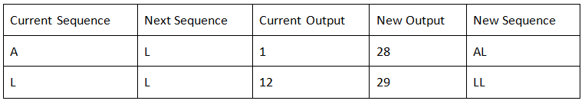

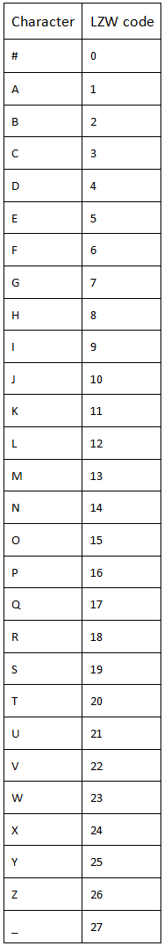

LZW compression uses a “dictionary” to hold a list of characters displayed as an array to lookup when converting for compression. The compression uses a set of actions to set a number value to each character entered and set new values for a set of the characters within the file compressed this changing 2 to four character words to 2 digit numbers which can be changed back on decompression.

The compression formats the file to hexadecimal numbered strings to allow for a smaller size when transferring. the sections are recorded by making new values in a type of array, the array works as a Dictionary holding a set of letters, punctuation and spaces to replace with a value and allow for the text to be shortened as this would take two or more of the characters and with their counterpart values, the program will change it to an additional value set for the two characters as shown below.

## References

* techtarget LZW compression by Margaret Rouse Last updated [April 2005].Available From:  (<https://whatis.techtarget.com/definition/LZW-compression>) [Accessed 3rd December 2018]
* The Data Compression Book By Mark Nelson and Jean-Loup Gailly [30 Nov 1995] (chrome-extension://oemmndcbldboiebfnladdacbdfmadadm/<http://staff.uob.edu.bh/files/781231507_files/The-Data-Compression-Book-2nd-edition.pdf> ) [Accessed 5th December 2018]

Shift-And Approach to Pattern Matching in LZW Compressed Text by Takuya Kida, Masayuki Takeda, Ayumi Shinohara, Setsuo Arikawa [08 July 1999] (<https://link.springer.com/chapter/10.1007/3-540-48452-3_1> ) [Accessed 5th December 2018]