
《High-level Language Programming Project》 Report
Campus Life Simulator
Project Name: | Campus Life Simulator
School: | SCUT
Major: | AI
Student Name(s): | MaiZhuoKai
Teacher: | [PLEASE FILL IN]
Submission Date: | [PLEASE FILL IN]
Prepared according to Appendix 2 of the course project specification

Executive Summary
Campus Life Simulator is a pixel-art, single-player simulation game that models a fourteen-day university semester. The player moves through a campus map, enters functional buildings, selects activities, manages visible and hidden character variables, experiences branching events, completes milestone quests, and reaches one of several settlement outcomes. The repository is organized as a modern C++ application with SFML for rendering and input, TGUI for interface widgets, JSON-based data files, and CMake for cross-platform construction. Its scope is appropriate for a high-level language programming project because it combines object-oriented modeling, graphical user interaction, persistence, randomization, state transitions, and modular software architecture in one coherent system.
The central design idea is to treat campus life as a controlled state-transition system. A player decision does not merely show text: it advances time, changes character attributes, updates long-term hidden variables, unlocks or blocks subsequent events, and may influence combat difficulty or final outcomes. This design creates meaningful feedback between short-term actions and long-term results. It also provides natural opportunities to apply encapsulation, inheritance, polymorphism, separation of concerns, event-driven programming, and data-driven configuration.
This report follows the structure required by the course specification. It documents requirement analysis, key programming issues, team duties, runtime environment, general and detailed design, progress planning, testing, personal learning, and references. Because the author names, school, major, teacher, and final local test records were not supplied, these fields are intentionally marked for completion. Runtime test statuses in Section 5 distinguish repository/static verification from tests that must be executed on the final submission computer; this avoids presenting unperformed tests as measured results.

Project Compliance Overview
Course Requirement | Evidence in Campus Life Simulator | Assessment
Object-oriented features | Encapsulation, abstract classes, inheritance, overriding, and runtime polymorphism appear in the entity and UI designs. | Satisfied by design
At least five classes | The source tree contains many classes across core, entity, map, interaction, quest, UI, and file I/O modules. | Satisfied
Inheritance hierarchy of at least two levels | Entity → Character → Player/Enemy forms a three-level hierarchy. | Satisfied
Graphical UI | SFML provides the rendering/input window; TGUI provides panels, labels, progress bars, prompts, and settings/help screens. | Satisfied
File read/write/update | Save, configuration, localization, and event data are managed through file and JSON management modules. | Satisfied by architecture
At least 2,000 source lines | The repository contains dozens of C++ header/source files. A final cloc report should be attached as formal evidence. | Confirm with cloc
Clear comments | Core entity classes use descriptive documentation comments for responsibilities, relationships, methods, and parameters. | Satisfied in reviewed files

Editable fields: Replace every [PLEASE FILL IN] field, insert the final team-member names, and update the runtime test result column after executing the release build on the submission computer.

Contents
1. Requirement Analysis for System
2. Program Analysis
3. Technical Routine
4. Programming Progress
5. Testing Report
6. Personal Summary
7. Reference
Appendix A. Requirement Traceability Matrix
Appendix B. Final Submission Checklist

1. Requirement Analysis for System

1.1 The Background and Motivation of System
University students constantly balance academic work, sleep, exercise, food, social relationships, emotional pressure, and personal interests. These factors are interconnected: studying may improve academic progress but consume energy; exercise may take time but improve health; social activity may increase support but reduce study time; and repeated exhaustion can create long-term consequences. A simulation is well suited to this problem because it can convert the competing pressures of campus life into explicit rules, variables, decisions, and observable outcomes.
The project is also motivated by a programming-education need. A management-only application can demonstrate classes and files, but a campus simulation places the same technical ideas in a more engaging environment. The player sees a map, moves a character, interacts with buildings, opens graphical panels, reads event text, makes choices, and receives immediate visual feedback. Behind this experience, the program must coordinate rendering, input, time, character state, random checks, quests, persistence, configuration, and localization. Therefore, the project offers sufficient breadth to demonstrate both foundational and advanced object-oriented programming techniques.
The visual identity is based on pixel art. A stylized campus map gives a clear spatial model while keeping asset complexity manageable for a student team. Functional buildings such as the dormitory, library, gym, classroom, cafeteria, and convenience store are more than decorations; they connect spatial exploration to domain logic. The player can understand the consequences of a decision through familiar campus contexts rather than through abstract menus alone.
A further motivation is replayability. The simulator provides difficulty selection, probabilistic combat checks, SAN-dependent enemy behavior, branching events, hidden variables, milestone examinations, and multiple endings. Consequently, two playthroughs can follow different routes even when they share the same fourteen-day calendar. This replayability encourages the design of reusable classes and data-driven event definitions instead of hard-coding one linear script.
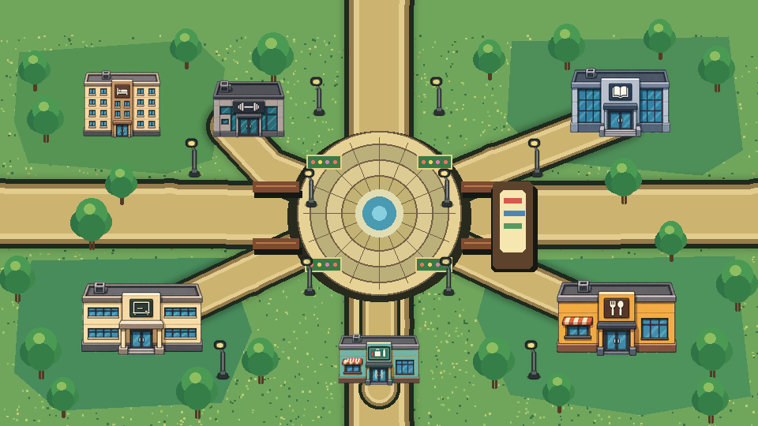
Figure 1. Campus map artwork used by the project (repository preview).

1.2 System Objectives
The overall objective is to design and implement a friendly, reliable, and extensible campus-life simulation that satisfies the course requirements while remaining understandable to future maintainers. The system should provide a complete game loop from title screen to final settlement, offer meaningful choices, and store enough state to resume a session accurately.
- Provide a graphical title screen, difficulty selection, help/settings panels, HUD, time display, prompts, and modal messages.
- Allow the player to explore the campus using keyboard or mouse control and to enter or leave functional buildings through portals.
- Model a fourteen-day semester starting at 08:00, with interaction-driven time advancement, daily routines, Day 7 midterm progression, and Day 14 final settlement.
- Represent academic progress, SAN, energy, health, social state, money, buffs, flags, and long-term hidden variables in a controlled character model.
- Implement location activities such as eating, reading, exercising, studying, gaming, sleeping, and classroom attendance, with clearly defined costs and effects.
- Provide a combat/check mechanism based on a d20 roll, character attributes, buffs, difficulty class, and SAN-dependent enemy scaling.
- Load branching events and configuration from external JSON data so content can be modified without recompiling gameplay code.
- Support save, load, configuration, and localization through dedicated file-management components.
- Use object-oriented design with abstract base classes, encapsulated state, inheritance hierarchies, overridden methods, and polymorphic update/render behavior.
- Maintain modular source organization, descriptive comments, and clear boundaries among UI, domain logic, map, interaction, quest, event, and file I/O responsibilities.

1.3 Functional Requirements
ID | Functional Requirement
FR-01 | Start a new game from the title screen and choose Easy, Normal, or Hard difficulty.
FR-02 | Move the player with WASD/arrow keys or point-to-move mouse control.
FR-03 | Enter a building or trigger an interaction by pressing Enter when appropriate.
FR-04 | Display real-time player attributes, current day/time, contextual notices, and modal information.
FR-05 | Advance game time through activities rather than through uncontrolled real-time ticking.
FR-06 | Restrict cafeteria service to lunch and dinner windows and apply meal-specific costs/effects.
FR-07 | Allow library reading, gym exercise, dormitory study/game/sleep, and classroom activities.
FR-08 | Trigger scheduled or interaction-based branching events according to conditions.
FR-09 | Spawn and resolve emotion-based combat encounters according to player SAN and difficulty.
FR-10 | Track milestone quests and settle the midterm, final examination, or immediate failure endings.
FR-11 | Save the current session, load a previous session, and preserve relevant gameplay state.
FR-12 | Read language/configuration/event assets and update user settings through external files.

1.4 Non-functional Requirements
Usability requires clear controls, legible text, consistent panel behavior, responsive input, and visible feedback after every action. Reliability requires state changes to be clamped to valid ranges, save files to be parsed safely, and time or ending logic to avoid contradictory states. Maintainability requires modules to have focused responsibilities, dependencies to flow in predictable directions, and content to be separated from engine code where practical. Portability requires a standard CMake build and commonly available libraries. Performance requires the main update/render loop to remain responsive while handling event checks, UI updates, and asset drawing.
The course specification additionally demands a friendly UI, random file processing, more than five classes, an inheritance hierarchy of at least two levels, at least 2,000 lines of source code, and detailed comments. The architecture addresses these conditions directly. The final delivery package should include a source-line-count report generated by a tool such as cloc, because a repository file count alone is not an auditable measurement of non-blank, non-comment source lines.

2. Program Analysis

2.1 Key Issues for System

2.1.1 Coordinating the Main Game State
The largest issue is coordination. Input, movement, collision, building transitions, time changes, event triggers, combat, quest progress, UI refresh, and persistence all operate on shared game state. If every component directly changes every other component, the project quickly becomes difficult to test and extend. The repository addresses this by introducing coordinating classes such as GameSession and GameContext, while focused systems such as TimeSystem, CombatSystem, SleepSystem, EventRunner, and SettlementResolver perform narrower tasks. This division makes state transitions explicit and reduces duplicated rules.

2.1.2 Maintaining Consistent Character Attributes
Visible and hidden variables must remain valid after many independent actions. For example, eating, reading, combat, sleep, and events may all modify energy or SAN. Character therefore encapsulates attribute storage and exposes controlled getters/setters and damage or movement operations. Clamping prevents invalid values from propagating into the HUD, combat calculations, or ending conditions. Hidden variables are kept separate from the visible interface so that long-term effects can influence outcomes without revealing every internal coefficient to the player.

2.1.3 Designing a Meaningful Time System
The simulation does not advance simply because real seconds pass. Time is a scarce gameplay resource consumed by activities. This creates a deterministic relationship between choices and opportunity cost: a library visit may improve academic progress but consume thirty minutes; exercise consumes time while changing physical variables; sleeping after the permitted time moves the calendar to the next morning. The time system must also trigger fixed milestones, including the daily morning-class condition, the Day 7 midterm, and the Day 14 semester conclusion.

2.1.4 Combining Deterministic Rules with Randomness
Pure randomness can feel unfair, while purely deterministic outcomes can become predictable. The combat system combines both. A d20 roll introduces uncertainty, but attributes, buffs, difficulty class, and SAN-dependent scaling allow the player’s previous choices to matter. The system must use one reproducible calculation path, display enough feedback to explain success or failure, and prevent random results from bypassing essential state validation.

2.1.5 Implementing Branching Data-driven Events
A large set of narrative branches would be expensive to maintain if each branch were implemented as a separate C++ function. The event schema instead describes graphs composed of display, choice, check, random-check, and outcome nodes. Triggers may be scheduled by time or activated by interaction; conditions may inspect location, attributes, and flags; outcomes apply visible deltas, hidden deltas, time advancement, and flags. EventRunner interprets the data, which separates content authoring from control logic and makes later balancing easier.

2.1.6 Synchronizing UI and World Interaction
The player must know where they are, what can be done, and how a decision changed the game. The HUD and time panel must refresh after state updates, prompts must capture input without also moving the player, and modal windows must temporarily block inappropriate world interactions. SFML and TGUI have different responsibilities, so the program must maintain a clear order: process events, update the active scene and model, update interface widgets, then render the world and overlays.

2.1.7 Persistence and Configuration
A save file is a snapshot of a connected state, not merely the player position. A reliable load operation must restore the day and time, attributes, hidden variables, flags, quest progress, relevant location information, and difficulty-dependent data consistently. Configuration and localization must be read separately from session saves. Dedicated file managers and JSON handling reduce repeated parsing code and create one place for error reporting, default values, and update behavior.
Combat Check
result = d20 + floor((relevant_attribute - 50) / 10) + temporary_buff
success when result ≥ enemy difficulty class (DC)

The formula gives a neutral character with an attribute of 50 no attribute modifier. Higher attributes improve the probability of success, lower attributes reduce it, and temporary buffs reward preparation. Enemy DC and attack values can scale with SAN, so emotional decline changes both encounter frequency and encounter difficulty.

2.2 Duty Assignments
Team information: The specification permits a team of six to eight students. The table below is an editable six-person allocation. Add rows for a larger team and replace all placeholders with actual names and verified contributions.

Team Member | Main Responsibilities
Member 1 [Name] | Project leader; requirements analysis; high-level architecture; integration of GameSession/GameContext; build and release coordination.
Member 2 [Name] | Entity model; Player/Enemy behavior; attribute constraints; combat formula; combat balancing and related tests.
Member 3 [Name] | Campus map; portals; building interiors; movement/collision; asset placement and navigation tests.
Member 4 [Name] | TGUI/SFML interface; title/difficulty screens; HUD/time/help/settings panels; localization presentation and usability tests.
Member 5 [Name] | Event runner; JSON event schema; quest progression; midterm/final settlement logic; narrative content validation.
Member 6 [Name] | Save/config/file management; integration testing; defect tracking; documentation; final report and submission checklist.

Although duties are divided, integration work should be shared. Every member should review at least one module written by another member, contribute test cases, and understand the system’s class relationships. This policy reduces knowledge silos and improves the team’s ability to answer demonstration questions. Git commits, issue records, and meeting notes should be retained as evidence of individual participation.

3. Technical Routine

3.1 Runtime Environment
The current CMake configuration requires CMake 3.20 or later and selects the C++20 language standard. The project uses SFML components for graphics, window management, system services, and audio; TGUI for graphical user-interface widgets; nlohmann/json for JSON parsing and serialization; and libcurl as a linked dependency. Assets are copied to the executable directory after the build. A build option controls the Chinese-language configuration, while localization resources are stored externally.
Item | Description
Programming language | Modern C++; CMake currently sets C++20.
Build system | CMake 3.20 or later; source files collected from src and linked into one executable.
Rendering/input/audio | SFML 3.x graphics, window, system, and audio components.
GUI framework | TGUI, used for panels, labels, progress bars, prompts, and menus.
Data serialization | nlohmann/json for configuration, events, localization-related data, and saves.
Other dependency | libcurl is linked by the project configuration.
Recommended Windows toolchain | Windows 10/11 x64, Visual Studio 2022, vcpkg, CMake, and Git.
Recommended macOS toolchain | A recent macOS version with Xcode command-line tools, Homebrew, CMake, and Git.
Hardware | A standard modern desktop/laptop with keyboard, mouse, audio output, and graphics support sufficient for SFML.

The repository README describes the game as a C++17 project, while the current CMake file explicitly sets C++20. The final submission should use one consistent statement. This report follows the executable build configuration and therefore records C++20. If the team intentionally targets C++17, the CMake standard and documentation should be revised together and the project rebuilt before submission.

3.2 General Design
The software follows a layered modular architecture. The presentation layer shows the game and collects user actions. Application coordination determines which scene or activity is active and invokes domain services. Domain classes model the player, enemies, time, combat, sleep, map, interactions, quests, and settlement. Infrastructure classes read and write saves, configuration, localization, and event data. Assets remain outside the executable source so visual, audio, and narrative content can be changed without restructuring the program.
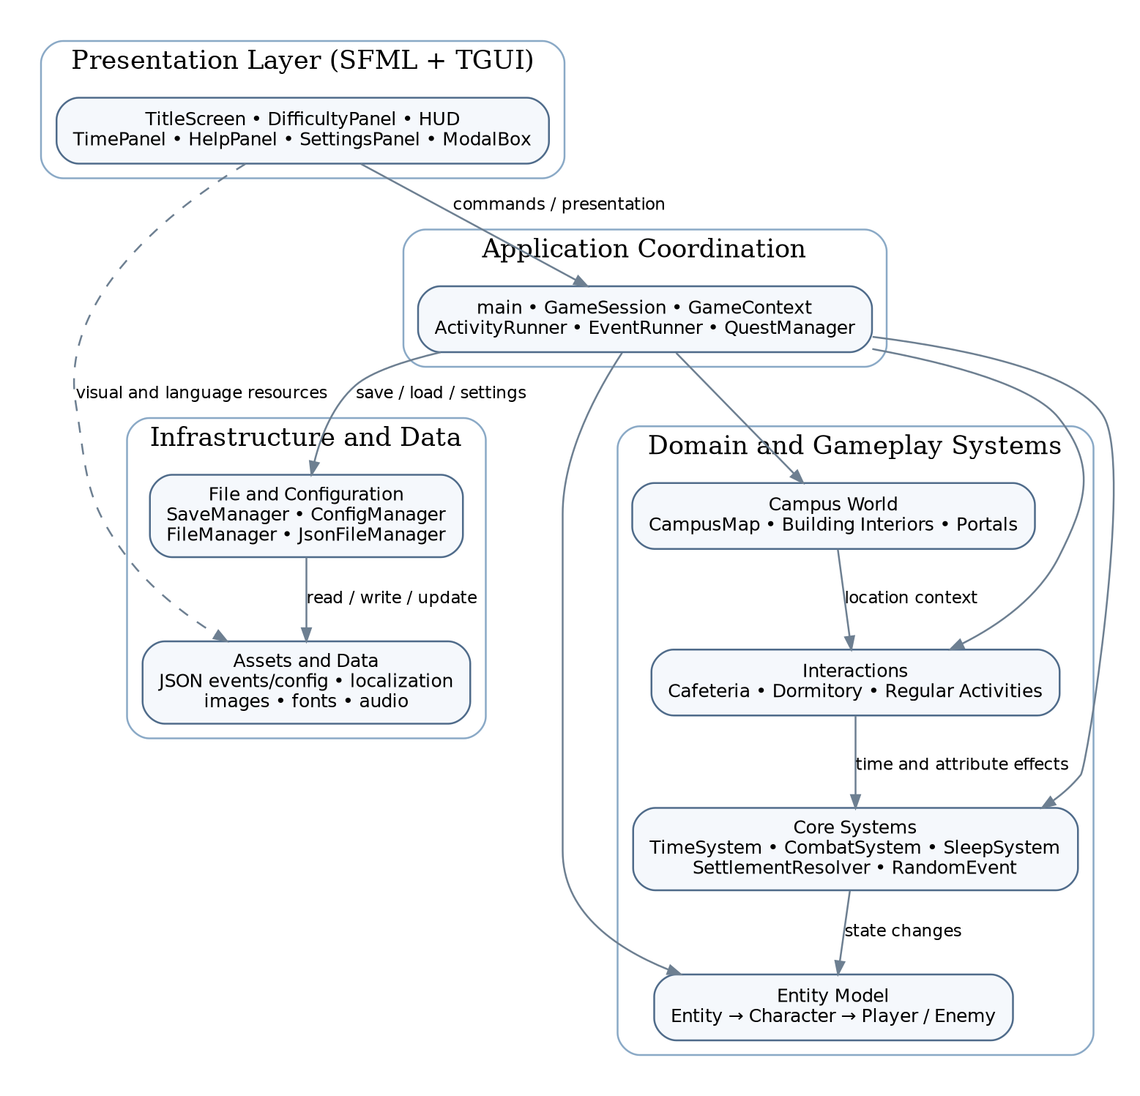
Figure 2. High-level architecture of Campus Life Simulator.

3.2.1 Module Organization
Module | Responsibility
core | Game coordination and reusable domain services: session/context, time, combat, sleep, settings, localization, random events, activities, and settlement.
entity | Abstract entity/character model and concrete Player and Enemy classes.
event | EventRunner and event type definitions for interpreting branching event data.
fileio | FileManager, JsonFileManager, ConfigManager, and SaveManager for persistence and configuration.
interaction | Cafeteria, dormitory, and regular activity logic.
map | CampusMap, portals, base/interior classes, and specific buildings.
quest | Quest manager and examination/simple quest classes.
ui | Title screen, difficulty panel, HUD, time panel, prompts, help/settings, modal box, theme/context, and reusable UI components.
assets | Audio, fonts, images, configuration files, and locale data copied beside the executable.

3.2.2 Object-oriented Design
The entity hierarchy is the clearest demonstration of inheritance and polymorphism. Entity is an abstract root with common spatial and lifecycle properties and pure virtual update/render operations. Character derives from Entity, adds attributes and hidden variables, and remains abstract through its movement contract. Player and Enemy are concrete third-level classes that override movement, update, and rendering while adding their own data. Code that works with an Entity or Character reference can invoke the correct derived behavior without hard-coding the concrete type.
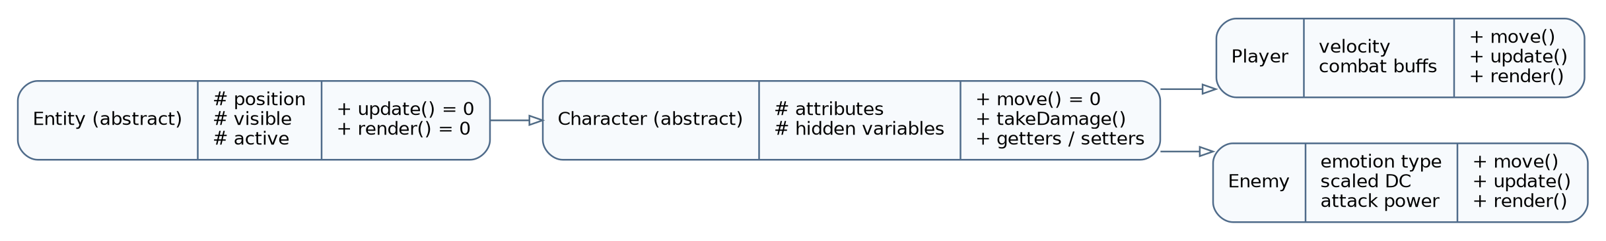
Figure 3. Verified three-level entity inheritance hierarchy.
Encapsulation is achieved by protecting internal position and character data and exposing validated behavior through methods. The character interface can clamp attribute values and centralize damage handling, preventing UI or interaction code from directly creating invalid state. Abstraction is achieved through pure virtual functions and through service classes that hide algorithms behind focused operations. Composition is used extensively: GameSession owns or coordinates systems and game objects; the HUD refers to model state but does not become a character; interactions use the time and character services rather than inheriting from them.
The UI architecture also uses a reusable component concept. UIComponent defines a common update/render interface, and HUD is a concrete implementation that manages labels and six progress bars. Other screens and panels follow the same presentation conventions even when their detailed inheritance differs. This reduces duplication in the main loop and supports consistent lifecycle handling for overlays.

3.2.3 Main Gameplay Flow
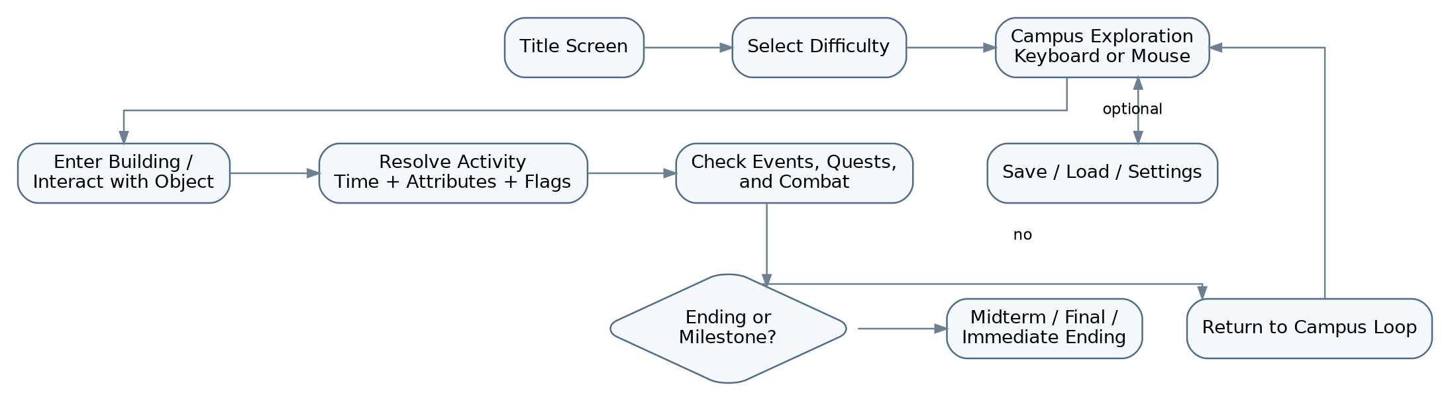
Figure 4. Main gameplay and settlement flow.
After starting the application, the player selects a difficulty and enters the campus exploration loop. Movement and interaction identify the current context. An activity then changes time, attributes, hidden variables, or flags. The program checks event, quest, combat, and ending conditions before returning to exploration. Save/load and settings are side paths that preserve or change the loop without replacing the domain model. The loop finishes at a midterm/final settlement or an immediate failure condition.

3.3 Detailed Design

3.3.1 Entity and Character State
Entity stores properties common to objects that exist in the game world, including position, visibility, and active state. Its abstract update and render operations define the minimum behavior required by the world loop. Character extends this idea with visible attributes and long-term hidden variables. Player adds movement velocity, acceleration/deceleration behavior, and combat buffs. Enemy adds an emotion type, base and scaled difficulty class, attack power, and visual presentation associated with the emotion category.
The distinction between visible attributes and hidden variables is important. Visible values support immediate decisions and HUD feedback; hidden values preserve long-term consequences. For example, SAN is displayed as a positive resource, while stress can be interpreted as 100 minus SAN. A health index can represent long-term physical condition and then project effects onto visible health. Stage variables such as friend, club, or innovation progress can store relationship or activity development without filling the HUD with implementation details.

3.3.2 Movement, Map, and Portals
The player can move with WASD or arrow keys and can also use point-to-move mouse input. Smooth acceleration and deceleration make movement feel less abrupt than direct position jumps. CampusMap draws the outdoor world and identifies interactive regions. MapPortal objects connect the campus and building interiors. Every interior provides a contained activity space, and the return path must restore the correct outdoor position and scene state.
A robust transition procedure should check that an interaction key is pressed near a valid portal, save the source location, switch the active map, place the player at a safe destination, update contextual UI, and debounce the input so one key press does not immediately reverse the transition. Collision or boundary rules should be applied in the active map only. These steps prevent common defects such as entering two rooms at once, spawning inside an obstacle, or oscillating between portal endpoints.

3.3.3 Time and Daily Schedule
The semester begins at 08:00 and lasts fourteen game days. Time advances through meaningful actions rather than continuously. This decision makes the simulation turn-like even though movement and rendering are real-time. It allows a player to inspect the environment without losing opportunities and makes every activity cost explicit. The time service normalizes minutes and hours, updates the day when necessary, and notifies higher-level logic when scheduled thresholds are crossed.
Important schedule rules include the first arrival at 08:50 for morning class, cafeteria lunch service from 12:00 to 14:00, dinner service from 17:00 to 19:00, dormitory sleep after 22:30, the Day 7 midterm, and the Day 14 semester ending. Boundary tests are essential because 11:59, 12:00, 14:00, 14:01, 22:29, and 22:30 may lead to different permitted actions. The system should clearly explain a blocked action instead of silently ignoring input.

3.3.4 Location Interactions
Location | Detailed Behavior
Cafeteria | Offer meal choices only during the lunch/dinner windows. Each choice consumes money and changes energy, health, or other attributes according to its balance.
Library | Provide four bookshelves/books. A reading action consumes approximately thirty minutes and increases relevant progress by 25% according to the selected subject.
Gym | Offer treadmill and barbell activities with different time and attribute effects, rewarding health/energy management.
Dormitory | Support studying, gaming, and sleeping. Sleep after 22:30 advances to the next day at 08:00; sleeping on Day 14 initiates final settlement.
Classroom | Support attendance and examination-related progression, including scheduled morning-class and milestone logic.
Convenience Store / regular interactions | Provide additional campus actions through the shared interaction framework and contextual prompts.

Each interaction follows the same transaction pattern: validate location and time; show available choices; validate costs or prerequisites; calculate effects; apply attribute/hidden-variable/flag changes; advance time; show a result message; then re-evaluate events, quests, combat, and endings. Centralizing this pattern through activity or interaction helpers reduces inconsistent behavior among buildings.

3.3.5 Combat and Emotion Enemies
Combat represents emotional pressure rather than conventional physical monsters. Enemy categories correspond to Academic, SAN, Energy, and Social challenges. Encounter frequency depends on SAN: at high SAN there are no enemies; as SAN falls, the permitted enemy count and spawn probability rise. The documented ranges are SAN at least 30: no enemies; 20–29: up to one enemy with a 40% chance; 10–19: up to two with a 60% chance; below 10: up to three with a 90% chance.
During a check, the system chooses the relevant attribute, rolls d20, applies the attribute modifier and temporary buff, and compares the result with the enemy DC. Success resolves the encounter favorably; failure applies an attack or other penalty. Enemy DC and attack can scale with SAN, which creates a feedback loop: poor emotional management increases both the number and difficulty of challenges. The design must nevertheless avoid an unrecoverable spiral by providing restoration actions such as the V-key SAN recovery mechanism, balanced sleep/food options, or difficulty-dependent scaling.

3.3.6 Event Engine
Events are described as directed graphs stored in JSON. A top-level event has an identifier, trigger information, a root step, and a collection of named steps. Triggers can be based on a time schedule or an interaction. Conditions can combine location, attribute, and flag tests through logical AND/OR structures. The supported node concepts include display, choice, random check, deterministic check, and outcome. Outcome data can apply visible deltas, hidden deltas, time advancement, and flags before moving to another step or completing the event.
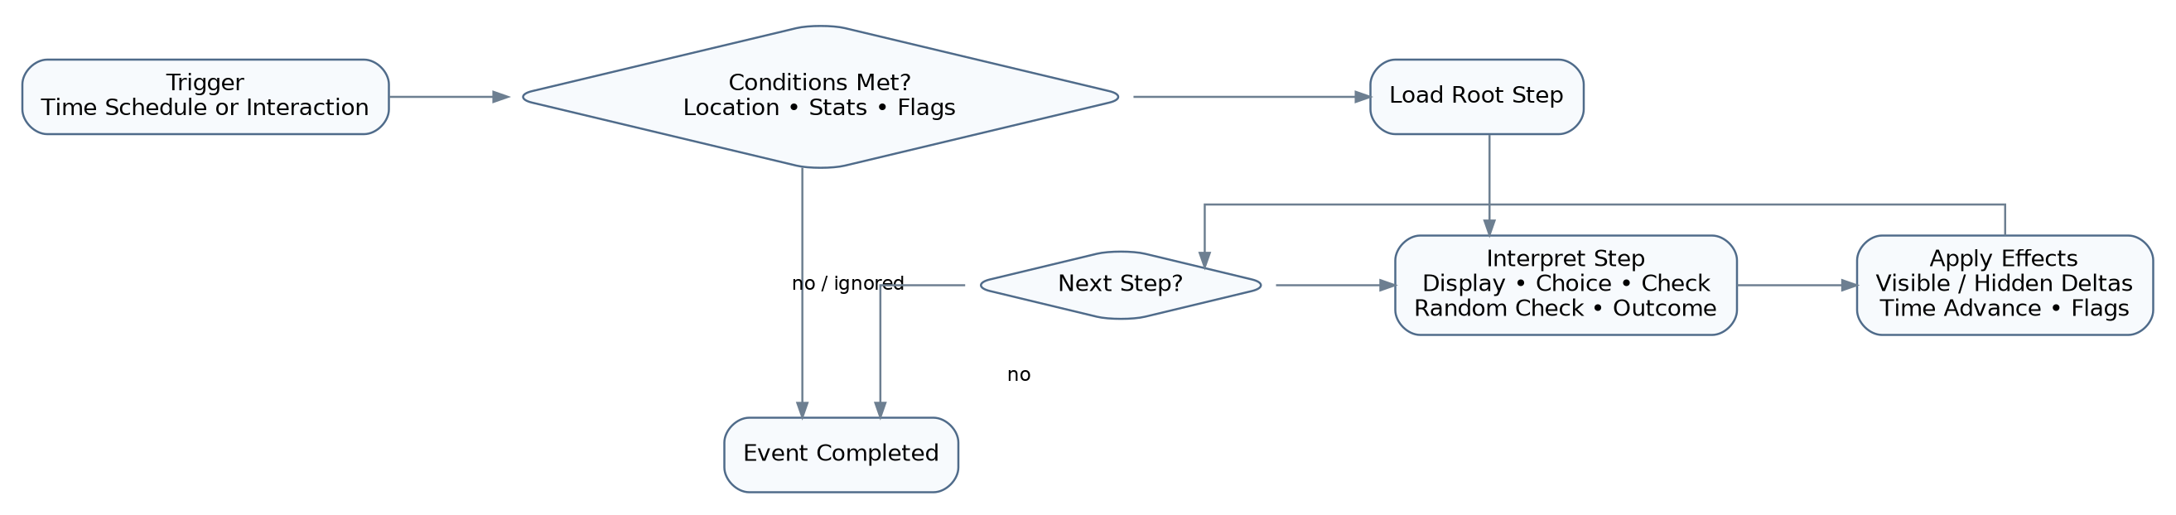
Figure 5. Data-driven event interpretation flow.
This design acts as a small domain-specific language. Content designers can add or rebalance an event by editing data, while EventRunner remains the interpreter. Validation should confirm that every referenced step exists, every root is valid, numeric fields have acceptable ranges, and cycles are intentional. If a data error is found, the engine should log the event identifier and fall back safely rather than leaving the application in an undefined modal state.

3.3.7 Quest and Settlement Logic
QuestManager tracks ongoing goals and milestone progression. Examination-related classes represent the midterm and final phases, while simple quests represent smaller objectives. The Day 7 midterm evaluates progress without ending the whole semester, and the Day 14 final settlement combines state and stage information to select an outcome. SettlementResolver isolates this final decision from UI text and from individual activity code.
Immediate endings must be evaluated consistently after any operation that changes relevant variables. Documented examples include medical leave when the long-term health index reaches zero, and breakdown/dropout when low-energy days reach the threshold or SAN reaches zero. Final titles can be loaded from data and combined with the resolver. The engine should choose one ending deterministically when multiple conditions become true on the same action; priority rules need to be documented and tested.

3.3.8 User Interface Design
The interface combines SFML-drawn scenes with TGUI widgets. The title screen introduces the project and routes to a new session. DifficultyPanel collects the challenge level before play. HUD shows the character state through labels and six progress bars. TimePanel presents day and clock information. ChoicePrompt and ModalBox guide event and activity decisions. HelpPanel explains controls, while SettingsPanel provides configuration access. Theme and context helpers keep fonts, colors, and widget resources consistent.
Interaction design follows three principles. First, important state is continuously visible: time and core attributes do not require opening a separate menu. Second, context-sensitive actions are announced near the moment they become available. Third, modal choices temporarily take input focus so the same keystroke cannot both select an option and move the player. Keyboard shortcuts include Enter for interaction, C for a SAN-related shock action, F for combat, V to restore SAN, X for a test buff, K/L for save/load, Ctrl+H for help, and Ctrl+S for settings.

3.3.9 File Processing and Persistence
The file I/O package contains FileManager, JsonFileManager, ConfigManager, and SaveManager. FileManager provides general file operations; JsonFileManager centralizes JSON parsing and serialization; ConfigManager handles settings; and SaveManager persists a gameplay session. This separation satisfies the requirement for file reading, writing, and updating while preventing gameplay classes from duplicating low-level file code.
A save operation should build a complete serializable snapshot, write to a temporary file, verify successful output, and then replace the previous save. This strategy reduces corruption if the program is interrupted. A load operation should validate file existence, JSON syntax, version information, required fields, numeric ranges, and cross-field consistency before applying the state. Configuration updates should preserve unrelated keys, and missing optional values should use documented defaults. Human-readable JSON is convenient for debugging, but release builds should still reject malformed or impossible state.
Operation | Expected Behavior
Read | Load configuration, localization resources, event graphs, and previous save data.
Write | Create or replace a session save and record updated user settings.
Update | Modify selected configuration values or overwrite a save with a newer snapshot while preserving schema integrity.
Validation | Check parse success, required keys, type/range constraints, and compatible schema/version.
Recovery | Use defaults or a clear error message when optional configuration is missing; avoid partially applying a bad save.

3.3.10 Error Handling and Maintainability
The safest design validates input at module boundaries. UI code validates selections; interaction code validates time and costs; character setters validate ranges; event parsing validates data; and save loading validates the snapshot before model mutation. Errors should be reported with enough context to locate the module and data item. The game should remain usable after a recoverable configuration error and should fail with an explicit message when a required asset or dependency is unavailable.
Maintainability is supported by descriptive file names, module directories, abstract interfaces, documentation comments, and external data. Further improvement could include automated unit tests, continuous integration for Windows and macOS, a formal save-schema version, deterministic random seeds for test mode, and a generated API reference from Doxygen comments. These additions are not required to understand the current design but would reduce regression risk.

4. Programming Progress
The original course template requests weekly progress records. Because the exact project calendar and commit history were not provided, the table below is a realistic phase-based record that must be aligned with the team’s actual dates before submission. “Repository evidence” identifies the deliverable that demonstrates the phase. Members should replace the week labels with real mission periods and confirm actual completion dates from Git history or meeting notes.
Mission Period | Planned Work | Planned Completion | Repository Evidence | Actual Completion
Week 1 | Determine topic; analyze specification; write proposal. | Topic, objectives, course-requirement matrix, initial backlog. | README and final project topic are present. | [Enter actual date/status]
Week 2 | Design architecture, data model, class hierarchy, and main loop. | Module diagram; Entity/Character abstractions; build skeleton. | core/entity/ui/fileio module structure exists. | [Enter actual date/status]
Week 3 | Implement player movement, campus map, portals, and interiors. | Exploration scene; keyboard/mouse movement; building transitions. | CampusMap and interior/portal classes exist. | [Enter actual date/status]
Week 4 | Implement time, activities, attributes, and location interactions. | TimeSystem; cafeteria/library/gym/dormitory rules. | Core and interaction classes plus documented behavior exist. | [Enter actual date/status]
Week 5 | Implement title, difficulty, HUD, time, help, settings, prompts. | Complete graphical UI with feedback and control help. | UI directory contains the required screens/panels. | [Enter actual date/status]
Week 6 | Implement events, quests, combat, hidden variables, settlement. | Event graph interpreter; d20 combat; milestones/endings. | Event, quest, combat, and settlement modules exist. | [Enter actual date/status]
Week 7 | Implement save/load, configuration, localization, and integration. | JSON persistence; settings update; language resources. | fileio package, JSON dependency, locales/assets exist. | [Enter actual date/status]
Week 8 | Run system tests; fix defects; improve comments; package release and report. | Test record; executable; source archive; final report. | Report prepared; runtime test record still requires local execution. | [Enter actual date/status]

Progress should be reviewed at the end of each phase using a demonstrable build rather than only a percentage estimate. A feature counts as complete when it has source code, user-visible behavior or a testable interface, documentation, and at least one test case. Integration should begin early; postponing all module integration until the final week creates high risk because state, input focus, and asset paths affect many modules simultaneously.

5. Testing Report

5.1 Function Testing
Verification status: This report was produced from repository/document inspection, not by executing the final binary in the current environment. “Static PASS” means the required module, rule, or documented interface is present. “Runtime pending” must be replaced with Pass/Fail and actual observations after the team builds and runs the submission package.

ID | Function | Procedure / Input | Expected Result | Verification Basis | Result
FT-01 | Launch and title | Start the executable. | Title screen appears; no missing-font or missing-asset error. | UI/CMake/assets inspection | Runtime pending
FT-02 | Difficulty selection | Start a new game and select Easy, Normal, and Hard in separate runs. | Selected difficulty is stored and used by gameplay balancing. | DifficultyPanel present | Runtime pending
FT-03 | Keyboard movement | Hold W/A/S/D and arrow keys outdoors. | Player moves smoothly in the expected direction and remains within valid bounds. | Player movement design | Runtime pending
FT-04 | Mouse movement | Click a reachable campus point. | Player moves toward the target and stops near it without oscillation. | README behavior | Runtime pending
FT-05 | Portal transition | Stand near each building entrance and press Enter. | Correct interior loads; return path restores outdoor play. | Map/interior/portal modules | Runtime pending
FT-06 | HUD refresh | Perform actions that change all visible attributes. | Labels and six bars reflect the current model values and stay in valid ranges. | HUD + Character interfaces | Runtime pending
FT-07 | Interaction-driven time | Wait without acting, then perform a timed activity. | Clock is stable while waiting and advances by the activity cost. | Time design documented | Runtime pending
FT-08 | Cafeteria boundary | Try at 11:59, 12:00, 14:00, 14:01, 17:00, and 19:01. | Meals are available only in documented lunch/dinner windows; blocked attempts explain why. | Cafeteria rule present | Runtime pending
FT-09 | Library reading | Select each of the four bookshelves/books. | Thirty minutes are consumed and relevant progress increases by 25%. | README behavior | Runtime pending
FT-10 | Gym activities | Use treadmill and barbell. | Each option applies its defined time and attribute effects once. | Gym interior/module | Runtime pending
FT-11 | Dormitory actions | Use study, game, and sleep actions at valid/invalid times. | Study/game effects are applied; sleep is blocked before 22:30 and advances to next day at/after 22:30. | Dormitory/SleepSystem | Runtime pending
FT-12 | Daily morning trigger | Cross the first 08:50 threshold of a day. | Morning-class logic triggers once for that day, not repeatedly. | README schedule | Runtime pending
FT-13 | Midterm milestone | Advance to Day 7 with controlled state. | Midterm quest/settlement is invoked and the semester can continue afterward. | Quest classes present | Runtime pending
FT-14 | Final milestone | Advance to Day 14 and complete the ending action. | Final settlement selects and displays one outcome/title. | Final quest/resolver | Runtime pending
FT-15 | Enemy spawning by SAN | Test SAN ≥30, 20–29, 10–19, and <10 repeatedly with a fixed test seed. | Counts and probabilities follow the documented tiers. | Combat rules documented | Runtime pending
FT-16 | d20 success check | Use controlled roll, attribute, buff, and DC values. | Result equals d20 + floor((attribute−50)/10) + buff; comparison to DC is correct. | Combat formula | Static PASS / runtime pending
FT-17 | Enemy scaling | Reduce SAN while holding other inputs constant. | Scaled DC/attack do not decrease unexpectedly and remain in allowed ranges. | Enemy fields/methods | Runtime pending
FT-18 | Save | Press K after changing time, location, attributes, flags, and quest state. | A valid save is written without partially corrupting the previous state. | SaveManager/fileio | Runtime pending
FT-19 | Load | Change the session, then press L to load the saved snapshot. | All persisted fields return consistently, not only player position. | SaveManager/fileio | Runtime pending
FT-20 | Settings/help | Use Ctrl+S and Ctrl+H; change settings and close panels. | Panels open, take focus, apply/retain values, and return control to gameplay safely. | Settings/Help UI | Runtime pending
FT-21 | Branching event | Trigger an event with display, choice, check/random check, and outcome nodes. | Correct branch is selected; effects/time/flags are applied once; event completes. | Event schema/runner | Static PASS / runtime pending
FT-22 | Immediate endings | Force health index ≤0, low-energy threshold, and SAN ≤0 in separate test saves. | The documented ending is selected once with a clear message and stable final state. | Hidden-variable rules | Runtime pending

5.2 System Testing
System testing evaluates complete behavior across module boundaries. It should be performed from a clean clone using the documented dependency installation procedure, not only from a developer’s existing build directory. The tester should record the operating system, compiler, dependency versions, CMake generator, screen resolution, language option, save-file location, and commit hash. Screenshots or short videos are useful evidence for the demonstration and report.
Test Area | Method | Acceptance Criterion | Status
Build portability | Configure and build a clean Release version on the designated Windows environment; optionally repeat on macOS. | CMake finds all dependencies, assets are copied, and the executable starts from the packaged directory. | Runtime pending
Performance | Play for at least 30 minutes while moving, opening panels, entering buildings, and triggering events. | Responsive input and stable frame presentation; no progressive memory or handle growth visible to the user. | Runtime pending
Usability | Ask a student unfamiliar with the code to start, move, find help, eat, read, save, and load. | Core tasks can be completed from visible prompts/help without developer explanation. | Runtime pending
Persistence reliability | Create multiple saves at different days/locations, restart the program, and load each. | State is restored consistently; malformed save produces a clear, safe error path. | Runtime pending
Long-session stability | Complete a full fourteen-day playthrough with multiple events and encounters. | No crash, duplicated event, impossible time, negative resource, or stuck modal state. | Runtime pending
Localization | Build/run the supported language configuration and inspect all major panels/events. | Text is readable, fonts contain required glyphs, and controls are not clipped. | Runtime pending
Regression | Repeat a fixed smoke-test checklist after every critical defect fix. | Previously passing core paths remain passing. | Process recommendation
Maintainability | Run warnings, inspect comments, and generate a source-line count. | No unreviewed critical warning; class/function comments are meaningful; >2,000-line evidence is attached. | Static review partial

5.3 Defect Risks and Recommended Corrections
Static inspection reveals several items that deserve explicit verification. First, documentation and CMake disagree about C++17 versus C++20; this should be resolved before the demonstration. Second, probabilistic spawn tests should use a deterministic random seed or a large sample, otherwise a correct distribution can appear wrong in a small run. Third, save/load tests must cover hidden variables, event flags, and quest stages because these fields are easy to omit while visible attributes still appear correct. Fourth, UI focus should be tested around modal panels to ensure one key press cannot perform two actions. Fifth, the team should attach an actual cloc report rather than estimating line count.
The absence of a dedicated automated test directory in the inspected source listing does not prove that no tests exist, but it suggests that manual acceptance testing is especially important. A minimal future test suite should cover attribute clamping, time normalization, combat calculations, event condition evaluation, save round-trips, and ending priority. These algorithms have clear inputs and outputs and can be tested independently of SFML rendering.

6. Personal Summary
This project demonstrates that object-oriented programming is most useful when it organizes changing responsibilities rather than merely increasing the number of classes. At the beginning, a campus simulator may appear to be a collection of independent features: movement, food, books, exercise, examinations, enemies, and saving. During design, it becomes clear that all of these features modify a shared state and must obey common rules. The most important learning outcome is therefore not the syntax of inheritance, but the discipline of deciding which class owns each rule and how other classes are allowed to request a change.
The Entity–Character–Player/Enemy hierarchy is a strong example. Common spatial and lifecycle behavior belongs at the top; character-specific variables belong in the middle; and player/enemy behavior belongs in concrete classes. Pure virtual methods make incomplete concepts impossible to instantiate and allow the game loop to call derived behavior through a shared interface. At the same time, the project shows that inheritance is not the answer to every relationship. The HUD is not a Character, and the SaveManager is not a GameSession; they are composed and coordinated. Learning when to use inheritance and when to use composition is more valuable than using inheritance everywhere.
Another major acquisition is the importance of encapsulation. When many activities can change the same attribute, direct public access would create inconsistent ranges and duplicated checks. Centralized setters, damage methods, time services, and settlement logic protect invariants. This design also makes testing easier because the calculation can be exercised through a small public interface. Encapsulation therefore improves both correctness and communication: a method name explains why a state is changing, while a raw assignment only shows that it changed.
The data-driven event engine provides experience beyond basic classroom examples. It transforms JSON into an executable decision graph with triggers, conditions, choices, checks, outcomes, and transitions. This requires careful separation between schema, parser, runtime state, and presentation. The approach has clear advantages: narrative content can be edited without rebuilding C++, repeated node types use one interpreter, and event balancing is centralized in data. It also introduces new responsibilities such as schema validation, meaningful error messages, and compatibility when data evolves. This is a practical lesson in how flexibility moves complexity rather than eliminating it.
Graphical programming also changes debugging habits. A defect may come from the model, the update order, the event queue, widget focus, coordinate conversion, asset path, or render order. Logging and small reproducible test scenes are therefore essential. The debug sandbox panel and explicit module boundaries can help isolate these problems. The team should avoid debugging only through visual observation; controlled inputs, fixed random seeds, save snapshots, and assertions produce faster and more reliable diagnosis.
The persistence feature reinforces the idea that a program state is a consistent whole. Saving only visible values is insufficient when hidden variables, flags, quest stages, difficulty, time, and location affect future behavior. A correct load must reconstruct a valid session, not merely copy fields. Versioned schemas, temporary-file replacement, validation before mutation, and backward-compatible defaults are professional techniques that can be applied to many future applications, including management systems and network clients.
From a project-management perspective, the module structure enables parallel development but does not remove the need for frequent integration. Interfaces should be agreed early, and every weekly milestone should end with a runnable build. Code review is particularly important for shared state and boundary conditions. A team that waits until the final week to combine map, UI, time, and events may discover that each module is individually correct but uses different assumptions. Continuous integration, even if only a clean build and smoke test, would reduce this risk.
The strongest aspects of Campus Life Simulator are its coherent theme, clear object model, rich graphical interaction, and combination of deterministic and probabilistic systems. The principal improvements would be a consistent language-standard statement, formal automated tests, explicit save-schema versioning, measurable performance and line-count evidence, and a completed runtime acceptance record. These changes would not alter the game concept; they would make the implementation easier to verify and maintain.
Overall, the project meets the educational purpose of the course by connecting object-oriented design to a practical, visible result. It requires analysis before coding, repeated debugging, integration across modules, data/file processing, and clear written explanation. Completing the final local test table and replacing the personal/team placeholders will turn this repository-based draft into a submission-ready report that accurately represents the group’s own work and experience.

7. Reference
[1] Satqri, “CampusLifeSimulator,” GitHub repository, project source code and README. https://github.com/Satqri/CampusLifeSimulator
[2] Campus Life Simulator, “CMakeLists.txt,” current build configuration and dependency declaration. https://github.com/Satqri/CampusLifeSimulator/blob/main/CMakeLists.txt
[3] SFML Development Team, “SFML Documentation,” graphics, window, system, and audio APIs. https://www.sfml-dev.org/documentation/
[4] TGUI Project, “TGUI Documentation,” graphical user-interface widgets for SFML. https://tgui.eu/documentation/
[5] Niels Lohmann and contributors, “JSON for Modern C++ Documentation,” JSON parsing and serialization. https://json.nlohmann.me/
[6] Kitware, “CMake Documentation,” cross-platform build system reference. https://cmake.org/documentation/
[7] High-level Language Programming Project—Specification, course handout, Appendix 2 report template and evaluation requirements.

Appendix A. Requirement Traceability Matrix
ID | Specification Requirement | Implementation Trace | Final Evidence
R1 | Use classes and objects | Entity, Character, Player, Enemy, GameSession, TimeSystem, UI, map, quest, interaction, and file I/O classes. | Source review and class diagram.
R2 | Encapsulation | Protected/private state with methods for movement, damage, attributes, settings, and persistence. | Inspect class headers; test range validation.
R3 | Inheritance | Entity → Character → Player/Enemy; UIComponent → HUD is also present. | Compile and inspect overridden methods.
R4 | Polymorphism | Virtual update/render/move behavior invoked through base interfaces. | Runtime scene/entity tests and source inspection.
R5 | At least five classes | Many classes are distributed across eight source modules. | Directory/class inventory.
R6 | At least two inheritance levels | The entity hierarchy has three levels. | Figure 3 and source headers.
R7 | Friendly UI | Title, difficulty, HUD, time, prompts, help, settings, modal components. | Usability test and screenshots.
R8 | Random file processing | JSON configuration/event/save data are read, written, and updated; random event/check logic is included. | Save round-trip and event-data tests.
R9 | At least 2,000 source lines | Large multi-module source tree; formal measurement required. | Attach cloc output to submission.
R10 | Detailed comments | Reviewed entity headers contain responsibility, relationship, and method documentation. | Comment review/Doxygen generation.
R11 | Correctness | Functional and system test plan covers the complete loop and boundary conditions. | Execute Section 5 and record evidence.
R12 | Reasonable and efficient design | Layered modules, data-driven events, dedicated services, and external assets. | Architecture review and performance test.

Appendix B. Final Submission Checklist
☐ Replace all [PLEASE FILL IN] fields on the cover and duty-assignment table.
☐ Verify that the report still contains at least 3,000 English words after team-specific editing.
☐ Reconcile C++17/C++20 documentation and build settings.
☐ Build from a clean clone on the submission computer and record compiler/dependency versions.
☐ Execute every runtime-pending test in Section 5 and replace the status with Pass/Fail plus evidence.
☐ Generate and attach a cloc report proving that the submitted source satisfies the 2,000-line requirement.
☐ Confirm that source comments explain class responsibilities, inheritance/derivation, function objectives, parameters, and main algorithm steps.
☐ Package the source code, executable, required DLLs/framework files, and complete assets directory.
☐ Test save/load from the packaged directory, not only from the IDE working directory.
☐ Remove personal debug files, temporary saves, build caches, and machine-specific absolute paths.
☐ Confirm that the proposal, final report, source code, and executable are all included.
☐ Review plagiarism policy and ensure the report accurately reflects the team’s own implementation and contributions.

