Project Setup:

Pre-requisition Softwares:
GitHub(GUI or command prompt)
https://git-scm.com/downloads (command prompt)
https://desktop.github.com/ (GUI)
Eclipse IDE for Java Developers
http://www.eclipse.org/downloads/packages/eclipse-ide-java-developers/oxygen3
VisualStudio Code
https://code.visualstudio.com/download
And NodeJS for npm
https://nodejs.org/en/download/
Test if this is properly installed by typing the following command in command prompt:
node -v
npm -v

Check out project:
Go to your desired work location and open command prompt from that folder
Then use the following commands:
git clone http://github.com/kaush4l/Indigo.git
This should download the project in the given folder location.
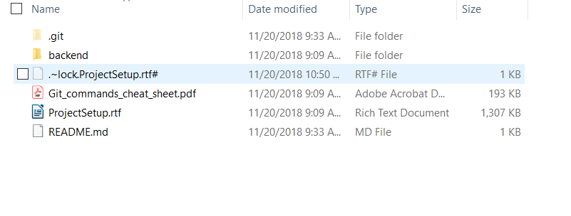

SETTING UP WORK SPACE
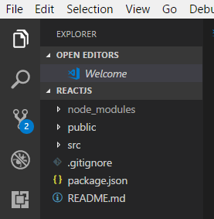
FRONT END(REACTJS):

Open Visual studio code.
Select New → Open Folder and select backend\src\main\webapp\frontend folder
The EXPLORER should look like this.

To run the program select the Integrated Termial from View → Integrated Termial or use shortcut (ctrl+`) and it should open a terminal from the reactjs location
OR go to reactjs folder and open command window.
Then type
npm start
This is build the project and open the react project in localhost:3000

BACK END(SPRING BOOT):
Open eclipse IDE.
Select import -> Add new Maven project -> Load backend folder. The whole project is a single maven project.

select pom.xml and click finish.

Once project is loaded, right click on project and run as → maven install. This will install all the respective jars as said in the dependencies.

The right click on project and run as → maven build.
Under goals specify eclipse:eclipse.
Apply and run build.

Project should be started as a Spring boot application with the main class named IndigoApplication.java

Steps to add changes:
Create a new branch for each feature to be added
git checkout stable
git pull
git checkout -b <BRANCH>

After working on changes, open terminal from the master folder and the branch is the correct working branch.
Then use the following command:
git add .
git commit -m “Type your message”
git push

if the push fails it is because the branch is not in the server so we do
git push –set-upstream origin <BRANCH>

After pushing the branch create a pull request from the feature branch to stable.
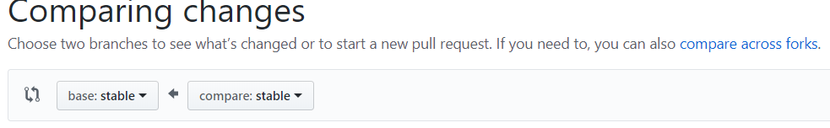
The base should be stable(base: stable) and compare should be the feature branch.

Pull requests will be viewed and merged.

