BY

Siddhant Varyambat, Akshat Varugeese

Sahil Sheikh and Anmol Gambhir

**ADULTERANT AND ADULTERATION:**

An **adulterant** is another term for a substance found within other substances such as food ,fuels or chemicals, although it should not be present for some reason. It will not normally be present in any specification or declared contents of the substance, and may not be legally allowed.

The addition of adulterants is called **adulteration**.

**WHY ADULTERATION OF RICE?**

Rice is grown in many regions across India. For about 65% of the people living in India, rice is a staple food for them. Rice is essential food to life in India and it is grown on a majority of the rural farms.

Being the most consumed food commodity it aroused scope for improvement and work interest in us.

ABSTRACT:

Different type of rice grain varieties is studied using image processing techniques. In the present work a digital imaging approach has been devised in order to investigate different types of characteristics to identify the rice varieties.

Two different common rice varieties were used in tests for defining. These include existing standards for rice length, area and aspect ratio features of rice. It successfully shows the effectiveness of compactness as its features

.

When the data base of this work can recognize the different types of rice, which has been trained in the data a number of times; effective identification takes place.

**Keywords**: MATLAB, pre-processing, segmentation, blob analysis, feature matching.

**BLOCK DIAGRAM OF HOW OUR PRODUCT WILL WORK:**

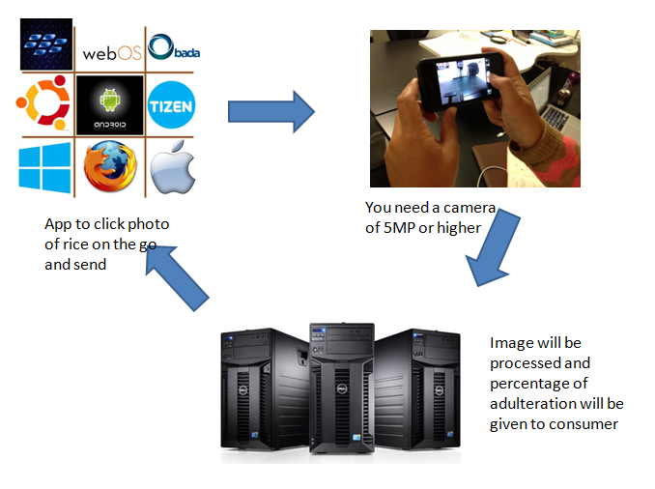

The above process will take about 5 seconds.

**BLOCK DIAGRAM FOR IMPLEMENTATION OF OUR IMAGE PROCESSING:**



**STAGES AND PROCESSES INVOLVED:**

**IMAGE ACQUISITION:**

Most image processing programs are designed to start by loading an image from disk. There are different types of file formats that are used in image acquisition.

Image acquisition is software dependent. It is usually implemented through specific MIL (matrix imaging library) real time camera.

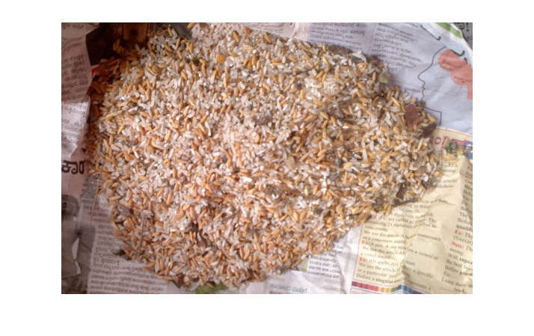

Fig. - Input Images of different types of rice

**PREPROCESSING:**

1) Gray Scale Image:

Gray scale image is an image in which each pixel of rice holds a single sample, the rice intensity information, also known as black-and-white image. The intensity is calculated by common formula:

30% of Red + 59% of Green + 11 % of Blue. After processing the gray scale level for image, It has only black and-white. It varies from black at the weakest intensity to white at the strongest.

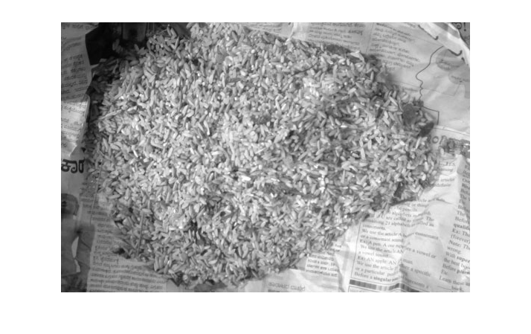

FIGURE: CONVERSION FROM RGB TO GREYSCALE

2) RGB to Gray:

Image in which each pixel is specified by three values one each for the red, blue, and green.

The array of class single, or double pixel values specify intensity values. So it converts RGB to Gray scale . For single or double arrays, values range from [0, 1]. Similarly for unit 8, values range from [0, 255]and for uint16, values range from [0, 65535]. In this work, the image has been taken from the RGB colour in jpeg format. It has high pixel rate, due to which pixel rate error can occur. Therefore RGB image is converted into

gray scale image . It is only two dimensional as pixel rate also reduces easily to give real image.

3) Binary Image: It converts the gray scale to binary. The output image replaces all pixels in the input image with luminance greater than level with value 1 (white) and replaces all other pixels with value 0 (black).It specifies the level in the range [0,1], regardless of the class of the input image. The function gray thresh can be used to compute the level argument automatically in order to separate an object in the image from the background. The colour of the object (usually white) is referred to as the foreground colour. The rest

(usually black) is referred to as the background colour.

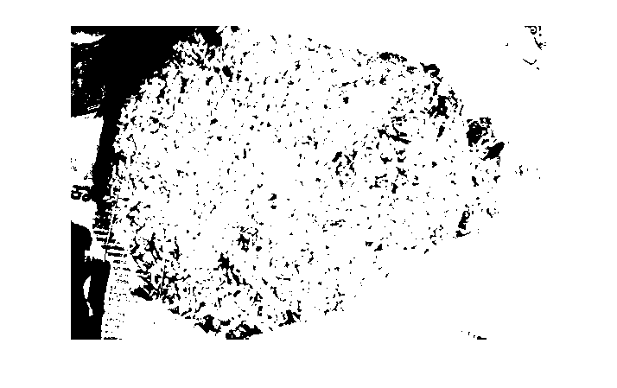

FIGURE: AFTER CONVERSION FROM BINARY TO GREY SCALE.

**FILTERING:**

The purpose of smoothing is to reduce noise and improve the visual quality of the image. Often, smoothing is referred to as filtering. In this work, median filter is used.

Median Filter: A median filter is a non-linear digital filter which is able to preserve sharp signal changes and is very effective in removing impulse noise. Median filter is widely used in digital signal and image/video processing applications. The main problem of the median filter is its high computational cost

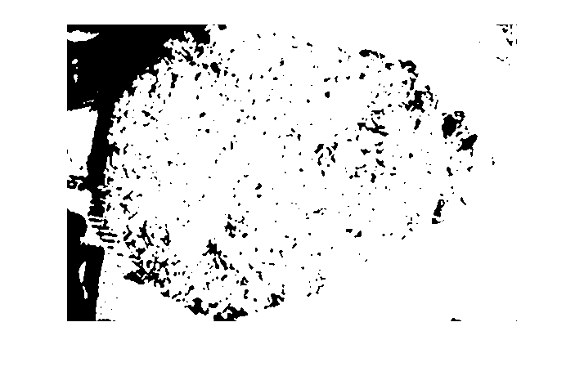

FIGURE: AFTER USING MEDIAN FILTER TO FILTER NOISE

**SEGMENTATION:**

The purpose of image segmentation is to partition an image into meaningful regions. The segmentation is based on measurements taken from the images and might be grey level, colour, texture, depth or motion

Our group has used edge based segmentation.

Edge Based Segmentation: An edge-detection filter can be used to improve the rice’s appearance of blurred image. Such image computing techniques have found wide applications in Image processing .One of the important applications is edge detection for Image segmentation.

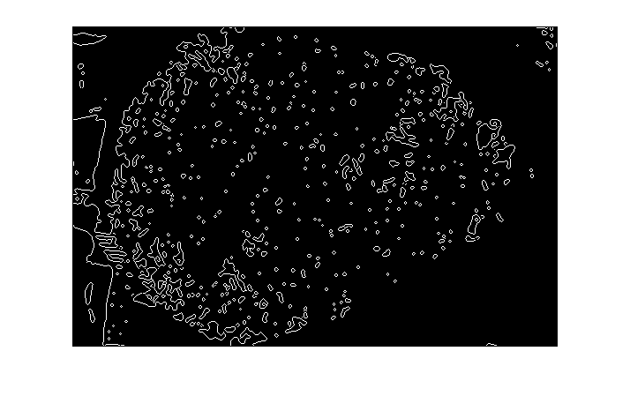

FIGURE: AFTER ‘CANNY’ EDGE BASED SEGMENTATION.

**BLOB ANALYSIS:**

The blob is defined as a region of connected rice pixels. Blob analysis is the identification and study of these regions in a rice grain’s image. The algorithms discern pixels by their value and place them in one of two categories: the foreground ( pixels with a non-zero value) or the background (pixel a zero value).In applications that use blob analysis, the blob features usually calculated are area and perimeter, feret diameter, blob shape, location. The versatility of blob analysis tools make them suitable for a wide variety of applications such as pick-and place.

1) Region Props:

It measures the properties of image regions

2) Area:

The function region props in MATLAB were used to measure the rice area of a selected region of an image in pixel count. Before applying the function region props, the actual image is converted into a binary image .The Region props instruction is used to estimate area enclosed .The area is the actual number of pixels in the selected region. The pixel count of the processed image depends on the distance between the camera and the

object when the picture is taken, smallest distance and larger pixel counts.

3) Bounding Box:

The bounding box measures the rice grain’s length, and area by using digital image processing method.

**FEATURE MATCHING:**

Feature matching depends on the rice length and area changes in the induced non-rigid

deformation between the two structures. The metric on two varieties of rice grains is properly incorporated into the formulation matching. This approach calculates the rice area and length using image processing and Logic algorithm to match the rice data. If rice data matches it is equal to zero (=0).If rice data is not equal means it is not equal to zero (=/0)

**CONCLUSION:**

MATLAB Software system helps us provide direct assessment of quality of rice grains. It provides all relevant parameters about rice grains by image analysis. With proper selection of software tools, we can design a low cost tool for quality analysis of rice grains. In future, varieties of rice grains will be taken and calculation of area, length and shape analysis will be done using digital image processing.