L2 - 2. What is JavaScript

**What is JavaScript?**

JavaScript is a **dynamic, weakly typed** programming language which is **compiled at runtime**. It can be executed as part of a webpage in a browser or directly on any machine (“**host environment**”).

JavaScript was created **to make webpages more dynamic** (e.g. change content on a page directly from inside the browser). Originally, it was called LiveScriptbut due to the popularity of Java, it was renamed to JavaScript.

JavaScript is totally **independent** from Java and has **nothing in common with Java**!

**How Do Webpages Work?**

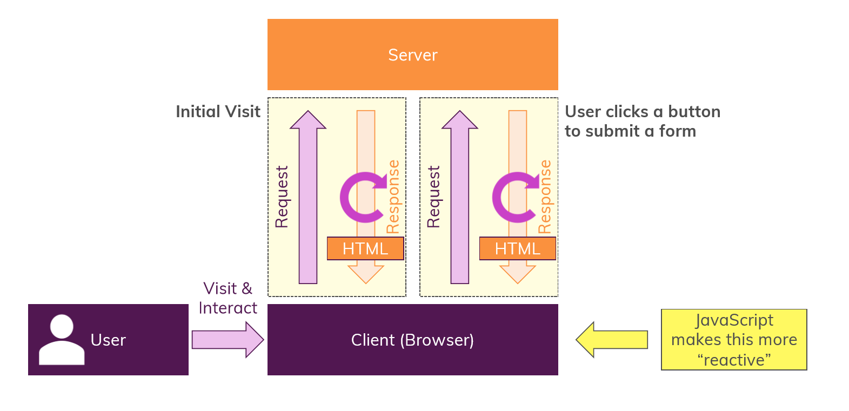

Extensions

