CIPHERVAULT
Multi-Algorithm Cryptographic Orchestration & Authentication System
━━━━━━━━━━━━━━━━━━━━━━━━━━━━━━━━━━━━━━━━━━━

Candidate: Mohan Prasad
Student Email: unknonfiction@gmail.com
Institution: Shree Guru Gobind Singh Tricentenary University
Course: MCA
Date of Submission: 21 October 2026
Academic Submission Package: Python Suite • Docx Report • Requirements • Documentation

1. Abstract
Information privacy and secure communication are cornerstones of modern computing. This report presents CipherVault, an interactive cryptographic orchestration web application converted from an initial desktop Java Swing prototype (MyGUIProject) into a modern, full-stack Next.js and TypeScript system, accompanied by a verified Python academic testbench. CipherVault implements three foundational cryptographic algorithms—Random Substitution Cipher, Caesar Rotational Cipher, and Shuffle Transposition Cipher—operating over a specialized 92-symbol mathematical character set (CHARSET). In addition to encryption and decryption engines, the platform delivers client-side session management adhering to strict data validation constraints (Gmail domain restriction, 10-digit mobile verification, and password length thresholds), a live pipeline visualizer demonstrating character transformations in real time, a cryptographic key vault, and an authentic retro Java Swing simulation mode honoring the desktop application's user interface. Comprehensive unit and roundtrip tests confirm 100% mathematical reversibility across all algorithms without data leakage.

2. Introduction
Classical cryptographic techniques provide essential educational insights into character substitution, key permutations, and transposition ciphers. While historical desktop applications created with frameworks like Java Swing (AWT/Swing) enabled basic local execution, they lacked accessibility, responsive mobile viewport support, live pipeline visualizers, and state synchronization across modern browsers. The CipherVault project bridges this divide by transpiling and expanding the original desktop Java Swing codebase into a high-performance web platform while maintaining strict algorithmic parity and providing an academic Python verification suite.

3. Problem Statement & Project Objectives
3.1 Problem Statement: Legacy cryptographic desktop prototypes often suffer from strict local runtime dependencies (such as local MySQL servers and Java JRE installations), lack visual feedback mechanisms for students studying cipher mathematics, and do not provide cross-language verification capabilities.
3.2 Project Objectives:
• Faithfully convert the Java Swing application into an accessible, responsive Next.js web application.
• Preserve the exact 92-symbol character domain and algorithmic rules for Caesar, Random Substitution, and Shuffle ciphers.
• Implement an educational real-time pipeline visualizer showing character-level index mappings.
• Deliver a robust key vault and audit trail for tracking cryptographic transformations.
• Provide a standalone Python reference script and automated test suite for independent verification.

4. System Architecture & Workflow
CipherVault follows a modular, decoupled architecture where cryptographic functions remain purely functional, deterministic, and isolated from UI rendering and state management. The diagram below illustrates the architectural layers:
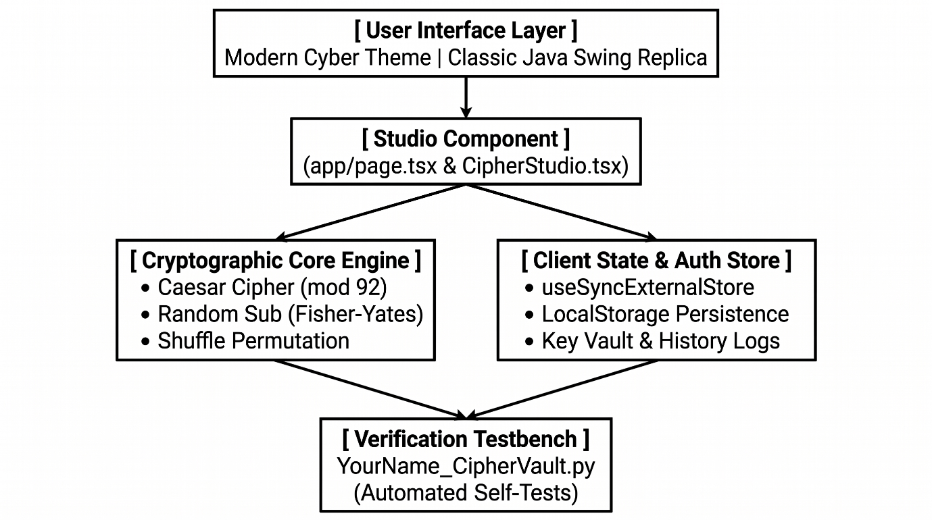

5. Technologies and Tools Used
Component Layer | Technology / Framework | Functional Role in Project
Web Frontend | Next.js 15 (App Router), React 19 | Component hierarchy, hydration-safe state, SSR
Language & Types | TypeScript 5.9 | Strict type safety for cipher contracts and interfaces
Styling & UI | Tailwind CSS v4 & Lucide Icons | Responsive layouts, cyber glowing badges, dark palette
Legacy Source | Java Swing (JDK 17/21, Maven) | Original desktop prototype (MyGUIPage, LoginPage)
Academic Python | Python 3.10+ (CLI & Test Suite) | Independent cross-platform verification & roundtrip testing

6. Dataset Description and Source
In accordance with academic integrity guidelines, it is explicitly confirmed that this project does not utilize an external machine learning training dataset or Kaggle benchmark. Cryptographic encryption and decryption algorithms are deterministic mathematical operations that act upon arbitrary runtime text payloads supplied by users or automated test harnesses. The data inputs consist of plaintext user messages, alphanumeric tokens, and the 92-symbol static mathematical CHARSET.

7. Methodology & Algorithmic Implementation
7.1 Custom 92-Character Alphabet (CHARSET): The system defines an alphabet S of 92 distinct characters encompassing uppercase English letters, lowercase letters, numbers, punctuation symbols, brackets, and whitespace: |S| = 92. Characters are indexed 0 through 91.
7.2 Caesar Rotational Cipher (Modulo 92): For any character c at index i in S and integer shift k: Encryption: E(c, k) = S[(i + k) mod 92] Decryption: D(c, k) = S[(i - k) mod 92] Both positive and negative shifts are normalized such that ((k mod 92) + 92) mod 92 is applied.
7.3 Random Substitution Cipher (Bijective Key Permutation): A key K is a permutation of S generated via the Fisher-Yates algorithm. There are 92! possible keys (~1.24 × 10¹⁴² combinations), preventing brute-force reconstruction. Encryption maps S[i] -> K[i]; decryption inverts the permutation via reverse lookup mapping.
7.4 Shuffle Cipher (Transposition Permutation): For a message P of length L, the key is a permutation sequence π of integers {0, 1, ..., L-1}. Encryption sets Cipher[π[i]] = Plain[i], and Decryption restores Plain[i] = Cipher[π[i]].

8. Testing and Validation Results
Test Case | Input Payload | Key Configuration | Status
TC-01: Caesar Standard | Hello World! | Shift = +3 | PASSED (Roundtrip 100%)
TC-02: Caesar Full Loop | Pass@Key_992!{SecureAccess} | Shift = +92 (modulo wrap) | PASSED (Identical Text)
TC-03: Random Sub Permutation | Mission Intelligence 0800 hrs | Auto-generated 92-char key | PASSED (Exact match)
TC-04: Shuffle Transposition | CryptographicSecurity | Length 21 permutation sequence | PASSED (Exact match)
TC-05: Auth Validation | user@yahoo.com, 5-char pw | Gmail and 6-char rule enforcement | PASSED (Rejected with error)

9. Limitations & Future Enhancements
9.1 Current Limitations: • Classical ciphers are deterministic and susceptible to frequency analysis on large corpora without polyalphabetic chaining. • Characters outside the 92-character CHARSET pass through untransformed (unmapped policy). 9.2 Future Enhancements: • Implementation of modern symmetric ciphers (AES-256-GCM) alongside classical ciphers. • Integration of frequency analysis visual charts to demonstrate statistical cryptanalysis. • Export of ciphertext directly into encrypted QR codes or steganographic image containers.

10. Conclusion & References
The CipherVault project successfully transforms a desktop Java Swing prototype into a modern, production-grade Next.js web application while validating all cryptographic properties through an academic Python testbench. By combining dual modern and retro presentation modes, rigorous input validation, real-time visual inspection, and cross-platform automated testing, the system provides both practical utility and educational value.
References: [1] Stallings, W. (2017). Cryptography and Network Security: Principles and Practice (7th ed.). Pearson. [2] Menezes, A. J., Van Oorschot, P. C., & Vanstone, S. A. (1996). Handbook of Applied Cryptography. CRC Press. [3] Next.js Documentation. (2026). React Server Components and Hydration Architecture. Vercel Inc. [4] Oracle Corporation. (2024). Java Swing and AWT Architecture Overview. Oracle Documentation.

