Routing

* A Router is a process of selecting path along which the data can be transferred from source to the destination. Routing is performed by a special device known as a router.
* A Router works at the network layer in the OSI model and internet layer in TCP/IP model
* A router is a networking device that forwards the packet based on the information available in the packet header and forwarding table.
* The routing algorithms are used for routing the packets. The routing algorithm is nothing but a software responsible for deciding the optimal path through which packet can be transmitted.
* The routing protocols use the metric to determine the best path for the packet delivery.

The metric is the standard of measurement such as hop count, bandwidth, delay, current load on the path, etc. used by the routing algorithm to determine the optimal path to the destination.

* The routing algorithm initializes and maintains the routing table for the process of path

determination.

## The most common metric values are given below:

* **Hop count:** Hop count is defined as a metric that specifies the number of passes through internetworking devices such as a router, a packet must travel in a route to move from source to the destination. If the routing protocol considers the hop as a primary metric value, then the path with the least hop count will be considered as the best path to move from source to the destination.
* **Delay:** It is a time taken by the router to process, queue and transmit a datagram to an interface. The protocols use this metric to determine the delay values for all the links along the path end-to-end. The path having the lowest delay value will be considered as the best path.
* **Bandwidth:** The capacity of the link is known as a bandwidth of the link. The bandwidth is measured in terms of bits per second. The link that has a higher transfer rate like gigabit is preferred over the link that has the lower capacity like 56 kb. The protocol will determine the bandwidth capacity for all the links along the path, and the overall higher bandwidth will be considered as the best route.
* **Load:** Load refers to the degree to which the network resource such as a router or network link is busy. A Load can be calculated in a variety of ways such as CPU utilization, packets processed per second. If the traffic increases, then the load value will also be increased. The load value changes with respect to the change in the traffic.
* **Reliability:** Reliability is a metric factor may be composed of a fixed value. It depends on the network links, and its value is measured dynamically. Some networks go down more often than others. After network failure, some network links repaired more easily than other network links. Any reliability factor can be considered for the assignment of reliability ratings, which are generally numeric values assigned by the system administrator.

Types of Routing

Routing can be classified into three categories:

* Static Routing
* Default Routing
* Dynamic Routing

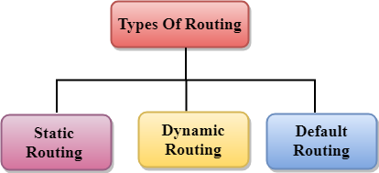

Static Routing

* Static Routing is also known as Nonadaptive Routing.
* It is a technique in which the administrator manually adds the routes in a routing table.
* A Router can send the packets for the destination along the route defined by the administrator.
* In this technique, routing decisions are not made based on the condition or topology of the networks

Advantages Of Static Routing

Following are the advantages of Static Routing:

* **No Overhead:** It has ho overhead on the CPU usage of the router. Therefore, the cheaper router can be used to obtain static routing.
* **Bandwidth:** It has not bandwidth usage between the routers.
* **Security:** It provides security as the system administrator is allowed only to have control over the routing to a particular network.

Disadvantages of Static Routing:

Following are the disadvantages of Static Routing:

* For a large network, it becomes a very difficult task to add each route manually to the routing table.
* The system administrator should have a good knowledge of a topology as he has to add each route manually.

Default Routing

* Default Routing is a technique in which a router is configured to send all the packets to the same hop device, and it doesn't matter whether it belongs to a particular network or not. A Packet is transmitted to the device for which it is configured in default routing.
* Default Routing is used when networks deal with the single exit point.
* It is also useful when the bulk of transmission networks have to transmit the data to the same hp device.
* When a specific route is mentioned in the routing table, the router will choose the specific route rather than the default route. The default route is chosen only when a specific route is not mentioned in the routing table.

Dynamic Routing

* It is also known as Adaptive Routing.
* It is a technique in which a router adds a new route in the routing table for each packet in response to the changes in the condition or topology of the network.
* Dynamic protocols are used to discover the new routes to reach the destination.
* In Dynamic Routing, RIP and OSPF are the protocols used to discover the new routes.
* If any route goes down, then the automatic adjustment will be made to reach the destination.

## The Dynamic protocol should have the following features:

* All the routers must have the same dynamic routing protocol in order to exchange the routes.
* If the router discovers any change in the condition or topology, then router broadcast this information to all other routers.

Advantages of Dynamic Routing:

* It is easier to configure.
* It is more effective in selecting the best route in response to the changes in the condition or topology.

Disadvantages of Dynamic Routing:

* It is more expensive in terms of CPU and bandwidth usage.
* It is less secure as compared to default and static routing.

## Difference between Static and Dynamic Routing:

|  |  |  |
| --- | --- | --- |
| S.NO | Static Routing | Dynamic Routing |
| 1. | In static routing routes are user-defined. | In dynamic routing, routes are updated according to the  topology. |
| 2. | Static routing does not use  complex routing algorithms. | Dynamic routing uses  complex routing algorithms. |
| 3. | Static routing provides high  or more security. | Dynamic routing provides  less security. |
| 4. | Static routing is manual. | Dynamic routing is  automated. |
| 5. | Static routing is  implemented in small networks. | Dynamic routing is  implemented in large networks. |
| 6. | In static routing, additional resources are not required. | In dynamic routing,  additional resources are required. |
| 7. | In static routing, failure of  the link disrupts the rerouting. | In dynamic routing, failure  of the link does not interrupt the rerouting. |
| 8. | Less Bandwidth is required  in Static Routing. | More Bandwidth is required  in Dynamic Routing. |

|  |  |  |
| --- | --- | --- |
| 9. | Static Routing is difficult to  configure. | Dynamic Routing is easy to  configure. |
| 10. | Another name for static routing is non-adaptive  routing. | Another name for dynamic routing is adaptive routing. |

**Distance Vector Routing Example-**

Consider-

* There is a network consisting of 4 routers.
* The weights are mentioned on the edges.
* Weights could be distances or costs or delays.

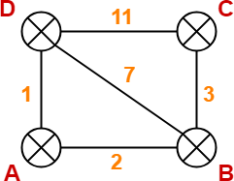

**Step-01:**

Each router prepares its routing table using its local knowledge. Routing table prepared by each router is shown below-

**At Router A-**

|  |  |  |
| --- | --- | --- |
| **Destination** | **Distance** | **Next Hop** |
| A | 0 | A |
| B | 2 | B |
| C | ∞ | – |

|  |  |  |
| --- | --- | --- |
| D | 1 | D |

**At Router B-**

|  |  |  |
| --- | --- | --- |
| **Destination** | **Distance** | **Next Hop** |
| A | 2 | A |
| B | 0 | B |
| C | 3 | C |
| D | 7 | D |

**At Router C-**

|  |  |  |
| --- | --- | --- |
| **Destination** | **Distance** | **Next Hop** |
| A | ∞ | – |
| B | 3 | B |
| C | 0 | C |
| D | 11 | D |

**At Router D-**

|  |  |  |
| --- | --- | --- |
| **Destination** | **Distance** | **Next Hop** |
| A | 1 | A |
| B | 7 | B |
| C | 11 | C |
| D | 0 | D |

**Step-02:**

* Each router exchanges its distance vector obtained in Step-01 with its neighbors.
* After exchanging the distance vectors, each router prepares a new routing table.

This is shown below-

**At Router A-**

* Router A receives distance vectors from its neighbors B and D.
* Router A prepares a new routing table as-

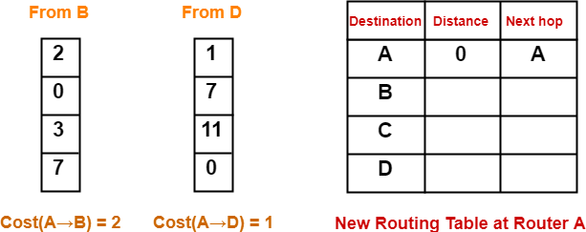

* Cost of reaching destination B from router A = min { 2+0 , 1+7 } = 2 via B.
* Cost of reaching destination C from router A = min { 2+3 , 1+11 } = 5 via B.
* Cost of reaching destination D from router A = min { 2+7 , 1+0 } = 1 via D.

**Explanation For Destination B**

* Router A can reach the destination router B via its neighbor B or neighbor D.
* It chooses the path which gives the minimum cost.
* Cost of reaching router B from router A via neighbor B = Cost (A→B) + Cost (B→B)= **2 + 0** = 2
* Cost of reaching router B from router A via neighbor D = Cost (A→D) + Cost (D→B) = **1 + 7** = 8
* Since the cost is minimum via neighbor B, so router A chooses the path via B.
* It creates an entry (2, B) for destination B in its new routing table.
* Similarly, we calculate the shortest path distance to each destination router at every router.

Thus, the new routing table at router A is-

|  |  |  |
| --- | --- | --- |
| **Destination** | **Distance** | **Next Hop** |
| A | 0 | A |
| B | 2 | B |

|  |  |  |
| --- | --- | --- |
| C | 5 | B |
| D | 1 | D |

**At Router B-**

* Router B receives distance vectors from its neighbors A, C and D.
* Router B prepares a new routing table as-

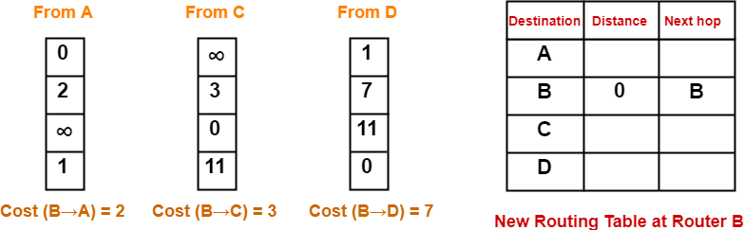

* Cost of reaching destination A from router B = min { 2+0 , 3+∞ , 7+1 } = 2 via A.
* Cost of reaching destination C from router B = min { 2+∞ , 3+0 , 7+11 } = 3 via C.
* Cost of reaching destination D from router B = min { 2+1 , 3+11 , 7+0 } = 3 via A.

Thus, the new routing table at router B is-

|  |  |  |
| --- | --- | --- |
| **Destination** | **Distance** | **Next Hop** |
| A | 2 | A |
| B | 0 | B |
| C | 3 | C |
| D | 3 | A |

**At Router C-**

* Router C receives distance vectors from its neighbors B and D.
* Router C prepares a new routing table as-

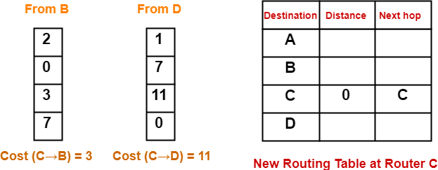

* Cost of reaching destination A from router C = min { 3+2 , 11+1 } = 5 via B.
* Cost of reaching destination B from router C = min { 3+0 , 11+7 } = 3 via B.
* Cost of reaching destination D from router C = min { 3+7 , 11+0 } = 10 via B.

Thus, the new routing table at router C is-

|  |  |  |
| --- | --- | --- |
| **Destination** | **Distance** | **Next Hop** |
| A | 5 | B |
| B | 3 | B |
| C | 0 | C |
| D | 10 | B |

**At Router D-**

* Router D receives distance vectors from its neighbors A, B and C.
* Router D prepares a new routing table as-

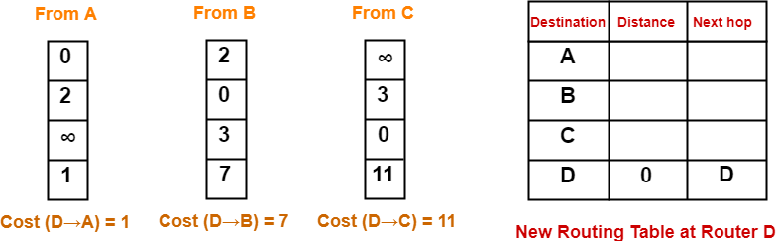

* Cost of reaching destination A from router D = min { 1+0 , 7+2 , 11+∞ } = 1 via A.
* Cost of reaching destination B from router D = min { 1+2 , 7+0 , 11+3 } = 3 via A.
* Cost of reaching destination C from router D = min { 1+∞ , 7+3 , 11+0 } = 10 via B.

Thus, the new routing table at router D is-

|  |  |  |
| --- | --- | --- |
| **Destination** | **Distance** | **Next Hop** |
| A | 1 | A |
| B | 3 | A |
| C | 10 | B |
| D | 0 | D |

**Step-03:**

* Each router exchanges its distance vector obtained in Step-02 with its neighboring routers.
* After exchanging the distance vectors, each router prepares a new routing table.

This is shown below-

**At Router A-**

* Router A receives distance vectors from its neighbors B and D.
* Router A prepares a new routing table as-

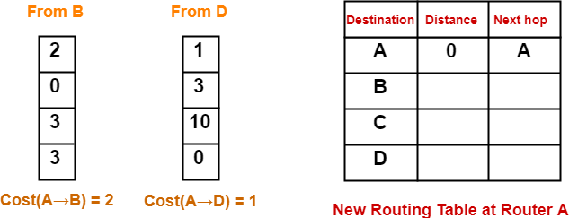

* Cost of reaching destination B from router A = min { 2+0 , 1+3 } = 2 via B.
* Cost of reaching destination C from router A = min { 2+3 , 1+10 } = 5 via B.
* Cost of reaching destination D from router A = min { 2+3 , 1+0 } = 1 via D.

Thus, the new routing table at router A is-

|  |  |  |
| --- | --- | --- |
| **Destination** | **Distance** | **Next Hop** |
| A | 0 | A |
| B | 2 | B |
| C | 5 | B |
| D | 1 | D |

**At Router B-**

* Router B receives distance vectors from its neighbors A, C and D.
* Router B prepares a new routing table as-

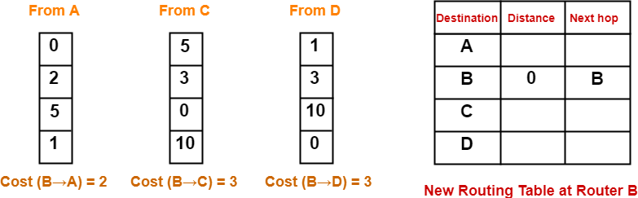

* Cost of reaching destination A from router B = min { 2+0 , 3+5 , 3+1 } = 2 via A.
* Cost of reaching destination C from router B = min { 2+5 , 3+0 , 3+10 } = 3 via C.
* Cost of reaching destination D from router B = min { 2+1 , 3+10 , 3+0 } = 3 via A.

Thus, the new routing table at router B is-

|  |  |  |
| --- | --- | --- |
| **Destination** | **Distance** | **Next Hop** |
| A | 2 | A |
| B | 0 | B |
| C | 3 | C |
| D | 3 | A |

**At Router C-**

* Router C receives distance vectors from its neighbors B and D.
* Router C prepares a new routing table as-

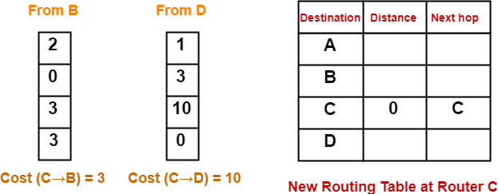

* Cost of reaching destination A from router C = min { 3+2 , 10+1 } = 5 via B.
* Cost of reaching destination B from router C = min { 3+0 , 10+3 } = 3 via B.
* Cost of reaching destination D from router C = min { 3+3 , 10+0 } = 6 via B.

Thus, the new routing table at router C is-

|  |  |  |
| --- | --- | --- |
| **Destination** | **Distance** | **Next Hop** |
| A | 5 | B |
| B | 3 | B |
| C | 0 | C |
| D | 6 | B |

**At Router D-**

* Router D receives distance vectors from its neighbors A, B and C.
* Router D prepares a new routing table as-

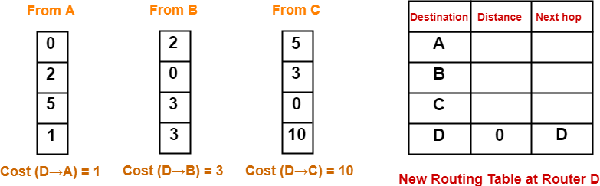

* Cost of reaching destination A from router D = min { 1+0 , 3+2 , 10+5 } = 1 via A.
* Cost of reaching destination B from router D = min { 1+2 , 3+0 , 10+3 } = 3 via A.
* Cost of reaching destination C from router D = min { 1+5 , 3+3 , 10+0 } = 6 via A.

Thus, the new routing table at router D is-

|  |  |  |
| --- | --- | --- |
| **Destination** | **Distance** | **Next Hop** |
| A | 1 | A |
| B | 3 | A |
| C | 6 | A |
| D | 0 | D |

These will be the final routing tables at each router.

Link State Routing

Link state routing is a technique in which each router shares the knowledge of its neighborhood with every other router in the internetwork.

## The three keys to understand the Link State Routing algorithm:

* **Knowledge about the neighborhood:** Instead of sending its routing table, a router sends the information about its neighborhood only. A router broadcast its identities and cost of the directly attached links to other routers.
* **Flooding:** Each router sends the information to every other router on the internetwork

except its neighbors. This process is known as Flooding. Every router that receives the

packet sends the copies to all its neighbors. Finally, each and every router receives a copy of the same information.

* **Information sharing:** A router sends the information to every other router only when

the change occurs in the information.

Link State Routing has two phases:

Reliable Flooding

* **Initial state:** Each node knows the cost of its neighbors.
* **Final state:** Each node knows the entire graph.

Route Calculation

Each node uses Dijkstra's algorithm on the graph to calculate the optimal routes to all nodes.

* The Link state routing algorithm is also known as Dijkstra's algorithm which is used to find the shortest path from one node to every other node in the network.
* The Dijkstra's algorithm is an iterative, and it has the property that after kth iteration of the algorithm, the least cost paths are well known for k destination nodes.

Example

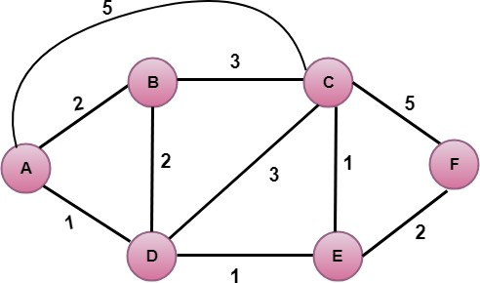

## In the above figure, source vertex is A.

Step 1:

The first step is an initialization step. The currently known least cost path from A to its directly attached neighbors, B, C, D are 2,5,1 respectively. The cost from A to B is set to 2, from A to D is set to 1 and from A to C is set to 5. The cost from A to E and F are set to infinity as they are not directly linked to A.

|  |  |  |  |  |  |  |
| --- | --- | --- | --- | --- | --- | --- |
| **Step** | **N** | **D(B),P(B)** | **D(C),P(C)** | **D(D),P(D)** | **D(E),P(E)** | **D(F),P(F)** |
| 1 | A | 2,A | 5,A | 1,A | ∞ | ∞ |

Step 2:

In the above table, we observe that vertex D contains the least cost path in step 1. Therefore, it is added in N. Now, we need to determine a least-cost path through D vertex.

## Calculating shortest path from A to B

* 1. v = B, w = D

2. D(B) = min( D(B) , D(D) + c(D,B) )

3. = min( 2, 1+2)>

4. = min( 2, 3)

1. The minimum value is 2. Therefore, the currently shortest path from A to B is 2.

## Calculating shortest path from A to C

1. v = C, w = D

7. D(B) = min( D(C) , D(D) + c(D,C) )

8. = min( 5, 1+3)

9. = min( 5, 4)

1. The minimum value is 4. Therefore, the currently shortest path from A to C is 4.</p>

## Calculating shortest path from A to E

1. v = E, w = D

12. D(B) = min( D(E) , D(D) + c(D,E) )

13. = min( ∞, 1+1)

14. = min(∞, 2)

1. The minimum value is 2. Therefore, the currently shortest path from A to E is 2. Note: The vertex D has no direct link to vertex E. Therefore, the value of D(F) is infinity.

|  |  |  |  |  |  |  |
| --- | --- | --- | --- | --- | --- | --- |
| **Step** | **N** | **D(B),P(B)** | **D(C),P(C)** | **D(D),P(D)** | **D(E),P(E)** | **D(F),P(F)** |
| 1 | A | 2,A | 5,A | 1,A | ∞ | ∞ |
| 2 | AD | 2,A | 4,D |  | 2,D | ∞ |

Step 3:

In the above table, we observe that both E and B have the least cost path in step 2. Let's consider the E vertex. Now, we determine the least cost path of remaining vertices through E.

## Calculating the shortest path from A to B.

1. v = B, w = E

17. D(B) = min( D(B) , D(E) + c(E,B) )

18. = min( 2 , 2+ ∞ )

19. = min( 2, ∞)

1. The minimum value is 2. Therefore, the currently shortest path from A to B is 2.

## Calculating the shortest path from A to C.

1. v = C, w = E

22. D(B) = min( D(C) , D(E) + c(E,C) )

23. = min( 4 , 2+1 )

24. = min( 4,3)

1. The minimum value is 3. Therefore, the currently shortest path from A to C is 3.

## Calculating the shortest path from A to F.

1. v = F, w = E

27. D(B) = min( D(F) , D(E) + c(E,F) )

28. = min( ∞ , 2+2 )

29. = min(∞ ,4)

1. The minimum value is 4. Therefore, the currently shortest path from A to F is 4.

|  |  |  |  |  |  |  |
| --- | --- | --- | --- | --- | --- | --- |
| **Step** | **N** | **D(B),P(B)** | **D(C),P(C)** | **D(D),P(D)** | **D(E),P(E)** | **D(F),P(F)** |
| 1 | A | 2,A | 5,A | 1,A | ∞ | ∞ |
| 2 | AD | 2,A | 4,D |  | 2,D | ∞ |
| 3 | ADE | 2,A | 3,E |  |  | 4,E |

Step 4:

In the above table, we observe that B vertex has the least cost path in step 3. Therefore, it is added in N. Now, we determine the least cost path of remaining vertices through B.

## Calculating the shortest path from A to C.

1. v = C, w = B

32. D(B) = min( D(C) , D(B) + c(B,C) )

33. = min( 3 , 2+3 )

34. = min( 3,5)

1. The minimum value is 3. Therefore, the currently shortest path from A to C is 3.

## Calculating the shortest path from A to F.

1. v = F, w = B

37. D(B) = min( D(F) , D(B) + c(B,F) )

38. = min( 4, ∞)

39. = min(4, ∞)

1. The minimum value is 4. Therefore, the currently shortest path from A to F is 4.

|  |  |  |  |  |  |  |
| --- | --- | --- | --- | --- | --- | --- |
| **Step** | **N** | **D(B),P(B)** | **D(C),P(C)** | **D(D),P(D)** | **D(E),P(E)** | **D(F),P(F)** |
| 1 | A | 2,A | 5,A | 1,A | ∞ | ∞ |
| 2 | AD | 2,A | 4,D |  | 2,D | ∞ |
| 3 | ADE | 2,A | 3,E |  |  | 4,E |
| 4 | ADEB |  | 3,E |  |  | 4,E |

Step 5:

In the above table, we observe that C vertex has the least cost path in step 4. Therefore, it is added in N. Now, we determine the least cost path of remaining vertices through C.

## a) Calculating the shortest path from A to F.

1. v = F, w = C

42. D(B) = min( D(F) , D(C) + c(C,F) )

43. = min( 4, 3+5)

44. = min(4,8)

1. The minimum value is 4. Therefore, the currently shortest path from A to F is 4.

|  |  |  |  |  |  |  |
| --- | --- | --- | --- | --- | --- | --- |
| **Step** | **N** | **D(B),P(B)** | **D(C),P(C)** | **D(D),P(D)** | **D(E),P(E)** | **D(F),P(F)** |
| 1 | A | 2,A | 5,A | 1,A | ∞ | ∞ |
| 2 | AD | 2,A | 4,D |  | 2,D | ∞ |
| 3 | ADE | 2,A | 3,E |  |  | 4,E |
| 4 | ADEB |  | 3,E |  |  | 4,E |
| 5 | ADEBC |  |  |  |  | 4,E |

Final table:

|  |  |  |  |  |  |  |
| --- | --- | --- | --- | --- | --- | --- |
| **Step** | **N** | **D(B),P(B)** | **D(C),P(C)** | **D(D),P(D)** | **D(E),P(E)** | **D(F),P(F)** |
| 1 | A | 2,A | 5,A | 1,A | ∞ | ∞ |
| 2 | AD | 2,A | 4,D |  | 2,D | ∞ |
| 3 | ADE | 2,A | 3,E |  |  | 4,E |
| 4 | ADEB |  | 3,E |  |  | 4,E |
| 5 | ADEBC |  |  |  |  | 4,E |
| 6 | ADEBCF |  |  |  |  |  |

Disadvantage:

Heavy traffic is created in Line state routing due to Flooding. Flooding can cause an infinite looping, this problem can be solved by using Time-to-leave field

## Timer

TCP uses several timers to ensure that excessive delays are not encountered during communications. Several of these timers are elegant, handling problems that are not immediately obvious at first analysis. Each of the timers used by TCP is examined in the following sections, which reveal its role in ensuring data is properly sent from one connection to another.

## TCP implementation uses four timers –

* **Retransmission Timer –** To retransmit lost segments, TCP uses retransmission timeout (RTO). When TCP sends a segment the timer starts and stops when the acknowledgment is received. If the timer expires timeout occurs and the segment is retransmitted. RTO (retransmission timeout is for 1 RTT) to calculate retransmission timeout we first need to calculate the RTT(round trip time).

RTT three types –

* + **Measured RTT(RTTm) –** The measured round-trip time for a segment is the time required for the segment to reach the destination and be acknowledged, although the acknowledgement may include other segments.
  + **Smoothed RTT(RTTs) –** It is the weighted average of RTTm. RTTm is likely to change and its fluctuation is so high that a single measurement cannot be used to calculate RTO.

Initially -> No value

After the first measurement -> RTTs=RTTm

After each measurement -> RTTs= (1-t)*RTTs + t*RTTm Note: t=1/8 (default if not given)

* **Deviated RTT(RTTd) –** Most implementations do not use RTTs alone so RTT deviated is also calculated to find out RTO.

Initially -> No value

After the first measurement -> RTTd=RTTm/2

After each measurement -> RTTd= (1-k)*RTTd + k*(RTTm-RTTs) Note: k=1/4 (default if not given)

* **Persistent Timer –** To deal with a zero-window-size deadlock situation, TCP uses a persistence timer. When the sending TCP receives an acknowledgment with a window

size of zero, it starts a persistence timer. When the persistence timer goes off, the sending TCP sends a special segment called a probe. This segment contains only 1 byte of new data. It has a sequence number, but its sequence number is never acknowledged; it is even ignored in calculating the sequence number for the rest of the data. The probe causes the receiving TCP to resend the acknowledgment which was lost.

* **Keep Alive Timer –** A keepalive timer is used to prevent a long idle connection between two TCPs. If a client opens a TCP connection to a server transfers some data and becomes silent the client will crash. In this case, the connection remains open forever. So a keepalive timer is used. Each time the server hears from a client, it resets this timer. The time-out is usually 2 hours. If the server does not hear from the client after 2 hours, it sends a probe segment. If there is no response after 10 probes, each of which is 75 s apart, it assumes that the client is down and terminates the connection.
* **Time Wait Timer –** This timer is used during [tcp connection termination](https://www.geeksforgeeks.org/computer-network-tcp-connection-termination/). The timer starts after sending the last Ack for 2nd FIN and closing the connection.
* *After a TCP connection is closed, it is possible for datagrams that are still making their way through the network to attempt to access the closed port. The quiet timer is intended to prevent the just-closed port from reopening again quickly and receiving these last datagrams.*
* The **quiet timer** is usually set to twice the maximum segment lifetime (the same value as the Time-To-Live field in an IP header), ensuring that all segments still heading for the port have been discarded.

## Quality of service (QoS)

**Quality-of-Service (QoS)** refers to traffic control mechanisms that seek to either differentiate performance based on application or network-operator requirements or provide predictable or guaranteed performance to applications, sessions, or traffic aggregates. Basic phenomenon for QoS means in terms of packet delay and losses of various kinds.

## Need for QoS –

* Video and audio conferencing require bounded delay and loss rate.
* Video and audio streaming requires bounded packet loss rate, it may not be so sensitive to delay.
* Time-critical applications (real-time control) in which bounded delay is considered to be an important factor.
* Valuable applications should be provided better services than less valuable applications.

## QoS Specification –

**QoS requirements can be specified as:**

Delay

Delay Variation(Jitter) Throughput

Error Rate

There are two types of QoS Solutions:

## Stateless Solutions –

**Routers maintain no fine-grained state about traffic, one positive factor of it is that it is scalable and robust. But it has weak services as there is no guarantee about the kind of delay or performance in a particular application which we have to encounter.**

## Stateful Solutions –

**Routers maintain a per-flow state as flow is very important in providing the Quality-of-Service i.e. providing powerful services such as guaranteed services and high resource utilization, providing protection, and is much less scalable and robust.**

## Integrated Services(IntServ) –

An architecture for providing QoS guarantees in IP networks for individual application sessions.

Relies on resource reservation, and routers need to maintain state information of allocated resources and respond to new call setup requests.

Network decides whether to admit or deny a new call setup request.

## IntServ QoS Components –

* Resource reservation: call setup signaling, traffic, QoS declaration, per-element admission control.
* QoS-sensitive scheduling e.g WFQ queue discipline.
* QoS-sensitive routing algorithm(QSPF)
* QoS-sensitive packet discard strategy.

## RSVP-Internet Signaling –

**It creates and maintains distributed reservation state, initiated by the receiver and scales for multicast, which needs to be refreshed otherwise reservation times out as it is in soft state. Latest paths were discovered through “PATH” messages (forward direction) and used by RESV messages (reserve direction).**

## Call Admission –

* Session must first declare it’s QoS requirement and characterize the traffic it will send through the network.
* **R-specification:** defines the QoS being requested, i.e. what kind of bound we want on the delay, what kind of packet loss is acceptable, etc.
* **T-specification:** defines the traffic characteristics like bustiness in the traffic.
* A signaling protocol is needed to carry the R-spec and T-spec to the routers where reservation is required.
* Routers will admit calls based on their R-spec, T-spec and based on the current resource allocated at the routers to other calls.

## Diff-Serv –

**Differentiated Service is a stateful solution in which each flow doesn’t mean a different state. It provides reduced state services i.e. maintaining state only for larger granular flows rather than end-to-end flows tries to achieve the best of both worlds.**

Intended to address the following difficulties with IntServ and RSVP:

## Flexible Service Models:

**IntServ has only two classes, want to provide more qualitative service classes: want to provide ‘relative’ service distinction.**

## Simpler signaling:

**Many applications and users may only want to specify a more qualitative notion of service.**

## Streaming Live Multimedia –

* **Examples:** Internet radio talk show, Live sporting event.
* **Streaming:** playback buffer, playback buffer can lag tens of seconds after and still have timing constraint.
* **Interactivity:** fast forward is impossible, but rewind and pause is possible.

## Traffic shaping and traffic policing

Traffic shaping, also known as packet shaping, is a congestion management method that regulates network data transfer by delaying the flow of less important or less desired [packets](https://www.techtarget.com/searchnetworking/definition/packet). It is used to optimize network performance by prioritizing certain traffic flows and ensuring the traffic rate doesn't exceed the [bandwidth](https://www.techtarget.com/searchnetworking/definition/bandwidth) limit.

Regulating the flow of packets into a network is known as data transfer throttling. Regulation of the flow of packets out of a network is known as rate limiting.

In addition to bandwidth, three major factors affect the quality of a network: [latency,](https://www.techtarget.com/whatis/definition/latency) [jitter](https://www.techtarget.com/searchunifiedcommunications/definition/jitter) and [loss](https://www.techtarget.com/searchnetworking/definition/packet-loss).

Traffic shaping attempts to prevent delay, jitter and loss by controlling the burst size and using a [leaky bucket algorithm](https://www.techtarget.com/whatis/definition/leaky-bucket-algorithm) to smooth the output rate over at least eight time intervals. If [traffic](https://www.techtarget.com/searchnetworking/definition/network-traffic) is arriving at a rate lower than the configured rate, then it will be forwarded normally. If traffic

arrives faster than the configured rate, then it will be delayed and held in a buffer until it can be sent without going over the limit.

## What is traffic shaping used for?

Traffic shaping is a quality of service ([QoS](https://www.techtarget.com/searchunifiedcommunications/definition/QoS-Quality-of-Service)) technique that is configured on network interfaces to allow higher-priority traffic to flow at optimal levels even when the link becomes overutilized. By creating a bandwidth limit for less critical packets, traffic shaping lessens the possibility that more important packets will be delayed or dropped as they leave the interface.

Common uses of traffic shaping include:

* Time-sensitive data may be given priority over traffic that can be delayed briefly, often with little-to-no ill effect.
* In a corporate environment, business-related traffic may be given priority over other traffic.
* A large internet service provider ([ISP](https://www.techtarget.com/whatis/definition/ISP)) may shape traffic based on customer priority.
* An ISP may limit maximum bandwidth consumption for certain applications to reduce costs and create the capacity to take on additional subscribers. This practice can effectively limit a subscriber's "unlimited connection" and is often imposed without notification.
* Traffic shaping is an integral component of the proposed two-tiered internet, in which certain customers or services receive traffic priority for a premium charge.

## Importance of traffic shaping

Traffic shaping is important when network [uplinks](https://www.techtarget.com/searchmobilecomputing/definition/downlink-and-uplink) become overwhelmed with data being sent out of an interface. Without traffic shaping, any excess traffic that cannot be sent out of an interface will either be dropped or queued, which can cause delays in all packets. This can result in poor performance of mission-critical applications. The enablement of traffic shaping allows administrators to specify certain applications that are considered less important -- and, therefore, creates intelligence around which packets will be dropped or delayed first.

Overall, traffic shaping is one of the most important traffic management techniques for ensuring high network performance.

## Traffic shaping methods

Shaping can only occur on packets that are leaving an interface as opposed to coming into the interface. The network device can use several different methods to identify the application that an IP packet exiting an interface belongs to. Based on this information, the interface can drop or hold these specific packets inside a temporary queue until a certain bandwidth limit has been reached. Shaping uses a leaky bucket algorithm to eventually release the delayed packets for delivery. While this may increase latency, it's usually more efficient compared to dropping the packets.

Traffic shaping methods include:

**Generic traffic shaping (GTS).** This method supports traffic shaping of most media and [encapsulation](https://www.techtarget.com/searchnetworking/definition/encapsulation) data types on a router. GTS will:

* perform traffic shaping on a per-interface basis and use access control lists ([ACLs](https://www.techtarget.com/searchsoftwarequality/definition/access-control-list)) to choose what traffic to shape;
* dynamically adapt to the available bandwidth by integrating shapes and backward explicit congestion notifications (BECNs) at a defined rate; and
* respond to resource reservation protocol ([RSVP](https://www.techtarget.com/searchnetworking/definition/RSVP)) features that are signaled over statically configured asynchronous transfer mode (ATM) permanent virtual circuits ([PVCs](https://www.techtarget.com/searchnetworking/definition/permanent-virtual-circuit)).

**Frame relay traffic shaping (FRTS).** Similar to GTS, FRTS eliminates [bottlenecks](https://www.techtarget.com/searchnetworking/definition/bottleneck) occurring in frame relay networks with high-speed connections at the central site and low speeds at the branch sites.

**Class-based traffic shaping.** This method allows users to configure traffic shaping on a per- traffic-class basis, meaning the shaping can be specified to one or more categories of data. Class-based shaping also enables users to optimize the available bandwidth by specifying an average or peak rate for shaping. This will allow more data than the configured rate to be sent if bandwidth is available. Finally, the class-based shaping method allows users to create a hierarchical policy map structure. This means traffic shaping can be placed in a primary policy map while other QoS features are placed in a secondary policy map.

## Traffic shaping vs. traffic policing

Traffic shaping impacts packets leaving an interface. Packets determined to be less important are temporarily stored in a buffer queue and sent more slowly using a leaky bucket technique. Traffic policing, on the other hand, can be configured for both traffic exiting and entering an interface. Policing will simply drop packets as opposed to storing them in a temporary queue. Thus, policing is considered less efficient in most cases.

**Session layer functionality and design issues**

# Dialog Control –

Session layer allows two systems to enter into a dialog exchange mechanism which can either be full or half-duplex.

# Managing Tokens –

The communicating systems in a network try to perform some critical operations and it is Session Layer

which prevents collisions which might occur while performing these operations which would otherwise result in a loss.

# Synchronization –

Checkpoints are the midway marks that are added after a particular interval during stream of data

transfer. These points are also referred to as synchronization points. The Session layer permits process to add these checkpoints.

For example, suppose a file of 400 pages is being sent over a network, then it is highly beneficial to set up a checkpoint after every 50 pages so that next 50 pages are sent only when previous pages are received and acknowledged.

# Design Issues with Session Layer :

**Establish sessions between machines –**

The establishment of session between machines is an important service provided by session layer. This session is responsible for creating a dialog between connected machines. The Session Layer provides mechanism for opening, closing and managing a session between end-user application processes, i.e. a semi-permanent dialogue. This session consists of requests and responses that occur between applications.

# Enhanced Services –

Certain services such as checkpoints and management of tokens are the key features of session layer and thus it becomes necessary to keep enhancing these features during the layer’s design.

# To help in Token management and Synchronization –

The session layer plays an important role in preventing collision of several critical operation as well as ensuring better data transfer over network by establishing synchronization points at specific intervals. Thus it becomes highly important to ensure proper execution of these services.