 2022-2023
Sessional Test -II
EVEN SEMESTER
ID No: ………………………… [Total No. of Pages: 03]
Time: 90 minutes
Department: Computer Science & Engineering
Title of the Course: Object-Oriented Software Engineering Max. Marks: 40
Course Code: CS107

Instructions:
For Section A
- There is one question having five parts. Each part is having four distinct options out of which only one choice will be correct. There is no negative marking for incorrect answers.
For Section B
- There are 6 Questions of 2 marks each. There is a choice to attempt 5 questions out of 6.
For Section C
- There are 4 Questions of 5 marks each. There is a choice to attempt 3 questions out of 4.
For Section D
- There are 2 Questions of 10 marks each. There is a choice to attempt 1 question out of 2.
__________________________________________________________________________________
Section-A
(All Questions are Compulsory, Each question carries 01 mark)
1.
- You need to fix a bug in software; identify the testing used to check the code:
(i) | Grey box testing | (ii) | Black box testing
(iii) | White-box testing | (iv) | Red box testing
- According to an IBM research,''31% of projects are abandoned before they are completed ,53% exceed their cost projections by an average of 189 percent , and 94 projects are restarted for every 100 projects.'' What can be the reasons for these figures?
(i) | Lack of software ethics and understanding | (ii) | Management issues in the company
(iii) | Lack of adequate training | (iv) | All of the mentioned
- Consider the basic COCOMO model where E is the effort applied in person – months ,D is the development time in chronological months, KLOC is the estimated number of delivered lines of code (in thousands) and ab bb cb db have their usual meanings. The basic COCOMO equations are of the form :
(i) | E=ab (KLOC)exp(bb), D=cb (E) | (ii) | D=ab (KLOC)exp(bb), D=cb (E)
(iii) | E=ab exp(bb), D=cb (KLOC)exp | (iv) | E=ab exp(bb), D=cb (KLOC)exp

- Regression testing is primarily related to :
(i) | Functional testing | (ii) | Development testing
(iii) | Data flow testing | (iv) | Maintenance testing
- The tools for computing critical path and project completion times from activity networks is/are :
(a) CPM (b) DRE (c) FP (d) PERT
(i) | Both (a) and (c) above | (ii) | Both (a) and (d) above
(iii) | Both (b) and (d) above | (iv) | Both (b) and (c) above

Answers 1
a) | (iii)
b) | (iii)
c) | (i)
d) | (i)
e) | (ii)

Section-B
(Attempt any 5 questions, each question carries 02 marks)
- Consider a software project using semi-detached mode with 300 Kloc .find out Development Time. Assume Coefficient values a=3.0, b=1.12, c=1.25, d=0.35.
Answer:
Development Time (D) =
c(E)d =
2.5(1784.42)0.35 =
34.35 Months(M)
- You need to test a project that is incomplete and missing some functions. How can you Stubs and Drivers for testing the project using these simulators.
Answer: Stubs and drivers are used in software testing as a part of the incremental or top-down testing approach to test individual units or components of a larger system. The main purpose of using stubs and drivers in testing is to simulate the behavior of the dependent components that are not yet available or have not yet been developed.
The purpose of stubs and drivers in testing:
- Stubs: A stub is a simple program or code module that replaces a larger software component that is not yet developed or available. The purpose of a stub is to provide a temporary replacement that mimics the behavior of the missing component to enable testing of other components that are dependent on it. Stubs are typically used in bottom-up testing, where the lower-level components are developed and tested first before the higher-level components.
- Drivers: A driver is a software component or program that is used to test a particular unit or component of a larger system. The purpose of a driver is to provide the necessary inputs to the component being tested and to simulate its behavior or output to other components or systems that depend on it. Drivers are typically used in top-down testing, where the higher-level components are developed and tested first before the lower-level components.

- Distinguish the role of Size oriented and Function oriented metrics while estimating the cost of a software project.
Answer: Size-oriented and function-oriented metrics are two different approaches used in software development to measure and manage the software development process.
Size-oriented metrics are based on the size of the software code or the data used by the software. Examples of size-oriented metrics include lines of code, number of files, and number of functions. These metrics are useful for measuring the amount of effort required to develop, test, and maintain the software. They are also useful for estimating project schedules, budgets, and resource requirements.
Function-oriented metrics, on the other hand, are based on the functionality provided by the software. Examples of function-oriented metrics include function points and use case points. These metrics are useful for measuring the software's functionality, which can be used to estimate the software's complexity and maintainability. They are also useful for determining the software's quality and for measuring the effectiveness of the development process.
The main difference between size-oriented and function-oriented metrics is that size-oriented metrics focus on the size of the software code or data, while function-oriented metrics focus on the functionality provided by the software. Size-oriented metrics are easier to measure and provide a quick estimate of the software development effort, but they do not provide a complete picture of the software's functionality or quality. Function-oriented metrics are more complex to measure, but they provide a more accurate estimate of the software's functionality and quality.
- Suggest some situations where you use Statement coverage and Branch Coverage, which is a better criteria for project testing?
Answer: Statement coverage and branch coverage are two popular testing criteria used to measure the effectiveness of test cases in software testing.
Statement coverage is a metric that measures the percentage of statements executed during the testing process, whereas branch coverage is a metric that measures the percentage of decision outcomes tested during the testing process.
Both statement coverage and branch coverage have their strengths and weaknesses, and the choice of the stronger criteria depends on the software testing goals and requirements.
Here are some arguments for each criterion:
Statement Coverage:
Statement coverage is a relatively simple and easy-to-use testing metric that provides an overview of the completeness of the testing process. Statement coverage ensures that all statements in the code are executed at least once, which can help detect syntax errors and other coding issues.
Statement coverage is a good starting point for testing and can be used to identify untested code areas that need further attention.
Branch Coverage:
Branch coverage is a more sophisticated testing metric that provides a more detailed view of the testing process by considering decision points in the code.
Branch coverage ensures that all possible decision outcomes are tested, which can help detect logical errors and other design issues.
Branch coverage is more thorough and can uncover more issues in the code compared to statement coverage.
Overall, branch coverage is generally considered a stronger testing criterion compared to statement coverage since it provides a more detailed and comprehensive view of the testing process. However, statement coverage is still a valuable testing metric that can be used in conjunction with other testing criteria to ensure a thorough and effective testing process.
- Generalize on how productivity and cost related to function points.
Answer: Function points are a measure of the functional size of a software application based on the user's perspective. They are used to estimate the development effort required to deliver a software product, as well as to measure and improve software productivity and quality.
Productivity and cost are related to function points in the following ways:
- Productivity: Function points can be used to measure software productivity by calculating the number of function points delivered per unit of effort, such as hours or person-months. This measure allows organizations to track and compare the productivity of different projects and teams, and to identify areas for improvement.
- Cost: Function points can also be used to estimate the cost of software development by multiplying the number of function points by the cost per function point. This estimate can be used to allocate budgets, to negotiate contracts with vendors, and to evaluate the cost-effectiveness of different software development options.
In general, the higher the number of function points in a software application, the more effort and cost will be required to develop it. However, the relationship between function points, productivity, and cost is not always linear, as it can be affected by various factors such as the complexity of the software, the level of reuse of existing code, the experience and skill level of the development team, and the development methodology used.
Therefore, function points should be used in conjunction with other measures of software development, such as lines of code, defect density, and customer satisfaction, to get a more comprehensive picture of the software's quality, productivity, and cost-effectiveness.

- Differentiate verification and validation. Which type of testing address verification? Which type of testing address validation?
Answer:
- verification | - validation
- The verifying process includes checking documents, design, code, and program | - It is a dynamic mechanism of testing and validating the actual product
- It does not involve executing the code | - It always involves executing the code
- Verification uses methods like reviews, walkthroughs, inspections, and desk- checking etc. | - It uses methods like Black Box Testing, White Box Testing, and non-functional testing
- Whether the software conforms to specification is checked | - It checks whether the software meets the requirements and expectations of a customer
- It finds bugs early in the development cycle | - It can find bugs that the verification process can not catch
- Target is application and software architecture, specification, complete design, high level, and database design etc. | - Target is an actual product

Section-C
(Attempt any 3 questions, each question carries 5 marks, and subparts (if any) carry equal weightage)
- A patient visits a doctor for routine checkup. Draw a Sequence Diagram for complete process.
Answer:
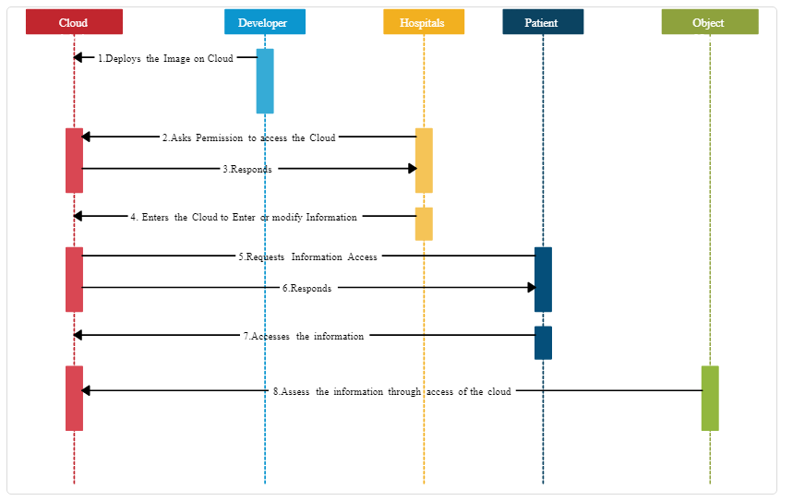
- Draw a Collaboration Diagram for UCO Bank ATM Machine, taking suitable assumptions for objects.
Answer:
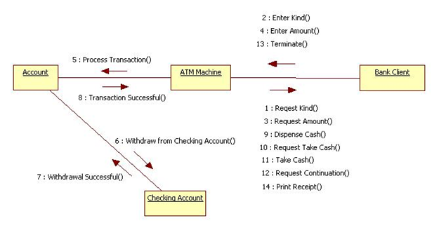
- COCOMO model helps software developers in estimation of software costing?
Answer: Cocomo (Constructive Cost Model) is a regression model based on LOC, i.e number of Lines of Code. It is a procedural cost estimate model for software projects and is often used as a process of reliably predicting the various parameters associated with making a project such as size, effort, cost, time, and quality. It was proposed by Barry Boehm in 1981 and is based on the study of 63 projects, which makes it one of the best-documented models. The key parameters which define the quality of any software products, which are also an outcome of the Cocomo are primarily Effort & Schedule:
- Effort: Amount of labor that will be required to complete a task. It is measured in person-months units.
- Schedule: Simply means the amount of time required for the completion of the job, which is, of course, proportional to the effort put in. It is measured in the units of time such as weeks, and months.
COCOMO formula :
Effort(E)= a*(KLOC)^b PM(Person month)
Time = c(E)d
Person Required = effort/time
- Where,
KLOC = size of the product i.e. no. of lines of code.
a, b, c, d are constants and have different values for different models.
Time is the time required to develop the product and the unit is months.
And the effort is the total effort calculated that will be required to complete the work calculated in PM (Person Months).
COCOMO model helps software developers in estimation of software costing in various way:
Provides a systematic way to estimate the cost and effort of a software project.
Can be used to estimate the cost and effort of a software project at different stages of the development process.
Helps in identifying the factors that have the greatest impact on the cost and effort of a software project.
Can be used to evaluate the feasibility of a software project by estimating the cost and effort required to complete it.

- A restaurant sells food items to students and receives payment through a payment App. Draw a class diagram describing the order of transactions, objects and classes.
Answer:
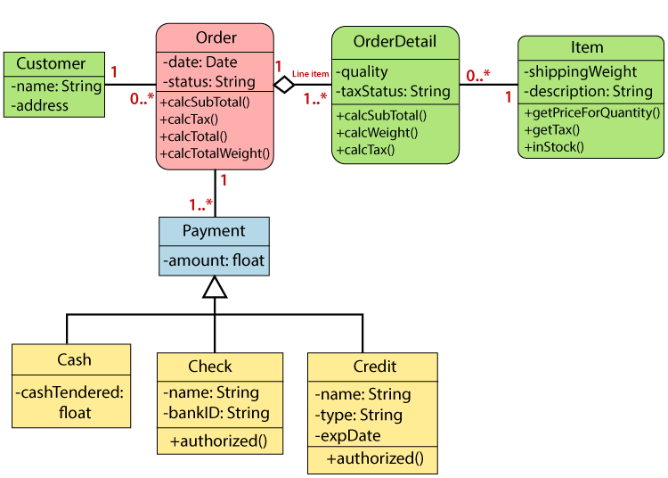
Section-D
(Attempt any one question, each question carries 10 marks, and subparts (if any) carry equal weightage)
- Develop the process of ordering a pizza over the phone. Create the activity diagram representing each step of the process, from when you pick up the phone to when you start eating the pizza. Include activities that others need to perform. Add exception handling to the activity diagram you developed. Consider at least two exceptions (e.g. delivery person wrote down the wrong address or a delivery person brings the wrong pizza).
Answer:
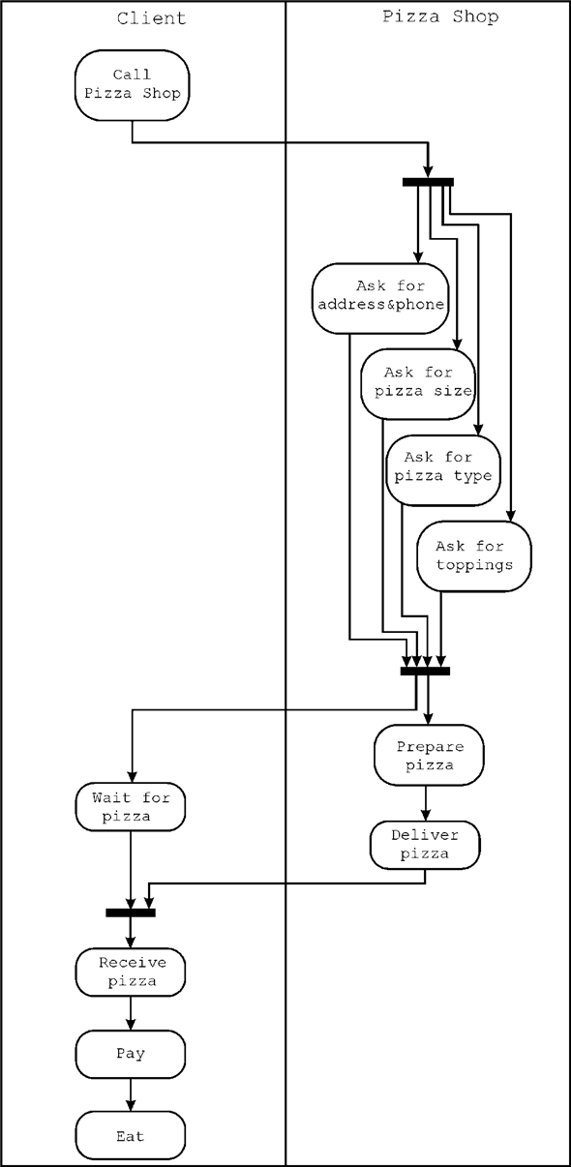

- Create an activity diagram.
Consider the scenario where a customer wants to do an eye checkup. The steps involved in the process are as follows:
A customer makes an appointment with an ophthalmologist (Eye Doctor).
- The ophthalmologist conducts an examination.
- The ophthalmologist writes the prescription.
- The customer goes to the eyewear store.
- The customer chooses the frame.
- The customer selects the lenses.
- The glasses shop makes the glasses.
- The customer tries them on. If they match, the customer pays for them and goes home.
- If they don't fit, the eyewear store adjusts the fit, and the customer tries them on again.
- The previous step is repeated until the glasses fit.
Answer:

