 2022-2023
Sessional Test -II
EVEN SEMESTER
ID No: ………………………… [Total No. of Pages: 03]
Time: 90 Minutes
Department: Computer Science & Engineering
Title of the Course: Object Oriented Software Engineering Max. Marks: 40
Course Code: CS107

Instructions:
For Section A
- There is one question having five parts. Each part is having four distinct options out of which only one choice will be correct. There is no negative marking for incorrect answers.
For Section B
- There are 6 Questions of 2 marks each. There is a choice to attempt 5 questions out of 6.
For Section C
- There are 4 Questions of 5 marks each. There is a choice to attempt 3 questions out of 4.
For Section D
- There are 2 Questions of 10 marks each. There is a choice to attempt 1 question out of 2.
__________________________________________________________________________________
Section-A
(All Questions are Compulsory, Each question carries 01 mark)
1.
- Recognize which of the following testing is also called Acceptance testing?
(i) | Beta testing | (ii) | White-box testing
(iii) | Grey box testing | (iv) | Alpha testing

- Identify which of the following is not a project factor that should be considered when planning the structure of software developing teams?
(i) | The rigidity of the delivery date | (ii) | The degree of sociability required for the project
(iii) | High frustration caused by personal, business, or technological factors that causes friction among team members | (iv) | The difficulty of the problem to be solved

- COCOMO Model is an abbreviation for:
(i) | Cost Constructive Estimation Model | (ii) | Constructive Cost Estimation Model
(iii) | Constructive Case Estimation Model | (iv) | Constructive Cost Estimating Model

- Select the suitable statement which is in contrast to the given statement.“Engineers developing software should not ________”.
(i) | Be dependent on their colleagues | (ii) | Maintain integrity and independence in their professional judgment
(iii) | Not knowingly accept work that is outside your competence | (iv) | Not use your technical skills to misuse other people’s computers

- Regardless of application area, project size, or complexity, software development work may be divided into three generic phases: the ______phase, which focuses on what, the ______phase, which focuses on how, and the ______phase, which focuses on change.
(a) Support (b) development (c) definition
 | (i) | c,b,a |  |  | (ii) | c,a,b
 | (iii) | a,b,c |  |  | (iv) | b,a,c
Answers 1
a) |  |  | (i)
b) |  |  | (ii)
c) |  |  | (ii)
d) |  |  | (i)
e) |  |  | (i)

Section-B
(Attempt any 5 questions, each question carries 02 marks)
- Consider a software project using semi-detached mode with 300 Kloc .find out Effort estimation. Assume Coefficient values a=3.0, b=1.12, c=1.25, d=0.35.
Answer:
Effort (E) =
a*(KLOC)b =
3.0*(300)1.12 =
1784.42 PM
- You need to estimate the cost and efforts of a project as a project manager. You have given information about Line of Codes used in that project. How this information will help you in cost estimation?
Answer: LOC (Lines of Code) based estimation is a software estimation technique that involves estimating the size of a software project based on the number of lines of code that will be written to implement the project. The purpose of LOC based estimation is to provide a rough estimate of the size and complexity of a software project, which can be used to estimate the project's cost, schedule, and resource requirements.
The primary advantage of LOC based estimation is its simplicity and ease of use. It is relatively easy to count the number of lines of code that will be written to implement a software project, and this can be used to estimate the project's size and complexity. Additionally, LOC based estimation can be used to estimate the effort required to implement the project, which can be useful for planning purposes.
However, there are also several limitations to LOC based estimation. One of the main limitations is that it does not take into account the quality of the code that is being written. Some code may be more complex or difficult to write than other code, even if it contains the same number of lines of code. Additionally, LOC based estimation does not take into account the software's functionality or requirements, which can significantly affect the project's size and complexity.

- Summarize various testing strategies for conventional software. How its helps in bug removal and quality improvements?
Answer: There are several testing strategies used for conventional software, which can be broadly classified into the following categories:
- Black Box Testing: This type of testing involves testing the software without looking into its internal structure or design. Test cases are designed based on the software requirements or specifications. The main goal of black box testing is to ensure that the software meets its functional requirements and works as expected from a user's perspective.
- White Box Testing: This type of testing involves testing the software based on its internal structure, code, and design. Test cases are designed to ensure that the software is robust, reliable, and performs well under different conditions. The main goal of white box testing is to identify any defects or issues in the code or design of the software.
- Grey Box Testing: This type of testing combines elements of both black box and white box testing. In grey box testing, the tester has partial knowledge of the software's internal structure and design, which enables them to design more comprehensive test cases that cover both functional and structural aspects of the software.
- Regression Testing: This type of testing involves retesting the software after making changes or modifications to ensure that the changes have not introduced any new defects or issues. Regression testing is usually performed after bug fixes, new feature additions, or system upgrades.
- Integration Testing: This type of testing involves testing how different components or modules of the software work together. The goal of integration testing is to ensure that the software system functions as a whole, and there are no defects or issues caused by the interaction between different modules.
- Acceptance Testing: This type of testing involves testing the software from the end-user's perspective to ensure that it meets the user's needs and requirements. Acceptance testing is usually performed after the software has been developed and tested by the developers.
- Performance Testing: This type of testing involves testing the software's performance under different conditions such as load, stress, and volume. The goal of performance testing is to ensure that the software can handle the expected workload and perform well under different conditions.

- In a team of 5 students you have to develop a software Project for Online Shopping , plan this project step by step.
Answer: Project planning is an essential process that helps project managers and stakeholders to define the scope of the project, estimate the resources required, and create a roadmap for achieving the project objectives. Here are some steps involved in project planning:
- Define the project scope: The first step is to define the project's scope, including its goals, objectives, deliverables, and requirements. This step will help stakeholders to have a clear understanding of what the project will achieve.
- Identify the project stakeholders: Identify all the stakeholders who will be involved in the project, including the project team members, customers, suppliers, and other relevant parties. This step will help to ensure that everyone who is affected by the project is aware of the project's goals and objectives.
- Develop a project plan: Develop a detailed project plan that includes the project timeline, budget, resources, tasks, milestones, and risks. This step will help to ensure that the project is completed within the specified time and budget.
- Identify project risks: Identify potential risks that could affect the project's success, such as scope creep, resource constraints, technology failures, and other issues. This step will help to develop contingency plans to mitigate any risks.
- Assign tasks and responsibilities: Assign tasks and responsibilities to the project team members, and ensure that everyone knows what they are responsible for. This step will help to ensure that the project progresses smoothly, and all tasks are completed on time.
- Monitor and control the project: Monitor the progress of the project against the project plan, and make any necessary adjustments. This step will help to ensure that the project stays on track and is completed within the specified time and budget.
- Evaluate the project: Evaluate the project after completion to identify any areas of improvement and to learn from the project's successes and failures. This step will help to improve the project management process for future projects.

- Summarize Top-down Integration testing and Bottom - integration testing.
Answer: Top-down integration testing and bottom-up integration testing are two popular approaches to integrating and testing software components.
Top-down Integration Testing:
Top-down integration testing is an incremental testing approach that begins with the high-level modules or components and proceeds downwards towards the lower-level modules or components. In this approach, the higher-level modules are tested first, and stubs are used to simulate the behavior of the lower-level modules that have not been developed yet. Once the lower-level modules are developed, they are integrated with the higher-level modules, and the testing process proceeds until all modules are integrated and tested.
Advantages of top-down integration testing:
• Early detection of high-level design issues
• Faster feedback on the overall system performance
• Better visibility of the system architecture
Disadvantages of top-down integration testing:
• Delayed testing of lower-level modules
• Increased reliance on stubs and simulators
• More difficult to isolate lower-level issues
Bottom-up Integration Testing:
Bottom-up integration testing is an incremental testing approach that begins with the low-level modules or components and proceeds upwards towards the higher-level modules or components. In this approach, the lower-level modules are tested first, and drivers are used to simulate the behavior of the higher-level modules that have not been developed yet. Once the higher-level modules are developed, they are integrated with the lower-level modules, and the testing process proceeds until all modules are integrated and tested.
Advantages of bottom-up integration testing:
• Early detection of low-level design issues
• Faster feedback on the behavior of individual modules
• Easier to isolate and fix lower-level issues
Disadvantages of bottom-up integration testing:
• Delayed testing of higher-level modules
• Increased reliance on drivers and simulators
• Less visibility of the system architecture
- Generalize the concept of project metrics in software engineering.
Answer: Project metrics are measures used to evaluate the performance and progress of a project. They provide valuable insights into various aspects of the project, such as its schedule, cost, quality, risk, and resource utilization. Project metrics help project managers and stakeholders to monitor the project's progress, identify potential issues, and make informed decisions to ensure the project's success.
Some common types of project metrics include:
- Schedule metrics: Schedule metrics track the progress of the project against the planned schedule. They include metrics such as planned vs. actual start and end dates, percentage of tasks completed, and schedule variance.
- Cost metrics: Cost metrics track the project's expenditures and compare them to the budget. They include metrics such as actual vs. planned costs, cost variance, and cost performance index.
- Quality metrics: Quality metrics track the quality of the project deliverables and the process used to develop them. They include metrics such as defect density, customer satisfaction, and adherence to quality standards.
- Risk metrics: Risk metrics track the potential risks and their impact on the project. They include metrics such as risk probability and impact, risk mitigation effectiveness, and risk exposure.
- Resource metrics: Resource metrics track the utilization of project resources, such as human resources, equipment, and materials. They include metrics such as resource utilization, resource availability, and resource productivity.
- Project metrics should be carefully selected based on the project goals and objectives, and should be regularly reviewed and updated throughout the project lifecycle. They should be communicated effectively to all stakeholders, and used to guide decision-making and drive project improvements.
Section-C
(Attempt any 3 questions, each question carries 5 marks, and subparts (if any) carry equal weightage)
- Suppose you are developing a software project for Automatic Attendance System. You need to estimate the cost of the project. Which model for cost estimation you will prefer? Justify the reasons for selection of your selected model.
Answer: I will prefer COCOMO model.
Advantages of the COCOMO model:
- Provides a systematic way to estimate the cost and effort of a software project.
- Can be used to estimate the cost and effort of a software project at different stages of the development process.
- Helps in identifying the factors that have the greatest impact on the cost and effort of a software project.
- Can be used to evaluate the feasibility of a software project by estimating the cost and effort required to complete it.
Disadvantages of the COCOMO model:
- Assumes that the size of the software is the main factor that determines the cost and effort of a software project, which may not always be the case.
- Does not take into account the specific characteristics of the development team, which can have a significant impact on the cost and effort of a software project.
- Does not provide a precise estimate of the cost and effort of a software project, as it is based on assumptions and averages.
- Chitkara University Stationary Shop sells stationery items to students. Draw a class diagram describing the sells order system for the Stationary Shop.
Answer: 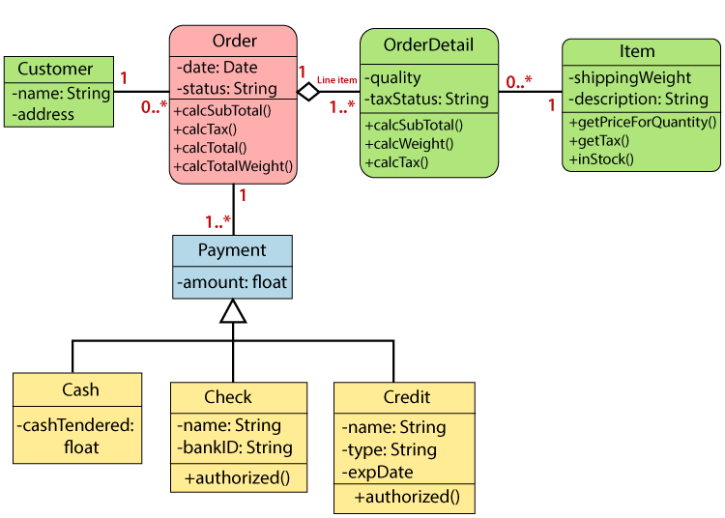
- Contrast Black Box Testing and White Box Testing. Mention the situations where you will opt for Black Box Testing.
Answer:
Differences between Black Box Testing vs White Box Testing:
S. No. | Black Box Testing | White Box Testing
1. | It is a way of software testing in which the internal structure or the program or the code is hidden and nothing is known about it. | It is a way of testing the software in which the tester has knowledge about the internal structure or the code or the program of the software.
2. | Implementation of code is not needed for black box testing. | Code implementation is necessary for white box testing.
3. | It is mostly done by software testers. | It is mostly done by software developers.
4. | No knowledge of implementation is needed. | Knowledge of implementation is required.
5. | It can be referred to as outer or external software testing. | It is the inner or the internal software testing.
6. | It is a functional test of the software. | It is a structural test of the software.
7. | This testing can be initiated based on the requirement specifications document. | This type of testing of software is started after a detail design document.
8. | No knowledge of programming is required. | It is mandatory to have knowledge of programming.
9. | It is the behavior testing of the software. | It is the logic testing of the software.
10. | It is applicable to the higher levels of testing of software. | It is generally applicable to the lower levels of software testing.

- Examine the role of project metrics. Assess the popular metrics available for project measurement. How defect removal efficiency measure helps in improving software quality?
Answer: Project Metrics
- Used by project managers and software team to adapt project workflow and technical activities
- Objective is
  - To minimize the development schedule by making adjustments that can avoid delays and mitigate potential problems
  - To assess product quality on an ongoing basis and when necessary, modify technical approach to improve quality
  - Most important use of metrics is estimation of time, effort.

Software Measurement Categories
- Direct Measures
  - Of software process are
    - Cost and effort
  - Of product are
    - Line of Code (LOC)
    - Execution Speed
    - Defects over specified period of time
- Indirect Measures
  - Of product are
    - Functionality
    - Quality
    - Complexity
    - Efficiency
    - Reliability
    - Maintainability
    - .. Other Abilities

Defect Removal Efficiency
- It is a measure of the filtering ability of the quality assurance and control activities as they are applied through out the process framework.
- DRE = E / (E + D)
  - E = # of errors found before delivery
  - D = # of defects found after delivery
- Ideal value of DRE is 1
- Realistically D will be greater than 0
- As E increases, DRE begins to approach 1
- DRE can also be applied on each process framework activity and hence find the team’s ability to assess errors before they are passed to next activity or software engineering task.
- DRE = E_{i} / (E_{i} + E_{i+1})
  - E_{i} = errors in activity i
E_{i+1} = errors in activity i+1 that were not discovered in activity

Section-D
(Attempt any one question, each question carries 10 marks, and subparts (if any) carry equal weightage)
- In Create an activity diagram for the online banking system. Consider following functions can be performed online.
- A customer can log in to the online portal.
- Customers can transfer funds.
- The customers can check the account balance.
- Customers can add and remove beneficiaries.
- Customers can take print of bank statements.
- Customers can give feedback or raise complaints.
- Customers log out of the online platform.
Answer:
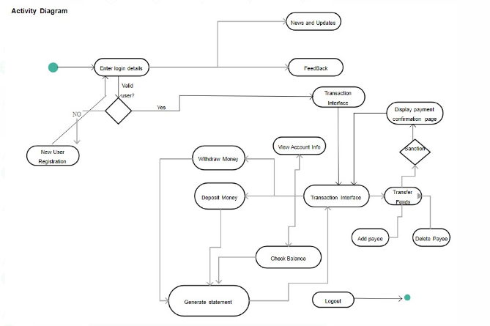

- Consider an order processing system. Requested order is input parameter of the activity after order is accepted and all required information is filled in, payment is accepted and order is shipped. Note that this business flow allows order shipment before invoice is sent or payment is confirmed. Draw the activity diagram for the system.
The following activity should be considered:
- Send order by customer
- Shipment of order
- Receipt of the order
- Confirm order
- Dispatch order
Answer:
