Object Oriented Software Engineering
ETE Notes

MCQ
1.
- Software is defined as ___________
(i) | set of programs, documentation & configuration of data | (ii) | set of programs
(iii) | documentation and configuration of data | (iv) | None of the mentioned
- What is Software Engineering?
(i) | Designing a software | (ii) | Testing a software
(iii) | Application of engineering principles to the design a software | (iv) | None of the above
- Who is the father of Software Engineering?
(i) | Margaret Hamilton | (ii) | Watts S. Humphrey
(iii) | Alan Turing | (iv) | Boris Beizer
- Define Agile scrum methodology
(i) | project management that emphasizes incremental progress | (ii) | project management that emphasizes decremental progress
(iii) | project management that emphasizes neutral progress | (iv) | project management that emphasizes no progress
- What does SDLC stands for?
(i) | System Design Life Cycle | (ii) | Software Design Life Cycle
(iii) | Software Development Life Cycle | (iv) | System Development Life cycle
Answers: a) i b) iii c) ii d) i e) iii

- What are the various phases of SDLC?
Answer:
There are seven primary stages of the modern system development life cycle. Here’s a brief breakdown:
- Planning Stage
- Feasibility or Requirements of Analysis Stage
- Design and Prototyping Stage
- Software Development Stage
- Software Testing Stage
- Implementation and Integration
- Operations and Maintenance Stage

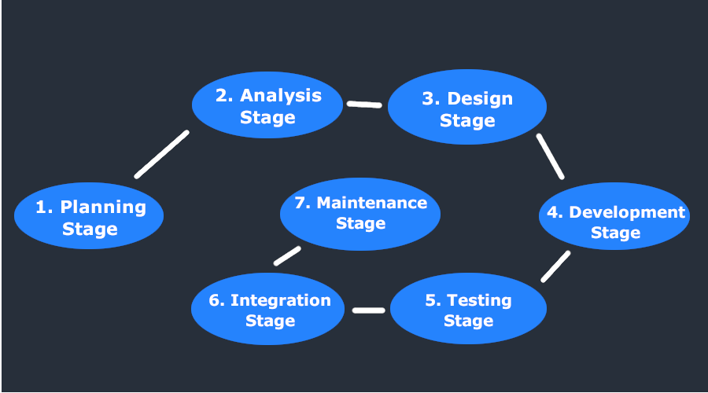
- Describe the Waterfall Model with its phases.
Answer:
The Waterfall Model was the first Process Model to be introduced. It is also referred to as a linear-sequential life cycle model. It is very simple to understand and use. In a waterfall model, each phase must be completed before the next phase can begin and there is no overlapping in the phases.
The Waterfall model is the earliest SDLC approach that was used for software development.
The waterfall Model illustrates the software development process in a linear sequential flow. This means that any phase in the development process begins only if the previous phase is complete. In this waterfall model, the phases do not overlap.

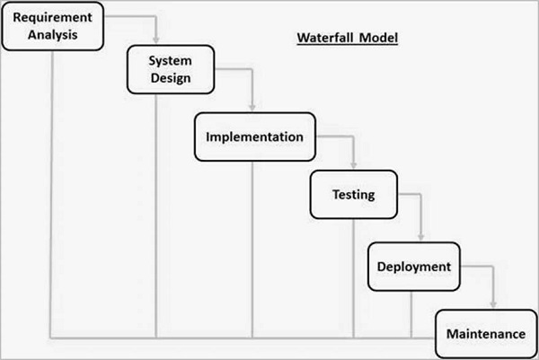
- Elaborate Agile Process Models
Answer: The meaning of Agile is swift or versatile."Agile process model" refers to a software development approach based on iterative development. Agile methods break tasks into smaller iterations, or parts do not directly involve long term planning. The project scope and requirements are laid down at the beginning of the development process. Plans regarding the number of iterations, the duration and the scope of each iteration are clearly defined in advance.
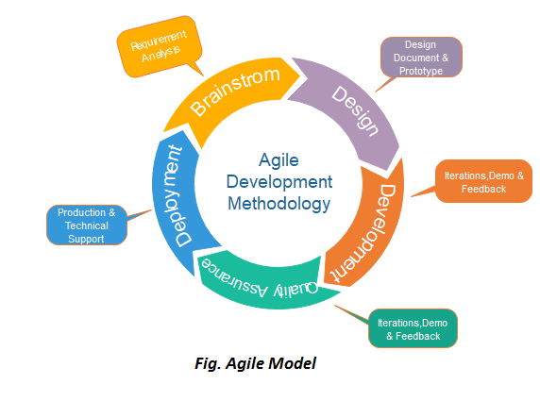

- Spiral Model is suitable for which type of software projects?
Answer:
Spiral model is a great option for large, complex projects. The progressive nature of the model allows developers to break a big project into smaller pieces and tackle one feature at a time, ensuring nothing is missed. Furthermore, since the prototype building is done progressively, the cost estimation of the whole project can sometimes be easier.
Other benefits of the spiral model include:
Flexibility - Changes made to the requirements after development has started can be easily adopted and incorporated.
Risk handling - The spiral model involves risk analysis and handling in every phase, improving security and the chances of avoiding attacks and breakages. The iterative development process also facilitates risk management.
Customer satisfaction - The spiral model facilitates customer feedback. If the software is being designed for a customer, then the customer will be able to see and evaluate their product in every phase. This allows them to voice dissatisfactions or make changes before the product is fully built, saving the development team time and money.
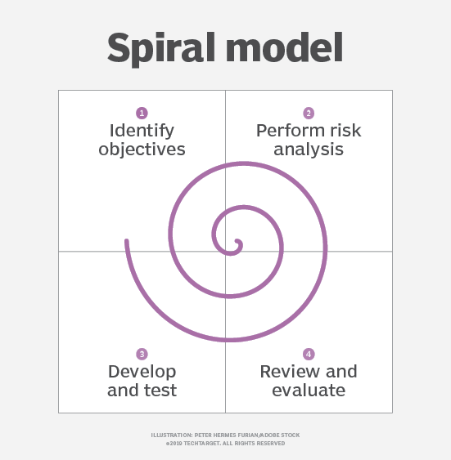

- Describe the steps of the requirements engineering process.
Answer:
Requirements engineering (RE) refers to the process of defining, documenting, and maintaining requirements in the engineering design process. Requirement engineering provides the appropriate mechanism to understand what the customer desires, analyzing the need, and assessing feasibility, negotiating a reasonable solution, specifying the solution clearly, validating the specifications and managing the requirements as they are transformed into a working system. Thus, requirement engineering is the disciplined application of proven principles, methods, tools, and notation to describe a proposed system's intended behavior and its associated constraints.
Requirement Engineering Process
It is a four-step process, which includes -
- Feasibility Study
- Requirement Elicitation and Analysis
- Software Requirement Specification
- Software Requirement Validation
- Software Requirement Management
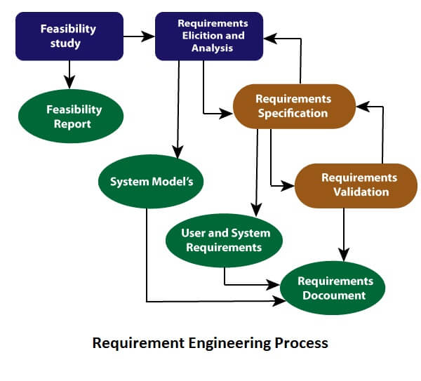
- State all XP prinicples.
Answer
- The planning process
- small releases
- Metaphor
- Simple design
- Testing
- Refactoring
- Pair programming
- Collective ownership
- Continuours Integration
- 40 Hour week
- On Site Customer
- Coding Standard
- How do you decide whether to conduct a software project using agile or waterfall methodology?
Answer:
An Agile methodology is a superior choice when the client is uncertain about requirements or wants to be closely involved in the development process, and if timelines are short and they want rapid delivery. Waterfall is superior if there are complex dependencies, but Agile is preferable when dependencies are minimal. Agile is also best if speed is more important than quality.
We can opt Waterfall model if there are enough time and less revision in project. For all the criticism of Waterfall, there are some real benefits to its implementation:
- It is a simple, straight-forward approach.
- It is easy to develop a plan for managing a Waterfall project since every phase has a start and end, and you know prior to coding what is to be developed, when it is due, when testing is to begin, etc.
- The early planning provides a good basis for designing components that integrate with external systems.

- Differentiate Agile and Waterfall Model.
Answer: Key Difference Between Waterfall and Agile
- Waterfall is a Linear Sequential Life Cycle Model, whereas Agile is a continuous iteration of development and testing in the software development process.
- In Agile vs Waterfall difference, the Agile methodology is known for its flexibility, whereas Waterfall is a structured software development methodology.
- Comparing the Waterfall methodology vs Agile, which follows an incremental approach, whereas the Waterfall is a sequential design process.
- Agile performs testing concurrently with software development, whereas in Waterfall methodology, testing comes after the “Build” phase.
- Agile allows changes in project development requirements, whereas Waterfall has no scope of changing the requirements once the project development starts.

- Is spiral Model is suitable for small software projects? Justify your answer.
Answer:
Spiral Model is not suitable for small projects as it is expensive.
- Too much dependability on Risk Analysis: The successful completion of the project is very much dependent on Risk Analysis. Without very highly experienced experts, it is going to be a failure to develop a project using this model.
- Difficulty in time management: As the number of phases is unknown at the start of the project, so time estimation is very difficult.
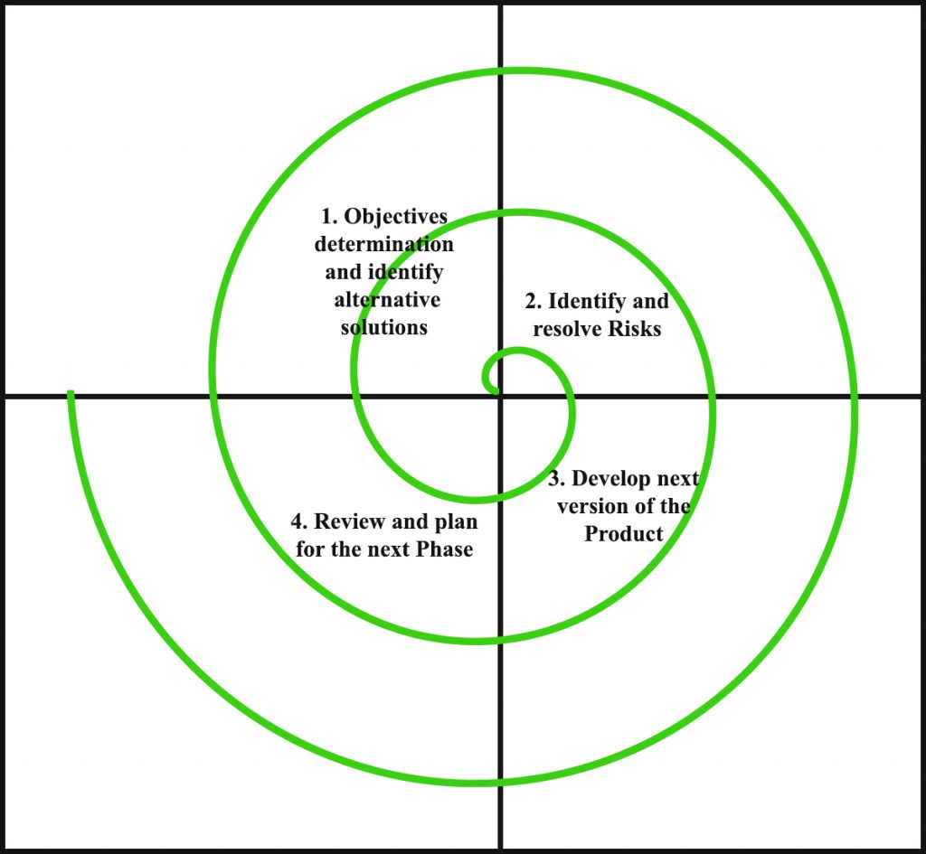

- In a rapidly changing client’s requirement where the Adaptive Software Development (ASD) strategy helps to satisfy the demand?
Answer :
Adaptive Software Development (ASD) is a direct outgrowth of an earlier agile framework, Rapid Application Development (RAD). Moreover, it aims to enable teams to quickly and effectively adapt to changing requirements or market needs by evolving their products with lightweight planning and continuous learning. Lastly, The ability to adapt allows teams to align with organizational goals. The ASD approach encourages teams to develop according to a three-phase process: speculate, collaborate, learn.
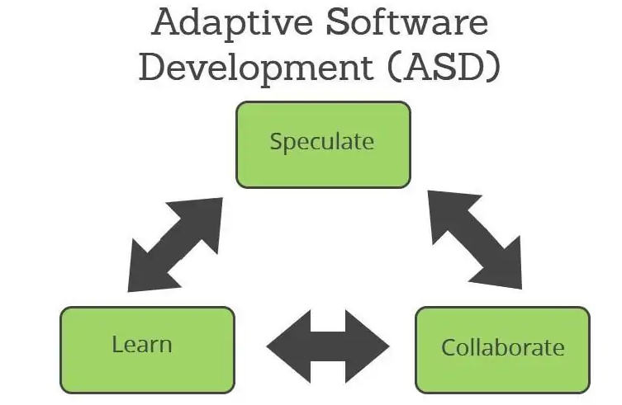

Section-D
(Attempt any one question, each question carries 10 marks, subparts (if any) carry equal weightage)
- Construct a Class diagram for Library Management System.
Answer:

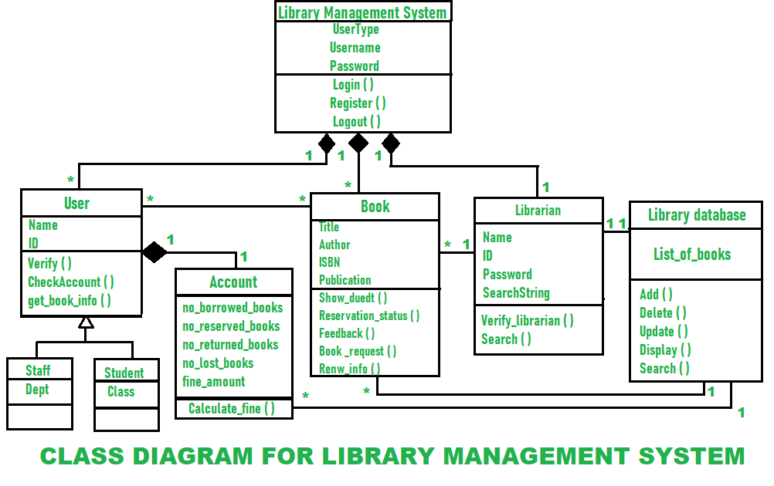
.
13. Construct a Use Case diagram for Chitkara University management System.
Answer
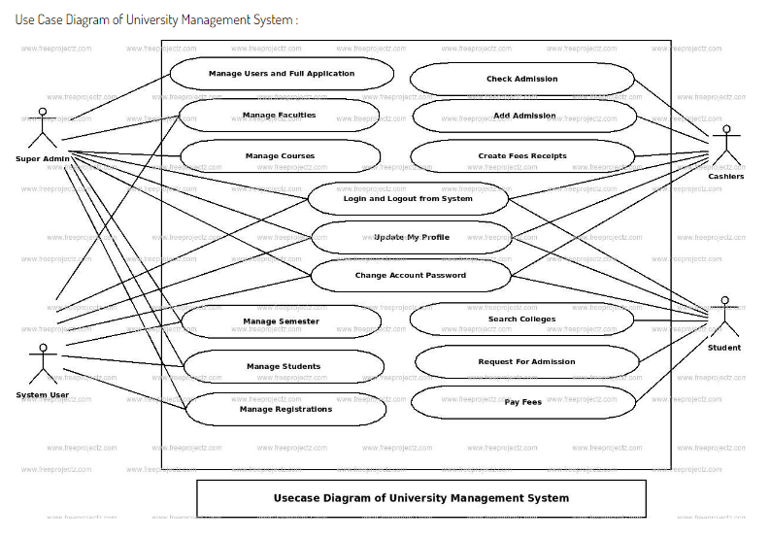

Section-A
(All Questions are Compulsory, Each question carries 01 mark)
1.

- What is the major drawback of the Spiral Model?
(i) | Higher amount of risk analysis | (ii) | Doesn't work well for smaller projects
(iii) | Additional functionalities are added later on | (iv) | Strong approval and documentation control
- What is the first step in the software development lifecycle?
(i) | System Design | (ii) | Coding
(iii) | System Testing | (iv) | Preliminary Investigation and Analysis
- Agile software engineering refers
(i) | A philosophy and a set of development guidelines | (ii) | An active and continuous communication between developers and customers
(iii) | Encourages customer satisfaction | (iv) | All of the mentioned above
- What is true about Extreme Programming?
(i) | XP is a lightweight | (ii) | XP is efficient
(iii) | XP is low-risk | (iv) | All of the above
- Which of the following is not a UML diagram?
(i) | Class diagram | (ii) | Object Diagram
(iii) | Interface diagram | (iv) | Use case model

Answers : a) ii b) iv c) iv d) iv e) iii
- The main purpose of a use case diagram is to portray the dynamic aspect of a system, explain briefly.
Answer :
he main purpose of a use case diagram is to portray the dynamic aspect of a system. It accumulates the system's requirement, which includes both internal as well as external influences. It invokes persons, use cases, and several things that invoke the actors and elements accountable for the implementation of use case diagrams. It represents how an entity from the external environment can interact with a part of the system.
Following are the purposes of a use case diagram given below:
- It gathers the system's needs.
- It depicts the external view of the system.
- It recognizes the internal as well as external factors that influence the system.
- It represents the interaction between the actors.

- UML Diagrams helps in visualize a software system, justify the statement.
Answer: UML is a diagramming language created for software developers to visualize, construct and document aspects of software. UML typically has graphic elements that represent design aspects of software. Although some might think time spent learning to draw diagrams is time wasted, the skill can pay off in big ways. Diagrams focus conversations and facilitate communication, and they can cut down on time that would be wasted on explaining and re-explaining. Rather than writing a long document, one can draw a few diagrams to show how it works together. Explaining what all the different shapes on a diagram mean to a new audience could take some time. Standards like UML only require that everyone learn one standard, rather than adapting to each diagrammer’s individual style each time.

- SDLC aims to produce a high-quality software that meets customer expectations, explain?
Answer :
Software Development Life Cycle (SDLC) is a process used by the software industry to design, develop and test high quality softwares. The SDLC aims to produce a high-quality software that meets or exceeds customer expectations, reaches completion within times and cost estimates.
SDLC is a process followed for a software project, within a software organization. It consists of a detailed plan describing how to develop, maintain, replace and alter or enhance specific software. The life cycle defines a methodology for improving the quality of software and the overall development process.
The graphical representation of the various stages of a typical SDLC.
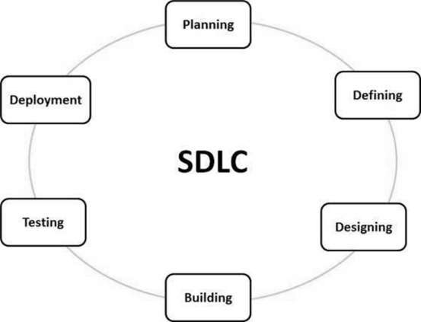

- Describe the function of Adaptive Software Development Model.
Answer:
Adaptive Software Development is a method to build complex software and system. ASD focuses on human collaboration and self-organization. ASD “life cycle” incorporates three phases namely:
1. Speculation
2. Collaboration
3. Learning
These are explained as following below.
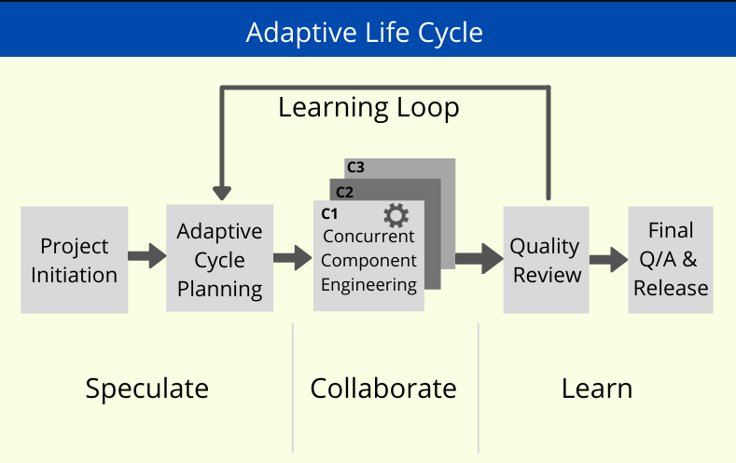
- Agile is a time-bound, iterative approach to software delivery, explain briefly.
Answer :
Agile is a time boxed, iterative approach to software delivery that builds software incrementally from the start of the project, instead of trying to deliver it all at once near the end.
It works by breaking projects down into little bits of user functionality called user stories, prioritizing them, and then continuously delivering them in short two week cycles called iterations.
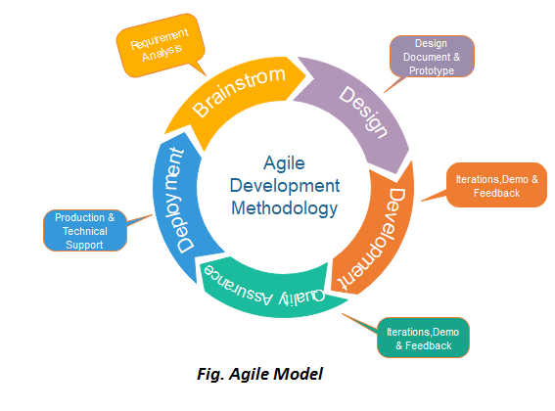
- Decide the essential steps of requirement analysis for a software project for Online Shopping System .
Answer:
The various steps of requirement analysis are:
a) Draw the context diagram
b) Development of a Prototype (optional)
c) Model the requirements:
d) Finalize the requirements
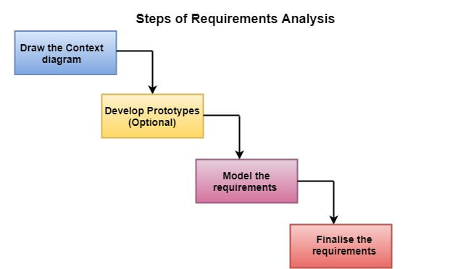
- Elaborate the Evolving Role software engineering.
Answer: Software Evolution is a term which refers to the process of developing software initially, then timely updating it for various reasons, i.e., to add new features or to remove obsolete functionalities etc. The evolution process includes fundamental activities of change analysis, release planning, system implementation and releasing a system to customers.
The cost and impact of these changes are accessed to see how much system is affected by the change and how much it might cost to implement the change. If the proposed changes are accepted, a new release of the software system is planned. During release planning, all the proposed changes (fault repair, adaptation, and new functionality) are considered.
A design is then made on which changes to implement in the next version of the system. The process of change implementation is an iteration of the development process where the revisions to the system are designed, implemented and tested.
The necessity of Software evolution: Software evaluation is necessary just because of the following reasons:
a) Change in requirement with time: With the passes of time, the organization’s needs and modus Operandi of working could substantially be changed so in this frequently changing time the tools(software) that they are using need to change for maximizing the performance.
b) Environment change: As the working environment changes the things(tools) that enable us to work in that environment also changes proportionally same happens in the software world as the working environment changes then, the organizations need reintroduction of old software with updated features and functionality to adapt the new environment.
c) Errors and bugs: As the age of the deployed software within an organization increases their preciseness or impeccability decrease and the efficiency to bear the increasing complexity workload also continually degrades. So, in that case, it becomes necessary to avoid use of obsolete and aged software. All such obsolete Softwares need to undergo the evolution process in order to become robust as per the workload complexity of the current environment.
d) Security risks: Using outdated software within an organization may lead you to at the verge of various software-based cyberattacks and could expose your confidential data illegally associated with the software that is in use. So, it becomes necessary to avoid such security breaches through regular assessment of the security patches/modules are used within the software. If the software isn’t robust enough to bear the current occurring Cyber attacks so it must be changed (updated).
e) For having new functionality and features: In order to increase the performance and fast data processing and other functionalities, an organization need to continuously evolute the software throughout its life cycle so that stakeholders & clients of the product could work efficiently.
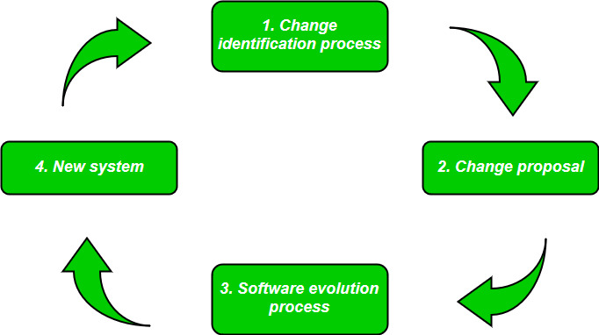

- Waterfall model does not allow much revision, Justify.
Answer:
The disadvantage of waterfall development is that it does not allow much reflection or revision. Once an application is in the testing stage, it is very difficult to go back and change something that was not well-documented or thought upon in the concept stage.
The major disadvantages of the Waterfall Model are as follows −
- No working software is produced until late during the life cycle.
- High amounts of risk and uncertainty.
- Not a good model for complex and object-oriented projects.
- Poor model for long and ongoing projects.
- Not suitable for the projects where requirements are at a moderate to high risk of changing. So, risk and uncertainty is high with this process model.
- It is difficult to measure progress within stages.
- Cannot accommodate changing requirements.
- Adjusting scope during the life cycle can end a project.
- Integration is done as a "big-bang. at the very end, which doesn't allow identifying any technological or business bottleneck or challenges early.

- Requirement analysis is significant and essential activity after elicitation, Justify.
Answer:
Requirement analysis is significant and essential activity after elicitation. We analyze, refine, and scrutinize the gathered requirements to make consistent and unambiguous requirements. This activity reviews all requirements and may provide a graphical view of the entire system. After the completion of the analysis, it is expected that the understandability of the project may improve significantly. Here, we may also use the interaction with the customer to clarify points of confusion and to understand which requirements are more important than others.

- The software becomes more popular if its user interface is easy and attractive, explain.
Answer:
User interface is the front-end application view to which user interacts in order to use the software. User can manipulate and control the software as well as hardware by means of user interface. Today, user interface is found at almost every place where digital technology exists, right from computers, mobile phones, cars, music players, airplanes, ships etc.
User interface is part of software and is designed such a way that it is expected to provide the user insight of the software. UI provides fundamental platform for human-computer interaction.
UI can be graphical, text-based, audio-video based, depending upon the underlying hardware and software combination. UI can be hardware or software or a combination of both.
The software becomes more popular if its user interface is:
- Attractive
- Simple to use
- Responsive in short time
- Clear to understand
- Consistent on all interfacing screens

- Construct a Class Diagram for Chitkara University Management System.
Answer :

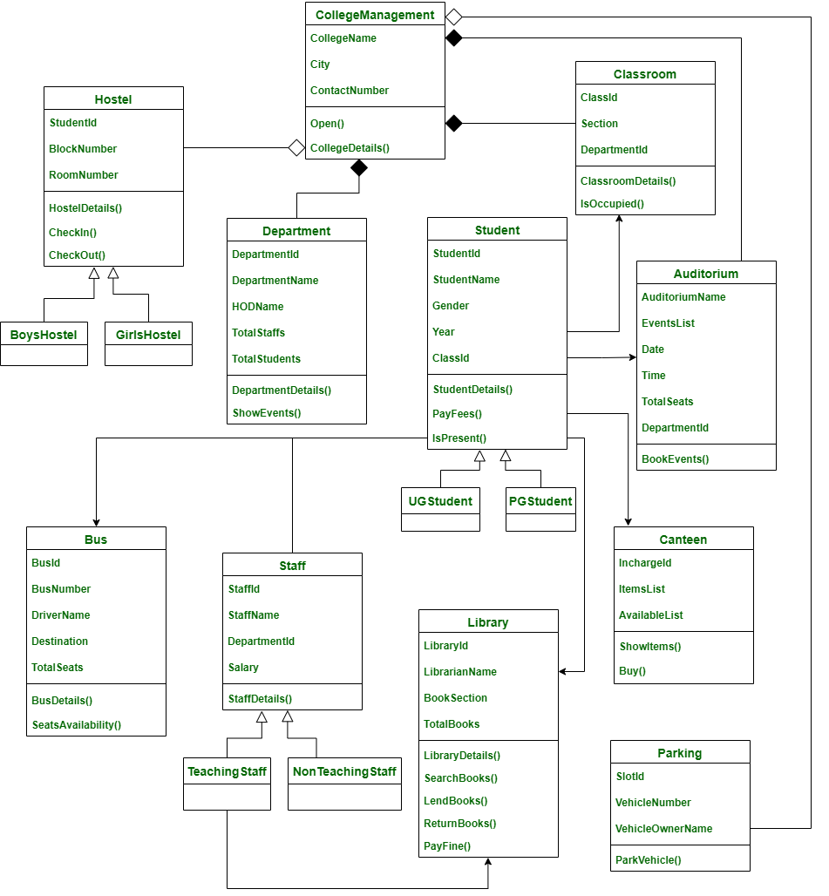

- Construct a Use case Diagram for Chitkara Library Management system with suitable assumptions.
Answer:
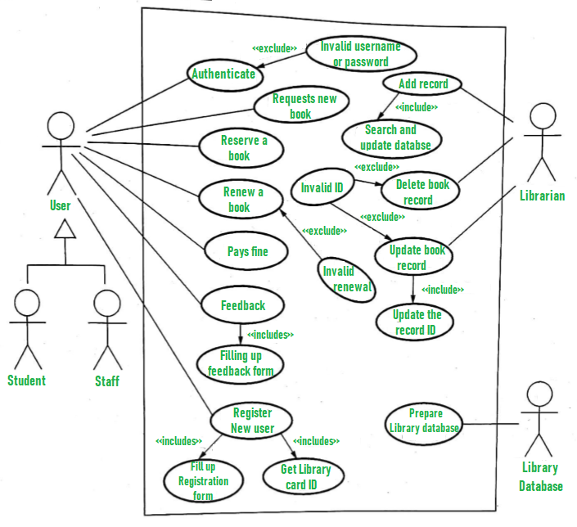
MCQ

1.
- You need to fix a bug in software; identify the testing used to check the code:
(i) | Grey box testing | (ii) | Black box testing
(iii) | White-box testing | (iv) | Red box testing
- According to an IBM research,''31% of projects are abandoned before they are completed ,53% exceed their cost projections by an average of 189 percent , and 94 projects are restarted for every 100 projects.'' What can be the reasons for these figures?
(i) | Lack of software ethics and understanding | (ii) | Management issues in the company
(iii) | Lack of adequate training | (iv) | All of the mentioned
- Consider the basic COCOMO model where E is the effort applied in person – months ,D is the development time in chronological months, KLOC is the estimated number of delivered lines of code (in thousands) and ab bb cb db have their usual meanings. The basic COCOMO equations are of the form :
(i) | E=ab (KLOC)exp(bb), D=cb (E) | (ii) | D=ab (KLOC)exp(bb), D=cb (E)
(iii) | E=ab exp(bb), D=cb (KLOC)exp | (iv) | E=ab exp(bb), D=cb (KLOC)exp

- Regression testing is primarily related to :
(i) | Functional testing | (ii) | Development testing
(iii) | Data flow testing | (iv) | Maintenance testing
- The tools for computing critical path and project completion times from activity networks is/are :
(a) CPM (b) DRE (c) FP (d) PERT
(i) | Both (a) and (c) above | (ii) | Both (a) and (d) above
(iii) | Both (b) and (d) above | (iv) | Both (b) and (c) above

Answers 1
a) | (iii)
b) | (iii)
c) | (i)
d) | (i)
e) | (ii)

- Consider a software project using semi-detached mode with 300 Kloc .find out Development Time. Assume Coefficient values a=3.0, b=1.12, c=1.25, d=0.35.
Answer:
Development Time (D) =
c(E)d =
2.5(1784.42)0.35 =
34.35 Months(M)
- You need to test a project that is incomplete and missing some functions. How can you Stubs and Drivers for testing the project using these simulators.
Answer: Stubs and drivers are used in software testing as a part of the incremental or top-down testing approach to test individual units or components of a larger system. The main purpose of using stubs and drivers in testing is to simulate the behavior of the dependent components that are not yet available or have not yet been developed.
The purpose of stubs and drivers in testing:
- Stubs: A stub is a simple program or code module that replaces a larger software component that is not yet developed or available. The purpose of a stub is to provide a temporary replacement that mimics the behavior of the missing component to enable testing of other components that are dependent on it. Stubs are typically used in bottom-up testing, where the lower-level components are developed and tested first before the higher-level components.
- Drivers: A driver is a software component or program that is used to test a particular unit or component of a larger system. The purpose of a driver is to provide the necessary inputs to the component being tested and to simulate its behavior or output to other components or systems that depend on it. Drivers are typically used in top-down testing, where the higher-level components are developed and tested first before the lower-level components.

- Distinguish the role of Size oriented and Function oriented metrics while estimating the cost of a software project.
Answer: Size-oriented and function-oriented metrics are two different approaches used in software development to measure and manage the software development process.
Size-oriented metrics are based on the size of the software code or the data used by the software. Examples of size-oriented metrics include lines of code, number of files, and number of functions. These metrics are useful for measuring the amount of effort required to develop, test, and maintain the software. They are also useful for estimating project schedules, budgets, and resource requirements.
Function-oriented metrics, on the other hand, are based on the functionality provided by the software. Examples of function-oriented metrics include function points and use case points. These metrics are useful for measuring the software's functionality, which can be used to estimate the software's complexity and maintainability. They are also useful for determining the software's quality and for measuring the effectiveness of the development process.
The main difference between size-oriented and function-oriented metrics is that size-oriented metrics focus on the size of the software code or data, while function-oriented metrics focus on the functionality provided by the software. Size-oriented metrics are easier to measure and provide a quick estimate of the software development effort, but they do not provide a complete picture of the software's functionality or quality. Function-oriented metrics are more complex to measure, but they provide a more accurate estimate of the software's functionality and quality.
- Suggest some situations where you use Statement coverage and Branch Coverage, which is a better criteria for project testing?
Answer: Statement coverage and branch coverage are two popular testing criteria used to measure the effectiveness of test cases in software testing.
Statement coverage is a metric that measures the percentage of statements executed during the testing process, whereas branch coverage is a metric that measures the percentage of decision outcomes tested during the testing process.
Both statement coverage and branch coverage have their strengths and weaknesses, and the choice of the stronger criteria depends on the software testing goals and requirements.
Here are some arguments for each criterion:
Statement Coverage:
Statement coverage is a relatively simple and easy-to-use testing metric that provides an overview of the completeness of the testing process. Statement coverage ensures that all statements in the code are executed at least once, which can help detect syntax errors and other coding issues.
Statement coverage is a good starting point for testing and can be used to identify untested code areas that need further attention.
Branch Coverage:
Branch coverage is a more sophisticated testing metric that provides a more detailed view of the testing process by considering decision points in the code.
Branch coverage ensures that all possible decision outcomes are tested, which can help detect logical errors and other design issues.
Branch coverage is more thorough and can uncover more issues in the code compared to statement coverage.
Overall, branch coverage is generally considered a stronger testing criterion compared to statement coverage since it provides a more detailed and comprehensive view of the testing process. However, statement coverage is still a valuable testing metric that can be used in conjunction with other testing criteria to ensure a thorough and effective testing process.
- Generalize on how productivity and cost related to function points.
Answer: Function points are a measure of the functional size of a software application based on the user's perspective. They are used to estimate the development effort required to deliver a software product, as well as to measure and improve software productivity and quality.
Productivity and cost are related to function points in the following ways:
- Productivity: Function points can be used to measure software productivity by calculating the number of function points delivered per unit of effort, such as hours or person-months. This measure allows organizations to track and compare the productivity of different projects and teams, and to identify areas for improvement.
- Cost: Function points can also be used to estimate the cost of software development by multiplying the number of function points by the cost per function point. This estimate can be used to allocate budgets, to negotiate contracts with vendors, and to evaluate the cost-effectiveness of different software development options.
In general, the higher the number of function points in a software application, the more effort and cost will be required to develop it. However, the relationship between function points, productivity, and cost is not always linear, as it can be affected by various factors such as the complexity of the software, the level of reuse of existing code, the experience and skill level of the development team, and the development methodology used.
Therefore, function points should be used in conjunction with other measures of software development, such as lines of code, defect density, and customer satisfaction, to get a more comprehensive picture of the software's quality, productivity, and cost-effectiveness.

- Differentiate verification and validation. Which type of testing address verification? Which type of testing address validation?
Answer:
- verification | - validation
- The verifying process includes checking documents, design, code, and program | - It is a dynamic mechanism of testing and validating the actual product
- It does not involve executing the code | - It always involves executing the code
- Verification uses methods like reviews, walkthroughs, inspections, and desk- checking etc. | - It uses methods like Black Box Testing, White Box Testing, and non-functional testing
- Whether the software conforms to specification is checked | - It checks whether the software meets the requirements and expectations of a customer
- It finds bugs early in the development cycle | - It can find bugs that the verification process can not catch
- Target is application and software architecture, specification, complete design, high level, and database design etc. | - Target is an actual product

- A patient visits a doctor for routine checkup. Draw a Sequence Diagram for complete process.
Answer:
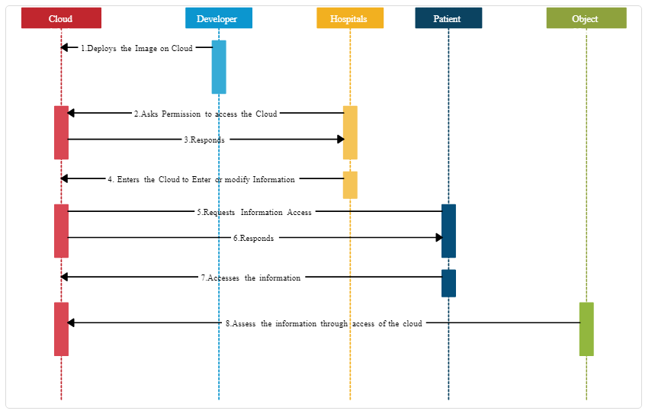
- Draw a Collaboration Diagram for UCO Bank ATM Machine, taking suitable assumptions for objects.
Answer:
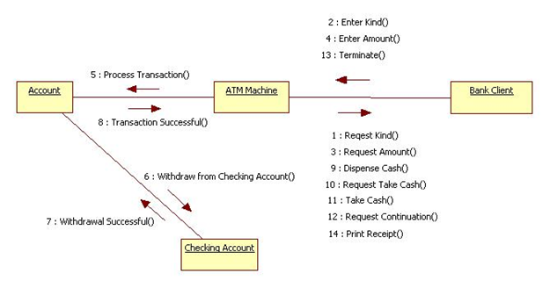
- COCOMO model helps software developers in estimation of software costing?
Answer: Cocomo (Constructive Cost Model) is a regression model based on LOC, i.e number of Lines of Code. It is a procedural cost estimate model for software projects and is often used as a process of reliably predicting the various parameters associated with making a project such as size, effort, cost, time, and quality. It was proposed by Barry Boehm in 1981 and is based on the study of 63 projects, which makes it one of the best-documented models. The key parameters which define the quality of any software products, which are also an outcome of the Cocomo are primarily Effort & Schedule:
- Effort: Amount of labor that will be required to complete a task. It is measured in person-months units.
- Schedule: Simply means the amount of time required for the completion of the job, which is, of course, proportional to the effort put in. It is measured in the units of time such as weeks, and months.
COCOMO formula :
Effort(E)= a*(KLOC)^b PM(Person month)
Time = c(E)d
Person Required = effort/time
- Where,
KLOC = size of the product i.e. no. of lines of code.
a, b, c, d are constants and have different values for different models.
Time is the time required to develop the product and the unit is months.
And the effort is the total effort calculated that will be required to complete the work calculated in PM (Person Months).
COCOMO model helps software developers in estimation of software costing in various way:
Provides a systematic way to estimate the cost and effort of a software project.
Can be used to estimate the cost and effort of a software project at different stages of the development process.
Helps in identifying the factors that have the greatest impact on the cost and effort of a software project.
Can be used to evaluate the feasibility of a software project by estimating the cost and effort required to complete it.

- A restaurant sells food items to students and receives payment through a payment App. Draw a class diagram describing the order of transactions, objects and classes.
Answer:
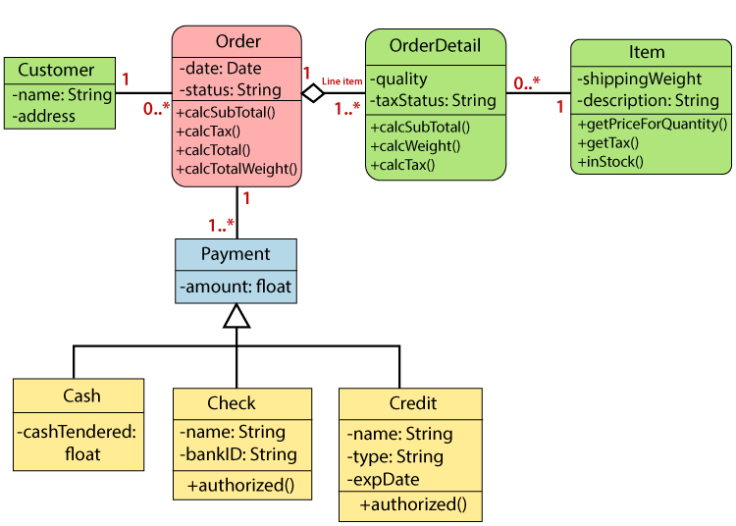
Section-D
(Attempt any one question, each question carries 10 marks, and subparts (if any) carry equal weightage)
- Develop the process of ordering a pizza over the phone. Create the activity diagram representing each step of the process, from when you pick up the phone to when you start eating the pizza. Include activities that others need to perform. Add exception handling to the activity diagram you developed. Consider at least two exceptions (e.g. delivery person wrote down the wrong address or a delivery person brings the wrong pizza).
Answer:
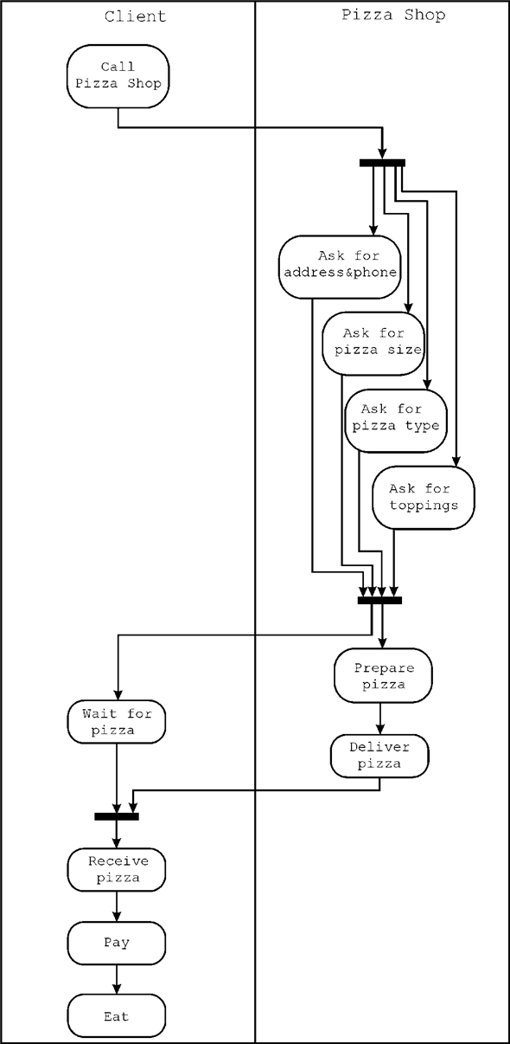

- Create an activity diagram.
Consider the scenario where a customer wants to do an eye checkup. The steps involved in the process are as follows:
A customer makes an appointment with an ophthalmologist (Eye Doctor).
- The ophthalmologist conducts an examination.
- The ophthalmologist writes the prescription.
- The customer goes to the eyewear store.
- The customer chooses the frame.
- The customer selects the lenses.
- The glasses shop makes the glasses.
- The customer tries them on. If they match, the customer pays for them and goes home.
- If they don't fit, the eyewear store adjusts the fit, and the customer tries them on again.
- The previous step is repeated until the glasses fit.
Answer:

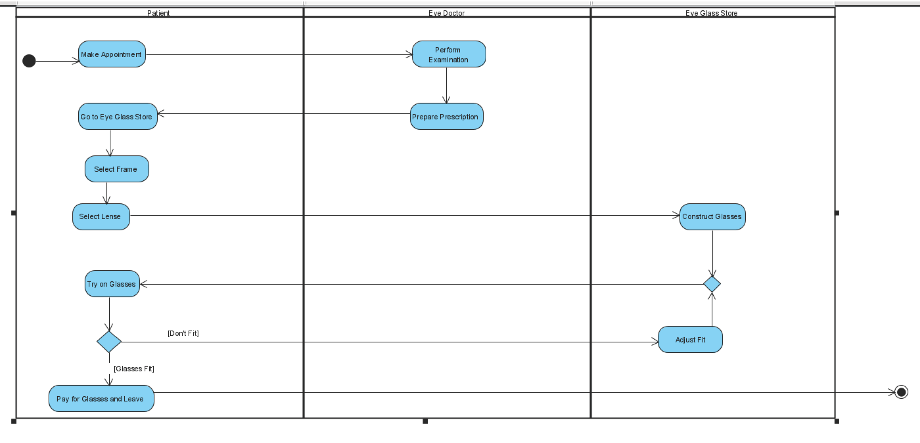
MCQ
1.
- Recognize which of the following testing is also called Acceptance testing?
(i) | Beta testing | (ii) | White-box testing
(iii) | Grey box testing | (iv) | Alpha testing

- Identify which of the following is not a project factor that should be considered when planning the structure of software developing teams?
(i) | The rigidity of the delivery date | (ii) | The degree of sociability required for the project
(iii) | High frustration caused by personal, business, or technological factors that causes friction among team members | (iv) | The difficulty of the problem to be solved

- COCOMO Model is an abbreviation for:
(i) | Cost Constructive Estimation Model | (ii) | Constructive Cost Estimation Model
(iii) | Constructive Case Estimation Model | (iv) | Constructive Cost Estimating Model

- Select the suitable statement which is in contrast to the given statement.“Engineers developing software should not ________”.
(i) | Be dependent on their colleagues | (ii) | Maintain integrity and independence in their professional judgment
(iii) | Not knowingly accept work that is outside your competence | (iv) | Not use your technical skills to misuse other people’s computers

- Regardless of application area, project size, or complexity, software development work may be divided into three generic phases: the ______phase, which focuses on what, the ______phase, which focuses on how, and the ______phase, which focuses on change.
(a) Support (b) development (c) definition
 | (i) | c,b,a |  |  | (ii) | c,a,b
 | (iii) | a,b,c |  |  | (iv) | b,a,c
Answers 1
a) |  |  | (i)
b) |  |  | (ii)
c) |  |  | (ii)
d) |  |  | (i)
e) |  |  | (i)

- Consider a software project using semi-detached mode with 300 Kloc .find out Effort estimation. Assume Coefficient values a=3.0, b=1.12, c=2.5, d=0.35.
Answer:
Effort (E) =
a*(KLOC)b =
3.0*(300)1.12 =
1784.42 PM
- You need to estimate the cost and efforts of a project as a project manager. You have given information about Line of Codes used in that project. How this information will help you in cost estimation?
Answer: LOC (Lines of Code) based estimation is a software estimation technique that involves estimating the size of a software project based on the number of lines of code that will be written to implement the project. The purpose of LOC based estimation is to provide a rough estimate of the size and complexity of a software project, which can be used to estimate the project's cost, schedule, and resource requirements.
The primary advantage of LOC based estimation is its simplicity and ease of use. It is relatively easy to count the number of lines of code that will be written to implement a software project, and this can be used to estimate the project's size and complexity. Additionally, LOC based estimation can be used to estimate the effort required to implement the project, which can be useful for planning purposes.
However, there are also several limitations to LOC based estimation. One of the main limitations is that it does not take into account the quality of the code that is being written. Some code may be more complex or difficult to write than other code, even if it contains the same number of lines of code. Additionally, LOC based estimation does not take into account the software's functionality or requirements, which can significantly affect the project's size and complexity.

- Summarize various testing strategies for conventional software. How its helps in bug removal and quality improvements?
Answer: There are several testing strategies used for conventional software, which can be broadly classified into the following categories:
- Black Box Testing: This type of testing involves testing the software without looking into its internal structure or design. Test cases are designed based on the software requirements or specifications. The main goal of black box testing is to ensure that the software meets its functional requirements and works as expected from a user's perspective.
- White Box Testing: This type of testing involves testing the software based on its internal structure, code, and design. Test cases are designed to ensure that the software is robust, reliable, and performs well under different conditions. The main goal of white box testing is to identify any defects or issues in the code or design of the software.
- Grey Box Testing: This type of testing combines elements of both black box and white box testing. In grey box testing, the tester has partial knowledge of the software's internal structure and design, which enables them to design more comprehensive test cases that cover both functional and structural aspects of the software.
- Regression Testing: This type of testing involves retesting the software after making changes or modifications to ensure that the changes have not introduced any new defects or issues. Regression testing is usually performed after bug fixes, new feature additions, or system upgrades.
- Integration Testing: This type of testing involves testing how different components or modules of the software work together. The goal of integration testing is to ensure that the software system functions as a whole, and there are no defects or issues caused by the interaction between different modules.
- Acceptance Testing: This type of testing involves testing the software from the end-user's perspective to ensure that it meets the user's needs and requirements. Acceptance testing is usually performed after the software has been developed and tested by the developers.
- Performance Testing: This type of testing involves testing the software's performance under different conditions such as load, stress, and volume. The goal of performance testing is to ensure that the software can handle the expected workload and perform well under different conditions.

- In a team of 5 students you have to develop a software Project for Online Shopping , plan this project step by step.
Answer: Project planning is an essential process that helps project managers and stakeholders to define the scope of the project, estimate the resources required, and create a roadmap for achieving the project objectives. Here are some steps involved in project planning:
- Define the project scope: The first step is to define the project's scope, including its goals, objectives, deliverables, and requirements. This step will help stakeholders to have a clear understanding of what the project will achieve.
- Identify the project stakeholders: Identify all the stakeholders who will be involved in the project, including the project team members, customers, suppliers, and other relevant parties. This step will help to ensure that everyone who is affected by the project is aware of the project's goals and objectives.
- Develop a project plan: Develop a detailed project plan that includes the project timeline, budget, resources, tasks, milestones, and risks. This step will help to ensure that the project is completed within the specified time and budget.
- Identify project risks: Identify potential risks that could affect the project's success, such as scope creep, resource constraints, technology failures, and other issues. This step will help to develop contingency plans to mitigate any risks.
- Assign tasks and responsibilities: Assign tasks and responsibilities to the project team members, and ensure that everyone knows what they are responsible for. This step will help to ensure that the project progresses smoothly, and all tasks are completed on time.
- Monitor and control the project: Monitor the progress of the project against the project plan, and make any necessary adjustments. This step will help to ensure that the project stays on track and is completed within the specified time and budget.
- Evaluate the project: Evaluate the project after completion to identify any areas of improvement and to learn from the project's successes and failures. This step will help to improve the project management process for future projects.

- Summarize Top-down Integration testing and Bottom - integration testing.
Answer: Top-down integration testing and bottom-up integration testing are two popular approaches to integrating and testing software components.
Top-down Integration Testing:
Top-down integration testing is an incremental testing approach that begins with the high-level modules or components and proceeds downwards towards the lower-level modules or components. In this approach, the higher-level modules are tested first, and stubs are used to simulate the behavior of the lower-level modules that have not been developed yet. Once the lower-level modules are developed, they are integrated with the higher-level modules, and the testing process proceeds until all modules are integrated and tested.
Advantages of top-down integration testing:
• Early detection of high-level design issues
• Faster feedback on the overall system performance
• Better visibility of the system architecture
Disadvantages of top-down integration testing:
• Delayed testing of lower-level modules
• Increased reliance on stubs and simulators
• More difficult to isolate lower-level issues
Bottom-up Integration Testing:
Bottom-up integration testing is an incremental testing approach that begins with the low-level modules or components and proceeds upwards towards the higher-level modules or components. In this approach, the lower-level modules are tested first, and drivers are used to simulate the behavior of the higher-level modules that have not been developed yet. Once the higher-level modules are developed, they are integrated with the lower-level modules, and the testing process proceeds until all modules are integrated and tested.
Advantages of bottom-up integration testing:
• Early detection of low-level design issues
• Faster feedback on the behavior of individual modules
• Easier to isolate and fix lower-level issues
Disadvantages of bottom-up integration testing:
• Delayed testing of higher-level modules
• Increased reliance on drivers and simulators
• Less visibility of the system architecture
- Generalize the concept of project metrics in software engineering.
Answer: Project metrics are measures used to evaluate the performance and progress of a project. They provide valuable insights into various aspects of the project, such as its schedule, cost, quality, risk, and resource utilization. Project metrics help project managers and stakeholders to monitor the project's progress, identify potential issues, and make informed decisions to ensure the project's success.
Some common types of project metrics include:
- Schedule metrics: Schedule metrics track the progress of the project against the planned schedule. They include metrics such as planned vs. actual start and end dates, percentage of tasks completed, and schedule variance.
- Cost metrics: Cost metrics track the project's expenditures and compare them to the budget. They include metrics such as actual vs. planned costs, cost variance, and cost performance index.
- Quality metrics: Quality metrics track the quality of the project deliverables and the process used to develop them. They include metrics such as defect density, customer satisfaction, and adherence to quality standards.
- Risk metrics: Risk metrics track the potential risks and their impact on the project. They include metrics such as risk probability and impact, risk mitigation effectiveness, and risk exposure.
- Resource metrics: Resource metrics track the utilization of project resources, such as human resources, equipment, and materials. They include metrics such as resource utilization, resource availability, and resource productivity.
- Project metrics should be carefully selected based on the project goals and objectives, and should be regularly reviewed and updated throughout the project lifecycle. They should be communicated effectively to all stakeholders, and used to guide decision-making and drive project improvements.
- Suppose you are developing a software project for Automatic Attendance System. You need to estimate the cost of the project. Which model for cost estimation you will prefer? Justify the reasons for selection of your selected model.
Answer: I will prefer COCOMO model.
Advantages of the COCOMO model:
- Provides a systematic way to estimate the cost and effort of a software project.
- Can be used to estimate the cost and effort of a software project at different stages of the development process.
- Helps in identifying the factors that have the greatest impact on the cost and effort of a software project.
- Can be used to evaluate the feasibility of a software project by estimating the cost and effort required to complete it.
Disadvantages of the COCOMO model:
- Assumes that the size of the software is the main factor that determines the cost and effort of a software project, which may not always be the case.
- Does not take into account the specific characteristics of the development team, which can have a significant impact on the cost and effort of a software project.
- Does not provide a precise estimate of the cost and effort of a software project, as it is based on assumptions and averages.
- Chitkara University Stationary Shop sells stationery items to students. Draw a class diagram describing the sells order system for the Stationary Shop.
Answer:
- Contrast Black Box Testing and White Box Testing. Mention the situations where you will opt for Black Box Testing.
Answer:
Differences between Black Box Testing vs White Box Testing:
S. No. | Black Box Testing | White Box Testing
1. | It is a way of software testing in which the internal structure or the program or the code is hidden and nothing is known about it. | It is a way of testing the software in which the tester has knowledge about the internal structure or the code or the program of the software.
2. | Implementation of code is not needed for black box testing. | Code implementation is necessary for white box testing.
3. | It is mostly done by software testers. | It is mostly done by software developers.
4. | No knowledge of implementation is needed. | Knowledge of implementation is required.
5. | It can be referred to as outer or external software testing. | It is the inner or the internal software testing.
6. | It is a functional test of the software. | It is a structural test of the software.
7. | This testing can be initiated based on the requirement specifications document. | This type of testing of software is started after a detail design document.
8. | No knowledge of programming is required. | It is mandatory to have knowledge of programming.
9. | It is the behavior testing of the software. | It is the logic testing of the software.
10. | It is applicable to the higher levels of testing of software. | It is generally applicable to the lower levels of software testing.

- Examine the role of project metrics. Assess the popular metrics available for project measurement. How defect removal efficiency measure helps in improving software quality?
Answer: Project Metrics
- Used by project managers and software team to adapt project workflow and technical activities
- Objective is
  - To minimize the development schedule by making adjustments that can avoid delays and mitigate potential problems
  - To assess product quality on an ongoing basis and when necessary, modify technical approach to improve quality
  - Most important use of metrics is estimation of time, effort.

Software Measurement Categories
- Direct Measures
  - Of software process are
    - Cost and effort
  - Of product are
    - Line of Code (LOC)
    - Execution Speed
    - Defects over specified period of time
- Indirect Measures
  - Of product are
    - Functionality
    - Quality
    - Complexity
    - Efficiency
    - Reliability
    - Maintainability
    - .. Other Abilities

Defect Removal Efficiency
- It is a measure of the filtering ability of the quality assurance and control activities as they are applied through out the process framework.
- DRE = E / (E + D)
  - E = # of errors found before delivery
  - D = # of defects found after delivery
- Ideal value of DRE is 1
- Realistically D will be greater than 0
- As E increases, DRE begins to approach 1
- DRE can also be applied on each process framework activity and hence find the team’s ability to assess errors before they are passed to next activity or software engineering task.
- DRE = E_{i} / (E_{i} + E_{i+1})
  - E_{i} = errors in activity i
E_{i+1} = errors in activity i+1 that were not discovered in activity

- In Create an activity diagram for the online banking system. Consider following functions can be performed online.
- A customer can log in to the online portal.
- Customers can transfer funds.
- The customers can check the account balance.
- Customers can add and remove beneficiaries.
- Customers can take print of bank statements.
- Customers can give feedback or raise complaints.
- Customers log out of the online platform.
Answer:
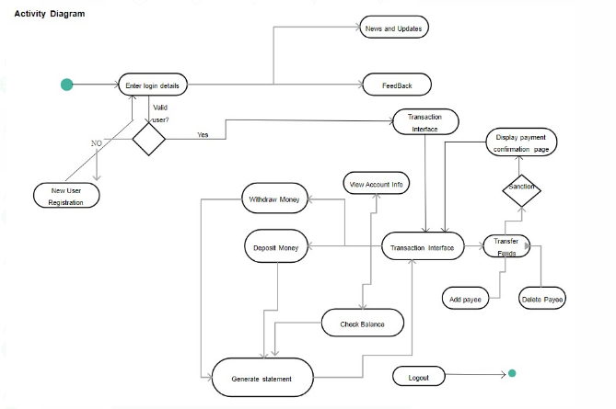

- Consider an order processing system. Requested order is input parameter of the activity after order is accepted and all required information is filled in, payment is accepted and order is shipped. Note that this business flow allows order shipment before invoice is sent or payment is confirmed. Draw the activity diagram for the system.
The following activity should be considered:
- Send order by customer
- Shipment of order
- Receipt of the order
- Confirm order
- Dispatch order
Answer:
