MCQ
1.
- Identify appropriate diagram types to handle applications that involve concurrent processing and real-time process control.
(i) | Activity diagram | (ii) | Sequence diagram
(iii) | State chart diagram | (iv) | Object diagram
- For a course, OOSE having a small number of students and one or more teachers, select the most suitable model of relationship :
(i) | Aggregation | (ii) | Association
(iii) | Composition | (iv) | Realization
- Identify the risk type which indicates problems with design, implementation, interface, verification, and maintenance.
(i) | Project risk | (ii) | Business Risk
(iii) | Technical risk | (iv) | Schedule risk

- Select a suitable diagram to show the physical relationship between software components and hardware in the delivered system.
(i) | Component diagram | (ii) | Deployment Diagram
(iii) | Class diagram | (iv) | Network diagram

- Match the features of columns A & B with the most relevant options.
A | B
- Good quality | (1) Program does not fail for a specified time in a given environment
- Correctness | - Meets the functional requirements
- Predictable | - Meets both functional and non-functional requirements
- Reliable | (4) Process is under statistical control codes

(i) | a-3, b-2, c-4, d-1 | (ii) | a-2, b-3, c-4, d-1
(iii) | a-1, b-2, c-3, d-4 | (iv) | a-4, b-1, c-2, d-3

- Summarize the spiral model addressing risks and uncertainties in software development. Define the role played in each spiral iteration.
- Examine the role of requirements engineering to ensure high-quality software which meets industry standards.
- Suppose you are testing a software application using white box testing techniques. The code for a particular module has been written in a way that all possible paths have been covered. Is it possible for any logical errors in the module? Explain briefly.
- Summarize the concept of critical path analysis, and show how it can be used to manage project schedules. Suggest an example to identify and manage potential delays in the CRM (Customer Relationship Management) software development project.
- In a scenario of a high-risk project, how would you use the Monte-Carlo simulation to evaluate the likelihood and impact of various risks?
- Exhibit how the Six Sigma methodology is used to identify and eliminate defects in a manufacturing or service process.

- Justify the use of the agile model for flexibility, collaboration, efficiency, and quality. Outline the adaptive software development (ASD) model's life cycle.
- Discuss the importance of software testing. Explain various levels of software testing.
- List the importance of software metrics in project evaluation. Summarize the various categories of software metrics.
- The size of a software project size is estimated to be 400 KLOC. Compute the effort & time for each of the 3 modes of development for given values of coefficients:
Software Product Type | a | b | c | d
Organic | 2.4 | 1.05 | 2.5 | 0.38
Semi-detached | 3.0 | 1.12 | 2.5 | 0.35
Embedded | 3.6 | 1.20 | 2.5 | 0.32

- Design a Use Case Diagram for the Airline Reservation System in the given scenario:
- The actors are Passengers, Admins, and Banks.
- The passenger is concerned with multiple use cases like login, checking for availability, and booking a ticket.
- The book ticket use case is concerning the choose seat use case.
- The admin has the right to cancel tickets and update flight schedules.
- Construct a Sequence Diagram for the UFood ordering system. The ordered sequence of events is as follows:
- Place an order.
- Pay money at the cash counter.
- Order Confirmation.
- Order preparation.
- Order serving.

Answer:1
a | (iii)
b | (i)
c | (iii)
d | (ii)
e | (i)

Answer 2:
The spiral model is a software development model that is designed to address risks and uncertainties in the software development process. In this model, the development process is divided into a series of iterations, or "spirals," each of which involves a cycle of planning, design, implementation, and testing.
Risks and uncertainties are addressed in each spiral iteration through a process of risk analysis and mitigation. At the beginning of each spiral iteration, the development team conducts a risk analysis to identify potential risks and uncertainties that may arise during the iteration. The team then develops a plan for mitigating these risks, which may involve changes to the project scope, schedule, or resources.
During the design phase of each spiral iteration, the development team focuses on addressing the highest-priority risks and uncertainties identified in the risk analysis. This may involve developing prototypes or conducting simulations to test potential solutions to these risks.
In the implementation phase of each spiral iteration, the development team implements the changes and improvements identified in the design phase, focusing on mitigating the highest-priority risks and uncertainties first. The team then conducts testing to verify that the changes have been successful in mitigating the identified risks.

Answer3:
Requirements engineering is a critical process in software development that involves eliciting, analyzing, specifying, validating, and managing the requirements for a software system. Effective requirements engineering can help ensure that the software developed is of high quality and meets industry standards by ensuring that the software system is designed and developed to meet the needs of its users and stakeholders. Here are some ways in which requirements engineering can contribute to high-quality software development:
- Eliciting and analyzing requirements: Requirements engineering begins with the process of eliciting and analyzing the requirements for the software system. This involves identifying the stakeholders who will use the software system and gathering information about their needs, preferences, and constraints
- Specifying requirements: Once the requirements have been elicited and analyzed, they must be specified in a clear, concise, and unambiguous manner. This requires developers to use a variety of techniques, such as use cases, user stories, and formal specification languages, to specify the requirements for the software system.
- Validating requirements: Requirements validation is the process of verifying that the specified requirements are correct, complete, and consistent. This involves using a variety of techniques, such as reviews, walkthroughs, and simulations, to validate the requirements for the software system. By validating the requirements, developers can ensure that the software system is designed and developed to meet the needs of its users and stakeholders.
- Managing requirements: Requirements management is the process of tracking and controlling changes to the requirements for the software system. This involves using a variety of tools, such as requirement management software, to manage the requirements for the software system. By managing the requirements, developers can ensure that the software system is designed and developed to meet the requirements of its users and stakeholders, even as these requirements change over time.

Answer 4 :
Yes, it is possible for logical errors to still exist in a module even if all possible paths have been covered in white box testing. While testing all possible paths may help identify some errors, it does not guarantee that there are no logical errors in the module.
White box testing, also known as structural testing, is a testing technique that involves examining the internal structure of the software application being tested. The goal of white box testing is to ensure that the code behaves as expected and that all possible paths have been covered. However, logical errors can still exist in the module due to the following reasons:
- Incomplete understanding of the requirements: White box testing only verifies that the code behaves as expected based on the code logic, but it does not verify that the logic is correct according to the requirements. If the requirements are incorrect or incomplete, there may be logical errors in the code even if all possible paths have been covered.
- Incorrect assumptions: The developer may have made incorrect assumptions about how the module should function or how the data should be processed. Even if all possible paths have been covered, there may still be logical errors in the code due to these incorrect assumptions.
- Data-related issues: White box testing may not identify logical errors related to data processing. For example, if the code is supposed to sort data in a certain way, but the sorting logic is incorrect, it may still pass white box testing as all paths are covered, but there may still be logical errors related to data processing.

Answer 5:
Critical path analysis is a project management technique that is used to identify the most critical activities or tasks in a project, and determine the shortest possible time to complete the project. The critical path refers to the sequence of activities or tasks that must be completed in order to finish the project on time.
To perform critical path analysis, the project manager needs to identify all the activities or tasks involved in the project, and determine the sequence in which they must be completed. For each activity, the project manager needs to estimate the time required to complete it, as well as any dependencies between activities. Once all activities have been identified and their dependencies established, the critical path can be determined by identifying the longest sequence of activities that must be completed in order to finish the project on time.
Critical path analysis can be used to manage project schedules by helping project managers to:
- Identify the most critical activities: Critical path analysis helps project managers to identify the activities that are most critical to the project’s success, and to ensure that these activities are completed on time.
- Determine the shortest possible time to complete the project: Critical path analysis helps project managers to determine the shortest possible time to complete the project, and to identify any activities that could cause delays.
- Manage resources: Critical path analysis can help project managers to allocate resources more effectively, by identifying the activities that require the most resources.
- Track progress: Critical path analysis can help project managers to track progress more effectively, by identifying the activities that have been completed and those that are still outstanding.
For example, let's say we are managing the development of a CRM software system. The project has several activities that need to be completed, including requirements gathering, design, coding, testing, and deployment. The critical path analysis shows that the requirements gathering, design, and coding activities must be completed in sequence, and that they will take a total of 20 weeks to complete. If any of these activities are delayed, it will delay the entire project. The testing and deployment activities can overlap with the design and coding activities, and will take a total of 8 weeks to complete.
To manage potential delays in the project, the project manager can use the critical path analysis to identify the most critical activities and ensure that they are given the highest priority. If any of these activities are delayed, the project manager can take steps to mitigate the delay by allocating more resources or adjusting the schedule. The project manager can also track progress more effectively by monitoring the completion of each activity and comparing it to the schedule. By using critical path analysis, the project manager can ensure that the project is completed on time and within budget.

Answer 6 :
Monte Carlo simulation is a technique used in risk analysis and management to evaluate the likelihood and impact of various risks in a project. It involves running a large number of simulations using probability distributions to model the uncertain variables in a project, such as the duration of tasks or the cost of resources. The output of these simulations provides a range of possible outcomes, along with their probabilities of occurrence.
When faced with a high-risk project, Monte Carlo simulation can be used to evaluate the likelihood and impact of various risks in the following steps:
- Identify the risks: The first step is to identify the risks that are relevant to the project. This can be done by consulting with stakeholders, reviewing project documentation, and using historical data from similar projects.
- Define probability distributions: For each risk identified, probability distributions need to be defined to represent the range of possible outcomes. This can be done using historical data, expert opinions, or other sources.
- Run the simulations: Once the probability distributions are defined, Monte Carlo simulation can be used to run a large number of simulations. Each simulation generates a possible outcome based on the probability distributions defined for each risk.
For example, let's say we are faced with a high-risk project to develop a new software application. We have identified several risks, including the possibility of delays in requirements gathering, unforeseen technical issues, and changes in customer requirements. We can use Monte Carlo simulation to evaluate the likelihood and impact of these risks.
To do this, we would define probability distributions for each risk. For example, we might use historical data to estimate the range of possible durations for requirements gathering, and use an expert opinion to define the likelihood and impact of technical issues. We could also use customer feedback to estimate the likelihood and impact of changes in requirements.
Next, we would run a large number of simulations using Monte Carlo simulation. Each simulation would generate a possible outcome based on the probability distributions defined for each risk. We could run thousands of simulations to generate a range of possible outcomes.

Answer 7:
Six Sigma is a data-driven methodology used to identify and eliminate defects in a manufacturing or service process. It is based on the concept of reducing process variation and improving process performance to minimize defects and maximize customer satisfaction. Some of the key principles of Six Sigma include:
- Focus on customer needs: The goal of Six Sigma is to improve customer satisfaction by understanding their needs and expectations, and then delivering products or services that meet or exceed those requirements.
- Use data and statistical analysis: Six Sigma uses statistical methods to analyze data and identify the root causes of defects in a process. This helps to determine the most effective solutions to eliminate the defects and improve process performance.
- Define, measure, analyze, improve, control (DMAIC): DMAIC is a structured problem-solving approach used in Six Sigma. It involves defining the problem, measuring the current performance of the process, analyzing the data to identify the root cause of the problem, improving the process to eliminate the root cause, and controlling the process to maintain the improvements.
- Use a team-based approach: Six Sigma requires the involvement of a cross-functional team to implement the methodology. This team typically includes individuals from different departments, with different skills and perspectives, to ensure that all aspects of the process are considered.
- Set performance goals: Six Sigma sets performance goals for a process based on customer needs and expectations. These goals are typically expressed in terms of the defect rate or the process capability.
Answer 8:
Adaptive Software development (ASD) is a technique for building complex software and systems. An ASD life cycle incorporates three phases: speculation, collaboration, and learning.
Speculation
During speculation, the project is initiated and adaptive cycle planning is conducted. Adaptive cycle planning uses project initiation information- the customer's mission statement, project constraints and basic requirements.
Collaboration
Motivated people work together in a way that multiplies their talent and creative output beyond their absolute numbers. This collaborative approach is a recurring theme in all agile methods. People working together must trust one another to (1) criticize without animosity; (2) assist without resentment; (3) work as hard or harder as they do; (4) have the skill set to contribute to the work at hand: and (5) communicate problems or concern in a way that leads to effective actions.
Learning
As members of an ASD team begin to develop the components that are part of an adaptive cycle, the emphasis is on learning as much as it is on progress toward a completed cycle. The learning will help them to improve their level of real understanding. ASD teams learn in three ways:
1. Focus Groups. The customer and/or end-users provide feedback on software increments that are being delivered. This provides a direct indication of whether or not the product is satisfying business needs. 2. Formal technical Reviews. ASD team members review the software components that are developed, improving quality and learning as they proceed. 3. Postmortems. The ASD team becomes introspective, addressing its own performance and process.

Answer 9:
In software testing, we have four different levels of testing, which are as discussed below:
- Unit Testing
- Integration Testing
- System Testing
- Acceptance Testing

Level1: Unit Testing
Unit testing is the first level of software testing, which is used to test if software modules are satisfying the given requirement or not.
The first level of testing involves analyzing each unit or an individual component of the software application.
Unit testing is also the first level of functional testing. The primary purpose of executing unit testing is to validate unit components with their performance.
A unit component is an individual function or regulation of the application, or we can say that it is the smallest testable part of the software. The reason of performing the unit testing is to test the correctness of inaccessible code.
Unit testing will help the test engineer and developers in order to understand the base of code that makes them able to change defect causing code quickly. The developers implement the unit.
Level2: Integration Testing
The second level of software testing is the integration testing. The integration testing process comes after unit testing.
It is mainly used to test the data flow from one module or component to other modules.
In integration testing, the test engineer tests the units or separate components or modules of the software in a group.
The primary purpose of executing the integration testing is to identify the defects at the interaction between integrated components or units.
When each component or module works separately, we need to check the data flow between the dependent modules, and this process is known as integration testing.
We only go for the integration testing when the functional testing has been completed successfully on each application module.
In simple words, we can say that integration testing aims to evaluate the accuracy of communication among all the modules.
Level3: System Testing
The third level of software testing is system testing, which is used to test the software's functional and non-functional requirements.
It is end-to-end testing where the testing environment is parallel to the production environment. In the third level of software testing, we will test the application as a whole system.
To check the end-to-end flow of an application or the software as a user is known as System testing.

In system testing, we will go through all the necessary modules of an application and test if the end features or the end business works fine, and test the product as a complete system.
In simple words, we can say that System testing is a sequence of different types of tests to implement and examine the entire working of an integrated software computer system against requirements.
Level4: Acceptance Testing
The last and fourth level of software testing is acceptance testing, which is used to evaluate whether a specification or the requirements are met as per its delivery.
The software has passed through three testing levels (Unit Testing, Integration Testing, System Testing). Some minor errors can still be identified when the end-user uses the system in the actual scenario.
In simple words, we can say that Acceptance testing is the squeezing of all the testing processes that are previously done.

Answer 10 : Software metrics is a standard of measure that contains many activities which involve some degree of measurement. It can be classified into three categories: product metrics, process metrics, and project metrics.
Product metrics describe the characteristics of the product such as size, complexity, design features, performance, and quality level.
Process metrics can be used to improve software development and maintenance. Examples include the effectiveness of defect removal during development, the pattern of testing defect arrival, and the response time of the fix process.
Project metrics describe the project characteristics and execution. Examples include the number of software developers, the staffing pattern over the life cycle of the software, cost, schedule, and productivity.

Answer 11:
As we know that 3 modes of development are
- Organic
- Semi-detached
- Embedded
Also we know that
Effort = a (KLOC)b person month
Time = c (Effort)d Months
Here, we are given KLOC = 400

Organic
Effort = a (KLOC)b person month
= 2.4 (400)1.05 person month
= 1295 person month
Time = c (Effort) d Months
= 2.5 (1295) 0.38 Months
= 38 Months
Semi-detached
Effort = a (KLOC)b person month
= 3 (400)1.12 person month
= 2462 person month
Time = c (Effort) d Months
= 2.5 (2462) 0.35 Months
= 38.4 Months
Embedded
Effort = a (KLOC)b person month
= 3.6 (400)1.2 person month
= 4772 person month
Time = c (Effort) d Months
= 2.5 (4772) 0.32 Months
= 38 Months

Answer 12:
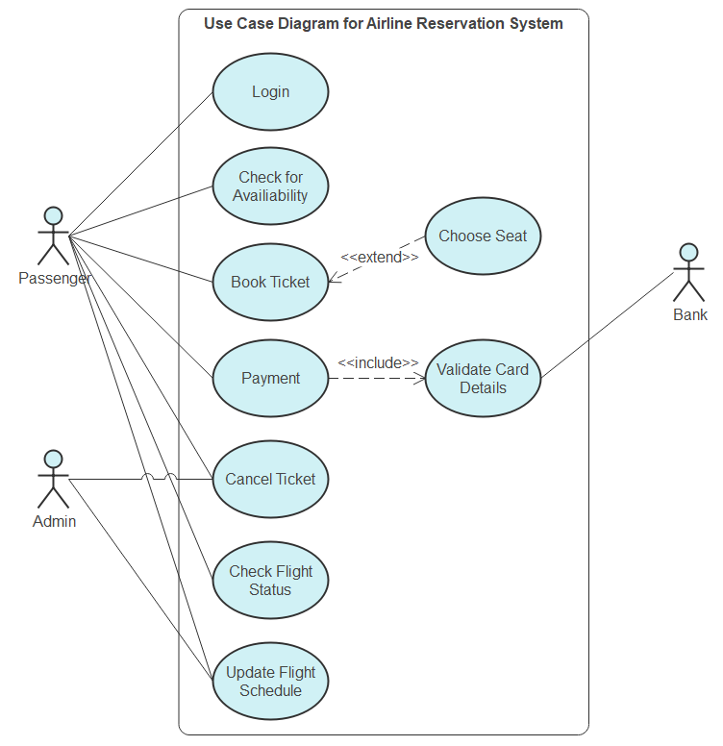

Answer 13:

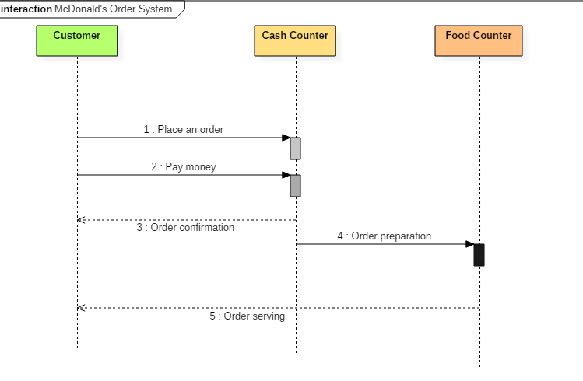

MCQ
1.
- A relation is given as: “a department has labs”; identify the most appropriate model of the relationship between the department and labs.
(i) | Aggregation | (ii) | Association
(iii) | Composition | (iv) | Realization
- Business turnover and communication gaps with the customers are risks that are inferred from past experiences are called :
(i) | Business risk | (ii) | Predictable risks
(iii) | Project risks | (iv) | Technical risks
- In the COCOMO model Programmer months are given by E=3.6*(KLOC) ^{1.2} for embedded projects. Calculate the PM required for 1000 KLOC.
(i) | 3.6 PM | (ii) | 0.36 PM
(iii) | 0.0036 PM | (iv) | 7.23 PM
- Estimate the current failure intensity for a program that had 200 failures earlier; now this program improved and now experienced only 100 failures. The initial failure intensity was 20 failures/CPU hr.
(i) | 5 failures/CPU hr. | (ii) | 10 failures/CPU hr.
(iii) | 20 failures/CPU hr. | (iv) | 40 failures/CPU hr.
- Match the phases of requirement engineering with the correct pair given in the table:
- Requirement Elicitation | - Module development and integration
- Design | - Analysis
- Implementation | - Structure and behavioral
- Maintenance | - Performance tuning

(i) | a-2, b-3, c-1, d-4 | (ii) | a-2, b-3, c-4, d-1
(iii) | a-1, b-2, c-3, d-4 | (iv) | a-4, b-1, c-2, d-3

- Examine how the spiral model integrates the waterfall and iterative model in the Software Development Life Cycle process.
- Demonstrate how the Requirements Engineering be used to ensure that the software developed meets the needs of both the client and end-users.
- Discuss the limitations of white box testing, and describe two scenarios where black box testing would be more appropriate than white box testing for testing the e-commerce website.
- Review the challenges you might face when managing the project schedule for the CRM (Customer Relationship Management) software project development. Suggest strategies you might use to overcome these challenges.
- Identify the key factors that determine the success or failure of a risk management program, and how can these factors be measured and evaluated?
- Validate the quality management principles, such as continuous improvement and customer focus, to improve the organization's culture and values. How do these principles help a project manager in maintaining product quality?
- Determine the situations where the extreme programming approach of the agile model is suitable to use for a software project. Explain the various phases of its life cycle.
- The software can be tested using black-box and white-box testing. Identify the key differences between these two approaches to software testing.
- Explain the role of project metrics in software engineering. Discuss the various ways of project measurement. How does defect removal efficiency helps in improving the quality of software?
- A company needs to develop digital signal processing software for one of its newest inventions. The software is expected to have 20000 lines of code. The company needs to determine the effort in person months required to develop this software using the basic COCOMO model. This model's multiplicative factor is 2.2 for the software development on embedded systems, while the exponentiation factor is 1.50. What is the estimated effort in person months?
- Construct a Use Case Diagram for an online shopping system. Consider the given scenario:
- It has use cases like viewing items, making a purchase, checkout, and client registration.
- It has multiple actors like the registered user, web customer, and new customer.
- Actors are related to each other. The use cases are also in a relationship.
- The actors PayPal and credit payment services are the organizations interacting with the subsystem with different use cases.
- Develop a Collaboration Diagram for a student information management system with the following features:
- A student requests a login through the login system.
- An authentication mechanism of software checks the request.
- If a student entry exists in the database, then access is allowed; otherwise, an error is returned.

Answers: 1
a) | (iii)
b) | (ii)
c) | (i)
d) | (ii)
e) | (i)

Answer 2:
The spiral model of software development integrates elements of both the Waterfall model and the Iterative model in its approach to software development. The model combines the linear and sequential nature of the Waterfall model with the iterative and cyclic nature of the Iterative model.
The Spiral model is divided into several phases, including Planning, Risk Analysis, Engineering, and Evaluation. Each phase includes a set of activities that the development team performs to move the project forward.
In the Planning phase, the requirements are gathered, and the project objectives are defined. This phase is similar to the Requirements and Planning phase of the Waterfall model.
In the Risk Analysis phase, the project team identifies potential risks and develops strategies to mitigate them. This phase is similar to the Risk Assessment phase of the Iterative model.
In the Engineering phase, the project team designs, develops, and tests the software. This phase includes multiple iterations of development and testing, much like the iterations of the Iterative model.
In the Evaluation phase, the project team reviews the software's quality and makes necessary changes to ensure that it meets the customer's requirements. This phase is similar to the Testing and Deployment phase of the Waterfall model.

Answer: 3
Requirements Engineering is a process of eliciting, analyzing, documenting, validating, and managing software requirements. It is a critical process in software development that ensures the software meets the needs of both the client and end-users.
Here are some ways Requirements Engineering can be used to ensure that the software developed meets the needs of both the client and end-users:
- Elicitation of Requirements: Requirements elicitation is the process of gathering requirements from stakeholders. Requirements engineers should involve both the client and end-users in the elicitation process. This ensures that the requirements gathered are comprehensive and address the needs of both the client and end-users.
- Analysis of Requirements: Once the requirements are elicited, the next step is to analyze them to ensure they are complete, consistent, and unambiguous. Requirements engineers should analyze the requirements to ensure they meet the needs of both the client and end-users.
- Validation of Requirements: Requirements validation is the process of ensuring that the requirements meet the needs of both the client and end-users. This process involves reviewing the requirements with stakeholders to ensure that they are complete, accurate, and consistent with the stakeholder's expectations.
- Management of Requirements: Requirements management is the process of managing requirements throughout the software development lifecycle. Requirements engineers should manage the requirements to ensure that they are prioritized based on the stakeholder's needs, traceable to the software design, and documented.
By following the above practices, Requirements Engineering can help ensure that the software developed meets the needs of both the client and end-users. By involving stakeholders in the elicitation process, analyzing and validating the requirements, and managing them throughout the software development lifecycle, Requirements Engineering helps ensure that the software developed meets the stakeholders' expectations.

Answer 4
White box testing is a software testing technique that examines the internal workings of an application's code. While this method has several advantages, it also has some limitations that can affect its effectiveness. The following are some limitations of white box testing:
- Limited Scope: White box testing is only effective when the tester has access to the source code of the application. In cases where the source code is not available, such as when using third-party applications or proprietary software, white box testing is not possible.
- Time-consuming: White box testing requires a high level of technical expertise and is time-consuming, as it involves testing each line of code for errors. This can be a tedious and time-consuming process, especially for large applications.
- Bias: White box testing can be influenced by the tester's preconceptions about the code, which can lead to confirmation bias, where the tester looks for errors that confirm their assumptions rather than finding all potential errors.
Black box testing, on the other hand, is a software testing technique that focuses on the functionality of an application, without any knowledge of the internal workings of the application's code. This method is more appropriate in scenarios where the tester does not have access to the source code of the application. Here are two scenarios where black box testing would be more appropriate than white box testing for testing an e-commerce website:
- Testing the User Interface: Testing the user interface of an e-commerce website is more suited to black box testing. In this scenario, the tester focuses on the functionality of the website and how it interacts with the user, rather than the underlying code.
- Testing the Performance of the Website: Testing the performance of an e-commerce website is more suited to black box testing. In this scenario, the tester focuses on the website's response time, page load times, and other metrics that measure the website's performance, without any knowledge of the underlying code.

Answer 5:
Managing the project schedule for the CRM software development project can be a challenging task. Some of the challenges that project managers might face while managing the project schedule are:
- Changes in Requirements: Changes in requirements can impact the project schedule. If the changes are significant, then the project schedule may need to be reworked entirely. To address this challenge, project managers can involve stakeholders in the requirements gathering process and ensure that there is a process in place to manage changes effectively.
- Resource Constraints: Resource constraints, such as a lack of skilled resources or a shortage of equipment, can impact the project schedule. To address this challenge, project managers can identify critical resources and ensure that they are available when needed. They can also consider outsourcing or contracting to fill resource gaps.
To overcome these challenges, project managers can adopt several strategies, including:
- Developing a Detailed Project Plan: A detailed project plan helps to identify potential roadblocks and provides a framework for addressing issues that arise during the project's lifecycle.
- Regularly Reviewing the Project Schedule: Regularly reviewing the project schedule ensures that the project is on track and helps to identify any potential issues early on.
- Assigning Clear Roles and Responsibilities: Assigning clear roles and responsibilities ensures that team members understand what is expected of them and helps to avoid confusion and delays.
- Monitoring Progress Closely: Monitoring progress closely helps to identify issues early on and provides the opportunity to take corrective action before they become significant problems.

Answer 6:
There are several key factors that can determine the success or failure of a risk management program, including:
- Leadership and commitment: The commitment of leadership and the support they provide is critical for the success of a risk management program. If leaders are not committed to the program, it is likely to fail.
- Culture: The organizational culture plays a vital role in the success of risk management. If there is a culture of openness and transparency, it is more likely that risks will be identified and addressed in a timely manner.
- Communication: Effective communication is critical for the success of any risk management program. The communication channels should be clear and open, and the information should be communicated in a timely and accurate manner.
- Risk identification: The success of a risk management program depends on the ability to identify risks. The risks should be identified at an early stage, and a robust risk assessment process should be in place.
- Risk analysis and evaluation: Once the risks have been identified, they need to be analyzed and evaluated to determine their potential impact and likelihood.
- Risk treatment: After the risks have been analyzed and evaluated, risk treatment strategies need to be developed and implemented.
- Monitoring and review: The risk management program should be monitored and reviewed regularly to ensure that it is effective and to identify areas for improvement.

Answer 7:
Integrating quality management principles, such as continuous improvement and customer focus, into an organization's culture and values can be challenging, but it is critical for long-term success. Here are some ways to integrate these principles into an organization's culture and values:
- Establish clear goals and objectives: Clearly define quality goals and objectives and communicate them throughout the organization. Ensure that everyone understands how their role contributes to achieving these goals and how their work affects the customer experience.
- Lead by example: Leaders should model the behaviors they want to see in the organization. They should promote a culture of continuous improvement and customer focus by providing regular feedback, recognizing and rewarding good performance, and addressing issues that may be hindering progress.
- Involve employees: Involve employees in the quality management process by empowering them to identify and report quality issues, and providing opportunities for training and development to improve their skills and knowledge.
- Use data to drive decision-making: Use data to identify areas for improvement and to track progress towards quality goals. This can help to ensure that decisions are based on objective evidence rather than opinions or assumptions.
- Foster a culture of innovation: Encourage employees to think creatively and come up with new ideas to improve quality and customer satisfaction. Foster a culture where experimentation and risk-taking are encouraged, and failures are seen as learning opportunities.

Answer 8:
XP uses an object- oriented approach as its preferred development paradigm. XP encompasses a set of rules and practice that occur within the context of four framework activities: planning, design, coding, and testing.
Planning
The planning activity begins with the creation of a set of stories that describes required feature and functionality for software to be built. Each story is written by the customer and is placed on an index card. The customer assigns a value (i.e., a priority) to the story based on the overall business value of the feature or function. Members of the CXP team assess each story and assign a cost- measured in development weeks to it. If the story will require more than three development weeks, the customer is asked to split the story into smaller stories and the assignment of value and cost occurs again. It is important to note that new stories can be written at any time.
Customers and the XP team work together to decide how to group stories into the next release to be developed XP team. Once a basic commitment is made for a release, the XP team orders the stories that will be developed in one of three ways: (1) all stories will be implemented immediately (within a few weeks); (2) the stories with highest value will be moved up in the schedule and implemented first; or (3) the riskiest stories will be moved up in the scheduled and implemented first.
After the first project release has been delivered, the XP team computers project velocity, Stated simply, project velocity is the number of customer stories implemented during the first release. Project velocity can then be used to help estimate delivery dates and the schedule for subsequent releases, and determine whether an over- commitment occurs, the content of releases is modified or end- delivery dates are changed.
As development work proceeds, the customer can add stories, change the value of an existing story, split stories, or eliminate them. The XP team then reconsider all remaining releases and modifies its plans accordingly.
Design
XP design rigorously follows the KIS) Keep it simple) principle. A simple design is always preferred over a more complex representation. In addition, the design provides implementation guidance for a story as it is written- nothing less, nothing more. The design of extra functionality (because the developer assumes it will be required later) is discouraged.

XP encourages the use of CCRC cards as an effective mechanism for thinking about the software in an object- oriented context. CRC (class- responsibility collaborator) cards identify and organize the object-oriented classes that are relevant to the current software increment. The CRC cards are the only design work product produced as part of the XP process.
If a difficult design problem is encountered as part of the design of a story, XP recommends the immediate creation of an operational prototype of that portion of the design, called a spike solution. This design prototype is implemented and evaluated. The intent is to lower the risk with the implementation and to validate the original estimates for the story containing the design problem.
Coding
XP recommends that after stories are developed and preliminary design work is done, the team should not move to code, but rather develop a series of unit tests that will exercise each of the stories that is to be included in the current release. Once the unit test has been created, the developer is better able to focus on what must be implemented to pass the unit test. Once the code is complete, it can be unit tested immediately, thereby providing instantaneous feedback to thee developers.
Testing
The unit tests that are created should be implemented using a framework that enables them to be automated.
As the individual unit tests are organized into a "universal testing suite" integration and validation testing of the system can occur on daily basis. This provides the XP team with a continual indication of progress and also can raise warming flags early if things are going awry.
XP acceptance tests, also called customer tests, are specified by the customers and focus on overall system features and functionality that are visible and reviewable by the customer. Acceptance tests are derived from user stories that have been implemented as part of a software release.

Answer 9:
Differences between Black Box Testing vs White Box Testing:
Black Box Testing | White Box Testing
It is a way of software testing in which the internal structure or the program or the code is hidden and nothing is known about it. | It is a way of testing the software in which the tester has knowledge about the internal structure or the code or the program of the software.
Implementation of code is not needed for black box testing. | Code implementation is necessary for white box testing.
It is mostly done by software testers. | It is mostly done by software developers.
No knowledge of implementation is needed. | Knowledge of implementation is required.
It can be referred to as outer or external software testing. | It is the inner or the internal software testing.
It is a functional test of the software. | It is a structural test of the software.
This testing can be initiated based on the requirement specifications document. | This type of testing of software is started after a detail design document.
No knowledge of programming is required. | It is mandatory to have knowledge of programming.
It is the behavior testing of the software. | It is the logic testing of the software.
It is applicable to the higher levels of testing of software. | It is generally applicable to the lower levels of software testing.
It is also called closed testing. | It is also called as clear box testing.
It is least time consuming. | It is most time consuming.
It is not suitable or preferred for algorithm testing. | It is suitable for algorithm testing.
Can be done by trial and error ways and methods. | Data domains along with inner or internal boundaries can be better tested.
Example: Search something on google by using keywords | Example: By input to check and verify loops
Black-box test design techniques-  - Decision table testing  - All-pairs testing  - Equivalence partitioning  - Error guessing | White-box test design techniques-  - Control flow testing  - Data flow testing  - Branch testing
Types of Black Box Testing:  - Functional Testing  - Non-functional testing  - Regression Testing | Types of White Box Testing:  - Path Testing  - Loop Testing  - Condition testing
It is less exhaustive as compared to white box testing. | It is comparatively more exhaustive than black box testing.

Answer 10:
Project Metrics Used by project managers and software team to adapt project workflow and technical activities Objective is :
To minimize the development schedule by making adjustments that can avoid delays and mitigate potential problems To assess product quality on an ongoing basis and when necessary, modify technical
approach to improve quality Most important use of metrics is estimation of time, effort.
Software Measurement Categories
Direct Measures Of software process are Cost and effort Of product are:
Line of Code (LOC) , Execution Speed , Defects over specified period of time ,
Indirect Measures Of product are :
Functionality, Quality, Complexity , Efficiency , Reliability , Maintainability.
Other Abilities:
Defect Removal Efficiency
It is a measure of the filtering ability of the quality assurance and control activities as they are applied through out the process framework.
DRE = E / (E + D)
E = # of errors found before delivery
D = # of defects found after delivery
Ideal value of DRE is 1
Realistically D will be greater than 0
As E increases, DRE begins to approach 1
DRE can also be applied on each process framework activity and hence find the team's ability to assess errors before they are passed to next activity or software engineering task.
DRE = E i / (E i + E i+1 )
E i = errors in activity i
E i+1 = errors in activity i+1 that were not discovered in activity
Answer 11:
Line of code (LOC)= 20000
KLOC = 20K
Multiplicative value ‘a’ = 2.2,
Exponential value' b' =1.5
Basic COCOMO forumala for Effoort = a(KLOC)^{b}
=2.2*(20)^{1.5}
= 2.2*89.44
=196.77
Effort value is = 196.77.
Answer 12:
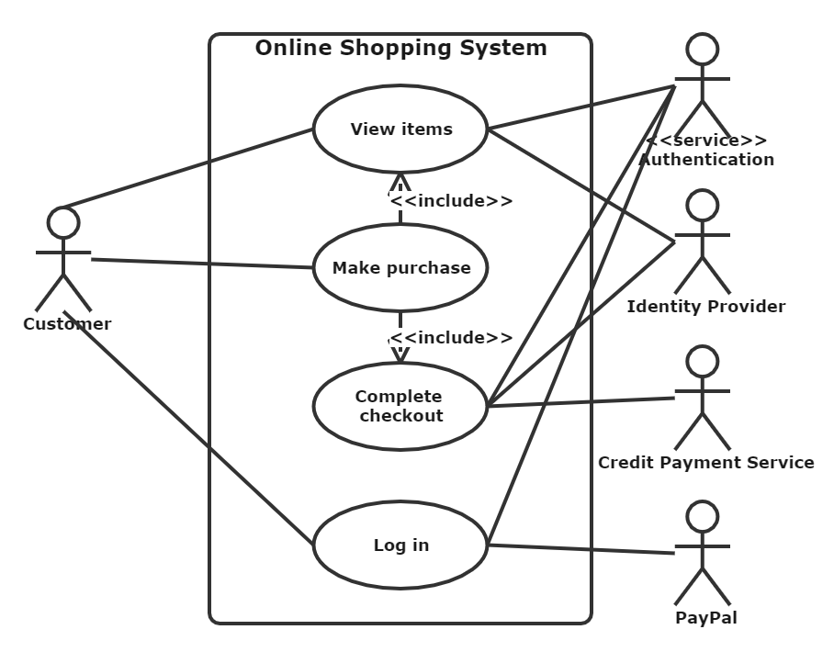

Answer 13:
