Functions

In this task, you create a Kotlin program and learn about the main() function, as well as how to pass arguments to a program from the command line.

You may remember the printHello() function that you entered into the REPL in a previous codelab:

fun printHello() {

println ("Hello World")}

printHello()

⇒ Hello World

You define functions using the fun keyword, followed by the name of the function. As with other programming languages, the parentheses () are for function arguments, if any. Curly braces {} frame the code for the function. There is no return type for this function, because it doesn't return anything.

## Step 1: Create a Kotlin file

1. Open IntelliJ IDEA.
2. The ****Project**** pane on the left in IntelliJ IDEA shows a list of your project files and folders. Find and right-click the ****src**** folder under ****Hello Kotlin.****(You should already have the ****Hello Kotlin**** project from the previous codelab.)
3. Select ****New > Kotlin File / Class****.
4. Keep ****Kind**** as ****File****, and name the file ****Hello****.
5. Click ****OK****.

There is now a file in the ****src**** folder called ****Hello.kt****.

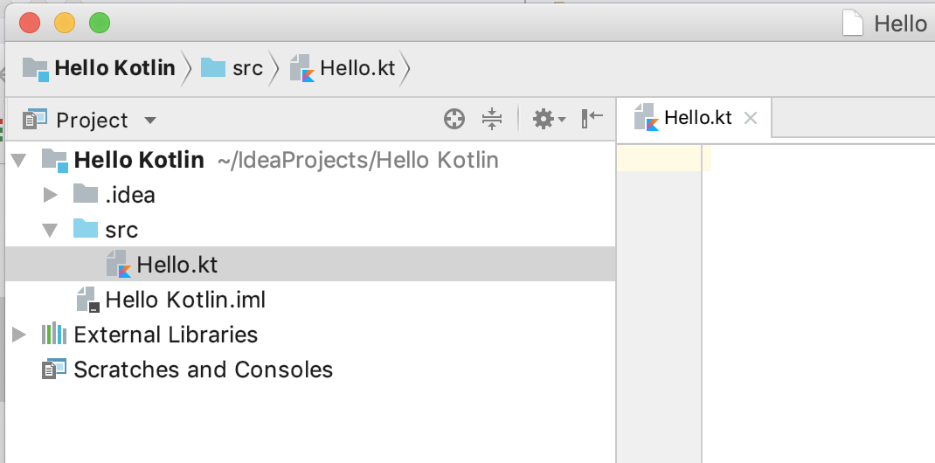

## Step 2: Add code and run your program

1. As with other languages, the Kotlin main() function specifies the entry point for execution. Any command line arguments are passed as an array of strings.  
     
   Type or paste the following code into the ****Hello.kt****file:

fun main(args: Array<String>) {

println("Hello, world!")}

****Tip:**** As of Kotlin 1.3, if your main() function doesn't use any parameters, you don't need to define args.

Like your earlier printHello() function, this function has no return statement. Every function in Kotlin returns something, even when nothing is explicitly specified. So a function like this main() function returns a type kotlin.Unit, which is Kotlin's way of saying no value.

****Note:**** When a function returns kotlin.Unit, you don't have to specify it explicitly. This is different from some other languages, where you have to explicitly say that you are returning nothing.

1. To run your program, click the green triangle to the left of the main() function. Select ****Run 'HelloKt'**** from the menu.
2. IntelliJ IDEA compiles the program and runs it. The results appear in a log pane at the bottom, as shown below.

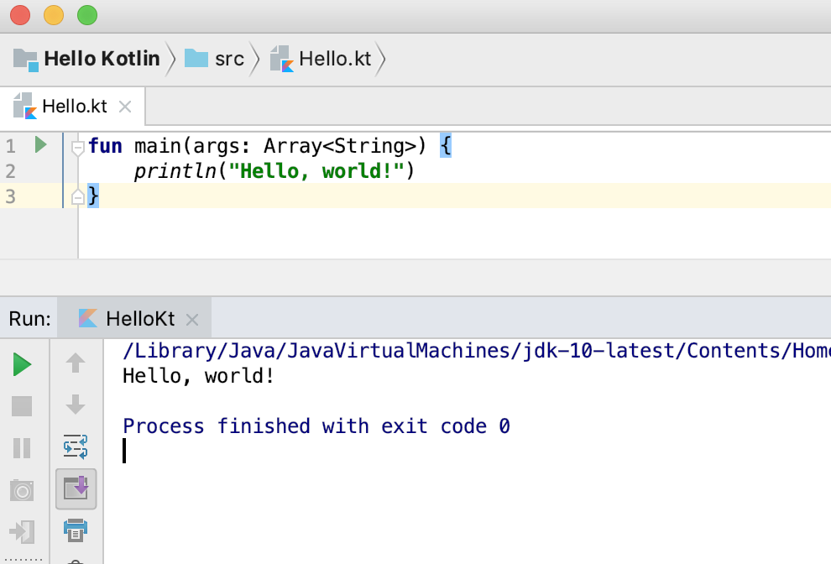

****Java programmers:**** If you're using a previously installed version of IntelliJ IDEA instead of installing a fresh copy, at this point you may have problems accessing the Kotlin compiler. Be sure your project is referring to the correct version of the JDK. See [this discussion on Stack Overflow](https://stackoverflow.com/a/44907745" \t "/tmp/wps-satvik/x/_blank) and the [Change project SDK documentation](https://www.jetbrains.com/help/idea/sdk.html" \l "change-project-sdk" \t "/tmp/wps-satvik/x/_blank) for IntelliJ IDEA.

## Step 3: Pass arguments to main()

Because you are running your program from IntelliJ IDEA and not from the command line, you need to specify any arguments to the program a little differently.

1. Select ****Run > Edit Configurations****. The ****Run/Debug Configurations**** window opens.
2. Type Kotlin! in the ****Program arguments**** field.
3. Click ****OK****.

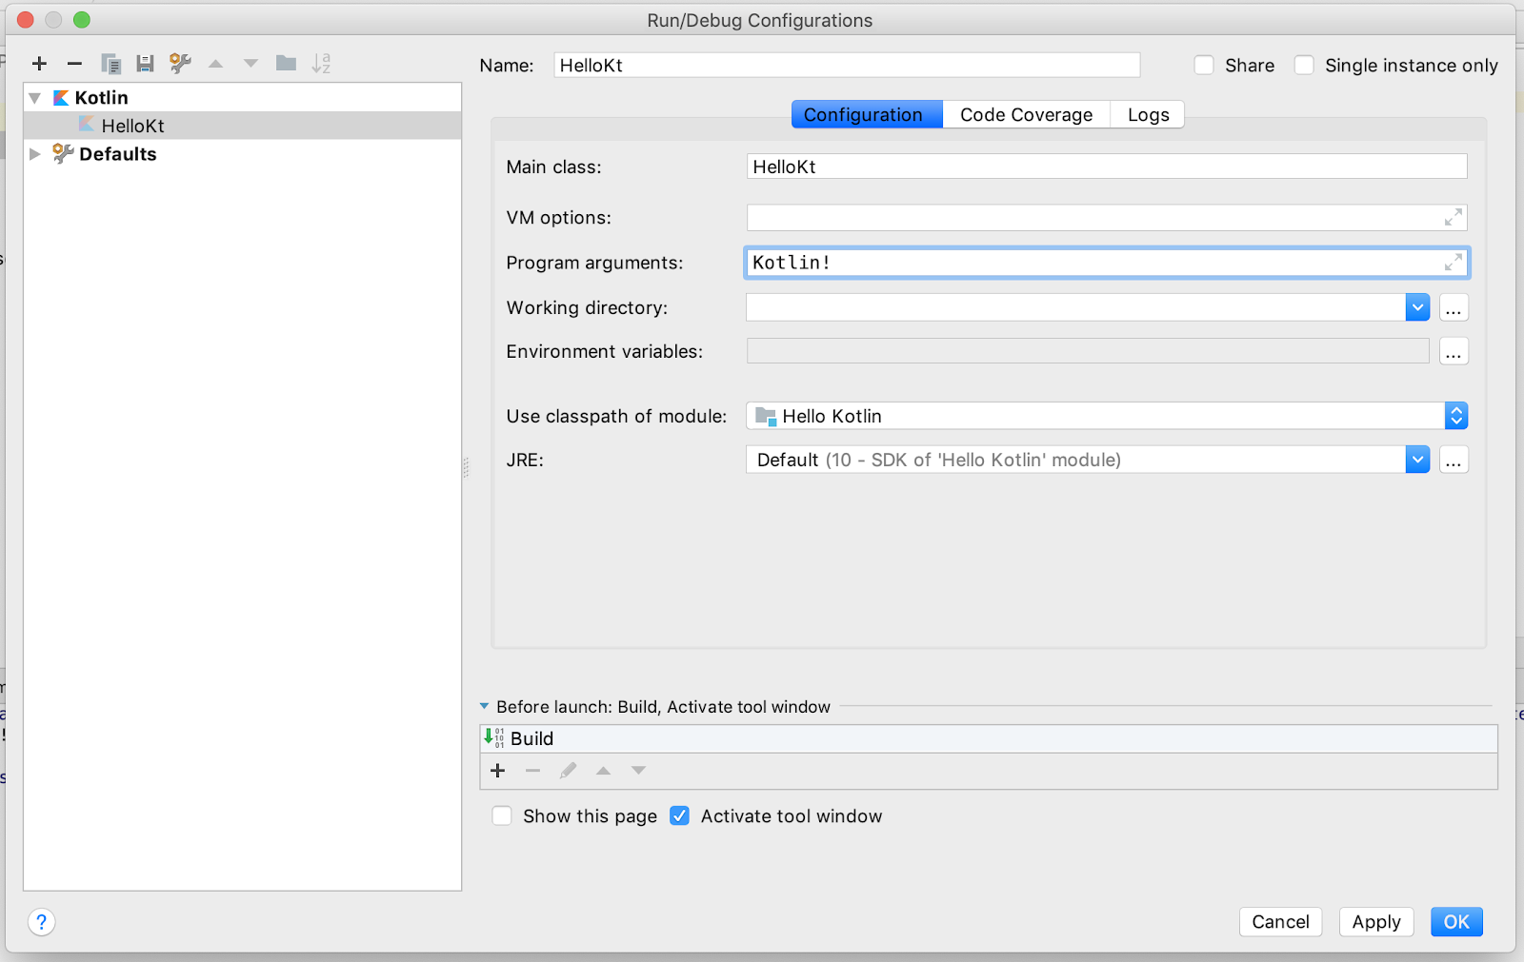

## Step 4: Change the code to use a string template

A [string template](https://kotlinlang.org/docs/reference/basic-types.html" \l "string-templates" \t "/tmp/wps-satvik/x/_blank) inserts a variable or expression into a string, and $ specifies that part of the string will be a variable or expression. Curly braces {} frame the expression, if any.

1. In ****Hello.kt****, change the greeting message to use the first argument passed into the program, args[0], instead of "world".

fun main(args: Array<String>) {

println("Hello, ${args[0]}")}

1. Run the program, and the output includes the argument you specified.

⇒ Hello, Kotlin!

In this task, you learn why almost everything in Kotlin has a value, and why that's useful.

Some other languages have statements, which are lines of code that don't have a value. In Kotlin, almost everything is an expression and has a value—even if that value is kotlin.Unit.

1. In ****Hello.kt****, write code in main() to assign a println() to a variable called isUnit and print it. (println() does not return a value, so it returns kotlin.Unit.)

*// Will assign kotlin.Unit*

val isUnit = println("This is an expression")

println(isUnit)

1. Run your program. The first println() prints the string "This is an expression". The second println() prints the value of the first println() statement, that is, kotlin.Unit.

⇒ This is an expression

kotlin.Unit

1. Declare a val called temperature and initialize it to 10.
2. Declare another val called isHot and assign the return value of an if/else statement to isHot, as shown in the following code. Because it is an expression, you can use the value of the if expression right away.

val temperature = 10

val isHot = if (temperature > 50) true else false

println(isHot)

⇒ false

1. Use the value of an expression in a string template. Add some code to check the temperature to determine whether a fish is safe or too warm, then run your program.

val temperature = 10

val message = "The water temperature is ${ if (temperature > 50) "too warm" else "OK" }."

println(message)

⇒ The water temperature is OK.

****Note:**** Loops are exceptions to "everything has a value." There's no sensible value for for loops or while loops, so they do not have values. If you try to assign a loop's value to something, the compiler gives an error.

In this task, you learn more about functions in Kotlin, and more about the very useful when conditional expression.

## Step 1: Create some functions

In this step, you put together some of what you've learned and create functions with different types. You can replace the contents of ****Hello.kt**** with this new code.

1. Write a function called feedTheFish() that calls randomDay() to get a random day of the week. Use a string template to print a food for the fish to eat that day. For now, the fish eat the same food every day.

fun feedTheFish() {

val day = randomDay()

val food = "pellets"

println ("Today is $day and the fish eat $food")}

fun main(args: Array<String>) {

feedTheFish()}

1. Write the randomDay() function to pick a random day from an array and return it.

The nextInt() function takes an integer limit, which limits the number from Random() to 0 through 6 to match the week array.

fun randomDay() : String {

val week = arrayOf ("Monday", "Tuesday", "Wednesday", "Thursday",

"Friday", "Saturday", "Sunday")

return week[Random().nextInt(week.size)]}

1. The Random() and nextInt() functions are defined in java.util.\*. At the top of the file, add the needed import:

import java.util.\* *// required import*

****Tip:**** Before you add the import, Random() gives an unresolved reference error in IntelliJ IDEA. To add the import automatically, click on Random(), then press Alt+Enter (Option+Enteron a Mac). Select ****Import > java.util.Random****.

1. Run your program, and check the output.

⇒ Today is Tuesday and the fish eat pellets

## Step 2: Use a when expression

Extending this further, change the code to pick different food for different days using a when expression. The when statement is similar to switch in other programming languages, but when automatically breaks at the end of each branch. It also makes sure your code covers all the branches if you are checking an enum.

1. In ****Hello.kt****, add a function called fishFood() that takes a day as a String and returns the fish's food for the day as a String. Use when(), so that each day the fish gets a specific food. Run your program a few times to see different outputs.

fun fishFood (day : String) : String {

var food = ""

when (day) {

"Monday" -> food = "flakes"

"Tuesday" -> food = "pellets"

"Wednesday" -> food = "redworms"

"Thursday" -> food = "granules"

"Friday" -> food = "mosquitoes"

"Saturday" -> food = "lettuce"

"Sunday" -> food = "plankton"

}

return food}

fun feedTheFish() {

val day = randomDay()

val food = fishFood(day)

println ("Today is $day and the fish eat $food")}

⇒ Today is Thursday and the fish eat granules

1. Add a default branch to the when expression using else. For testing, to make sure the default is taken sometimes in your program, remove the Tuesday and Saturday branches.  
     
   Having a default branch ensures that food gets a value before being returned, so it doesn't need to be initialized anymore. Because the code now assigns a string to food only once, you can declare food with val instead of var.

fun fishFood (day : String) : String {

val food : String

when (day) {

"Monday" -> food = "flakes"

"Wednesday" -> food = "redworms"

"Thursday" -> food = "granules"

"Friday" -> food = "mosquitoes"

"Sunday" -> food = "plankton"

else -> food = "nothing"

}

return food}

1. Because every expression has a value, you can make this code a little more concise. Return the value of the when expression directly, and eliminate the food variable. The value of the when expression is the value of the last expression of the branch that satisfied the condition.

fun fishFood (day : String) : String {

return when (day) {

"Monday" -> "flakes"

"Wednesday" -> "redworms"

"Thursday" -> "granules"

"Friday" -> "mosquitoes"

"Sunday" -> "plankton"

else -> "nothing"

}}

The final version of your program looks something like the code below.

import java.util.\* *// required import*

fun randomDay() : String {

val week = arrayOf ("Monday", "Tuesday", "Wednesday", "Thursday",

"Friday", "Saturday", "Sunday")

return week[Random().nextInt(week.size)]}

fun fishFood (day : String) : String {

return when (day) {

"Monday" -> "flakes"

"Wednesday" -> "redworms"

"Thursday" -> "granules"

"Friday" -> "mosquitoes"

"Sunday" -> "plankton"

else -> "nothing"

}}

fun feedTheFish() {

val day = randomDay()

val food = fishFood(day)

println ("Today is $day and the fish eat $food")}

fun main(args: Array<String>) {

feedTheFish()}

In this task, you learn about default values for functions and methods. You also learn about compact functions, which can make your code more concise and readable, and can reduce the number of code paths for testing. Compact functions are also called single-expression functions.

## Step 1: Create a default value for a parameter

In Kotlin, you can pass arguments by parameter name. You can also specify default values for parameters: if an argument isn't supplied by the caller, the default value is used. Later, when you write methods (member functions), it means you can avoid writing lots of overload versions of the same method.

1. In ****Hello.kt****, write a swim() function with a String parameter named speed that prints the fish's speed. The speed parameter has a default value of "fast".

fun swim(speed: String = "fast") {

println("swimming $speed")}

1. From the main() function, call the swim() function three ways. First call the function using the default. Then call the function and pass the speed parameter without a name, then call the function by naming the speed parameter.

swim() *// uses default speed*

swim("slow") *// positional argument*

swim(speed="turtle-like") *// named parameter*

⇒ swimming fast

swimming slow

swimming turtle-like

****Note:**** Arguments don't have to use the parameter names; you can just pass the arguments in the defined order. But with default values, this can get a little confusing, so it is best practice to put parameters without defaults first, and the ones with defaults after.

## Step 2: Add required parameters

If no default is specified for a parameter, the corresponding argument must always be passed.

1. In ****Hello.kt****, write a shouldChangeWater() function that takes three parameters: day, temperature, and a dirty level. The function returns true if the water should be changed, which happens if it's Sunday, if the temperature is too high, or if the water is too dirty. The day of the week is required, but the default temperature is 22, and the default dirty level is 20.  
     
   Use a when expression without an argument, which in Kotlin acts as a series of if/else if checks.

fun shouldChangeWater (day: String, temperature: Int = 22, dirty: Int = 20): Boolean {

return when {

temperature > 30 -> true

dirty > 30 -> true

day == "Sunday" -> true

else -> false

}}

1. Call shouldChangeWater() from feedTheFish() and supply the day. The day parameter doesn't have a default, so you must specify an argument. The other two parameters of shouldChangeWater() have default values, so you don't have to pass arguments for them.

fun feedTheFish() {

val day = randomDay()

val food = fishFood(day)

println ("Today is $day and the fish eat $food")

println("Change water: ${shouldChangeWater(day)}")}

=> Today is Thursday and the fish eat granules

Change water: false

## Step 3: Make compact functions

The when expression that you wrote in the previous step packs a lot of logic into a small amount of code. If you wanted to unpack it a little, or if the conditions to check were more complicated, you could use some well-named local variables. But the Kotlin way to do it is with compact functions.

Compact functions, or [single-expression functions](https://kotlinlang.org/docs/reference/idioms.html" \l "single-expression-functions" \t "/tmp/wps-satvik/x/_blank), are a common pattern in Kotlin. When a function returns the results of a single expression, you can specify the body of the function after an = symbol, omit the curly braces {}, and omit the return.

1. in ****Hello.kt****, add compact functions to test the conditions.

fun isTooHot(temperature: Int) = temperature > 30

fun isDirty(dirty: Int) = dirty > 30

fun isSunday(day: String) = day == "Sunday"

1. Change shouldChangeWater() to call the new functions.

fun shouldChangeWater (day: String, temperature: Int = 22, dirty: Int = 20): Boolean {

return when {

isTooHot(temperature) -> true

isDirty(dirty) -> true

isSunday(day) -> true

else -> false

}}

1. Run your program. The output from the println() with shouldChangeWater() should be the same as it was before you switched to using compact functions.

## Default values

The default value for a parameter doesn't have to be a value. It can be another function, as shown in the following partial sample:

fun shouldChangeWater (day: String, temperature: Int = 22, dirty: Int = getDirtySensorReading()): Boolean {

...

****Note:**** A function used as a default value is evaluated at runtime, so do not put an expensive operation like a file read or a large memory allocation in the function. The operation is executed every time your function is called, which may slow down your program.

In this task, you learn a bit about filters in Kotlin. Filters are a handy way to get part of a list based on some condition.

## Step 1: Create a filter

1. In ****Hello.kt****, define a list of aquarium decorations at the top level with listOf(). You can replace the contents of ****Hello.kt****.

val decorations = listOf ("rock", "pagoda", "plastic plant", "alligator", "flowerpot")

1. Create a new main() function with a line to print only the decorations that start with the letter 'p'. The code for the filter condition is in curly braces {}, and it refers to each item as the filter loops through. If the expression returns true, the item is included.

fun main() {

println( decorations.filter {it[0] == 'p'})}

1. Run your program, and you see the following output in the ****Run**** window:

⇒ [pagoda, plastic plant]

## Step 2: Compare eager and lazy filters

If you're familiar with filters in other languages, you may wonder whether filters in Kotlin are eager or lazy. Is the result list created immediately, or when the list is accessed? In Kotlin, it happens whichever way you need it to. By default, filter is eager, and each time you use the filter, a list is created.

To make the filter lazy, you can use a [Sequence](https://kotlinlang.org/api/latest/jvm/stdlib/kotlin.sequences/index.html" \t "/tmp/wps-satvik/x/_blank), which is a collection that can only look at one item at a time, starting at the beginning, and going to the end. Conveniently, this is exactly the API that a lazy filter needs.

1. In ****Hello.kt****, change your code to assign the filtered list to a variable called eager, then print it.

fun main() {

val decorations = listOf ("rock", "pagoda", "plastic plant", "alligator", "flowerpot")

*// eager, creates a new list*

val eager = decorations.filter { it [0] == 'p' }

println("eager: $eager")

1. Below that code, evaluate the filter using a Sequence with asSequence(). Assign the sequence to a variable called filtered, and print it.

*// lazy, will wait until asked to evaluate*

val filtered = decorations.asSequence().filter { it[0] == 'p' }

println("filtered: $filtered")

When you return the filter results as a Sequence, the filtered variable won't hold a new list—it'll hold a Sequence of the list elements and knowledge of the filter to apply to those elements. Whenever you access elements of the Sequence, the filter is applied, and the result is returned to you.

1. Force evaluation of the sequence by converting it to a List with toList(). Print the result.

*// force evaluation of the lazy list*

val newList = filtered.toList()

println("new list: $newList")

1. Run your program and observe the output.

⇒ eager: [pagoda, plastic plant]

filtered: kotlin.sequences.FilteringSequence@386cc1c4

new list: [pagoda, plastic plant]

To visualize what's going on with the Sequence and lazy evaluation, use the map() function. The map() function performs a simple transformation on each element in the sequence.

1. With the same decorations list as above, make a transformation with map() that does nothing, and simply returns the element that was passed. Add a println() to show each time an element is accessed, and assign the sequence to a variable called lazyMap.

val lazyMap = decorations.asSequence().map {

println("access: $it")

it

}

1. Print lazyMap, print the first element of lazyMap using first(), and print lazyMap converted to a List.

println("lazy: $lazyMap")

println("-----")

println("first: ${lazyMap.first()}")

println("-----")

println("all: ${lazyMap.toList()}")

1. Run your program, and observe the output. Printing lazyMap just prints a reference to the Sequence—the inner println() isn't called. Printing the first element accesses only the first element. Converting the Sequence to a List accesses all the elements.

⇒ lazy: kotlin.sequences.TransformingSequence@5ba23b66

-----

access: rock

first: rock

-----

access: rock

access: pagoda

access: plastic plant

access: alligator

access: flowerpot

all: [rock, pagoda, plastic plant, alligator, flowerpot]

1. Create a new Sequence using the original filter before applying map. Print that result.

val lazyMap2 = decorations.asSequence().filter {it[0] == 'p'}.map {

println("access: $it")

it

}

println("-----")

println("filtered: ${lazyMap2.toList()}")

1. Run your program and observe the additional output. As with getting the first element, the inner println() is only called for the elements that are accessed.

⇒

-----

access: pagoda

access: plastic plant

filtered: [pagoda, plastic plant]

In this task, you get an introduction to [lambdas and higher-order functions](https://kotlinlang.org/docs/reference/lambdas.html" \t "/tmp/wps-satvik/x/_blank) in Kotlin.

## Lambdas

In addition to traditional named functions, Kotlin supports lambdas. A lambda is an expression that makes a function. But instead of declaring a named function, you declare a function that has no name. Part of what makes this useful is that the lambda expression can now be passed as data. In other languages, lambdas are called anonymous functions, function literals, or similar names.

## Higher-order functions

You can create a higher-order function by passing a lambda to another function. In the previous task, you created a higher-order function called filter. You passed the following lambda expression to filter as the condition to check:  
{it[0] == 'p'}

Similarly, map is a higher-order function, and the lambda you passed to it was the transformation to apply.

## Step 1: Learn about lambdas

1. Like named functions, lambdas can have parameters. For lambdas, the parameters (and their types, if needed) go on the left of what is called a function arrow ->. The code to execute goes to the right of the function arrow. Once the lambda is assigned to a variable, you can call it just like a function.  
     
   Using the REPL (****Tools > Kotlin > Kotlin REPL****), try out this code:

var dirtyLevel = 20

val waterFilter = { dirty : Int -> dirty / 2}

println(waterFilter(dirtyLevel))

⇒ 10

In this example, the lambda takes an Int named dirty, and returns dirty / 2. (Because filtering removes dirt.)

1. Kotlin's syntax for function types is closely related to its syntax for lambdas. Use this syntax to cleanly declare a variable that holds a function:

val waterFilter: (Int) -> Int = { dirty -> dirty / 2 }

Here's what the code says:

* Make a variable called waterFilter.
* waterFilter can be any function that takes an Int and returns an Int.
* Assign a lambda to waterFilter.
* The lambda returns the value of the argument dirty divided by 2.

Note that you don't have to specify the type of the lambda argument anymore. The type is calculated by type inference.

## Step 2: Create a higher-order function

So far, the examples for lambdas look mostly like functions. The real power of lambdas is using them to create higher-order functions, where the argument to one function is another function.

1. Write a higher-order function. Here's a basic example, a function that takes two arguments. The first argument is an integer. The second argument is a function that takes an integer and returns an integer. Try it out in the REPL.

fun updateDirty(dirty: Int, operation: (Int) -> Int): Int {

return operation(dirty)}

The body of the code calls the function that was passed as the second argument, and passes the first argument along to it.

1. To call this function, pass it an integer and a function.

val waterFilter: (Int) -> Int = { dirty -> dirty / 2 }

println(updateDirty(30, waterFilter))

⇒ 15

The function you pass doesn't have to be a lambda; it can be a regular named function instead. To specify the argument as a regular function, use the :: operator. This way Kotlin knows that you are passing the function reference as an argument, not trying to call the function.

1. Try passing a regular named function to updateDirty().

fun increaseDirty( start: Int ) = start + 1

println(updateDirty(15, ::increaseDirty))

⇒ 16

****Note:**** Kotlin prefers that any parameter that takes a function is the last parameter. When working with higher-order functions, Kotlin has a special syntax, called the [last parameter call syntax](https://kotlinlang.org/docs/reference/lambdas.html" \l "passing-a-lambda-to-the-last-parameter" \t "/tmp/wps-satvik/x/_blank), which lets you make the code even more concise. In this case, you can pass a lambda for the function parameter, but you don't need to put the lambda inside the parentheses.

var dirtyLevel = 19;

dirtyLevel = updateDirty(dirtyLevel) { dirtyLevel -> dirtyLevel + 23}

println(dirtyLevel)

⇒ 42

## Summary

* To create a Kotlin source file in IntelliJ IDEA, start with a Kotlin project.
* To compile and run a program in IntelliJ IDEA, click the green triangle next to the main() function. Output appears in a log window below.
* In IntelliJ IDEA, specify command line arguments to pass to the main() function in ****Run > Edit Configurations****.
* Almost everything in Kotlin has a value. You can use this fact to make your code more concise by using the value of an if or when as an expression or return value.
* Default arguments remove the need for multiple versions of a function or method. For example:  
  fun swim(speed: String = "fast") { ... }
* Compact functions, or single-expression functions, can make your code more readable. For example:  
  fun isTooHot(temperature: Int) = temperature > 30
* You've learned some basics about filters, which use lambda expressions. For example:  
  val beginsWithP = decorations.filter { it [0] == 'p' }
* A lambda expression is an expression that makes an unnamed function. Lambda expressions are defined between curly braces {}.
* In a higher-order function, you pass a function such as a lambda expression to another function as data. For example:  
  dirtyLevel = updateDirty(dirtyLevel) { dirtyLevel -> dirtyLevel + 23}

There's a lot in this lesson, especially if you're new to lambdas. A later lesson revisits lambdas and higher-order functions.