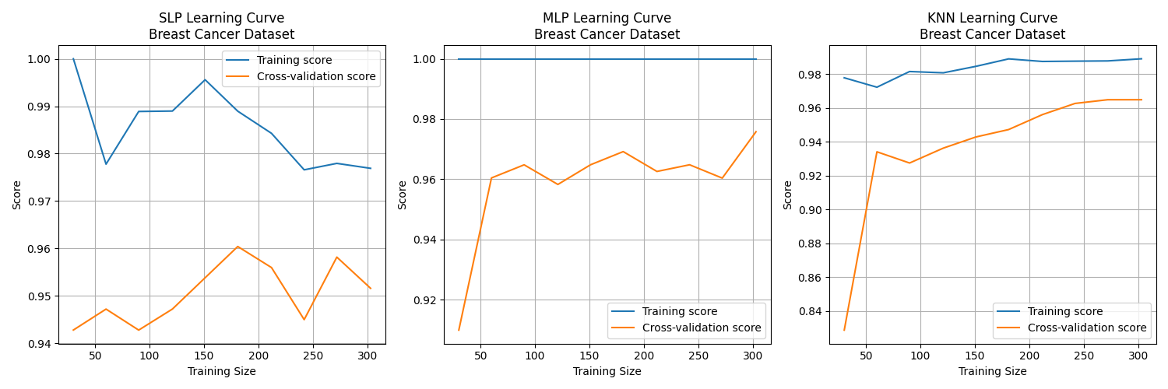

**Breast Cancer Dataset:**

* **SLP:** Mean accuracy of 95.6%, with slight class-wise variation in precision and recall.
* **MLP:** Best performance with 96.7% mean accuracy, consistent high precision and recall across classes.
* **KNN:** 96.5% mean accuracy, similar to MLP, with stable results.

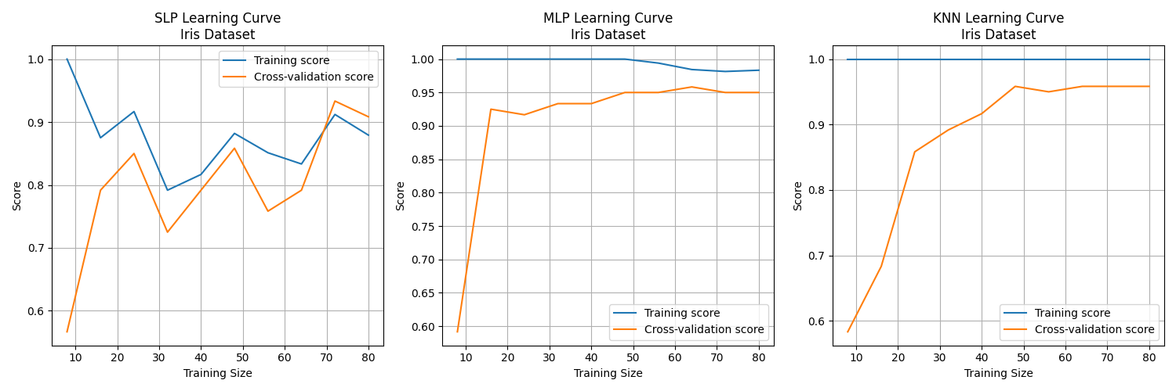

**Iris Dataset:**

* **SLP:** 90.8% accuracy, varied performance by class.
* **MLP:** Highest accuracy (95%), perfect precision and recall.
* **KNN:** Similar to MLP, 95.8% accuracy, with perfect class metrics.

**Analysis:**

* **Best Models:** MLP and KNN for both datasets, showing low variance and high accuracy.
* **Overfitting:** Mild overfitting in SLP and KNN for Breast Cancer, MLP performed consistently well across datasets.