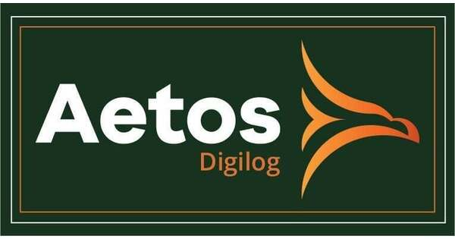

AI ENGINEER ASSESSMENT

AI-Native Inventory
Decision Platform
A practical architecture for AI-assisted ERP/WMS onboarding and explainable stockout decisions.
Prepared by  Satvik Pandey | Prepared for  Aetos Digilog

SUBMISSION LINKS
Live prototype · GitHub repository
Version 1.0 · September 2026

01 / EXECUTIVE SUMMARY

A decision platform, not an autonomous black box
The proposed platform reduces integration effort while preserving the controls required for operational inventory decisions.
The design uses AI where ambiguity and explanation matter, and deterministic services where correctness and repeatability matter. During onboarding, AI proposes mappings from customer-specific ERP/WMS structures into a versioned canonical model. The suggestions include evidence, confidence, transformations and validations; a customer data owner remains accountable for approval. At runtime, an agent converts natural-language questions into governed tool calls, while inventory services—not the language model—calculate forecasts, stockout dates, safety stock and replenishment quantities.
Core design position
AI proposes, prioritizes and explains. Deterministic business services validate, calculate and execute. Every answer carries its assumptions, source freshness and lineage.

Scope and assumptions
- Inventory decisions are calculated at SKU-location-day grain. A SKU can be healthy globally and unavailable at one location.
- WMS is authoritative for physical stock, reservations and inventory condition; ERP is authoritative for product, order and inter-location flow context. Ownership is explicit per canonical field.
- Only confirmed and usable receipts enter the base projection. Planned or low-confidence receipts are shown as scenarios, not silently counted.
- If location is omitted, the system evaluates all active locations the user is authorized to view and states that assumption in the answer.
- The public prototype uses representative data and a point forecast. The production design supports probabilistic forecasts and customer-specific calendars and policies.

Document guide
Section | Question answered | Primary outcome
02–04 | How can AI reduce onboarding time? | Governed mapping and validation workflow
05–06 | What happens for a 14-day stockout question? | Deterministic calculation with grounded explanation
07 | How would this be operated and demonstrated? | Controls, prototype and production evolution

02 / ARCHITECTURE

The platform separates data, decisions and language
This separation makes the system easier to test, audit and evolve across customers with different ERP/WMS products.
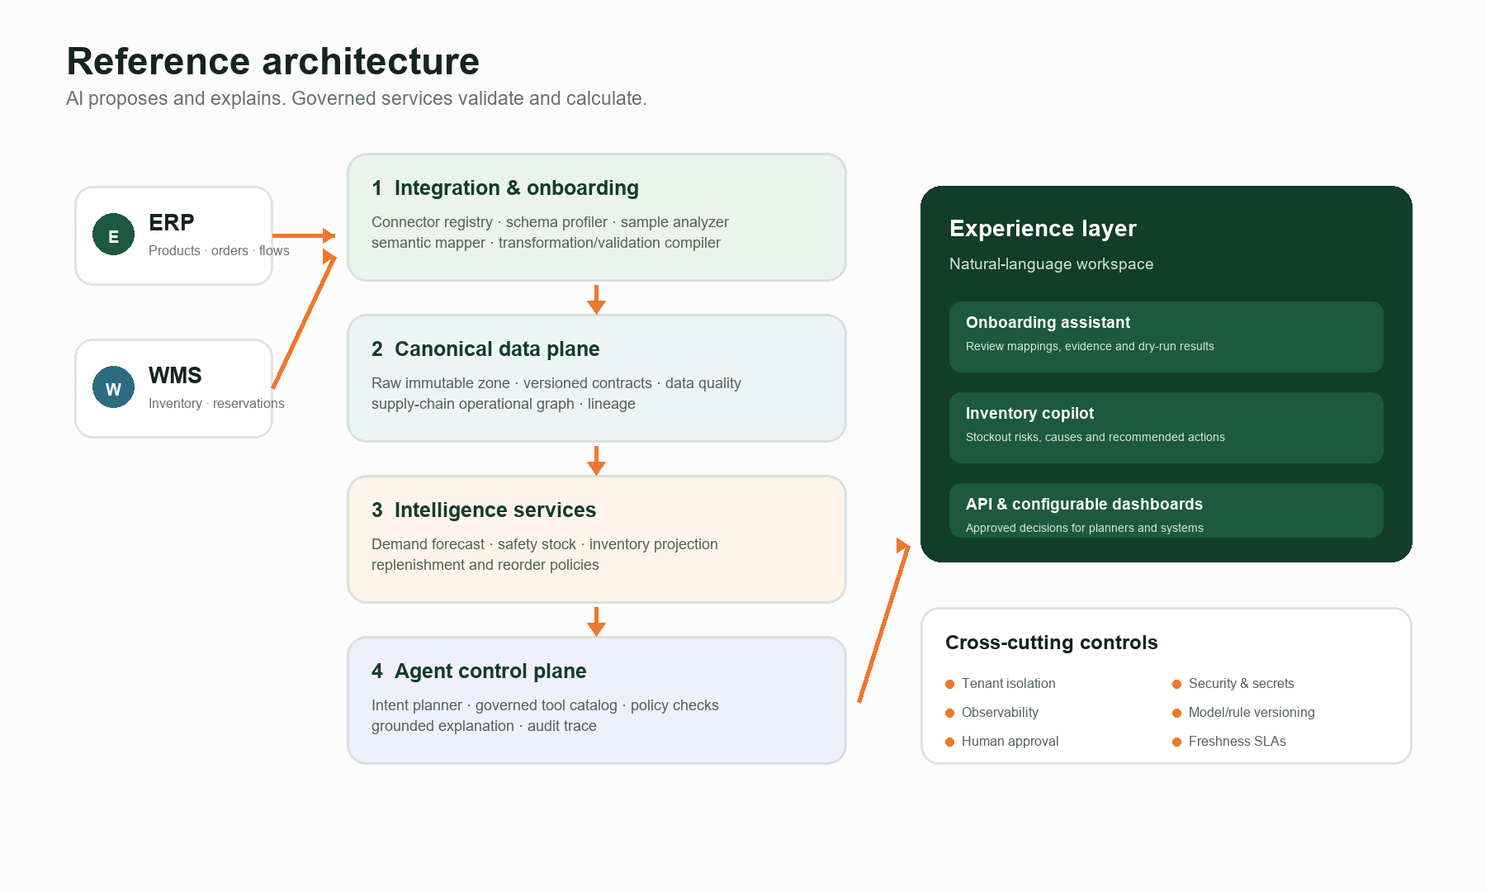
Figure 1. Reference architecture aligned to the six layers in the brief.

Pragmatic implementation choices
- The operational graph is a logical model first. It may be backed by relational tables and relationship views initially; a graph database is justified only when traversal patterns and scale demand it.
- Core nodes include Product, Location, Supplier, InventoryPosition, SupplyOrder, Transfer, Shipment, Forecast and Policy. Typed relationships capture where a product is stocked, how it flows, what supplies it and which policy governs it.
- Canonical events and entities are versioned contracts. Raw payloads remain immutable so any transformation can be reproduced.
- Forecasting, stock projection and replenishment are independently testable services exposed through a typed tool catalog.
- The agent has read-only decision tools by default. Mutating actions such as creating a purchase order require explicit policy and human approval.

03 / QUESTION 1

How AI accelerates ERP/WMS onboarding
Onboarding is treated as an evidence-driven compiler pipeline—not a one-time prompt that generates opaque integration code.
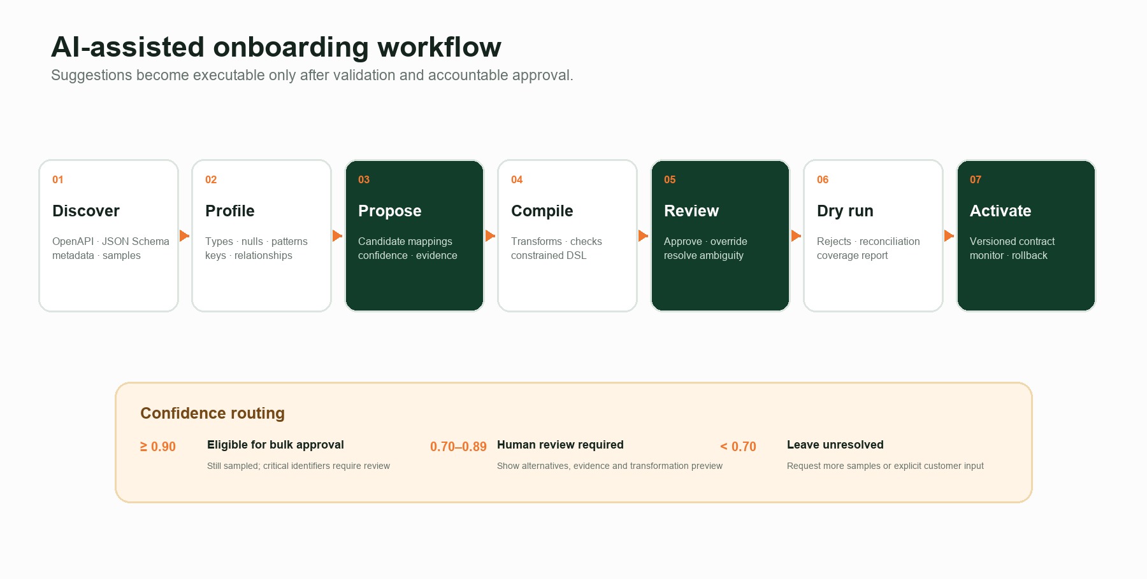
Figure 2. Proposed mapping lifecycle with explicit confidence routing.
01 | Discover source contracts  Read OpenAPI documents, JSON Schema, database metadata and representative payloads. Capture endpoints, objects, pagination, rate limits and update semantics without assuming field names are reliable.
02 | Profile structure and values  Measure types, null rates, uniqueness, ranges, timestamp formats, units and identifier patterns. Infer primary/foreign-key candidates and compare values across ERP and WMS.
03 | Retrieve canonical candidates  Use the canonical dictionary, customer terminology and previously approved mappings to retrieve a small set of plausible target fields.
04 | Reason over ambiguous matches  A constrained LLM compares field meaning, sample evidence, neighboring fields and cross-system relationships. It returns structured candidates—not prose-only guesses.
05 | Generate an executable specification  Produce a declarative mapping DSL containing source path, target path, transform chain, validations, confidence, evidence and ownership metadata.
06 | Review, dry-run and activate  A data owner resolves ambiguity, then the platform tests representative payloads, reports rejected rows and reconciles totals before versioned activation.

04 / ONBOARDING DETAIL

From a suggestion to a trusted data contract

Illustrative mapping output
Source | Canonical target | Transform | Validation | Confidence
ERP.item_code | Product.productId | trim; uppercase | required; unique per tenant | 0.98
ERP.site_code | Location.locationId | reference lookup | must resolve to active location | 0.94
ERP.expected_delivery | SupplyOrder.expectedAt | parse ISO date; UTC | not before order date | 0.89
WMS.available_qty | Inventory.availableQty | decimal; base UOM | ≥ 0; reconcile with total | 0.97
WMS.last_updated | Inventory.observedAt | timestamp; UTC | within freshness SLA | 0.96
Confidence combines semantic similarity, type compatibility, value patterns, relationship context, canonical definitions and cross-source agreement. The weights are calibrated on approved mappings; thresholds route work but do not replace ownership.

Generated rules
Structural | Required fields, types, formats, allowed values, array cardinality and schema evolution compatibility.
Referential | Every inventory record resolves to a known Product and Location; supplier and order references are valid.
Business | Quantities are non-negative, dates are feasible, units are convertible and order status supports the claimed receipt.
Reconciliation | Source counts, inventory totals and order quantities reconcile within an agreed tolerance.
Operational | Freshness, volume, null-rate and mapping-distribution drift stay within customer-specific SLAs.

Guardrails that make the AI safe to use
- Schema and payload text is treated as untrusted data. Prompt injection inside descriptions cannot grant tools or change policy.
- The model emits JSON conforming to a strict schema and an allowlisted transformation DSL; arbitrary generated code is never executed.
- Sensitive sample values are minimized or masked, encrypted in transit/at rest, tenant-scoped and excluded from model training by policy.
- Every approved contract records model/rule version, reviewer, source evidence, dry-run metrics and rollback target.
- Low-confidence fields remain unresolved. The system asks for more samples or a customer decision instead of fabricating certainty.

05 / QUESTION 2

The path from natural language to a stockout answer
The agent orchestrates a controlled plan. It never invents inventory facts or performs the stock calculation in free-form text.
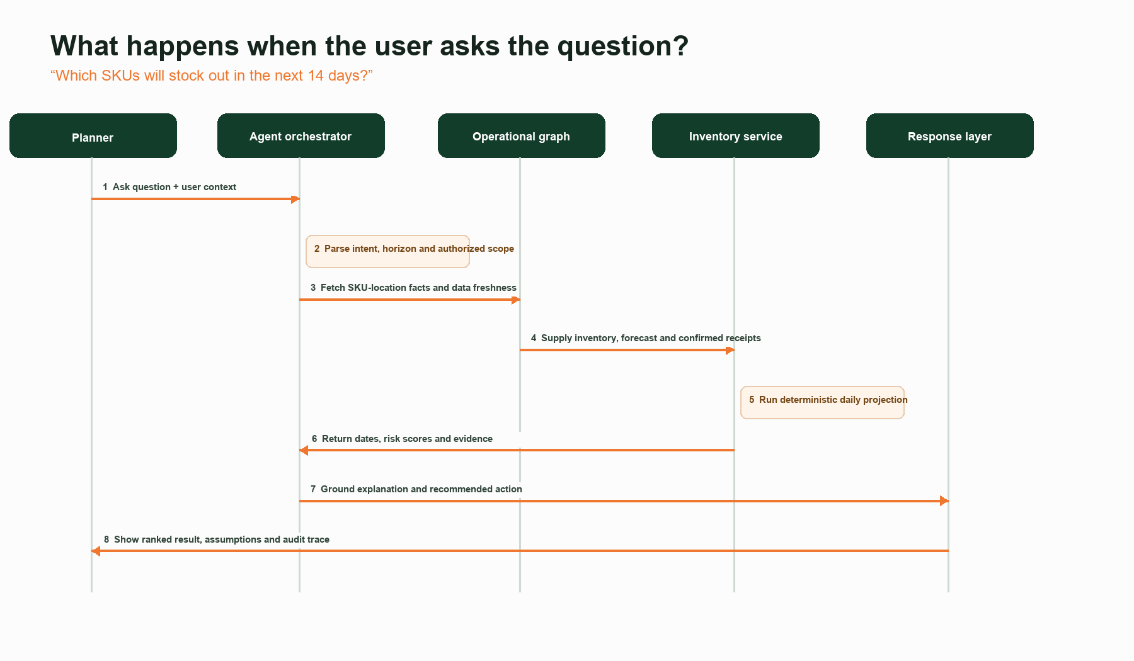
Figure 3. Runtime sequence for the question in the assignment.

Structured intent produced by the agent
{
"intent": "stockout_risk",
"horizon_days": 14,
"grain": "sku_location_day",
"locations": "authorized_active_locations",
"receipt_policy": "confirmed_only",
"forecast_scenario": "base"
}
If conversation context does not identify a location, the agent uses all authorized active locations and states that assumption. If the user asks for certainty that the data cannot support, the response expresses risk and confidence rather than presenting a probabilistic forecast as fact.

06 / DECISION LOGIC

Deterministic projection, evidence-backed explanation

Data assembled for each SKU-location
- Usable on-hand inventory, quarantine/damaged stock, reservations, allocations and backorders from WMS.
- Confirmed purchase/production orders, transfers, expected receipt dates, cancellation status and quantities from ERP/WMS.
- Daily demand forecast and uncertainty bands, recent sales signals, events and product lifecycle state from intelligence services.
- Lead-time distribution, working calendars, MOQ/order multiples, service-level target and customer inventory policy.
Daily projection
NetAvailable₀ = usable on-hand − reservations − blocked inventory
ProjectedNet₍d₎ = NetAvailable₀ + confirmed receipts through day d − forecast demand through day d − confirmed outbound transfers
StockoutDay = first day d ≤ 14 where ProjectedNet₍d₎ ≤ 0
A base answer uses the approved point forecast. For production planning, the service also evaluates forecast scenarios or quantiles and returns probability of stockout. Falling below safety stock is reported as ‘at risk’; reaching zero is reported as a projected stockout. This avoids conflating policy buffer consumption with physical unavailability.

Response contract
What the user sees | Why it matters | Example | Source
SKU + location | Correct decision grain | TS-104 · Delhi DC | Canonical graph
Stockout date/risk | Prioritizes intervention | Day 7 · Critical | Projection service
Primary cause | Makes result actionable | Demand consumes stock before receipt | Forecast + order
Recommended action | Supports planner decision | Expedite/transfer ≥ 28 units | Replenishment service
Freshness + confidence | Prevents false certainty | Inventory 8 min old | Lineage service

Failure-aware behaviour
- Stale inventory: warn and suppress automatic recommendation beyond the agreed SLA.
- Missing forecast: fall back only to an approved baseline and label it; otherwise request input.
- Conflicting ERP/WMS values: apply documented field ownership, surface the discrepancy and retain both source facts.
- Tool timeout or partial location failure: return partial results with explicit coverage, never a silent all-clear.
- Recommendation conflict with MOQ, calendar or supplier constraint: recalculate through the deterministic replenishment service.

07 / OPERATIONS & PROTOTYPE

Designed to earn trust after the demo

Production controls
Security  Tenant-scoped identities, least-privilege connectors, secret vault, encryption and complete access logs. | Quality  Contract tests, freshness/volume checks, rejects quarantine, reconciliation and ownership alerts. | Observability  Trace each answer across prompt, tool calls, data versions, rule versions, latency and cost.
Model governance  Offline mapping evaluation, confidence calibration, prompt/model versioning and drift review. | Resilience  Idempotent ingestion, retries with limits, checkpointed batches, circuit breakers and replay. | Human control  Approval gates for mappings and write actions; feedback becomes labeled evaluation data.

Public prototype
Launch the live prototype | Review the source repository
The prototype demonstrates both workflows in the browser: reviewable ERP/WMS mappings with confidence and evidence, followed by a 14-day SKU-location projection with causes, recommendations and an execution trace. It is static by design, contains no credentials and performs deterministic planning calculations locally.
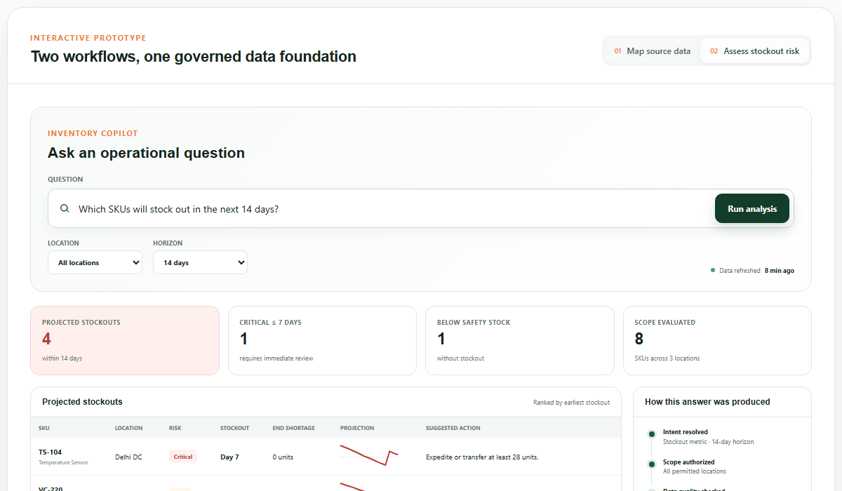
Figure 4. Inventory Copilot prototype using representative data.

08 / TRADE-OFFS

What is intentionally out of scope
The prototype proves the interaction and decision boundaries. It does not imitate production scale with unnecessary infrastructure.
01 | Live customer connectors  Replace samples with connector SDKs, secret management, incremental sync and rate-limit handling.
02 | Forecast model training  Add backtesting, hierarchy reconciliation, event features, model registry and customer-specific selection.
03 | Production graph storage  Select relational, graph or hybrid storage after measuring traversal patterns, volume and latency.
04 | Transactional execution  Add approval workflows, segregation of duties and idempotent ERP write-back before creating orders.
05 | Enterprise identity  Integrate SSO/RBAC and row-level tenant/location policies.
06 | Continuous learning  Capture mapping corrections and planner decisions as governed labels; retrain only after evaluation gates.

Suggested delivery sequence
Phase 1 · Foundation  Canonical contracts, one ERP/WMS pair, quality/lineage and stockout projection. | Phase 2 · Intelligence  Forecast and safety-stock services, scenario analysis and mapping evaluation. | Phase 3 · Action  Governed replenishment recommendations, approvals and controlled ERP write-back.
Closing perspective
The differentiator is not an LLM sitting above fragmented data. It is a governed decision system in which canonical facts, deterministic inventory services and an explainable agent reinforce one another. That combination reduces onboarding effort while keeping operational decisions reviewable and trustworthy.
Prepared by Satvik Pandey for Aetos Digilog

