**SRM Student Academic Satisfaction Survey**

**COURSE PROJECT REPORT**

# 18CSE398J -Machine Learning - Core Concepts with Applications

**(2018 Regulation)**

**III Year/ VI Semester**

**Academic Year: 2022 -2023 (EVEN)**

By

**TRAYI KASHYAP – RA2011003010162 SATVIK DWIVEDI – RA2011003010140**

Under the guidance of

**Professor V. Vijayalakshmi**

**Department of Computing Technologies**



## DEPARTMENT OF COMPUTING TECHNOLOGIES

**FACULTY OF ENGINEERING AND TECHNOLOGY**

**SRM INSTITUTE OF SCIENCE AND TECHNOLOGY**

**Kattankulathur, Kancheepuram**

**MAY 2023**

**INDEX**

|  |  |  |
| --- | --- | --- |
| **S.No.** | **Title** | **Pg.No.** |
| 1 | Abstract | 1 |
| 2 | Introduction | 2 |
| 3 | Dataset | 3 |
| 4 | Methods | 4 |
| 5 | Experiments and Result | 5 |
| 6 | Conclusion and Future Work | 6 |
| 7 | References | 7 |

**ABSTRACT**

In education system, student’s feedback is important to measure the quality of teaching. India has witnessed a rapid expansion in the higher education institutions and with this fast pace of growth day by day, competition has set in among the institutes. Before taking admission in an institution student assess the facilities and standard of the institution by referring to the website, other admission portals and by taking peer opinion and public perception. Educational institutions around the world are now requesting students’ feedback on all elements of academic life in the form of a satisfaction feedback questionnaire. The goal of this research is to describe the development and implementation of a survey to assess undergraduate and postgraduate student satisfaction.

The Student Satisfaction Survey is a useful and effective instrument that tries to focus resources on areas, where there is low satisfaction but high importance. This paper gives detailed information about the methodology, calculation and outcome of the exercise utilizing Likert scale analysis. With the recent emerging trends, this innovative method offers flexibility to integrate more parameters, group certain parameters to get feedback on a particular issue and transmute the type of questions with changing environment and structure. The analysis is done using a statistical method. The survey result directly highlights the importance and flexibility of method to evaluate overall satisfaction, satisfaction cognate to a single parameter and satisfaction for questions grouped together underlining some paramount aspects of higher education.

**INTRODUCTION**

The Indian higher education system is the third largest in the world. The higher education institutions are governed by the norms set by the affiliating University based on the guidelines provided by the University Grant Commission (UGC). National Assessment and Accreditation Council (NAAC) has been established to strengthen the education system, to ensure complete transparency, to stimulate the academic environment for promotion of quality of teaching–learning and research in higher education institutions (HEI).

Students are the most important stakeholders of any educational institution. Along with students’ progression and placements one of the main indicators of a college's progress is the students’ level of satisfaction. In India HEIs are not only imparting the required skills and improving the abilities of their graduates but are also concentrating to gratify students’ feelings about their scholastic experiences in the institution. There is emphasis on primary activities such as teaching learning, evaluation, research, extension activities, innovation along with emphasis on infrastructure facilities, quality of services, welfare measures for students and staff and overall satisfaction. of overall educational experience. To progress in the right direction complete knowledge of student diversity, socio economic status, expectations and academic preferences are very useful parameters.

The gratified individual will have greater efficiency and will contribute to further progress of the institution and nation at large. Students who are studying in a higher educational institution seek more quality education and perfection of the system, in terms of approachability of the place, good infrastructure, quality education system, services offered by the institution, additional inputs in the form of value addition and employability enhancement courses etc. As stated by Usman ([2010](https://innovation-entrepreneurship.springeropen.com/articles/10.1186/s13731-022-00196-6#ref-CR14)) the infrastructure facilities are becoming important, because these facilities satisfy student’s perception, esteem and develop them with all the essentials and capabilities to be an efficacious learner.

HEI’s all across the world are increasingly vying for students on a national and international level. They strive to improve student satisfaction to admit and retain students. This can only be accomplished if all the services that contribute to “academic life” are of sufficient quality. Students’ satisfaction can be defined as an attitude resulting from an assessment of students’ educational experience, services and facilities provided by the institution. Because students are the important internal judges of performance of the institute, student satisfaction surveys are important and help the HEI to improve and adjust accordingly in the landscape of higher education. It also provides satisfaction to the institute of offering quality education.

**DATASET**

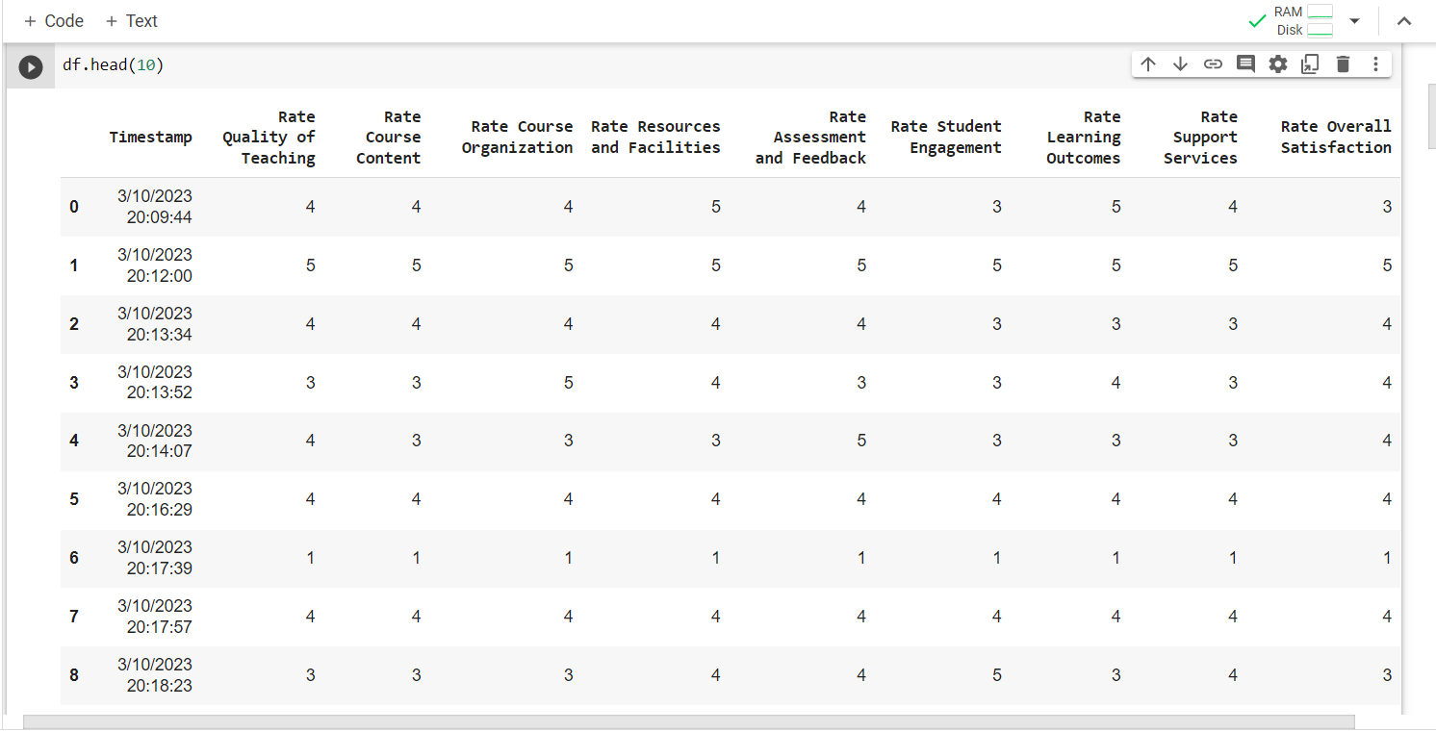

This dataset is collected through google form link. The attributes or features of this dataset are Rate Quality of Teaching, Rate Course Content, Rate Course Organization, Rate Resources and Facilities, Rate Assessment and Feedback , Rate Student Engagement , Rate Learning Outcomes , Rate Support Services and Rate Overall Satisfaction. The dataset has been checked for any missing values before further proceeding with the training of model dataset. It has also been checked and taken care for the redundant data and segregated for numerical and categorical data. In the next step the outlier has been taken care of by dropping method for outlier treatment.

Further, the we have imported sklearn library ,numpy, pandas etc. for further training the model. R2_score and regressor.score and accuracy_score has been used to calculate the performance and the accuracy of dataset by splitting the data as x_train,y_train,x_test and y_test.

**METHODS**

The model used in this model is Linear regression which is a supervised machine learning method for calculating the accuracy of the predicted value from the actual value. Linear regression algorithm shows a linear relationship between a dependent (y) and one or more independent (x) variables, hence called as linear regression.

The model describes the relationship between the dependent variable, Rate Overall Satisfaction, and the explanatory variable, Rate Quality of Teaching, Rate Course Content, Rate Course Organization, Rate Resources and Facilities, etc. The linear regression model provides a sloped straight line representing the relationship between the variables.

A linear regression model helps in predicting the value of a dependent variable, and it can also help explain how accurate the prediction is.

Mathematically, we can represent a linear regression as:

**y= a0+a1x+ ε**

Y=Dependent Variable (Target Variable)  
 X= Independent Variable (predictor Variable)  
 a0= intercept of the line (Gives an additional degree of freedom)  
 a1 = Linear regression coefficient (scale factor to each input value).  
 ε = random error

This is denoted by the R-squared and p-value values. The R-squared value indicates how much of the variation in the dependent variable can be explained by the explanatory variable and the p-value explains how reliable that explanation is. The R-squared values range between 0 and 1. A value of 0.8 means that the explanatory variable can explain 80 percent of the variation in the observed values of the dependent variable. A value of 1 means that a perfect prediction can be made, which is rare in practice. A value of 0 means the explanatory variable does not help at all in predicting the dependent variable.

**EXPERIMENTS AND RESULTS**

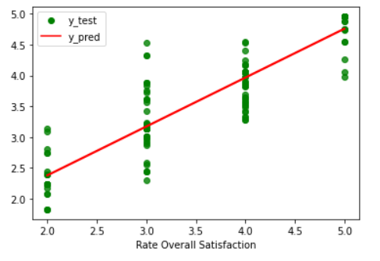

The graph given here is linear regression graph of the actual vs predicted values. The red line in the above represent the predicted value whereas the green dots represent the actual value of the given dataset. We have calculated the accuracy of this dataset to see how much accurate it is by using r2_score function and its accuracy is compared with the SVM model to know how much accurate it is with respect to other model. The accuracy value of Linear Regression model using r2_score function came as 0.80% and of SVM model it came as 0.86%.

A value of 0.8 means that the explanatory variable can explain 80 percent of the variation in the observed values of the dependent variable. A value of 1 means that a perfect prediction can be made, which is rare in practice. According to this information we get the result that the model provide almost accurate information regarding the predicted and the actual value which shows that it is a reliable model to calculate the accuracy and performance for this type of dataset.

**CONCLUSION AND FUTURE WORK**

The students’ satisfaction and the whole exercise is an innovative method to obtain students’ feedback on their academic experience, perceptions and expectations from the higher education institution and finally to assess their satisfaction level. It contributes in understanding student’s perception, likes and dislikes and more importantly which educational experience they think of as the most important and which facilities require improvement. The method devised to obtain feedback of students of HEI is very innovative, generic, flexible and easy to adopt by any higher education institution. The questions can be changed and altered based on the requirements of the institution. Various interpretations can be obtained using this technique.

One survey analysis is capable of highlighting many parameters and aspects of higher education institutions. This analysis helps us in determination of parameters which require higher levels of improvement and changes to offer students greater levels of satisfaction. It also helps us in assessing the parameters, where institutions are strong and which can become their strengths. It provides information about actions that can be taken to maintain high levels of satisfaction and improve student learning experiences in the institution. Higher satisfaction level will definitely contribute to better outcomes.

Each question in the questionnaire highlights different aspects of an underlying perception. If few questions are combined together and even Likert scale is used, a reasonably accurate measure of the satisfaction can be obtained and effectiveness of that parameter can be analyzed easily. For instance, Teacher quality in imparting curriculum and giving extra inputs and effectiveness of library services is analyzed in the observation. If this method is used on a regular basis it may provide many insights into satisfaction level of students, changes in student priority, Quality of teachers, factors that really contribute to students’ satisfaction. The study also emphasizes that there is a need to make students aware of objectives and intended learning outcomes. It can help administrators to understand the relative importance and accordingly plan improvement in facilities and resources.

The method developed is a useful tool for selecting the most efficient parameters which help in improvement of experience, which leads to satisfaction. The facilities and services of organizations can then be improved to maximize efficiency. This study presents an easy, reliable and complete quality assessment method to obtain student feedback with no additional cost for any software purchase

**REFERENCES**

1) <https://www.w3schools.com/python/python_ml_linear_regression.asp>

2) <https://towardsdatascience.com/customer-satisfaction-prediction-using-machine-learning-66240e032962>

3) <https://journals.plos.org/plosone/article?id=10.1371/journal.pone.0249423>

4) <https://www.ncbi.nlm.nih.gov/pmc/articles/PMC9259360/>

5) <https://ieeexplore.ieee.org/document/9965116>

6) <https://link.springer.com/article/10.1007/s10734-019-00389-1>

7) <https://www.frontiersin.org/articles/10.3389/fpsyg.2021.746558/full>

8) <https://www.analyticsvidhya.com/blog/2021/06/linear-regression-in-machine-learning/>

9) <https://www.geeksforgeeks.org/ml-linear-regression/>

10) <https://machinelearningmastery.com/linear-regression-for-machine-learning/>

11) <https://www.edureka.co/blog/linear-regression-for-machine-learning/>

**Github link of the project work**

**(each individual student page link)**

* [**https://github.com/trayi/ML**](https://github.com/trayi/ML)
* [**https://github.com/SatvikDwivedi**](https://github.com/SatvikDwivedi)