**Boat**

**Club**



Ph. No: 020 – 25507179 Fax: 020 – 25507299 Email: boatclub@coep.ac.in Website[: www.coepboatclub.com](http://www.coepboatclub.com/)

# 97th Regatta

*Jalmaitri Camp 25*

* **Introduction**

Jalmaitri 25, a **two-day, one-night i.e from 5th and 6th**, was organized by the **COEP Boat Club** at **Panshet Dam**. The camp aimed to provide participants with adventure, team-building activities, and an opportunity to explore the natural surroundings. A total of **180 participants**, divided into **15 groups of 12 members each**, took part in this event.The camp had events like **kayaking, fun games, a bonfire, a power plant visit, and various games like cricket, badminton, football** also **kite flying** was included ensuring an engaging experience for all participants.

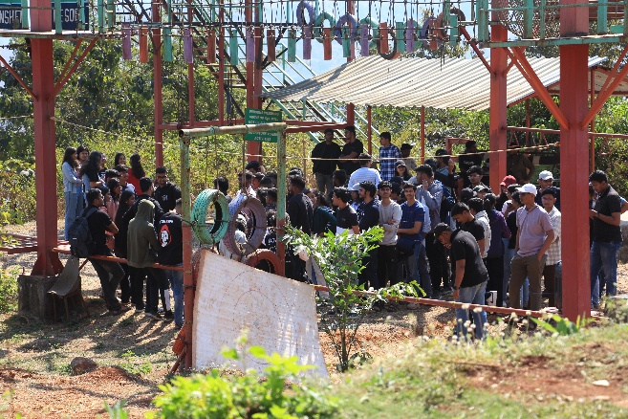

* **Day 1 (5th of February)**

On 5th morning all groups left for the location in 4 buses which were provided for transportation. The event was conducted in **batches** to ensure smooth coordination **Batch-1 having Groups 1-8 which was d**eparted at **6:30 AM and Batch 2 having Groups 9-15** which was departedat **9:00 AM**.

Upon arrival at **Panshet** all halted at **ADVENTURE MAVAL** a wonderful resort in panshet having beautiful lake- view, had a delicious breakfast. Rooms were allotted and all participants were divided into smaller groups for **kayaking sessions**. Every group were assigned with coordinators. The kayaking schedule was well-structured, with Batch 1 groups starting from 9:00 AM and concluding by 1:00 PM, ensuring a smooth transition between activities. Similarly, Batch 2 groups had their kayaking slots from 12:30 PM to 4:00 PM, allowing all participants to engage in this exciting experience without delays. Lunch was scheduled from 12:00 to 2:00 PM. Post-lunch the other groups were taking to the site of kayaking session where each session lasted for **30 minutes**, with **six participants kayaking at a time for 15 minutes** in the K4 kayaks of Boat Club.

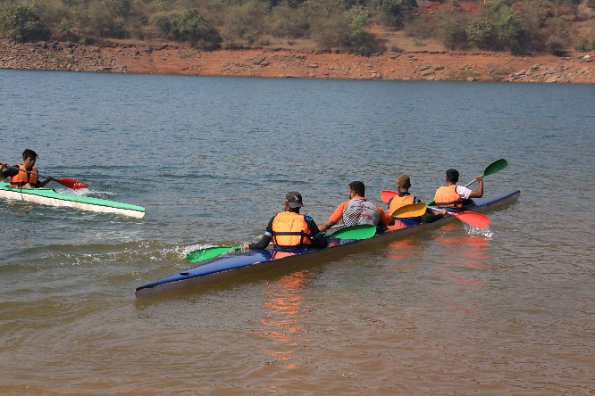

The **KB team** and **committee members** worked hard and made the event more adventurous and encouraged participants. The structured schedule allowed everyone to experience this thrilling water sport under expert supervision provided with speed boats.

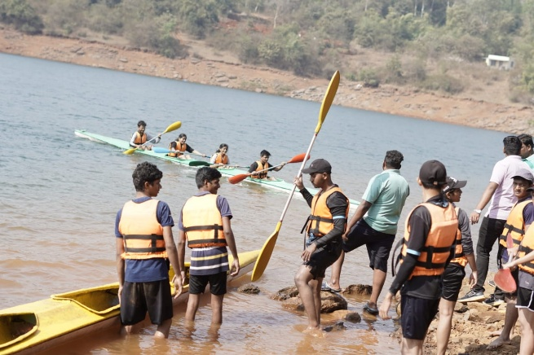

**Other teams were enjoying various sports activities like flying Kites in the open sky to playing different spots like cricket , badminton and football, also Musical chair and Indoor rowing were part of activities.** The sessions ran from **2:30 PM to 8:00 PM**, with groups rotating every **45 minutes**, allowing each group to participate in all games. The games not only encouraged friendly competition but also strengthened bonds among the participants. 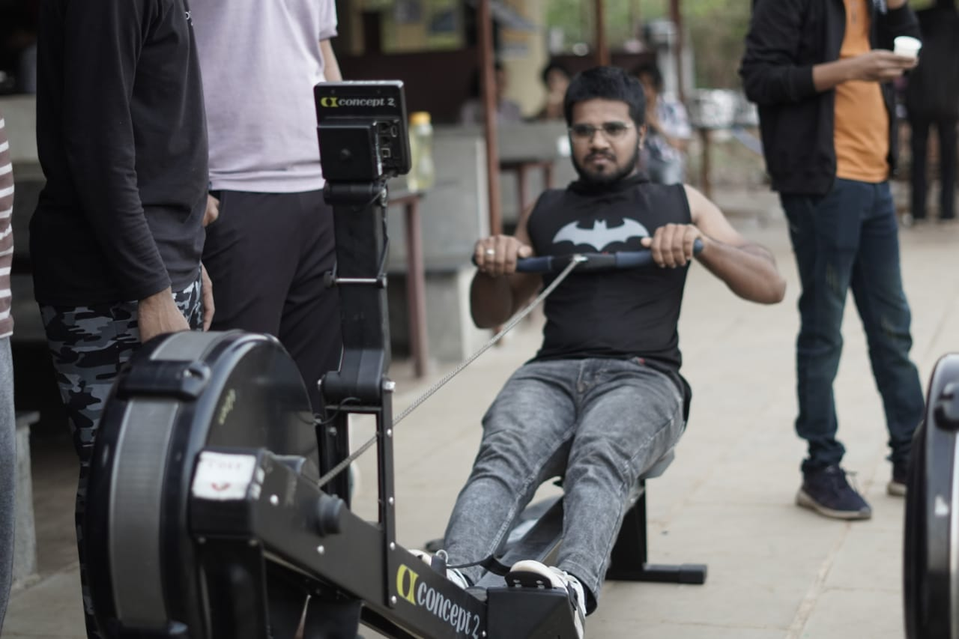 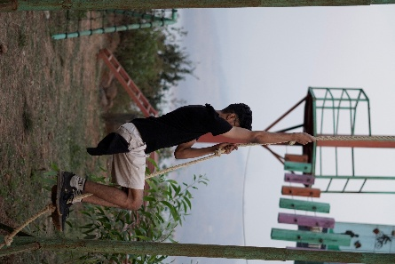

Dinner was served soon between 8:00 - 9:30 PM As the sun set, the participants gathered for a **lively campfire session** which was between 9:30 till 11:00 PM . The evening featured **music, dance, and storytelling**, creating an atmosphere of camaraderie and relaxation. This session provided an excellent opportunity for participants to unwind after an eventful day.

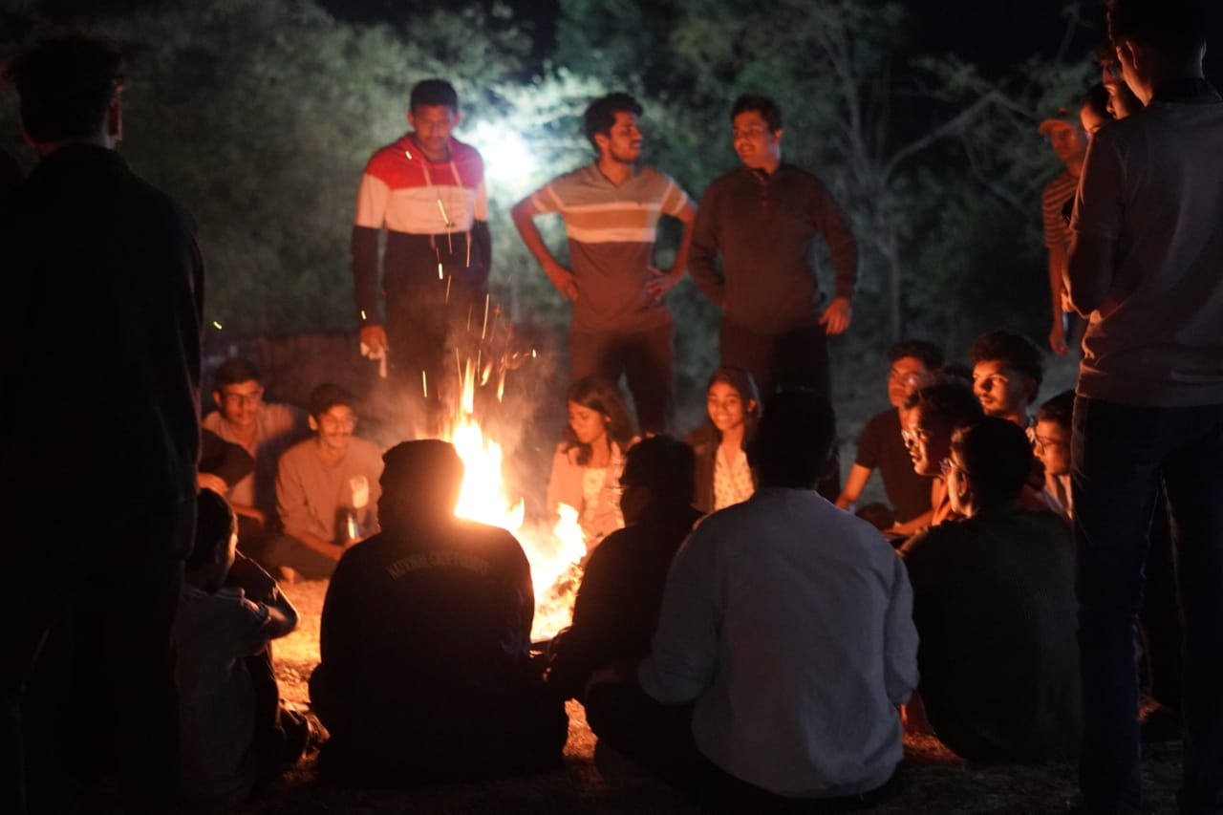

* **Day 2 (6th of February)**

The second day began with a beautiful view of Sunrise, **refreshing morning routine,** allowing participants to relax **& Freshen Up from** 6:30 - 7:00 AM , followed by **Breakfast**  7:00 - 7:30 AM and then a **Committee Kayaking session from** 7:30 - 8:30 AM. The remaining groups had their outings thereafter followed by lunch from 12:30 - 2:00 PM. After their lunch a small thanksgiving and appreciation session was conducted for all faculties and owner of the resort for proving such wonderful facilities**. Batch 2 Lunch was scheduled then from** 2:30 - 3:30 PM. After lunch all Groups packed up and **departed at** 4:30 PM

.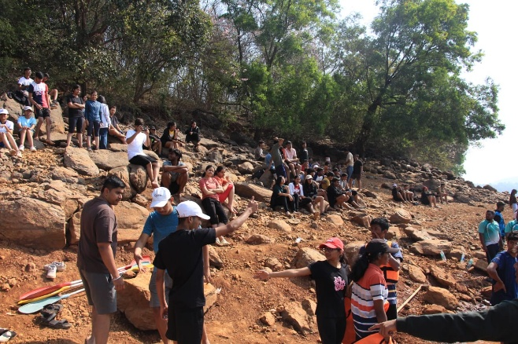

* **Conclusion**

The Jalmaitri Camp was a well-structured and engaging experience for all participants. The combination of adventure, teamwork, and recreational activities contributed to a memorable and enriching outing. The event was executed smoothly, ensuring the enjoyment and safety of all participants. The event not only fostered **physical endurance and mental agility** but also encouraged **collaboration and bonding** among the participants. Overall, **Jalmaitri 25 was a grand success**, leaving participants with lasting memories and valuable experiences.