Weekly Business Review: Olist E-commerce Marketplace
Big Data in Industry, Take-Home Assignment 1 | Prepared by: Satvika Gada – 49 (127003234) | 13 October 2026
1. Data-Quality Findings (Part B)
Pipeline summary. Eight raw CSV files are loaded into the raw schema, cleaned into typed staging tables, and checked by six SQL data-quality checks that stop the pipeline with an alarm if any check still fails after handling. The analysis-ready table mart.order_summary holds exactly one row per order. Loading is idempotent: raw tables are dropped and recreated inside one transaction, and staging and mart tables are rebuilt on every run, so a second run never duplicates data.
# | Check | Rows failing | Handling | Why this handling
1 | Null or duplicate order_id | 0 | Drop null IDs; keep one row per order_id | An order must be uniquely identifiable or every sum double-counts.
2 | Delivered date earlier than purchase date | 0 | Set delivery date to NULL | Such a timestamp is impossible, but the order itself is real.
3 | Payment total not equal to item price + freight | 303 | Flagged (payment_mismatch_flag); rows kept | Instalment interest and vouchers can cause legitimate gaps; dropping would lose real revenue.
4 | Orders with no matching customer | 0 | Drop | Cannot be attributed to a customer or state.
5 | More than one review per order (own check) | 547 | Keep the latest review per order | One review per order is needed so joins do not duplicate orders.
6 | Status delivered but no delivery date (own check) | 8 | Flagged; excluded from delay metrics | The date is missing; guessing one would bias delay figures.

After handling, checks 1, 2, 4, 5 and 6 return 0 failing rows. Check 3 still reports 303 rows because those rows are deliberately flagged and kept, so the alarm query excludes rows that already carry the flag and returns 0. The pipeline raises an error and does not build the mart if any check still fails.
Check 3 is the one to watch: the 303 orders are about 0.3% of all orders, so the effect on revenue figures is small, and the flag lets any analysis exclude them if needed.

2. SQL Results (Part C)
All five queries use CTEs and window functions only. Revenue means the sum of item prices on delivered orders. Full result tables are saved in the repository under reports/query_results/.
Q1. Month-over-month revenue (LAG). Revenue grew from BRL 111,798 in Jan 2017 to a peak of BRL 987,765 in Nov 2017 (+52.4% on October), the Black Friday month. After a dip in Dec 2017 (-26.5%), revenue held between BRL 826k and 978k through 2018 and was BRL 838,577 in Aug 2018 (-3.4%). Sep 2016 to Dec 2016 are excluded from interpretation because they contain only a handful of orders, which makes their growth percentages meaningless.
Q2. Top 3 categories per customer state (DENSE_RANK). Selected large states shown below; all 27 states are in the CSV. Beauty and health (beleza_saude) and watches and gifts (relogios_presentes) appear in the top 3 of most states, while bed, bath and table (cama_mesa_banho) leads in SP and RS.
State | Rank 1 | Rank 2 | Rank 3
SP | cama_mesa_banho (472,238) | beleza_saude (453,916) | relogios_presentes (421,547)
RJ | relogios_presentes (174,895) | cama_mesa_banho (144,252) | beleza_saude (140,236)
MG | beleza_saude (154,324) | cama_mesa_banho (128,760) | relogios_presentes (121,622)
RS | cama_mesa_banho (60,041) | moveis_decoracao (53,775) | informatica_acessorios (52,380)

Q3. 7-day rolling average of daily orders. Missing days are filled with zero. Daily orders were typically near 200 per day in mid-2018 (the 7-day average averaged about 198 over Jun and Jul 2018). The highest daily count was 1,176 orders on 24 Nov 2017 (Black Friday), and the rolling average peaked at 493.6 on 29 Nov 2017. The fall after late Aug 2018 reflects the end of the dataset, not a real decline.
Q4. Repeat-purchase rate. 2,801 of 93,358 customers (3.0%) placed more than one delivered order. customer_id is regenerated for every order in Olist, so it cannot identify a returning customer; customer_unique_id is the real person identifier and is used here.
Q5. Delivery delay versus estimate and review score. Average review score falls steadily as lateness grows.
Delivery vs estimate | Orders | Avg delay (days) | Avg review | 1-2 star %
Early | 88,163 | -13.71 | 4.29 | 9.2
On estimated day | 1,280 | 0.00 | 4.03 | 12.4
1-3 days late | 1,852 | 1.83 | 3.29 | 32.1
4-7 days late | 1,748 | 5.52 | 2.10 | 67.7
8+ days late | 2,781 | 19.45 | 1.70 | 79.3
All delivered orders | 95,824 | -11.91 | 4.16 | 12.8

The overall average delay is -11.91 days; a negative value means orders usually arrive well before the estimated date.

3. Metric Definitions (Part D)
One North Star metric and four supporting or guardrail metrics. Current values come from the delivered-order data in mart.order_summary.
Role | Metric | Exact formula | Current value | Why it matters
North Star | Satisfied Order Rate | Delivered orders with review_score >= 4 divided by delivered orders with a review | 78.93% | The goal is customer satisfaction, and this tracks it directly.
Supporting | On-time Delivery Rate | Delivered orders with delivered date <= estimated date divided by delivered orders with a delivery date | 93.23% | The main operational driver of review scores.
Supporting | Repeat-purchase Rate | Customers (customer_unique_id) with 2 or more delivered orders divided by customers with 1 or more delivered order | 3.00% | Satisfaction should show up as customers who come back.
Supporting | Monthly Revenue | SUM(item price) of delivered orders in the month | BRL 838,577 (Aug 2018) | Tracks business growth.
Guardrail | Cancellation Rate | Orders with status canceled divided by all orders | 0.63% | Stops improvements elsewhere from hiding lost orders.

How the metrics connect. Delivery performance is the operational lever: orders that arrive after the estimated date receive far lower reviews (1.70 to 3.29 stars versus 4.29 for early orders), so the on-time rate feeds directly into the Satisfied Order Rate. Satisfaction in turn should drive repeat purchase, and at 3.0% the repeat rate shows how much room there is to grow if first-time buyers are happier. Monthly revenue shows whether growth is holding while this happens. The cancellation rate is the guardrail: the company could raise on-time delivery or reviews simply by cancelling hard orders, so a rising cancellation rate would signal that an apparent improvement is not genuine.
Reading the values. The on-time rate is high at 93.23%, yet only 78.93% of reviewed orders are rated 4 or 5 stars. The gap is explained by the minority of late orders, which are rated very poorly (see Section 2, Q5), so the satisfaction problem is concentrated and therefore fixable.

4. Charts
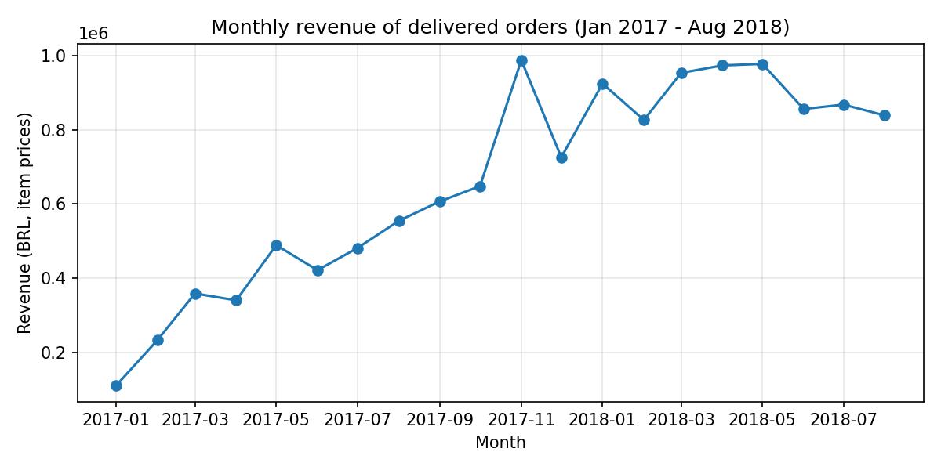 | 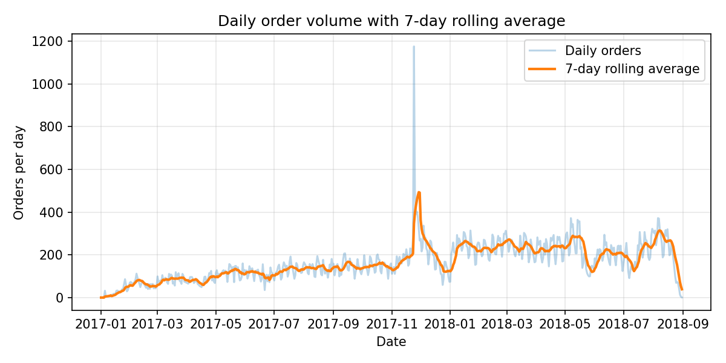
Figure 1. Monthly revenue rose from BRL 112k in Jan 2017 to a BRL 988k peak in Nov 2017 and then plateaued. | Figure 2. Daily orders spiked to 1,176 on Black Friday 2017 (24 Nov); the rolling average peaked at 494.
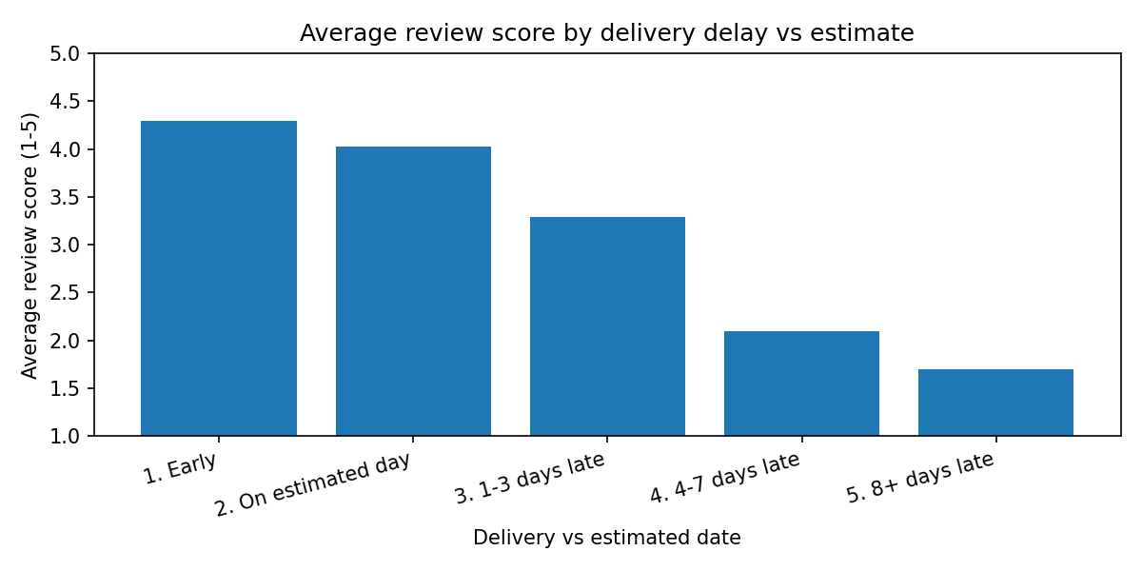 | 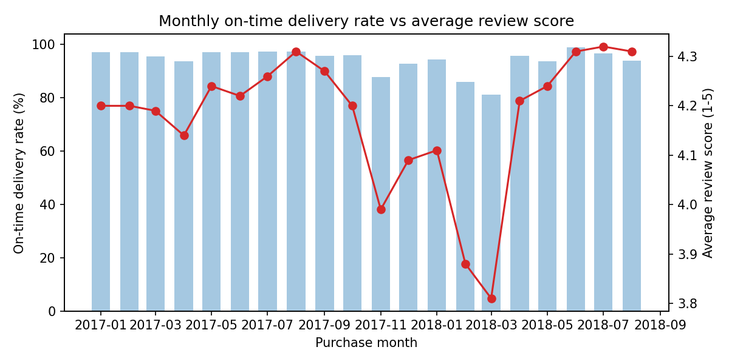
Figure 3. Average review drops from 4.29 for early orders to 1.70 when 8 or more days late. | Figure 4. The weakest on-time months (Nov 2017, Feb to Mar 2018) are also the months with the lowest average reviews.

5. Memo to the Vice President
TO: | Vice President, Customer Experience
FROM: | Satvika Gada, Data Analyst
DATE: | 13 October 2026
SUBJECT: | Late deliveries are the biggest controllable driver of low reviews

KEY FINDING
Delivery lateness, not product or price, is what pulls our satisfaction metric down. Orders delivered after the estimated date average 1.70 to 3.29 stars, against 4.29 for orders that arrive early, and an order that is 8 or more days late is about 8.6 times as likely to get a 1-2 star review (79.3% versus 9.2%).
EVIDENCE
- Review score falls at every step of lateness: 4.29 (early), 4.03 (on the day), 3.29 (1-3 days late), 2.10 (4-7 days late), 1.70 (8+ days late). The share of 1-2 star reviews rises from 9.2% to 32.1%, 67.7% and 79.3% across the late buckets.
- The months with the weakest on-time performance also had the weakest reviews: Nov 2017, Feb 2018 and Mar 2018 had the lowest on-time rates (about 88%, 86% and 81%) and the lowest average reviews (3.99, 3.88 and 3.81), against about 4.3 in the best months.
- The problem is concentrated: only about 7% of delivered orders arrive late (the on-time rate is 93.23%), but these 6,381 orders drag the Satisfied Order Rate down to 78.93%.
- The business cost shows in retention: the repeat-purchase rate is only 3.0%, so an unhappy first-time buyer rarely returns, and the cancellation rate (0.63%) is low enough that fixing delivery will not simply push losses elsewhere.
RECOMMENDATION
Logistics Operations should (1) add a delivery-time buffer to the estimated date for routes and sellers with a history of late orders, and (2) alert sellers whose orders have not been handed to the carrier by the shipping limit date, so that at-risk orders are escalated before they become late. Target: cut orders that are 4 or more days late from 4.7% of delivered orders to below 2.5% within one quarter, tracked weekly against the Satisfied Order Rate (goal: from 78.9% to above 82%), with the cancellation rate as the guardrail.

