**Ukraine crisis & Impact**

**Oil price rise**

A resurgent economy after a pandemic-induced downturn drove oil prices upward, while Russia's invasion of Ukraine cut world supply by 3 million barrels a day. India's crude import expenses are soaring up as its import demands rise. Crude prices over $100 will hurt the average consumer already struggling with inflation. Rising crude import prices drain foreign money, weakening the rupee. With a $60 per barrel market cap on Russian crude oil, Russia has redirected most of its supplies to India, China, and other Asian nations at reduced rates which will ease some high price issues in India.

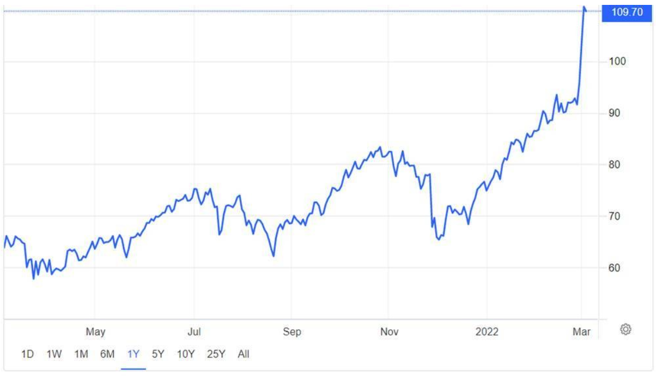

**Inflation**

Russia and Ukraine provide titanium, palladium, wheat, maize, and oil. The war's influence on commodity prices, inflation, and consumer expenditure is more crucial than trade contagion. We foresee rising commodity prices due to disrupted Ukrainian food and other exports and Russian sanctions. The battle has likely caused a 30% rise in oil prices, a 90% rise in European gas costs, and a 17% rise in food prices.Global inflation is projected to increase to 6.7 per cent in 2022, twice the average of 2.9 per cent during 2010–2020, with sharp rises in food and energy prices.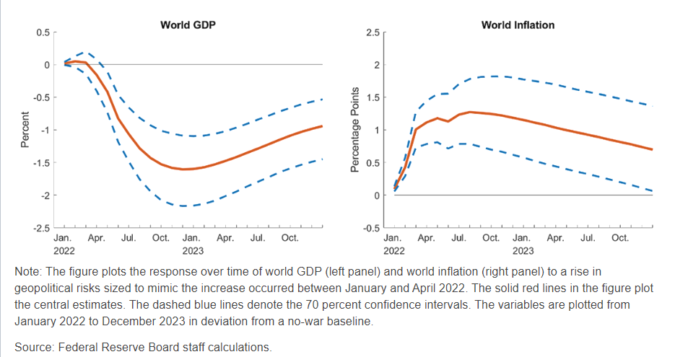

**Balance of Payment**

Petroleum importers in ASEAN, India, and frontier economies, including several Pacific Islands, would be most affected. This might be exacerbated by falling Russian tourism. A $5 per barrel (bbl) rise in crude oil prices would increase trade or current account deficit by $6.6 billion, according to Ind-Ra. In the January-March quarter of FY22, India's BoP fell $16 billion. Previous quarters had a surplus.

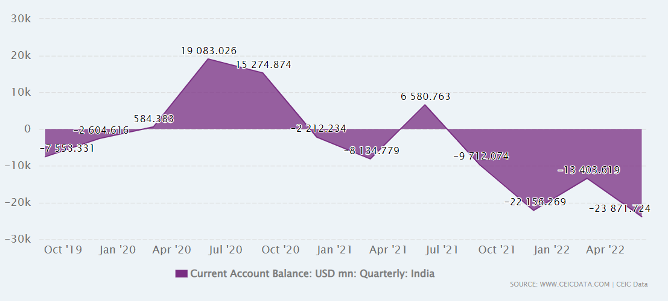

**How Covid and later Ukraine crisis impacted US inflation necessitating withdrawal of QE and interest rate rise**

The US economy was recovering from the pandemic, but the Ukraine-Russia war has strained supply lines, driving up costs. In the year before January 2022, inflation reached 6%, much beyond the Fed's 2% target.

Major central banks, which aim to hike interest rates to battle inflation, are also preparing a collective pullout from crucial financial markets in a first-ever bout of global "quantitative tightening"

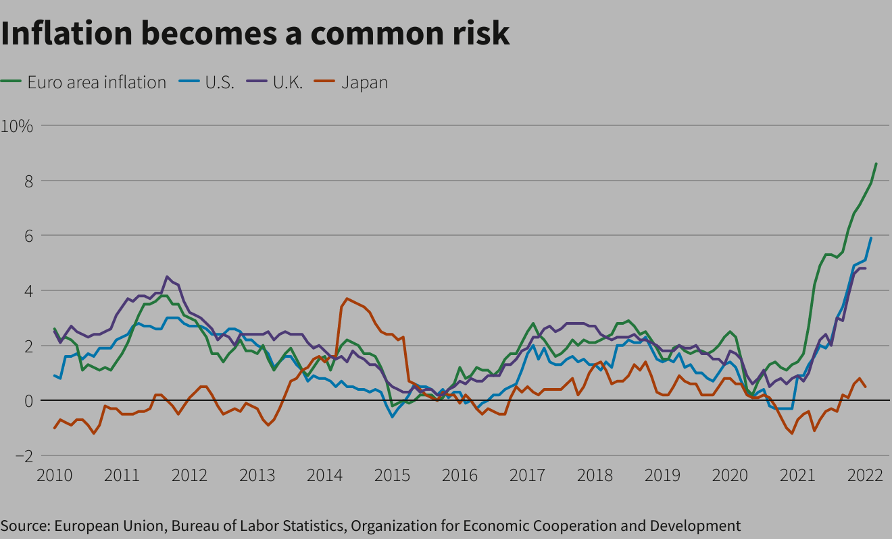

Quantitative Tightening is accomplished by direct sales of government bonds on the secondary market or the Fed's unwillingness to buy maturing bonds.

Both QT implementations would increase bond supply. To stop inflation, focus on reducing money in circulation. This strategy raises interest rates.

Bond buyers would require higher yields if they knew the supply would expand owing to future sales or a lack of government demand. Higher returns would raise customers' borrowing costs, making them wary of debt. This reduces asset demand (goods and services). Less demand means price stability and inflation control.

The Fed will let $1 trillion in assets expire without reinvestment starting June 1, 2022. This total is approximately comparable to a 25-basis-point rate hike, according to the Fed.