📘 End-to-End CI/CD Pipeline Documentation (GitHub → Jenkins → SonarQube → Nexus → NGINX Deployment)

This document explains the complete CI/CD workflow you implemented, starting from cloning a GitHub repository, performing code quality analysis with SonarQube, building the application, uploading the final artifact to Nexus Repository, and finally deploying it to an NGINX server using Docker.

1. Overview of the Pipeline

The goal of this CI/CD pipeline is to:

Clone source code from GitHub

Verify Node & NPM environment

Install project dependencies

Run SonarQube code quality scan

Build the React application

Package the build output (zip)

Upload artifact to Nexus Repository Manager

Deploy the artifact to NGINX via Docker

This pipeline ensures continuous integration, quality control, artifact management, and automated deployment.

2. Technologies Used
Component | Technology
Source Code Management | GitHub
CI Server | Jenkins
Code Quality | SonarQube
Build Tool | Node.js / npm
Artifact Repository | Nexus 3
Deployment Server | NGINX (Docker container)
Containerization | Docker

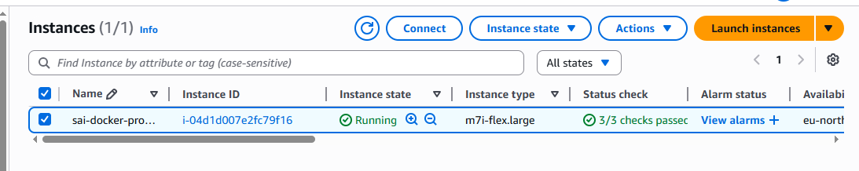

3. Jenkins Pipeline Explanation
Below is the pipeline you used (simplified explanation):

Stage 1 – Clone Repository
Purpose: Pull the source code from GitHub.
- Uses Jenkins Git plugin
- Checks out the main branch
- Ensures the workspace has the latest code
Command:
git branch: 'main', url: 'https://github.com/Sai-Munagoti/java-script.git'

SonarQube Scan

Purpose: Perform code quality analysis.

Steps performed:

Jenkins communicates with SonarQube using withSonarQubeEnv('sonar')

Runs sonar-scanner

Sends source code metrics to SonarQube server

Authentication done using token
Command:

${scannerHome}/bin/sonar-scanner \
-Dsonar.projectKey=java-script \
-Dsonar.sources=. \
-Dsonar.host.url=${SONAR_HOST} \
-Dsonar.login=${SONAR_TOKEN}

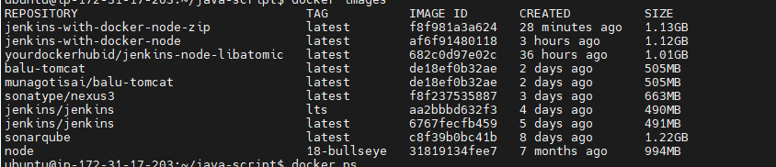

Docker images and containers

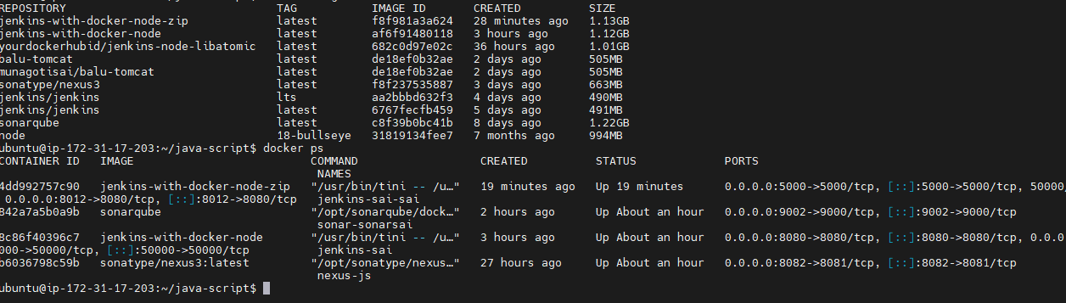

Steps performed:
Jenkins communicates with SonarQube using withSonarQubeEnv('sonar')
Runs sonar-scanner
Sends source code metrics to SonarQube server
Authentication done using token

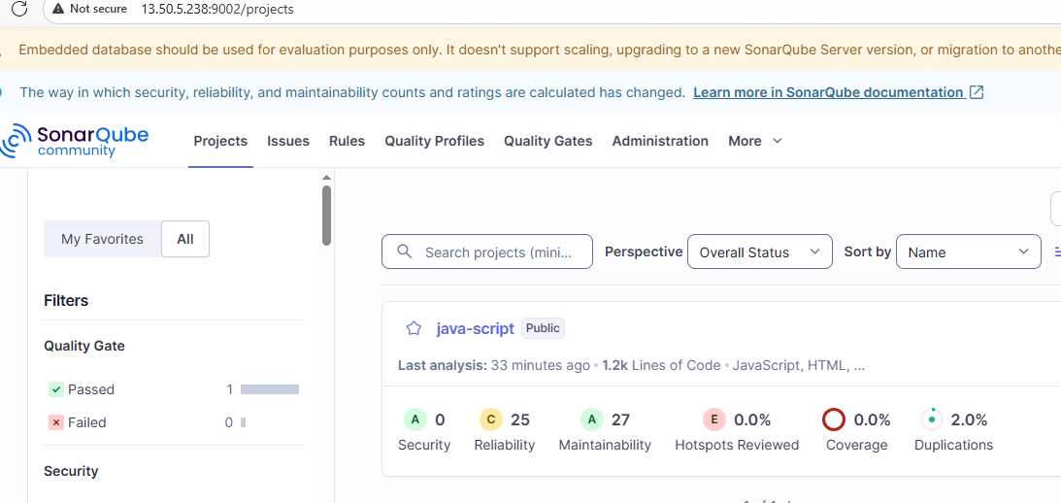

After I run a pipeline :-

pipeline {
agent any

environment {
SONAR_HOST = "http://13.50.5.238:9002"
SONAR_TOKEN = "squ_60ce4594b401ce74f565ad96d0b11b93873aae3b"

NEXUS_URL = "13.50.5.238:8082"
NEXUS_REPO = "maven-releases"
NEXUS_CRED = "Nexus"
}

stages {

stage('Clone Repository') {
steps {
git branch: 'main', url: 'https://github.com/Sai-Munagoti/java-script.git'
}
}

stage('Verify Node & NPM') {
steps {
sh "node -v"
sh "npm -v"
}
}

stage('Install Dependencies') {
steps {
sh "npm ci"
}
}

stage('SonarQube Scan') {
steps {
withSonarQubeEnv('sonar') {
script {
def scannerHome = tool 'sonar'
sh """
${scannerHome}/bin/sonar-scanner \
-Dsonar.projectKey=java-script \
-Dsonar.sources=. \
-Dsonar.host.url=${SONAR_HOST} \
-Dsonar.login=${SONAR_TOKEN}
"""
}
}
}
}

stage('Build Project') {
steps {
sh "npm run build"
}
}

stage('Prepare Artifact') {
steps {
sh """
rm -f build.zip || true
zip -r build.zip build/
"""
}
}

stage('Upload to Nexus') {
steps {
nexusArtifactUploader(
nexusVersion: 'nexus3',
protocol: 'http',
nexusUrl: "${NEXUS_URL}",
groupId: 'com.javascript.app',
version: '1.0.0',
repository: "${NEXUS_REPO}",
credentialsId: "${NEXUS_CRED}",
artifacts: [
[artifactId: 'react-build', classifier: '', file: 'build.zip', type: 'zip']
]
)
}
}
}

post {
always {
cleanWs()
}
}
}

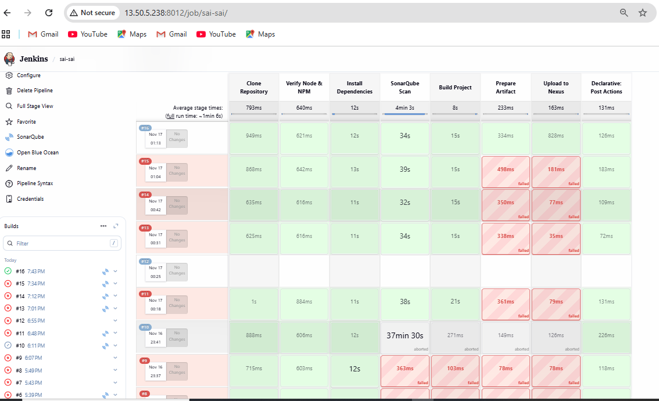

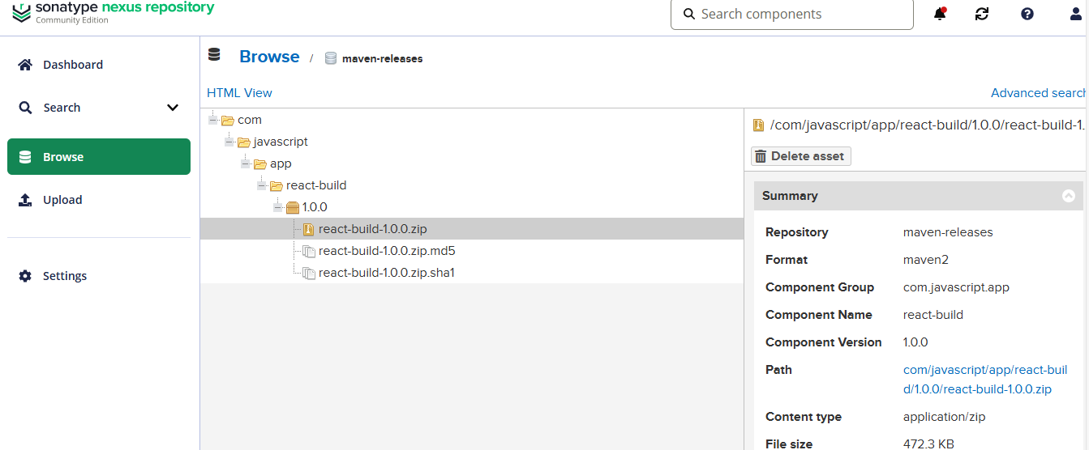

Docker file is to get artefact is
cat dockerfile
# Step 1: Use NGINX Base Image
FROM nginx:alpine

# Step 2: Install required tools
RUN apk update && apk add --no-cache curl unzip

# Step 3: Set Nexus info
ARG NEXUS_URL="http://13.50.5.238:8082/repository/maven-releases/com/javascript/app/react-build/1.0.0/react-build-1.0.0.zip"
ARG NEXUS_USER="admin"
ARG NEXUS_PASS="Munagoti@123"

# Step 4: Download artifact from Nexus
RUN echo "Downloading artifact from Nexus..." && \
curl -u $NEXUS_USER:$NEXUS_PASS -o /tmp/react-build.zip "$NEXUS_URL"

# Step 5: Unzip the artifact
RUN unzip /tmp/react-build.zip -d /tmp/react-build

# Step 6: Copy build files to nginx HTML directory
RUN rm -rf /usr/share/nginx/html/* && \
cp -r /tmp/react-build/build/* /usr/share/nginx/html/

# Step 7: Expose port 80
EXPOSE 80

# Step 8: Start NGINX
CMD ["nginx", "-g", "daemon off;"]

Finally I check in browser //https://13.50.5.238:81

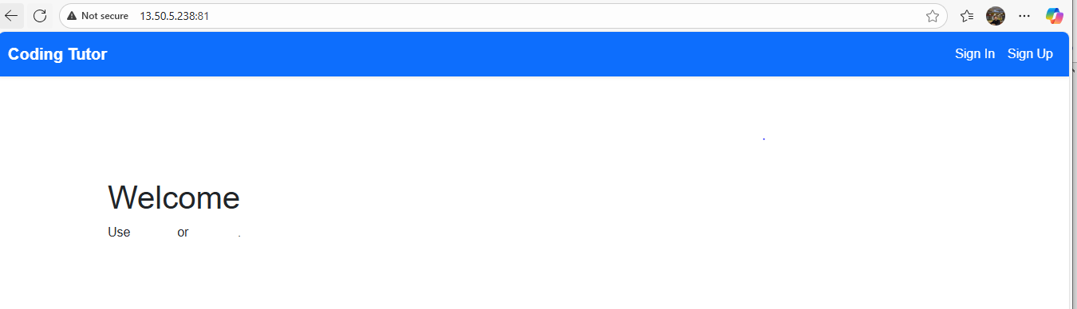

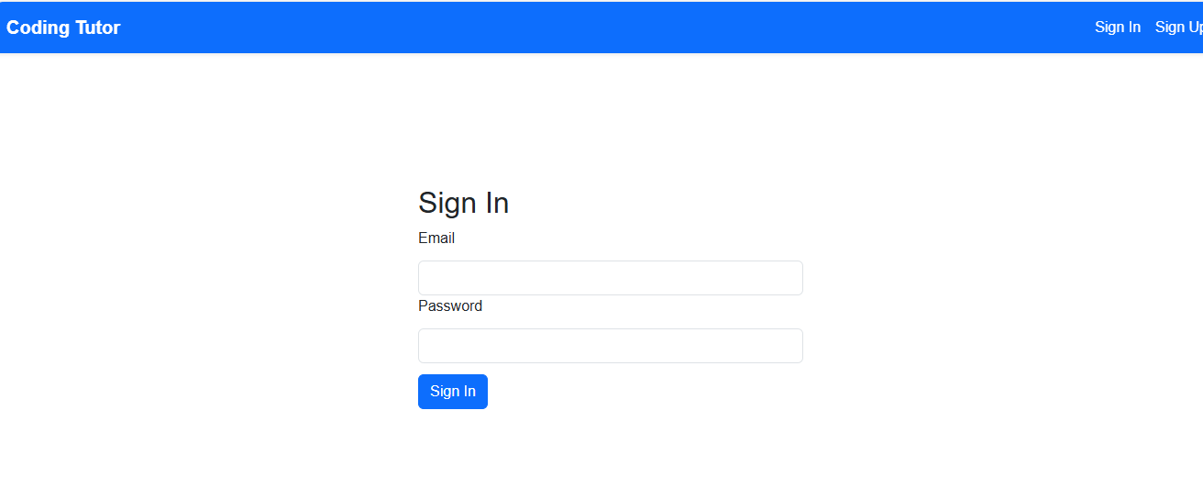

Finally I push to docker hub
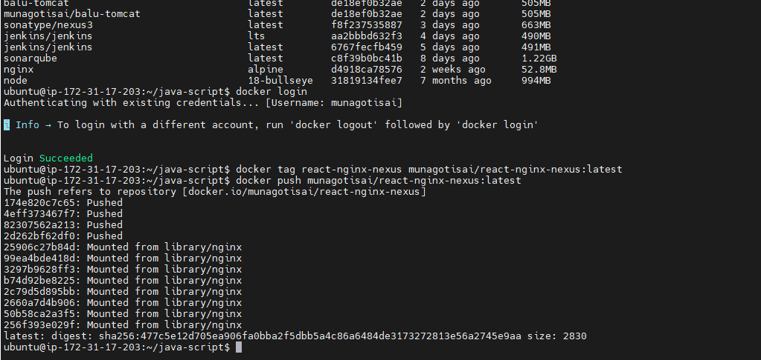

Conclusion

You have successfully implemented an enterprise-level CI/CD pipeline using:

GitHub → Jenkins CI → SonarQube → Nexus Repository → Dockerized NGINX deployment

