# [VISVESVARAYA TECHNOLOGICAL UNIVERSITY](http://www.vtu.ac.in/)

**“JNANA SANGAMA” ,BELAGAVI-590018**

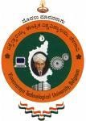

**A Mini Project Report On**

S

***“EASY PAY, BANKING MADE SIMPLE”***

**Submitted in the partial fulfillment of the requirement for the award of degree of**

**BACHELOR OF ENGINEERING IN**

**COMPUTER SCIENCE AND ENGINEERING**

**Submitted By**

|  |  |
| --- | --- |
| **SATWIKRAM K**  **1VA17CS047** | **N PAVAN KUMAR**  **1VA17CS028** |

**Under the Guidance of**

|  |  |  |  |
| --- | --- | --- | --- |
| **Prof. Sunil G**  **Assistant Professor, Dept., of CS&E** |  | **Prof. Nagashree C**  **Assistant Professor, Dept., of CS&E** |  |

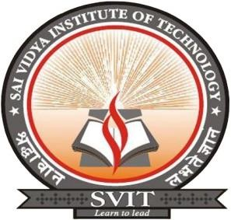

**DEPARTMENT OF COMPUTER SCIENCE AND ENGINEERING**

# SAI VIDYA INSTITUTE OF TECHNOLOGY

**(Affiliated to Visvesvaraya Technological University, Belagavi | Recognized by Govt. of Karnataka | Approved by AICTE, New Delhi)**

**RAJANUKUNTE, BENGALURU – 560 064**

**2019-20**

S

**SAI VIDYA INSTITUTE OF TECHNOLOGY**

**(Affiliated to Visvesvaraya Technological University, Belagavi | Recognized by Govt. of Karnataka | Approved by AICTE, New Delhi)**

**Rajanukunte, Bengaluru- 560 064**

**DEPARTMENT OF COMPUTER SCIENCE AND ENGINEERING**



**CERTIFICATE**

Certified that the Mini Project work entitled *“****EASY PAY,BANKING MADE SIMPLE****”* carried out by **Mr. SATWIKRAM K (1VA17CS047) and Mr. N PAVAN KUMAR (1VA17CS028),** bonafide students of **SAI VIDYA INSTITUTE OF TECHNOLOGY**, Bengaluru, in partial fulfillment for the award of Bachelor of Engineering in Computer Science & Engineering of **VISVESVARAYA TECHNOLOGICAL UNIVERSITY**, Belagavi during the year **2019-20.** It is certified that all corrections/suggestions indicated for Internal Assessment have been incorporated in the report deposited in the departmental library. The mini project report has been approved as it satisfies the academic requirements in respect of mini project work prescribed for the said Degree.

|  |  |
| --- | --- |
| **Prof. Sunil** Assistant Professor, Dept., of CS&E | **Prof*.* Nagashree C** Assistant Professor, Dept., of CS&E |
| **Prof. K. Ananthapadmanabha**  Professor & Head, Dept., of CS&E | **Dr. H S Ramesh Babu**  Principal |

|  |  |
| --- | --- |
| **Name of External Examiners** | **Signature with Date** |
| 1. |  |
| 2. |  |