SAI VIDYA INSTITUTE OF TECHNOLOGY
Rajanukunte, Bengaluru- 560 064

DEPARTMENT OF COMPUTER SCIENCE AND ENGINEERING
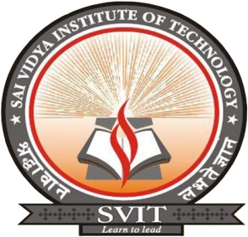

CERTIFICATE

Certified that the Mini project work entitled “Lazy Shopping” carried out by Mr. SATWIK RAM K (1VA17CS047), Mr. SHABAZ KHAN Z (1VA17CS048), and PAVAN KUMAR N (1VA17CS028) bonafide students of SAI VIDYA INSTITUTE OF TECHNOLOGY, Bengaluru, in partial fulfillment for the award of Bachelor of Engineering in Computer Science and Engineering of VISVESVARAYA TECHNOLOGICAL UNIVERSITY, Belagavi during the year 2020-21. It is certified that all corrections/suggestions indicated for Internal Assessment have been incorporated in the report deposited in the departmental library. The project report has been approved as it satisfies the academic requirements in respect of Mini Project work prescribed for the Web Technology Laboratory with Mini Project (17CSL77).

Mr. Nagamahesh B S  Assistant Professor,  Dept. of CS&E, SVIT | Dr. Archana R A  HOD  Dept. of CS&E, SVIT | Dr. H S Ramesh Babu  Principal

External Viva:

Name | Signature
- ___________________________ | __________________________
- ___________________________ | __________________________

