SAI VIDYA INSTITUTE OF TECHNOLOGY

(Affiliated to Visvesvaraya Technological University, Belagavi | Recognized by Govt. of Karnataka | Approved by AICTE, New Delhi)

**Rajanukunte, Bengaluru- 560 064**

**DEPARTMENT OF COMPUTER SCIENCE AND ENGINEERING**

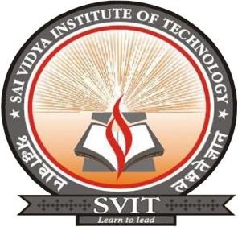

**CERTIFICATE**

Certified that the Mini Project work entitled *“****A SCENIC VIEW OF A WINDMILL****”* carried out by **Mr. Satwik Ram K(1VA17CS047),** a bonafide student of **SAI VIDYA INSTITUTE OF TECHNOLOGY**, Bengaluru, in partial fulfillment for the award of Bachelor of Engineering in Computer Science and Engineering of **VISVESVARAYA TECHNOLOGICAL UNIVERSITY**, Belagavi during the year **2019-20.** It is certified that all corrections/suggestions indicated for Internal Assessment have been incorporated in the Report deposited in the departmental library. The Mini Project report has been approved as it satisfies the academic requirements in respect of Computer Graphics Laboratory with Miniproject(17CSL68) prescribed for the said Degree.

|  |  |  |
| --- | --- | --- |
|  |  |  |
| **Dr.Sangeetha.V** |  | **Prof. Sunil G L** |
| Associate Professor |  | Assistant Professor |
| Dept. of ISE,SVIT |  | Dept. of CSE,SVIT |

|  |  |
| --- | --- |
|  |  |
| **Dr. K. Ananthapadmanabha** | **Dr. H S Ramesh Babu** |
| Professor & Head | Principal |
| Dept. of CSE,SVIT | SVIT |

**External Viva:**

|  |  |
| --- | --- |
| **Name of the Examiner** | **Signature with date** |
| **1.** |  |
| **2.** |  |