**NN&DeepLearning_ICP10**

**Satwik Mopuru reddy**

700740060

**Lesson Overview:**

In this lesson, we are going to discuss types of ANNs and Recurrent Neural Network.

**Use Case Description:**

1. Sentiment Analysis on the Twitter dataset

**Programming elements:**

# 1. Basics of LSTM 2. Types of RNN 3. Use case: Sentiment Analysis on the Twitter data set

**In class programming:**

1. Save the model and use the saved model to predict on new text data (ex, “**A lot of good things are happening. We are respected again throughout the world, and that's a great thing**.@realDonaldTrump”)
2. Apply GridSearchCV on the source code provided in the class

**Solution:**

**# Import necessary libraries**

**# Import necessary libraries**

**import numpy as np**

**from keras.models import Sequential, load_model**

**from keras.layers import LSTM, Embedding, Dense**

**from keras.preprocessing.text import Tokenizer**

**from tensorflow.keras.preprocessing.sequence import pad_sequences**

**from keras.wrappers.scikit_learn import KerasClassifier**

**from sklearn.model_selection import GridSearchCV**

**# Sample Twitter dataset and labels (replace these with your actual dataset)**

**tweets = ["A lot of good things are happening.", "We are respected again throughout the world, and that's a great thing. @realDonaldTrump"]**

**labels = [1, 0] # 1 for positive sentiment, 0 for negative sentiment**

**# Tokenize the tweets**

**tokenizer = Tokenizer()**

**tokenizer.fit_on_texts(tweets)**

**vocab_size = len(tokenizer.word_index) + 1**

**# Convert text to sequences and pad the sequences**

**sequences = tokenizer.texts_to_sequences(tweets)**

**max_length = max([len(seq) for seq in sequences])**

**X = pad_sequences(sequences, maxlen=max_length, padding='post')**

**# Convert labels to numpy array**

**y = np.array(labels)**

**# LSTM Model**

**def create_lstm_model(units=100, embedding_dim=50):**

**model = Sequential()**

**model.add(Embedding(input_dim=vocab_size, output_dim=embedding_dim, input_length=max_length))**

**model.add(LSTM(units=units))**

**model.add(Dense(units=1, activation='sigmoid'))**

**model.compile(optimizer='adam', loss='binary_crossentropy', metrics=['accuracy'])**

**return model**

**# Train the LSTM model**

**model = create_lstm_model()**

**model.fit(X, y, epochs=10, batch_size=1, verbose=1)**

**# Save the model**

**model.save('sentiment_analysis_lstm_model.h5')**

**# Load the saved model**

**loaded_model = load_model('sentiment_analysis_lstm_model.h5')**

**# Example text for prediction**

**new_text = ["A lot of good things are happening. We are respected again throughout the world, and that's a great thing. @realDonaldTrump"]**

**# Tokenize and pad the new text data**

**new_sequences = tokenizer.texts_to_sequences(new_text)**

**new_X = pad_sequences(new_sequences, maxlen=max_length, padding='post')**

**# Predict sentiment using the loaded model**

**predicted_sentiment = loaded_model.predict(new_X)**

**# Print the predicted sentiment**

**print(predicted_sentiment)**

**# Define hyperparameters for GridSearchCV**

**param_grid = {**

**'units': [50, 100, 150],**

**'embedding_dim': [50, 100, 150]**

**}**

**from keras.wrappers.scikit_learn import KerasClassifier**

**from sklearn.model_selection import GridSearchCV**

**# ... (import other libraries and define functions)**

**# Create a KerasClassifier for GridSearchCV**

**model = KerasClassifier(model=create_lstm_model, epochs=10, batch_size=1, verbose=0)**

**# Define hyperparameters for GridSearchCV**

**param_grid = {**

**'units': [50, 100, 150],**

**'embedding_dim': [50, 100, 150]**

**}**

**# Perform GridSearchCV**

**grid = GridSearchCV(estimator=model, param_grid=param_grid, cv=2)**

**grid_result = grid.fit(X, y)**

**# Print the best parameters and their corresponding accuracy**

**print("Best Parameters: ", grid_result.best_params_)**

**print("Best Accuracy: ", grid_result.best_score_)**

**OUTPUT:**

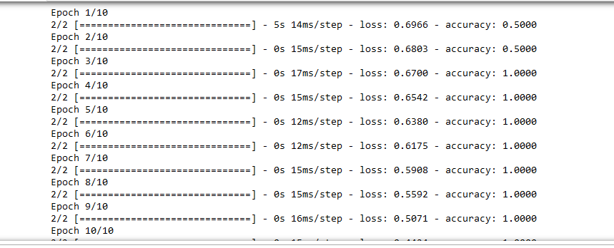

**GITLINK:**

[**https://github.com/Satwikreddymopuru/ICP_9**](https://github.com/Satwikreddymopuru/ICP_9)