AI Based Disease Prediction and Doctor Recommendation
A Major Project Synopsis Submitted in Partial Fulfillment for the Award of the Degree of Bachelor of Technology in Branch Name
Submitted To

Dr. A.P.J. Abdul Kalam Technical University, Lucknow
Submitted By:
Satwik Tiwari (2300100100337)
Arpita Mishra (2300100100108)
Saurabh Mishra (2300100100351)
Saumya Dwivedi (2300100100349)
Under the Supervision of
Mr. Shesh Kumar
Assistant Professor

Department of Computer Science and Engineering
United College of Engineering & Research,
Prayagraj, India

Abstract
Artificial Intelligence is steadily reshaping healthcare — it's helping with diagnosis, treatment planning and how patients are managed day to day. Among the many things that decide whether a disease can be treated successfully, catching it early is probably the single biggest factor. Blood cancer is one of those diseases where this matters the most, because it tends to progress quickly once it takes hold, and a delay in diagnosis can turn what might have been treatable into something life-threatening. This is the gap our project tries to address.
This project, the AI Based Blood Cancer Prediction & Doctor Recommendation System, takes the symptoms and basic medical details a patient provides and uses them to estimate how likely blood cancer is. On the technical side, the web application is built using Spring Boot on the backend along with MongoDB, Express.js, React.js and Node.js, while the prediction itself relies on Machine Learning models — Naive Bayes, Logistic Regression and Random Forest — trained to work with this kind of symptom data. Beyond the prediction, the platform also handles patient registration and login, the symptoms form, doctor matching, appointment booking, and an admin dashboard to keep everything organised.
Once a patient submits their details, the system places them into a low, medium or high risk category and, based on that, points them towards the right specialist — a Hematologist or an Oncologist, for instance. The hope is that a tool like this can genuinely be useful to hospitals, clinics and patients alike, by shortening the time it takes to get a first opinion, making that first opinion easier to reach, and giving doctors a bit of extra support when they're making decisions.

Introduction
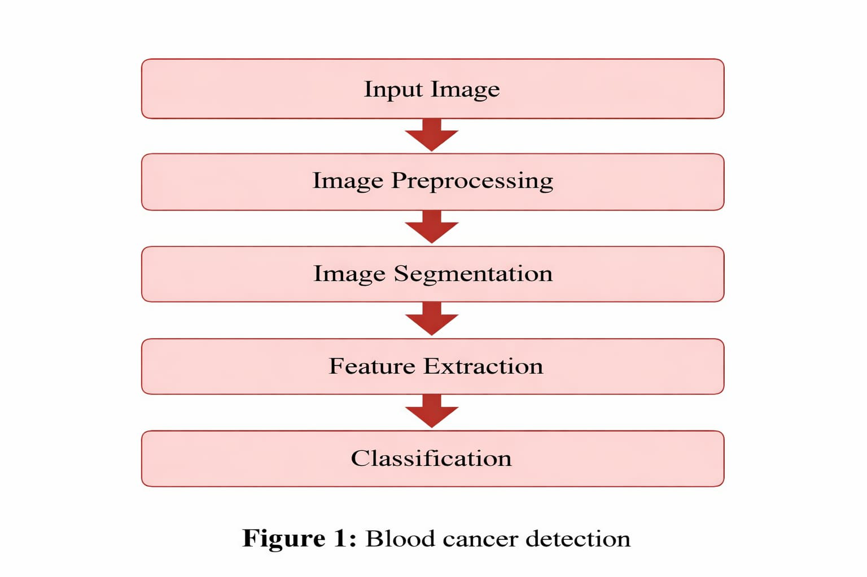
Healthcare is, without question, one of the sectors society depends on the most, yet it's also one that's constantly under strain. As the population grows and hospitals get more crowded, a lot of patients simply don't get seen or diagnosed as quickly as they should be. Blood cancer is a condition where this delay can be particularly costly — it needs attention right away, because waiting even a little longer can allow it to become far more serious.
Blood cancer, broadly speaking, interferes with how blood cells are produced and how they function, and it usually originates either in the bone marrow or the lymphatic system. It's generally grouped into three main types: Leukemia, which affects the blood and bone marrow; Lymphoma, which affects the lymphatic system; and Myeloma, which affects plasma cells. The symptoms that come with it — persistent fever, tiredness that doesn't go away, catching infections often, unexplained weight loss, bone pain, night sweats, swollen lymph nodes, or bruising and bleeding more easily than usual — are unfortunately quite easy to brush off, since they overlap with so many everyday illnesses.
That tendency to overlook early symptoms is really what motivated this project. We wanted to build something where a person could simply describe what they're experiencing, get a quick sense of the risk involved, and then be pointed towards the specialist best suited to look into it further. Spring Boot gives us a backend that's secure and can scale as needed, while the Machine Learning component is what actually does the work of turning symptoms into a meaningful prediction.

Problem Statement
Blood cancer remains one of the more serious diseases people face today, and catching it early continues to be one of the strongest predictors of whether treatment will actually work. The trouble is that its early symptoms — fatigue, fever, weakness, weight loss, bone pain, frequent infections — read almost exactly like the symptoms of far less serious, everyday illnesses, so patients often don't think much of them until things have progressed.
On top of that, the usual route to diagnosis — lab tests, medical reports, a specialist appointment — takes time, and isn't always easy to access, particularly for people living in rural or underserved areas. Even when someone does decide to seek help, figuring out which specialist to see and getting an appointment booked can itself become a hurdle. What's missing, in our view, is a system that can look at a patient's symptoms, give an early indication of blood cancer risk, and then guide them to the right doctor without much friction.
This is what our project sets out to do — an AI Based Blood Cancer Prediction & Doctor Recommendation System, built on Spring Boot and Machine Learning, that combines early prediction, specialist recommendation, appointment booking and basic digital health record-keeping in one place.

Objectives
Primary objectives:
- Build a healthcare system capable of predicting blood cancer risk from patient-reported symptoms.
- Apply Machine Learning techniques to analyse those symptoms in a meaningful way.
- Classify each patient's risk level as Low, Medium or High.
- Automatically recommend a suitable specialist based on that classification.
- Allow patients to book appointments with the recommended doctor online.
- Keep patient records stored securely.
Secondary objectives:
- Cut down the time patients spend on a preliminary diagnosis.
- Make healthcare a bit more reachable for people in rural areas.
- Give doctors an additional, AI-driven perspective to support their own judgement.
- Offer a healthcare portal that's actually easy and pleasant to use.

Literature Review
There's no shortage of healthcare platforms out there, but most of them are built around appointment scheduling or fairly generic symptom checkers. Very few are aimed specifically at predicting blood cancer and then connecting that prediction to a doctor recommendation — which is the space we're trying to fill.
Algorithms considered:
- Naive Bayes — works well for symptom-based classification problems.
- Logistic Regression — suited to estimating the probability of a disease being present.
- Random Forest — tends to give better accuracy since it combines many decision trees.
- CNN (planned as future work) — could be used later to analyse blood report images or microscopic scans.
Gaps we noticed:
- Very few systems are built specifically around blood cancer.
- Doctor recommendation is rarely integrated with the prediction itself.
- Prediction, booking and an admin dashboard are almost never offered together on one platform.
Addressing these gaps is the core motivation behind this project.

Proposed Methodology
The system is organised into a set of modules that work together, described step by step below.
Step 1 — Patient Registration & Login
Users create an account and log in securely, providing basic details — name, age, gender, email and password.
Step 2 — Symptoms Form Submission
The patient fills in the symptoms they're experiencing — fever, fatigue, weight loss, bone pain, weakness, frequent infections, night sweats, swollen nodes, and so on.
Step 3 — Data Preprocessing
Before the data reaches the model, it goes through cleaning — handling missing values, encoding categorical fields, scaling features and removing noise.
Step 4 — Machine Learning Prediction Engine
Three algorithms are used here: Naive Bayes, which is quick and works reasonably well on medical datasets; Logistic Regression, which estimates the probability of disease; and Random Forest, which generally gives the best accuracy and is the most robust of the three.
Step 5 — Prediction Output
Based on the model's output, the patient is classified as Low, Medium or High risk for blood cancer.
Step 6 — Doctor Recommendation
Depending on that result, the system suggests a relevant specialist — a Hematologist, Oncologist, Pathologist or General Physician.
Step 7 — Appointment Booking
Finally, the patient can pick from the available doctors and book a consultation slot directly through the platform.

System Architecture
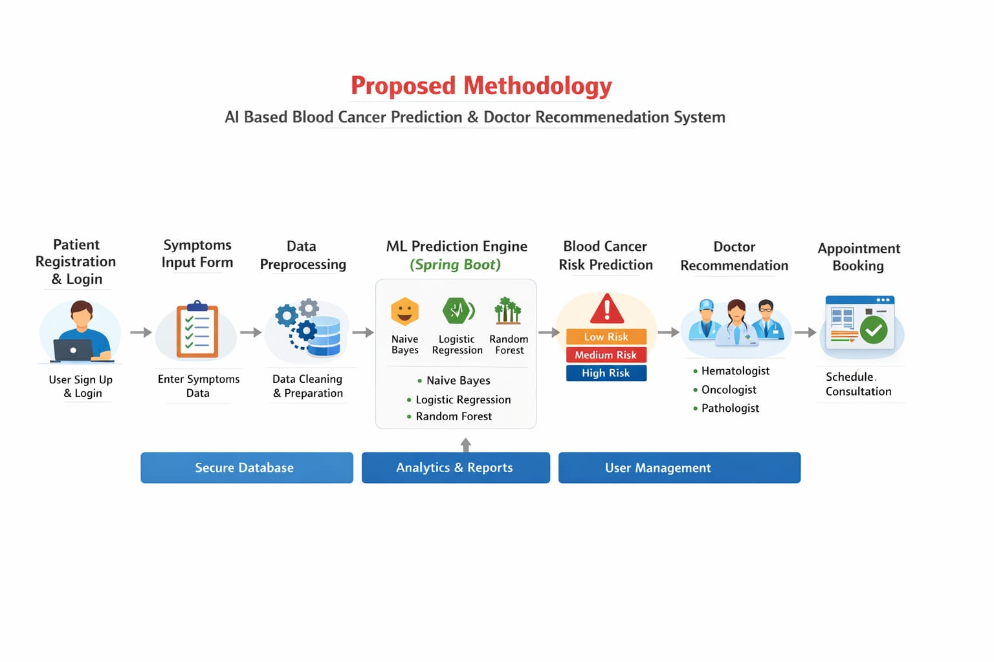
Figure 2: System Architecture
The system follows a layered architecture, where the frontend, backend, database and Machine Learning components each handle a distinct part of the workflow and communicate through Spring Boot's APIs. It's designed this way mainly so that performance stays smooth as usage grows, and so new features can be added without disturbing what's already working.
Main components:
- Patient Registration / Login
- Symptoms Input Form
- Prediction Result Page
- Doctor Recommendation Page
- Appointment Booking Page
- Admin Dashboard
Roughly, the flow moves from Patient Login/Register, to Enter Symptoms, into the Spring Boot Backend API, through to the ML Prediction Engine, which produces the Blood Cancer Risk Output. That output feeds the Doctor Recommendation step, followed by Appointment Booking, with the Admin Dashboard sitting alongside to manage the system as a whole.
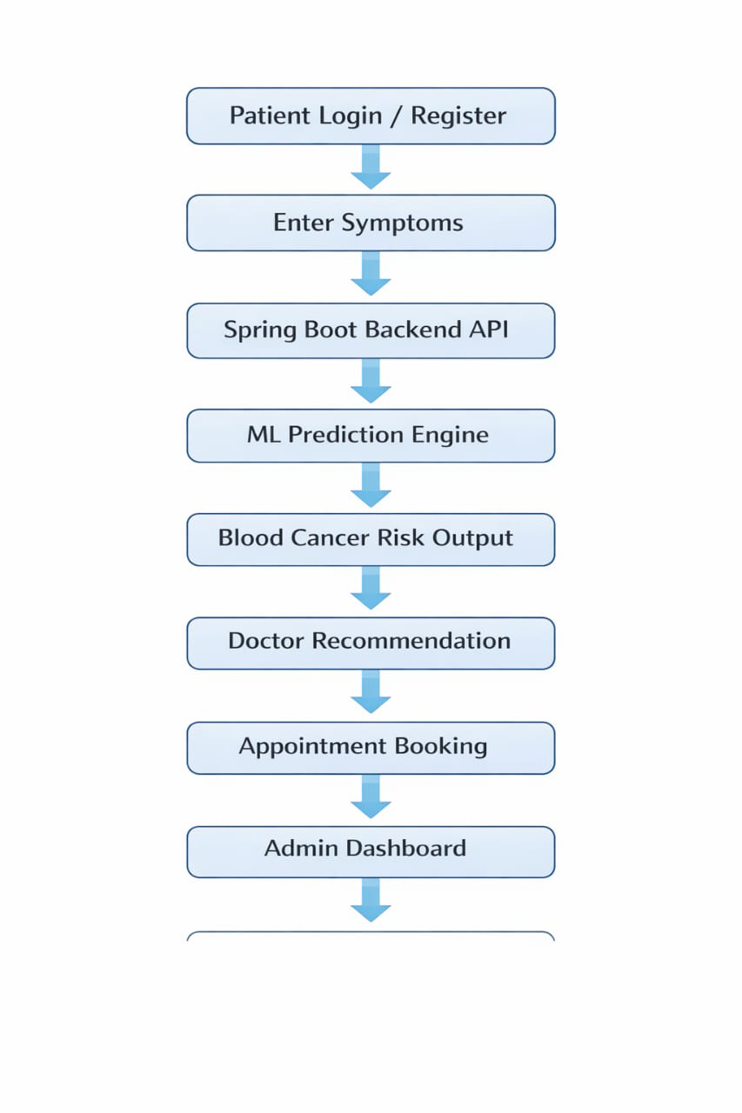
Figure 3: Architecture Flow Diagram

Tools and Technologies
This section covers the software, languages, frameworks and tools that make up the technical stack, and gives a sense of how feasible the project is to build and maintain.
Frontend:
- HTML5, CSS3, Bootstrap, JavaScript
- React.js / Thymeleaf (optional UI layer)
Backend:
- Spring Boot, Spring Security, Hibernate, Java
Database:
- MySQL / PostgreSQL
Machine Learning:
- Python, Scikit-learn, Pandas, NumPy, Matplotlib
Development tools:
- IntelliJ IDEA / Eclipse IDE, Postman, GitHub, Jupyter Notebook

Expected Results
Functional:
- Patients can register and log in without issues
- The symptoms form submits smoothly
- Blood cancer predictions come out accurate
- Doctor recommendations are relevant to the risk level
- Appointments can be scheduled through the portal
Technical:
- Quick API response times
- A secure authentication system
- A backend that scales reasonably well
- High prediction accuracy from the ML models
Social benefits:
- Support for earlier diagnosis
- Better access to healthcare, especially for underserved areas
- Less time spent waiting at hospitals
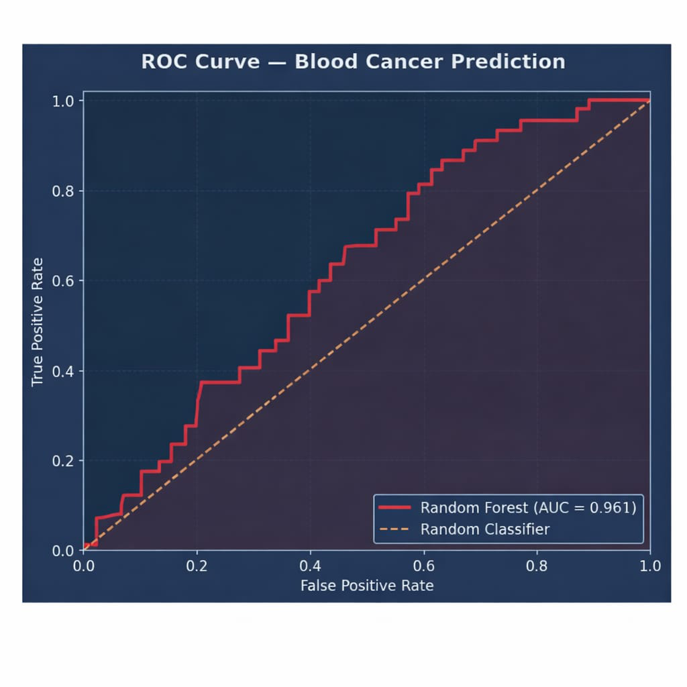
Figure 4: Blood Cancer Prediction — ROC Curve

Project Timeline
This section lays out roughly how the project's phases are expected to unfold, which helps in tracking progress along the way.
Phase | Activities | Duration
Requirement Analysis | Problem identification, data collection | 2 Weeks
System Design | Architecture design, module planning | 2 Weeks
Implementation | Coding and model development | 6 Weeks
Testing | Unit testing, integration testing | 3 Weeks
Deployment | Final system deployment | 1 Week
Maintenance | Improvements and updates | Ongoing

Scope of the Project
Current scope:
- Blood cancer risk prediction
- Specialist recommendation
- Online appointment booking
- Secure storage of patient data
- Admin analytics dashboard
Future scope:
- Letting patients upload CBC reports for automatic analysis
- CNN-based detection from blood cell images
- An AI chatbot for basic health support
- An Android/iOS app
- Live video consultations
- Support for multiple languages
- Integration with hospitals and diagnostic labs
Advantages of the system:
- Helps identify disease risk early
- Saves time during initial diagnosis
- Backed by a secure Spring Boot architecture
- Improves access to healthcare
- Connects patients to the right specialist intelligently
- Built on a scalable, enterprise-ready architecture

Conclusion
The AI Based Blood Cancer Prediction & Doctor Recommendation System is our attempt at building something that can genuinely help patients get a sense of their blood cancer risk before it's too late. By pairing a Spring Boot backend with Machine Learning models, the system is able to offer prediction, doctor recommendations and appointment booking as one connected experience. We believe a project like this, even in its current form, points towards how modern healthcare services can cut down delays, become more accessible, and give medical professionals a bit of AI-backed support in their day-to-day decisions.

References
- Spring Boot Official Documentation. Spring Boot Reference Guide.
- Scikit-learn Developers Team. Machine Learning Algorithms Documentation.
- Han, J., Kamber, M., Pei, J. Data Mining: Concepts and Techniques. Morgan Kaufmann Publication.
- Kotu, V., Deshpande, B. Predictive Analytics and Data Mining. Elsevier Publication.
- MySQL Official Documentation. MySQL Reference Manual.
- Python Software Foundation. Python Documentation.
- World Health Organization (WHO). Cancer and Blood Cancer Awareness Reports.
- National Cancer Institute. Blood Cancer Types, Symptoms and Treatment.
- Breiman, L. (2001). Random Forests. Machine Learning Journal.
- Hosmer, D.W., Lemeshow, S. Applied Logistic Regression. Wiley Publication.

