* [**Home**](http://www.ultimatesolutionscorp.com)
* [**About Us**](http://www.ultimatesolutionscorp.com/company-profile/)
* [**Manufacturing**](http://www.ultimatesolutionscorp.com/manufacturing/)
* [**Test Capabilities**](http://www.ultimatesolutionscorp.com/test-capabilities/)
* [**Software Staffing**](http://www.ultimatesolutionscorp.com/information-technology-staffing/)
* [**Design**](http://www.ultimatesolutionscorp.com/)
  + [**Hardware Design**](http://www.ultimatesolutionscorp.com/design/)
  + [**Software Design**](http://www.ultimatesolutionscorp.com/design)
* [**Quote**](http://www.ultimatesolutionscorp.com/quote)
* [**Contact Us**](http://www.ultimatesolutionscorp.com/contact-us/)

[**Menu**](http://www.ultimatesolutionscorp.com/)

* [**Home**](http://www.ultimatesolutionscorp.com)
* [**About Us**](http://www.ultimatesolutionscorp.com/company-profile/)
* [**Manufacturing**](http://www.ultimatesolutionscorp.com/manufacturing/)
* [**Test Capabilities**](http://www.ultimatesolutionscorp.com/test-capabilities/)
* [**Software Staffing**](http://www.ultimatesolutionscorp.com/information-technology-staffing/)
* [**Design**](http://www.ultimatesolutionscorp.com/)
  + [**Hardware Design**](http://www.ultimatesolutionscorp.com/design/)
  + [**Software Design**](http://www.ultimatesolutionscorp.com/design)
* [**Quote**](http://www.ultimatesolutionscorp.com/quote)
* [**Contact Us**](http://www.ultimatesolutionscorp.com/contact-us/)

[Search](http://www.ultimatesolutionscorp.com/)

Top of Form



Bottom of Form

[**Ultimate Solutions Corp**](http://www.ultimatesolutionscorp.com)

* 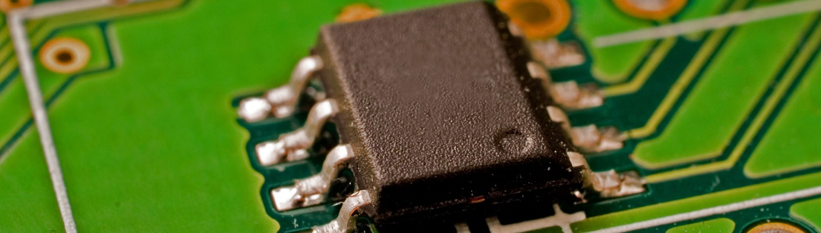

**More than 20 Years in business**

* [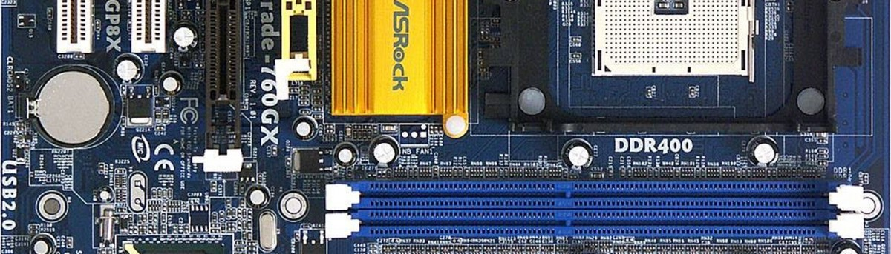](http://www.ultimatesolutionscorp.com/wp-content/uploads/2012/12/Motherboard.png)

[**WHY US**](http://www.ultimatesolutionscorp.com/wp-content/uploads/2012/12/Motherboard.png)

Ultimate Solutions Primary goal is to build long lasting relationships with all of our customers

* 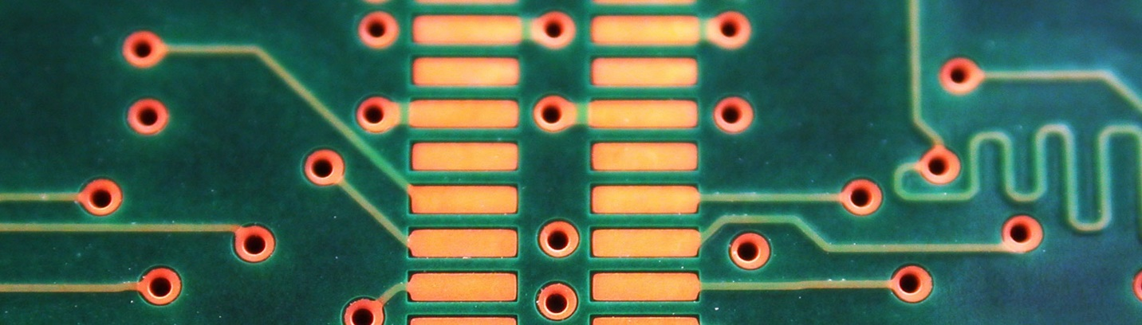

**Get Free Quote**

We will review the manufacturability of your design(DFM) and suggest improvements if you desire.

* 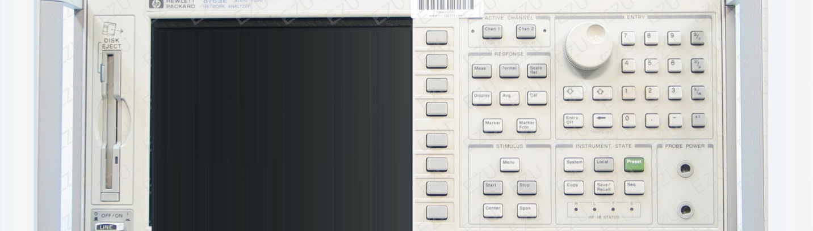

**Our Mission**

It is Ultimate Solutions consistently exceed our customer’s expectation.

* [1](http://www.ultimatesolutionscorp.com/)
* [2](http://www.ultimatesolutionscorp.com/)
* [3](http://www.ultimatesolutionscorp.com/)
* [4](http://www.ultimatesolutionscorp.com/)

Ultimate Solutions provides the complete manufacturing solution, which includes Printed Circuit Boards Assembly, Electro-Mechanical Assembly, and comprehensive testing for Digital, RF, High-speed data, Product Design, software development for communications, solar, led lights & software industry.

**[Customers](http://www.ultimatesolutionscorp.com/?page_id=)**

Our primary responsibility is to our customers. We will respond to their needs with products and services of the highest quality and the greatest possible value, which in turn will assure our profitability and return for our share holders

**[Employees](http://www.ultimatesolutionscorp.com/?page_id=)**

Our employees are the most important assets to the company. We provide a save exciting and caring work environment, reward and recognize their accomplishments through life long career opportunities and the best pay and benefits program in our industry.

**[Services](http://www.ultimatesolutionscorp.com/?page_id=)**

Our production development services are flexible and based on the customer needs it can handle low volume and high volume production of both high and low mix products. It is Ultimate Solutions policy to provide Highest Quality, Defect Free Products, and Excellent Service, which consistently satisfy the Quality requirements of our customers

**[Mission](http://www.ultimatesolutionscorp.com/?page_id=)**

It is Ultimate Solutions goal to consistently exceed our customer expectation.  
  
* Performance  
* Reliability / Quality  
* Delivery / Cost

**Featured Services:**

* [Zoom](http://www.ultimatesolutionscorp.com/gallery/staffing_1)

[**Staffing**](http://www.ultimatesolutionscorp.com/gallery/staffing_1)

Information Technology Staffing

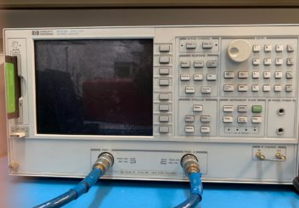[Zoom](http://www.ultimatesolutionscorp.com/gallery/electro-mechanical-assembly-test-capabilities)

[**Electro-Mechanical assembly**](http://www.ultimatesolutionscorp.com/gallery/electro-mechanical-assembly-test-capabilities)

Company Profile

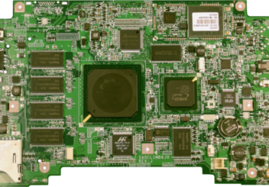[Zoom](http://www.ultimatesolutionscorp.com/gallery/pcb-assembly)

[**PCB Assembly**](http://www.ultimatesolutionscorp.com/gallery/pcb-assembly)

Manufacturing

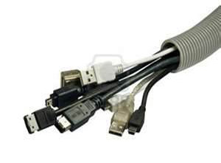[Zoom](http://www.ultimatesolutionscorp.com/gallery/cables)

[**Cables**](http://www.ultimatesolutionscorp.com/gallery/cables)

Test Capabilities

* [1](http://www.ultimatesolutionscorp.com/)

We will review the manufacturibility of your design(DFM) and suggest improvements if you desire.

[Get Quote](http://www.ultimatesolutionscorp.com/?page_id=89)

[Back to top](http://www.ultimatesolutionscorp.com/)

**Contact Us**

1425 Koll Circle, Bldg 107  
San Jose, CA – 95112  
  
sales@ultimatesolutionscorp.com   
  
Tel. 1.408.437.9449

About Us

* [Home](http://www.ultimatesolutionscorp.com/)
* Company Profile

Company Profile

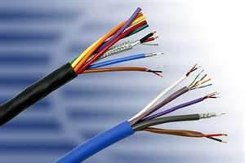

ULTIMATE Solutions is an ISO9002 compliant company that provides the Global Turnkey Manufacturing Solution, for more than 20 years in the heart of silicon valley which includes electronics assembly, testing, PCB Layout, Product design and software development for the RF, Microwave, Wireless, and High-speed digital data communications and software industry. In addition, it provides complete manufacturing solutions for the Fiber-optics industry Electro-optical components.

**WHY US**

Ultimate Solutions Primary goal is to build long lasting relationships with all of our customers by providing them with Cost-effective manufacturing solutions. We take great pride in Providing high-quality Services, and customer satisfaction.

http://www.ultimatesolutionscorp.com/wp-content/themes/qresponsive/images/icons/question.png**WHAT WE OFFER**

• Lead-Free Soldering  
• PCB Assembly  
• Surface Mount  
• Thru-hole (PTH)  
• BGA / Micro BGA/QFN/CSP  
• 0402 & 0201 Packages  
• Micro-electronics Assembly  
• Electro-Mechanical assembly  
• System / Module Integration  
• Box Build  
• Testing: RF, Functional  
• Product Design  
• PCB Layout  
• Web Design  
• Software Development

**OUR MISSION**

It is Ultimate Solutions consistently exceed our customers expectation:

• Performance  
• Reliability / Quality  
• Delivery/Cost

**ORGANIZATION**

• Chief Executive Officer  
• Vice President of Operation  
• Vice President of Quality Assurance  
• Vice President of Engineering  
• Vice President of Marketing and Sales  
• Chief Financial Officer

Manufacturing

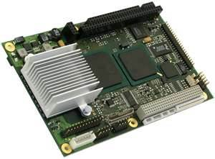

Ultimate Solutions have been providing complete Global Manufacturing solutions for more than 20 years which includes PCB Assembly, Box Build, Cables, testing, design, software development, and web design.

Our production services are flexible and based on the customer needs and can handle the low volume and high volume production of both high and low-mix products.

It is Ultimate Solutions’ policy to provide the Highest Quality, Defect Free Products, and Excellent Service, which consistently satisfy the Quality requirements of our Customers.

Ultimate Solutions , offers assembly of lead-free (Pb-Free) and RoHS and WEEE-compliant circuit board assemblies.

http://www.ultimatesolutionscorp.com/wp-content/themes/qresponsive/images/icons/info.png**TEST CAPABILITIES**

» RF/ Microwave  
» Network Analysis  
» Frequency Response  
» Spectrum Analysis  
» Functional  
» Optical Analysis

http://www.ultimatesolutionscorp.com/wp-content/themes/qresponsive/images/icons/bulb.png**QUALITY SYSTEM**

• Quality Audit  
• ESD Control  
• Supplier Qualification  
• SPC  
• Calibration  
• Training  
• Corrective and preventive action  
• NPI  
• ON TIME DELIVERY

http://www.ultimatesolutionscorp.com/wp-content/themes/qresponsive/images/icons/bubble.png**MANUFACTURING CAPABILITIES**

**SERVICE LIST**

**» Assembly:**  
• PCB assembly  
• Lead Free Soldering  
• Flex Circuit Assembly  
• Pin Thru-hole (PTH)  
• Surface Mount  
• Burn-in Boards  
• Electro-Mechanical assembly  
• System / Module Integration

**» Optics:**  
• Laser Installation  
• Fiber Splicing  
• Connectorization

**» Cables:**  
• Flex cable  
• Wire wrap  
• RF Cables (Coax)  
• Custom Power & Ground  
Harnesses

Test Capabilities

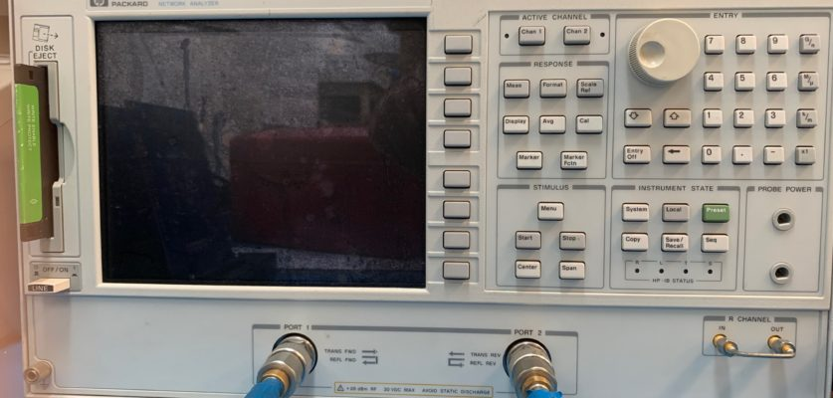

**Reliability Testing and Verification:**

We can support your requirements for a variety of reliability testing. Ultimate Solutions Corporation has extensive experience with the reliability testing, environmental testing and root cause analysis of: bare printed circuit boards (PCB), plated through hole (PTH), surface mount (SMT), and press-fit interconnects. Our engineers are well versed in destructive and non-destructive test methods. The Ultimate Solution Corporation Team can support your requirements in-house, or manage them through one of our subcontractors.

**PRODUCTS LIST**

• RF/ Microwave  
• Network Analysis  
• Frequency Response  
• Spectrum Analysis  
• Functional  
• Digital  
• Optical Analysis

Information Technology Staffing



Information Technology Staffing is a leading supplier of IT specialists on a national scale. We supply our teams of IT specialists on a contract or permanent basis. Our information technology staffing teams specialize in projects ranging from system integration and administration to network security, Software Applications and technical support in following Industries:

• Telecommunications  
• Finance  
• Banking and Mortgage  
• HealthCare/Biotechnology  
• Utilities/Transportation  
• Automobile  
• Aviation  
• High Tech services  
• Retail  
• Entertainment and Gaming  
• eCommerce  
• Federal/State  
Experties:  
• ERP/CRM: Oracle Applications, SAP, Siebel, People soft, Broad vision  
• Databases: Oracle, SQL, Informix, Sybase, SQL Server & DB2  
• Development Tools: C, C++, Visual C++, C#, COM/DCOM, COM+, Visual Basic, UML, SOAP, data dynamics, active reports, crystal reports, Monarch data pump, kernel level drivers, Windows WDM Drivers, Printer and USB and Network drivers, driver development tools like DDK, SDK and softIce, Kofax Ascent Capture Server, Oracle developer, Unix Shell Script.  
• Web Tools: J2EE, Java, JSP, Java Servlets, RMI, EJB, XML, .NET, ASP, ASP.NET, VB.NET, XML technologies (XSLT, XPATH, XSD and DTD), XML Parsers technologies (SAX/DOM), Jess Rule engine, Visual Interdev, MTS, PERL, CGI, IBM Content Management Software, Struts, eCatalog, Web services.  
• Web / Application Servers: Web Objects, Web logic, Web Sphere, ColdFusion, ATG, Netscape, IIS, commerce server 2000, Oracle, SQL Server, ASP.NET, Visual Basic, Active Directory  
• Datawarehousing: Business Objects, Brio, Informatica, Microstrategy, Cognos, Ascential & ERWIN.  
• Operating Systems: NT, UNIX, LINUX  
• Systems Or Oracle Database Administrators with experience in designing, administering, supporting, installation, maintenance of several of the following: UNIX, Windows, Windows NT; LINUX, Sun Solaris, AIX, HP; LAN/WAN Administration, Oracle Or Sybase Database Administration & CISCO Engineering, Oracle Portal and OEM; database administration on Oracle Data ware housing and OWB, Shareplex

Design

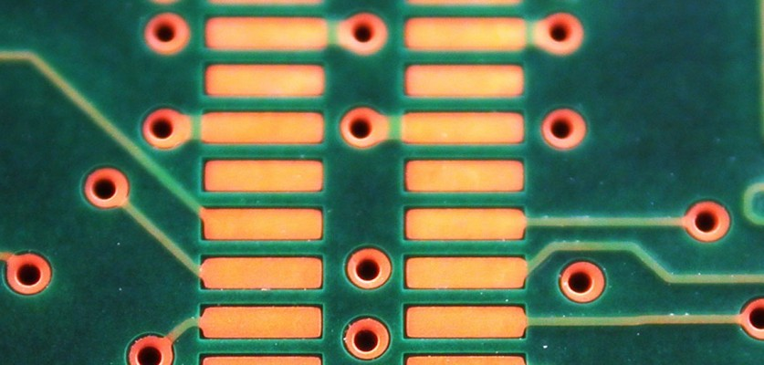

**HARDWARE DESIGN**

• Product Design  
• Fixture Design  
• RF  
• Socket Design  
• Digital  
• High Speed  
• Power Supply Design  
• PCB layout Designs (up to 26 layers)  
• Burn-in  
• RF / Microwave  
• Digital  
• Load Board  
• Optical Passive Component Design

**SOFTWARE DESIGN**

• Test Design  
• PC Software  
• Embeded Software  
• Firmware Development

**OTHER SERVICES**

• Design for Manufactureability(DFM)  
• Set up Manufacturing Operations using world class  
• Manufacturing Techniques  
• Demand Flow Technology(DFT)  
• Continuous Flow  
• Just in Time (JIT)  
• Regulatory Compliance  
• Telecordia Qualification  
• Reliability Management  
• Environmental Testing  
• ESD Compliance

**SOFTWARE DESIGN**

• Web Design & Development  
• Data Base  
• Applications:  
• Mobile  
• Andorid  
• IPhone  
• Webbase  
• Big Data ‘  
• Apex Software  
**• Cloud computing**  
• Infrastructure as a service (IaaS)  
• Platform as a service (PaaS)  
• Software as a service (SaaS)  
• Storage as a service (STaaS)  
• Security as a service (SECaaS)  
• Data as a service (DaaS)  
• Database as a service (DBaaS)  
• Test environment as a service (TEaaS)  
• Desktop virtualization  
• API as a service (APIaaS)  
• Backend as a service (BaaS)

**WE USE THESE SOFTWARE**

Allegro, Protel, OrCAD, Express PCB, Eagle, Visual Basic, Camtastic, Java, AutoCAD, Solid Works etc.

Quote

Simply fill out the form below and we will quote from the information you provide here. If you have an urgent question, please contact Ultimate Solutions representative at (408)437-9449 or email to sales@ultimatesoultionscorp.com.

Top of Form

Your Name (required)  


Company (required)  


Addess (required)  


City (required)  


State (required)  


Zip Code (required)  


Country (required)  


Your Email (required)  


Phone (required)  


Fax  


Part No.  


Qty  


Turn Days  


Subject (required)  


Your Message (required)  


Bottom of Form

Contact Us

1425 Koll Circle, Bldg 107  
San Jose, CA – 95112  
  
sales@ultimatesolutionscorp.com   
  
Tel. 1.408.437.9449

[View Small Map](https://maps.google.com/maps?f=q&source=embed&hl=en&geocode=&q=1425+Koll+Circle,+Bldg+107+San+Jose,+CA+%E2%80%93+95112&sll=44.001231,-71.566139&sspn=3.80095,7.69043&vpsrc=0&ie=UTF8&hq=&hnear=1425+Koll+Cir,+San+Jose,+California+95112&t=m&z=14&ll=37.365171,-121.905792)

Connect With Us

loading tweets...

Recent Posts

* [Ultimate Solutions Corp](http://www.ultimatesolutionscorp.com/archives/20)

Apr 20 - about

Contact Us

Top of Form

Your Name (required)  


Your Email (required)  


Subject  


Your Message  




Bottom of Form

**Company Address:**

1425 Koll Circle, Bldg 107  
San Jose, CA – 95112

sales@ultimatesolutionscorp.com

**Tel.** 1.408.437.9449