

**TEAM**

**17**

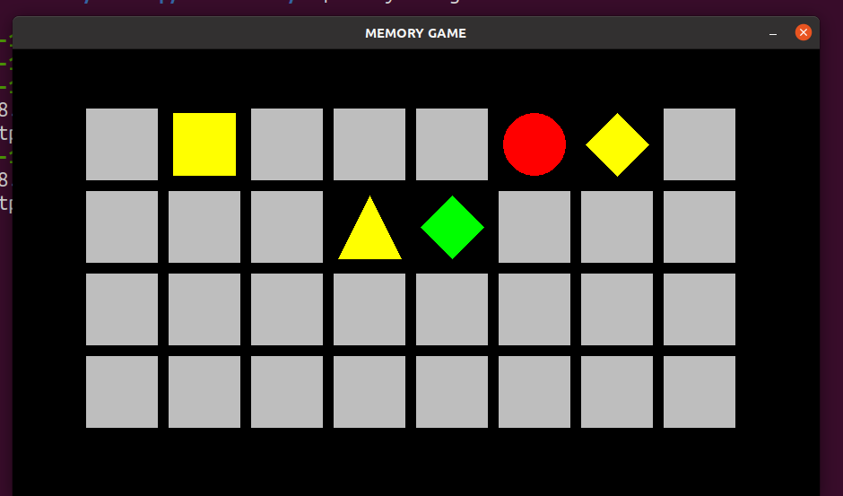  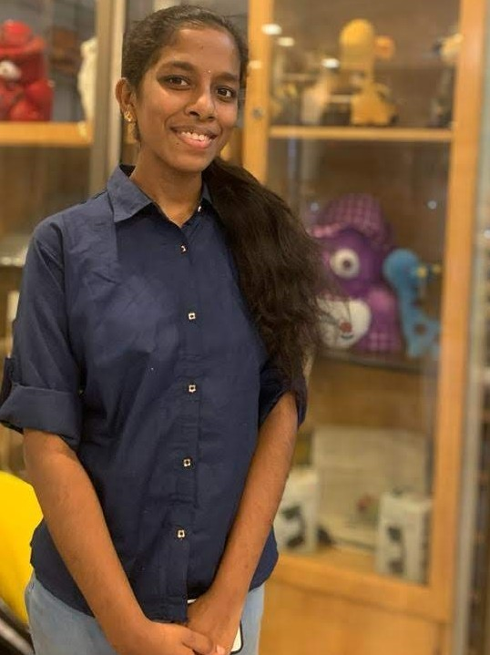

A.Satya Anusha K.Divya K.Bhargavi

**18WH1A1201**  **18WH1A1258**   **18WH1A1224**

**Github Links:**

<https://github.com/KujalaDivya25/Hobby_Project>

<https://github.com/Satya-Anusha/Hobbyproject>

<https://github.com/bhargaviK1224/hobbyproject>

**Team members**:

**Tools and Technologies:**

* Python 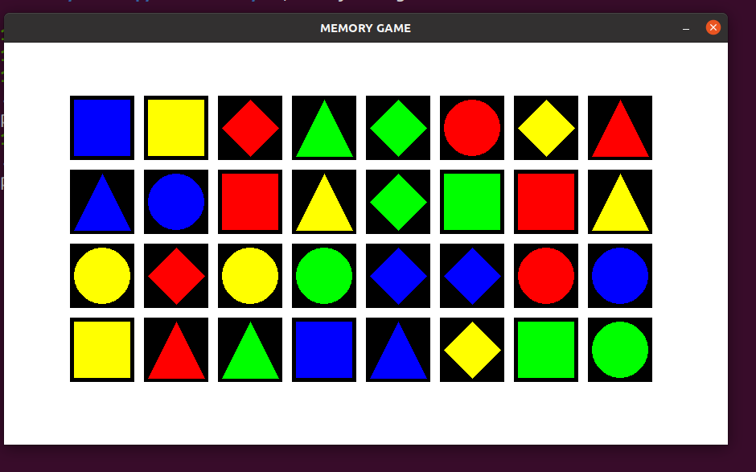3.6
* Terminal
* Pygame

**Conclusion and Future Scope:**

In this project, we produced an easy memory game in the basic form using python. We would like to further develop this with higher speed rate and also add in score board. Connect this score board to social networking sites.

**Game Screenshots**

**Modules**

pygame

random

itertools

**MEMORY PUZZLE**

**Abstract:**

"Memory" is a fun game that you may have played in "real life", with actual paper tiles. It's called that because the main skill in the game is your memory - how well you can remember the position of tiles.When the game starts, all tiles are turned face down.The player then flips over two cards, selecting them by clicking on them.If the two tiles have the same image, they remain face up. If not, they should be flipped face down again after a short delay.

**BVRIT HYDERABAD**

**College of Engineering for Women**

**Department of Information Technology**

**Hobby Project – III B.Tech I Sem - Academic Year 2020-21**