STUDENT MANAGEMENT CRUD WEB APPLICATION
1. INTRODUCTION
The Student Management CRUD Web Application is a web-based application developed to manage student information in an organized and efficient manner. The application allows users to add, view, update, and delete student records through a simple web interface.
The project follows a client-server architecture in which the frontend provides the user interface, while the backend handles the application logic and communication with the database. REST APIs are used to connect the frontend and backend.
The application stores student details such as student name, email, department, year, and phone number. Basic validation is also implemented to ensure that the entered information is in the required format.
The project demonstrates the practical implementation of frontend development, backend development, REST API integration, database connectivity, CRUD operations, validation, testing, and Git-based version control.

2. OBJECTIVE
The main objective of this project is to develop a functional CRUD-based web application for managing student records.
The objectives of the project are:
- To create a simple and user-friendly frontend for student management.
- To develop a backend application using Spring Boot.
- To implement REST APIs for communication between frontend and backend.
- To connect the application with a database using Spring Data JPA.
- To perform CRUD operations on student records.
- To implement basic input validation.
- To test the REST APIs using Postman.
- To maintain the project using Git and GitHub.

3. TECHNOLOGIES USED
The following technologies and tools were used to develop the application:
Technology / Tool | Purpose
HTML | Creating the structure of the web page
CSS | Designing and styling the frontend
JavaScript | Implementing frontend functionality and API communication
Java | Backend programming
Spring Boot | Developing the backend application
Spring Web | Creating REST APIs
Spring Data JPA | Database operations and persistence
H2 Database | Storing student records
Maven | Project build and dependency management
Postman | Testing REST APIs
Git | Version control
GitHub | Hosting and managing the project repository
Visual Studio Code | Development environment

4. SYSTEM DESCRIPTION
The Student Management CRUD Web Application consists of three main components:
4.1 Frontend
The frontend provides the interface through which users can manage student records. It is developed using HTML, CSS, and JavaScript.
The frontend provides options to:
- Add a new student.
- View existing student records.
- Edit student information.
- Delete student records.
- Search student records.
- Validate the phone number before submitting the form.
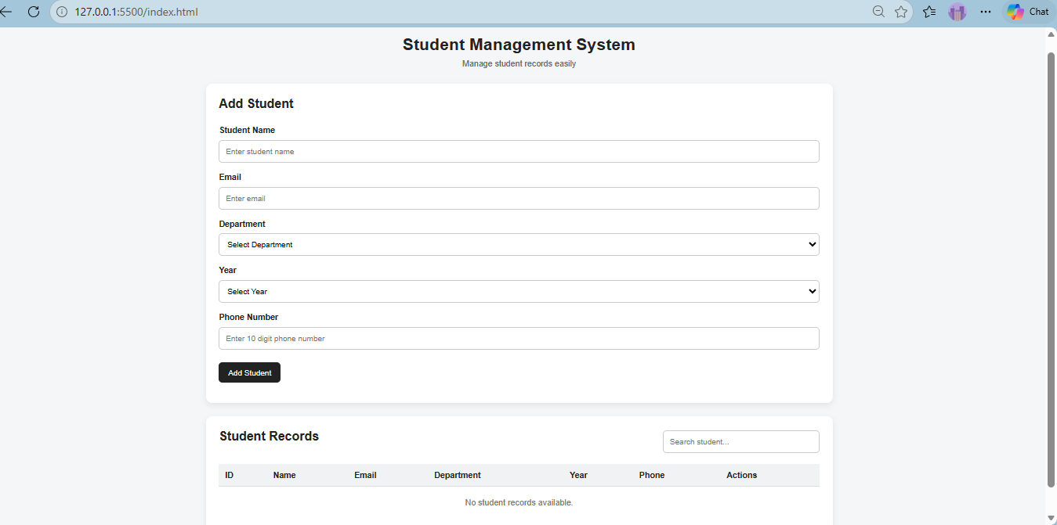
Figure 1: Student Management Web Interface
4.2 Backend
The backend is developed using Java and Spring Boot. It receives requests from the frontend through REST APIs and performs the required operations.
The backend consists of:
- Model – Represents the student data.
- Repository – Handles database operations.
- Service – Contains the application logic.
- Controller – Provides REST API endpoints.
4.3 Database
The application uses the H2 database to store student information. Spring Data JPA is used to perform database operations without writing SQL queries for basic CRUD operations.
The database stores the following student details:
- Student ID
- Name
- Email
- Department
- Year
- Phone Number

5. PROJECT STRUCTURE
The project is organized into frontend and backend components.
Frontend
The frontend contains the following files:
- index.html – Defines the structure of the user interface.
- style.css – Provides styling for the web page.
- script.js – Handles user actions, validation, and communication with the backend API.
Backend
The backend contains the following main components:
- Student.java – Entity/model class representing student details.
- StudentRepository.java – Repository interface for database operations.
- StudentService.java – Service layer for CRUD operations.
- StudentController.java – REST controller for handling API requests.
- StudentManagementApplication.java – Main Spring Boot application class.
- application.properties – Contains application and database configuration.

6. DATABASE DESIGN
The application uses an H2 file-based database for persistent storage.
The student entity contains the following fields:
Field | Description
ID | Unique identifier for each student
Name | Name of the student
Email | Email address of the student
Department | Department of the student
Year | Current academic year
Phone | Phone number of the student
The id field is automatically generated and acts as the primary key.
The database is configured using Spring Data JPA, which maps the Java Student entity to the database table.

7. CRUD OPERATIONS
CRUD stands for Create, Read, Update, and Delete. These operations form the main functionality of the Student Management Web Application.
7.1 Create – Add Student
The Create operation is used to add a new student record to the database.
The user enters the required student details through the frontend form. When the form is submitted, the frontend sends a POST request to the backend.
The backend receives the student data and saves it into the database.
HTTP Method: POST
Endpoint:
/api/students
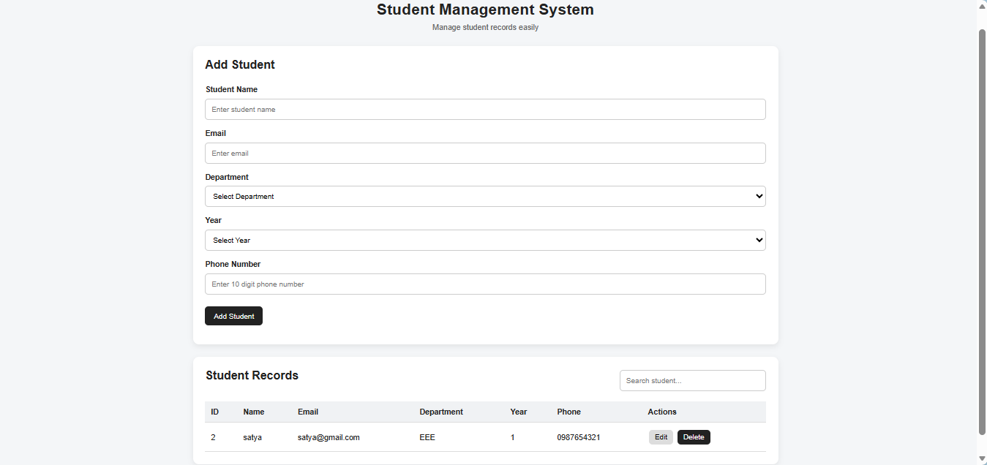
Figure 2: Adding a New Student Record

7.2 Read – View Students
The Read operation is used to retrieve student records from the database.
The application can retrieve all student records and can also retrieve a particular student using the student's ID.
HTTP Method: GET
Endpoints:
/api/students
/api/students/{id}
The retrieved information is displayed in the frontend.
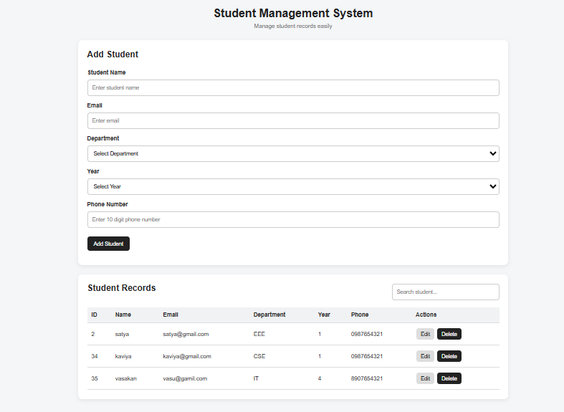
Figure 3: Viewing Student Records

7.3 Update – Edit Student
The Update operation is used to modify an existing student record.
When the user selects the edit option, the existing student details are loaded into the form. After making changes, the updated information is sent to the backend using a PUT request.
HTTP Method: PUT
Endpoint:
/api/students/{id}
The backend updates the corresponding student record in the database.
The update process is performed using the unique student ID, which helps the application identify the exact record that needs to be modified. Before updating, the backend checks whether a student with the given ID exists. If the record is found, only the required student details are changed while the existing ID remains unchanged.
The service layer is responsible for handling the update operation. It retrieves the existing record from the repository, assigns the new values to the student object, and saves the modified record back to the database. This separates the database operation from the controller and keeps the application organized.

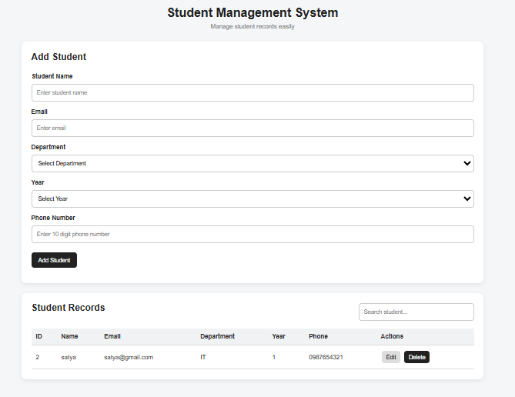
Figure 4: Updating Student Details

7.4 Delete – Delete Student
The Delete operation is used to remove a student record from the database.
When the user selects the delete option, a DELETE request is sent to the backend with the student's ID.
HTTP Method: DELETE
Endpoint:
/api/students/{id}
The corresponding student record is removed from the database.
The Delete operation is used to permanently remove an existing student record from the database. It allows the user to remove records that are no longer required. Each student is identified using a unique ID, which ensures that the correct record is selected for deletion.
When the user clicks the Delete option for a particular student, the frontend sends a DELETE request to the backend using the student's ID. The request is sent to the REST API endpoint:
DELETE /api/students/{id}
The StudentController receives the DELETE request and passes the student ID to the StudentService. Before deleting the record, the backend checks whether a student with the given ID exists. If the record exists, the service deletes it from the database through the StudentRepository.

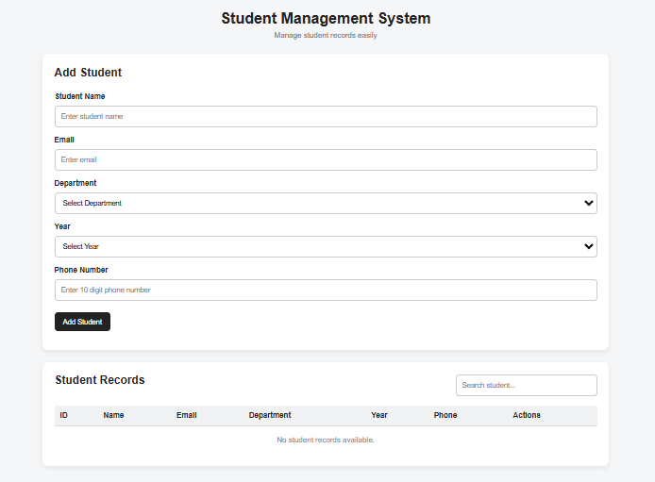
Figure 5: Deleting a Student Record

8. REST API
REST APIs are used to establish communication between the frontend and backend.
The following REST API endpoints are implemented in the application:
HTTP Method | Endpoint | Purpose
POST | /api/students | Add a new student
GET | /api/students | Retrieve all students
GET | /api/students/{id} | Retrieve a student by ID
PUT | /api/students/{id} | Update a student
DELETE | /api/students/{id} | Delete a student
The REST controller handles these requests and communicates with the service layer to perform the required operations.

9. INPUT VALIDATION
Basic validation is implemented in the frontend to prevent invalid phone numbers from being submitted.
The application checks whether the phone number contains exactly 10 numeric digits.
If an invalid phone number is entered, the application displays an appropriate validation message and prevents the invalid data from being submitted.
For example:
12345
is rejected because it does not contain 10 digits.
A valid 10-digit phone number is accepted and submitted to the backend.

10. APPLICATION WORKFLOW
The working process of the application is as follows:
- The user opens the Student Management web application.
- The frontend displays the student management form and existing records.
- The user enters student details.
- JavaScript validates the entered information.
- The frontend sends a REST API request to the Spring Boot backend.
- The controller receives the request.
- The service layer processes the request.
- The repository communicates with the H2 database.
- The requested CRUD operation is performed.
- The response is returned to the frontend.
- The updated student information is displayed to the user.

11. TESTING
Testing was performed to verify that the application functions correctly and satisfies the required CRUD operations.
11.1 Frontend Testing
The following operations were tested through the web interface:
Test Case | Operation | Result
1 | Add student | Passed
2 | View student records | Passed
3 | Edit student details | Passed
4 | Delete student record | Passed
5 | Invalid phone number validation | Passed
6 | Valid phone number submission | Passed
7 | Refresh and verify stored data | Passed

11.2 REST API Testing
The REST APIs were tested using Postman.
The following API operations were tested:
- POST request for adding a student.
- GET request for retrieving all students.
- GET request for retrieving a student by ID.
- PUT request for updating student information.
- DELETE request for deleting a student.
The API responses were verified to ensure that the required operations were performed successfully.
POST API:

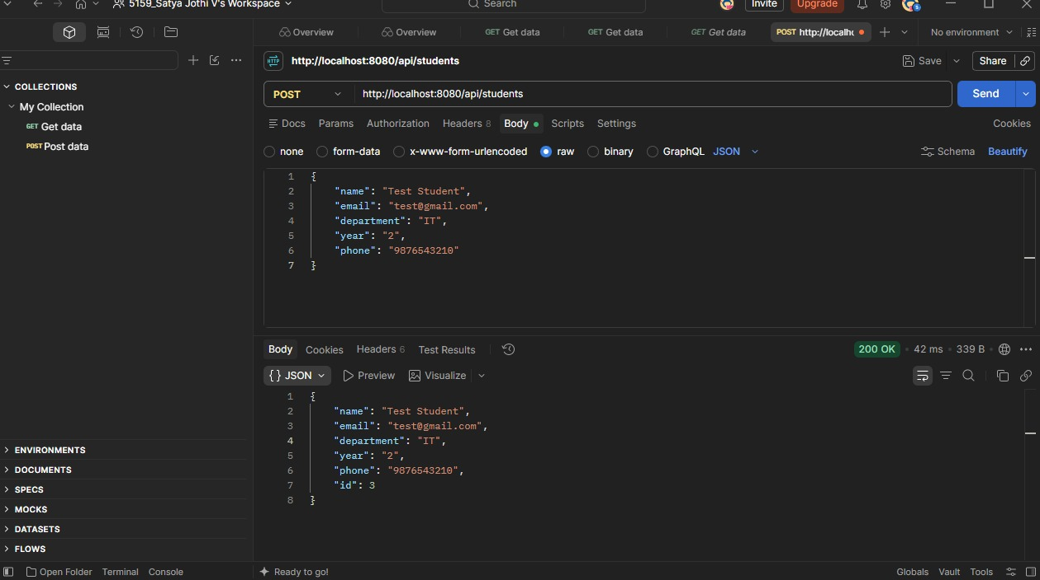
Figure 6: POST API – Adding a Student
GET All API:

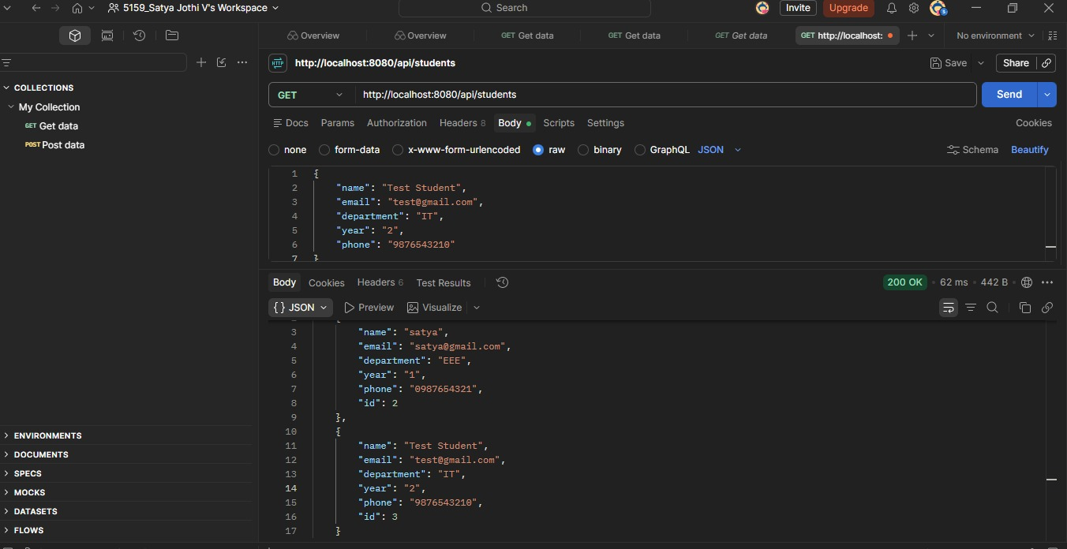
Figure 7: GET API – Retrieving All Students

GET by ID:

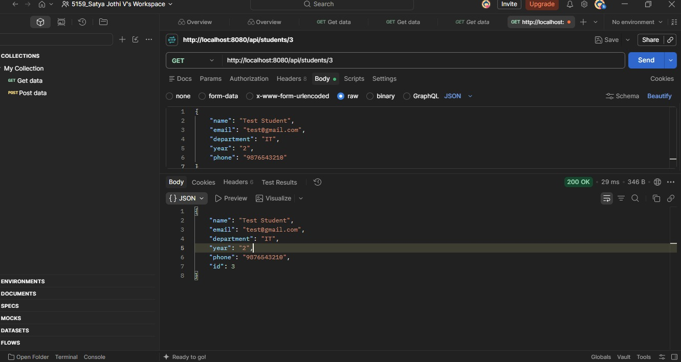
Figure 8: GET API – Retrieving Student by ID

PUT API:

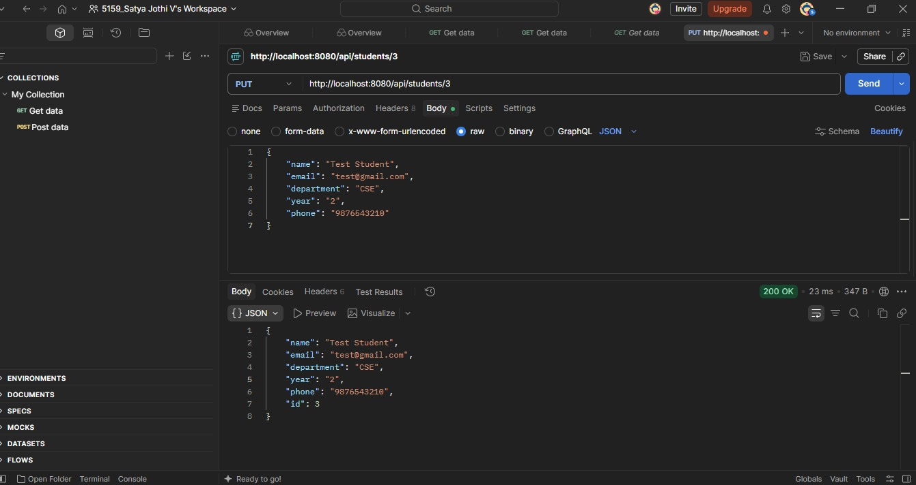
Figure 9: PUT API – Updating Student Details

DELETE API:
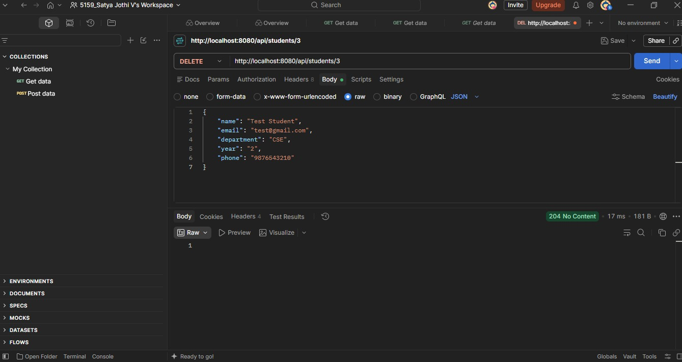
Figure 10: DELETE API – Deleting a Student

12. DATABASE PERSISTENCE
The application uses a file-based H2 database so that student records are stored persistently.
After adding student records, the application was refreshed and the records were still available. This confirmed that the data was being stored in the database rather than only being maintained temporarily in the browser.

13. GIT AND GITHUB
Git was used as the version control system for maintaining the project source code.
The project was initialized as a Git repository and the completed application was committed to the repository.
GitHub was used to host the project repository online.
The repository contains:
- Backend source code
- Frontend files
- Maven project files
- Configuration files
- Git configuration files
GitHub Repository:
https://github.com/Satya-Jothi-V422008/student-management-crud
The project was successfully pushed to GitHub using the main branch.

14. HOW TO RUN THE APPLICATION
Step 1: Start the Backend
Open the project folder in Visual Studio Code and open the terminal.
Run:
.\mvnw.cmd spring-boot:run
The Spring Boot application runs on:
http://localhost:8080
Step 2: Open the Frontend
Open the following file from the project folder:
frontend/index.html
The frontend communicates with the backend through the REST API.
Step 3: Perform CRUD Operations
The user can then:
- Add student records.
- View student records.
- Edit student records.
- Delete student records.
The backend must remain running while using the frontend.

15. RESULT
The Student Management CRUD Web Application was successfully developed and tested.
The application successfully performs the required Create, Read, Update, and Delete operations. The frontend communicates with the Spring Boot backend through REST APIs, and student information is stored in the H2 database.
Basic phone number validation was also implemented and tested. The REST APIs were tested using Postman, and the project was successfully maintained and uploaded to GitHub.

16. CONCLUSION
The Student Management CRUD Web Application demonstrates the development of a complete web application using frontend technologies, Java Spring Boot, REST APIs, and a database.
The project provides the basic functionality required to manage student records and demonstrates how the frontend, backend, REST API, and database work together. CRUD operations, validation, API testing, database persistence, and GitHub version control were successfully implemented.
This project provides practical experience in developing and testing a database-driven web application using modern software development tools and technologies.

