1. Create a Flask application with an /api route. When this route is accessed, it should return a JSON list. The data should be stored in a backend file, read from it, and sent as a response.
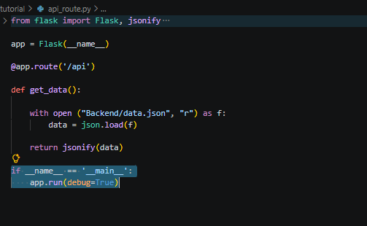
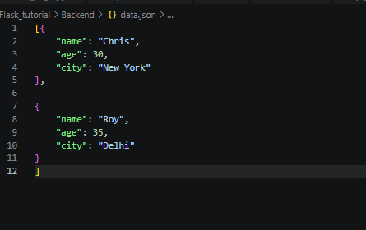
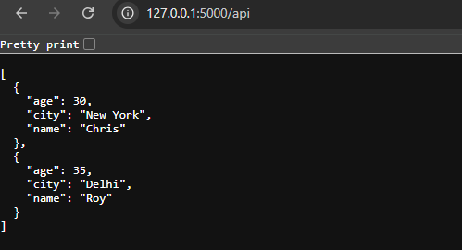
- @app.route("/api") is a decorator that tells Flask when someone visits /api, run the function below.
get_data() is just a function name — it runs whenever /api is requested.

- with open ("Backend/data.json", "r") as f:
data = json.load(f) (“It will open the data.json file from Backend folder)
json.load(f) (“it reads the file's contents and converts it from JSON text into a Python object — here, a list of dictionaries.”)
with statement automatically closes the file afterward, even if an error occurs
- if __name__ == '__main__':
app.run(debug=True)
This block only runs when you execute the script directly
app.run(debug=True), it starts the server on 127.0.0.1:5000 by default.
And (debug=True), it will automatically reload the code after code changes

