LOANZO PROTOCOL: UML USE CASE DIAGRAMS
OMG UML 2.5 Standard Architecture & Subsystem Models
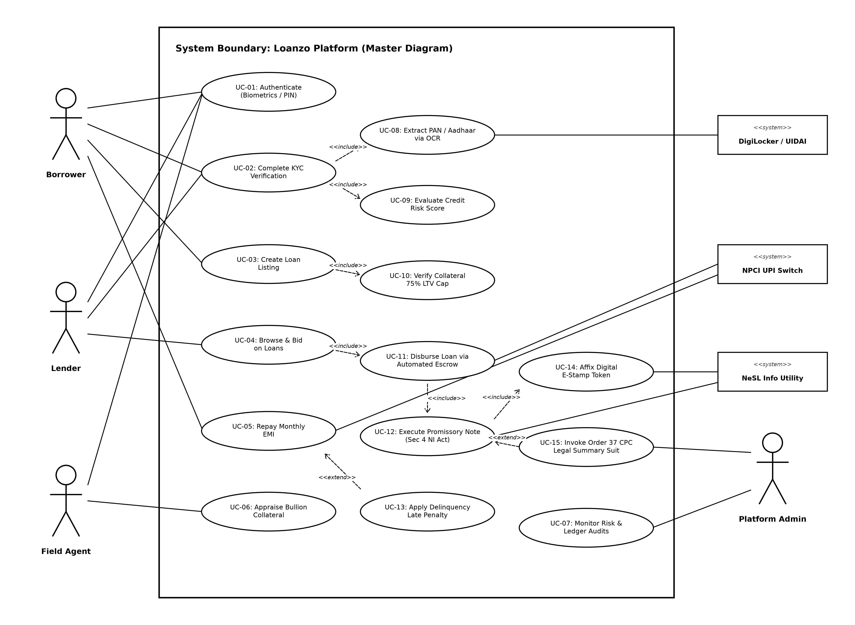
Figure 1: Master System Boundary UML Use Case Diagram (Full Platform Architecture)

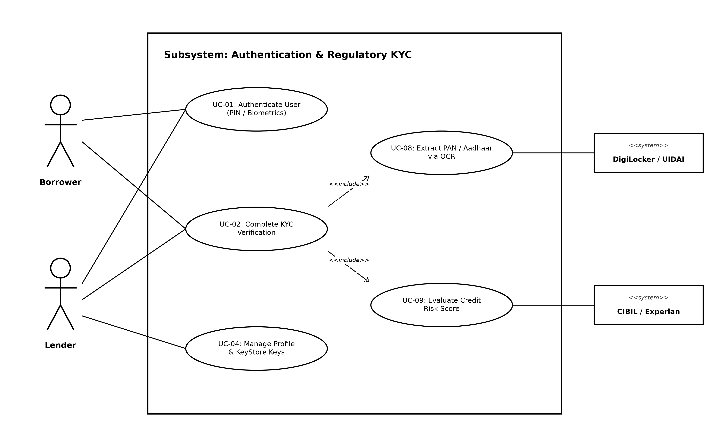
Figure 2: Subsystem 1 - Identity, Authentication & Regulatory KYC

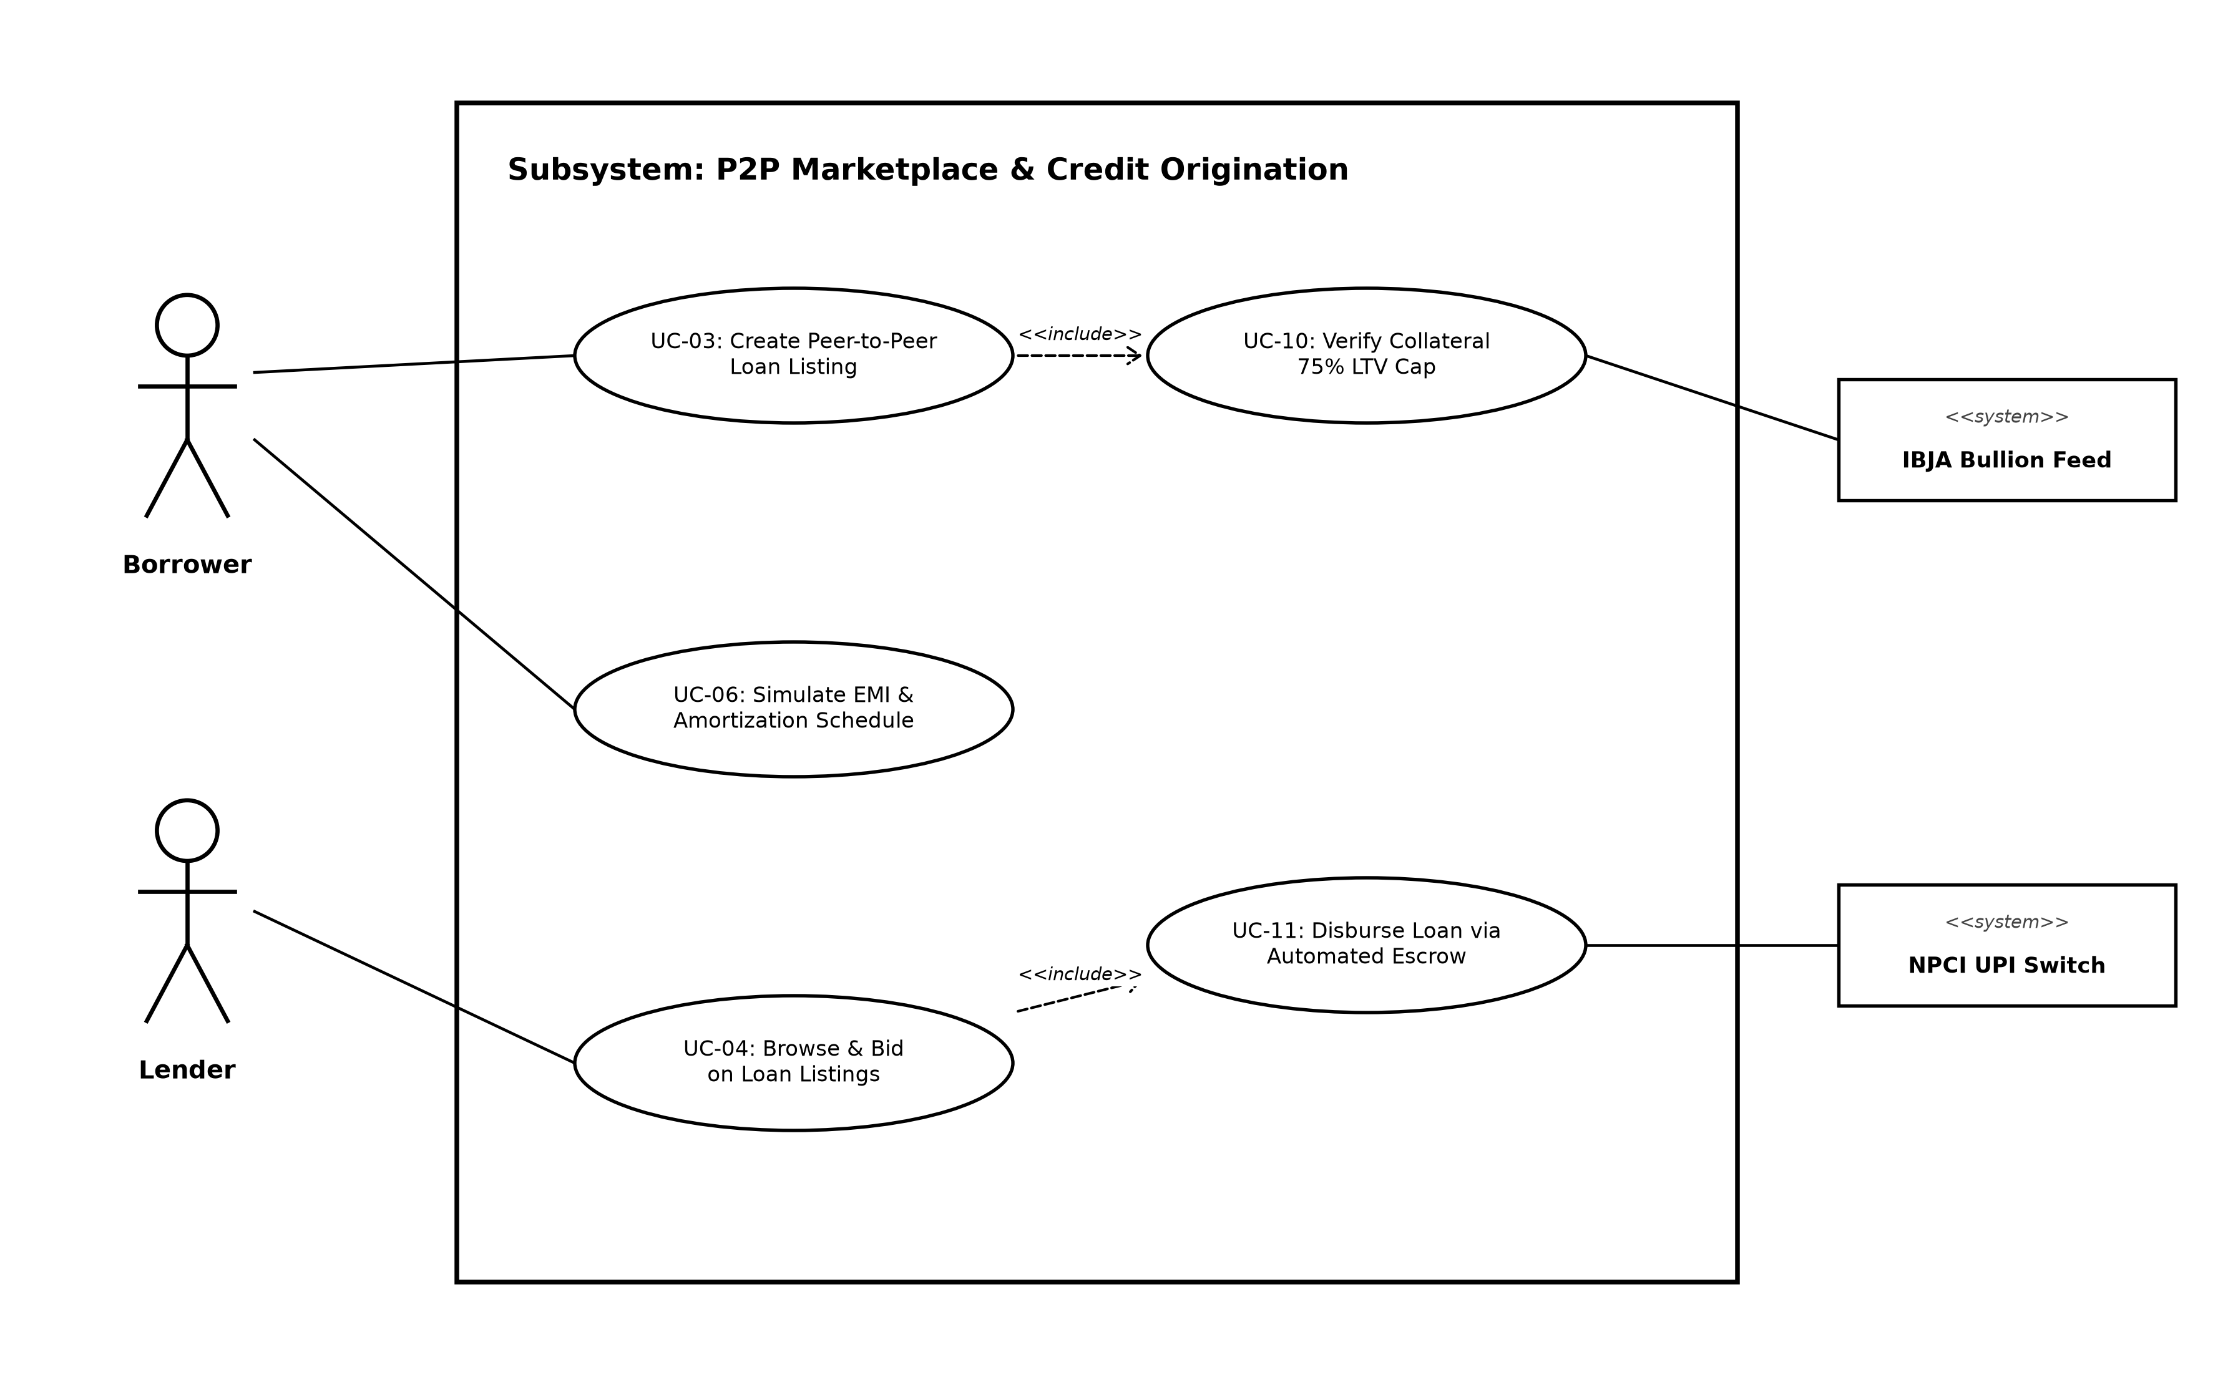
Figure 3: Subsystem 2 - Peer-to-Peer Marketplace & Credit Origination

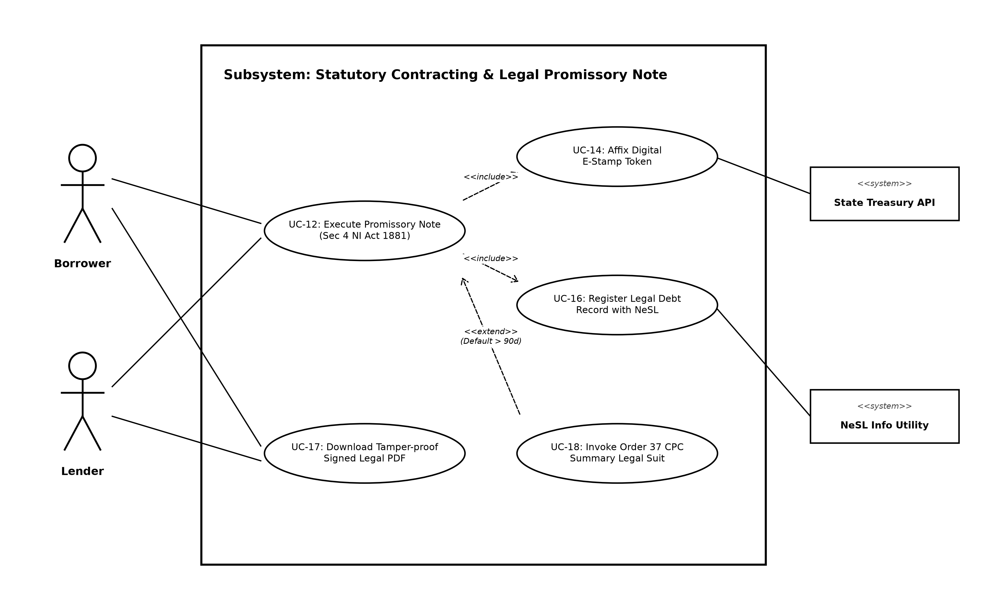
Figure 4: Subsystem 3 - Statutory Legal Contracting & Promissory Note (Sec 4 NI Act)

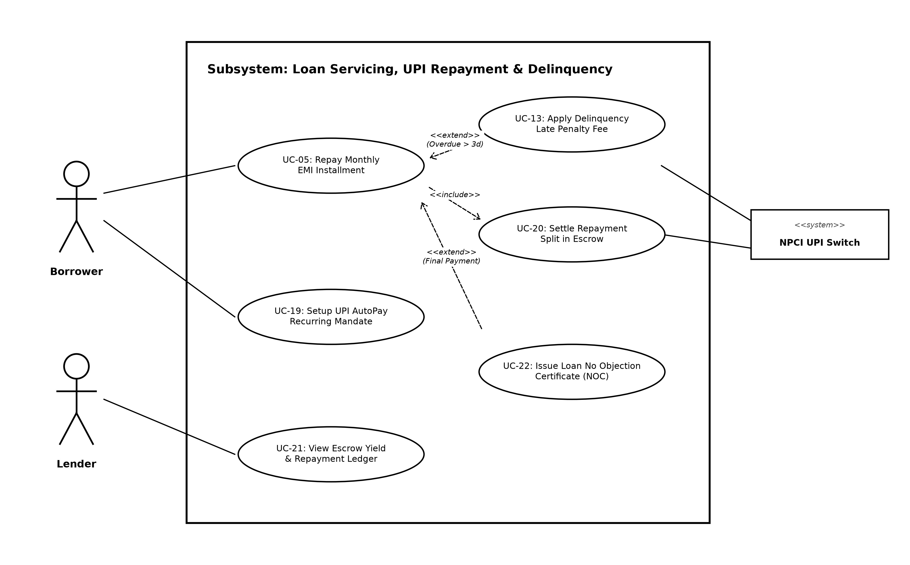
Figure 5: Subsystem 4 - Loan Servicing, UPI Repayment & Delinquency Servicing

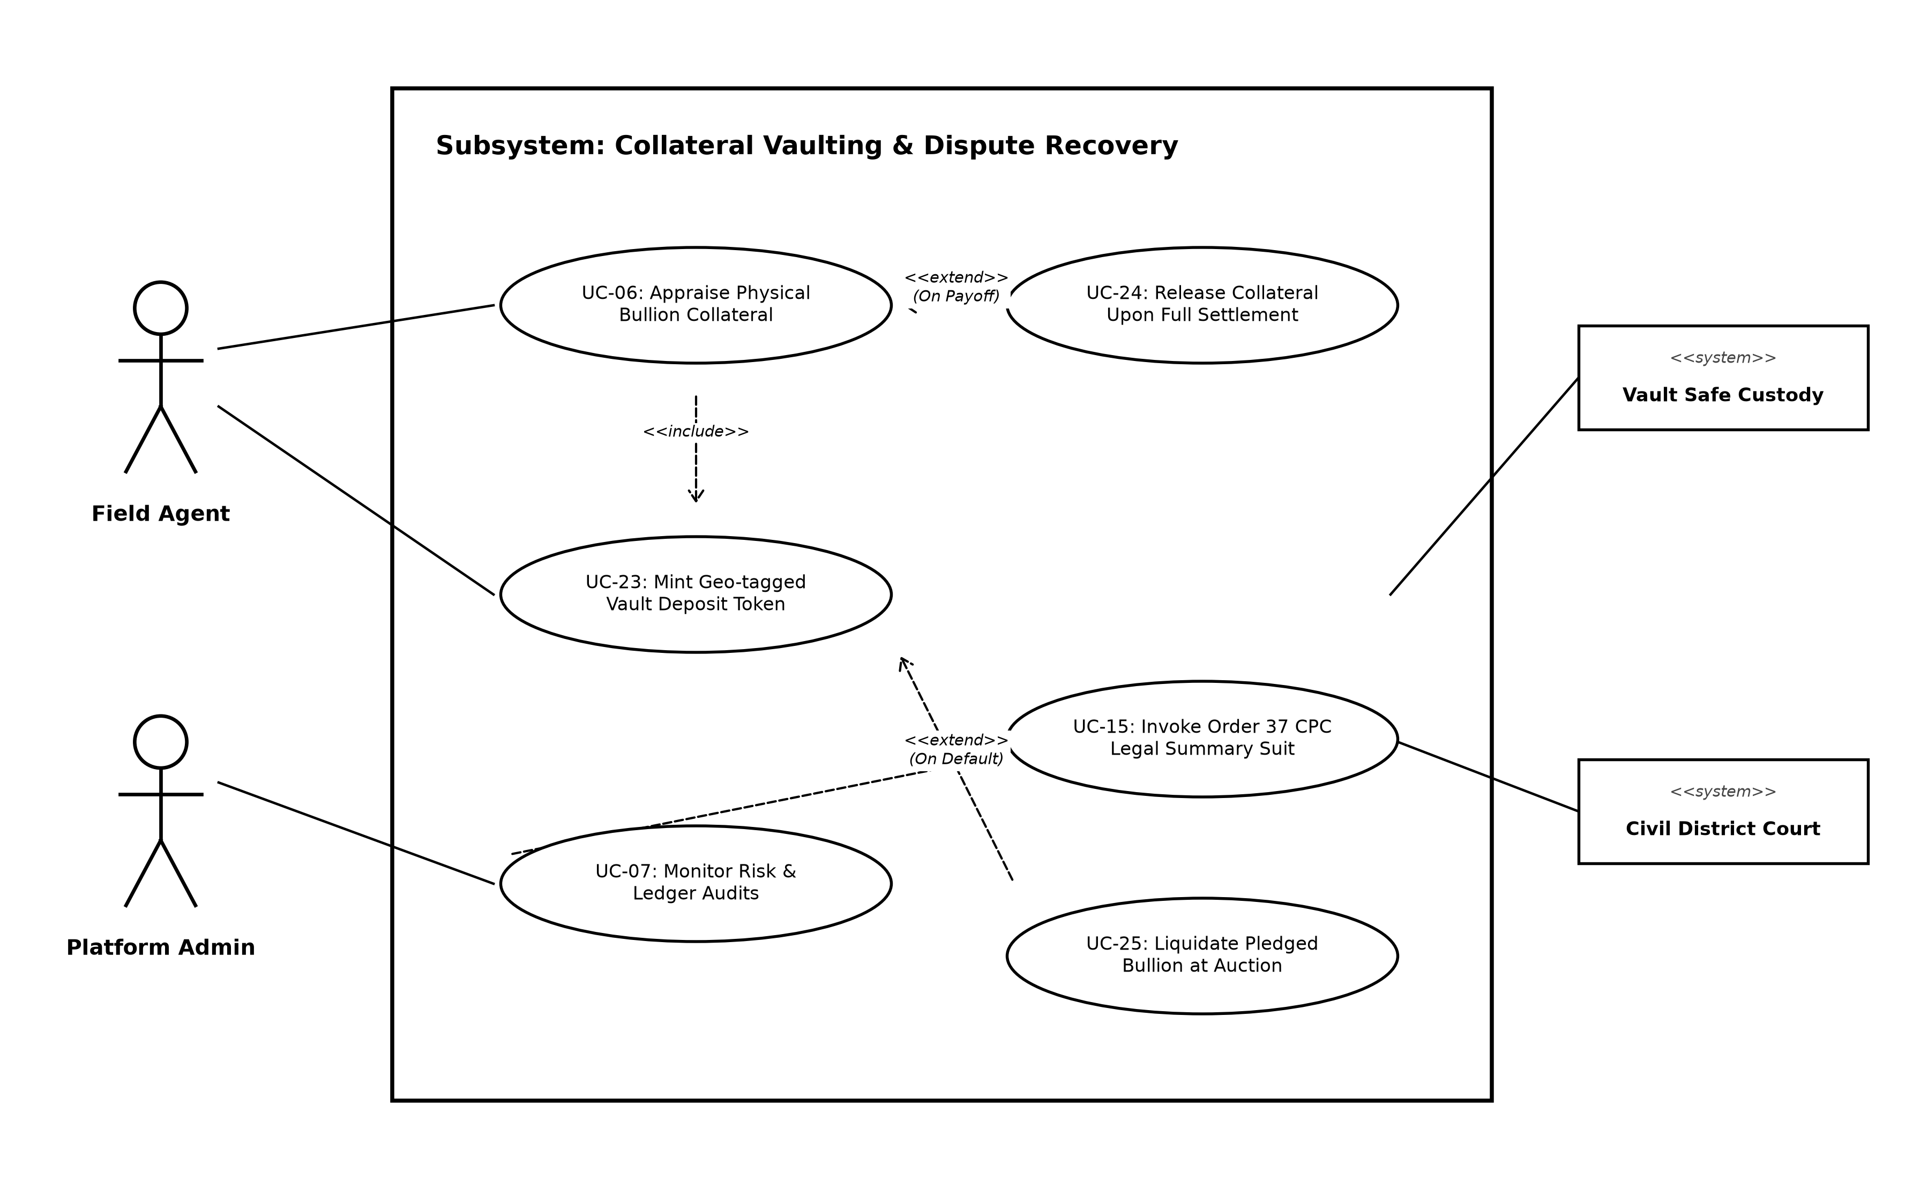
Figure 6: Subsystem 5 - Collateral Vaulting & Order 37 CPC Summary Legal Recovery

