LOANZO PROTOCOL: UML USE CASE DIAGRAMS
OMG UML 2.5 Architecture Models (Color-Coded Line Tracing, Clean Stereotypes & Multi-Party Roles)
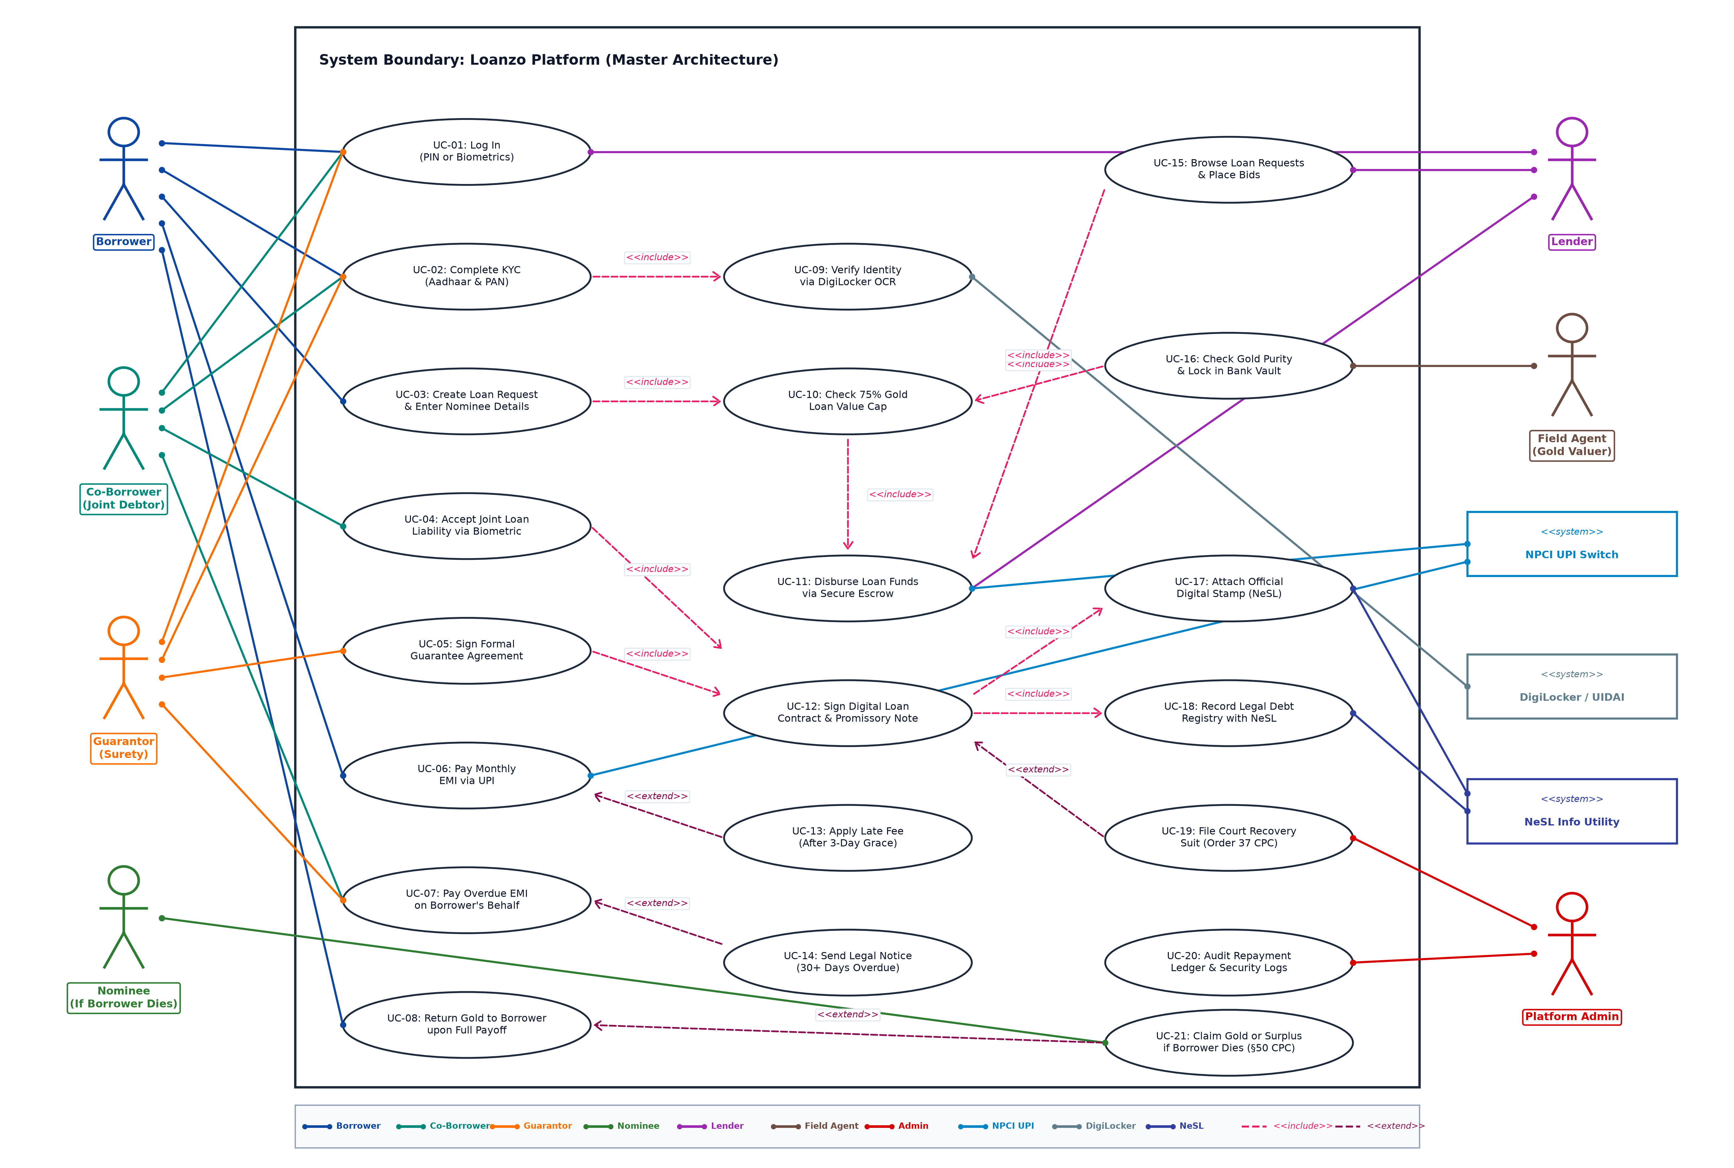
Figure 1: Master System Boundary UML Use Case Diagram (Full Architecture with Color-Coded Origin-to-Destination Associations for Borrower, Co-Borrower, Guarantor, Nominee, Lender, Field Agent & Admin)

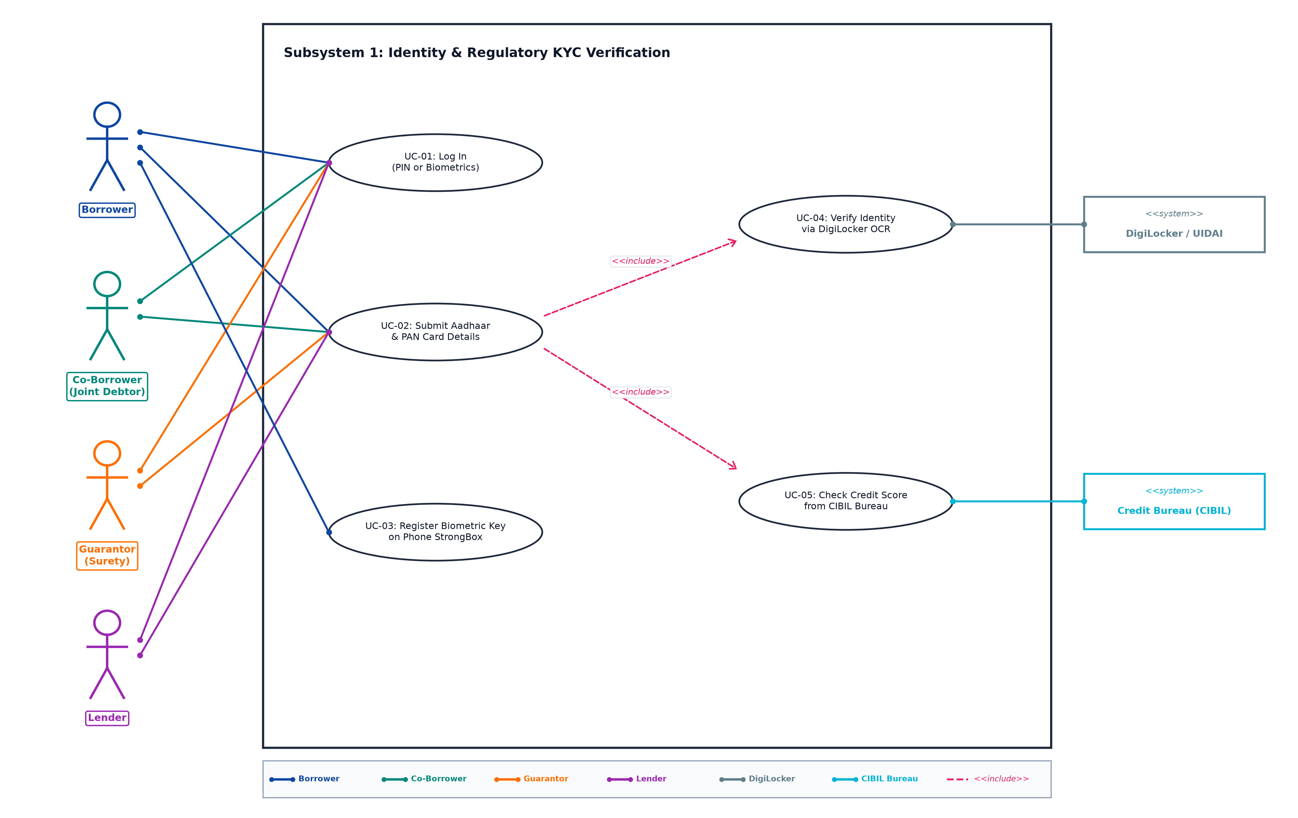
Figure 2: Subsystem 1 - Identity & Regulatory KYC Verification (Borrower [Blue], Co-Borrower [Teal], Guarantor [Amber], Lender [Purple])

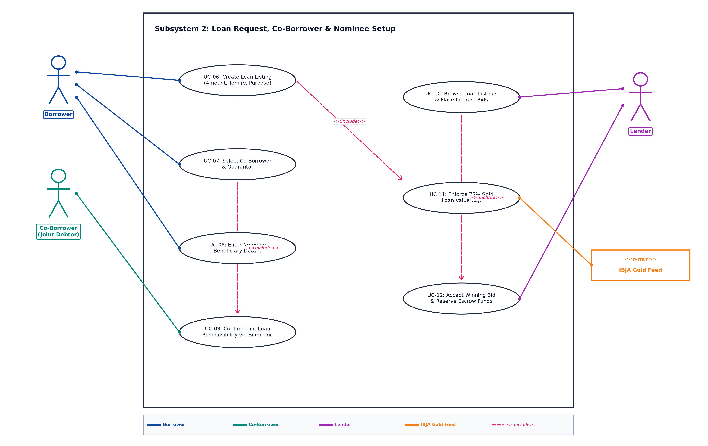
Figure 3: Subsystem 2 - Loan Request, Co-Borrower & Nominee Setup (Borrower [Blue], Co-Borrower [Teal], Lender [Purple])

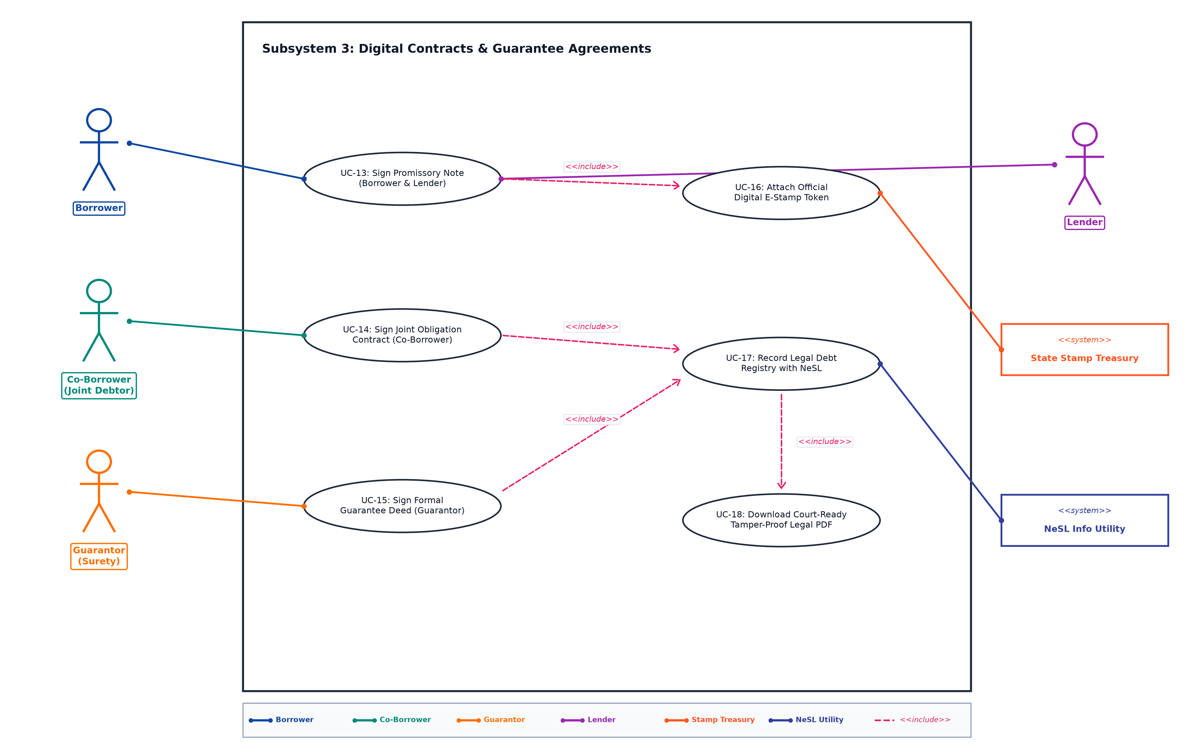
Figure 4: Subsystem 3 - Digital Contracts & Guarantee Agreements (Promissory Note & Guarantee Deeds)

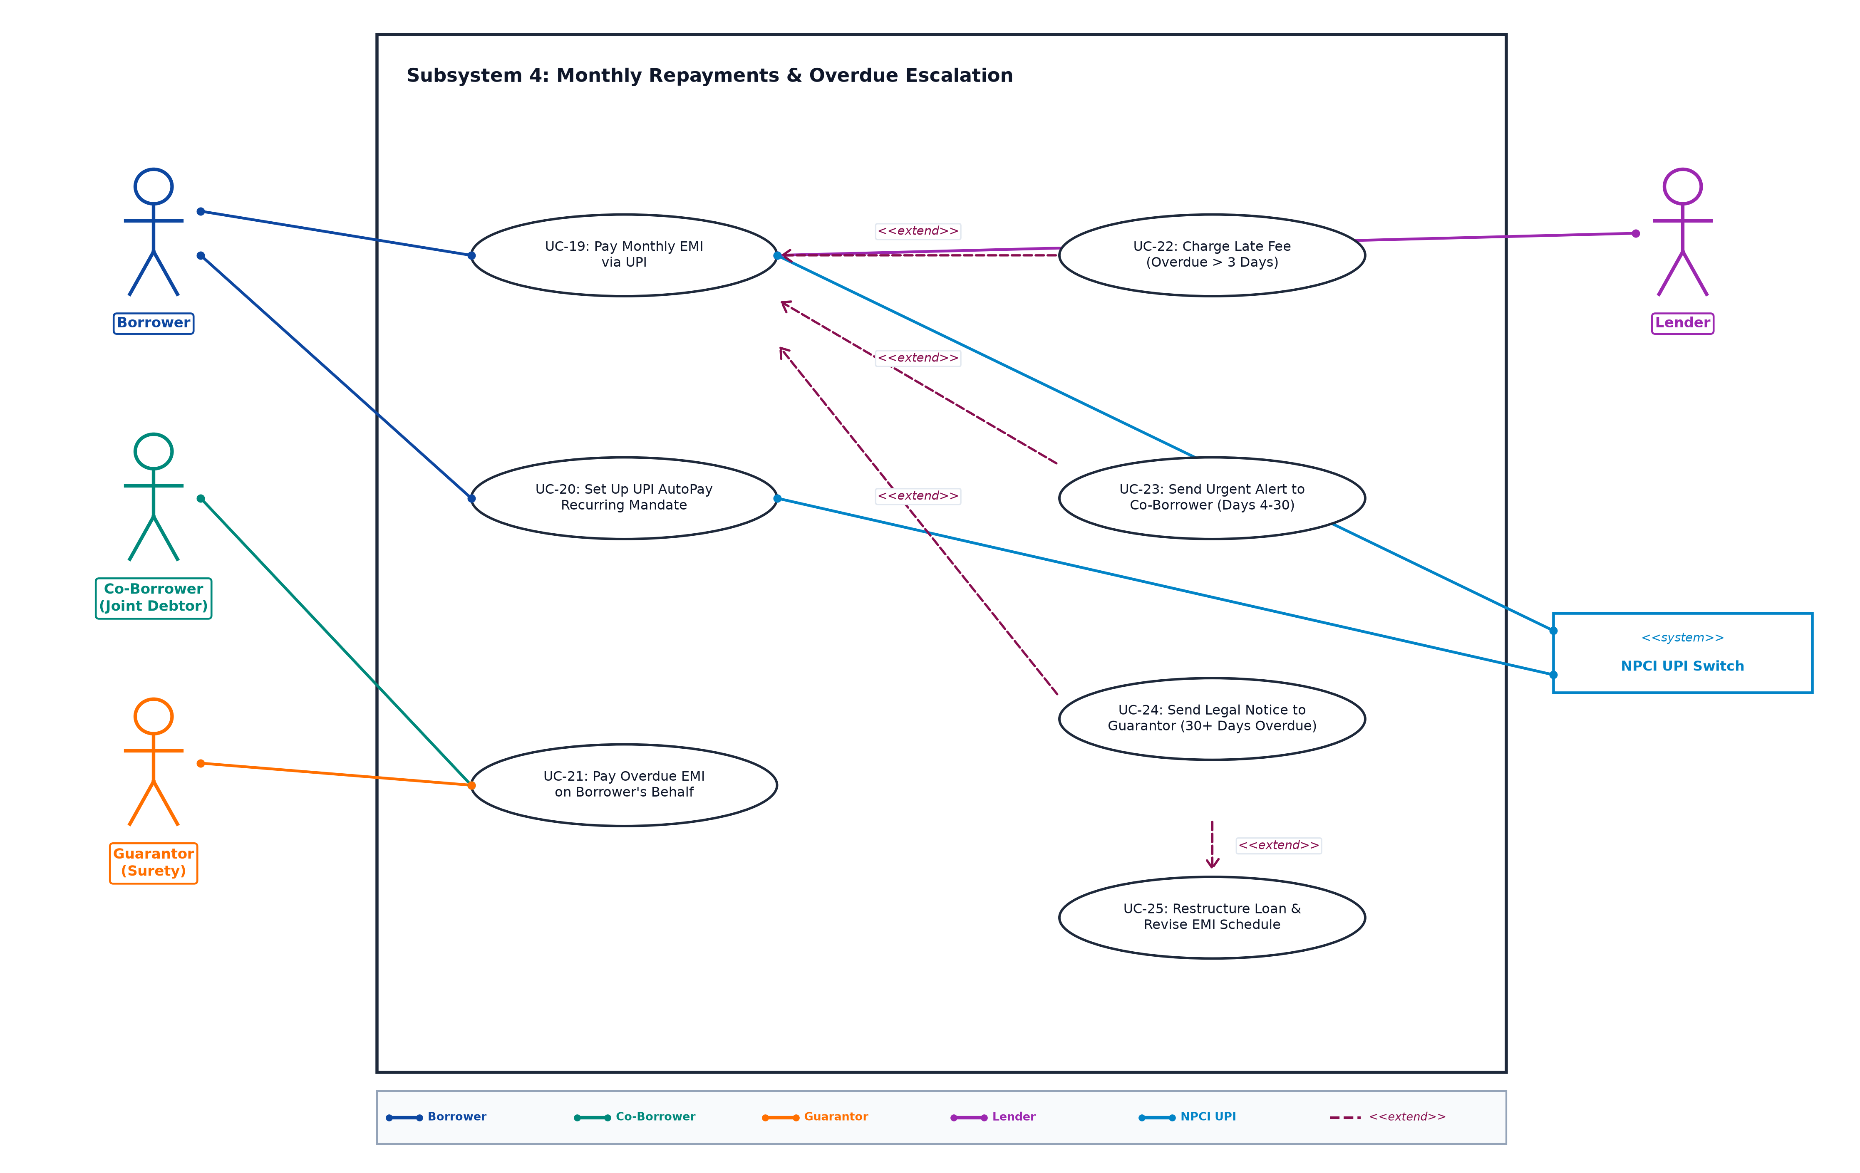
Figure 5: Subsystem 4 - Monthly Repayments & Overdue Escalation (Borrower [Blue], Co-Borrower [Teal], Guarantor [Amber], Lender [Purple])

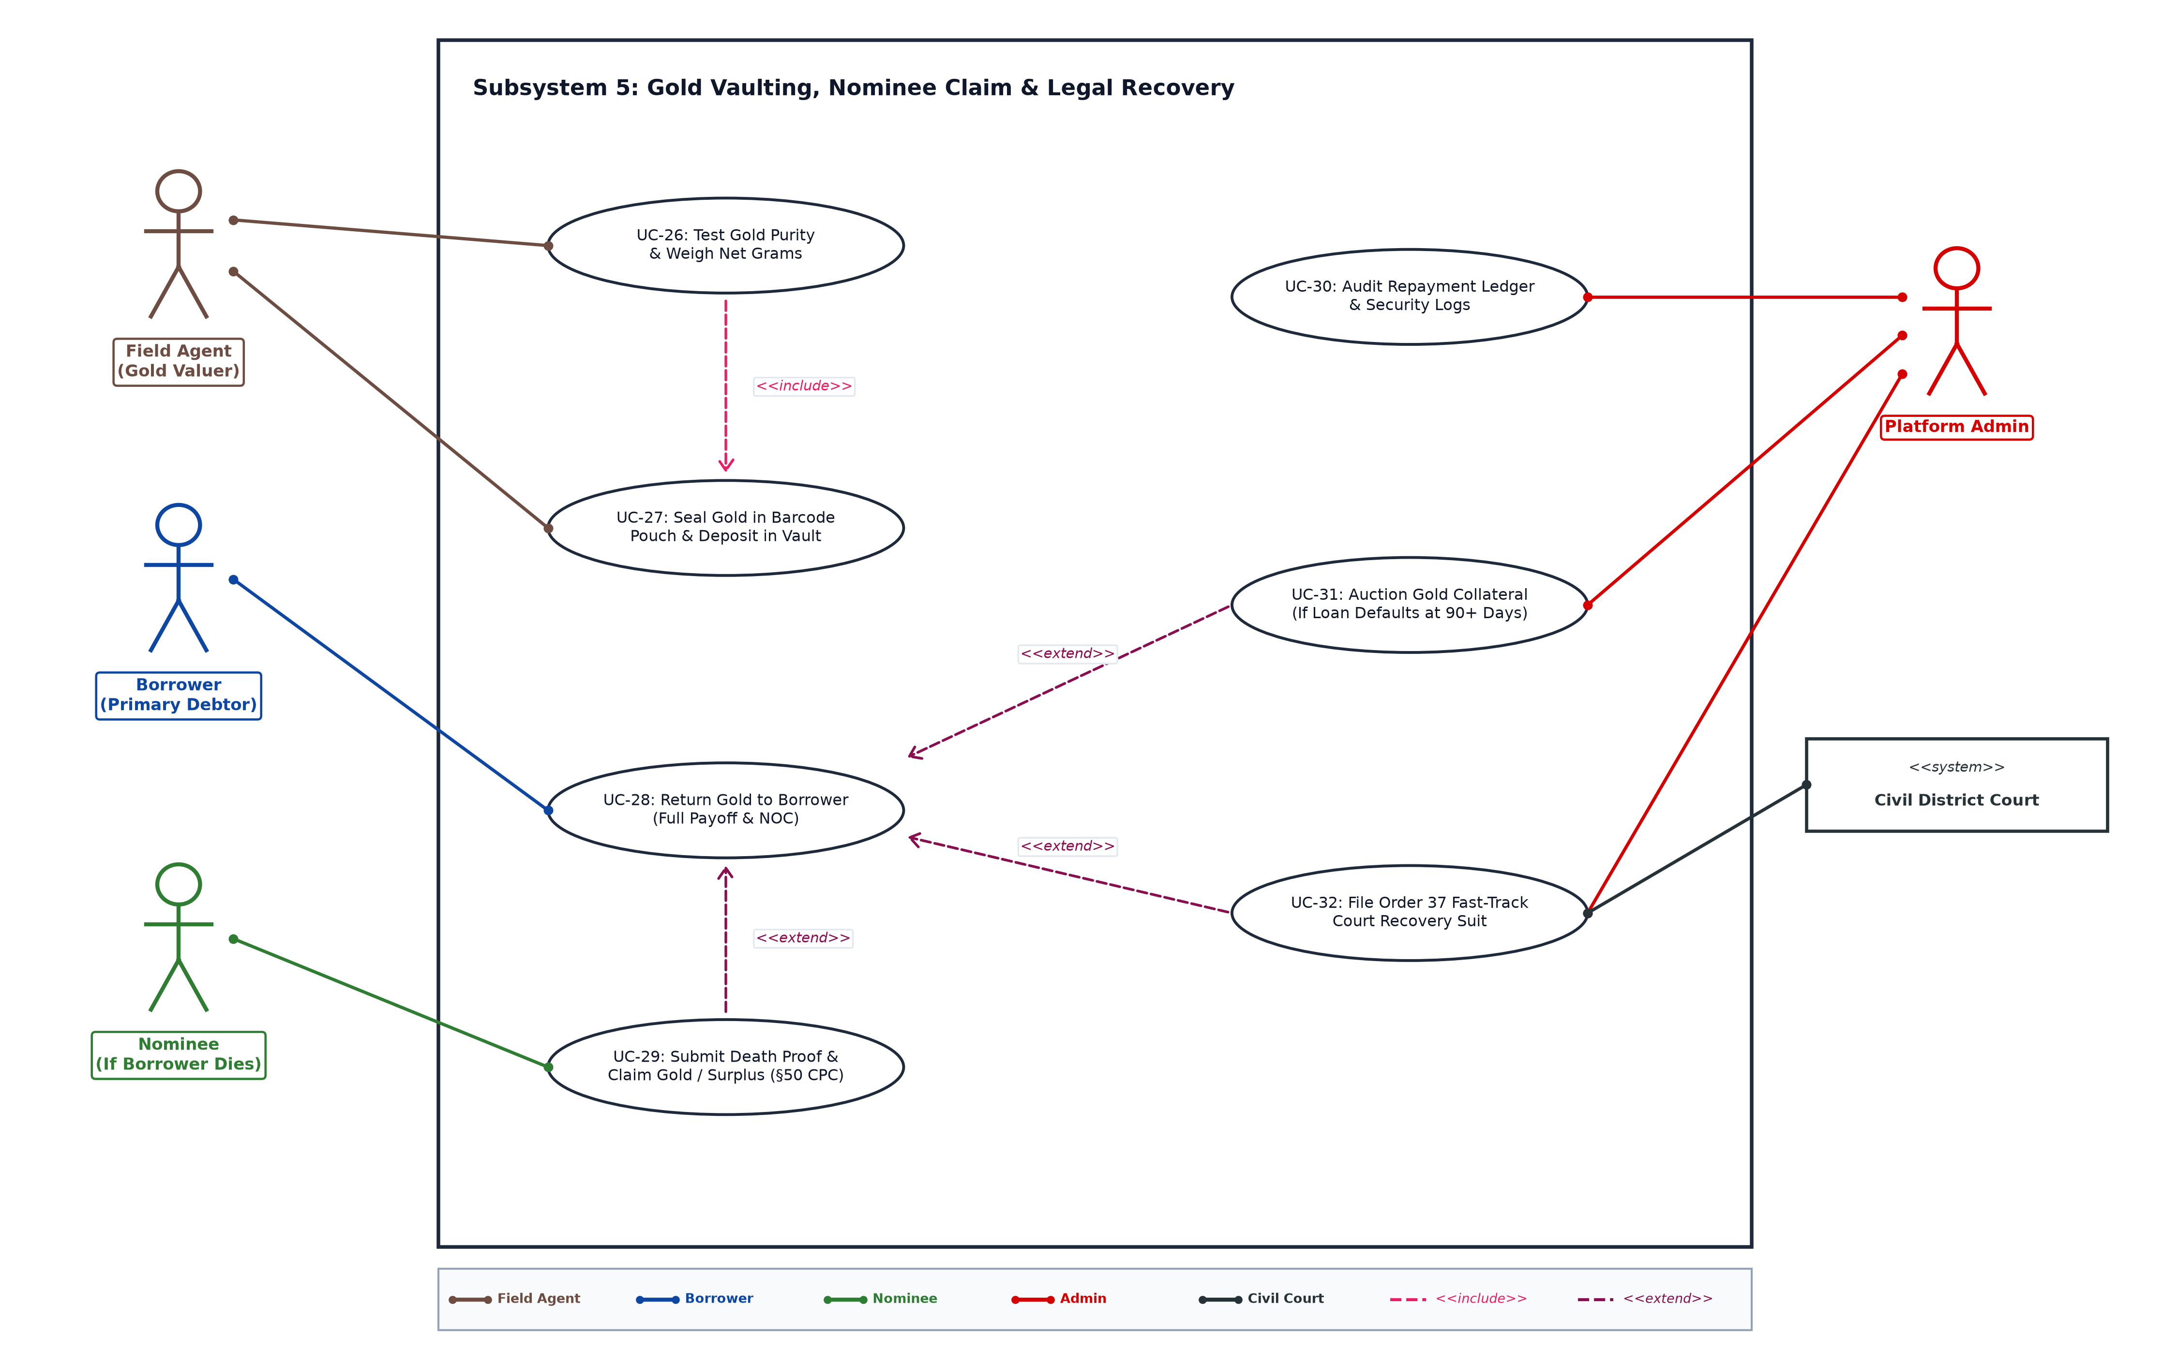
Figure 6: Subsystem 5 - Gold Vaulting, Nominee Claim & Legal Recovery (Field Agent [Brown], Borrower [Blue], Nominee [Green], Admin [Red])

