**PLSQL_Exercises**

**Exercise 1: Control Structures**

**Code**

**sql**

**-- CLEANUP (optional, avoids conflict on rerun)**

**BEGIN**

**EXECUTE IMMEDIATE 'DROP TABLE LOAN';**

**EXECUTE IMMEDIATE 'DROP TABLE CUST';**

**EXCEPTION**

**WHEN OTHERS THEN NULL;**

**END;**

**/**

**-- CREATE TABLES**

**CREATE TABLE CUST (**

**CUST_ID NUMBER PRIMARY KEY,**

**CUST_NAME VARCHAR2(100),**

**CUST_DOB DATE,**

**CUST_BAL NUMBER,**

**CUST_LAST_MOD DATE**

**);**

**CREATE TABLE LOAN (**

**LOAN_ID NUMBER PRIMARY KEY,**

**CUST_ID NUMBER,**

**LOAN_AMT NUMBER,**

**LOAN_INT_RATE NUMBER,**

**LOAN_START_DATE DATE,**

**LOAN_END_DATE DATE,**

**FOREIGN KEY (CUST_ID) REFERENCES CUST(CUST_ID)**

**);**

**-- INSERT SAMPLE DATA**

**INSERT INTO CUST VALUES (1, 'John Doe', TO_DATE('1950-05-15', 'YYYY-MM-DD'), 12000, SYSDATE);**

**INSERT INTO CUST VALUES (2, 'Jane Smith', TO_DATE('1990-07-20', 'YYYY-MM-DD'), 8000, SYSDATE);**

**INSERT INTO LOAN VALUES (101, 1, 5000, 5, SYSDATE, SYSDATE + 15);**

**INSERT INTO LOAN VALUES (102, 2, 7000, 6, SYSDATE, SYSDATE + 45);**

**COMMIT;**

**-- ENABLE SERVER OUTPUT**

**SET SERVEROUTPUT ON;**

**-- SCENARIO 1: Apply Interest Discount for Senior Citizens**

**BEGIN**

**FOR rec IN (**

**SELECT CUST_ID, EXTRACT(YEAR FROM SYSDATE) - EXTRACT(YEAR FROM CUST_DOB) AS AGE**

**FROM CUST**

**) LOOP**

**IF rec.AGE > 60 THEN**

**UPDATE LOAN SET LOAN_INT_RATE = LOAN_INT_RATE - 1 WHERE CUST_ID = rec.CUST_ID;**

**DBMS_OUTPUT.PUT_LINE('Interest reduced for Customer ID: ' || rec.CUST_ID);**

**ELSE**

**DBMS_OUTPUT.PUT_LINE('No change for Customer ID: ' || rec.CUST_ID || ', Age: ' || rec.AGE);**

**END IF;**

**END LOOP;**

**COMMIT;**

**END;**

**/**

**-- SCENARIO 2: Add VIP column based on balance**

**ALTER TABLE CUST ADD CUST_VIP CHAR(5) CHECK (CUST_VIP IN ('TRUE','FALSE'));**

**BEGIN**

**FOR rec IN (SELECT CUST_ID, CUST_BAL FROM CUST) LOOP**

**IF rec.CUST_BAL > 10000 THEN**

**UPDATE CUST SET CUST_VIP = 'TRUE' WHERE CUST_ID = rec.CUST_ID;**

**DBMS_OUTPUT.PUT_LINE('VIP Assigned to Customer ID: ' || rec.CUST_ID);**

**ELSE**

**UPDATE CUST SET CUST_VIP = 'FALSE' WHERE CUST_ID = rec.CUST_ID;**

**DBMS_OUTPUT.PUT_LINE('No VIP for Customer ID: ' || rec.CUST_ID);**

**END IF;**

**END LOOP;**

**COMMIT;**

**END;**

**/**

**-- SCENARIO 3: Loan due in 30 days reminder**

**BEGIN**

**DECLARE**

**found BOOLEAN := FALSE;**

**BEGIN**

**FOR rec IN (**

**SELECT l.LOAN_ID, l.LOAN_END_DATE, c.CUST_NAME**

**FROM LOAN l**

**JOIN CUST c ON l.CUST_ID = c.CUST_ID**

**WHERE l.LOAN_END_DATE BETWEEN SYSDATE AND SYSDATE + 30**

**) LOOP**

**DBMS_OUTPUT.PUT_LINE('Reminder: Loan ' || rec.LOAN_ID || ' for ' || rec.CUST_NAME || ' is due on ' || TO_CHAR(rec.LOAN_END_DATE, 'YYYY-MM-DD'));**

**found := TRUE;**

**END LOOP;**

**IF NOT found THEN**

**DBMS_OUTPUT.PUT_LINE('No loans due in the next 30 days.');**

**END IF;**

**END;**

**END;**

**/**

**-- VIEW FINAL DATA**

**SELECT * FROM CUST;**

**SELECT * FROM LOAN;**

**Output**

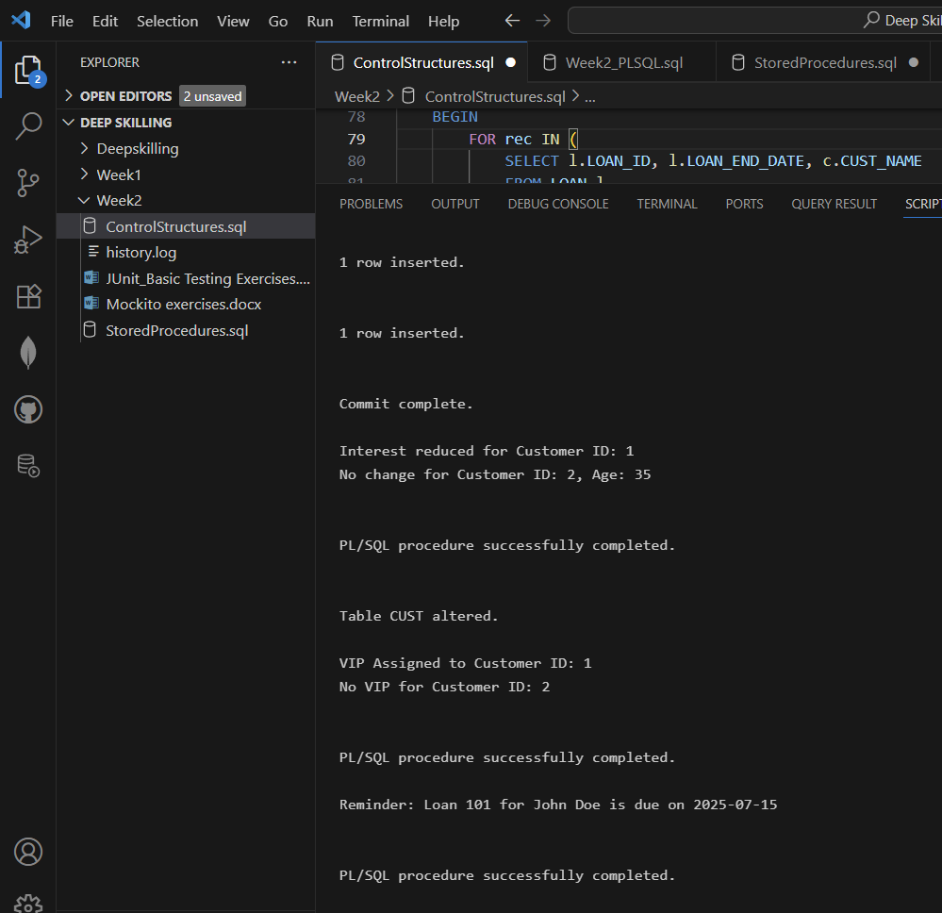

**Exercise 3: Stored Procedures**

**Code**

**SET SERVEROUTPUT ON;**

**-- Procedure 1: Apply 1% interest to savings accounts**

**CREATE OR REPLACE PROCEDURE ProcessMonthlyInterest AS**

**BEGIN**

**FOR acc_rec IN (**

**SELECT AccountID, Balance**

**FROM Accounts**

**WHERE AccountType = 'Savings'**

**) LOOP**

**UPDATE Accounts**

**SET Balance = acc_rec.Balance + (acc_rec.Balance * 0.01),**

**LastModified = SYSDATE**

**WHERE AccountID = acc_rec.AccountID;**

**DBMS_OUTPUT.PUT_LINE('→ Interest applied to Savings Account ID: ' || acc_rec.AccountID);**

**END LOOP;**

**END;**

**/**

**-- Procedure 2: Add bonus to employee salaries in a department**

**CREATE OR REPLACE PROCEDURE UpdateEmployeeBonus(**

**dept_name IN VARCHAR2,**

**bonus_percent IN NUMBER**

**) AS**

**BEGIN**

**FOR emp_rec IN (**

**SELECT EmployeeID, Salary**

**FROM Employees**

**WHERE Department = dept_name**

**) LOOP**

**UPDATE Employees**

**SET Salary = emp_rec.Salary + (emp_rec.Salary * bonus_percent / 100)**

**WHERE EmployeeID = emp_rec.EmployeeID;**

**DBMS_OUTPUT.PUT_LINE('→ Bonus of ' || bonus_percent || '% added to Employee ID: ' || emp_rec.EmployeeID);**

**END LOOP;**

**END;**

**/**

**-- Procedure 3: Transfer funds between two accounts**

**CREATE OR REPLACE PROCEDURE TransferFunds(**

**from_acc IN NUMBER,**

**to_acc IN NUMBER,**

**amount IN NUMBER**

**) AS**

**current_balance NUMBER;**

**BEGIN**

**SELECT Balance INTO current_balance**

**FROM Accounts**

**WHERE AccountID = from_acc**

**FOR UPDATE;**

**IF current_balance >= amount THEN**

**UPDATE Accounts**

**SET Balance = Balance - amount,**

**LastModified = SYSDATE**

**WHERE AccountID = from_acc;**

**UPDATE Accounts**

**SET Balance = Balance + amount,**

**LastModified = SYSDATE**

**WHERE AccountID = to_acc;**

**DBMS_OUTPUT.PUT_LINE('Transferred $' || amount || ' from Account ' || from_acc || ' to Account ' || to_acc);**

**ELSE**

**DBMS_OUTPUT.PUT_LINE('Transfer failed: Insufficient balance in Account ' || from_acc);**

**END IF;**

**EXCEPTION**

**WHEN NO_DATA_FOUND THEN**

**DBMS_OUTPUT.PUT_LINE('Error: One or both accounts not found.');**

**WHEN OTHERS THEN**

**DBMS_OUTPUT.PUT_LINE(' Unexpected error: ' || SQLERRM);**

**END;**

**/**

**-- Execution block to run all three procedures**

**BEGIN**

**DBMS_OUTPUT.PUT_LINE('--- Running Stored Procedures ---');**

**ProcessMonthlyInterest;**

**UpdateEmployeeBonus('IT', 10);**

**TransferFunds(1, 2, 200);**

**DBMS_OUTPUT.PUT_LINE('--- All operations completed successfully ---');**

**END;**

**/**

**Output**

