# spring-data-jpa-handson

## Spring Data JPA - Quick Example

Spring Data JPA with Spring Boot, Hibernate

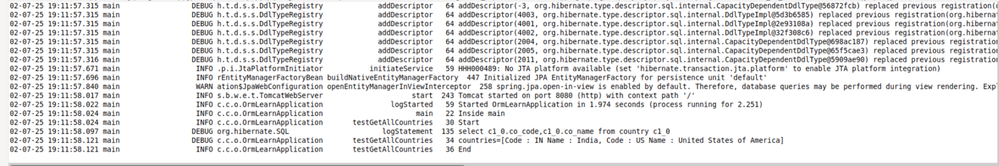

## Difference between JPA, Hibernate and Spring Data JPA

1) JPA (Java Persistence API)  
JPA is just a specification (a set of rules) for working with databases using Java objects.  
It defines key concepts like:  
- @Entity – marks a class as a database table.  
- @Id – marks the primary key.  
- EntityManager – used to interact with the database.  
JPA does not contain actual code—you need a library (like Hibernate) to use it.

2) Hibernate  
Hibernate is a framework that implements JPA and adds extra features.  
It provides the real functionality to connect Java objects with database tables.  
Hibernate also includes helpful features like:  
- Caching  
- Lazy loading  
- Query optimization  
If you use Hibernate directly, you manage sessions and transactions yourself (unless you use Spring).

3) Spring Data JPA  
Spring Data JPA is a part of the Spring Framework.  
It builds on top of JPA to make working with databases easier.  
You just define interfaces (like EmployeeRepository), and Spring handles the database code for you.  
It works smoothly with Spring Boot and handles transactions automatically.

## Code Comparison

Using Hibernate (Manual Handling)

public Integer addEmployee(Employee employee){  
 Session session = factory.openSession();  
 Transaction tx = null;  
 Integer employeeID = null;  
  
 try {  
 tx = session.beginTransaction();  
 employeeID = (Integer) session.save(employee);  
 tx.commit();  
 } catch (Exception e) {  
 if (tx != null) tx.rollback();  
 } finally {  
 session.close();  
 }  
  
 return employeeID;  
}

Using Spring Data JPA

Employee Repository  
public interface EmployeeRepository extends JpaRepository<Employee, Integer> {  
}  
  
Employee Service  
@Autowired  
private EmployeeRepository employeeRepository;  
  
@Transactional  
public void addEmployee(Employee employee) {  
 employeeRepository.save(employee);  
}  
