React

# 1) Welcome Message Project

## Code:

import React from 'react';  
function App() {  
 return (  
 <div>  
 <h1>Welcome to the first session of React</h1>  
 </div>  
 );  
}  
export default App;

## Output:

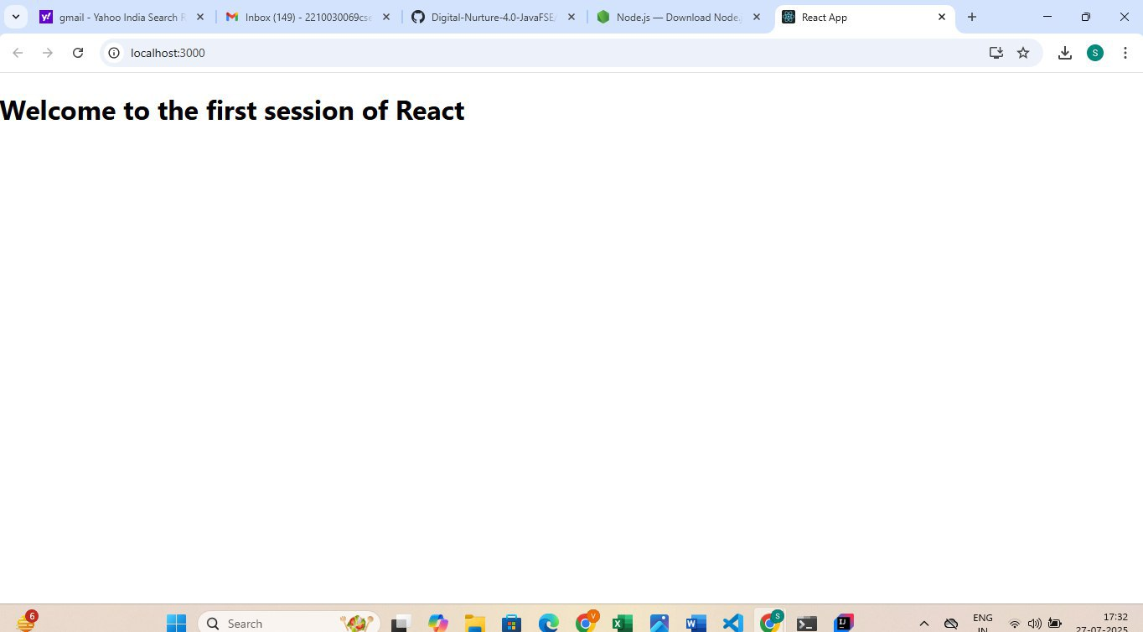

# 2) Student Management Portal

## Code:

// src/Components/Home.js  
import React, { Component } from 'react';  
class Home extends Component {  
 render() {  
 return (  
 <div>  
 <h2>Welcome to the Home page of Student Management Portal</h2>  
 </div>  
 );  
 }  
}  
export default Home;  
  
// src/Components/About.js  
import React, { Component } from 'react';  
class About extends Component {  
 render() {  
 return (  
 <div>  
 <h2>Welcome to the About page of the Student Management Portal</h2>  
 </div>  
 );  
 }  
}  
export default About;  
  
// src/Components/Contact.js  
import React, { Component } from 'react';  
class Contact extends Component {  
 render() {  
 return (  
 <div>  
 <h2>Welcome to the Contact page of the Student Management Portal</h2>  
 </div>  
 );  
 }  
}  
export default Contact;  
  
// src/App.js  
import React from 'react';  
import Home from './Components/Home';  
import About from './Components/About';  
import Contact from './Components/Contact';  
  
function App() {  
 return (  
 <div>  
 <Home />  
 <About />  
 <Contact />  
 </div>  
 );  
}  
export default App;

## Output:

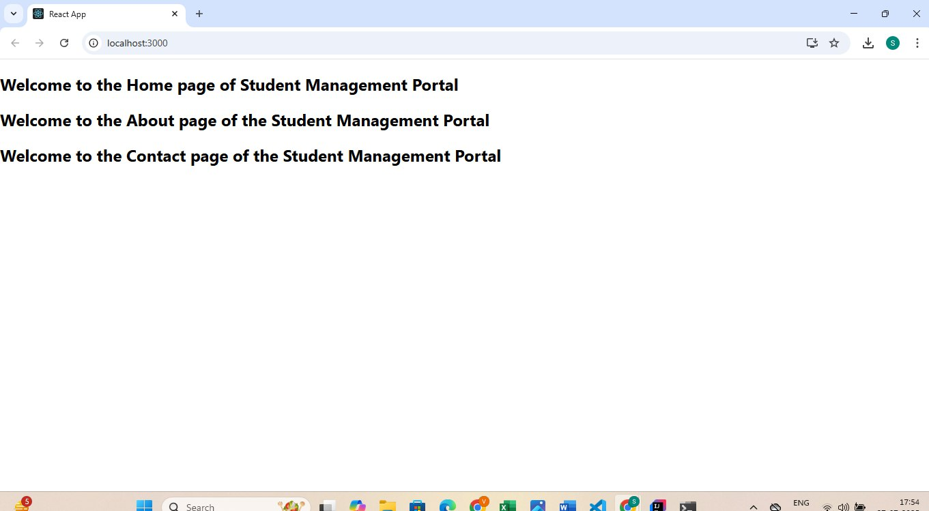

# 3) Student Score Calculator

## Code:

// src/Components/CalculateScore.js  
import React from 'react';  
import '../Stylesheets/mystyle.css';  
  
function CalculateScore() {  
 const name = "Steeve";  
 const school = "ABC International School";  
 const totalMarks = 450;  
 const goal = 500;  
 const average = (totalMarks / goal) * 100;  
  
 return (  
 <div className="score-container">  
 <h2>Student Score Calculator</h2>  
 <p><strong>Name:</strong> {name}</p>  
 <p><strong>School:</strong> {school}</p>  
 <p><strong>Total Marks:</strong> {totalMarks}</p>  
 <p><strong>Goal:</strong> {goal}</p>  
 <p><strong>Average Score:</strong> {average.toFixed(2)}%</p>  
 </div>  
 );  
}  
export default CalculateScore;  
  
// src/Stylesheets/mystyle.css  
.score-container {  
 background-color: #f0f8ff;  
 border: 2px solid #0077cc;  
 padding: 20px;  
 border-radius: 10px;  
 width: 400px;  
 margin: 50px auto;  
 text-align: left;  
 font-family: Arial, sans-serif;  
 box-shadow: 2px 2px 8px rgba(0, 0, 0, 0.1);  
}  
.score-container h2 {  
 text-align: center;  
 color: #0077cc;  
}  
.score-container p {  
 font-size: 16px;  
 line-height: 1.5;  
}  
  
// src/App.js  
import React from 'react';  
import CalculateScore from './Components/CalculateScore';  
  
function App() {  
 return (  
 <div>  
 <CalculateScore />  
 </div>  
 );  
}  
export default App;

## Output:



# 4) BlogApp with Posts from API

## Output:

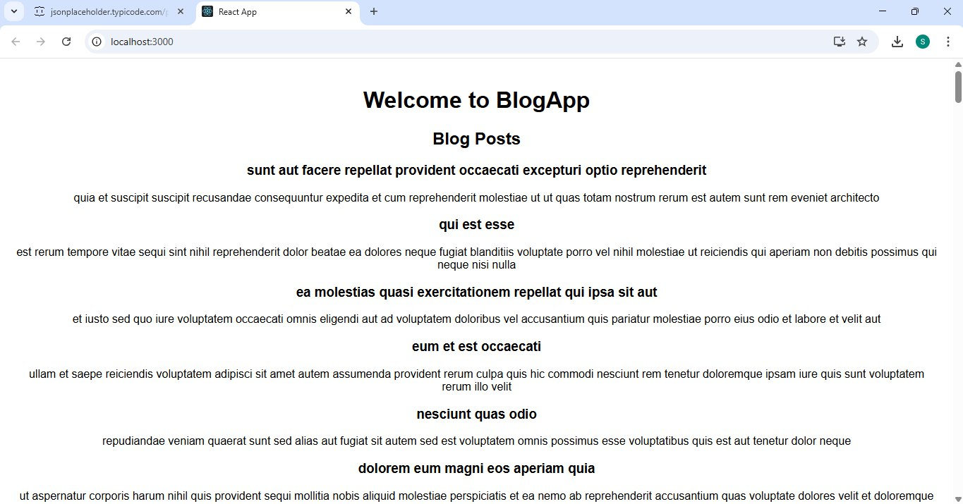

# 5) Cohort Tracker

import React from 'react';

import styles from './CohortDetails.module.css';

function CohortDetails(props) {

const { name, status, trainer, duration } = props;

const headingStyle = {

color: status.toLowerCase() === 'ongoing' ? 'green' : 'blue',

};

return (

<div className={styles.box}>

<h3 style={headingStyle}>{name}</h3>

<dl>

<dt>Status:</dt>

<dd>{status}</dd>

<dt>Trainer:</dt>

<dd>{trainer}</dd>

<dt>Duration:</dt>

<dd>{duration}</dd>

</dl>

</div>

);

}

export default CohortDetails;

.box {

width: 300px;

display: inline-block;

margin: 10px;

padding: 10px 20px;

border: 1px solid black;

border-radius: 10px;

}

dt {

font-weight: 500;

}

## Output:

