Employee Feedback & Process Analysis Report
1. Project Objective
The objective of this project was to collect feedback from newly onboarded employees, identify friction points in the onboarding process, and recommend improvements to enhance the overall employee experience.

2. Methodology
Employee Onboarding Feedback Survey
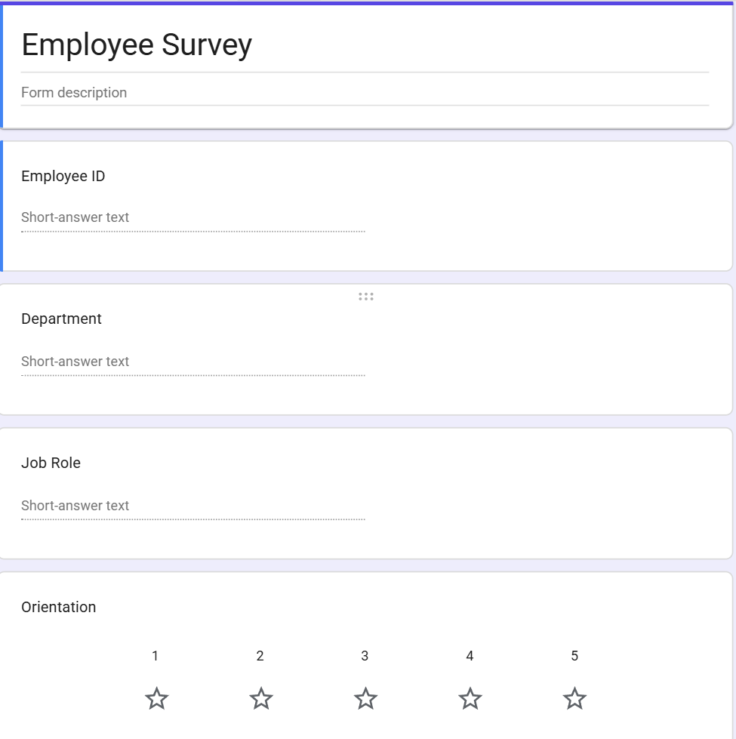
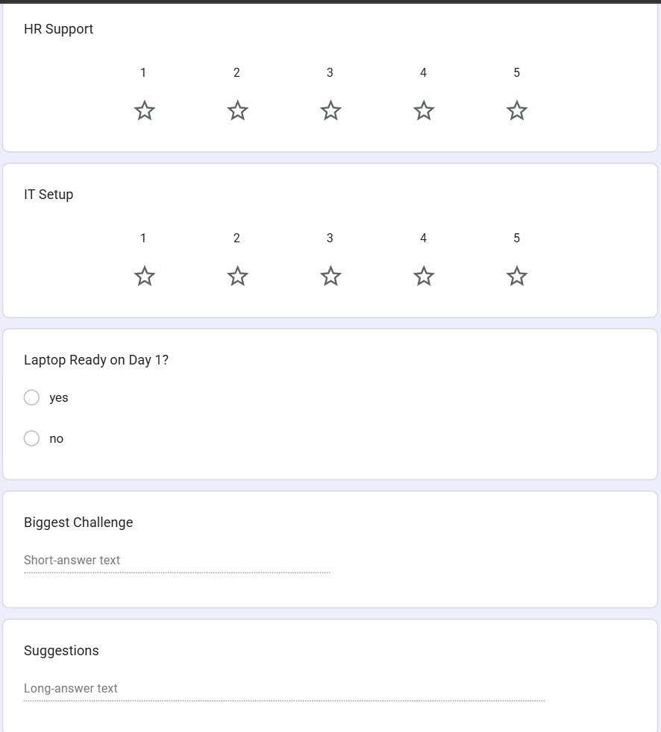

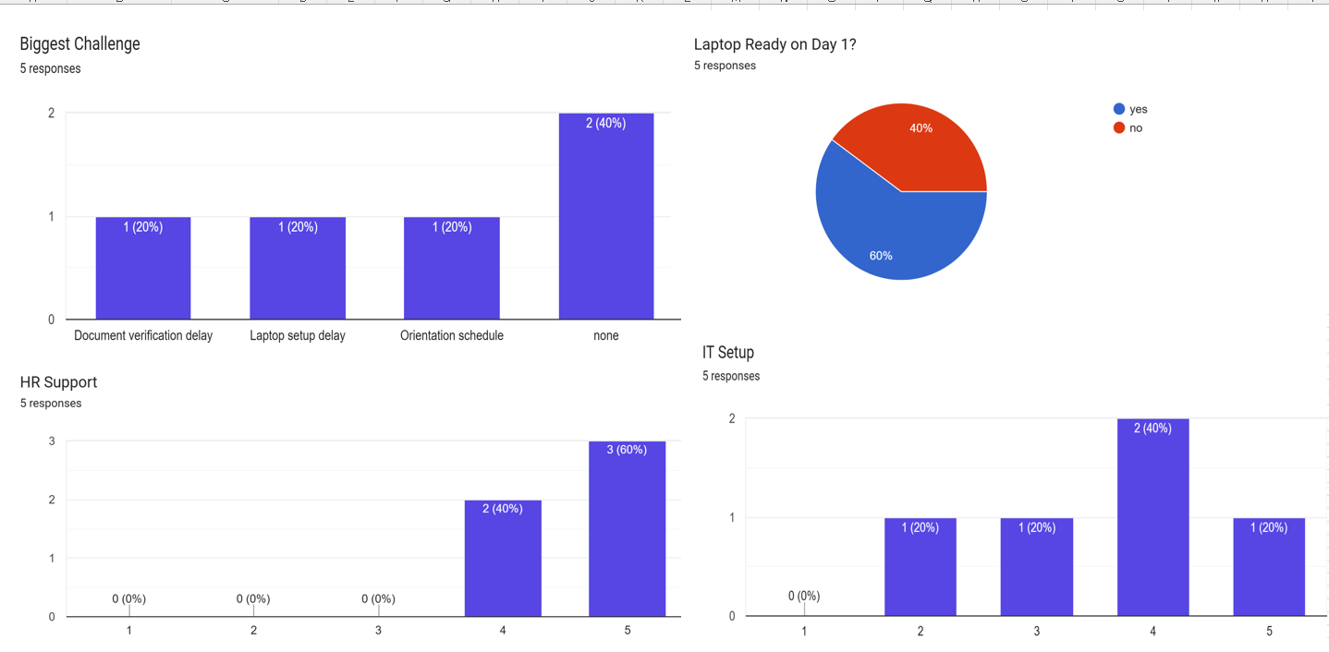
Employee Responses
- Total Responses: 5
Biggest Onboarding Challenges
- No issues reported – 2 employees
- Laptop setup delay – 1 employee
- Document verification delay – 1 employee
- Orientation schedule – 1 employee
Laptop Readiness
- Laptop ready on Day 1 – 3 employees (60%)
- Laptop not ready on Day 1 – 2 employees (40%)
HR Support Rating
- Rating 5 – 3 employees
- Rating 4 – 2 employees
Employees were generally satisfied with the support provided by the HR team.
IT Setup Rating
- Rating 5 – 1 employee
- Rating 4 – 2 employees
- Rating 3 – 1 employee
- Rating 2 – 1 employee
The IT setup process showed some inconsistencies, with a few employees experiencing delays or setup issues.
Orientation Rating
- Rating 5 – 2 employees
- Rating 4 – 2 employees
- Rating 3 – 1 employee
Most employees had a positive orientation experience, although there is room for improvement.

4. Process Issues Identified
- Laptop provisioning was delayed for some employees.
- Document verification was not completed before joining for some cases.
- Orientation schedules were not communicated clearly to all new joiners.
- IT setup quality was inconsistent across employees.

5. Process Improvement Recommendations
Issue | Recommendation
Laptop setup delay | Coordinate with the IT team to prepare laptops before the employee's joining date.
Document verification delay | Send a pre-joining document checklist and verify completion before Day 1.
Orientation schedule | Share the Day 1 agenda and onboarding schedule before the joining date.
IT setup issues | Implement an IT readiness checklist to ensure devices and accounts are configured before onboarding.

6. Conclusion
The onboarding process was generally effective, with employees expressing high satisfaction with HR support and orientation. However, operational improvements are needed in laptop provisioning, document verification, and IT readiness. Addressing these areas can improve the onboarding experience, reduce delays, and increase operational efficiency.

