PHARMACY MANAGEMENT SYSTEM

**E-R DIAGRAM**

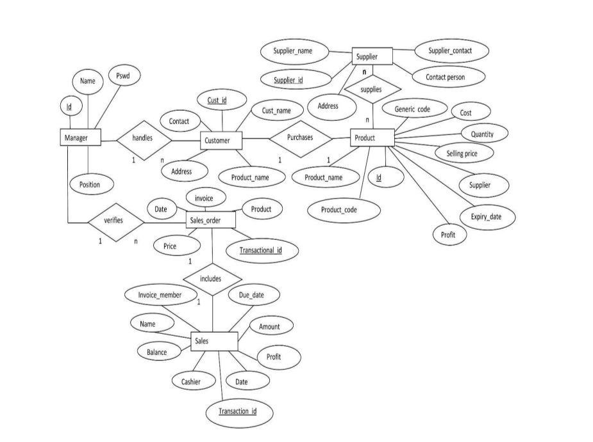

**DFD DIAGRAM**

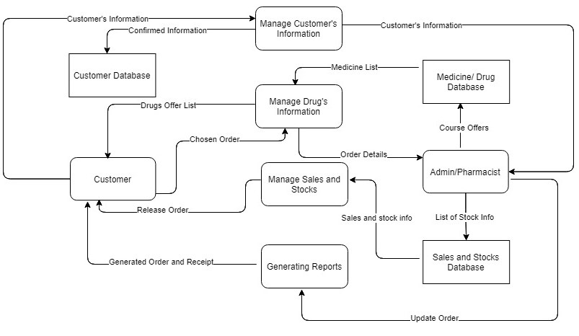

**ACTIVITY DIAGRAM**

