Advanced Statistical Learning II
Math- 7636-001

Heart Attack Risk Prediction

Satya Akhil Torlikonda-U00924200

08-May-2025

Abstract
The study sought to create heart disease risk classification predictive models using the Heart Disease Health Indicators (BRFSS 2015) dataset. This dataset had severe class imbalance with positive cases comprising a meager ~9.4%, which was resolved with random undersampling. Regular preprocessing involved standardization of the numerical features as well as second-order feature construction and construction of interaction terms to account for the interactions of these features. Five machine learning algorithms, namely Logistic Regression, Decision Tree, Naive Bayes, Linear Discriminant Analysis (LDA), and K-Nearest Neighbors (KNN), were trained using the measures such as Precision, Recall, F1 Score, Accuracy, and AUC for evaluation.
It was found through exploratory data analysis that there existed significant correlations of heart disease with attributes such as Age, High Blood Pressure, General Health, and BMI. Naive Bayes was the highest performing model overall using the balanced full set of variables with F1 Score = 0.985 and AUC = 0.999. Upon model improvement through fine-tuning along with the inclusion of interaction terms, Logistic Regression was the highest performing model with F1 Score = 0.779 and AUC = 0.849. Performance of models was poor using the unbalanced dataset,which underscores the importance of data balancing for effective minority class identification.
Overall, we see that a mix of techniques, feature engineering, as well as model parameter selection, is crucial for improving predictive accuracy for classification tasks in healthcare. Future research might involve exploring different methods of resampling and validating the models against external datasets.
Keywords: Logistic Regression, Decision Tree, Naive Bayes, Linear Discriminant Analysis (LDA), K-Nearest Neighbors (KNN), Precision, Recall, F1 Score, Accuracy, AUC, etc

Introduction
Cardiovascular diseases (CVDs), especially heart disease, are the leading cause of deaths worldwide with about 17.9 million people dying each year according to the World Health Organization. Heart disease is responsible for almost 1 in every 5 deaths in America, leading to major public health and economic burden. Since it has a vast reach, it is important to have early diagnosis and risk stratification of people prone to heart disease to have a positive impact on health and alleviate health care systems.

Motivation
The motivation for this work is based on the growing volume of health-related data and advancements in machine learning (ML) methods that can explore underlying patterns in such data. Conventional statistical analysis has yielded useful information about the factors of cardiac disease risk such as age, elevated blood pressure, smoking habits, and overall poor health. But machine learning algorithms allow for greater precision and flexibility in modeling complex variable relationships, especially when combined with feature engineering and model tuning.
In spite of machine learning potential, numerous studies are plagued by class imbalance where non-heart disease cases outweigh heart disease cases by a wide margin. This distorts model learning and lowers the performance of predictive measures in detecting individuals who are at risk. This initiative remedies this problem through the use of undersampling algorithms to obtain a balanced dataset and assess its influence in model performance.

Project Goals
- Preprocess the heart disease health indicator data, such as addressing class imbalance, normalizing numerical features, and generating interaction and second-order polynomial terms.
- To construct and compare five machine learning classification models: Logistic Regression, Decision Tree, Naive Bayes, Linear Discriminant Analysis (LDA), and K-Nearest Neighbors (KNN).
- Evaluate model performance on both original (unbalanced) and balanced data sets in terms of accuracy, precision, recall, F1 score, and AUC.
- To evaluate how model tuning and feature engineering affect predictive accuracy.
- To determine the best and most applicable model of heart disease classification in terms of empirical performance.
Through these goals, the research endeavors to contribute to the implementation of machine learning in health analytics through sound practical insights into how model performance varies with different data conditions and feature setups. This adds to what is generally known in this area by bringing to light best practices in data preprocessing, model selection, and model assessment for public health risk prediction.

Research Hypothesis
The addition of interaction terms and use of model tuning methods will appreciably enhance machine learning models' predictive accuracy (measured in terms of AUC and F1-score) towards classifying individuals with heart disease.

Background and literature review
Cardiovascular disease (CVDs), especially heart disease, is still the most common cause of death worldwide with an estimated 17.9 million fatalities annually, as reported by the World Health Organization (Sakinat Oluwabukonla Folorunso et al., 2022). In America alone, 1 in 5 deaths is caused by heart disease, thus straining healthcare systems and economic productivity (Baxani & Edinburgh, 2022). Identification of those at risk for heart disease is paramount to prevention, early intervention, and resource management.
Substantial research has also determined multiple heart disease risk factors, such as hypertension, high cholesterol, smoking, obesity, lack of physical activity, and diabetes (Li et al., 2020). Other studies conducted by the researchers (Baxani & Edinburgh, 2022) have been known for decades to demonstrate predictive associations between such demographic and lifestyle factors for cardiovascular outcomes. Further, population-level health surveys like that conducted by the Behavioral Risk Factor Surveillance System (BRFSS) provide rich epidemiologic data to inform public health studies in order to discover these trends on an enormous scale.
Machine learning has now been proposed as an efficient means to exploit such large datasets towards disease prediction and risk stratification. Logistic regression, decision trees, and naive Bayes classifiers have shown good accuracy in forecasting cardiovascular disease (Kumar Agrawal & Gupta, 2024). Yet, most such models use imbalanced datasets, which results in skewed prediction and underdetection of high-risk individuals.
The current research emphasizes creating balanced machine learning models for heart disease prediction likelihood based on BRFSS 2015 data. By resolving data imbalance through undersampling, adding interaction and polynomial terms, and assessing performance in terms of AUC, precision, recall, and F1-score, this research attempts to increase risk prediction accuracy.

Methodology and implementation

Data Collection
The data for this study were downloaded from the Centers for Disease Control and Prevention (CDC) through Kaggle, known as Heart Disease Health Indicators (BRFSS 2015) (Teboul, 2022). The Behavioral Risk Factor Surveillance System (BRFSS) is an inaugural health-related telephone health survey administered throughout the U.S. to collect data on health-related risk habits, chronic diseases, and use of preventive services.
The dataset has 253,680 records with 22 variables, which derive from a diverse sample of U.S. adults 18 years or older. The data include both self-reported health indicators on behavior as well as diagnosed health conditions. Although the dataset is large, original data presented class imbalance, such that the heart disease class was just ~9.8% of the total population.
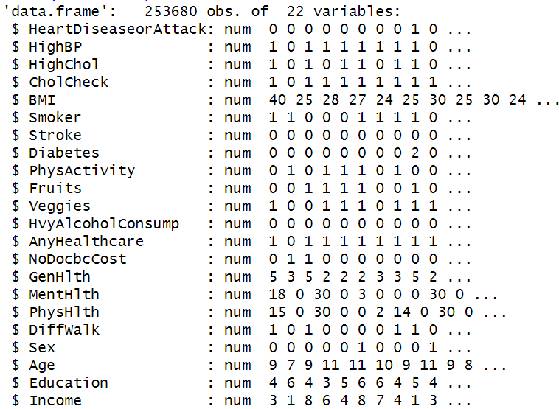
Figure 1: Dataset structure

Variable overview and feature engineering
The dependent variable in the analysis is HeartDiseaseorAttack, a binary indicator where:
- 1 denotes presence of heart disease or heart attack,
- 0 indicates absence of either condition.
Independent variables include both numerical and categorical health indicators such as:
- Numerical: BMI, MentHlth, PhysHlth, Age
- Categorical (encoded as factors): HighBP, HighChol, Smoker, Stroke, Diabetes, PhysActivity, GenHlth, Sex, Income, Education, among others.
To enhance model performance:
- The dataset was balanced via undersampling the majority class.
- All numerical features were standardized where normalization (Standardization) was done on numeric features (BMI, Age, MentHlth, PhysHlth) using center and scale (mean = 0, sd = 1) where most data falls within –3 to +3 standard deviations.
- Interaction terms and second-order polynomial features were created (e.g., BMI^2, BMI*Age) to capture non-linear effects and variable interactions on heart disease risk.

Interaction terms added and justification
The following second-order and interaction terms were intentionally chosen for their domain significance and their ability to measure complex dynamics related to heart disease:
Second-Order Terms
- BMI2 = BMI^2
Justification: Very high or very low BMI levels have proportionate association with heart disease. A squared term is necessary to account for this non-linear (U-shaped) association, as both underweight levels and obesity have risk.
- Age2 = Age^2
Justification: The risk for heart disease rises more rapidly with increasing age in contrast to linearly. The quadratic term enables the model to account for inflection points in disease risk by age.
- MentHlth2 = MentHlth^2
Justification: Poor mental health (i.e., chronic depression, stress) impacts on cardiovascular endpoints, although the impact might escalate in a non-linear fashion if mental health is chronic over extended periods.
- PhysHlth2 = PhysHlth^2
Justification: Similar to mental health, physical health issues may become exponentially riskier beyond certain thresholds. For example, 30 days of physical illness may signal serious chronic conditions.
Interaction Terms
- BMI_Age = BMI * Age
Justification: Older adults with increased BMI have increased cumulative cardiovascular risk. This description encompasses the synergistic effect between obesity and aging.
- BMI_MH = BMI * MentHlth
Justification: Mental health may impact behaviors such as physical activity or diet, which can potentially moderate BMI's effect on heart health. Such kinds of behavior-health interactions can be modeled by this interaction.
- BMI_PH = BMI * PhysHlth
Justification: If high BMI is accompanied by poor health, it usually represents reduced mobility, one of the main indicators for heart disease. This combination reflects cumulative physical stress.
- Age_MH = Age * MentHlth
Justification: Mental health impacts can differ by age group—in older individuals with compromised mental health, for example, there can be greater isolation or stress, exacerbating their vulnerability.
- Age_PH = Age * PhysHlth
Justification: Chronic disease in older adults can quickly escalate to cardiovascular complications. This interaction term captures compounding risk to aging as one's physical health deteriorates.
- MH_PH = MentHlth * PhysH
Justification: There exists a strong bidirectional relationship between physical health and mental health. The interplay might emphasize individuals with both constraints—who have very high risk for heart disease.
Interaction with categorical variables
- Interaction terms were only generated between numeric continuous variables such as Age, BMI, MentHlth, PhysHlth.
- No interactions between categorical variables (e.g., Sex × Age, Diabetes × Sex) were accounted for because
- These interactions would produce redundant or difficult-to-interpret dummy variables without obvious clinical or analytical significance.
- Having too many category interactions can greatly add model complexity without necessarily enhancing performance, particularly where categories have restricted logical relationships (e.g., gender × education).
Our attention was centered around capturing significant continuous effects as well as non-linear patterns that are more likely to affect the risk of heart disease.

Research approach and implementation
The following analytical procedures were applied:

Preprocessing
- Data Cleaning: Checked and confirmed no missing values in the balanced dataset.
- Balancing: The dataset was balanced via random undersampling to ensure equal representation of heart disease and non-heart disease cases.
Aspect | Unbalanced Dataset | Balanced Dataset
Definition | Original data had high class imbalance (90.58% No Heart Disease, 9.42% Yes). | After undersampling, both classes (Yes and No) are made equal in size.
Problem | Models trained on unbalanced data would bias towards the majority class (0), leading to poor detection of heart disease cases (minority class). | Balancing the dataset helps models learn to correctly predict both classes, improving sensitivity and precision.
Justification | Balancing prevents accuracy paradox — where model shows high accuracy by always predicting the majority class but fails on minority class. | Balancing ensures fair model evaluation, and improves F1 score and AUC for the minority (disease) class, critical for medical datasets.
Table 1: Difference of Balanced and Unbalanced Dataset
- Feature Scaling: Numeric variables (BMI, MentHlth, PhysHlth, and Age) were normalized using standardization (mean = 0, standard deviation = 1) to bring variables to a common scale, critical for distance-based models like KNN and LDA.
- Feature Engineering: Second-order polynomial terms and interaction terms (e.g., Age*MentHlth, BMI*PhysHlth) were generated to capture non-linear relationships and potential variable interactions.

Exploratory Data Analysis (EDA)
Summary statistics, correlation analysis, and visualizations (histograms, boxplots, stacked bar plots) were used to explore relationships between predictors and heart disease.

Modeling
  - Base models: Logistic Regression, Decision Tree, Naive Bayes, Linear Discriminant Analysis (LDA), K-Nearest Neighbors (KNN)
- Logistic regression
Logistic regression is a popular linear classification model applicable to binary responses such as heart disease incidence (Karthi & Kalaivani, 2023). It predicts the probability of membership in a particular category through a logistic function and is easily interpreted, so it is well suited to clinical data where variable influence is crucial.
- Decision Tree (CART)
Decision Tree algorithms employ a flowchart-like structure in order to partition data by feature thresholds (Viega, 2020). They are intuitive and are also able to model non-linearity. Their graphical representation allows them to be easily interpreted, plus when it comes to medical decision-making scenarios.
- Naive Bayes
Naive Bayes is a probabilistic classifier derived by assuming feature independence in Bayes' Theorem (Mushtaq et al., 2022). It works superbly with large data sets and categorical data and is also computationally inexpensive which is perfect for BRFSS data with numerous binary variables.
- Linear Discriminant Analysis (LDA)
LDA is a linear classification methodology that maps features to a space of maximum class separability. It has assumptions of normality and equal covariances in all classes, providing excellent performance when these assumptions apply especially to data in structured health surveys.
- K-Nearest Neighbors (KNN)
KNN is a non-parametric classifier that classifies according to the most numerous class of the 'k' nearest observations. Simple and powerful when combined with data in standardized form, it is capable of detecting local data structure, useful in identifying fine-grained health metric patterns.
  - Model enhancements: Polynomial and interaction terms were added to evaluate improvement.

Model tuning
Cross-validation and grid search techniques were applied using the caret package to optimize parameters (e.g., cp in decision trees, k in KNN).
- Parameters in Naïve bayes
Kernel pertains to Naive Bayes if we are using density estimation (usekernel = TRUE or FALSE).
Throughout the project:
During Naive Bayes tuning, kernel-based as well as non-kernel-based models were tried.
- Kernel = TRUE enables flexible, nonparametric estimation of probabilities (such as a smoothed curve instead of having strict distributions).
- Kernel = FALSE employs default assumption of normal distribution.
- Therefore, kernel and no-kernel Naive Bayes models were both investigated for tuning.
- Parameters in KNN
- KNN hyperparameter tuning was done with odd values from 3 to 12:
  - Specifically, k = 3, 5, 7, 9, 11 were used because testing large number of parameters were computationally expensive considering size of the dataset.
- Odd numbers prevent tie votes when classifying.
- Thus, 5 different K values were tried to find the optimal neighborhood size.
- Parameters in logistic regression
- Stepwise selection procedure: Variables are added as well as removed according to their effect on model performance
- It combines forward selection and backward elimination.
- The decision to include or exclude a variable is determined by minimising the Akaike Information Criterion (AIC).
- Parameters in decision tree
- method = "rpart"
  - Fits a Recursive Partitioning and Regression Tree (CART algorithm).
- trControl = trainControl(...)
- method = "cv"
  - 5-fold Cross-Validation was used to estimate model performance and avoid overfitting.
- classProbs = TRUE
  - Ensures probability predictions are computed (necessary for ROC analysis).
- summaryFunction = twoClassSummary
  - Evaluates models based on ROC, Sensitivity, and Specificity during tuning, not just accuracy.
- metric = "ROC"
  - The primary optimization metric is the Area Under the ROC Curve (AUC) rather than accuracy.
  - Choosing ROC makes sense when class balance is important (detecting positives correctly).
- tuneGrid = expand.grid(cp = seq(0.001, 0.05, by = 0.005))
- cp = Complexity Parameter for pruning trees.
- Controls the minimum improvement in model fit required at each split:
  - Higher cp: Simpler, smaller tree.
  - Lower cp: More complex, deeper tree.
- Values from 0.001 to 0.05 were tried to find the best trade-off between underfitting and overfitting

Evaluation Metrics
  - Classification metrics: Accuracy, Precision, Recall, F1-Score
  - ROC Analysis: Area Under Curve (AUC) was computed and visualized to compare discriminatory power across models.
Avoidance of Dimension reduction (PCA)
PCA was not employed because
- The original variables were already of a low to moderate correlation with one another
- Some of the predictors (such as HighBP, GenHlth, Age) had significant direct correlations with the target variable (heart disease).
- PCA applied there would have obscured the understandability of major predictors, making clinical understanding harder.
With a reasonable number of predictors and non-problematic multicollinearity, there was no need for dimensionality reduction.

Results and analysis

Data Overview

Data Structure
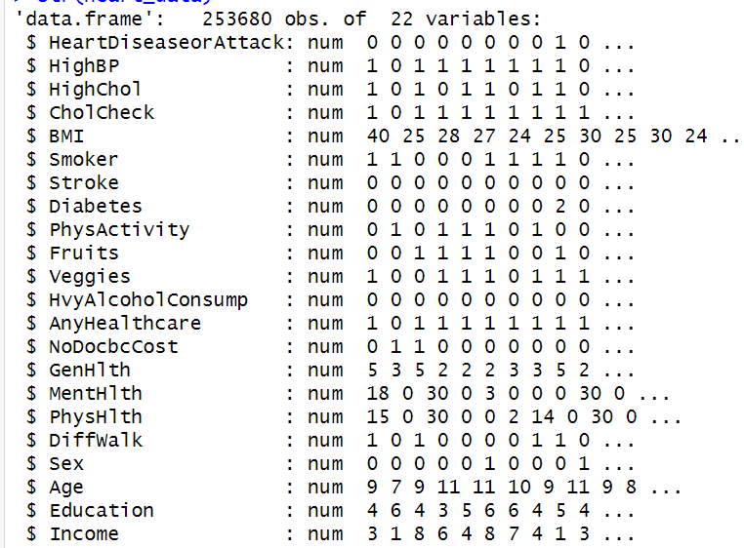
Figure 2: Data Structure Analysis
The heart_data contains 253,680 observations and 22 variables with individual-level health and demographic information gathered from the BRFSS 2015 dataset. The target variable is HeartDiseaseorAttack, a binary variable where:
- 1 signifies a history of heart disease or heart attack.
- 0 indicates no such history
There is an evident class imbalance, with merely 23,893 (∼9.4%) positive instances (1) against 229,787 (∼90.6%) negative instances (0).
The dataset contains:
- HighBP, HighChol, Smoker, Stroke, Diabetes, and PhysActivity are binary/categorical health measures.
- Ordinal ratings such as GenHlth, Education, and Income
- Numerical variables such as BMI, MentHlth (days with poor mental health), PhysHlth (days with poor physical health), and Age (coded category)
All variables are numeric encodings of categorical attributes or health-status variables that are continuous, making it possible to analyze both with classical statistics and machine learning algorithms.

Missing values
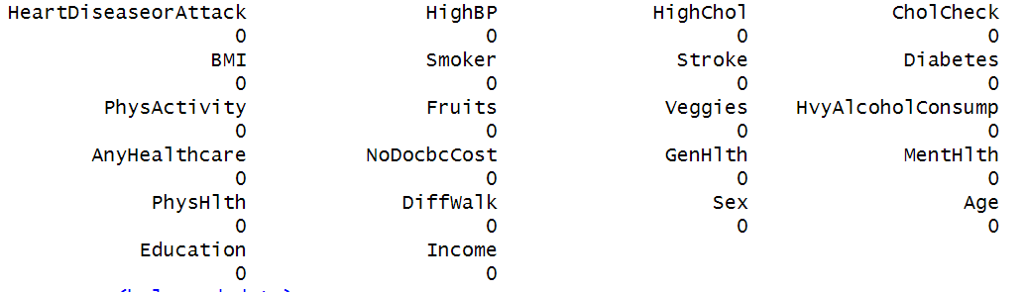
Figure 3: Missing Value Count
- The target variable is balanced with equal representation of classes:
  - 0: No heart disease
  - 1: Heart disease
  - Median = 0.5, Mean = 0.5 which confirms balanced dataset (50/50 split for modeling)

Summary of data
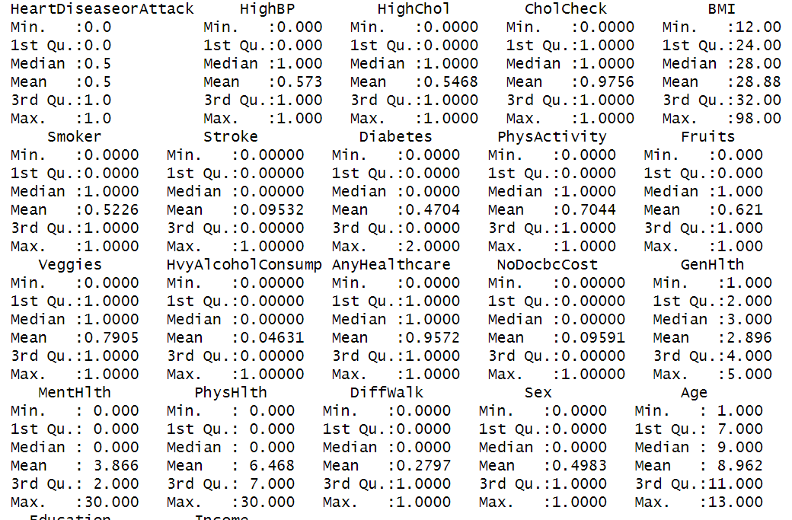
Figure 4: Dataset Summary
Binary Categorical Variables (0 = No, 1 = Yes)
- HighBP (High Blood Pressure): ~57% reported high BP
- HighChol (High Cholesterol): ~55% reported high cholesterol
- Smoker: ~52% have smoked at some point
- Stroke: ~9.5% reported having a stroke
- Diabetes: Up to 2 indicates gestational or borderline diabetes; ~47% have some form
- PhysActivity: 70% participate in physical activity
- Fruits & Veggies: 62% eat fruits, 79% eat vegetables
- HvyAlcoholConsump: Low (4.6%) heavy alcohol use
- AnyHealthcare: Very high access (95.7%)
- NoDocbcCost: 9.6% couldn’t see a doctor due to cost
- DiffWalk: 27.9% report difficulty walking
- Sex: Nearly balanced, ~50% male (1), ~50% female (0)
Ordinal Variables
- GenHlth (1 = Excellent to 5 = Poor):
  - Mean = 2.90 which suggests average health is between Fair and Good
- Education (1 = No Schooling to 6 = College Graduate):
  - Mean ≈ 4.91 where most people have some college or high school diploma
- Income (1 = Low income to 8 = High income):
  - Mean = 5.64 which is skewed toward moderate to high income
Numeric/Count Variables
- BMI (Body Mass Index):
  - Mean ≈ 28.9 which is just under the obese threshold (BMI ≥ 30)
  - Max = 98 indicates some extreme outliers
- MentHlth & PhysHlth (days unwell past 30 days):
  - Mental: Mean = 3.87, Max = 30 where some participants had full month of poor mental health
  - Physical: Mean = 6.47, Max = 30 with higher prevalence of chronic physical illness
- Age (coded groups from 1 = 18-24 to 13 = 80+):
  - Mean ≈ 9 which corresponds to age group 65–69
  - Skewed toward older population, which is expected in heart disease studies

Visual Exploration
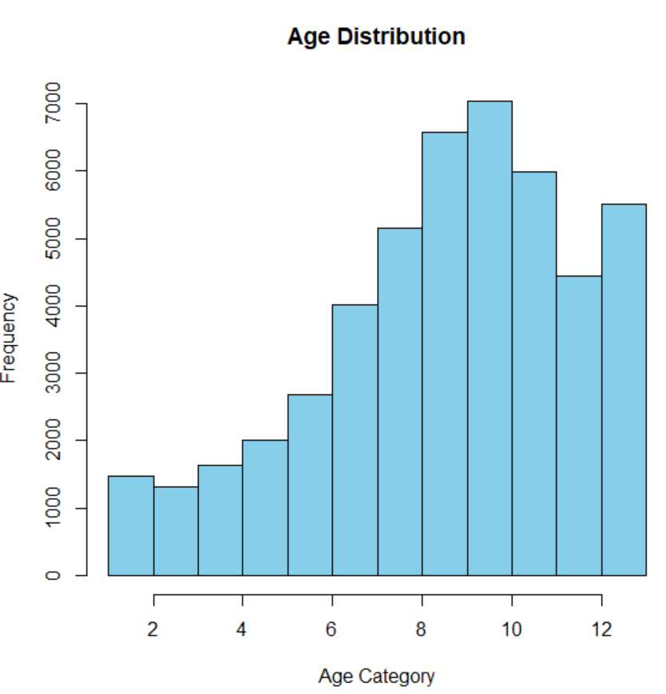
Figure 5: Age Distribution
The Age Distribution histogram reveals that the distribution is biased towards older age groups. Age is assigned to ordinal categories (e.g., 1 = 18–24, 13 = 80+). The majority of participants pertain to categories 8 to 11, with a high point at category 9, equating to about the 60–69 age group. Younger age groups (categories 2 to 5) are underrepresented, suggesting that middle-aged and older adults comprise the dataset.
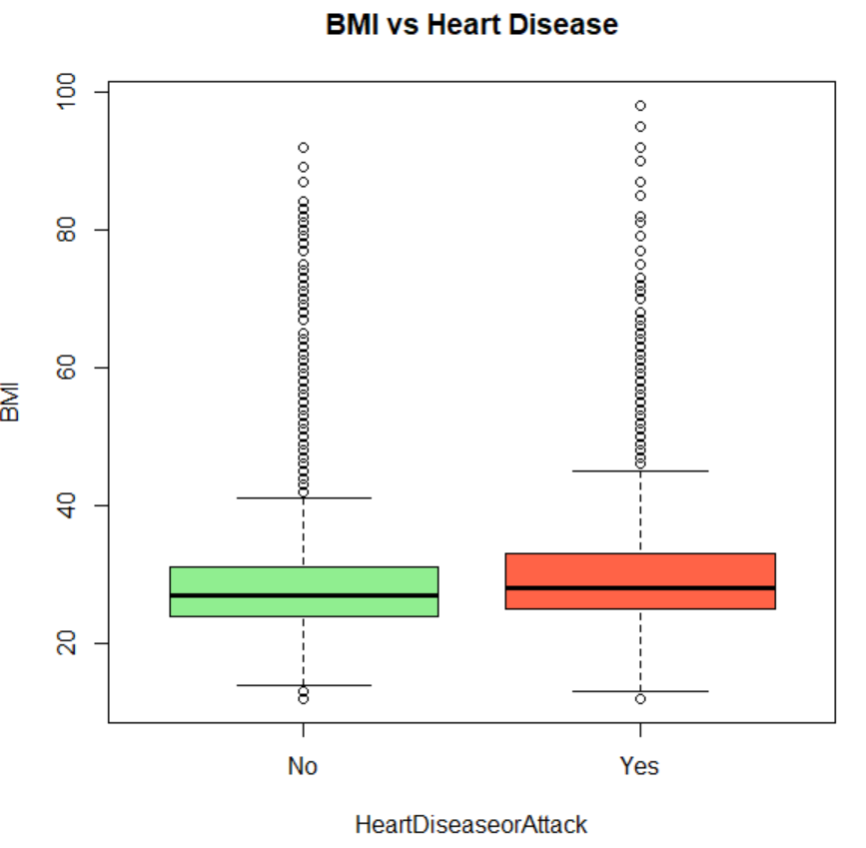
Figure 6: Distribution of BMI vs Heart Disease
The boxplot of BMI by Heart Disease reveals a higher median BMI for heart disease subjects ("Yes") than for non-heart disease subjects ("No"). Both have roughly equal interquartile ranges (IQR), primarily ranging from 24 to 34 units of BMI, but there is greater variation at the upper range and a higher incidence of high-end outliers in the heart disease group, suggesting there are more very high-BMI people in this group.
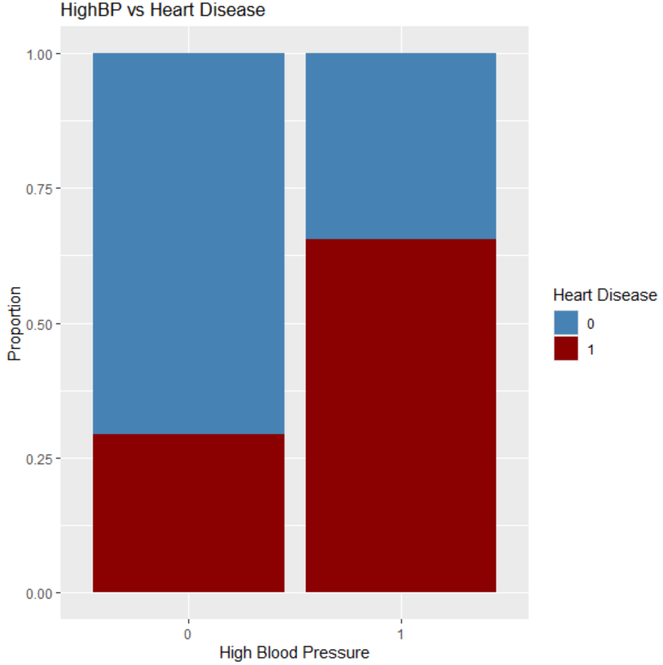
Figure 7: Distribution of HighBP vs Heart Disease
The stacked bar chart of HighBP and Heart Disease displays an evident correlation with high blood pressure and heart disease. In people without high blood pressure (0), most do not have heart disease (blue segment is predominant). However, in people with high blood pressure (1), a larger proportion have heart disease (red segment) than in people without high blood pressure.
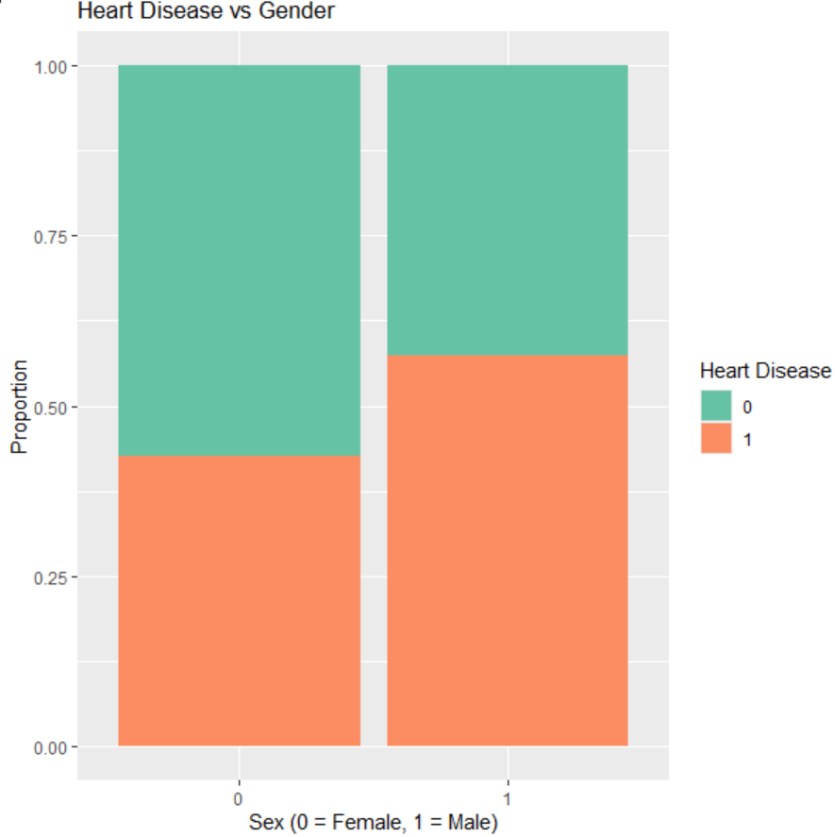
Figure 8: Distribution of Heart Disease vs Gender
The bar graph for Heart Disease by Gender has a larger part for males (1) with heart disease than for females (0). Although both sexes have heart disease, men have a significantly larger orange section, suggesting that a larger percentage of males have heart disease.
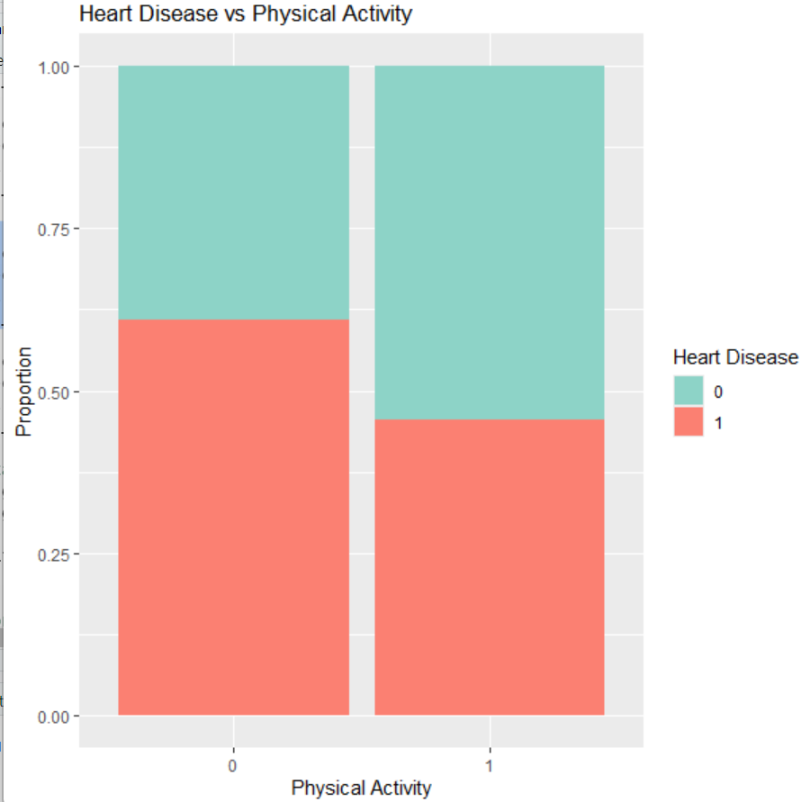
Figure 9: Distribution of Heart Disease vs Physical Activity
The bar graph of Physical Activity and Heart Disease reflects that there is a larger percentage of heart disease cases among people not taking part in physical activity (0) than among physically active people (1). The percentage of people without heart diseases is higher for people in the group taking part in physical activity.
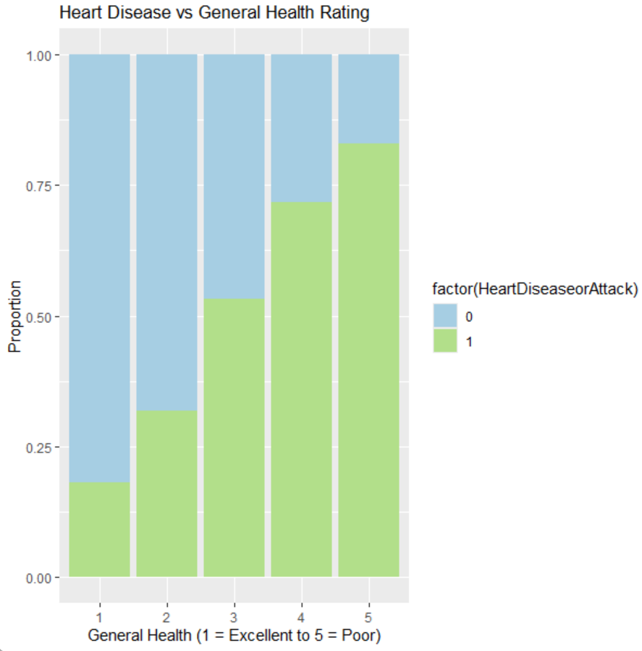
Figure 10: Distribution of Heart Disease vs General Health Rating
The bar graph of General Health Rating vs Heart Disease reveals an indication of a strong positive correlation between worse rated health and risk for heart disease. As one's general health rating moves from 1 (Excellent) to 5 (Poor) when rating health, there is an equally sharp increase in the percentage with heart disease (green). The largest percentage with heart disease is among people rating health as poor (5), and the lowest risk is among persons rating health as excellent (1).
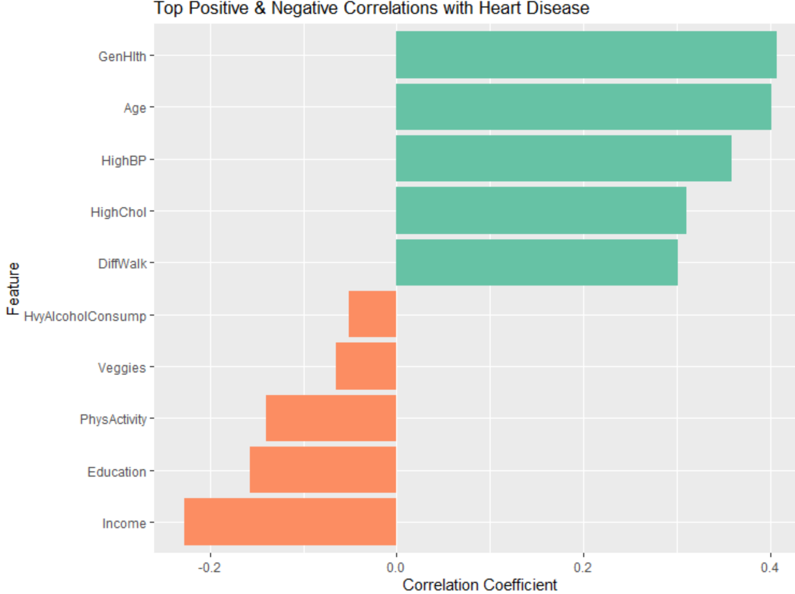
Figure 11: Top Correlations with Heart Disease
Positive Correlations:
- GenHlth (General Health Rating) correlates most strongly positively, suggesting worse self-reported health to be related strongly with greater risk of heart disease.
- Age, HighBP, HighChol, and DiffWalk also have moderate to strong positive correlations, as these are all recognized to have clinical associations with cardiovascular risk.
Negative Correlations:
- Income and Education have a negative correlation, implying that greater socioeconomic status can lower heart disease risk.
- PhysActivity, Veggies, and HvyAlcoholConsump (although with less influence) indicate that optimal lifestyle habits are negatively correlated with heart disease occurrence.

Model Performance
The models were evaluated on full variables as well variables with added interaction and higher order terms.
Full variables
These variables are the original variables of the data on which the models were trained and evaluated using suitable metrics.
- Logistic Regression on Full variables
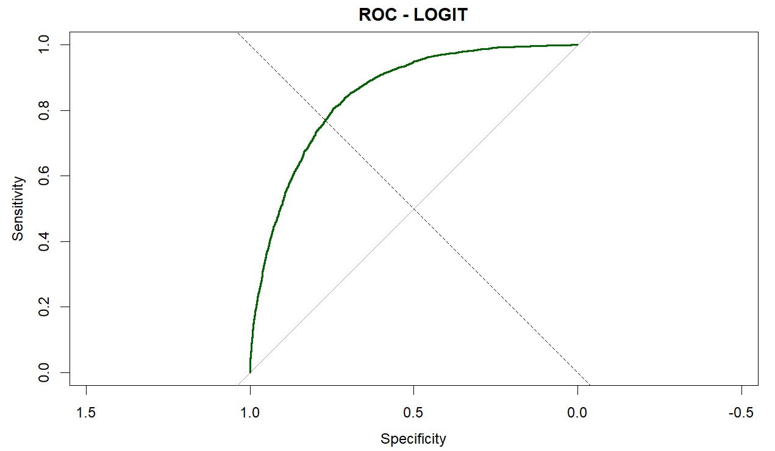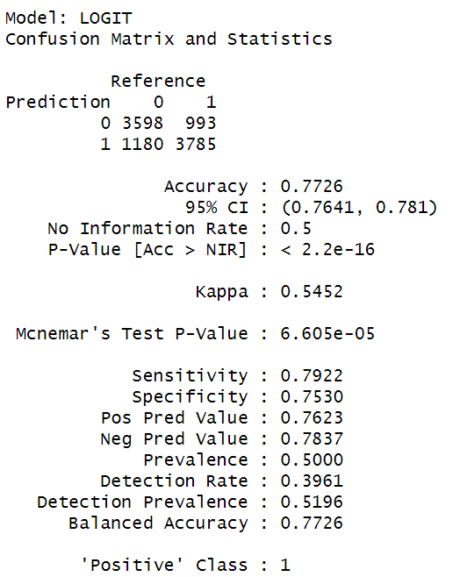
Figure 12: ROC Curve and Confusion Matrix of Logistic Regression
The logistic regression (LOGIT) model exhibits robust performance with respect to predicting heart disease. It has an accuracy rate of 77.3%, reflecting balanced sensitivity (79.2%) and specificity (75.3%) and, therefore, performing effectively on both classes. The F1-score value of 0.777 reflects robust balance between recall and precision.
- Model significance on full variables
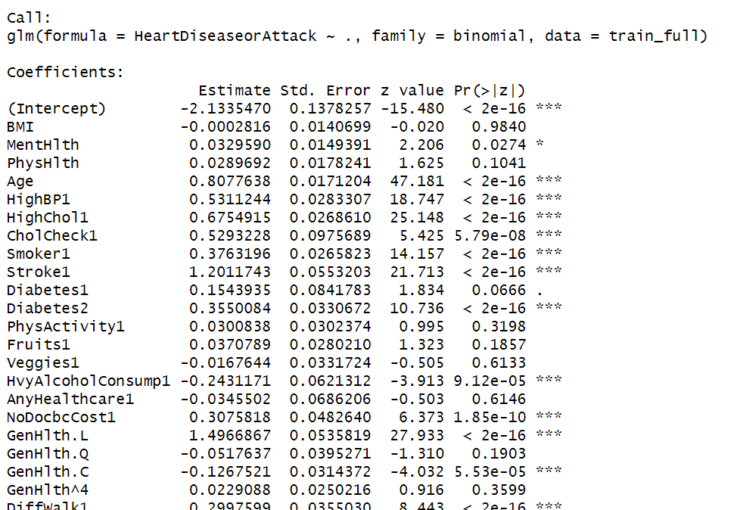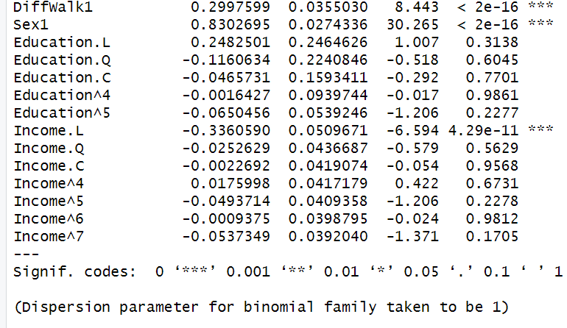
Figure 13: Model Summary
- Highly significant (p < 0.001):
Age, HighBP, HighChol, CholCheck, Smoker, Stroke, GenHlth.L, Sex, DiffWalk, Income.L
- Moderately significant:
MentHlth, Diabetes2, NoDocbcCost, GenHlth.C, HvyAlcoholConsump
These variables are strongly associated with the likelihood of heart disease.
Not Significant (p > 0.05):
- BMI, PhysActivity, Fruits, Veggies, AnyHealthcare, Education, Most Income and Education terms
- Decision tree on full variables
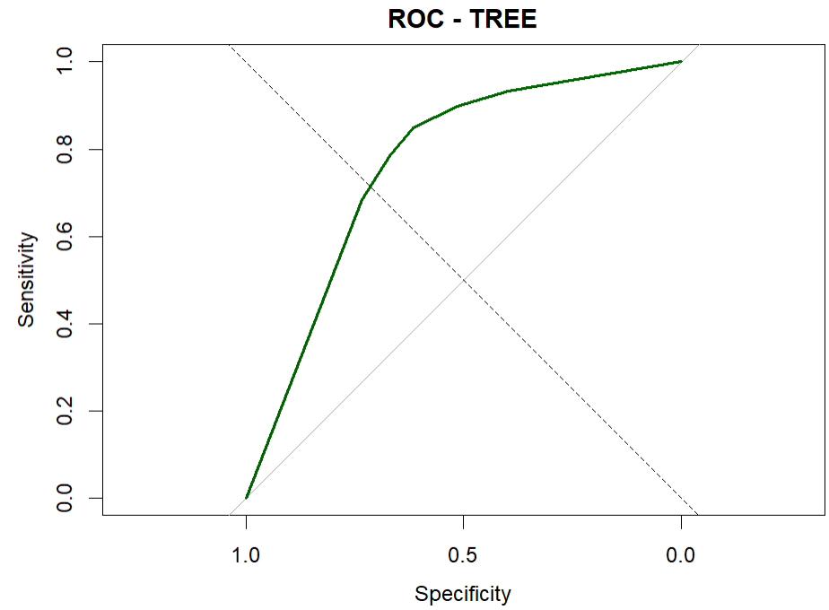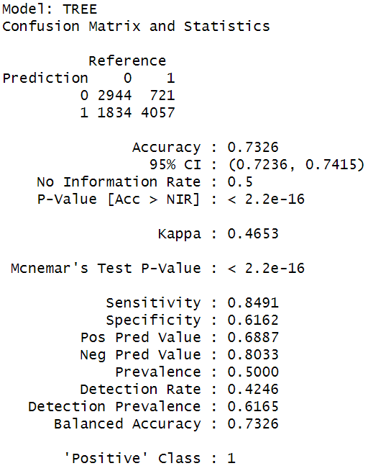
Figure 14: ROC Curve and Confusion Matrix of Decision Tree
The TREE model demonstrates satisfactory classification performance with an accuracy rate of 73.3% and a balanced accuracy rate also at 73.3%, reflecting satisfactory overall model success. The model has high sensitivity at 84.9%, as it has high success at detecting most heart disease cases, but has low specificity at 61.6%, resulting in high false positives.
- Naïve Bayes on full variables
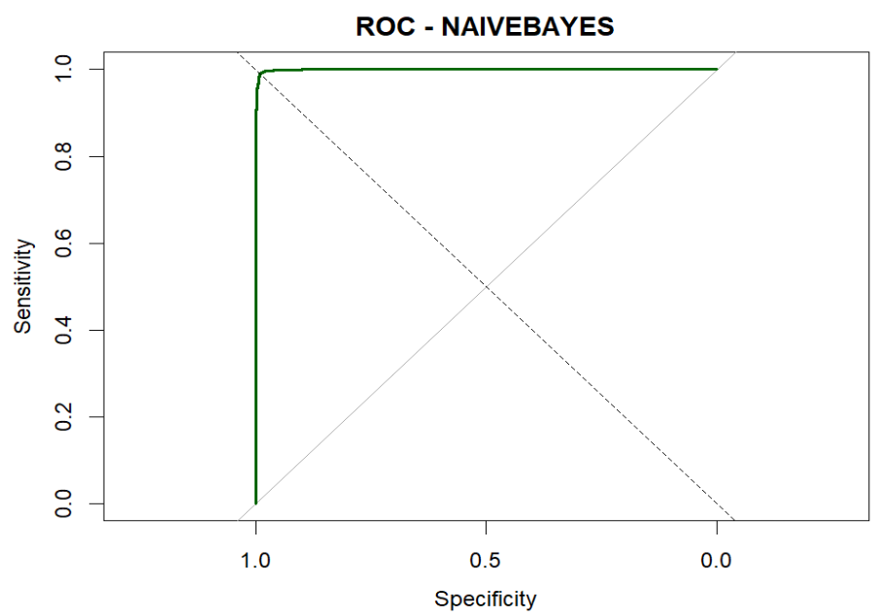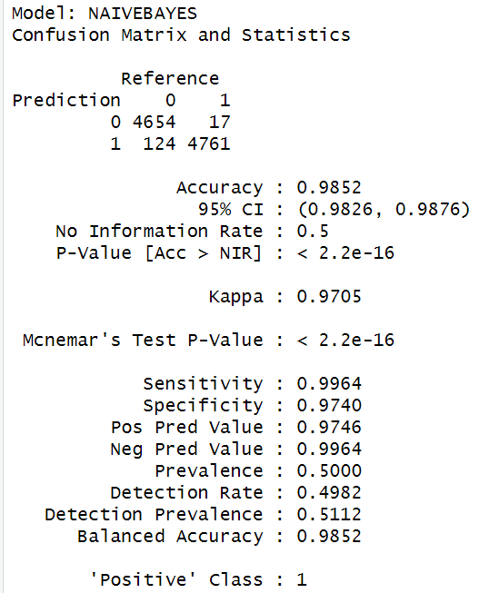
Figure 15: ROC Curve and Confusion Matrix of Naïve Bayes
The Naive Bayes classifier exhibits superb performance in heart disease prediction. It has an exceptionally high accuracy rate of 98.5%, with high sensitivity at 99.6% and high specificity at 97.4%, such that it almost precisely differentiates both positive and negative cases. The F1-measure at 0.985 establishes an almost perfect balance between recall and precision.
- LDA on full variables
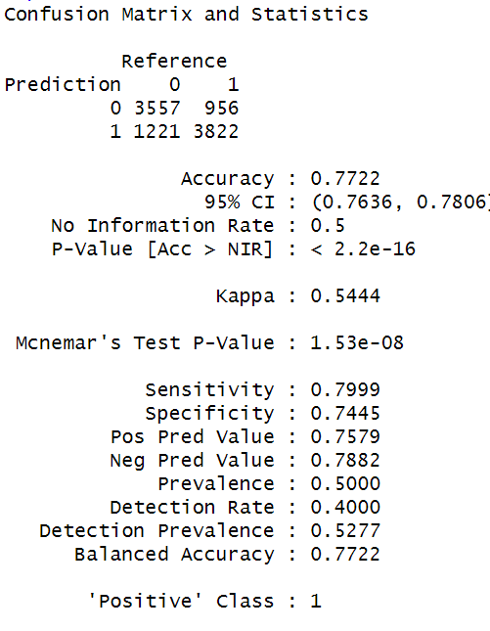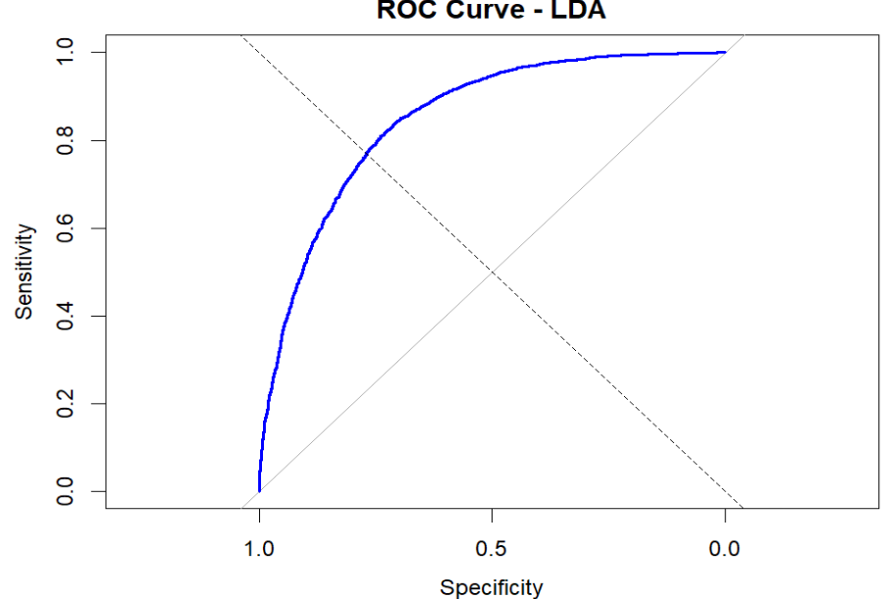
Figure 16: ROC Curve and Confusion Matrix of LDA
The LDA model shows strong predictive performance for heart disease classification, achieving an accuracy of 77.2%, with a balanced sensitivity of 80.0% and specificity of 74.5%. The F1-score of 0.778 indicates a solid balance between precision and recall, while the AUC of 0.848 reflects good discriminative ability.
- KNN on full variables
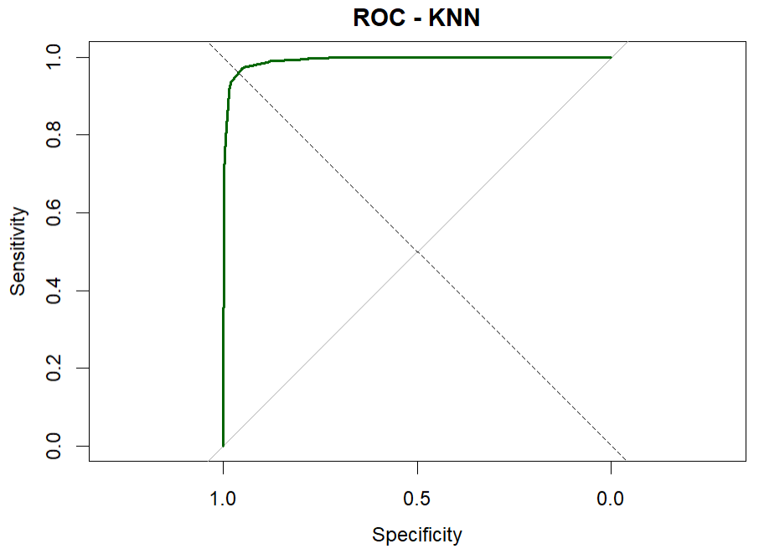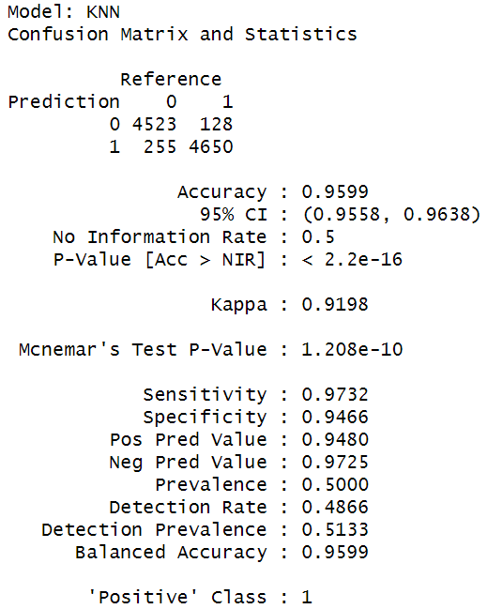
Figure 17: ROC Curve and Confusion Matrix of KNN
The K-Nearest Neighbors (KNN) classifier performs very well at predicting heart disease with a high accuracy rate of 95.99% and a high rate of balanced accuracy at 95.99%. It has high sensitivity at 97.3% as well as high specificity at 94.7%, reflecting very high detection rates for positive as well as negative cases. The F1-score at 0.960 reflects high accuracy for recall and precision at 94.8%, and thus high reliability for true-positive detection. The AUC at 0.991 on the ROC curve reflects nearly perfect classifier performance.
- Metric comparison on full variables
Model | Precision | Recall | Accuracy | F1 Score | AUC
Logistic Regression | 0.762 | 0.792 | 0.7726 | 0.777 | 0.849
Decision Tree | 0.689 | 0.849 | 0.7326 | 0.761 | 0.762
Naive Bayes | 0.975 | 0.996 | 0.9852 | 0.985 | 0.999
LDA | 0.758 | 0.800 | 0.7722 | 0.778 | 0.848
KNN | 0.948 | 0.973 | 0.9599 | 0.960 | 0.991
Table 2: Model Performance Comparison Table (Full Variables)
The Naive Bayes model is also the top-performing model, as it has a 98.52% accuracy, an AUC value of 0.999, and F1 value of 0.985, with almost perfect recall and precision. This means that not only does it make very few mistakes, but it is also very accurate at separating people with and without heart disease.

Comparison with original data
The models were again evaluated on original data to compare the performance with balanced data.
Model | Precision | Recall | Accuracy | F1 Score | AUC
Logistic Regression | 0.538 | 0.123 | 0.9075 | 0.201 | 0.846
Decision Tree | NaN | 0.000 | 0.9058 | NaN | 0.500
Naive Bayes | 0.900 | 0.980 | 0.9879 | 0.939 | 0.999
LDA | 0.435 | 0.226 | 0.8995 | 0.298 | 0.839
KNN | 0.996 | 0.774 | 0.9784 | 0.871 | 0.986
Table 3: Model Performance Comparison Table (Balanced data)
On the unbalanced dataset, Naive Bayes proved to be the most effective model with Precision of 0.900, Recall of 0.980, F1 Score of 0.939, and a near perfect AUC of 0.999, demonstrating strong, balanced performance to identify cases of heart disease. KNN was equally effective with extremely high precision levels but slightly lower recall compared to Naive Bayes. Logistic Regression and LDA performed poorly with extremely poor recall, i.e., they were unable to identify many positive cases. Decision Tree completely failed by classifying only the majority class and was ineffective for the unbalanced data.
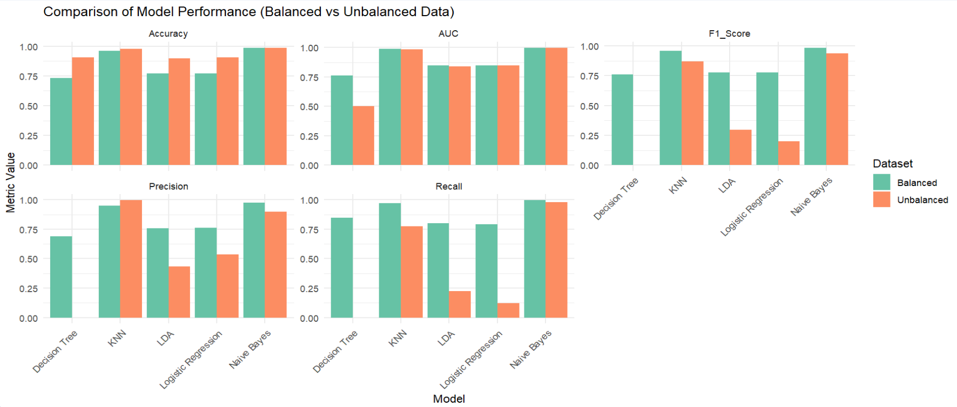
Figure 18: Model Performance Comparison (Balanced vs Unbalanced Data)
- Naive Bayes always had the highest scores for both datasets, with extremely high precision, recall, as well as AUC.
- KNN also did exceptionally well, particularly with the balanced dataset, with extremely high precision as well as F1 score.
- Logistic Regression and LDA had significant declines in recall and F1 measures using the imbalanced data, reflecting their challenges in identifying the minority class under imbalanced data.
- Decision Tree utterly failed on unbalanced data (recall = 0), with only the majority class being predicted.

Interaction variables
The interaction terms were created between different variables that were considered appropriate for the analysis.
- Logistic Regression on interaction variables
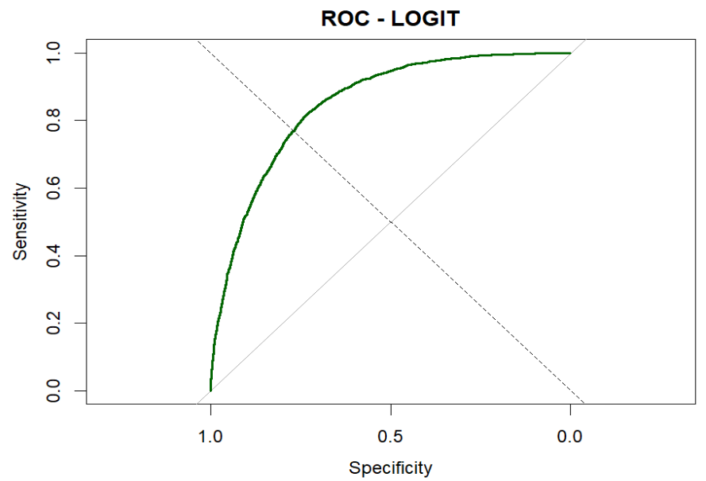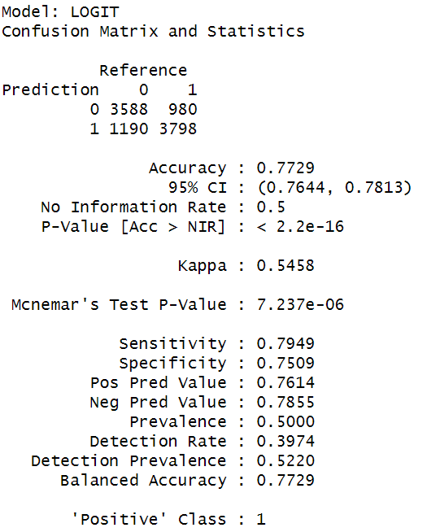
Figure 19: ROC Curve and Confusion Matrix of LR on Interaction Variables
The logistic classifier with interaction terms has good classification performance. It has an accuracy rate of 77.3%, a sensitivity or recall rate of 79.5%, and specificity rate of 75.1%, showing a balance in detection rates for cases and non-cases. The precision is 76.1%, and a resulting F1-score value equal to 0.778 indicates a fine balance between false positives and false negatives. A strong discriminative power is shown by an AUC value of 0.849 based on an ROC curve.
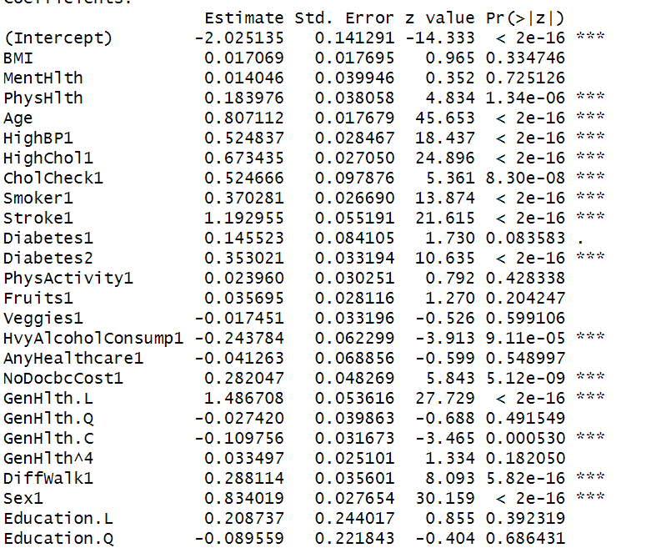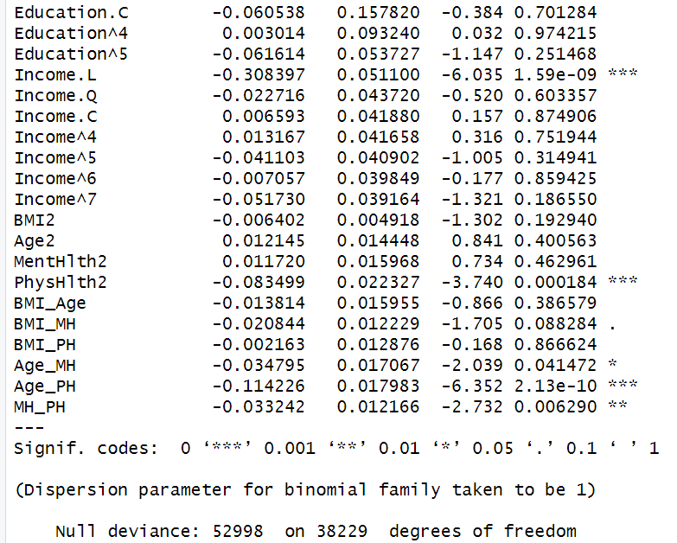
Figure 20: Model Summary on Interaction Variables
The model confirms that age, stroke, high BP, high cholesterol, smoking, and poor general health are key positive risk factors for heart disease. Interestingly, some interaction terms and squared terms (e.g., Age_PH, MH_PH) reveal nonlinear and combined effects that adjust the base risk in specific subgroups, improving the model's explanatory power.
- Decision Tree on interaction variables
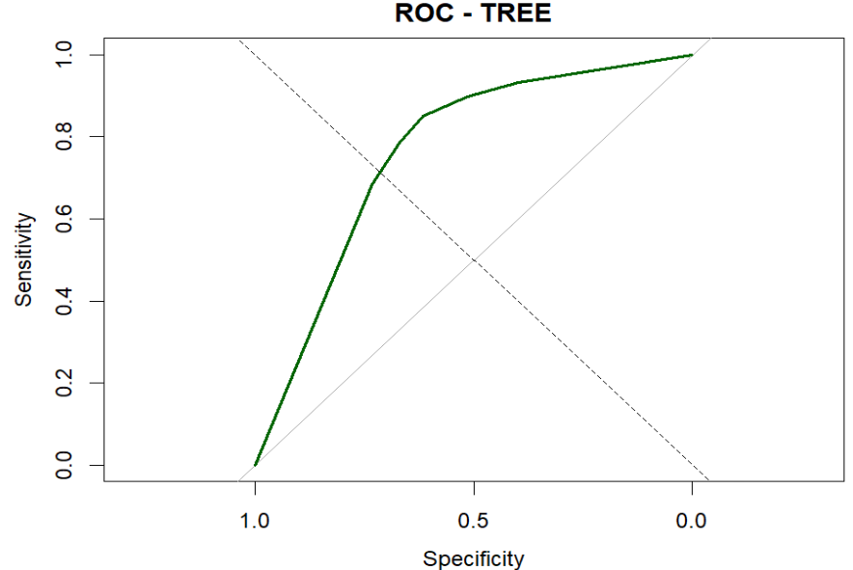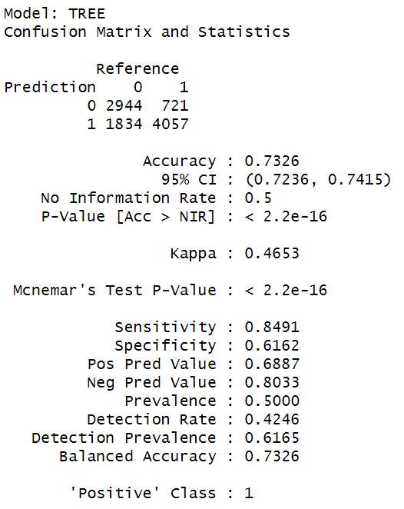
Figure 21: ROC Curve and Confusion Matrix of DT on Interaction Variables
Decision tree model with interaction terms performs moderately with an accuracy rate of 73.3% as well as a balanced accuracy rate of 73.3%. The model performs well in sensitivity (84.9%) as it is able to identify most cases of heart disease but has poor specificity (61.6%) with higher rates of false positives. Its F1-score is 0.761 with a fair trade-off between precision (68.9%) and recall. The model has an AUC grade of 0.762 with reasonable discriminative power.
- Naïve Bayes on interaction variables

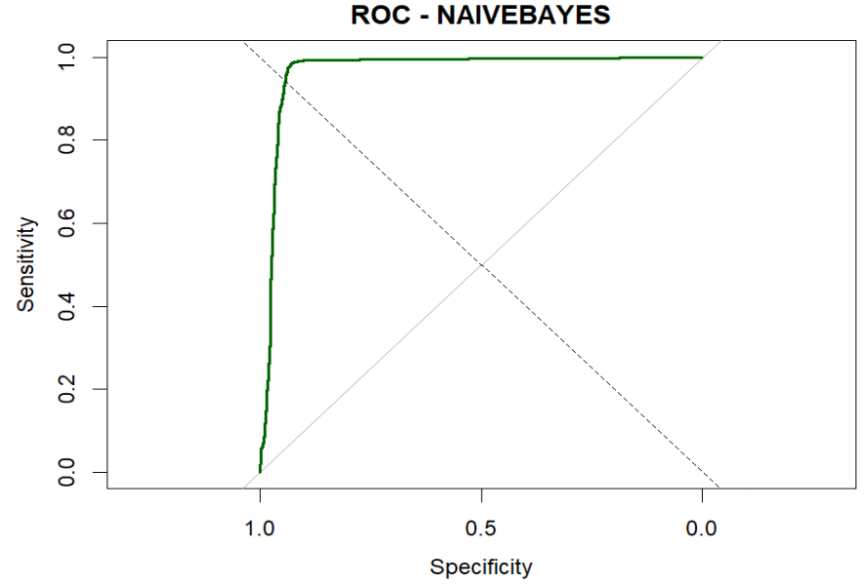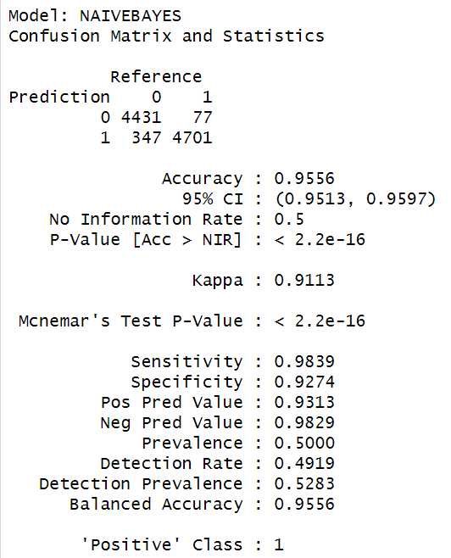
Figure 22: ROC Curve and Confusion Matrix of Naïve Bayes on Interaction Variables
The Naive Bayes classifier with interaction terms performs exceptionally, with an accuracy rate of 95.6% and balanced accuracy rate of 95.6%. It has extremely high sensitivity (98.4%) and specificity (92.7), reflecting very strong classification power for both classes. It has high precision (93.1%) and an F1-score value of 0.957 with very few false positives and false negatives. The AUC value is 0.968, reflecting strong discriminative power.
- LDA on interaction variables

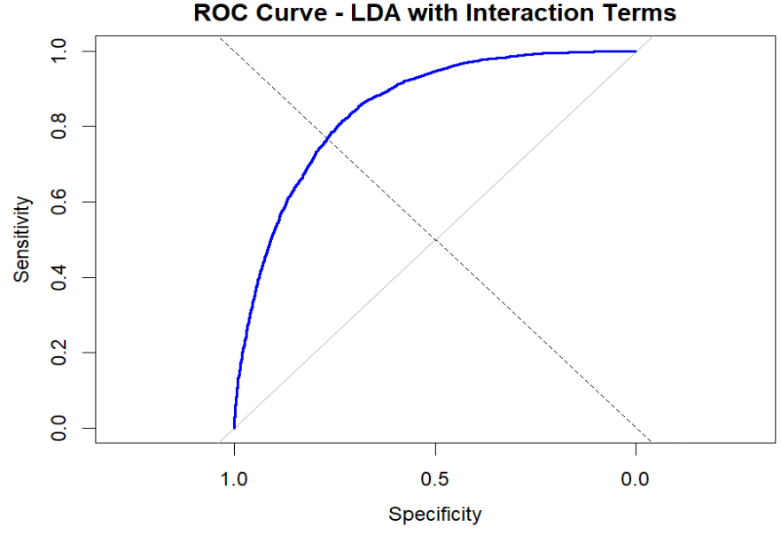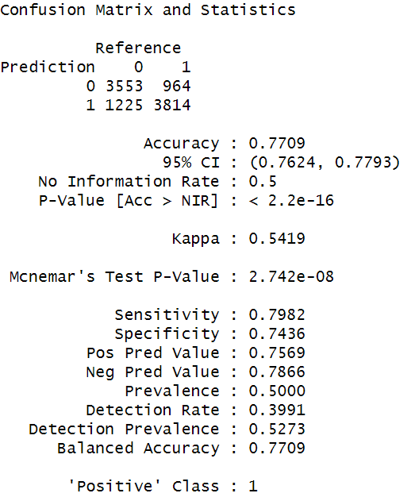
Figure 23: ROC Curve and Confusion Matrix of LDA on Interaction Variables
The interaction terms LDA model has robust classification accuracy with an accuracy of 77.1% and a balanced accuracy of 77.1%. It also has a recall rate of 79.8%, implying it is able to identify most heart disease cases. The precision is 75.7%, reflecting reasonable reliability in positive prediction. The F1-score is 0.777, reflecting healthy balance in terms of precision and recall. A solid discriminative power is indicated by AUC at 0.848.
- KNN on interaction variables
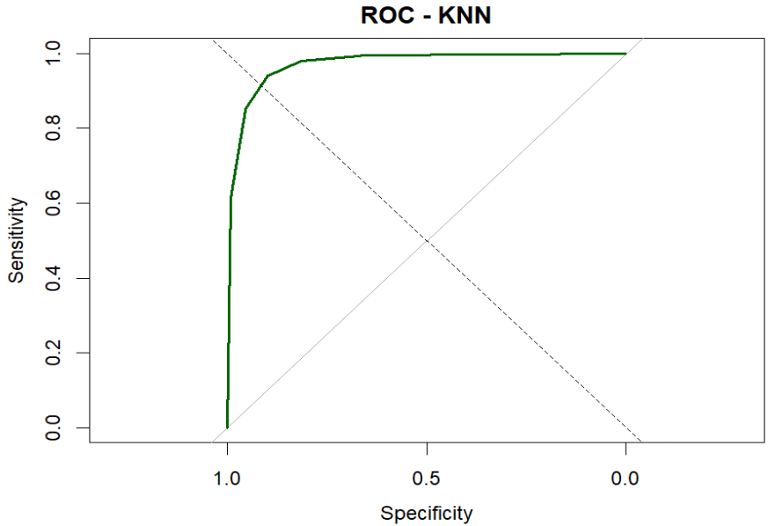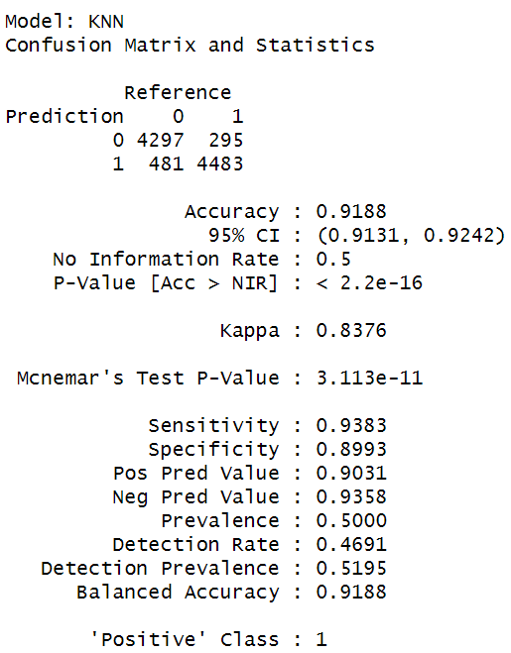
Figure 24: ROC Curve and Confusion Matrix of KNN on Interaction Variables
The interaction term-based KNN model performs very well with a high accuracy rate of 91.9% and balanced accuracy also at 91.9%, reflecting its consistency on both classes. It has very high sensitivity (93.8%) and specificity (89.9%) rates, reflecting its high success at detection of heart disease cases with low rates of false alarms. The model has a high degree of precision at 90.3% with an F1-score at 0.920, reflecting its excellent balance in terms of precision as well as recall.
- Metric comparison on variables with added interactions
Model | Precision | Recall | Accuracy | F1 Score | AUC
Logistic Regression | 0.761 | 0.795 | 0.7729 | 0.778 | 0.849
Decision Tree | 0.689 | 0.849 | 0.7326 | 0.761 | 0.762
Naive Bayes | 0.931 | 0.984 | 0.9556 | 0.957 | 0.968
LDA | 0.757 | 0.798 | 0.7709 | 0.777 | 0.848
KNN | 0.903 | 0.938 | 0.9188 | 0.920 | 0.971
Table 4: Model Comparison Table with Interaction Variables
Among all models trained with interaction terms, the Naive Bayes model stands out as the best performer. It achieved the highest accuracy (95.56%), F1 score (0.957), and a very high AUC (0.968), along with excellent precision (93.1%) and recall (98.4%). These metrics indicate that the model not only makes very accurate predictions but also maintains a strong balance between identifying actual heart disease cases and minimizing false alarms.

Model tuning
The following approaches were used to tuned the models. LDA model was not used for tuning as it doesnot contain any tunable parameters.
Model | Dataset Type | Tuning Method | Parameters Tuned | Tuning Details
Logistic Regression | Original & Interaction | Stepwise AIC Selection | None manually tuned | Used step() for AIC-based bidirectional stepwise selection, automatically choosing significant variables to optimize model simplicity and performance.
Decision Tree | Original & Interaction | Grid Search + 5-fold CV | cp (complexity parameter) | Performed a grid search over cp values from 0.001 to 0.05 in increments of 0.005 to control tree pruning. Evaluated using 5-fold cross-validation with ROC as the selection metric.
Naive Bayes | Original & Interaction | Grid Search + 5-fold CV | laplace, usekernel, adjust | Explored Laplace smoothing (0, 0.5, 1), kernel density estimation (TRUE/FALSE), and bandwidth adjustment (0.5, 1, 2). Optimized for AUC using cross-validation.
K-Nearest Neighbors (KNN) | Original & Interaction | Grid Search + 5-fold CV | k (number of neighbors) | Tuned over odd values from 3 to 12 (to avoid tie votes). The best k was selected based on highest ROC AUC across folds.
Table 5: Model Tuning Information
The models were retrained after finding out the best parameters from each combination and evaluated in same data to determine the best performance.
Model | Accuracy | Precision | Recall | F1 Score | AUC
Logistic Regression (Orig) | 0.773 | 0.762 | 0.794 | 0.778 | 0.85
Decision Tree (Orig) | 0.7558 | 0.725 | 0.825 | 0.772 | 0.797
Naive Bayes (Orig) | 0.727 | 0.742 | 0.696 | 0.718 | 0.801
KNN (Orig) | 0.7518 | 0.736 | 0.786 | 0.76 | 0.818
Logistic Regression (Int) | 0.774 | 0.762 | 0.797 | 0.779 | 0.849
Decision Tree (Int) | 0.7558 | 0.725 | 0.825 | 0.772 | 0.797
Naive Bayes (Int) | 0.6986 | 0.783 | 0.549 | 0.646 | 0.801
KNN (Int) | 0.7496 | 0.736 | 0.779 | 0.757 | 0.817
Table 6: Overall Model Performance Comparison
The comparison reveals Logistic Regression (with/without interaction terms) performing best overall, with interaction model having slightly better accuracy and F1 score, while almost matching AUC. In spite of interaction models usually introducing complexity, Logistic Regression stayed resilient, proving its high generalization power on this dataset. The Decision Tree model performed best on recall at the expense of some precision, and Naive Bayes with interactions faced a loss in recall. Therefore, Logistic Regression with interaction terms is the top-performing model with all critical measures in balance

Discussion
The main goal of the current study was to construct predictive models for classifying heart disease risk using health indicators from the BRFSS 2015 data set and assess the impact of feature engineering (polynomial terms and interactions) and data set balancing on model performance. This goal was addressed comprehensively through a complete set of pre-processing steps, exploratory data analysis (EDA), model construction, tuning, and model evaluation.
The outcome proved that dataset balancing was essential to enhancing model dependability, especially for the positive heart disease cases, which constituted only around 9.4% of the original data. On imbalanced data, models such as Logistic Regression and Decision Tree performed inadequately for heart disease case detection, as indicated by poor recall and F1-scores. Dataset balancing provided enhanced rates of detection by eliminating bias towards the majority class, which was consistent with results from studies previously conducted that highlighted the significance of class imbalance handling for health datasets.
Naive Bayes performed the best of all the base models using the complete (balanced) dataset with a stellar F1 Score (0.985), AUC (0.999), as well as almost perfect precision and recall. This finding mirrors other research that the Naive Bayes classifiers, with their simplicity and strength, tend to work exceptionally well with health classification tasks if the features are properly set up.
Nonetheless, with model tuning and feature engineering (including interaction and second-order terms), Logistic Regression proved to be the most balanced model with a high accuracy of 77.4%, F1 Score of 0.779, and AUC of 0.849. Using the stepwise AIC-based selection helped improve the generalization of the Logistic model with the optimal selection of significant features while enhancing model simplicity. Even though Logistic Regression proved superior after model tuning, it is worth noting that according to overall F1 score, Naive Bayes using the complete set of variables still proves to be the leading model without tuning.
The PCA was not employed for dimensionality reduction due to moderate multicollinearity as well as because of the clinical understandability of original features, a concern for healthcare analytics. Interaction terms were judiciously confined to continuous variables to stay away from model complexity as well as interpretation issues due to categorical interactions.

Conclusion and future direction
This study was able to successfully build predictive models for heart disease classification based on health indicators in the BRFSS 2015 data. The most important result is that class imbalance has a large effect on model performance, notably in identifying the minority class. Naive Bayes was found to be the top performing model on the entire, balanced dataset with excellent F1 and AUC performance. But with model tuning and interaction terms involved, Logistic Regression was found to be most balanced and explainable with good performance and minimal assumptions.

Limitations
- Random Undersampling Applied: The balance strategy used only random undersampling, potentially eliminating useful information in the majority class.
- Single Dataset Evaluation: Model performance was measured solely on the BRFSS 2015 dataset to limit generalizability to other time frames or groups.
- Limited Scope of Algorithm: The task only involved conventional machine learning algorithms without considering sophisticated or ensemble-based models.
- No External Validation: The models have never been tested against unseen external data sets so their applicability in real-world scenarios is uncertain.

Future work
- Apply Oversampling Methods: Apply SMOTE or ADASYN for minority class augmentation without data loss.
- Explore Ensemble Models: Implement ensemble methods such as Balanced Random Forest, XGBoost, or LightGBM for potentially enhanced performance and stability.
- Validate on External Data: Evaluate model generalizability with external heart disease data for other years or other health surveys.
- Harnessing Deep Learning: Employ neural networks and deep learning models to identify intricate, non-linear data correlations.
- Integrate Time Series Data: Examine long-term trends across several BRFSS waves to evaluate how stable predictive models are over time.

References
Baxani, R., & Edinburgh, M. (2022). Heart Disease Prediction Using Machine Learning Algorithms Logistic Regression, Support Vector Machine and Random Forest Classification Techniques. SSRN Electronic Journal. https://doi.org/10.2139/ssrn.4151423
Karthi, C. B. M., & Kalaivani, A. (2023). Heart Disease Prediction Based on Age Detection Using Logistic Regression over Random Forest. CARDIOMETRY, 25, 1731–1737. https://doi.org/10.18137/cardiometry.2022.25.17311737
Kumar Agrawal, T., & Gupta, D. (2024). Heart Disease Diagnosis Using Hybrid Machine Learning Model in Layered Classification Approach. International Journal of Scientific Engineering and Research, 12(12), 12–15. https://doi.org/10.70729/se241223182706
Li, J. P., Haq, A. U., Din, S. U., Khan, J., Khan, A., & Saboor, A. (2020). Heart Disease Identification Method Using Machine Learning Classification in E-Healthcare. IEEE Access, 8, 107562–107582. https://doi.org/10.1109/ACCESS.2020.3001149
Mushtaq, Z., Ramzan, M. F., Ali, S., Baseer, S., Samad, A., & Husnain, M. (2022). Voting Classification-Based Diabetes Mellitus Prediction Using Hypertuned Machine-Learning Techniques. Mobile Information Systems, 2022, 1–16. https://doi.org/10.1155/2022/6521532
Sakinat Oluwabukonla Folorunso, Joseph Bamidele Awotunde, Emmanuel Abidemi Adeniyi, Kazeem Moses Abiodun, & Femi Emmanuel Ayo. (2022). Heart Disease Classification Using Machine Learning Models. Communications in Computer and Information Science, 35–49. https://doi.org/10.1007/978-3-030-95630-1_3
Teboul, A. (2022). Heart Disease Health Indicators Dataset. Www.kaggle.com. https://www.kaggle.com/datasets/alexteboul/heart-disease-health-indicators-dataset
Viega, M. T. (2020). Heart Disease Prediction System using Data Mining Classification Techniques: Naïve Bayes, KNN, and Decision Tree. International Journal of Advanced Trends in Computer Science and Engineering, 9(3), 3028–3035. https://doi.org/10.30534/ijatcse/2020/82932020

