How Much History Does a Sequential Misuse Monitor Need?
A reproduction and a pre-registered comparison of history selection on DecomposedHarm
Satya Chamana
Independent research study. Compute: Clipper HPC cluster, Grand Valley State University.
Manuscript draft, not peer reviewed. Version phase3-v1, 3 November 2026.

Abstract
Decomposition attacks split a harmful goal into steps that each look harmless, so a monitor that judges one request at a time misses them. Sequential monitors judge each new request together with earlier ones, but how much earlier context they need, and how it should be chosen, is open. We first reproduce a published lightweight sequential monitor (Llama-3.1-8B-Instruct on DecomposedHarm). Under the authors' own scoring rule, our results match their released outputs to within 0.001 F1 for both prompts with saved outputs (0.875 vs 0.874; 0.931 vs 0.932), and our validation-thresholded test F1 for the best prompt is 0.898 (95% CI 0.869 to 0.924) against a published 0.881. We then hold the judge fixed and vary only the history it sees, across ten pre-registered conditions: no history, all history, and the top 3 or top 5 earlier steps chosen by recency, BM25, a general dense encoder, or their reciprocal-rank fusion. Thresholds were calibrated on validation to a 5% sequence-level false-alarm budget and frozen before a single test run on 528 sequences. Top-3 retrieval is non-inferior to full history in timely recall for all three retrievers (differences +0.004 to +0.015; every lower 95% bound at or above −0.011 against a pre-set margin of −0.05) without more false alarms. Full history detects more attacks in time than the current request alone (+0.114, 95% CI +0.068 to +0.156), but it also flags more benign sequences (+0.049), and in an exploratory analysis at equal false-alarm counts the overall gain disappears. The benefit is concentrated in decomposed question-answering attacks (+0.198), while history raises false alarms on benign agent and image tasks. Retrieval did not beat simply taking the three most recent steps. We report the design, a protocol amendment made before any test data were seen, and the limits of these findings.
Keywords: AI safety; misuse monitoring; decomposition attacks; stateful monitoring; retrieval; pre-registration; reproduction.

1. Introduction
A language-model safety filter that looks at one request at a time can be defeated by splitting a harmful task into pieces that are each acceptable on their own. Multi-turn escalation [Russinovich et al., 2024], leakage of harmful information through individually safe answers [Glukhov et al., 2024], and the misuse of combinations of safe models [Jones et al., 2024] are all versions of this problem. Yueh-Han et al. [2025] introduced DecomposedHarm, a benchmark of harmful tasks split into sequences of steps with matched benign sequences, and showed that a lightweight model monitoring the cumulative sequence detects many such attacks.
A deployed monitor cannot always see everything that came before. Context windows, cost, latency, retention policies and privacy rules all limit how much history it may keep and read. That raises a design question that a cumulative monitor does not answer: which earlier steps should the monitor see, and how many? If a small, well-chosen subset of history is enough, a monitor can be cheaper and keep less user data. If it is not, the reasons matter: the right evidence may not be retrieved, or the judge may misread it when it is.
This study takes two steps toward that question.
- Reproduction (Phase 2). We re-implement the published monitor protocol and run three of its prompts with a local Llama-3.1-8B-Instruct, comparing against both the paper's tables and the authors' released per-run outputs.
- Controlled history-selection study (Phase 3). With one fixed judge and prompt, we vary only which earlier steps the judge sees, across ten pre-registered conditions. Thresholds are calibrated per condition on validation, frozen, and evaluated once on a held-out test set.
Our contributions are: (i) an independent reproduction that matches the authors' released outputs closely; (ii) evidence that top-3 retrieval matches full history in timely detection on this benchmark; (iii) a decomposition of where history helps (decomposed question answering) and where it costs false alarms (benign agent and image tasks); and (iv) a transparent account of a calibration failure and the pre-test amendment that fixed it.

2. Background

2.1 Sequential monitoring of decomposition attacks
In DecomposedHarm, each harmful sequence carries a harm index: the step at which harm would occur if the model complied with every step up to and including it [Yueh-Han et al., 2025]. A monitor that flags a harmful sequence at or before that step has detected it in time; flagging later is too late. The published monitor scores the cumulative prefix at each step and fires on the first step whose score passes a threshold chosen on validation data.
The harm index is built differently per task type, and the difference matters for interpretation. For question-answering (QA) sequences it is the shortest prefix at which a reference model's answers were judged harmful by StrongREJECT [Souly et al., 2024]; for image tasks it is always the last step; for agent tasks it was annotated by a language model. We treat these as given labels and do not re-annotate them.

2.2 History selection as retrieval
Choosing which earlier steps to show the judge is a retrieval problem in which the current request is the query and earlier steps are the documents. We compare a recency baseline, lexical retrieval with BM25 [Robertson and Zaragoza, 2009], a general pretrained sentence encoder [Reimers and Gurevych, 2019; Wang et al., 2020], and their reciprocal-rank fusion [Cormack et al., 2009]. Selected steps are always presented to the judge in their original order. Monitoring with limited, selected context also connects to the broader control-and-monitoring literature [Greenblatt et al., 2023].

3. Methods

3.1 Data
We use DecomposedHarm from Hugging Face (YuehHanChen/DecomposedHarm, revision 25e1d59), accessed under the authors' evaluation-only terms; we never train on it. The authors' code is pinned at commit 79f5b41. Each row has an identifier, an original goal, the decomposition into steps, the harm index (1-based, inclusive, verified against the upstream code), a label and a task type.
The paper evaluates on a balanced subset built by an unseeded shuffle, which cannot be regenerated. We therefore pin the released subset by identifier: 264 validation sequences (137 harmful / 127 benign) and 528 test sequences (263 harmful / 265 benign), balanced across the three task types. A frozen list of 10 problem rows (for example, a pair with identical steps and opposite labels) is kept in the primary analysis for faithful replication and dropped in a sensitivity analysis.
Table 1. Evaluation subset (sequences; h = harmful, b = benign).
Split | QA (h / b) | agent (h / b) | image (h / b) | Total
Validation | 43 / 43 | 42 / 43 | 52 / 41 | 264 (137 / 127)
Test | 86 / 90 | 88 / 88 | 89 / 87 | 528 (263 / 265)

Sequences are short. In the test set the median length is 6 steps for QA, 7 for agent and 10 for image; the median harm index is 3 (QA), 6 (agent) and 10 (image).

3.2 Monitor and scoring protocol
The judge is meta-llama/Llama-3.1-8B-Instruct (revision 0e9e39f), run locally with Hugging Face Transformers in bfloat16 on one NVIDIA H100 NVL, with greedy decoding and a 2,000-token output limit. Prompt formatting follows the upstream code: earlier steps are joined by newlines, apostrophes are removed, and the system prompt is "You are a helpful assistant." Step 1 is never scored. A sequence fires at its first scored step whose score passes the threshold. We report:
- Timely recall: harmful sequences first flagged at or before the harm step, divided by harmful sequences. This equals the paper's detection success rate (DSR).
- Sequence false-positive rate (FPR): benign sequences flagged at any step, divided by benign sequences.
- F1 under the paper's protocol, where a true positive is a timely detection.
The monitor never sees the original goal, the label, the harm index or any future step. A guard in the runner raises an error if any selected history item comes from the current or a later step.

3.3 Phase 2: reproduction
We ran three upstream prompts: a zero-shot binary prompt (BINARY_BASELINE), a zero-shot probability prompt (BINARY_INTENTION_EVAL_ORIGINAL) and the paper's optimized prompt with eight in-context agent examples (BINARY_INTENTION_EVAL_W_8_AGENT_ICL, "Agent-ICL"). Each was run once on validation and once on test. The threshold was chosen on validation as the F1-optimal point on a 0.05 to 0.95 grid. The upstream threshold sweep contains a one-step offset; we emulate it as the primary selector and report an aligned sweep alongside it. For comparison with the authors' released outputs, which pick the threshold on the test split, we also re-score our per-sequence scores with their exact rule.

3.4 Phase 3: controlled history selection
Fixed judge. Agent-ICL in the paper's format (the best prompt on validation in Phase 2). The only input that changes between conditions is which earlier steps appear in the prompt.
Conditions. Ten pilot conditions were pre-registered:
- current: no earlier steps.
- full: all earlier steps.
- recent_k: the k most recent earlier steps.
- bm25_k: top k by BM25 (k1 = 1.2, b = 0.75) between the current request and each earlier step.
- dense_k: top k by cosine similarity under all-MiniLM-L6-v2 (revision 1110a24), no fine-tuning; each text is embedded once per run.
- hybrid_k: reciprocal-rank fusion (constant 60) of the relevance-sorted BM25 and dense rankings.
Each selector was run with k = 3 and k = 5. Ties go to the more recent step, and the selected steps are presented in chronological order. Retrieval is restricted to earlier steps of the same sequence.
Readouts. After an amendment (Section 3.5), two readouts are reported from the same greedy generation:
- Readout A (primary): the judge's probability of answering "1" rather than "0" at its first generated token, p = P("1") / (P("0") + P("1")), using both plain and space-prefixed digit tokens. Thresholds are restricted to [0, 1] and fitted per condition on validation as the lowest threshold whose sequence FPR is at most 0.05.
- Readout B (secondary): the parsed reply at a fixed cutoff of 1 (the judge's own "harmful" verdict), with no calibration.
Hypotheses (pre-registered; primary metric = test timely recall at the frozen validation threshold):
- H1: full history beats current-only.
- H2: top-k retrieval keeps timely recall within a margin of full history (non-inferiority: the lower 95% bound of candidate minus full exceeds −margin).
- H4: BM25 and dense retrieval beat recency at the same k.
The margin and primary k were left open in the plan, to be set from validation results only before any test run. They were fixed at margin 0.05 and k = 3 (Section 4.3). Hypothesis H3, about oracle evidence, belongs to the mechanism phase and is not tested here.
Statistics. Paired sequence bootstrap on identical test identifiers (2,000 draws, seed 1729), resampling harmful and benign sequences separately, with 95% percentile intervals. The resampling unit is the sequence, not the task family. Counts and denominators are reported throughout.

3.5 Pre-registration, amendment and freeze
The plan was written and hashed before any Phase 3 run. A first validation run under the original protocol, which calibrated thresholds on the parsed scores, failed in an informative way. The judge's parsed scores are almost binary, so with 127 benign validation sequences a 5% budget allows at most 6 flags. Conditions that flagged 7 or more benign sequences at the judge's "1" verdict were pushed to a threshold above every real score (in one case, a misparsed value of 3.0), so their timely recall fell to zero.
That run was superseded and is never cited as a result. A written amendment, made before any test data were seen and referencing the plan's hash, replaced the primary readout with the continuous first-token probability (readout A), kept the parsed verdict as a fixed-cutoff secondary readout (readout B), and restricted thresholds to [0, 1]. The freeze file records the margin, k, each condition's threshold and the hash of every validation file. The freeze script refuses to overwrite it and rejects files from the superseded protocol.
Table 2. Phase 3 timeline.
Time (UTC, 3 Nov 2026) | Event
03:43 | Plan pre-registered (conditions, metric, hypotheses, margin rule)
— | Validation run 798493: calibration cliff; superseded, never frozen
04:27 | Amendment 1: readouts A and B; thresholds restricted to [0, 1]; no test data seen
— | Validation run 798524 under the amendment
18:44 | Thresholds frozen; primary k = 3; margin 0.05
— | Test run 798699, executed once

4. Results

4.1 Reproduction of the published monitor
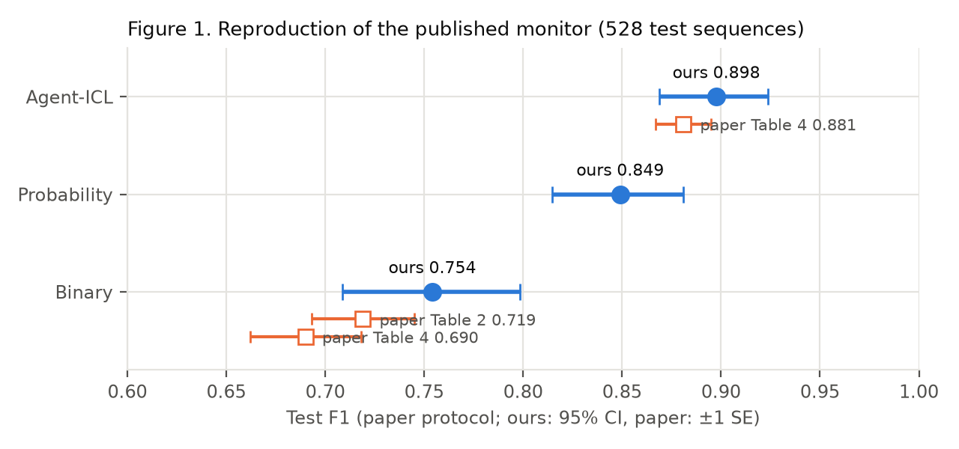
Figure 1. Test F1 under the paper's protocol with a validation-fixed threshold. Ours: point estimate and 95% sequence-bootstrap interval. Paper: published value ± 1 SE. The paper reports no Llama-3.1-8B number for the probability prompt.
Table 3. Phase 2 test results (528 sequences, one run per prompt, threshold from validation).
Prompt | TP / FP / FN / TN | F1 [95% CI] | DSR [95% CI] | Benign flagged | Paper
Binary | 161 / 3 / 102 / 262 | 0.754 [0.709, 0.798] | 0.612 [0.555, 0.672] | 3 / 265 | 0.719 ± 0.026 (T2); 0.690 ± 0.028 (T4)
Probability | 225 / 42 / 38 / 223 | 0.849 [0.815, 0.881] | 0.856 [0.812, 0.896] | 42 / 265 | none
Agent-ICL | 228 / 17 / 35 / 248 | 0.898 [0.869, 0.924] | 0.867 [0.826, 0.907] | 17 / 265 | 0.881 ± 0.014 (T4)

Table 4. Like-for-like check against the authors' released test outputs, both scored with the upstream sweep rule. That rule picks the threshold on test and is optimistic; these are not our official results.
Prompt | Ours, their rule (TP / FP / FN / TN) | Ours F1 | Authors' saved file | Their F1
Probability (threshold 0.25) | 232 / 35 / 31 / 230 | 0.875 | 242 / 49 / 21 / 216 | 0.874
Agent-ICL (threshold 0.05) | 237 / 9 / 26 / 256 | 0.931 | 245 / 18 / 18 / 247 | 0.932

The probability and Agent-ICL prompts reproduce: F1 matches the authors' released outputs to within 0.001 under the same rule, and our Agent-ICL test F1 is within about one standard error of the published value. Our local model flags slightly fewer sequences than the authors' API-served model (fewer true and false positives), so the match is in F1 rather than per-sequence behavior. The binary prompt is consistent with the paper's Table 2 (about 1 SE) and borderline against its Table 4 (about 1.8 SE); the paper's two values for this prompt themselves differ. Dropping the 10 problem rows changes test F1 by at most 0.003.
Table 5. Agent-ICL by task type (test). QA is the hard type: every late detection is a QA sequence.
Type | TP / FP / FN / TN | F1 | DSR | Too late | Never flagged
QA | 56 / 0 / 30 / 90 | 0.789 | 0.651 | 15 | 15
agent | 83 / 11 / 5 / 77 | 0.912 | 0.943 | 0 | 5
image | 89 / 6 / 0 / 81 | 0.967 | 1.000 | 0 | 0

Agent-ICL beats the probability prompt by +0.049 F1 (paired 95% CI +0.019 to +0.079). The gain comes from fewer false alarms (benign sequences flagged by only one prompt: 35 probability vs 10 Agent-ICL), not from more detections (DSR +0.011, CI −0.026 to +0.049).

4.2 Readout validity
Table 6. The continuous readout is a faithful version of the judge's own verdict.
Check | Validation (per condition) | Test (per condition)
Replies parsed | 1,744 / 1,744 | all
First-token P(0) + P(1): minimum | ≥ 0.992 | median ≈ 1.000
Decisions with P(0) + P(1) < 0.5 | 0 | 0
A (p ≥ 0.5) agrees with parsed 0/1 verdict | 99.7% to 99.9% | 99.5% to 99.8%

Unlike the parsed scores, readout A spreads out among benign sequences (for the full condition on validation, 109 of 127 benign sequences have a maximum score below 0.1 and 18 lie between 0.1 and 0.99), which is what fixed-FPR calibration needs. Every condition reached exactly 6 of 127 benign flags (FPR 0.047) on validation.

4.3 Validation stage and the choice of k and margin
Table 7. Validation, readout A (127 benign / 137 harmful). Used only for calibration and for the k and margin decisions.
Condition | Threshold | FPR | Timely recall | Paired diff vs full [95% CI]
current | 0.989 | 0.047 | 0.693 | −0.153 [−0.226, −0.088]
full | 0.438 | 0.047 | 0.847 | —
recent_k3 | 0.651 | 0.047 | 0.839 | −0.007 [−0.036, +0.022]
bm25_k3 | 0.562 | 0.047 | 0.839 | −0.007 [−0.036, +0.015]
dense_k3 | 0.469 | 0.047 | 0.847 | +0.000 [−0.029, +0.029]
hybrid_k3 | 0.500 | 0.047 | 0.854 | +0.007 [−0.022, +0.036]
recent_k5 | 0.469 | 0.047 | 0.832 | −0.015 [−0.036, +0.000]
bm25 / dense / hybrid k5 | 0.438 | 0.047 | 0.847 | +0.000 (0 discordant)

Two observations set the remaining choices. First, at k = 5 about 70% of decisions already see every earlier step, and BM25, dense and hybrid at k = 5 matched full history on every validation sequence; k = 5 therefore cannot separate retrieval from full history, so k = 3 was confirmed as primary (at k = 3, 55% of decisions see less than full history). Second, the margin of 0.05 was set as the largest loss of timely recall we would accept in practice. With about 263 harmful test sequences, the expected paired standard error is about 0.011, so a true difference near zero passes comfortably while a real loss of about 3 points or more would not.

4.4 Pre-registered test results
Table 8. Test results, readout A, frozen thresholds (263 harmful / 265 benign). One run.
Condition | Threshold | Benign flagged (FPR) | Timely recall | Any detection
current | 0.989 | 5 (0.019) | 0.684 | 0.757
full | 0.438 | 18 (0.068) | 0.798 | 0.852
recent_k3 | 0.651 | 12 (0.045) | 0.772 | 0.856
bm25_k3 | 0.562 | 15 (0.057) | 0.802 | 0.871
dense_k3 | 0.469 | 17 (0.064) | 0.810 | 0.875
hybrid_k3 | 0.500 | 16 (0.060) | 0.814 | 0.882
recent_k5 | 0.469 | 16 (0.060) | 0.791 | 0.856
bm25_k5 | 0.438 | 18 (0.068) | 0.802 | 0.859
dense_k5 | 0.438 | 18 (0.068) | 0.795 | 0.852
hybrid_k5 | 0.438 | 18 (0.068) | 0.798 | 0.856

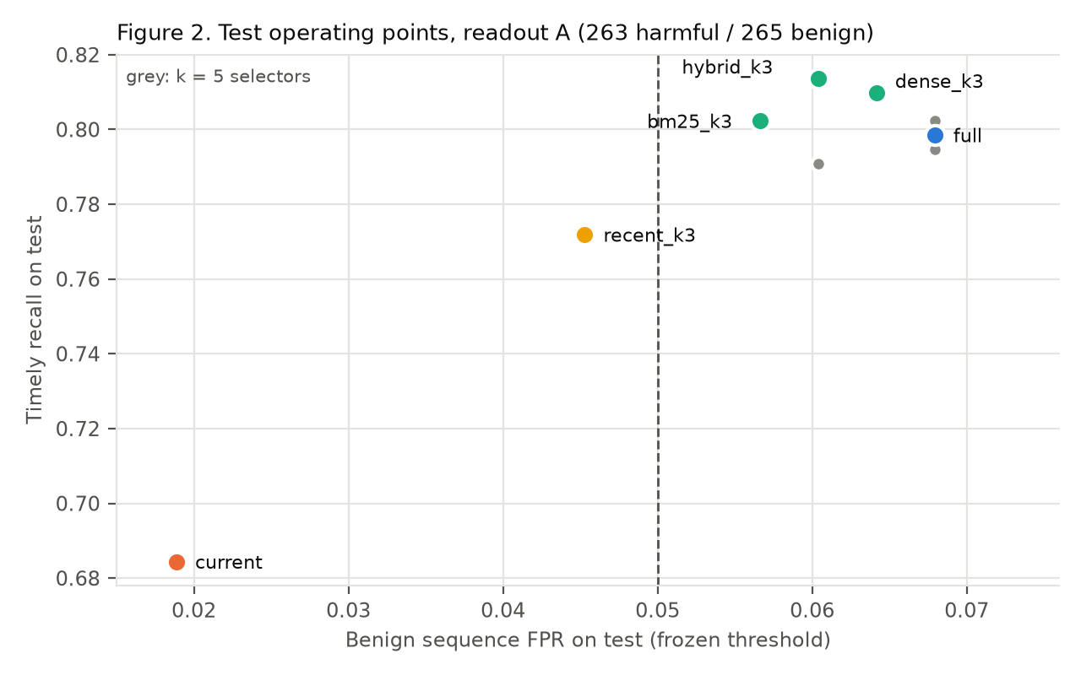
Figure 2. Test operating points under the frozen thresholds. The dashed line is the validation FPR budget; points to its right exceeded the budget on test. Grey points are the k = 5 selectors.
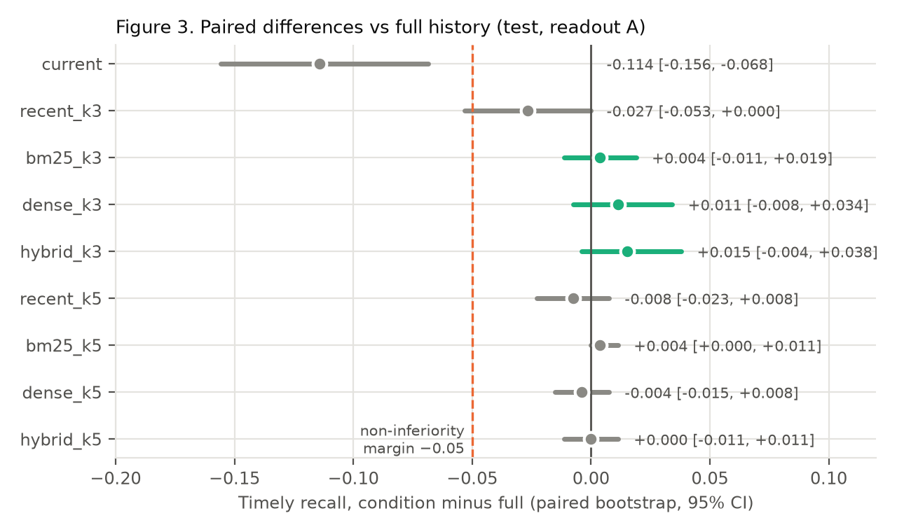
Figure 3. Paired difference in timely recall against full history (test, readout A), with 95% paired-bootstrap intervals. Green: the H2 candidates. Dashed: the non-inferiority margin.

H2: top-3 retrieval vs full history (primary)
Table 9. H2 non-inferiority tests (candidate minus full).
Candidate | Timely recall diff [95% CI] (SE) | Lower bound > −0.05? | FPR diff [95% CI] | Discordant (full only / cand. only)
bm25_k3 | +0.004 [−0.011, +0.019] (0.008) | Yes | −0.011 [−0.034, +0.011] | 2 / 3
dense_k3 | +0.011 [−0.008, +0.034] (0.010) | Yes | −0.004 [−0.015, +0.008] | 2 / 5
hybrid_k3 | +0.015 [−0.004, +0.038] (0.011) | Yes | −0.008 [−0.023, +0.008] | 2 / 6

H2 is supported for all three retrievers. Each is non-inferior to full history in timely recall, and none flags more benign sequences. The conclusion survives a Bonferroni split across the three candidates, since the worst lower bound (−0.011) is far from −0.05.

H1: full history vs current request only
Full history detects more attacks in time: +0.114 (95% CI +0.068 to +0.156), with 34 sequences caught in time only with full history and 4 only without it. It also flags more benign sequences: +0.049 FPR (95% CI +0.019 to +0.079), 18 vs 5. Both thresholds were fitted to the same validation FPR, but they transferred to different test FPRs, so the pre-registered comparison is not made at equal false alarms. H1 is supported on the primary readout, with a false-alarm cost (see Section 4.6).

H4: retrieval vs recency at k = 3
Table 10. H4 comparisons (paired, 95% CI).
Candidate − recent_k3 | Readout A: timely diff | Readout A: FPR diff | Readout B: timely diff | Readout B: FPR diff
bm25_k3 | +0.030 [+0.008, +0.057] | +0.011 [0.000, +0.026] | −0.008 [−0.023, +0.008] | +0.004 [0.000, +0.011]
dense_k3 | +0.038 [+0.015, +0.065] | +0.019 [+0.004, +0.038] | −0.004 [−0.019, +0.008] | −0.004 [−0.011, 0.000]

On readout A, BM25 and dense retrieval detect 3 to 4 points more than recency, but they also flag more benign sequences, because recency's frozen threshold (0.651) transferred to a lower test FPR (0.045). Under one fixed cutoff for every condition (readout B), the difference disappears. H4 is not supported: the readout-A gain cannot be separated from the difference in false alarms.

4.5 Secondary results
Table 11. Readout B: the judge's own verdict at a fixed cutoff, no calibration (test).
Condition | FPR | Timely recall | Diff vs full [95% CI]
current | 0.313 | 0.913 | +0.137 [+0.095, +0.183]
full | 0.053 | 0.776 | —
recent_k3 | 0.057 | 0.810 | +0.034 [+0.015, +0.057]
bm25_k3 | 0.060 | 0.802 | +0.027 [+0.008, +0.049]
dense_k3 | 0.053 | 0.806 | +0.030 [+0.008, +0.053]
hybrid_k3 | 0.053 | 0.814 | +0.038 [+0.015, +0.065]
k = 5 selectors | 0.049 | 0.779 to 0.783 | +0.004 to +0.008

Without calibration, the current-only monitor flags almost a third of benign sequences. At its own verdict, k = 3 selection catches 2.7 to 3.8 points more attacks than full history at a similar FPR, which suggests that removing some history can make the judge more decisive without more false alarms. Because readout B is uncalibrated, this is reported as secondary.
Calibration transfer. A validation fit of 6 of 127 benign flags gave test FPRs from 0.019 (current) to 0.068 (full and the k = 5 conditions). Full history exceeded the 0.05 budget on test. With 127 benign calibration sequences, one sequence moves the FPR by 0.8 points, so the budget is estimated coarsely.
Cost. Mean judge input tokens per decision were 1,477 (current), about 1,525 (k = 3), about 1,544 (k = 5) and 1,556 (full). The fixed few-shot prompt dominates the input, so k = 3 retrieval saves only about 2% of input tokens here (Figure 6). Dense retrieval adds one embedding per text. Wall-clock seconds per decision depended on the cluster node and are not compared.
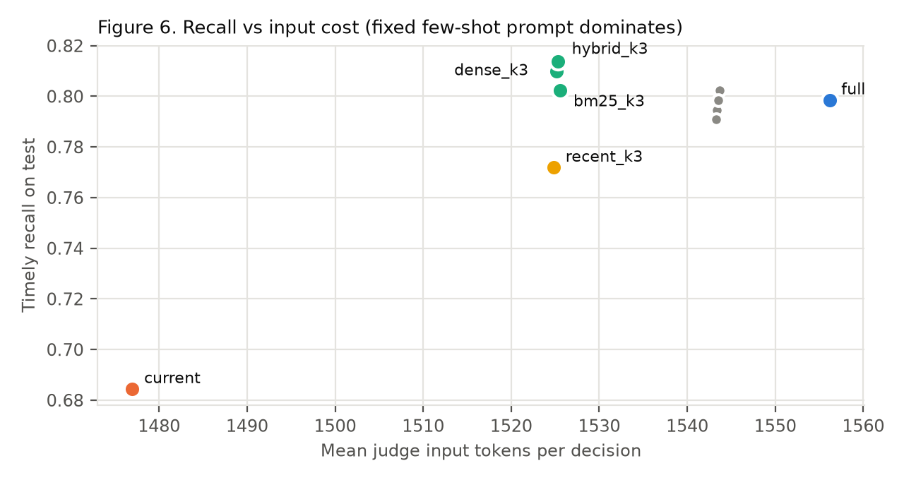
Figure 6. Timely recall against mean judge input tokens per decision (test). The x-axis spans only about 80 tokens.

4.6 Exploratory analyses (decided after unblinding)
The analyses in this section were chosen after the test results were seen and tune thresholds on test. They are not confirmatory.
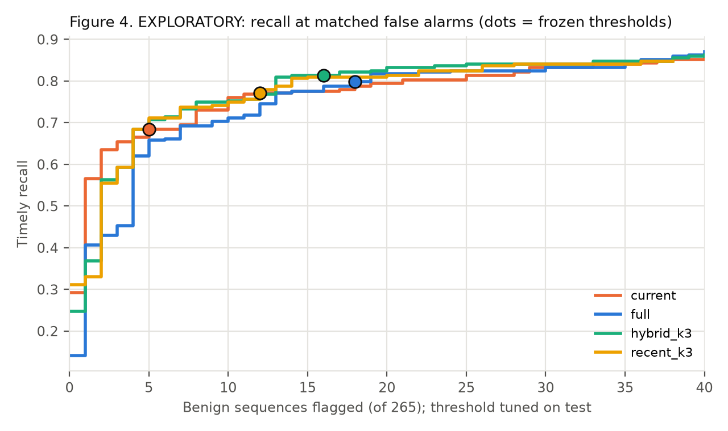
Figure 4. EXPLORATORY. Timely recall as a function of the number of benign test sequences flagged, with the threshold tuned on test; dots mark the frozen pre-registered thresholds.
Table 12. EXPLORATORY. Timely recall at matched benign-flag counts (actual count in parentheses).
Condition | ≤ 5 benign flags | ≤ 13 benign flags | ≤ 18 benign flags
current | 0.684 (5) | 0.772 (12) | 0.787 (18)
full | 0.658 (5) | 0.772 (13) | 0.798 (18)
recent_k3 | 0.711 (5) | 0.787 (13) | 0.810 (18)
bm25_k3 | 0.700 (5) | 0.760 (13) | 0.802 (18)
dense_k3 | 0.700 (5) | 0.802 (13) | 0.810 (17)
hybrid_k3 | 0.707 (5) | 0.810 (13) | 0.821 (17)

At equal false alarms, full history does not beat current-only overall, recency is not worse than retrieval, and k = 3 is not worse than full. The H1 gain in Section 4.4 therefore reflects a different operating point as much as better discrimination overall.
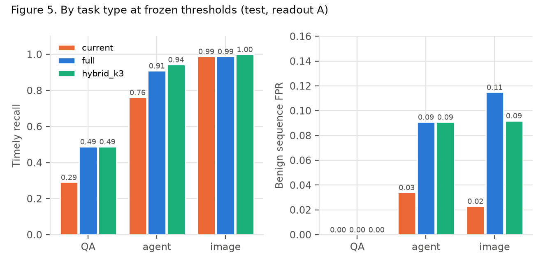
Figure 5. Timely recall (left) and benign sequence FPR (right) by task type at the frozen thresholds (test, readout A).
Table 13. EXPLORATORY. Paired differences by task type at the frozen thresholds.
Comparison | Type (harmful / benign) | Timely diff [95% CI] | FPR diff [95% CI] | Discordant
full − current | QA (86 / 90) | +0.198 [+0.093, +0.302] | 0.000 | 3 / 20
full − current | agent (88 / 88) | +0.148 [+0.080, +0.227] | +0.057 [0.000, +0.114] | 0 / 13
full − current | image (89 / 87) | 0.000 [−0.034, +0.034] | +0.092 [+0.023, +0.161] | 1 / 1
hybrid_k3 − recent_k3 | QA | +0.093 [+0.035, +0.163] | 0.000 | 0 / 8
hybrid_k3 − recent_k3 | agent | +0.034 [−0.023, +0.091] | +0.011 [0.000, +0.034] | 2 / 5
hybrid_k3 − full | QA | 0.000 [−0.035, +0.035] | 0.000 | 1 / 1

The per-type view resolves the apparent conflict between Sections 4.4 and 4.6.
- Decomposed QA is where history helps cleanly: no condition flags any benign QA sequence, and full history raises timely QA recall from 0.291 to 0.488. Hybrid retrieval matches full history here and beats recency by 9 points (8 sequences to 0), consistent with the relevant QA pieces not always being the most recent ones.
- Agent detection also improves with history (+0.148), but benign agent FPR rises from 0.034 to 0.091.
- Image attacks are caught almost perfectly with or without history, while benign image FPR rises from 0.023 to 0.115 with full history.
Overall, history buys QA and agent detections at the price of benign agent and image false alarms. When the threshold is moved to equalize false alarms, the two effects roughly cancel.

5. Discussion
A small, relevant history is enough here. The most robust result is H2: giving the judge its three most relevant earlier steps matches full history in timely detection, without more false alarms, for every retriever tested. It holds on the pre-registered readout, at matched false alarms, and on the fixed-cutoff readout, where k = 3 is in fact more sensitive than full history. For a monitor that must limit what it keeps or reads, this is the encouraging direction.
History is not free. Full history does not simply make the monitor better; it shifts where it errs. It recovers decomposed QA attacks that the current request alone hides, and it makes the judge more suspicious of benign agent and image sequences. A deployment that adds history to a monitor should expect to recalibrate, and should measure benign false alarms per task type rather than only overall.
Retrieval vs recency is unresolved on this benchmark. DecomposedHarm sequences are short (at k = 5, about 70% of decisions already see every earlier step), so recency and retrieval often choose nearly the same steps, and the benchmark cannot show retrieval's advantage on long histories, or its cost advantage. The QA-only hint that hybrid retrieval beats recency is a hypothesis for a pre-registered follow-up on longer traces, not a finding.
Calibration on small benign sets is fragile. Two problems appeared, both about calibration rather than detection: near-binary scores made fixed-FPR calibration impossible until the continuous readout was used, and thresholds fitted on 127 benign sequences transferred to test FPRs between 1.9% and 6.8%. Comparisons between monitors at a nominal FPR are only as good as the benign calibration set.

6. Limitations
- Test reuse. The 528 test sequences were also evaluated in Phase 2. No Phase 3 choice used them, the reuse was disclosed in the plan before any Phase 3 run, and a fresh hold-out would have been 172 unbalanced rows.
- Threshold transfer confounds H1 and H4 on readout A. A larger benign calibration set, or a comparison at a fixed test FPR pre-registered in advance, would remove it.
- Short sequences limit what history selection can show, and make cost savings negligible.
- One judge, one run. One 8B model with greedy decoding. GPU decoding is not bit-identical across runs, and run-to-run spread was not measured, since that would reuse the test set.
- Statistics use a sequence-level bootstrap. Benign sequences were derived from harmful ones and some goals repeat, so task-family clustering would likely widen the intervals.
- Labels are taken as given. The harm index is built differently per task type, and for agent tasks it was annotated by a language model.
- Protocol amendment. The primary readout changed after a first validation run, never on test. The reasons, the evidence and the superseded files are recorded.
- Mechanism untested. This study shows that decisions change with history, not why; separating retrieval failures from judge misinterpretation needs independent evidence annotations (H3).

7. Conclusion and next experiment
On DecomposedHarm, with a reproduced Llama-3.1-8B sequential monitor, top-3 retrieval of earlier requests is non-inferior to full history in timely detection, without more false alarms. History helps most on decomposed question-answering attacks and costs false alarms on benign agent and image tasks, so at equal false alarms its overall benefit disappears. Smart retrieval did not beat recency here.
The next planned experiment is a mechanism study. On a small, pre-specified subset with independent human annotations of which earlier steps carry the attack, it would give the judge exactly that evidence (an oracle) and remove, restore or replace individual steps with matched benign controls. Its aim is to separate two failure modes: the right evidence not being retrieved, and the judge misreading evidence it was given, including the benign false alarms that history introduces.

Data, code and ethics
Code. The full experiment code, tests (103 passing), configuration, pre-registration, amendment, frozen thresholds and analysis scripts are in the project repository, tag phase3-v1. Every number in this manuscript is produced by scripts in that repository from local result files.
Data. DecomposedHarm is gated and evaluation-only. Raw benchmark text, per-sequence result files and model weights are kept out of version control, and no benchmark text appears in this manuscript. Configuration files contain row identifiers only.
Ethics. No harmful objective was generated or executed; the monitor only classifies pre-existing benchmark requests. All inference was local; no benchmark prompt was sent to a remote service. The benchmark was never used for training.

References
Cormack, G. V., Clarke, C. L. A., and Buettcher, S. (2009). Reciprocal rank fusion outperforms Condorcet and individual rank learning methods. SIGIR 2009.
Glukhov, D., et al. (2024). Breach by a thousand leaks: Unsafe information leakage in "safe" AI responses. arXiv:2407.02551.
Grattafiori, A., et al. (2024). The Llama 3 herd of models. arXiv:2407.21783.
Greenblatt, R., Shlegeris, B., Sachan, K., and Roger, F. (2023). AI control: Improving safety despite intentional subversion. arXiv:2312.06942.
Jones, E., Dragan, A., and Steinhardt, J. (2024). Adversaries can misuse combinations of safe models. arXiv:2406.14595.
Reimers, N., and Gurevych, I. (2019). Sentence-BERT: Sentence embeddings using Siamese BERT-networks. EMNLP 2019.
Robertson, S., and Zaragoza, H. (2009). The probabilistic relevance framework: BM25 and beyond. Foundations and Trends in Information Retrieval, 3(4).
Russinovich, M., Salem, A., and Eldan, R. (2024). Great, now write an article about that: The Crescendo multi-turn LLM jailbreak attack. arXiv:2404.01833.
Souly, A., et al. (2024). A StrongREJECT for empty jailbreaks. arXiv:2402.10260.
Wang, W., et al. (2020). MiniLM: Deep self-attention distillation for task-agnostic compression of pre-trained transformers. NeurIPS 2020.
Yueh-Han, C., et al. (2025). Monitoring decomposition attacks in LLMs with lightweight sequential monitors. arXiv:2506.10949 (ICLR 2026).

Appendix A. Setup and deviations from the paper
Table A1. Pinned setup.
Item | Value
Dataset | YuehHanChen/DecomposedHarm @ 25e1d5910c2cccbdcae11799193595cea999bda8
Upstream code | YuehHanChen/Monitoring-Decomposition-Attack @ 79f5b4109aec8ff88f92ffe2d7a94eb419699d68
Judge | meta-llama/Llama-3.1-8B-Instruct @ 0e9e39f249a16976918f6564b8830bc894c89659, bfloat16
Encoder | sentence-transformers/all-MiniLM-L6-v2 @ 1110a243fdf4706b3f48f1d95db1a4f5529b4d41
Hardware | NVIDIA H100 NVL (95,830 MiB), driver 610.43.02, PyTorch 2.15.0+cu132
Decoding | greedy, max_new_tokens 2,000
Jobs | Phase 2: 798355, 798359, 798360; Phase 3: validation 798524, test 798699; superseded 798493

- Serving: local Transformers in bfloat16 vs the paper's API-served model (quantization not verified).
- Chat template: the local tokenizer's Llama 3.1 template; the API's server-side formatting is not observable.
- Nondeterminism: greedy GPU decoding is not bit-identical across runs.
- Threshold search: the upstream sweep has a one-step offset; we emulate it as primary and report an aligned sweep beside it.
- Problem rows kept in the primary analysis (sensitivity analysis drops them).
- Parsing: upstream rule (last number in the reply). 11 of 5,202 Phase 2 replies had no number and were mapped to benign, as upstream does.

Appendix B. Reproducing the numbers
python scripts/summarize_paper_runs.py results/paper_eval_*.json
python scripts/summarize_phase3.py results/phase3a1_test_*.json
python scripts/summarize_phase3.py --reference recent_k3 results/phase3a1_test_*.json
python scripts/phase3_exploratory.py results/phase3a1_test_*.json
PYTHONPATH=src python scripts/make_figures.py
Inputs: configs/phase3_plan.json, configs/phase3_amendment_1.json, configs/phase3_thresholds.json (which records the SHA-256 of every validation file). The full change history is in docs/experiment_log.md.

